

**Novel Coronavirus(2019-nCoV)**

**Situation Report - 8**

**Data as reported by 28 January 2020\***

**HIGHLIGHTS**

* A World Health Organization (WHO) senior leadership team, led by Director-General Dr Tedros Adhanom Ghebreyesus, today met President Xi Jinping of the

People’s Republic of China in Beijing. They shared the latest information on the outbreak and reiterated their commitment to bring it under control.

* The discussions focused on continued collaboration to improve containment measures in Wuhan, to strengthen public health measures in other cities and provinces, to conduct further studies and transmissibility of the virus, to continue to share data, and for China to share biological material with WHO. These measures will advance scientific understanding of the virus and contribute to the development such as vaccines and treatments. <https://www.who.int/news-room/detail/28-01-2020-who-china-leaders-discuss-next-steps-in-battle-against-coronavirus-outbreak>
* WHO is launching a Global 2019-nCoV Clinical Data Platform to allow Member States to contribute anonymized clinical data in order to inform the public health clinical response
* WHO is continually monitoring developments and the Director-General can reconvene the Emergency Committee on very short notice as needed. Committee members are regularly informed of developments.

**SITUATION IN NUMBERS**

**Globally**

**4593** confirmed

**China**

**4537** confirmed

**6973** suspected

1. severe
2. deaths

**Outside of China**

1. confirmed

**14** countries

**WHO RISK ASSESSMENT1**

**China** **Very High**

**Regional Level** **High**

**Global Level** **High**

1. An error in the wording of the situation reports dated 23, 24 and 25 January was corrected on 26 January. Those reports did not correctly reflect the WHO risk assessment. The risk assessment used to inform our actions, our advice to countries, and to brief Emergency Committee members, evaluates the risk as follows: very high in China, high in the region and high globally. (The situation reports on the above dates incorrectly reported it as moderate at the global level. They have been corrected.)

*The situation report includes information reported to WHO Geneva by 10 AM

**Figure 1. Countries, territories or areas with reported confirmed cases of 2019-nCoV, 28 January 2020**

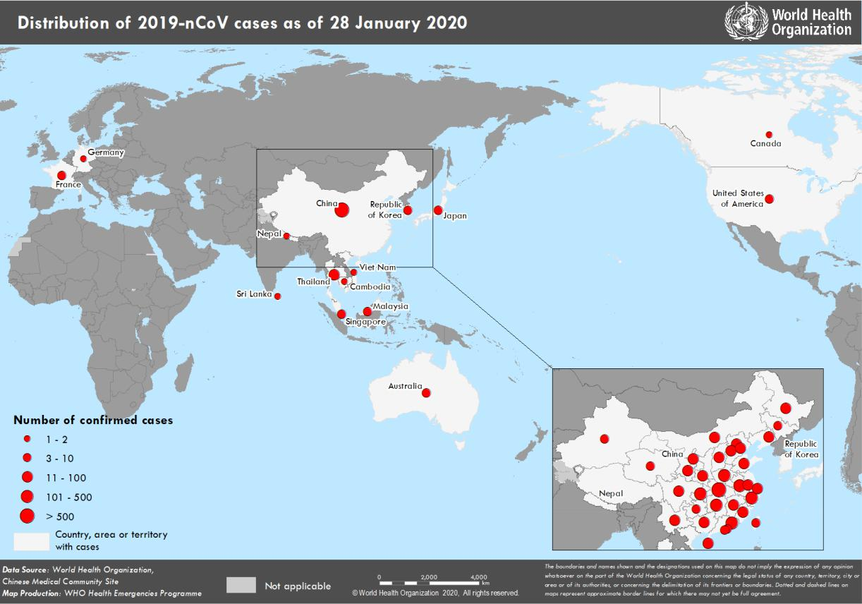

**TECHNICAL FOCUS: Clinical Management:**

Patients with 2019-nCoV infection, are presenting with a wide range of symptoms. Most seem to have mild disease, and about 20% appear to progress to severe disease, including pneumonia, respiratory failure and in some cases death.

Clinical care of suspected patients with 2019-nCoV should focus on early recognition, immediate isolation (separation), implementation of appropriate infection prevention and control (IPC) measures and provision of optimized supportive care. WHO is convening a bi-weekly call with clinical experts around the globe, to better understand, in real-time, the clinical presentation and treatment interventions.

WHO has published [interim clinical care guidance](https://www.who.int/emergencies/diseases/novel-coronavirus-2019/technical-guidance) for hospitalized patients and for mildly ill patients at home, and developed a standardized clinical case record form (CRF) that will be available the website. To facilitate the aggregation of standardized clinical data, WHO is launching a Global 2019-nCoV Clinical Data Platform to allow Member States to contribute anonymized clinical data in order to inform the public health clinical response. As there is currently no known effective antiviral therapy for 2019-nCoV, the WHO R&D blueprint is conducting a systematic review to evaluate potential therapeutics and develop master clinical protocols that are necessary to accelerate this globally.

WHO has also updated the [Disease Commodity Package](https://www.who.int/publications-detail/disease-commodity-package---novel-coronavirus-(ncov)) that includes an essential list of biomedical equipment, medicines and supplies necessary to care for patients with 2019-nCoV.

In addition, a notification was sent out to the Emergency Medical Teams network requesting an expression of interest for clinical operations support teams to support triage, referral systems, clinical care and IPC.

**SURVEILLANCE**

**Table 1. Countries, territories or areas with reported confirmed cases of 2019-nCoV, 28 January 2020**

|  |  |  |  |  |  |  |
| --- | --- | --- | --- | --- | --- | --- |
|  | **WHO Regional Office** |  | **Country/Territory/Area** |  | **Confirmed Cases** |  |
|  |  |  |  |  |  |  |
|  |  |  | **China**\* |  | **4537** |  |
|  |  |  |  |  |  |  |
|  |  |  |  |  | |  |
|  |  |  | Japan |  | 6 |  |
|  | **Western Pacific** |  |  |  |  |  |
|  |  |  |  |  |  |
|  |  | Republic of Korea |  | 4 |  |
|  |  |  |  |  |
|  |  |  |  |  |  |  |
|  |  |  |  |  |  |  |
|  |  |  | Viet Nam |  | 2 |  |
|  |  |  |  |  |  |  |
|  |  |  |  |  |  |  |
|  |  |  | Singapore |  | 7 |  |
|  |  |  |  |  |  |  |
|  |  |  |  |  | |  |
|  |  |  | Australia |  | 5 |  |
|  |  |  |  |  |  |  |
|  |  |  |  |  | |  |
|  |  |  | Malaysia |  | 4 |  |
|  |  |  |  |  |  |  |
|  |  |  |  |  | |  |
|  |  |  | Cambodia |  | 1 |  |
|  |  |  |  |  |  |  |
|  |  |  |  |  | |  |
|  |  |  | Thailand |  | 14 |  |
|  |  |  |  |  |  |  |
|  |  |  |  |  |  |  |
|  | **South-East Asia** |  | Nepal |  | 1 |  |
|  |  |  |  |  |  |  |
|  |  |  |  |  | |  |
|  |  |  | Sri Lanka |  | 1 |  |
|  |  |  |  |  |  |  |
|  |  |  |  |  | |  |
|  | **Region of the Americas** |  | United States of America |  | 5 |  |
|  |  |  |  |  |  |  |
|  |  |  |  |  | |  |
|  |  |  | Canada |  | 2 |  |
|  |  |  |  |  |  |  |
|  |  |  |  |  | |  |
|  |  |  | France |  | 3 |  |
|  | **European Region** |  |  |  |  |  |
|  |  |  |  |  |  |
|  |  |  |  |  |  |
|  |  |  | Germany |  | 1 |  |
|  |  |  |  |  |  |  |
|  |  |  |  |  | |  |
|  | **Total Confirmed cases** |  | Total |  | 4593 |  |
|  |  |  |  |  |  |  |

*Confirmed cases in China include cases confirmed in Hong Kong SAR (8 confirmed cases), Macau SAR (7 confirmed cases) and Taipei (7 confirmed cases).

**Figure 2: Epidemic curve by date of onset of 2019-nCoV cases identified outside of China, 28 January 2020**

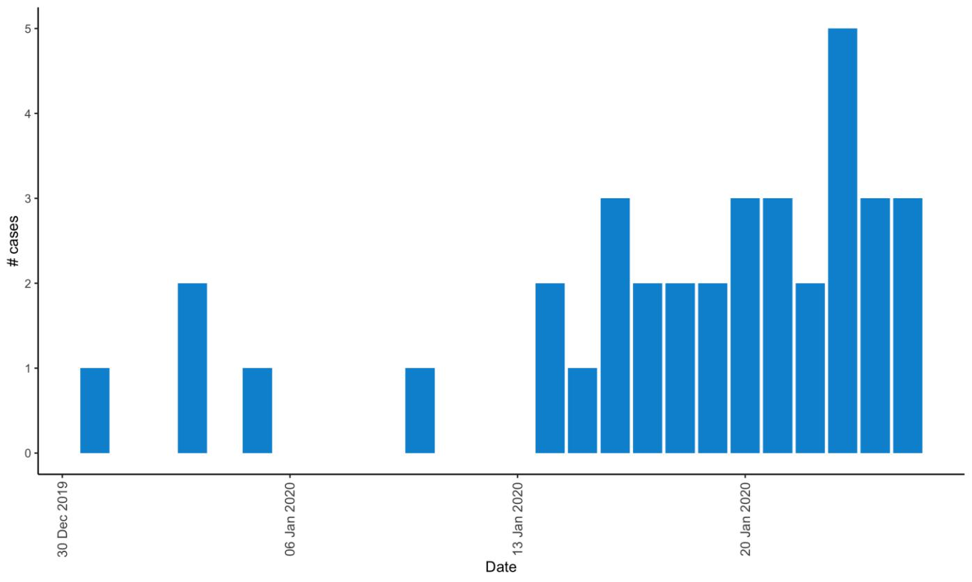

Note: for figure 2: Of the 56 cases reported outside China, three were detected while asymptomatic. For remaining 53 cases, information is available only for 36 cases as presented in the epi curve.

**STRATEGIC OBJECTIVES**

WHO’s strategic objectives for this response are to:

* Limit human-to-human transmission including reducing secondary infections among close contacts and health care workers, preventing transmission amplification events, and preventing further international spread from China*;
* Identify, isolate and care for patients early, including providing optimized care for infected patients;
* Identify and reduce transmission from the animal source;
* Address crucial unknowns regarding clinical severity, extent of transmission and infection, treatment options, and accelerate the development of diagnostics, therapeutics and vaccines;
* Communicate critical risk and event information to all communities and counter misinformation;
* Minimize social and economic impact through multisectoral partnerships.

*This can be achieved through a combination of public health measures, such as rapid identification, diagnosis and management of the cases, identification and follow up of the contacts, infection prevention and control in healthcare settings, implementation of health measures for travellers, awareness- raising in the population and risk communication.

**PREPAREDNESS AND RESPONSE**

* WHO has been in regular and direct contact with Member States where cases have been reported. WHO is also informing other countries about the situation and providing support as requested.
* WHO has developed interim guidance for [laboratory diagnosis,](https://www.who.int/health-topics/coronavirus/laboratory-diagnostics-for-novel-coronavirus) [clinical management](https://www.who.int/publications-detail/clinical-management-of-severe-acute-respiratory-infection-when-novel-coronavirus-(ncov)-infection-is-suspected)[, infection prevention and](https://www.who.int/publications-detail/infection-prevention-and-control-during-health-care-when-novel-coronavirus-(ncov)-infection-is-suspected) [control in health care settings,](https://www.who.int/publications-detail/infection-prevention-and-control-during-health-care-when-novel-coronavirus-(ncov)-infection-is-suspected) [home care for patients with suspected novel coronavirus](https://www.who.int/publications-detail/home-care-for-patients-with-suspected-novel-coronavirus-(ncov)-infection-presenting-with-mild-symptoms-and-management-of-contacts) , [risk communication](https://www.who.int/publications-detail/risk-communication-and-community-engagement-readiness-and-initial-response-for-novel-coronaviruses-(-ncov)) [and community engagement.](https://www.who.int/publications-detail/risk-communication-and-community-engagement-readiness-and-initial-response-for-novel-coronaviruses-(-ncov))
* WHO has provided recommendations to reduce risk of [transmission from animals to humans.](https://www.who.int/health-topics/coronavirus/who-recommendations-to-reduce-risk-of-transmission-of-emerging-pathogens-from-animals-to-humans-in-live-animal-markets)
* WHO has published an [updated advice for international traffic in relation to the outbreak of the novel](https://www.who.int/ith/2020-24-01-outbreak-of-Pneumonia-caused-by-new-coronavirus/en/) [coronavirus 2019-nCoV.](https://www.who.int/ith/2020-24-01-outbreak-of-Pneumonia-caused-by-new-coronavirus/en/)
* Activation of R&D blueprint to accelerate diagnostics, vaccines, and therapeutics.
* WHO has developed an [online course](https://openwho.org/courses/introduction-to-ncov) to provide general introduction to emerging respiratory viruses, including novel coronaviruses.
* WHO is providing guidance on [early investigations,](https://www.who.int/emergencies/diseases/novel-coronavirus-2019/early-investigations/) which are critical to carry out early in an outbreak of a new virus. The data collected from the study protocols can be used to refine recommendations for surveillance and case definitions, to characterize the key epidemiological transmission features of 2019-nCoV, help understand spread, severity, spectrum of disease, impact on the community and to inform operational models for implementation of countermeasures such as case isolation, contact tracing and isolation. The first protocol that is available is a: [Household transmission investigation protocol for 2019-novel coronavirus (2019-nCoV)](https://www.who.int/publications-detail/household-transmission-investigation-protocol-for-2019-novel-coronavirus-(2019-ncov)-infection) [infection.](https://www.who.int/publications-detail/household-transmission-investigation-protocol-for-2019-novel-coronavirus-(2019-ncov)-infection)
* WHO is working with its networks of researchers and other experts to coordinate global work on surveillance, epidemiology, modelling, diagnostics, clinical care and treatment, and other ways to identify, manage the disease and limit onward transmission. WHO has issued interim guidance for countries, updated to take into account the current situation.
* WHO is working with global expert networks and partnerships for laboratory, infection prevention and control, clinical management and mathematical modelling.

**RECOMMENDATIONS AND ADVICE**

During previous outbreaks due to other coronavirus (Middle-East Respiratory Syndrome (MERS) and Severe Acute Respiratory Syndrome (SARS), human-to-human transmission occurred through droplets, contact and fomites, suggesting that the transmission mode of the 2019-nCoV can be similar. The basic principles to reduce the general risk of transmission of acute respiratory infections include the following:

* Avoiding close contact with people suffering from acute respiratory infections.
* Frequent hand-washing, especially after direct contact with ill people or their environment.
* Avoiding unprotected contact with farm or wild animals.
* People with symptoms of acute respiratory infection should practice cough etiquette (maintain distance, cover coughs and sneezes with disposable tissues or clothing, and wash hands).
* Within healthcare facilities, enhance standard infection prevention and control practices in hospitals, especially in emergency departments.

WHO does not recommend any specific health measures for travellers. In case of symptoms suggestive of respiratory illness either during or after travel, travellers are encouraged to seek medical attention and share their travel history with their healthcare provider. [Travel guidance](https://www.who.int/ith/2020-24-01-outbreak-of-Pneumonia-caused-by-new-coronavirus/en/) was updated on 24 January.

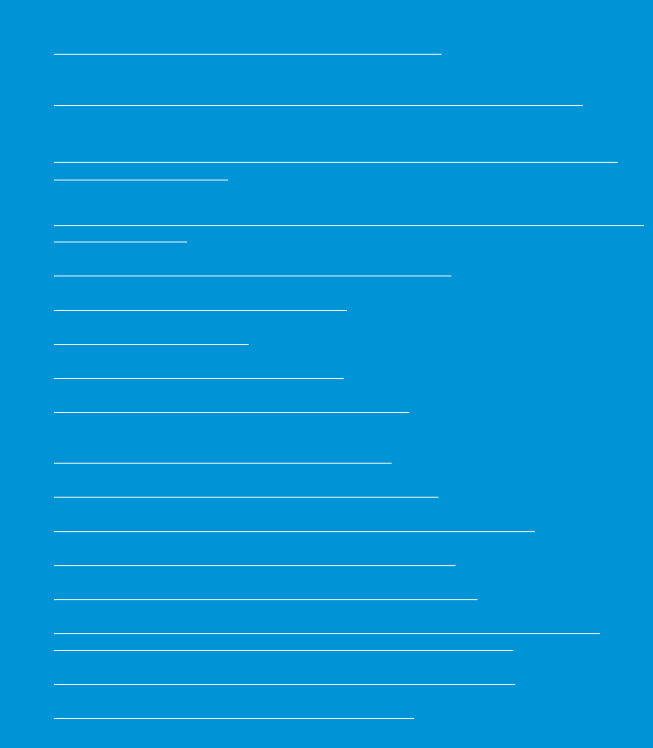**Resources:**

* Technical interim guidance for novel coronavirus, WHO: <https://www.who.int/emergencies/diseases/novel-coronavirus-2019>
* WHO travel advice for international travel and trade in relation to the outbreak of the novel coronavirus 2019-nCoV
* <https://www.who.int/ith/2020-24-01-outbreak-of-Pneumonia-caused-by-new-coronavirus/en/>
* Readiness is the key to detect, combat spread of the new coronavirus:

<https://www.who.int/southeastasia/news/detail/27-01-2020-readiness-is-the-key-to-detect-combat-spread-of-the-new-coronavirus>

* WHO’s Eastern Mediterranean Region scales up preparedness for novel coronavirus <http://www.emro.who.int/media/news/whos-eastern-mediterranean-region-scales-up-preparedness-for-novel-coronavirus.html>
* Press statements by KCDC (in Korean): <https://www.cdc.go.kr/board/board.es?mid=a20501000000&bid=0015>
* Wuhan Municipal Health Commission's briefing on the pneumonia epidemic situation, (in Chinese): http://wjw.wuhan.gov.cn/front/web/list2nd/no/710
* Disease outbreak news, Novel Coronavirus: <https://www.who.int/csr/don/en/>
* Thailand Ministry of Public Health situation update on novel coronavirus (in Thai): <https://ddc.moph.go.th/viralpneumonia/index.html>
* Press statement by Ministry of Health, Labour and Welfare, Japan (in Japanese): <https://www.mhlw.go.jp/stf/houdou/houdou_list_202001.html>
* Notice sent out from Health and Food Safety Planning Division, Quarantine Station Operation Management Office (in Japanese): <https://www.mhlw.go.jp/content/10900000/000582967.pdf>
* Situation report by WHO on Novel Coronavirus (2019-nCoV) <https://www.who.int/emergencies/diseases/novel-coronavirus-2019>
* CDC press release. First Travel-related Case of 2019 Novel Coronavirus Detected in United States <https://www.cdc.gov/media/releases/2020/p0121-novel-coronavirus-travel-case.html>
* Hong Kong SAR Department of Health, Press Release <https://www.info.gov.hk/gia/general/202001/23/P2020012300970.htm>
* Epidemic Prevention Measures, Macau SAR Health Bureau <https://www.ssm.gov.mo/apps1/PreventWuhanInfection/ch.aspx#clg17048>
* Press release on 23 January 2020, Ministry of Health Singapore. <https://www.moh.gov.sg/news-highlights/details/confirmed-imported-case-of-novel-coronavirus-infection-in-singapore-multi-ministry-taskforce-ramps-up-precautionary-measures>
* CDC press release. Second Travel-related Case of 2019 Novel Coronavirus Detected in United States <https://www.cdc.gov/media/releases/2020/p0124-second-travel-coronavirus.html>
* New South Wales Government: Health: Coronavirus cases confirmed in NSW <https://www.health.nsw.gov.au/news/Pages/20200125_03.aspx>