

**Novel Coronavirus(2019-nCoV)**

**Situation Report - 9**

**Data as reported by 29 January 2020\***

**HIGHLIGHTS**

* Four confirmed cases reported in United Arab Emirates, in individuals traveling from Wuhan City.
* World Health Organization (WHO), in collaboration with the World Economic Forum, has set up a public private collaboration called “The Pandemic Supply Chain Network (PSCN)”. It is a Market Network that seeks to provide a platform for data sharing, market visibility, and operational coordination and connecting.
* Today, PSCN is launching the first of several teleconference calls with over 30 private sector organizations and 10 multilateral organizations to develop a market capacity and risk assessment for personal protective equipment (PPE).

This assessment will be used as the basis to match the global demand for PPE with the global supply. The market and risk assessment for PPE is expected to be completed by 5 February 2020.

* The Emergency Committee on the novel coronavirus (2019-nCoV) under the International Health Regulations (IHR 2005) is re-convened by the World Health Organization Director-General Dr Tedros Adhanom Ghebreyesus on 30 January.

**SITUATION IN NUMBERS**

**Globally**

**6065** confirmed

**China**

**5997** confirmed

**9239** suspected

**1239** severe

1. deaths

**Outside of China**

1. confirmed

**15** countries

**WHO RISK ASSESSMENT**

**China** **Very High**

**Regional Level** **High**

**Global Level** **High**

**Figure 1. Countries, territories or areas with reported confirmed cases of 2019-nCoV, 29 January 2020**

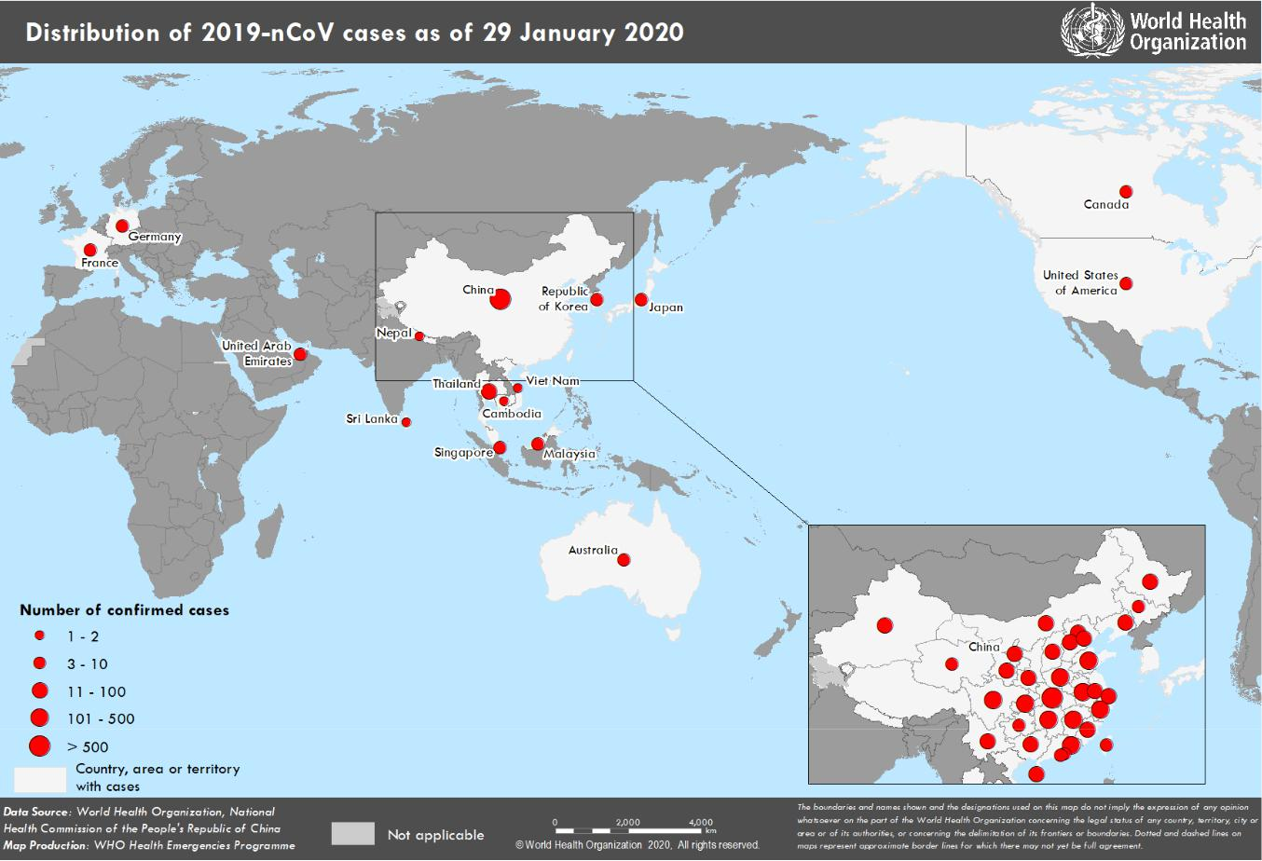

*The situation report includes information reported to WHO Geneva by 10 AM

**TECHNICAL FOCUS: Travel advice:**

WHO has published [travel advice for international traffic](https://www.who.int/ith/2020-27-01-outbreak-of-Pneumonia-caused-by-new-coronavirus/en/) on 27 January . This document includes advice for individual travelers on general measures to reduce the risk of acute respiratory infection, as well as advice on health measures related to international traffic. Exit screening is advised for areas with ongoing transmission of the novel coronavirus 2019-nCoV (currently in People’s Republic of China). Exit screening includes checking for signs and symptoms (fever above 38°, cough), interview of passengers with respiratory infection symptoms leaving the affected areas with regards to potential exposure to high-risk contacts or to the presumed animal source, directing symptomatic travelers to further medical examination, followed by testing for 2019-nCoV, and keeping confirmed cases under isolation and treatment. The evidence from the past outbreaks shows that effectiveness of entry screening is uncertain, but it may support risk communication strategy by providing information to travellers from affected countries/areas to reduce the general risk of acute respiratory infections, and to seek medical attention early if they develop symptoms compatible with the infection.

During the current outbreak with the novel coronavirus 2019-nCoV, a number of exported cases were detected through entry screening implemented by some countries. Symptomatic cases may be detected through temperature screening at Point of Entry, for whom medical examination and laboratory tests will be conducted for confirmation. Temperature screening to detect potential suspect cases at Point of Entry may miss travellers incubating the disease or travellers concealing fever during travel and may require substantial investments. A focused approach targeting direct flights from affected areas could be more effective and less resource demanding. If entry screening is implemented, temperature screening should always be accompanied by dissemination of risk communication messages at Points of Entry. This can be done through posters, leaflets or electronic bulletin aiming at raising awareness among travellers about signs and symptoms of the disease, and encouragement of health care seeking behavior, including when to seek medical care, and reporting of their travel history.

When implementing temperature screening, countries should take into account national policy and capacity considerations. Countries implementing temperature screening are encouraged to establish proper mechanism for data collection and analysis such as numbers of travellers screened and confirmed cases out of screened passengers, and method of screening.

WHO advises against the application of any restrictions of international traffic based on the information currently available on this event.

**SURVEILLANCE**

**Table 1. Countries, territories or areas with reported confirmed cases of 2019-nCoV, 29 January 2020**

|  |  |  |  |  |  |  |
| --- | --- | --- | --- | --- | --- | --- |
|  | **WHO Regional Office** |  | **Country/Territory/Area** |  | **Confirmed Cases** |  |
|  |  |  |  |  |  |  |
|  |  |  | **China**\* |  | **5997** |  |
|  |  |  |  |  |  |  |
|  |  |  |  |  | |  |
|  |  |  | Japan |  | 7 |  |
|  | **Western Pacific** |  |  |  |  |  |
|  |  |  |  |  |  |
|  |  | Republic of Korea |  | 4 |  |
|  |  |  |  |  |
|  |  |  |  |  |  |  |
|  |  |  |  |  |  |  |
|  |  |  | Viet Nam |  | 2 |  |
|  |  |  |  |  |  |  |
|  |  |  |  |  |  |  |
|  |  |  | Singapore |  | 7 |  |
|  |  |  |  |  |  |  |
|  |  |  |  |  | |  |
|  |  |  | Australia |  | 7 |  |
|  |  |  |  |  |  |  |
|  |  |  |  |  | |  |
|  |  |  | Malaysia |  | 4 |  |
|  |  |  |  |  |  |  |
|  |  |  |  |  | |  |
|  |  |  | Cambodia |  | 1 |  |
|  |  |  |  |  |  |  |
|  |  |  |  |  | |  |
|  |  |  | Thailand |  | 14 |  |
|  |  |  |  |  |  |  |
|  |  |  |  |  |  |  |
|  | **South-East Asia** |  | Nepal |  | 1 |  |
|  |  |  |  |  |  |  |
|  |  |  |  |  | |  |
|  |  |  | Sri Lanka |  | 1 |  |
|  |  |  |  |  |  |  |
|  |  |  |  |  | |  |
|  | **Region of the Americas** |  | United States of America |  | 5 |  |
|  |  |  |  |  |  |  |
|  |  |  |  |  | |  |
|  |  |  | Canada |  | 3 |  |
|  |  |  |  |  |  |  |
|  |  |  |  |  | |  |
|  |  |  | France |  | 4 |  |
|  | **European Region** |  |  |  |  |  |
|  |  |  |  |  |  |
|  |  |  |  |  |  |
|  |  |  | Germany |  | 4 |  |
|  |  |  |  |  |  |  |
|  |  |  |  |  | |  |
|  | **Eastern Mediterranean** |  | United Arab Emirates |  | 4 |  |
|  |  |  |  |  |  |  |
|  |  |  |  |  | |  |
|  | **Total Confirmed cases** |  | Total |  | 6065 |  |
|  |  |  |  |  |  |  |

*Confirmed cases in China include cases confirmed in Hong Kong SAR (8 confirmed cases), Macau SAR (7 confirmed cases) and Taipei (8 confirmed cases).

**Figure 2: Epidemic curve by date of onset of 2019-nCoV cases identified outside of China, 29 January 2020**

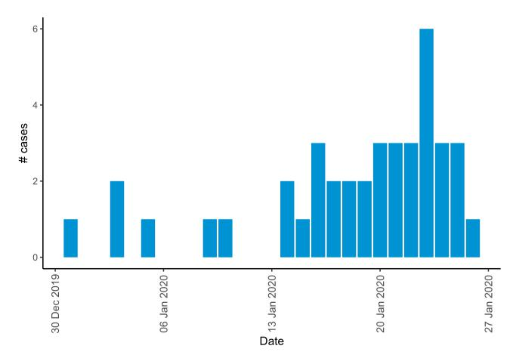

Note for figure 2: Of the 68 cases reported outside China, three were detected while asymptomatic. For the remaining 65 cases, information is available only for 40 cases as presented in the epi curve.

**STRATEGIC OBJECTIVES**

WHO’s strategic objectives for this response are to:

* Limit human-to-human transmission including reducing secondary infections among close contacts and health care workers, preventing transmission amplification events, and preventing further international spread from China*;
* Identify, isolate and care for patients early, including providing optimized care for infected patients;
* Identify and reduce transmission from the animal source;
* Address crucial unknowns regarding clinical severity, extent of transmission and infection, treatment options, and accelerate the development of diagnostics, therapeutics and vaccines;
* Communicate critical risk and event information to all communities and counter misinformation;
* Minimize social and economic impact through multisectoral partnerships.

*This can be achieved through a combination of public health measures, such as rapid identification, diagnosis and management of the cases, identification and follow up of the contacts, infection prevention and control in healthcare settings, implementation of health measures for travellers, awareness- raising in the population and risk communication.

**PREPAREDNESS AND RESPONSE**

* WHO has been in regular and direct contact with Member States where cases have been reported. WHO is also informing other countries about the situation and providing support as requested.
* WHO has developed interim guidance for [laboratory diagnosis,](https://www.who.int/health-topics/coronavirus/laboratory-diagnostics-for-novel-coronavirus) [clinical management](https://www.who.int/publications-detail/clinical-management-of-severe-acute-respiratory-infection-when-novel-coronavirus-(ncov)-infection-is-suspected)[, infection prevention and](https://www.who.int/publications-detail/infection-prevention-and-control-during-health-care-when-novel-coronavirus-(ncov)-infection-is-suspected) [control in health care settings,](https://www.who.int/publications-detail/infection-prevention-and-control-during-health-care-when-novel-coronavirus-(ncov)-infection-is-suspected) [home care for patients with suspected novel coronavirus](https://www.who.int/publications-detail/home-care-for-patients-with-suspected-novel-coronavirus-(ncov)-infection-presenting-with-mild-symptoms-and-management-of-contacts) , [risk communication](https://www.who.int/publications-detail/risk-communication-and-community-engagement-readiness-and-initial-response-for-novel-coronaviruses-(-ncov)) [and community engagement.](https://www.who.int/publications-detail/risk-communication-and-community-engagement-readiness-and-initial-response-for-novel-coronaviruses-(-ncov))
* Prepared [disease commodity package](https://www.who.int/publications-detail/disease-commodity-package---novel-coronavirus-(ncov)) that includes an essential list of biomedical equipment, medicines and supplies necessary to care for patients with 2019-nCoV.
* WHO has provided recommendations to reduce risk of [transmission from animals to humans.](https://www.who.int/health-topics/coronavirus/who-recommendations-to-reduce-risk-of-transmission-of-emerging-pathogens-from-animals-to-humans-in-live-animal-markets)
* WHO has published an [updated advice for international traffic in relation to the outbreak of the novel](https://www.who.int/ith/2020-24-01-outbreak-of-Pneumonia-caused-by-new-coronavirus/en/) [coronavirus 2019-nCoV.](https://www.who.int/ith/2020-24-01-outbreak-of-Pneumonia-caused-by-new-coronavirus/en/)
* Activation of R&D blueprint to accelerate diagnostics, vaccines, and therapeutics.
* WHO has developed an [online course](https://openwho.org/courses/introduction-to-ncov) to provide general introduction to emerging respiratory viruses, including novel coronaviruses.
* WHO is providing guidance on early investigations, which are critical to carry out early in an outbreak of a new virus. The data collected from the study protocols can be used to refine recommendations for surveillance and case definitions, to characterize the key epidemiological transmission features of 2019-nCoV, help understand spread, severity, spectrum of disease, impact on the community and to inform operational models for implementation of countermeasures such as case isolation, contact tracing and isolation. The first protocol that is available is a: [Household transmission investigation protocol for 2019-novel coronavirus (2019-nCoV)](https://www.who.int/publications-detail/household-transmission-investigation-protocol-for-2019-novel-coronavirus-(2019-ncov)-infection) [infection.](https://www.who.int/publications-detail/household-transmission-investigation-protocol-for-2019-novel-coronavirus-(2019-ncov)-infection)
* WHO is working with its networks of researchers and other experts to coordinate global work on surveillance, epidemiology, modelling, diagnostics, clinical care and treatment, and other ways to identify, manage the disease and limit onward transmission. WHO has issued interim guidance for countries, updated to take into account the current situation.
* WHO is working with global expert networks and partnerships for laboratory, infection prevention and control, clinical management and mathematical modelling.

**RECOMMENDATIONS AND ADVICE**

During previous outbreaks due to other coronavirus (Middle-East Respiratory Syndrome (MERS) and Severe Acute Respiratory Syndrome (SARS), human-to-human transmission occurred through droplets, contact and fomites, suggesting that the transmission mode of the 2019-nCoV can be similar. The basic principles to reduce the general risk of transmission of acute respiratory infections include the following:

* Avoiding close contact with people suffering from acute respiratory infections.
* Frequent hand-washing, especially after direct contact with ill people or their environment.
* Avoiding unprotected contact with farm or wild animals.
* People with symptoms of acute respiratory infection should practice cough etiquette (maintain distance, cover coughs and sneezes with disposable tissues or clothing, and wash hands).
* Within healthcare facilities, enhance standard infection prevention and control practices in hospitals, especially in emergency departments.

WHO does not recommend any specific health measures for travellers. In case of symptoms suggestive of respiratory illness either during or after travel, travellers are encouraged to seek medical attention and share their travel history with their healthcare provider.



**Resources:**

* Technical interim guidance for novel coronavirus, WHO: <https://www.who.int/emergencies/diseases/novel-coronavirus-2019>
* WHO travel advice for international travel and trade in relation to the outbreak of the novel coronavirus 2019-nCoV <https://www.who.int/ith/2020-24-01-outbreak-of-Pneumonia-caused-by-new-coronavirus/en/>
* Readiness is the key to detect, combat spread of the new coronavirus:

<https://www.who.int/southeastasia/news/detail/27-01-2020-readiness-is-the-key-to-detect-combat-spread-of-the-new-coronavirus>

* WHO’s Eastern Mediterranean Region scales up preparedness for novel coronavirus <http://www.emro.who.int/media/news/whos-eastern-mediterranean-region-scales-up-preparedness-for-novel-coronavirus.html>
* Press statements by KCDC (in Korean): <https://www.cdc.go.kr/board/board.es?mid=a20501000000&bid=0015>
* Wuhan Municipal Health Commission's briefing on the pneumonia epidemic situation, (in Chinese): http://wjw.wuhan.gov.cn/front/web/list2nd/no/710
* Disease outbreak news, Novel Coronavirus: <https://www.who.int/csr/don/en/>
* Thailand Ministry of Public Health situation update on novel coronavirus (in Thai): <https://ddc.moph.go.th/viralpneumonia/index.html>
* Press statement by Ministry of Health, Labour and Welfare, Japan (in Japanese): <https://www.mhlw.go.jp/stf/houdou/houdou_list_202001.html>
* Notice sent out from Health and Food Safety Planning Division, Quarantine Station Operation Management Office (in Japanese): <https://www.mhlw.go.jp/content/10900000/000582967.pdf>
* Situation report by WHO on Novel Coronavirus (2019-nCoV) <https://www.who.int/emergencies/diseases/novel-coronavirus-2019>
* CDC press release. First Travel-related Case of 2019 Novel Coronavirus Detected in United States <https://www.cdc.gov/media/releases/2020/p0121-novel-coronavirus-travel-case.html>
* Hong Kong SAR Department of Health, Press Release <https://www.info.gov.hk/gia/general/202001/23/P2020012300970.htm>
* Epidemic Prevention Measures, Macau SAR Health Bureau <https://www.ssm.gov.mo/apps1/PreventWuhanInfection/ch.aspx#clg17048>
* Press release on 23 January 2020, Ministry of Health Singapore. <https://www.moh.gov.sg/news-highlights/details/confirmed-imported-case-of-novel-coronavirus-infection-in-singapore-multi-ministry-taskforce-ramps-up-precautionary-measures>
* CDC press release. Second Travel-related Case of 2019 Novel Coronavirus Detected in United States <https://www.cdc.gov/media/releases/2020/p0124-second-travel-coronavirus.html>
* New South Wales Government: Health: Coronavirus cases confirmed in NSW <https://www.health.nsw.gov.au/news/Pages/20200125_03.aspx>