

**Novel Coronavirus(2019-nCoV)**

**Situation Report - 11**

**Data as reported by 31 January 2020\***

**HIGHLIGHTS**

* The Emergency Committee on the novel coronavirus (2019-nCoV) under the International Health Regulations (IHR 2005) was reconvened on 30 January. WHO declared the outbreak to be a public health emergency of international concern. The Emergency Committee has provided advice to WHO, to the People’s Republic of China, to all countries, and to the global community, on measures to control this outbreak. The Committee believes that it is still possible to interrupt virus spread, provided that countries put in place strong measures to detect disease early, isolate and treat cases, trace contacts, and promote social distancing measures commensurate with the risk. More details can be found [here](https://www.who.int/news-room/detail/30-01-2020-statement-on-the-second-meeting-of-the-international-health-regulations-(2005)-emergency-committee-regarding-the-outbreak-of-novel-coronavirus-(2019-ncov)) and in Annex to this situation report.
* Today, the first two confirmed cases of 2019-nCoV acute respiratory disease were reported in Italy; both had travel history to Wuhan City.
* WHO’s Risk Communication Team has launched a new information platform called WHO Information Network for Epidemics (EPI-WIN). EPI-WIN will use a series of amplifiers to share tailored information for specific target groups. EPI-WIN began this week to establish connections to health care and travel and tourism sectors and will work with food and agriculture and business/employer sectors next week.

**SITUATION IN NUMBERS**

**Globally**

**9826** confirmed

**China**

**9720** confirmed

**15238** suspected

**1527** severe

1. deaths

**Outside of China**

1. confirmed **19** countries

**WHO RISK ASSESSMENT**

**China** **Very High**

**Regional Level** **High**

**Global Level** **High**

**Figure 1. Countries, territories or areas with reported confirmed cases of 2019-nCoV, 31 January 2020**

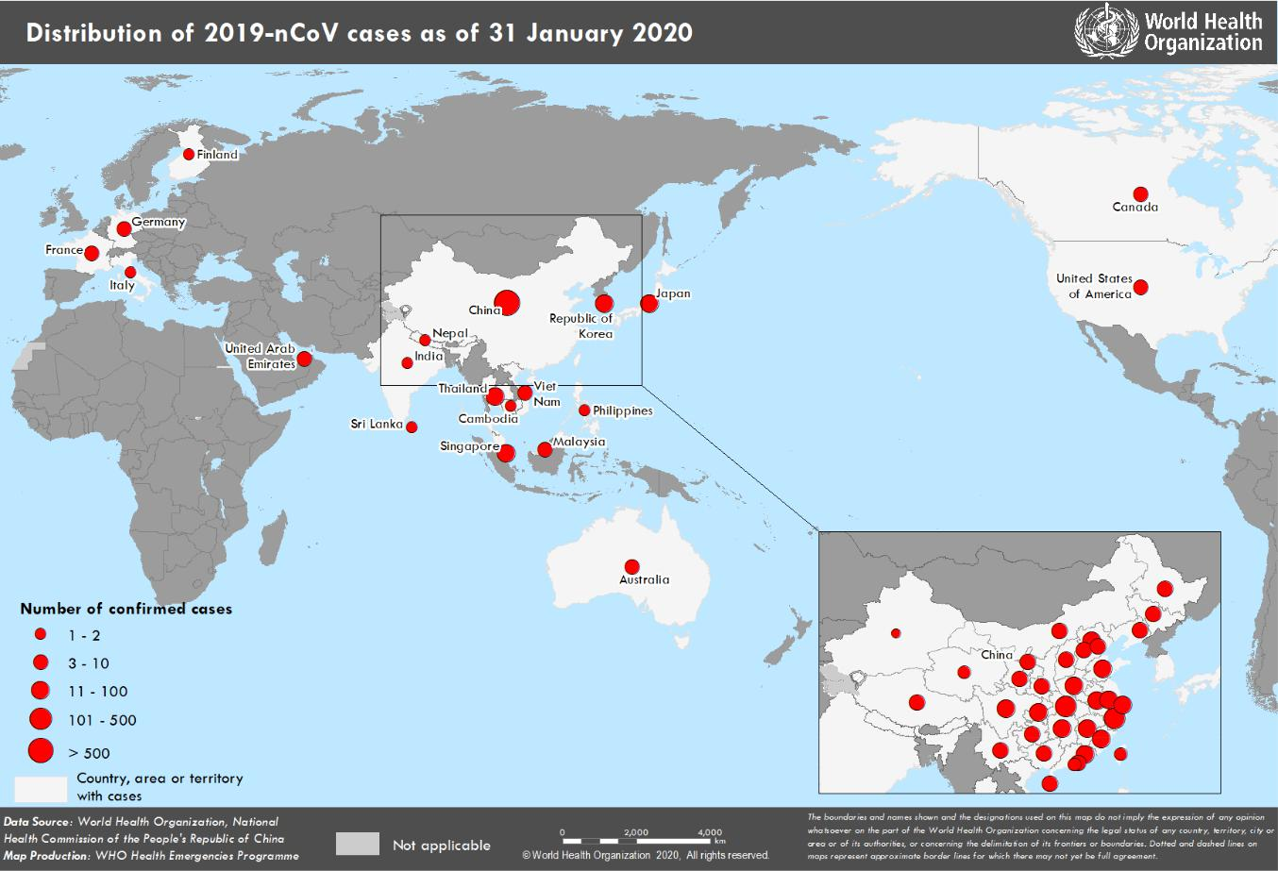

*The situation report includes information reported to WHO Geneva by 10 AM

**TECHNICAL FOCUS:**

**Research and innovation**

As part of WHO’s response to the outbreak, the R&D Blueprint has been activated to accelerate evaluation of the diagnostics, vaccines and therapeutics for this novel coronavirus

The global imperative for research is to maintain a high-level discussion platform which enables consensus on strategic directions, nurtures scientific collaborations and, supports optimal and rapid research to address crucial gaps, without duplication of efforts.

Understanding the disease, its reservoirs, its transmission, its clinical severity and developing effective counter measures including therapeutics and vaccines is critical for the control of the outbreak, the reduction of related mortality and minimization of economic impact.

Recent reports regarding expert research consultations can be found here [https://www.who.int/blueprint/priority-diseases/key-action/novel-coronavirus/en/.](https://www.who.int/blueprint/priority-diseases/key-action/novel-coronavirus/en/)

**SURVEILLANCE**

**Table 1. Countries, territories or areas with reported confirmed cases of 2019-nCoV, 31 January 2020**

|  |  |  |  |  |  |  |
| --- | --- | --- | --- | --- | --- | --- |
|  | **WHO Regional Office** |  | **Country/Territory/Area** |  | **Confirmed Cases** |  |
|  |  |  |  |  |  |  |
|  |  |  | **China**\* |  | **9720** |  |
|  |  |  |  |  |  |  |
|  |  |  |  |  | |  |
|  |  |  | Japan |  | 14 |  |
|  |  |  |  |  |  |  |
|  |  |  |  |  | |  |
|  | **Western Pacific** |  | Republic of Korea |  | 11 |  |
|  |  |  |  |  |  |
|  |  |  |  |  |  |
|  |  |  | Viet Nam |  | 5 |  |
|  |  |  |  |  |  |  |
|  |  |  |  |  |  |  |
|  |  |  | Singapore |  | 13 |  |
|  |  |  |  |  |  |  |
|  |  |  |  |  | |  |
|  |  |  | Australia |  | 9 |  |
|  |  |  |  |  |  |  |
|  |  |  |  |  | |  |
|  |  |  | Malaysia |  | 8 |  |
|  |  |  |  |  |  |  |
|  |  |  |  |  | |  |
|  |  |  | Cambodia |  | 1 |  |
|  |  |  |  |  |  |  |
|  |  |  |  |  | |  |
|  |  |  | Philippines |  | 1 |  |
|  |  |  |  |  |  |  |
|  |  |  |  |  | |  |
|  |  |  | Thailand |  | 14 |  |
|  |  |  |  |  |  |  |
|  |  |  |  |  | |  |
|  |  |  | Nepal |  | 1 |  |
|  | **South-East Asia** |  |  |  |  |  |
|  |  |  |  |  |  |
|  |  |  |  |  |  |
|  |  |  | Sri Lanka |  | 1 |  |
|  |  |  |  |  |  |  |
|  |  |  |  |  | |  |
|  |  |  | India |  | 1 |  |
|  |  |  |  |  |  |  |
|  |  |  |  |  | |  |
|  |  |  | United States of America |  | 6 |  |
|  | **Region of the Americas** |  |  |  |  |  |
|  |  |  |  |  |  |
|  |  |  |  |  |  |
|  |  |  | Canada |  | 3 |  |
|  |  |  |  |  |  |  |
|  |  |  |  |  | |  |
|  |  |  | France |  | 6 |  |
|  |  |  |  |  |  |  |
|  |  |  |  |  | |  |
|  |  |  | Finland |  | 1 |  |
|  | **European Region** |  |  |  |  |  |
|  |  |  |  |  |  |
|  |  |  |  |  |  |
|  |  |  | Germany |  | 5 |  |
|  |  |  |  |  |  |  |
|  |  |  |  |  | |  |
|  |  |  | Italy |  | 2 |  |
|  |  |  |  |  |  |  |
|  |  |  |  |  | |  |
|  | **Eastern Mediterranean** |  | United Arab Emirates |  | 4 |  |
|  |  |  |  |  |  |  |
|  |  |  |  |  | |  |
|  | **Total Confirmed cases** |  | Total |  | 9826 |  |
|  |  |  |  |  |  |  |

*Confirmed cases in China include cases confirmed in Hong Kong SAR (12 confirmed cases), Macau SAR (7 confirmed cases) and Taipei (9 confirmed cases).

**Figure 2: Epidemic curve of 2019-nCoV cases (n=62) identified outside of China, by date of onset of symptoms and travel history, 31 January 2020**

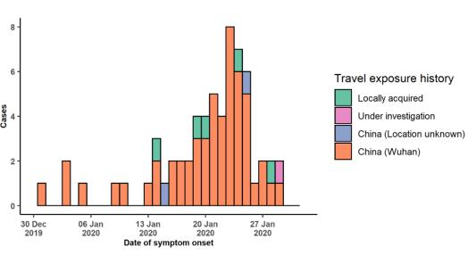

Note for figure 2: Of the 106 cases reported outside China, seven were detected while asymptomatic. For the remaining 99 cases, information on date of onset is available only for the 62 cases presented in the epidemiologic curve.

**Figure 3: Epidemic curve of 2019-nCoV cases (n=106) identified outside of China, by date of reporting and travel history, 31 January 2020**

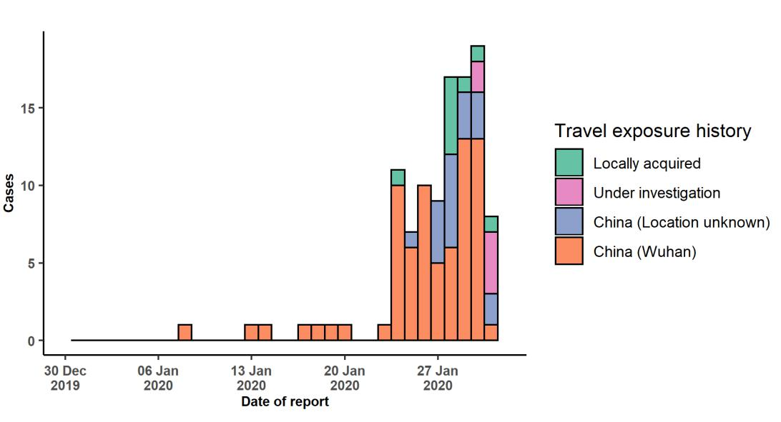

**STRATEGIC OBJECTIVES**

WHO’s strategic objectives for this response are to:

* Limit human-to-human transmission including reducing secondary infections among close contacts and health care workers, preventing transmission amplification events, and preventing further international spread from China*;
* Identify, isolate and care for patients early, including providing optimized care for infected patients;
* Identify and reduce transmission from the animal source;
* Address crucial unknowns regarding clinical severity, extent of transmission and infection, treatment options, and accelerate the development of diagnostics, therapeutics and vaccines;
* Communicate critical risk and event information to all communities and counter misinformation;
* Minimize social and economic impact through multisectoral partnerships.

*This can be achieved through a combination of public health measures, such as rapid identification, diagnosis and management of the cases, identification and follow up of the contacts, infection prevention and control in healthcare settings, implementation of health measures for travellers, awareness- raising in the population and risk communication.

**PREPAREDNESS AND RESPONSE**

* WHO has actively sought misinformation and responded to rumours through [‘myth busting’](https://www.who.int/emergencies/diseases/novel-coronavirus-2019/advice-for-public/myth-busters) on WHO’s social media and its [website.](https://www.who.int/emergencies/diseases/novel-coronavirus-2019/advice-for-public/myth-busters)
* WHO has developed a protocol for the investigation of early cases (the “[First Few X (FFX) Cases and contact](https://www.who.int/publications-detail/the-first-few-x-(ffx)-cases-and-contact-investigation-protocol-for-2019-novel-coronavirus-(2019-ncov)-infection) [investigation protocol for 2019-novel coronavirus (2019-nCoV) infection](https://www.who.int/publications-detail/the-first-few-x-(ffx)-cases-and-contact-investigation-protocol-for-2019-novel-coronavirus-(2019-ncov)-infection)”). The protocol is designed to gain an early understanding of the key clinical, epidemiological and virological characteristics of the first cases of 2019-nCoV infection detected in any individual country, to inform the development and updating of public health guidance to manage cases and reduce potential spread and impact of infection.
* WHO has been in regular and direct contact with Member States where cases have been reported. WHO is also informing other countries about the situation and providing support as requested.
* WHO has developed interim guidance for [laboratory diagnosis,](https://www.who.int/health-topics/coronavirus/laboratory-diagnostics-for-novel-coronavirus) [advice on the use of masks during home care and](https://www.who.int/publications-detail/advice-on-the-use-of-masks-the-community-during-home-care-and-in-health-care-settings-in-the-context-of-the-novel-coronavirus-(2019-ncov)-outbreak) [in health care settings in the context of the novel coronavirus (2019-nCoV) outbreak,](https://www.who.int/publications-detail/advice-on-the-use-of-masks-the-community-during-home-care-and-in-health-care-settings-in-the-context-of-the-novel-coronavirus-(2019-ncov)-outbreak) [clinical management](https://www.who.int/publications-detail/clinical-management-of-severe-acute-respiratory-infection-when-novel-coronavirus-(ncov)-infection-is-suspected)[,](https://www.who.int/publications-detail/infection-prevention-and-control-during-health-care-when-novel-coronavirus-(ncov)-infection-is-suspected) [infection prevention and control in health care settings,](https://www.who.int/publications-detail/infection-prevention-and-control-during-health-care-when-novel-coronavirus-(ncov)-infection-is-suspected) [home care for patients with suspected novel](https://www.who.int/publications-detail/home-care-for-patients-with-suspected-novel-coronavirus-(ncov)-infection-presenting-with-mild-symptoms-and-management-of-contacts) [coronavirus,](https://www.who.int/publications-detail/home-care-for-patients-with-suspected-novel-coronavirus-(ncov)-infection-presenting-with-mild-symptoms-and-management-of-contacts) [risk communication and community engagement.](https://www.who.int/publications-detail/risk-communication-and-community-engagement-readiness-and-initial-response-for-novel-coronaviruses-(-ncov))
* Prepared [disease commodity package](https://www.who.int/publications-detail/disease-commodity-package---novel-coronavirus-(ncov)) that includes an essential list of biomedical equipment, medicines and supplies necessary to care for patients with 2019-nCoV.
* WHO has provided recommendations to reduce risk of [transmission from animals to humans.](https://www.who.int/health-topics/coronavirus/who-recommendations-to-reduce-risk-of-transmission-of-emerging-pathogens-from-animals-to-humans-in-live-animal-markets)
* WHO has published an [updated advice for international traffic in relation to the outbreak of the novel](https://www.who.int/ith/2020-24-01-outbreak-of-Pneumonia-caused-by-new-coronavirus/en/) [coronavirus 2019-nCoV.](https://www.who.int/ith/2020-24-01-outbreak-of-Pneumonia-caused-by-new-coronavirus/en/)
* Activation of R&D blueprint to accelerate diagnostics, vaccines, and therapeutics.
* WHO has developed an [online course](https://openwho.org/courses/introduction-to-ncov) to provide general introduction to emerging respiratory viruses, including novel coronaviruses.
* WHO is providing guidance on early investigations, which are critical to carry out early in an outbreak of a new virus. The data collected from the protocols can be used to refine recommendations for surveillance and case definitions, to characterize the key epidemiological transmission features of 2019-nCoV, help understand spread, severity, spectrum of disease, impact on the community and to inform operational models for implementation of

countermeasures such as case isolation, contact tracing and isolation. The first protocol that is available is a:

[Household transmission investigation protocol for 2019-novel coronavirus (2019-nCoV) infection.](https://www.who.int/publications-detail/household-transmission-investigation-protocol-for-2019-novel-coronavirus-(2019-ncov)-infection)

* WHO is working with its networks of researchers and other experts to coordinate global work on surveillance, epidemiology, modelling, diagnostics, clinical care and treatment, and other ways to identify, manage the disease and limit onward transmission. WHO has issued interim guidance for countries, updated to take into account the current situation.
* WHO is working with global expert networks and partnerships for laboratory, infection prevention and control, clinical management and mathematical modelling.

**RECOMMENDATIONS AND ADVICE FOR THE PUBLIC**

During previous outbreaks due to other coronavirus (Middle-East Respiratory Syndrome (MERS) and Severe Acute Respiratory Syndrome (SARS), human-to-human transmission occurred through droplets, contact and fomites, suggesting that the transmission mode of the 2019-nCoV can be similar. The basic principles to reduce the general risk of transmission of acute respiratory infections include the following:

* Avoiding close contact with people suffering from acute respiratory infections.
* Frequent hand-washing, especially after direct contact with ill people or their environment.
* Avoiding unprotected contact with farm or wild animals.
* People with symptoms of acute respiratory infection should practice cough etiquette (maintain distance, cover coughs and sneezes with disposable tissues or clothing, and wash hands).
* Within healthcare facilities, enhance standard infection prevention and control practices in hospitals, especially in emergency departments.

WHO does not recommend any specific health measures for travellers. In case of symptoms suggestive of respiratory illness either during or after travel, travellers are encouraged to seek medical attention and share their travel history with their healthcare provider.

**ANNEX 1: Temporary Recommendations under the International Health Regulations associated with the declaration of the outbreak of 2019-nCoV as a Public Health Emergency of International Concern**

**To the People’s Republic of China**

Continue to:

* Implement a comprehensive risk communication strategy to regularly inform the population on the evolution of the outbreak, the prevention and protection measures for the population, and the response measures taken for its containment.
* Enhance public health measures for containment of the current outbreak.
* Ensure the resilience of the health system and protect the health workforce.
* Enhance surveillance and active case finding across China.
* Collaborate with WHO and partners to conduct investigations to understand the epidemiology and the evolution of this outbreak and measures to contain it.
* Share relevant data on human cases.
* Continue to identify the zoonotic source of the outbreak, and particularly the potential for circulation with WHO as soon as it becomes available.
* Conduct exit screening at international airports and ports, with the aim of early detection of symptomatic travelers for further evaluation and treatment, while minimizing interference with international traffic.

**To all countries**

It is expected that further international exportation of cases may appear in any country. Thus, all countries should be prepared for containment, including active surveillance, early detection, isolation and case management, contact tracing and prevention of onward spread of 2019-nCoVinfection, and to share full data with WHO. Technical advice is available on the WHO website.

Countries are reminded that they are legally required to share information with WHO under the IHR.

Any detection of 2019-nCoV in an animal (including information about the species, diagnostic tests, and relevant epidemiological information) should be reported to the World Organization for Animal Health (OIE) as an emerging disease.

Countries should place particular emphasis on reducing human infection, prevention of secondary transmission and international spread, and contributing to the international response though multi-sectoral communication and collaboration and active participation in increasing knowledge on the virus and the disease, as well as advancing research.

The Committee does not recommend any travel or trade restriction based on the current information available.

Countries must inform WHO about travel measures taken, as required by the IHR. Countries are cautioned against actions that promote stigma or discrimination, in line with the principles of Article 3 of the IHR.

The Committee asked the Director-General to provide further advice on these matters and, if necessary, to make new case-by-case recommendations, in view of this rapidly evolving situation.

**To the global community**

As this is a new coronavirus, and it has been previously shown that similar coronaviruses required substantial efforts to enable regular information sharing and research, the global community should continue to demonstrate solidarity and cooperation, in compliance with Article 44 of the IHR (2005), in supporting each other on the identification of the source of this new virus, its full potential for human-to-human transmission, preparedness for potential importation of cases, and research for developing necessary treatment.

Provide support to low- and middle-income countries to enable their response to this event, as well as to facilitate access to diagnostics, potential vaccines and therapeutics.

Under Article 43 of the IHR, States Parties implementing additional health measures that significantly interfere with international traffic (refusal of entry or departure of international travellers, baggage, cargo, containers, conveyances, goods, and the like, or their delay, for more than 24 hours) are obliged to send to WHO the public health rationale and justification within 48 hours of their implementation. WHO will review the justification and may request countries to reconsider their measures. WHO is required to share with other States Parties the information about measures and the justification received.