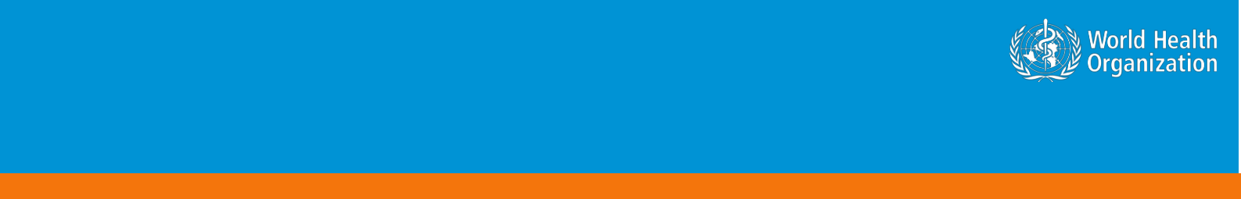**Novel Coronavirus(2019-nCoV)**

**Situation Report – 20**

**Data as reported by 9 February 2020\***

**HIGHLIGHTS**

* No new countries reported cases of 2019-nCoV in the past 24 hours.
* Update on Cruise Ship Diamond Princess:

On 9 February, Japanese National Health Authorities provided WHO with a detailed update on the situation of the Cruise Ship Diamond Princess, currently harboured in Yokohama, Japan. Following confirmation of a case of 2019-nCoV, all crew and passengers are being quarantined for a 14-day period on board the vessel, asked to stay in their cabins and to wear a mask when leaving their cabin. All crew and passengers are closely followed-up and are medically examined and tested for 2019-nCoV when displaying any signs or symptoms suggestive of 2019-nCoV disease. The quarantine period will come to an end on 19 February. Epidemiological and environmental investigations are ongoing.

As of 8 February, 64 individuals were found to have been infected with 2019-nCoV among passengers and crew members. All individuals testing positive were disembarked and admitted for medical care in infectious disease hospitals in the Yokohama area. Close contacts of the infected passengers are asked to remain in quarantine for 14 days from last contact with a confirmed case. Thus, the quarantine period will be extended beyond the 19 February as appropriate only for close contacts of newly confirmed cases.

**SITUATION IN NUMBERS**

**total and new cases in last 24 hours**

**Globally**

37 558 confirmed (2676 new)

**China**

37 251 confirmed (2657 new)

6188 severe (87 new)

812 deaths (89 new)

**Outside of China**

307 confirmed (19 new)

1. countries

1 death

**WHO RISK ASSESSMENT**

China Very High

Regional Level High

Global Level High

**Figure 1. Countries, territories or areas with reported confirmed cases of 2019-nCoV, 9 February 2020**

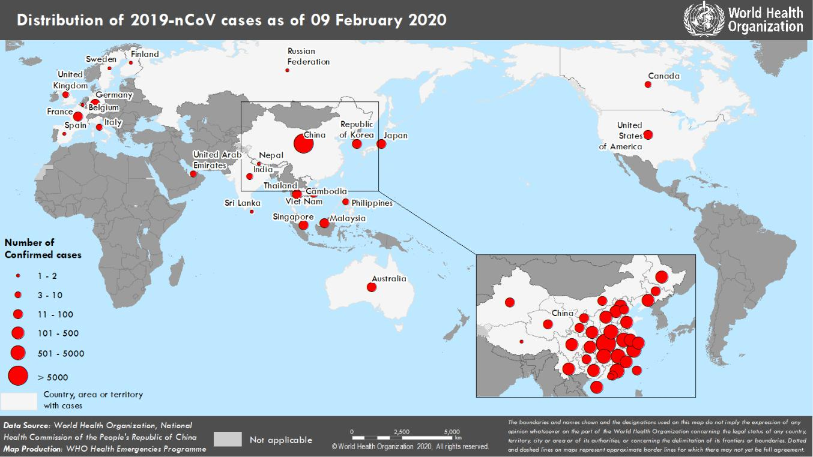

*The situation report includes information provided by national authorities as of 10 AM Central European Time

**TECHNICAL FOCUS: 2019-nCoV Training resources online on OpenWHO.org**

Through the lessons of past emergencies, WHO has learned the value of offering learning materials quickly in an outbreak that will provide critical information to fight disease and protect lives. These materials must be easily accessible in the languages of frontline responders. The WHO has rapidly developed and delivered two online trainings to support the response to the 2019-nCoV outbreak that are available on the open learning platform, [OpenWHO.org.](https://openwho.org/) The platform was established three years ago with emergencies such as 2019-nCoV in mind, in which WHO would need to reach millions of people across the globe with real-time, accessible learning materials.

The courses currently available are:

1. **Emerging respiratory viruses, including 2019-nCoV: methods for detection, prevention, response and**

**control:** <https://openwho.org/courses/introduction-to-ncov>

This course provides a general introduction to 2019-nCoV and emerging respiratory viruses and is intended for public health professionals, incident managers and personnel working for the United Nations, international organizations and NGOs. Approximately 26 000 people registered within the first 10 days of its launch on 26 January. WHO teams are working to translate the resources into all WHO official languages and Portuguese. Many countries have also initiated translation into their own local languages.

1. **WHO Critical Care Severe Acute Respiratory Infection course:** <https://openwho.org/courses/severe-acute-respiratory-infection>

This course includes content on clinical management of patients with a severe acute respiratory infection. Launched on 6 February, it enrolled 3500 users in its first 24 hours. The course is intended for clinicians who are working in intensive care units in low- and middle-income countries and managing adult and pediatric patients with severe forms of Severe Acute Respiratory Infection, including severe pneumonia, acute respiratory distress syndrome, sepsis and septic shock.

The following online learning courses are also in production in February: an occupational health and safety briefing for respiratory diseases (ePROTECT); an introductory course on Go.Data (an outbreak investigation tool for field data collection); an introduction to laboratory diagnostics and kits; and additional language versions of the published courses.

**SURVEILLANCE**

**Table 1. Confirmed cases of 2019-nCoV acute respiratory disease reported by provinces, regions and cities in China, 9 February 2020**

|  |  |
| --- | --- |
| **Province/Region/City** | **Confirmed Cases** |
| Hubei | 27 100 |
| Guangdong | 1120 |
| Zhejiang | 1075 |
| Henan | 1033 |
| Hunan | 838 |
| Anhui | 779 |
| Jiangxi | 740 |
| Jiangsu | 468 |
| Chongqing | 446 |
| Shandong | 435 |
| Sichuan | 386 |
| Beijing | 326 |
| Heilongjiang | 307 |
| Shanghai | 292 |
| Fujian | 250 |
| Shaanxi | 208 |
| Hebei | 206 |
| Guangxi | 195 |
| Yunnan | 140 |
| Hainan | 128 |
| Shanxi | 115 |
| Liaoning | 105 |
| Guizhou | 96 |
| Tianjin | 88 |
| Gansu | 81 |
| Jilin | 78 |
| Inner Mongolia | 54 |
| Ningxia | 45 |
| Xinjiang | 45 |
| Hong Kong SAR | 26 |
| Qinghai | 18 |
| Taipei and environs | 17 |
| Macao SAR | 10 |
| Xizang | 1 |
| **Total** | **37 251** |

**Table 2. Countries, territories or areas with reported confirmed 2019-nCoV cases and deaths. Data as of 9 February 2020**

|  |  |  |  |  |  |  |  |
| --- | --- | --- | --- | --- | --- | --- | --- |
|  |  |  | **Total** | **Total (new) cases** | **Total (new)** |  |  |
|  |  |  | **(new)** |  |  |
|  |  | **Confirmed\*** | **with possible** | **cases with site** |  |  |
|  |  | **cases with** | **Total (new)** |  |
| **WHO Region** | **Country/Territory/Area** | **or confirmed** | **of transmission** |  |
| **(new) cases** | **travel** | **deaths** |  |
|  |  | **transmission** | **under** |  |
|  |  |  | **history to** |  |  |
|  |  |  | **outside of China†** | **investigation** |  |  |
|  |  |  | **China** |  |  |
|  |  |  |  |  |  |  |
|  | China‡ | 37 251 (2657) |  |  |  | 812 (89) |  |
|  |  |  |  |  |  |  |  |
| **Western Pacific Region** | Singapore | 40 (7) | 21 (0) | 19 (7) | 0 (0) | 0 (0) |  |
| Republic of Korea | 27 (3) | 13 (2) | 12 (1) | 2 (0) | 0 (0) |  |
|  |  |
|  | Japan | 26 (1) | 22 (1) | 4 (0) | 0 (0) | 0 (0) |  |
|  |  |  |  |  |  |  |  |
|  | Malaysia | 17 (2) | 9 (0) | 4 (0) | 4 (2) | 0 (0) |  |
|  |  |  |  |  |  |  |  |
|  | Australia | 15 (0) | 15 (0) | 0 (0) | 0 (0) | 0 (0) |  |
|  | Viet Nam | 14 (1) | 8 (0) | 6 (1) | 0 (0) | 0 (0) |  |
|  |  |  |  |  |  |  |  |
|  | Philippines | 3 (0) | 2 (0) | 0 (0) | 1 (0) | 1 (0) |  |
|  | Cambodia | 1 (0) | 1 (0) | 0 (0) | 0 (0) | 0 (0) |  |
|  | Thailand | 32 (0) | 22 (0) | 6 (0) | 4 (0) | 0 (0) |  |
| **South-East Asia Region** | India | 3 (0) | 3 (0) | 0 (0) | 0 (0) | 0 (0) |  |
| Nepal | 1 (0) | 1 (0) | 0 (0) | 0 (0) | 0 (0) |  |
|  |  |
|  | Sri Lanka | 1 (0) | 1 (0) | 0 (0) | 0 (0) | 0 (0) |  |
|  | United States of |  |  |  |  |  |  |
|  |  |  |  |  |  |  |
| **Region of the Americas** | America | 12 (0) | 10 (0) | 2 (0) | 0 (0) | 0 (0) |  |
|  | Canada | 7 (0) | 6 (0) | 0 (0) | 1 (0) | 0 (0) |  |
|  | Germany | 14 (0) | 2 (0) | 12†† (0) | 0 (0) | 0 (0) |  |
|  |  |  |  |  |  |  |  |
|  | France | 11 (5) | 5 (0) | 6 (5) | 0 (0) | 0 (0) |  |
|  | Italy | 3 (0) | 3 (0) | 0 (0) | 0 (0) | 0 (0) |  |
|  | The United Kingdom | 3 (0) | 1 (0) | 2*** (0) | 0 (0) | 0 (0) |  |
| **European Region** |  |  |  |  |  |  |  |
| Russian Federation | 2 (0) | 2 (0) | 0 (0) | 0 (0) | 0 (0) |  |
|  | Belgium | 1 (0) | 1 (0) | 0 (0) | 0 (0) | 0 (0) |  |
|  | Finland | 1 (0) | 1 (0) | 0 (0) | 0 (0) | 0 (0) |  |
|  | Spain | 1 (0) | 0 (0) | 1§ (0) | 0 (0) | 0 (0) |  |
|  | Sweden | 1 (0) | 1 (0) | 0 (0) | 0 (0) | 0 (0) |  |
| **Eastern Mediterranean** |  |  |  |  |  |  |  |
| **Region** | United Arab Emirates | 7 (0) | 5 (0) | 1 (0) | 1 (0) | 0 (0) |  |
| **Other** | International | 64** (0) |  |  |  |  |  |
| conveyance (Japan) | 0 (0) | 0 (0) | 64 (0) | 0 (0) |  |
|  |  |

*Case classifications are based on [WHO case definitions](https://www.who.int/publications-detail/global-surveillance-for-human-infection-with-novel-coronavirus-(2019-ncov)) for 2019-nCoV.

**†**Location of transmission is classified based on WHO analysis of available official data, and may be subject to reclassification as additional data become available.

‡Confirmed cases in China include cases confirmed in Hong Kong SAR (26 confirmed cases, 1 death), Macao SAR (10 confirmed cases) and Taipei and environs (17 confirmed cases).

§The exposure occurred in Germany.

**Cases identified on a cruise ship currently in Japanese territorial waters.

***The exposure for one of the two cases occurred outside of the United Kingdom.

††Modified based on updated information.

**Figure 2: Epidemic curve of 2019-nCoV cases (n=138) identified outside of China, by date of onset of symptoms and travel history, 9 February 2020**

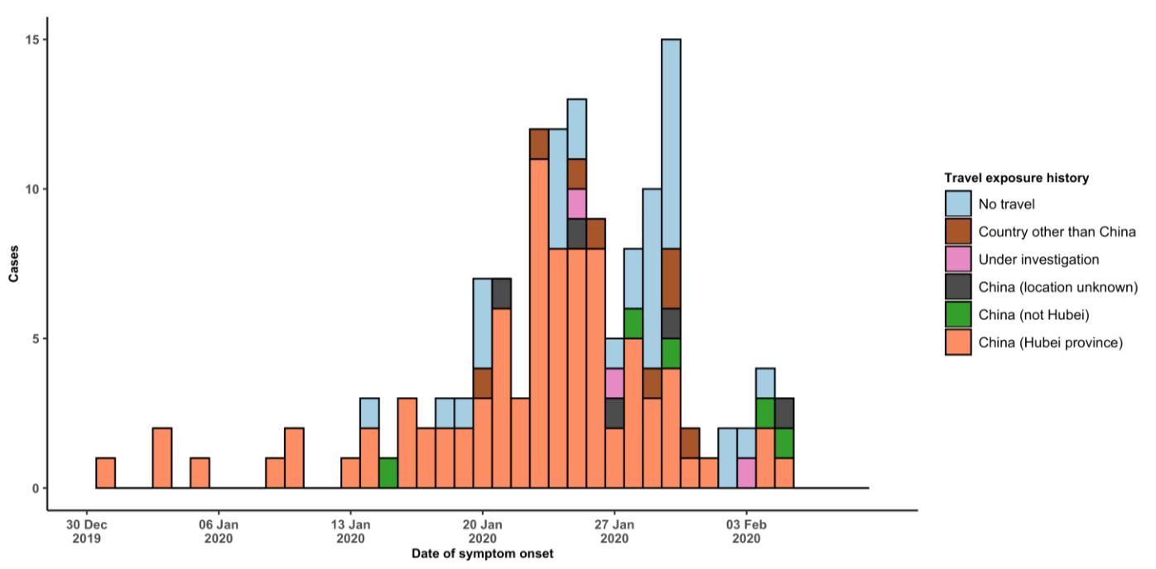

Note for figure 2: Of the 307 cases reported outside China, 16 were detected while asymptomatic. For the remaining 291 cases, information on date of onset is available only for the 138 cases presented in the epidemiologic curve.

**Figure 3: Epidemic curve of 2019-nCoV cases (n=307) identified outside of China, by date of reporting and travel history, 9 February 2020**

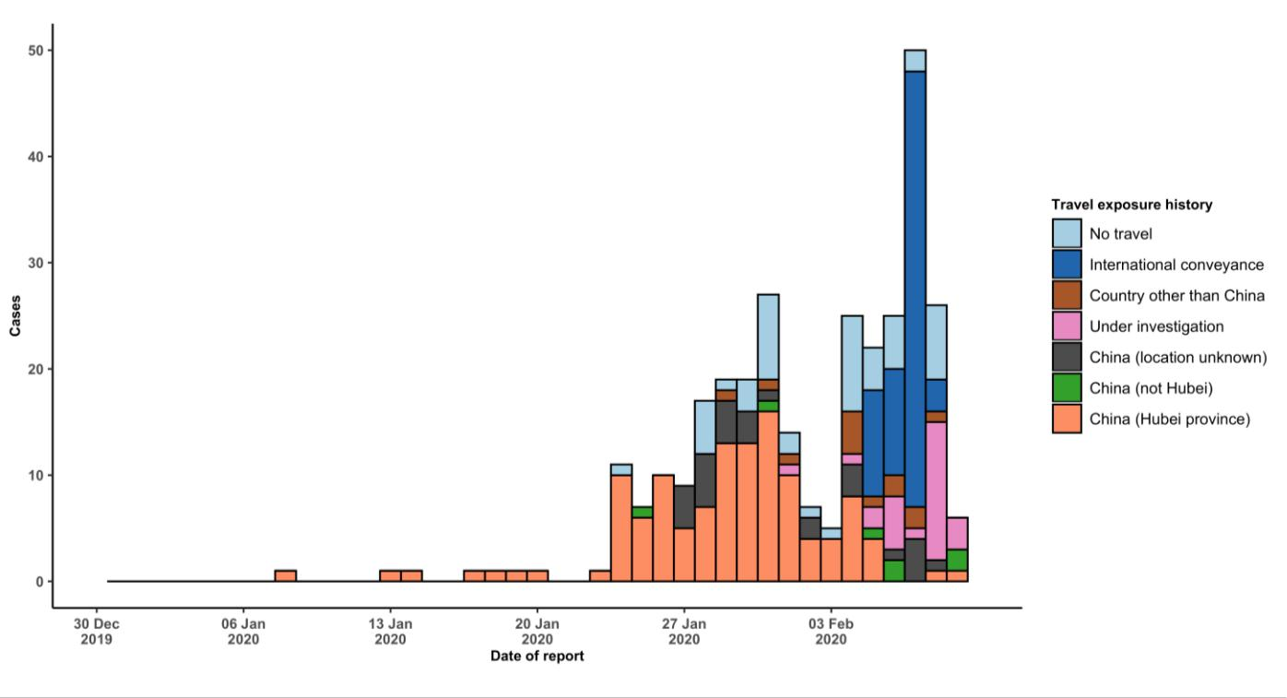

**STRATEGIC OBJECTIVES**

WHO’s strategic objectives for this response are to:

* Limit human-to-human transmission including reducing secondary infections among close contacts and health care workers, preventing transmission amplification events, and preventing further international spread from China*;
* Identify, isolate and care for patients early, including providing optimized care for infected patients;
* Identify and reduce transmission from the animal source;
* Address crucial unknowns regarding clinical severity, extent of transmission and infection, treatment options, and accelerate the development of diagnostics, therapeutics and vaccines;
* Communicate critical risk and event information to all communities and counter misinformation;
* Minimize social and economic impact through multisectoral partnerships.

*This can be achieved through a combination of public health measures, such as rapid identification, diagnosis and management of the cases, identification and follow up of the contacts, infection prevention and control in health care settings, implementation of health measures for travellers, awareness-raising in the population and risk communication.

**PREPAREDNESS AND RESPONSE**

* WHO is working closely with International Air Transport Association (IATA) and have jointly developed a guidance document to provide advice to cabin crew and airport workers, based on country queries. The guidance can be found on the [IATA webpage.](https://www.iata.org/en/programs/safety/health/diseases/#tab-2)
* WHO has developed a protocol for the investigation of early cases (the “[First Few X (FFX) Cases and contact](https://www.who.int/publications-detail/the-first-few-x-(ffx)-cases-and-contact-investigation-protocol-for-2019-novel-coronavirus-(2019-ncov)-infection) [investigation protocol for 2019-novel coronavirus (2019-nCoV) infection](https://www.who.int/publications-detail/the-first-few-x-(ffx)-cases-and-contact-investigation-protocol-for-2019-novel-coronavirus-(2019-ncov)-infection)”). The protocol is designed to gain an early understanding of the key clinical, epidemiological and virological characteristics of the first cases of 2019-nCoV infection detected in any individual country, to inform the development and updating of public health guidance to manage cases and reduce potential spread and impact of infection.
* WHO has been in regular and direct contact with Member States where cases have been reported. WHO is also informing other countries about the situation and providing support as requested.
* WHO has developed interim guidance for [laboratory diagnosis,](https://www.who.int/emergencies/diseases/novel-coronavirus-2019/technical-guidance/laboratory-guidance) [advice on the use of masks during home care and](https://www.who.int/publications-detail/advice-on-the-use-of-masks-the-community-during-home-care-and-in-health-care-settings-in-the-context-of-the-novel-coronavirus-(2019-ncov)-outbreak) [in health care settings in the context of the novel coronavirus (2019-nCoV) outbreak,](https://www.who.int/publications-detail/advice-on-the-use-of-masks-the-community-during-home-care-and-in-health-care-settings-in-the-context-of-the-novel-coronavirus-(2019-ncov)-outbreak) [clinical management](https://www.who.int/publications-detail/clinical-management-of-severe-acute-respiratory-infection-when-novel-coronavirus-(ncov)-infection-is-suspected)[,](https://www.who.int/publications-detail/infection-prevention-and-control-during-health-care-when-novel-coronavirus-(ncov)-infection-is-suspected) [infection prevention and control in health care settings,](https://www.who.int/publications-detail/infection-prevention-and-control-during-health-care-when-novel-coronavirus-(ncov)-infection-is-suspected) [home care for patients with suspected novel](https://www.who.int/publications-detail/home-care-for-patients-with-suspected-novel-coronavirus-(ncov)-infection-presenting-with-mild-symptoms-and-management-of-contacts) [coronavirus,](https://www.who.int/publications-detail/home-care-for-patients-with-suspected-novel-coronavirus-(ncov)-infection-presenting-with-mild-symptoms-and-management-of-contacts) [risk communication and community engagement](https://www.who.int/publications-detail/risk-communication-and-community-engagement-readiness-and-initial-response-for-novel-coronaviruses-(-ncov)) and [Global Surveillance for human infection with](https://www.who.int/publications-detail/global-surveillance-for-human-infection-with-novel-coronavirus-(2019-ncov)) [novel coronavirus (2019-nCoV).](https://www.who.int/publications-detail/global-surveillance-for-human-infection-with-novel-coronavirus-(2019-ncov))
* WHO has prepared [disease commodity package](https://www.who.int/publications-detail/disease-commodity-package---novel-coronavirus-(ncov)) that includes an essential list of biomedical equipment, medicines and supplies necessary to care for patients with 2019-nCoV.
* WHO has provided recommendations to reduce risk of [transmission from animals to humans.](https://www.who.int/health-topics/coronavirus/who-recommendations-to-reduce-risk-of-transmission-of-emerging-pathogens-from-animals-to-humans-in-live-animal-markets)
* WHO has published an [updated advice for international traffic in relation to the outbreak of the novel](https://www.who.int/ith/2019-nCoV_advice_for_international_traffic/en/) [coronavirus 2019-nCoV.](https://www.who.int/ith/2019-nCoV_advice_for_international_traffic/en/)
* WHO has activated of R&D blueprint to accelerate diagnostics, vaccines, and therapeutics.
* WHO has developed an [online course](https://openwho.org/courses/introduction-to-ncov) to provide general introduction to emerging respiratory viruses, including novel coronaviruses.
* WHO is providing guidance on early investigations, which are critical to carry out early in an outbreak of a new virus. The data collected from the protocols can be used to refine recommendations for surveillance and case definitions, to characterize the key epidemiological transmission features of 2019-nCoV, help understand spread, severity, spectrum of disease, impact on the community and to inform operational models for implementation of

countermeasures such as case isolation, contact tracing and isolation. Several protocols are available here:

<https://www.who.int/emergencies/diseases/novel-coronavirus-2019/technical-guidance/early-investigations>

* WHO is working with its networks of researchers and other experts to coordinate global work on surveillance, epidemiology, modelling, diagnostics, clinical care and treatment, and other ways to identify, manage the disease and limit onward transmission. WHO has issued interim guidance for countries, which are updated regularly.
* WHO is working with global expert networks and partnerships for laboratory, infection prevention and control, clinical management and mathematical modelling.

**RECOMMENDATIONS AND ADVICE FOR THE PUBLIC**

During previous outbreaks due to other coronavirus (Middle-East Respiratory Syndrome (MERS) and Severe Acute Respiratory Syndrome (SARS), human-to-human transmission occurred through droplets, contact and fomites, suggesting that the transmission mode of the 2019-nCoV can be similar. The basic principles to reduce the general risk of transmission of acute respiratory infections include the following:

* Avoiding close contact with people suffering from acute respiratory infections.
* Frequent hand-washing, especially after direct contact with ill people or their environment.
* Avoiding unprotected contact with farm or wild animals.
* People with symptoms of acute respiratory infection should practice cough etiquette (maintain distance, cover coughs and sneezes with disposable tissues or clothing, and wash hands).
* Within health care facilities, enhance standard infection prevention and control practices in hospitals, especially in emergency departments.

WHO does not recommend any specific health measures for travellers. In case of symptoms suggestive of respiratory illness either during or after travel, travellers are encouraged to seek medical attention and share their travel history with their health care provider.