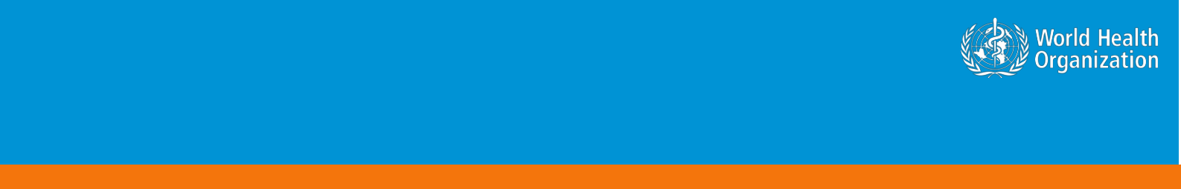

**Coronavirus disease 2019 (COVID-19)**

**Situation Report – 24**

**Data as reported by 13 February 2020\***

**HIGHLIGHTS**

* No new countries reported cases of COVID-19 in the past 24 hours.
* WHO has developed a database to collect the latest scientific findings and knowledge on Coronavirus disease. For more information, please see [here.](https://www.who.int/emergencies/diseases/novel-coronavirus-2019/global-research-on-novel-coronavirus-2019-ncov)
* The two-day global research and innovation forum regarding COVID-19 was convened in line with the WHO R&D Blueprint this week. Leading health experts from around the world met at WHO to assess the current level of knowledge about the new COVID-19 disease, identify gaps and work together to accelerate and fund priority research needed to help stop this outbreak and prepare for any future outbreaks. For more details, please see [here.](https://www.who.int/news-room/detail/12-02-2020-world-experts-and-funders-set-priorities-for-covid-19-research)
* Overnight 14’840 cases, including 13’332 clinically diagnosed cases were reported from Hubei. This is the first time China has reported clinically diagnosed cases in addition to laboratory-confirmed cases. For consistency, we report here only the number of laboratory-confirmed cases. WHO has formally requested additional information on the clinically diagnosed cases, in particular when these have occurred in the course of the outbreak and whether suspect cases were reclassified as clinically diagnosed cases.

**SITUATION IN NUMBERS**

**total and new cases in last 24 hours**

**Globally**

46 997 confirmed (1826 new)

**China**

46 550 confirmed (1820 new)

1368 deaths (254 new) **†**

**Outside of China**

447 confirmed (6 new)

1. countries

1 death

**WHO RISK ASSESSMENT**

China Very High

Regional Level High

Global Level High

**Figure 1. Countries, territories or areas with reported confirmed cases of COVID-19, 13 February 2020**

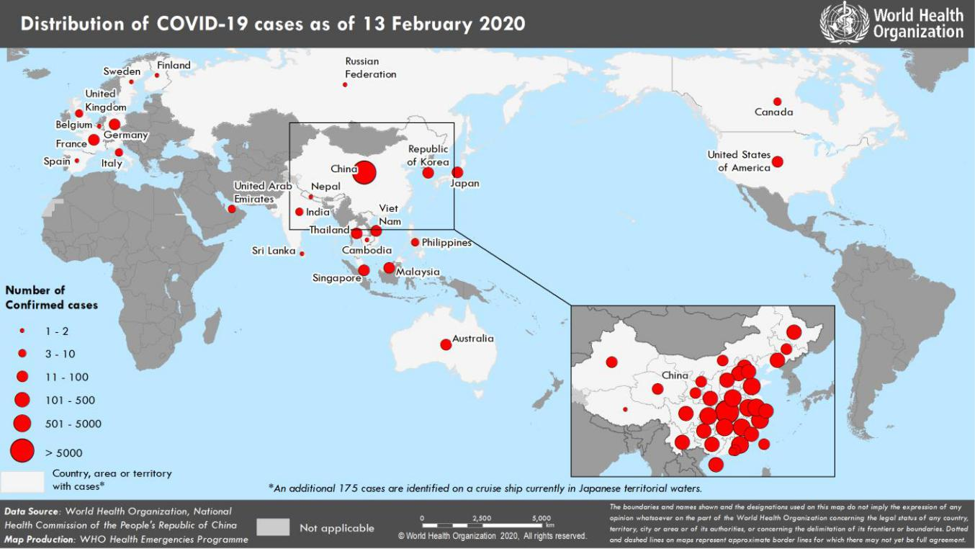

*The situation report includes information provided by national authorities as of 10 AM Central European Time †As reported by China

**TECHNICAL FOCUS: Investigation of COVID-19 cases outside of China**

As of 10am CET 13 Feb 2020, a total of 170 cases of COVID-19 who had a travel history to China have been reported outside of China. The vast majority of these (151, 89%) do not appear to lead to further transmission of the virus, while the remaining 19 have been associated with onward transmission within 12 distinct groups of epidemiologically linked cases (Fig 2). Among these, four groups have involved at least nine individuals. The largest involves 20 individuals in six countries thus far - United Kingdom (6), France (5), Malaysia (3), Singapore (3), Republic of Korea (2), Spain (1) - and has been linked to a conference held in Singapore between 20 and 22 January 2020 and a subsequent ski trip to the French Alps (Table 1, Figure 2). The next largest involves 15 cases and was linked to a conference in Bavaria, Germany. Among the attendees was an individual with an epidemiological link to confirmed cases in Wuhan, China. Additionally, one of the 15 cases was detected in, but did not involve transmission within, Spain.

Sixteen cases have been reported in four countries for which there are no clearly established epidemiological links.

For all these individuals, investigations are ongoing to establish the mechanism by which they were infected.

**Table 1. Summary of four events with linked cases and transmission out of China with number of confirmed cases larger than seven, as of 10 am 13 Feb 2020**

|  |  |  |  |  |  |  |  |  |  |  |  |  |
| --- | --- | --- | --- | --- | --- | --- | --- | --- | --- | --- | --- | --- |
|  | **Event** |  |  | **Countries Reporting** |  |  | **Number of Confirmed** |  |  | **Date of report to WHO of** |  |  |
|  | **Number** |  |  |  |  | **Cases** |  |  | **last case** |  |  |
|  |  |  |  |  |  |  |  |  |  |
|  |  |  |  | France (5), Malaysia (3), Republic of Korea |  |  |  |  |  |  |  |  |
|  | 1 |  |  | (2), Singapore (3), Spain (1), The United |  |  | 20 |  |  | 10 Feb 2020 |  |  |
|  |  |  |  | Kingdom (6) |  |  |  |  |  |  |  |  |
| 2 | |  |  | Germany (14), Spain (1) |  | 15 | |  |  | 11 Feb 2020 | |  |
|  | 3 |  |  | Viet Nam (9) |  |  | 9 |  |  | 11 Feb 2020 |  |  |
| 4 | |  |  | Singapore (9) |  | 9 | |  |  | 8 Feb 2020 | |  |

**Figure 2. Description of the known transmission chain of event originating in Singapore (Event Number 1, Table 1), as of 10 am 13 Feb 2020**

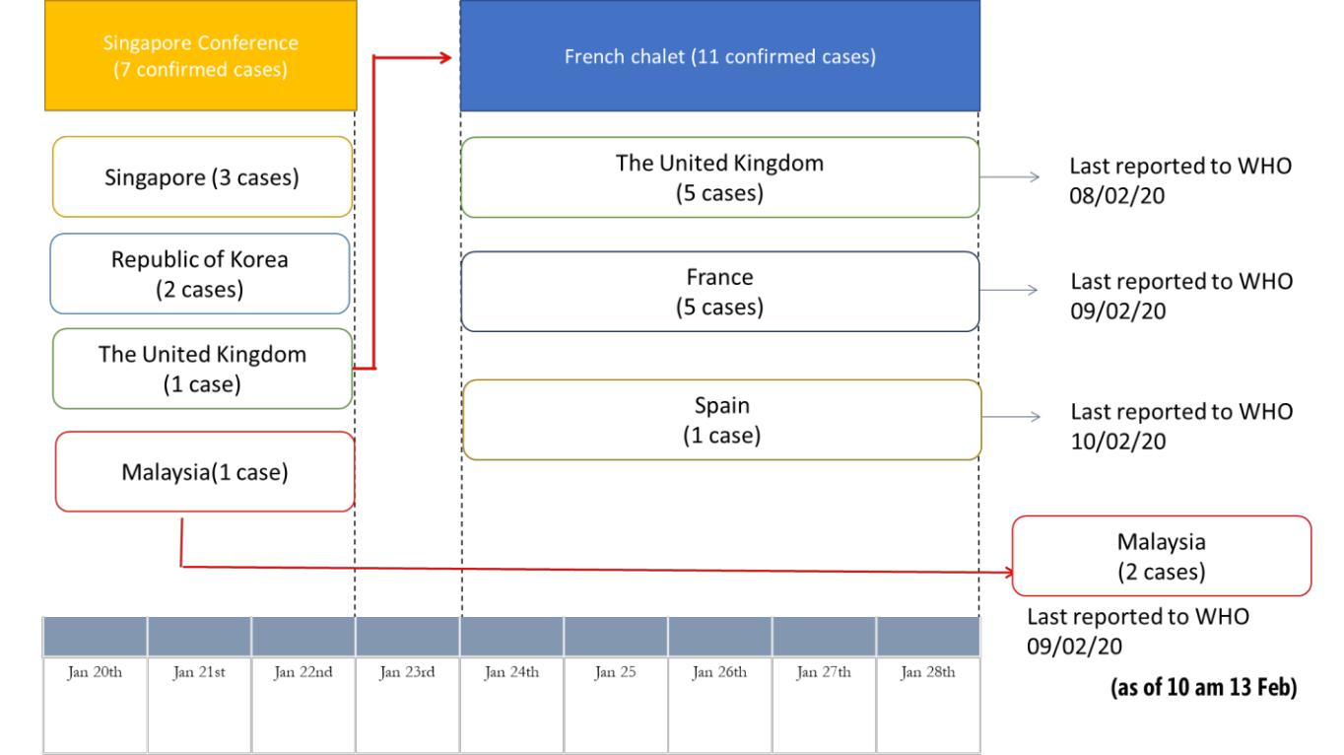

**SURVEILLANCE**

**Table 2. Confirmed cases of COVID-19 acute respiratory disease reported by provinces, regions and cities in China, 13 February 2020\***

|  |  |  |
| --- | --- | --- |
| **Province/Region/City1** | **Population (in 10,000s)** | **Confirmed Cases** |
| Hubei | 5917 | 34874 |
| Guangdong | 11346 | 1241 |
|  |  |  |
| Zhejiang | 5737 | 1145 |
| Henan | 9605 | 1169 |
|  |  |  |
| Hunan | 6899 | 968 |
| Anhui | 6324 | 910 |
|  |  |  |
| Jiangxi | 4648 | 872 |
| Jiangsu | 8051 | 570 |
|  |  |  |
| Chongqing | 3102 | 518 |
| Shandong | 10047 | 506 |
|  |  |  |
| Sichuan | 8341 | 451 |
| Heilongjiang | 3773 | 395 |
|  |  |  |
| Beijing | 2154 | 366 |
| Shanghai | 2424 | 313 |
|  |  |  |
| Fujian | 3941 | 279 |
| Hebei | 7556 | 265 |
|  |  |  |
| Shaanxi | 3864 | 229 |
| Guangxi | 4926 | 222 |
|  |  |  |
| Yunnan | 4830 | 155 |
| Hainan | 934 | 157 |
|  |  |  |
| Shanxi | 3718 | 126 |
| Guizhou | 3600 | 135 |
|  |  |  |
| Liaoning | 4359 | 116 |
| Tianjin | 1560 | 112 |
|  |  |  |
| Gansu | 2637 | 87 |
| Jilin | 2704 | 84 |
|  |  |  |
| Inner Mongolia | 2534 | 61 |
| Xinjiang | 2487 | 63 |
|  |  |  |
| Ningxia | 688 | 64 |
| Hong Kong SAR | 745 | 50 |
|  |  |  |
| Qinghai | 603 | 18 |
| Taipei and environs | 2359 | 18 |
|  |  |  |
| Macao SAR | 66 | 10 |
| Xizang | 344 | 1 |
|  |  |  |
| **Total** | 142823 | 46550 |
|  |  |  |

1. [China Statistical Yearbook - 2019](http://data.stats.gov.cn/english/easyquery.htm?cn=E0103)

*National Bureau of Statistics of China,* 1 October 2019

**Table 3. Countries, territories or areas with reported confirmed COVID-19 cases and deaths. Data as of 13 February 2020**

|  |  |  |  |  |  |  |  |
| --- | --- | --- | --- | --- | --- | --- | --- |
|  |  |  | **Total** | **Total cases with** | **Total cases with** |  |  |
|  |  |  | **cases with** | **possible or** | **site of** |  |  |
| **WHO Region** | **Country/Territory/Area** | **Confirmed\*** | **travel** | **confirmed** | **transmission** | **Total deaths** |  |
| **cases (new)** | **history to** | **transmission** | **under** | **(new)** |  |
|  |  |  |
|  |  |  | **China** | **outside of China†** | **investigation** |  |  |
|  |  |  | **(new)** | **(new)** | **(new)** |  |  |
|  | China‡ | 46 550 (1820) |  |  |  |  |  |
|  |  |  |  |  |  |
| **Western Pacific Region** | Singapore | 50 (3) | 22 (0) | 28 (3) | 0 (0) | 0 (0) |  |
| Japan | 29**††** (0) | 24 (0) | 5 (0) | 0 (0) | 0 (0) |  |
|  |  |
|  | Republic of Korea | 28 (0) | 13 (0) | 12§§ (0) | 3 (0) | 0 (0) |  |
|  |  |  |  |  |  |  |  |
|  | Malaysia | 18 (0) | 15 (0) | 3‡‡ (0) | 0 (0) | 0 (0) |  |
|  |  |  |  |  |  |  |  |
|  | Viet Nam | 16 (1) | 8 (0) | 8 (1) | 0 (0) | 0 (0) |  |
|  | Australia | 15 (0) | 15 (0) | 0 (0) | 0 (0) | 0 (0) |  |
|  |  |  |  |  |  |  |  |
|  | Philippines | 3 (0) | 3 (0) | 0 (0) | 0 (0) | 1 (0) |  |
|  | Cambodia | 1 (0) | 1 (0) | 0 (0) | 0 (0) | 0 (0) |  |
|  | Thailand | 33 (0) | 23 (0) | 6 (0) | 4 (0) | 0 (0) |  |
|  |  |
|  |  |  |  |  |  |  |  |
| **South-East Asia Region** | India | 3 (0) | 3 (0) | 0 (0) | 0 (0) | 0 (0) |  |
| Nepal | 1 (0) | 1 (0) | 0 (0) | 0 (0) | 0 (0) |  |
|  |  |
|  | Sri Lanka | 1 (0) | 1 (0) | 0 (0) | 0 (0) | 0 (0) |  |
|  | United States of |  |  |  |  |  |  |
|  |  |  |  |  |  |  |
| **Region of the Americas** | America | 14 (1) | 12 (1) | 2 (0) | 0 (0) | 0 (0) |  |
|  | Canada | 7 (0) | 6 (0) | 0 (0) | 1 (0) | 0 (0) |  |
|  | Germany | 16 (0) | 2 (0) | 14 (0) | 0 (0) | 0 (0) |  |
|  |  |
|  | France | 11 (0) | 5 (0) | 6 (0) | 0 (0) | 0 (0) |  |
|  |  |  |  |  |  |  |  |
|  | The United Kingdom | 9 (1) | 2 (1) | 7*** (0) | 0 (0) | 0 (0) |  |
|  | Italy | 3 (0) | 3 (0) | 0 (0) | 0 (0) | 0 (0) |  |
| **European Region** | Russian Federation | 2 (0) | 2 (0) | 0 (0) | 0 (0) | 0 (0) |  |
|  |  |  |  |  |  |  |  |
|  | Spain | 2 (0) | 0 (0) | 2§ (0) | 0 (0) | 0 (0) |  |
|  | Belgium | 1 (0) | 1 (0) | 0 (0) | 0 (0) | 0 (0) |  |
|  | Finland | 1 (0) | 1 (0) | 0 (0) | 0 (0) | 0 (0) |  |
|  |  |  |  |  |  |  |  |
|  | Sweden | 1 (0) | 1 (0) | 0 (0) | 0 (0) | 0 (0) |  |
|  |  |  |  |  |  |  |  |
| **Eastern Mediterranean** |  |  |  |  |  |  |  |
| **Region** | United Arab Emirates | 8 (0) | 6 (0) | 1 (0) | 1 (0) | 0 (0) |  |
| **Other** | International |  |  |  |  |  |  |
|  |  |  |  |  |  |
| conveyance (Japan) | 174** (0) | 0 (0) | 0 (0) | 174 (0) | 0 (0) |  |
|  |  |

*Case classifications are based on [WHO case definitions](https://www.who.int/publications-detail/global-surveillance-for-human-infection-with-novel-coronavirus-(2019-ncov)) for COVID-19.

**†**Location of transmission is classified based on WHO analysis of available official data and may be subject to reclassification as additional data become available.

‡Confirmed cases in China include cases confirmed in Hong Kong SAR (50 confirmed cases, 1 death), Macao SAR (10 confirmed cases) and Taipei and environs (18 confirmed cases).

**Cases identified on a cruise ship currently in Japanese territorial waters.

§The exposure for 2 cases occurred outside of Spain.

***The exposure for 6 cases occurred outside of the United Kingdom.

§§The exposure for 3 cases occurred outside of Republic of Korea.

‡‡The exposure for 1 case occurred outside of Malaysia.

**††**One case originally included in the international conveyance cases was reclassified as reported by Japan.

**Figure 3: Epidemic curve of COVID-19 cases (n=172) identified outside of China, by date of onset of symptoms and travel history, 13 February 2020**

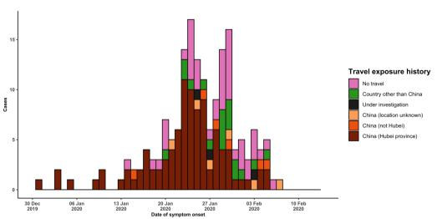

Note for figure 2: Of the 447 cases reported outside China, 16 were detected while apparently asymptomatic. For the remaining 431 cases, information on date of onset is available only for the 172 cases presented in the epidemiologic curve.

**Figure 4: Epidemic curve of COVID-19 cases (n=447) identified outside of China, by date of reporting and travel history, 13 February 2020**

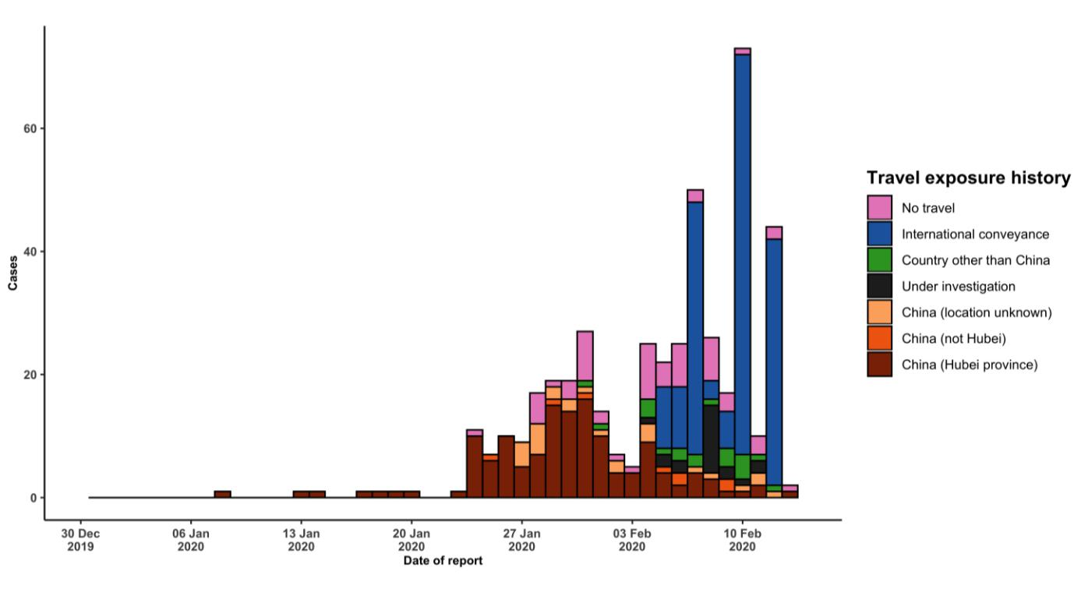

**STRATEGIC OBJECTIVES**

WHO’s strategic objectives for this response are to:

* Limit human-to-human transmission including reducing secondary infections among close contacts and health care workers, preventing transmission amplification events, and preventing further international spread from China*;
* Identify, isolate and care for patients early, including providing optimized care for infected patients;
* Identify and reduce transmission from the animal source;
* Address crucial unknowns regarding clinical severity, extent of transmission and infection, treatment options, and accelerate the development of diagnostics, therapeutics and vaccines;
* Communicate critical risk and event information to all communities and counter misinformation;
* Minimize social and economic impact through multisectoral partnerships.

*This can be achieved through a combination of public health measures, such as rapid identification, diagnosis and management of the cases, identification and follow up of the contacts, infection prevention and control in health care settings, implementation of health measures for travelers, awareness-raising in the population and risk communication.

**PREPAREDNESS AND RESPONSE**

* To view all technical guidance documents regarding COVID-19, please go to [this webpage.](https://www.who.int/emergencies/diseases/novel-coronavirus-2019/technical-guidance)
* WHO is working closely with International Air Transport Association (IATA) and have jointly developed a guidance document to provide advice to cabin crew and airport workers, based on country queries. The guidance can be found on the [IATA webpage.](https://www.iata.org/en/programs/safety/health/diseases/#tab-2)
* WHO has developed a protocol for the investigation of early cases (the “[First Few X (FFX) Cases and contact](https://www.who.int/publications-detail/the-first-few-x-(ffx)-cases-and-contact-investigation-protocol-for-2019-novel-coronavirus-(2019-ncov)-infection) [investigation protocol for 2019-novel coronavirus (2019-nCoV) infection](https://www.who.int/publications-detail/the-first-few-x-(ffx)-cases-and-contact-investigation-protocol-for-2019-novel-coronavirus-(2019-ncov)-infection)”). The protocol is designed to gain an early understanding of the key clinical, epidemiological and virological characteristics of the first cases of COVID-19 infection detected in any individual country, to inform the development and updating of public health guidance to manage cases and reduce potential spread and impact of infection.
* WHO has been in regular and direct contact with Member States where cases have been reported. WHO is also informing other countries about the situation and providing support as requested.
* WHO has developed interim guidance for [laboratory diagnosis,](https://www.who.int/emergencies/diseases/novel-coronavirus-2019/technical-guidance/laboratory-guidance) [advice on the use of masks during home care and](https://www.who.int/publications-detail/advice-on-the-use-of-masks-the-community-during-home-care-and-in-health-care-settings-in-the-context-of-the-novel-coronavirus-(2019-ncov)-outbreak) [in health care settings in the context of the novel coronavirus (2019-nCoV) outbreak,](https://www.who.int/publications-detail/advice-on-the-use-of-masks-the-community-during-home-care-and-in-health-care-settings-in-the-context-of-the-novel-coronavirus-(2019-ncov)-outbreak) [clinical management](https://www.who.int/publications-detail/clinical-management-of-severe-acute-respiratory-infection-when-novel-coronavirus-(ncov)-infection-is-suspected)[,](https://www.who.int/emergencies/diseases/novel-coronavirus-2019/technical-guidance/infection-prevention-and-control) [infection prevention and control in health care settings,](https://www.who.int/emergencies/diseases/novel-coronavirus-2019/technical-guidance/infection-prevention-and-control) [home care for patients with suspected novel](https://www.who.int/publications-detail/home-care-for-patients-with-suspected-novel-coronavirus-(ncov)-infection-presenting-with-mild-symptoms-and-management-of-contacts) [coronavirus,](https://www.who.int/publications-detail/home-care-for-patients-with-suspected-novel-coronavirus-(ncov)-infection-presenting-with-mild-symptoms-and-management-of-contacts) [risk communication and community engagement](https://www.who.int/publications-detail/risk-communication-and-community-engagement-readiness-and-initial-response-for-novel-coronaviruses-(-ncov)) and [Global Surveillance for human infection with](https://www.who.int/publications-detail/global-surveillance-for-human-infection-with-novel-coronavirus-(2019-ncov)) [novel coronavirus (2019-nCoV).](https://www.who.int/publications-detail/global-surveillance-for-human-infection-with-novel-coronavirus-(2019-ncov))
* WHO has prepared [disease commodity package](https://www.who.int/publications-detail/disease-commodity-package---novel-coronavirus-(ncov)) that includes an essential list of biomedical equipment, medicines and supplies necessary to care for patients with 2019-nCoV.
* WHO has provided recommendations to reduce risk of [transmission from animals to humans.](https://www.who.int/health-topics/coronavirus/who-recommendations-to-reduce-risk-of-transmission-of-emerging-pathogens-from-animals-to-humans-in-live-animal-markets)
* WHO has published an [updated advice for international traffic in relation to the outbreak of the novel](https://www.who.int/ith/2019-nCoV_advice_for_international_traffic/en/) [coronavirus 2019-nCoV.](https://www.who.int/ith/2019-nCoV_advice_for_international_traffic/en/)
* WHO has activated of R&D blueprint to accelerate diagnostics, vaccines, and therapeutics.
* WHO has developed an [online course](https://openwho.org/courses/introduction-to-ncov) to provide general introduction to emerging respiratory viruses, including novel coronaviruses.
* WHO is providing guidance on early investigations, which are critical to carry out early in an outbreak of a new virus. The data collected from the protocols can be used to refine recommendations for surveillance and case definitions, to characterize the key epidemiological transmission features of COVID-19, help understand spread, severity, spectrum of disease, impact on the community and to inform operational models for implementation of

countermeasures such as case isolation, contact tracing and isolation. Several protocols are available here:

<https://www.who.int/emergencies/diseases/novel-coronavirus-2019/technical-guidance/early-investigations>

* WHO is working with its networks of researchers and other experts to coordinate global work on surveillance, epidemiology, modelling, diagnostics, clinical care and treatment, and other ways to identify, manage the disease and limit onward transmission. WHO has issued interim guidance for countries, which are updated regularly.
* WHO is working with global expert networks and partnerships for laboratory, infection prevention and control, clinical management and mathematical modelling.

**RECOMMENDATIONS AND ADVICE FOR THE PUBLIC**

During previous outbreaks due to other coronavirus (Middle-East Respiratory Syndrome (MERS) and Severe Acute Respiratory Syndrome (SARS), human-to-human transmission occurred through droplets, contact and fomites, suggesting that the transmission mode of the COVID-19 can be similar. The basic principles to reduce the general risk of transmission of acute respiratory infections include the following:

* Avoiding close contact with people suffering from acute respiratory infections.
* Frequent hand-washing, especially after direct contact with ill people or their environment.
* Avoiding unprotected contact with farm or wild animals.
* People with symptoms of acute respiratory infection should practice cough etiquette (maintain distance, cover coughs and sneezes with disposable tissues or clothing, and wash hands).
* Within health care facilities, enhance standard infection prevention and control practices in hospitals, especially in emergency departments.

WHO does not recommend any specific health measures for travellers. In case of symptoms suggestive of respiratory illness either during or after travel, travellers are encouraged to seek medical attention and share their travel history with their health care provider.