**Coronavirus disease 2019 (COVID-19)**

**Situation Report – 25**

**Data as reported by 14 February 2020\***

**HIGHLIGHTS**

* No new countries reported cases of COVID-19 in the past 24 hours.
* The second death has been reported outside of China, in Japan. This individual did not have known travel history to China.
* In China, health care workers account for 1716 confirmed cases of COVID-19 including six deaths.

**SITUATION IN NUMBERS**

**total and new cases in last 24 hours**

**Globally**

1. 053 laboratory-confirmed

(2056 new)

**China**

1. 548 laboratory-confirmed

(1998 new)

1381 deaths (121 new) **†**

**Outside of China**

1. laboratory-confirmed (58 new)

24 countries

2 deaths (1 new)

**WHO RISK ASSESSMENT**

China Very High

Regional Level High

Global Level High

**Figure 1. Countries, territories or areas with reported confirmed cases of COVID-19, 14 February 2020**

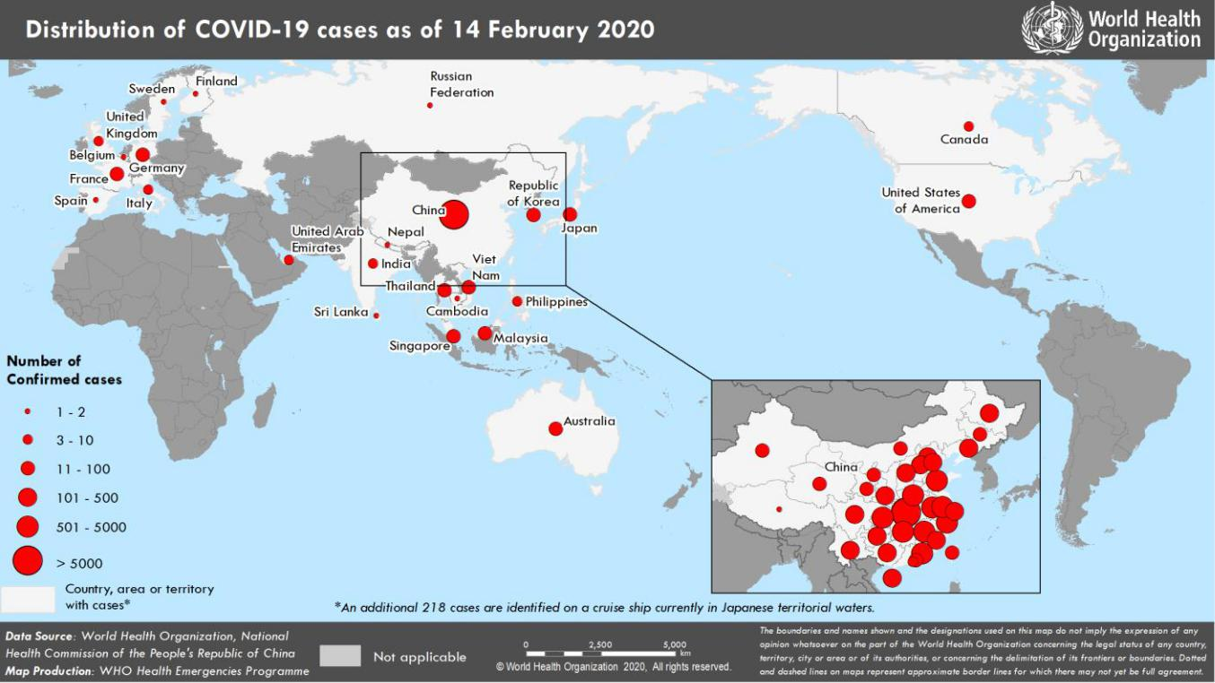

*The situation report includes information provided by national authorities as of 10 AM Central European Time †As reported by China

**TECHNICAL FOCUS: WHO Research & Development Blueprint**

The WHO R&D Blueprint is a global strategy and preparedness plan that allows the rapid activation of research and development activities during epidemics. Its aim is to fast-track the availability of effective tests, vaccines and medicines that can be used to save lives and avert further crisis.

In view of the urgency of the COVID-19 outbreak, the international community is mobilizing to find ways to significantly accelerate the development of interventions including vaccines and therapeutics. Nearly 400 world scientists met at WHO’s Geneva Headquarters from 11 to 12 February 2020 to assess the current level of knowledge about the new COVID-19 virus, agree on critical research questions that need to be answered urgently, and identify ways to work together to accelerate and fund priority research that can contribute to curtail this outbreak and prepare for future outbreaks. The meeting was organized by WHO, in collaboration with the Global Research Collaboration for Infectious Disease Preparedness.

Research topics discussed included: COVID-19 virus natural history, transmission and diagnostics; animal and environmental research on the virus origin; management measures at the human-animal interface; epidemiological studies; clinical characterization and management; infection prevention and control, including healthcare workers’ protection; candidate therapeutics R&D; candidate vaccines R&D; ethical considerations for research; and integrating social sciences in the outbreak response.

Experts identified key knowledge gaps and research priorities, and shared scientific data on ongoing research, thereby accelerating the generation of critical scientific information to contribute to the control the COVID-19 outbreak. There was broad consensus on the need for research to focus on actions that can save lives now to ensure that those affected are promptly diagnosed and receive optimal care. Eight immediate research priorities were agreed as part of this Forum:

1. Mobilize research on rapid point of care diagnostics for use at the community level
2. Assess available data to learn what standard of care approaches from China and elsewhere are the most effective
3. Evaluate as fast as possible the effect of adjunctive (given in addition to the main treatment) and supportive therapies
4. Optimize the use of protective equipment and other infection prevention and control measures in health care and community settings
5. Review all available evidence to identify animal host(s), prevent continued spill-over and better understand virus transmissibility in different contexts over time, the severity of disease and individuals more susceptible to infection
6. Accelerate the evaluation of investigational therapeutics and vaccines by using “Master Protocols”
7. Maintain a high degree of communication and interaction among funders so that critical research is implemented
8. Broadly and rapidly share virus materials, clinical samples and data for immediate public health purposes

For further information and to view documents related to the Forum, please visit [this webpage.](https://www.who.int/blueprint/priority-diseases/key-action/novel-coronavirus/en/)

**SURVEILLANCE**

**Table 1. Confirmed and suspected cases of COVID-19 acute respiratory disease reported by provinces, regions and cities in China, 14 February 2020\***

|  |  |  |  |  |  |  |  |  |  |  |  |  |  |  |  |  |  |  |  |  |  |  |  |  |  |  |  |  |  |  |  |  |  |
| --- | --- | --- | --- | --- | --- | --- | --- | --- | --- | --- | --- | --- | --- | --- | --- | --- | --- | --- | --- | --- | --- | --- | --- | --- | --- | --- | --- | --- | --- | --- | --- | --- | --- |
|  | **Province/** |  |  | **Population** |  |  |  |  |  |  |  | **Daily** | | |  |  |  |  |  |  |  |  |  |  | **Cumulative** | | | | |  |  |  |  |
|  | **Region/** |  |  |  |  |  |  |  |  |  |  |  |  |  |  |  |  |  |  |  |  |  |  |  |  |  |  |  |  |  |  |  |
|  |  |  | **(10,000s)** |  |  | Lab- |  |  | Clinically |  |  | Total |  |  | Suspected |  |  | Deaths |  |  | Lab- |  |  | Clinically |  |  | Total |  |  | Deaths |  |  |
|  | **City** |  |  |  |  | confirmed |  |  | diagnosed |  |  | cases |  |  | cases |  |  |  |  | confirmed |  |  | diagnosed |  |  | cases |  |  |  |  |
|  |  |  |  |  |  |  |  |  |  |  |  |  |  |  |  |  |  |  |  |  |  |  |  |  |  |
|  |  |  |  |  |  |  |  |  |  |  |  |  |  |  |  |  |  |  |  |  |  |  |  |  |  |  |  |  |  |  |  |  |  |
|  | Hubei |  |  | 5917 |  |  | 1728 |  |  | 3095 |  |  | 4823 |  |  | 1154 |  |  | 116 |  |  | 36 602 |  |  | 15 384 |  |  | 51 986 |  |  | 1318 |  |  |
|  | Guangdong | | 11 346 | |  | 20 | |  | - | |  | 20 | |  | 8 | |  | 0 | |  | 1261 | |  | - | |  | 1261 | |  | 2 | |  |  |
|  |  | |  | |  |  | |  |  | |  |  | |  |  | |  |  | |  |  | |  |  | |  |  | |  |  | |  |  |
|  | Henan |  |  | 9605 |  |  | 15 |  |  | - |  |  | 15 |  |  | 207 |  |  | 1 |  |  | 1184 |  |  | - |  |  | 1184 |  |  | 11 |  |  |
|  | Zhejiang | | 5737 | |  | 10 | |  | - | |  | 10 | |  | 22 | |  | 0 | |  | 1155 | |  | - | |  | 1155 | |  | 0 | |  |  |
|  |  | |  | |  |  | |  |  | |  |  | |  |  | |  |  | |  |  | |  |  | |  |  | |  |  | |  |  |
|  | Hunan |  |  | 6899 |  |  | 20 |  |  | - |  |  | 20 |  |  | 53 |  |  | 0 |  |  | 988 |  |  | - |  |  | 988 |  |  | 2 |  |  |
|  | Anhui | | 6324 | |  | 24 | |  | - | |  | 24 | |  | 16 | |  | 1 | |  | 934 | |  | - | |  | 934 | |  | 6 | |  |  |
|  |  | |  | |  |  | |  |  | |  |  | |  |  | |  |  | |  |  | |  |  | |  |  | |  |  | |  |  |
|  | Jiangxi |  |  | 4648 |  |  | 28 |  |  | - |  |  | 28 |  |  | 43 |  |  | 0 |  |  | 900 |  |  | - |  |  | 900 |  |  | 1 |  |  |
|  | Jiangsu | | 8051 | |  | 23 | |  | - | |  | 23 | |  | 14 | |  | 0 | |  | 593 | |  | - | |  | 593 | |  | 0 | |  |  |
|  |  | |  | |  |  | |  |  | |  |  | |  |  | |  |  | |  |  | |  |  | |  |  | |  |  | |  |  |
|  | Chongqing |  |  | 3102 |  |  | 11 |  |  | - |  |  | 11 |  |  | 138 |  |  | 1 |  |  | 529 |  |  | - |  |  | 529 |  |  | 4 |  |  |
|  | Shandong | | 10 047 | |  | 13 | |  | - | |  | 13 | |  | 37 | |  | 0 | |  | 519 | |  | - | |  | 519 | |  | 2 | |  |  |
|  |  | |  | |  |  | |  |  | |  |  | |  |  | |  |  | |  |  | |  |  | |  |  | |  |  | |  |  |
|  | Sichuan |  |  | 8341 |  |  | 12 |  |  | - |  |  | 12 |  |  | 77 |  |  | 0 |  |  | 463 |  |  | - |  |  | 463 |  |  | 1 |  |  |
|  | Heilongjiang | | 3773 | |  | 23 | |  | - | |  | 23 | |  | 35 | |  | 2 | |  | 418 | |  | - | |  | 418 | |  | 11 | |  |  |
|  |  | |  | |  |  | |  |  | |  |  | |  |  | |  |  | |  |  | |  |  | |  |  | |  |  | |  |  |
|  | Beijing |  |  | 2154 |  |  | 6 |  |  | - |  |  | 6 |  |  | 54 |  |  | 0 |  |  | 372 |  |  | - |  |  | 372 |  |  | 3 |  |  |
|  | Shanghai | | 2424 | |  | 5 | |  | - | |  | 5 | |  | 81 | |  | 0 | |  | 318 | |  | - | |  | 318 | |  | 1 | |  |  |
|  |  | |  | |  |  | |  |  | |  |  | |  |  | |  |  | |  |  | |  |  | |  |  | |  |  | |  |  |
|  | Hebei |  |  | 7556 |  |  | 18 |  |  | - |  |  | 18 |  |  | 12 |  |  | 0 |  |  | 283 |  |  | - |  |  | 283 |  |  | 3 |  |  |
|  | Fujian | | 3941 | |  | 2 | |  | - | |  | 2 | |  | 23 | |  | 0 | |  | 281 | |  | - | |  | 281 | |  | 0 | |  |  |
|  |  | |  | |  |  | |  |  | |  |  | |  |  | |  |  | |  |  | |  |  | |  |  | |  |  | |  |  |
|  | Shaanxi |  |  | 3864 |  |  | 1 |  |  | - |  |  | 1 |  |  | 37 |  |  | 0 |  |  | 230 |  |  | - |  |  | 230 |  |  | 0 |  |  |
|  | Guangxi | | 4926 | |  | 4 | |  | - | |  | 4 | |  | 79 | |  | 0 | |  | 226 | |  | - | |  | 226 | |  | 2 | |  |  |
|  |  | |  | |  |  | |  |  | |  |  | |  |  | |  |  | |  |  | |  |  | |  |  | |  |  | |  |  |
|  | Yunnan |  |  | 4830 |  |  | 7 |  |  | - |  |  | 7 |  |  | 29 |  |  | 0 |  |  | 162 |  |  | - |  |  | 162 |  |  | 0 |  |  |
|  | Hainan | | 934 | |  | 0 | |  | - | |  | 0 | |  | 32 | |  | 0 | |  | 157 | |  | - | |  | 157 | |  | 4 | |  |  |
|  |  | |  | |  |  | |  |  | |  |  | |  |  | |  |  | |  |  | |  |  | |  |  | |  |  | |  |  |
|  | Guizhou |  |  | 3600 |  |  | 5 |  |  | - |  |  | 5 |  |  | 16 |  |  | 0 |  |  | 140 |  |  | - |  |  | 140 |  |  | 1 |  |  |
|  | Shanxi | | 3718 | |  | 0 | |  | - | |  | 0 | |  | 24 | |  | 0 | |  | 126 | |  | - | |  | 126 | |  | 0 | |  |  |
|  |  | |  | |  |  | |  |  | |  |  | |  |  | |  |  | |  |  | |  |  | |  |  | |  |  | |  |  |
|  | Tianjin |  |  | 1560 |  |  | 7 |  |  | - |  |  | 7 |  |  | 172 |  |  | 0 |  |  | 119 |  |  | - |  |  | 119 |  |  | 3 |  |  |
|  | Liaoning | | 4359 | |  | 1 | |  | - | |  | 1 | |  | 66 | |  | 0 | |  | 117 | |  | - | |  | 117 | |  | 1 | |  |  |
|  |  | |  | |  |  | |  |  | |  |  | |  |  | |  |  | |  |  | |  |  | |  |  | |  |  | |  |  |
|  | Gansu |  |  | 2637 |  |  | 3 |  |  | - |  |  | 3 |  |  | 0 |  |  | 0 |  |  | 90 |  |  | - |  |  | 90 |  |  | 2 |  |  |
|  | Jilin | | 2704 | |  | 2 | |  | - | |  | 2 | |  | 10 | |  | 0 | |  | 86 | |  | - | |  | 86 | |  | 1 | |  |  |
|  |  | |  | |  |  | |  |  | |  |  | |  |  | |  |  | |  |  | |  |  | |  |  | |  |  | |  |  |
|  | Ningxia |  |  | 688 |  |  | 3 |  |  | - |  |  | 3 |  |  | 5 |  |  | 0 |  |  | 67 |  |  | - |  |  | 67 |  |  | 0 |  |  |
|  | Xinjiang | | 2487 | |  | 2 | |  | - | |  | 2 | |  | 5 | |  | 0 | |  | 65 | |  | - | |  | 65 | |  | 1 | |  |  |
|  |  | |  | |  |  | |  |  | |  |  | |  |  | |  |  | |  |  | |  |  | |  |  | |  |  | |  |  |
|  | Inner Mongolia |  |  | 2534 |  |  | 2 |  |  | - |  |  | 2 |  |  | 1 |  |  | 0 |  |  | 63 |  |  | - |  |  | 63 |  |  | 0 |  |  |
|  | Hong Kong Sar | | 745 | |  | 3 | |  | - | |  | 3 | |  | 0 | |  | 0 | |  | 53 | |  | - | |  | 53 | |  | 1 | |  |  |
|  |  | |  | |  |  | |  |  | |  |  | |  |  | |  |  | |  |  | |  |  | |  |  | |  |  | |  |  |
|  | Qinghai |  |  | 603 |  |  | 0 |  |  | - |  |  | 0 |  |  | 0 |  |  | 0 |  |  | 18 |  |  | - |  |  | 18 |  |  | 0 |  |  |
|  | Taipei and environs | | 2359 | |  | 0 | |  | - | |  | 0 | |  | 0 | |  | 0 | |  | 18 | |  | - | |  | 18 | |  | 0 | |  |  |
|  |  | |  | |  |  | |  |  | |  |  | |  |  | |  |  | |  |  | |  |  | |  |  | |  |  | |  |  |
|  | Macao Sar |  |  | 66 |  |  | 0 |  |  | - |  |  | 0 |  |  | 0 |  |  | 0 |  |  | 10 |  |  | - |  |  | 10 |  |  | 0 |  |  |
|  | Xizang | | 344 | |  | 0 | |  | - | |  | 0 | |  | 0 | |  | 0 | |  | 1 | |  | - | |  | 1 | |  | 0 | |  |  |
|  |  | |  | |  |  | |  |  | |  |  | | |  | |  |  | |  |  | |  |  | |  |  | |  |  | |  |  |
|  | **Totals** |  |  | **142 823** |  |  | **1998** |  |  | **3095** |  |  | **5093** |  |  | **2450** |  |  | **121** |  |  | **48 548** |  |  | **15 384** |  |  | **63 932** |  |  | **1381** |  |  |
|  |  |  |  |  |  |  |  |  |  |  |  |  |  |  |  |  |  |  |  |  |  |  |  |  |  |  |  |  |  |  |  |  |  |

*Deaths in table 1 include both lab-confirmed cases and clinically diagnosed cases of COVID-19.

**Table 2. Countries, territories or areas outside China with reported laboratory-confirmed COVID-19 cases and deaths. Data as of 14 February 2020**

|  |  |  |  |  |  |  |  |
| --- | --- | --- | --- | --- | --- | --- | --- |
|  |  |  | **Total** | **Total cases with** | **Total cases with** |  |  |
|  |  |  | **cases with** | **possible or** | **site of** |  |  |
| **WHO Region** | **Country/Territory/Area** | **Confirmed\*** | **travel** | **confirmed** | **transmission** | **Total deaths** |  |
| **cases (new)** | **history to** | **transmission** | **under** | **(new)** |  |
|  |  |  |
|  |  |  | **China** | **outside of China†** | **investigation** |  |  |
|  |  |  | **(new)** | **(new)** | **(new)** |  |  |
|  | Singapore | 58 (8) | 22 (0) | 36 (8) | 0 (0) | 0 (0) |  |
|  |  |  |  |  |  |  |  |
|  | Japan | 33 (4) | 24 (0) | 9 (4) | 0 (0) | 1 (1) |  |
|  |  |  |  |  |  |  |  |
|  | Republic of Korea | 28 (0) | 13 (0) | 12§§ (0) | 3 (0) | 0 (0) |  |
|  |  |  |  |  |  |  |  |
| **Western Pacific Region** | Malaysia | 19 (1) | 15 (0) | 4‡‡ (1)‡‡‡ | 0 (0) | 0 (0) |  |
|  | Viet Nam | 16 (0) | 8 (0) | 8 (0) | 0 (0) | 0 (0) |  |
|  |  |  |  |  |  |  |  |
|  | Australia | 15 (0) | 15 (0) | 0 (0) | 0 (0) | 0 (0) |  |
|  |  |  |  |  |  |  |  |
|  | Philippines | 3 (0) | 3 (0) | 0 (0) | 0 (0) | 1 (0) |  |
|  |  |  |  |  |  |  |  |
|  | Cambodia | 1 (0) | 1 (0) | 0 (0) | 0 (0) | 0 (0) |  |
|  | Thailand | 33 (0) | 23 (0) | 6 (0) | 4 (0) | 0 (0) |  |
|  |  |  |  |  |  |  |  |
| **South-East Asia Region** | India | 3 (0) | 3 (0) | 0 (0) | 0 (0) | 0 (0) |  |
| Nepal | 1 (0) | 1 (0) | 0 (0) | 0 (0) | 0 (0) |  |
|  |  |
|  |  |  |  |  |  |  |  |
|  | Sri Lanka | 1 (0) | 1 (0) | 0 (0) | 0 (0) | 0 (0) |  |
|  | United States of |  |  |  |  |  |  |
| **Region of the Americas** | America | 15 (1) | 13 (1) | 2 (0) | 0 (0) | 0 (0) |  |
|  | Canada | 7 (0) | 6 (0) | 0 (0) | 1 (0) | 0 (0) |  |
|  | Germany | 16 (0) | 2 (0) | 14 (0) | 0 (0) | 0 (0) |  |
|  |  |  |  |  |  |  |  |
|  | France | 11 (0) | 5 (0) | 6 (0) | 0 (0) | 0 (0) |  |
|  |  |  |  |  |  |  |  |
|  | The United Kingdom | 9 (0) | 2 (0) | 7*** (0) | 0 (0) | 0 (0) |  |
|  |  |  |  |  |  |  |  |
|  | Italy | 3 (0) | 3 (0) | 0 (0) | 0 (0) | 0 (0) |  |
|  |  |  |  |  |  |  |  |
| **European Region** | Russian Federation | 2 (0) | 2 (0) | 0 (0) | 0 (0) | 0 (0) |  |
|  |  |  |  |  |  |  |  |
|  | Spain | 2 (0) | 0 (0) | 2§ (0) | 0 (0) | 0 (0) |  |
|  |  |  |  |  |  |  |  |
|  | Belgium | 1 (0) | 1 (0) | 0 (0) | 0 (0) | 0 (0) |  |
|  |  |  |  |  |  |  |  |
|  | Finland | 1 (0) | 1 (0) | 0 (0) | 0 (0) | 0 (0) |  |
|  |  |  |  |  |  |  |  |
|  | Sweden | 1 (0) | 1 (0) | 0 (0) | 0 (0) | 0 (0) |  |
| **Eastern Mediterranean** |  |  |  |  |  |  |  |
| **Region** | United Arab Emirates | 8 (0) | 6 (0) | 1 (0) | 1 (0) | 0 (0) |  |
| **Other** | International |  |  |  |  |  |  |
| conveyance (Japan) | 218** (44) | 0 (0) | 0 (0) | 218 (44) | 0 (0) |  |
|  |  |
|  |  |  |  |  |  |  |  |

*Case classifications are based on [WHO case definitions](https://www.who.int/publications-detail/global-surveillance-for-human-infection-with-novel-coronavirus-(2019-ncov)) for COVID-19.

**†**Location of transmission is classified based on WHO analysis of available official data and may be subject to reclassification as additional data become available.

‡Confirmed cases in China include cases confirmed in Hong Kong SAR (53 confirmed cases, 1 death), Macao SAR (10 confirmed cases) and Taipei and environs (18 confirmed cases).

**Cases identified on a cruise ship currently in Japanese territorial waters.

§The exposure for 2 cases occurred outside of Spain.

***The exposure for 6 cases occurred outside of the United Kingdom.

§§The exposure for 3 cases occurred outside of Republic of Korea.

‡‡The exposure for 1 case occurred outside of Malaysia.

‡‡‡This patient also had travel history to China, but exposure likely occurred after return to Malaysia

**Figure 2. Epidemic curve of COVID-19 cases (n=192) identified outside of China, by date of onset of symptoms and travel history, 14 February 2020**

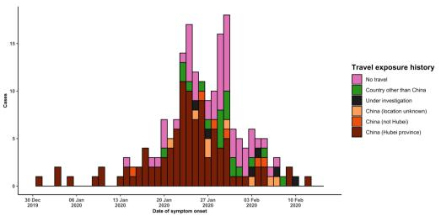

Note for figure 2: Of the 505 cases reported outside China, 17 were detected while apparently asymptomatic. For the remaining 488 cases, information on date of onset is available only for the 192 cases presented in the epidemiologic curve.

**Figure 3. Epidemic curve of COVID-19 cases (n=505) identified outside of China, by date of reporting and travel history, 14 February 2020**

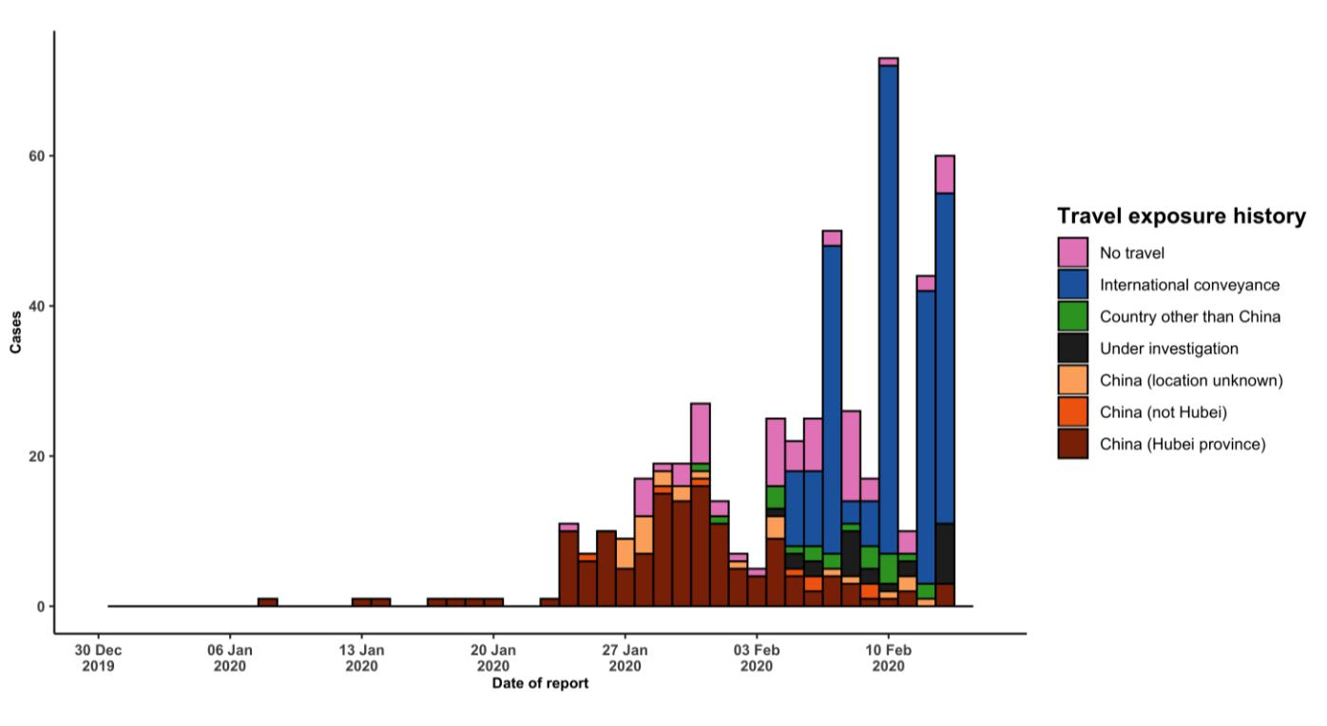

**STRATEGIC OBJECTIVES**

WHO’s strategic objectives for this response are to:

* Limit human-to-human transmission including reducing secondary infections among close contacts and health care workers, preventing transmission amplification events, and preventing further international spread from China*;
* Identify, isolate and care for patients early, including providing optimized care for infected patients;
* Identify and reduce transmission from the animal source;
* Address crucial unknowns regarding clinical severity, extent of transmission and infection, treatment options, and accelerate the development of diagnostics, therapeutics and vaccines;
* Communicate critical risk and event information to all communities and counter misinformation;
* Minimize social and economic impact through multisectoral partnerships.

*This can be achieved through a combination of public health measures, such as rapid identification, diagnosis and management of the cases, identification and follow up of the contacts, infection prevention and control in health care settings, implementation of health measures for travelers, awareness-raising in the population and risk communication.

**PREPAREDNESS AND RESPONSE**

* To view all technical guidance documents regarding COVID-19, please go to [this webpage.](https://www.who.int/emergencies/diseases/novel-coronavirus-2019/technical-guidance)
* WHO is working closely with International Air Transport Association (IATA) and have jointly developed a guidance document to provide advice to cabin crew and airport workers, based on country queries. The guidance can be found on the [IATA webpage.](https://www.iata.org/en/programs/safety/health/diseases/#tab-2)
* WHO has developed a protocol for the investigation of early cases (the “[First Few X (FFX) Cases and contact](https://www.who.int/publications-detail/the-first-few-x-(ffx)-cases-and-contact-investigation-protocol-for-2019-novel-coronavirus-(2019-ncov)-infection) [investigation protocol for 2019-novel coronavirus (2019-nCoV) infection](https://www.who.int/publications-detail/the-first-few-x-(ffx)-cases-and-contact-investigation-protocol-for-2019-novel-coronavirus-(2019-ncov)-infection)”). The protocol is designed to gain an early understanding of the key clinical, epidemiological and virological characteristics of the first cases of COVID-19 infection detected in any individual country, to inform the development and updating of public health guidance to manage cases and reduce potential spread and impact of infection.
* WHO has been in regular and direct contact with Member States where cases have been reported. WHO is also informing other countries about the situation and providing support as requested.
* WHO has developed interim guidance for [laboratory diagnosis,](https://www.who.int/emergencies/diseases/novel-coronavirus-2019/technical-guidance/laboratory-guidance) [advice on the use of masks during home care and](https://www.who.int/publications-detail/advice-on-the-use-of-masks-the-community-during-home-care-and-in-health-care-settings-in-the-context-of-the-novel-coronavirus-(2019-ncov)-outbreak) [in health care settings in the context of the novel coronavirus (2019-nCoV) outbreak,](https://www.who.int/publications-detail/advice-on-the-use-of-masks-the-community-during-home-care-and-in-health-care-settings-in-the-context-of-the-novel-coronavirus-(2019-ncov)-outbreak) [clinical management](https://www.who.int/publications-detail/clinical-management-of-severe-acute-respiratory-infection-when-novel-coronavirus-(ncov)-infection-is-suspected)[,](https://www.who.int/emergencies/diseases/novel-coronavirus-2019/technical-guidance/infection-prevention-and-control) [infection prevention and control in health care settings,](https://www.who.int/emergencies/diseases/novel-coronavirus-2019/technical-guidance/infection-prevention-and-control) [home care for patients with suspected novel](https://www.who.int/publications-detail/home-care-for-patients-with-suspected-novel-coronavirus-(ncov)-infection-presenting-with-mild-symptoms-and-management-of-contacts) [coronavirus,](https://www.who.int/publications-detail/home-care-for-patients-with-suspected-novel-coronavirus-(ncov)-infection-presenting-with-mild-symptoms-and-management-of-contacts) [risk communication and community engagement](https://www.who.int/publications-detail/risk-communication-and-community-engagement-readiness-and-initial-response-for-novel-coronaviruses-(-ncov)) and [Global Surveillance for human infection with](https://www.who.int/publications-detail/global-surveillance-for-human-infection-with-novel-coronavirus-(2019-ncov)) [novel coronavirus (2019-nCoV).](https://www.who.int/publications-detail/global-surveillance-for-human-infection-with-novel-coronavirus-(2019-ncov))
* WHO has prepared [disease commodity package](https://www.who.int/publications-detail/disease-commodity-package---novel-coronavirus-(ncov)) that includes an essential list of biomedical equipment, medicines and supplies necessary to care for patients with 2019-nCoV.
* WHO has provided recommendations to reduce risk of [transmission from animals to humans.](https://www.who.int/health-topics/coronavirus/who-recommendations-to-reduce-risk-of-transmission-of-emerging-pathogens-from-animals-to-humans-in-live-animal-markets)
* WHO has published an [updated advice for international traffic in relation to the outbreak of the novel](https://www.who.int/ith/2019-nCoV_advice_for_international_traffic/en/) [coronavirus 2019-nCoV.](https://www.who.int/ith/2019-nCoV_advice_for_international_traffic/en/)
* WHO has activated of R&D blueprint to accelerate diagnostics, vaccines, and therapeutics.
* WHO has developed an [online course](https://openwho.org/courses/introduction-to-ncov) to provide general introduction to emerging respiratory viruses, including novel coronaviruses.
* WHO is providing guidance on early investigations, which are critical to carry out early in an outbreak of a new virus. The data collected from the protocols can be used to refine recommendations for surveillance and case definitions, to characterize the key epidemiological transmission features of COVID-19, help understand spread, severity, spectrum of disease, impact on the community and to inform operational models for implementation of

countermeasures such as case isolation, contact tracing and isolation. Several protocols are available here:

<https://www.who.int/emergencies/diseases/novel-coronavirus-2019/technical-guidance/early-investigations>

* WHO is working with its networks of researchers and other experts to coordinate global work on surveillance, epidemiology, modelling, diagnostics, clinical care and treatment, and other ways to identify, manage the disease and limit onward transmission. WHO has issued interim guidance for countries, which are updated regularly.
* WHO is working with global expert networks and partnerships for laboratory, infection prevention and control, clinical management and mathematical modelling.

**RECOMMENDATIONS AND ADVICE FOR THE PUBLIC**

During previous outbreaks due to other coronavirus (Middle-East Respiratory Syndrome (MERS) and Severe Acute Respiratory Syndrome (SARS), human-to-human transmission occurred through droplets, contact and fomites, suggesting that the transmission mode of the COVID-19 can be similar. The basic principles to reduce the general risk of transmission of acute respiratory infections include the following:

* Avoiding close contact with people suffering from acute respiratory infections.
* Frequent hand-washing, especially after direct contact with ill people or their environment.
* Avoiding unprotected contact with farm or wild animals.
* People with symptoms of acute respiratory infection should practice cough etiquette (maintain distance, cover coughs and sneezes with disposable tissues or clothing, and wash hands).
* Within health care facilities, enhance standard infection prevention and control practices in hospitals, especially in emergency departments.

WHO does not recommend any specific health measures for travellers. In case of symptoms suggestive of respiratory illness either during or after travel, travellers are encouraged to seek medical attention and share their travel history with their health care provider.