**Coronavirus disease 2019 (COVID-19)**

**Situation Report – 30**

**Data as reported by 19 February 2020\***

**HIGHLIGHTS**

* No new countries reported cases of COVID-19 in the past 24 hours.
* WHO is working with an international network of statisticians and mathematical modelers to estimate key epidemiologic parameters of COVID-19, such as the incubation period (the time between infection and symptom onset), case fatality ratio (CFR, the proportion of cases that die), and the serial interval (the time between symptom onset of a primary and secondary case). Reports of current analyses that have estimated these parameters are provided in this Situation Report as a summary of currently available evidence. These values should be considered preliminary and parameters will likely be updated as more information becomes available. Modelling can support decision-making but needs to be combined with rigorous data collection and a comprehensive analysis of the situation. Please see the Subject in Focus section for more information.
* Several online courses related to COVID-19 have been added to the OpenWHO platform:

1. [A general introduction to emerging respiratory viruses,](https://openwho.org/courses/introduction-to-ncov) including novel coronaviruses (available in [French,](https://openwho.org/courses/introduction-au-ncov) [Simplified Chinese,](https://openwho.org/courses/introduction-to-ncov-ZH) and

[Spanish](https://openwho.org/courses/introduccion-al-ncov) as well).

1. [Critical Care of Severe Acute Respiratory Infections](https://openwho.org/courses/severe-acuterespiratory-infection)
2. [Health and safety briefing for respiratory diseases - ePROTECT](https://openwho.org/courses/eprotect-acute-respiratory-infections)

**SITUATION IN NUMBERS**

**total and new cases in last 24 hours**

**Globally**

75 204 confirmed (1872 new)

**China †**

74 280 confirmed (1752 new)

2006 deaths (136 new)

**Outside of China**

924 confirmed (120 new)

1. countries

3 deaths

**WHO RISK ASSESSMENT**

China Very High

Regional Level High

Global Level High

**Figure 1. Countries, territories or areas with reported confirmed cases of COVID-19, 19 February 2020**

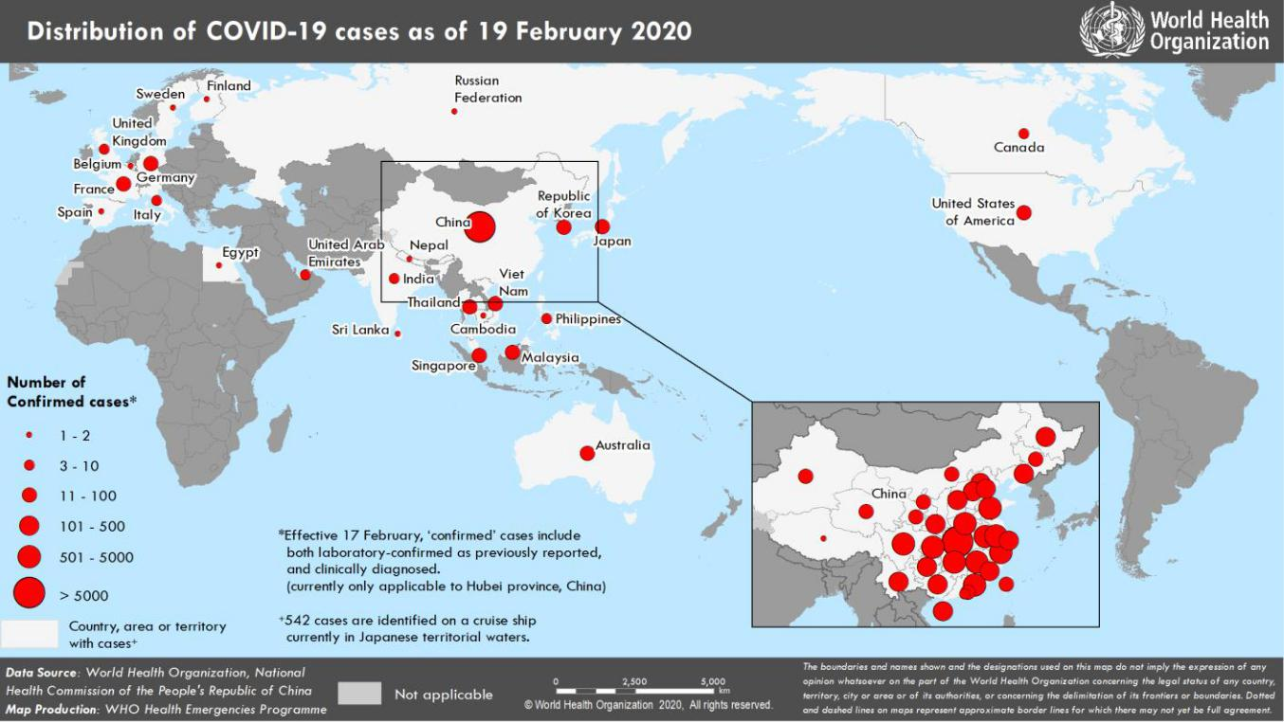

*The situation report includes information provided by national authorities as of 10 AM Central European Time

†As reported by China, which includes both laboratory confirmed and clinically diagnosed cases (currently only applicable to Hubei province, China)

**SUBJECT IN FOCUS: Advanced Analytics and Mathematical Modelling**

In order to mount an appropriate public health response for any epidemic pathogen, information and analyses of transmission dynamics, severity of disease and the impact of control and mitigation measures are needed. In addition to descriptive analyses of available epidemiologic and clinical data, mathematical modelling and advanced analytics are helpful tools that can be used to estimate key transmission and severity parameters.

WHO has been working with an international network of statisticians and mathematical modelers to estimate key epidemiologic parameters of COVID-19, such as the incubation period (the time between infection and symptom onset), case fatality ratio (CFR, the proportion of cases who die), infection fatality ratio (IFR, the portion of all of those infected who die), and the serial interval (the time between symptom onset of a primary and secondary case).

To calculate these parameters, statisticians and modelers use case-based data from COVID-19 surveillance activities, and data captured from early investigations, such as those studies which evaluate transmission within clusters of cases in households or other closed settings. Preliminary estimates1,2,3,4,5,6,7 of median incubation period are 5-6 days (ranging from 0-14 days) and estimates for the serial interval4,8 range from 4.4 to 7.5 days. Several estimates have been shared in pre-print and information will be updated as more information becomes available.

The confirmed case fatality ratio, or CFR, is the total number of deaths divided by the total number of confirmed cases at one point in time. Within China, the confirmed CFR, as reported by the Chinese Center for Disease Control and Prevention,9 is 2.3%. This is based on 1023 deaths amongst 44 415 laboratory-confirmed cases as of 11 February. This CFR does not include the number of more mild infections that may be missed from current surveillance, which has largely focused on patients with pneumonia requiring hospitalization; nor does it account for the fact that recently confirmed cases may yet develop severe disease, and some may die. As the outbreak continues, the confirmed CFR may change. Outside of China, CFR estimates among confirmed cases reported is lower than reported from within China. However, it is too early to draw conclusions as to whether there are real differences in the CFR inside and outside of China, as final outcome data (that is, who will recover and who will die) for the majority of cases reported from outside China are not yet known.

Modeling is a helpful tool to try to account for missed cases, such as those that are mild cases potentially missed in current surveillance activities, and the time lag between onset and death. Using an estimated number of total infections, the Infection Fatality Ratio can be calculated. This represents the fraction of all infections (both diagnosed and undiagnosed) that result in death. Based on these available analyses, current IFR estimates10,11,12 range from 0.3% to 1%. Without population-based serologic studies, it is not yet possible to know what proportion of the population has been infected with COVID-19.

Modeling has also been used to estimate the impact of the 23 January, 2020 Wuhan travel ban on reducing transmission both inside and outside of China.13,14 According to these models, travel restrictions alone are projected to have only a modest effect on the progression of the outbreak; they would need to be combined with other public health interventions, such as early case isolation, other forms of mobility restrictions, social distancing and population-level behavioral changes to be effective.

This is in line with several studies on travel restrictions during past influenza pandemics, including H1N1, reported in the recently published paper on “Nonpharmaceutical Measures for Pandemic Influenza in Nonhealthcare Settings— International Travel-Related Measures”15 .

During the February 2019 COVID-19 WHO Global research and innovation forum, the international gathering of scientists stressed that additional information is needed to refine the forecasting models, and to inform targeted guidance and measures for the public health response. This information should come from early investigations, such as:

* in the community and in households
* through health care workers risk factor assessments
* through clinical characterization of hospitalized cases
* in returning traveller cohort studies

WHO has provided protocols for these investigations, which are available on the WHO website [here.](https://www.who.int/emergencies/diseases/novel-coronavirus-2019/technical-guidance/early-investigations) This information will help to update the estimates of parameters.

**SURVEILLANCE**

**Table 1. Confirmed and suspected cases of COVID-19 acute respiratory disease reported by provinces, regions and cities in China, 19 February 2020**

|  |  |  |  |  |  |  |  |  |  |  |  |  |  |  |  |  |  |  |  |  |  |
| --- | --- | --- | --- | --- | --- | --- | --- | --- | --- | --- | --- | --- | --- | --- | --- | --- | --- | --- | --- | --- | --- |
|  | **Province/** |  |  | **Population** |  |  |  |  |  | **Daily** | |  |  |  |  | **Cumulative** | | | |  |  |
|  |  |  |  |  |  |  |  |  |  |  |  |  |  |  |  |  |  |  |  |
|  | **Region/** |  |  |  |  | **Confirmed** |  |  | **Suspected** |  |  |  |  |  | **Confirmed** |  |  |  |  |  |
|  |  |  | **(10,000s)** |  |  |  |  |  |  | **Deaths** |  |  |  |  | **Deaths** |  |  |
|  | **City** |  |  |  |  | **cases\*** |  |  | **cases** |  |  |  |  |  |  |  |  |
|  |  |  |  |  |  |  |  |  |  |  |  | **cases** |  |  |  |  |
|  |  |  |  |  |  |  |  |  |  |  |  |  |  |  |  |  |  |  |  |  |
|  |  |  |  |  |  |  |  |  |  |  |  |  |  |  |  |  |  |  |  |  |  |
|  | Hubei |  |  | 5917 |  |  | 1693 |  |  | 596 |  |  | 132 |  |  | 61682 |  |  | 1921 |  |  |
|  | Guangdong | | 11346 | |  | 3 | |  | 1 | |  | 1 | |  | 1331 | |  | 5 | |  |  |
|  |  | |  | |  |  | |  |  | |  |  | |  |  | |  |  | |  |  |
|  | Henan |  |  | 9605 |  |  | 5 |  |  | 121 |  |  | 0 |  |  | 1262 |  |  | 19 |  |  |
|  | Zhejiang | | 5737 | |  | 1 | |  | 9 | |  | 0 | |  | 1173 | |  | 0 | |  |  |
|  |  | |  | |  |  | |  |  | |  |  | |  |  | |  |  | |  |  |
|  | Hunan |  |  | 6899 |  |  | 1 |  |  | 12 |  |  | 0 |  |  | 1008 |  |  | 4 |  |  |
|  | Anhui | | 6324 | |  | 4 | |  | 0 | |  | 0 | |  | 986 | |  | 6 | |  |  |
|  |  | |  | |  |  | |  |  | |  |  | |  |  | |  |  | |  |  |
|  | Jiangxi |  |  | 4648 |  |  | 1 |  |  | 0 |  |  | 0 |  |  | 934 |  |  | 1 |  |  |
|  | Jiangsu | | 8051 | |  | 2 | |  | 0 | |  | 0 | |  | 631 | |  | 0 | |  |  |
|  |  | |  | |  |  | |  |  | |  |  | |  |  | |  |  | |  |  |
|  | Chongqing |  |  | 3102 |  |  | 2 |  |  | 41 |  |  | 0 |  |  | 555 |  |  | 5 |  |  |
|  | Shandong | | 10047 | |  | 1 | |  | 8 | |  | 1 | |  | 544 | |  | 3 | |  |  |
|  |  | |  | |  |  | |  |  | |  |  | |  |  | |  |  | |  |  |
|  | Sichuan |  |  | 8341 |  |  | 6 |  |  | 30 |  |  | 0 |  |  | 514 |  |  | 3 |  |  |
|  | Heilongjiang | | 3773 | |  | 6 | |  | 21 | |  | 1 | |  | 470 | |  | 12 | |  |  |
|  |  | |  | |  |  | |  |  | |  |  | |  |  | |  |  | |  |  |
|  | Beijing |  |  | 2154 |  |  | 6 |  |  | 58 |  |  | 0 |  |  | 393 |  |  | 4 |  |  |
|  | Shanghai | | 2424 | |  | 0 | |  | 78 | |  | 0 | |  | 333 | |  | 1 | |  |  |
|  |  | |  | |  |  | |  |  | |  |  | |  |  | |  |  | |  |  |
|  | Hebei |  |  | 7556 |  |  | 4 |  |  | 0 |  |  | 0 |  |  | 306 |  |  | 4 |  |  |
|  | Fujian | | 3941 | |  | 1 | |  | 4 | |  | 0 | |  | 293 | |  | 0 | |  |  |
|  |  | |  | |  |  | |  |  | |  |  | |  |  | |  |  | |  |  |
|  | Guangxi |  |  | 4926 |  |  | 2 |  |  | 12 |  |  | 0 |  |  | 244 |  |  | 2 |  |  |
|  | Shaanxi | | 3864 | |  | 2 | |  | 19 | |  | 0 | |  | 242 | |  | 0 | |  |  |
|  |  | |  | |  |  | |  |  | |  |  | |  |  | |  |  | |  |  |
|  | Yunnan |  |  | 4830 |  |  | 1 |  |  | 16 |  |  | 0 |  |  | 173 |  |  | 0 |  |  |
|  | Hainan | | 934 | |  | 0 | |  | 14 | |  | 0 | |  | 163 | |  | 4 | |  |  |
|  |  | |  | |  |  | |  |  | |  |  | |  |  | |  |  | |  |  |
|  | Guizhou |  |  | 3600 |  |  | 0 |  |  | 2 |  |  | 1 |  |  | 146 |  |  | 2 |  |  |
|  | Shanxi | | 3718 | |  | 1 | |  | 3 | |  | 0 | |  | 131 | |  | 0 | |  |  |
|  |  | |  | |  |  | |  |  | |  |  | |  |  | |  |  | |  |  |
|  | Tianjin |  |  | 1560 |  |  | 3 |  |  | 62 |  |  | 0 |  |  | 128 |  |  | 3 |  |  |
|  | Liaoning | | 4359 | |  | 0 | |  | 64 | |  | 0 | |  | 121 | |  | 1 | |  |  |
|  |  | |  | |  |  | |  |  | |  |  | |  |  | |  |  | |  |  |
|  | Gansu |  |  | 2637 |  |  | 0 |  |  | 0 |  |  | 0 |  |  | 91 |  |  | 2 |  |  |
|  | Jilin | | 2704 | |  | 1 | |  | 11 | |  | 0 | |  | 90 | |  | 1 | |  |  |
|  |  | |  | |  |  | |  |  | |  |  | |  |  | |  |  | |  |  |
|  | Xinjiang |  |  | 2487 |  |  | 0 |  |  | 0 |  |  | 0 |  |  | 76 |  |  | 1 |  |  |
|  | Inner Mongolia | | 2534 | |  | 2 | |  | 3 | |  | 0 | |  | 75 | |  | 0 | |  |  |
|  |  | |  | |  |  | |  |  | |  |  | |  |  | |  |  | |  |  |
|  | Ningxia |  |  | 688 |  |  | 1 |  |  | 0 |  |  | 0 |  |  | 71 |  |  | 0 |  |  |
|  | Hong Kong SAR | | 745 | |  | 2 | |  | 0 | |  | 0 | |  | 62 | |  | 1 | |  |  |
|  |  | |  | |  |  | |  |  | |  |  | |  |  | |  |  | |  |  |
|  | Taipei and environs |  |  | 2359 |  |  | 1 |  |  | 0 |  |  | 0 |  |  | 23 |  |  | 1 |  |  |
|  | Qinghai | | 603 | |  | 0 | |  | 0 | |  | 0 | |  | 18 | |  | 0 | |  |  |
|  |  | |  | |  |  | |  |  | |  |  | |  |  | |  |  | |  |  |
|  | Macao SAR |  |  | 66 |  |  | 0 |  |  | 0 |  |  | 0 |  |  | 10 |  |  | 0 |  |  |
|  | Xizang | | 344 | |  | 0 | |  | 0 | |  | 0 | |  | 1 | |  | 0 | |  |  |
|  |  | |  | |  |  | |  |  | |  |  | |  |  | |  |  | |  |  |
|  | **Total** |  |  | **142823** |  |  | **1752** |  |  | **1185** |  |  | **136** |  |  | **74280** |  |  | **2006** |  |  |
|  |  |  |  |  |  |  |  |  |  |  |  |  |  |  |  |  |  |  |  |  |  |

**\***‘Confirmed’cases include both laboratory confirmed and clinically diagnosed cases (currently only applicable to Hubei province, China)

**Table 2. Countries, territories or areas outside China with reported laboratory-confirmed COVID-19 cases and deaths. Data as of 19 February 2020**

|  |  |  |  |  |  |  |  |  |  |  |  |  |  |  |  |  |  |  |  |  |  |  |  |  |
| --- | --- | --- | --- | --- | --- | --- | --- | --- | --- | --- | --- | --- | --- | --- | --- | --- | --- | --- | --- | --- | --- | --- | --- | --- |
|  |  |  |  |  |  |  |  |  | **Likely place of exposure†** | | | | | | |  |  |  |  |  |  |  |  |  |
|  |  |  |  |  |  |  |  |  |  |  |  |  |  |  |  |  |  |  |  |  |  |  |  |  |
|  | **Country/Territory/** |  |  | **Confirmed\*** | | |  |  |  |  |  | **Outside** |  |  |  |  |  |  | **Total cases with site of** |  |  | **Total** |  |  |
|  |  |  |  |  | **China** |  |  | **reporting** |  |  | **In** | |  |  | **transmission under** |  |  | **deaths** |  |  |
|  | **Area** |  |  | **cases (new)** | | |  |  |  |  |  |  |  |  |  |  |  |  |
|  |  |  |  |  |  |  | **country and** |  |  | **reporting** | |  |  | **investigation (new)** |  |  | **(new)** |  |  |
|  |  |  |  |  |  |  |  |  | **(new)** |  |  |  |  |  |  |  |  |  |  |
|  |  |  |  |  |  |  |  |  |  |  | **outside** |  |  | **country** | |  |  |  |  |  |  |  |  |
|  |  |  |  |  |  |  |  |  |  |  |  |  |  |  |  |  |  |  |  |  |  |
|  |  |  |  |  |  |  |  |  |  |  |  | **China (new)** |  |  |  |  |  |  |  |  |  |  |  |  |
|  | **Western Pacific Region** | | | |  |  |  |  |  |  |  |  |  |  |  |  |  |  |  |  |  |  |  |  |
|  | Singapore | | 81 | | |  |  | 23 (0) | |  | 0 (0) | |  | 51 (3) | | |  | 7 (1) | |  | 0 (0) | |  |  |
|  |  | |  | | |  |  |  | |  |  | |  |  | | |  |  | |  |  | |  |  |
|  | Japan | | 73 | | |  |  | 26 (0) | |  | 3 (2) | |  | 39 (3) | | |  | 5 (3) | |  | 1 (0) | |  |  |
|  |  | |  | |  | |  |  | |  |  | |  |  | |  |  |  | |  |  | |  |  |
|  | Republic of Korea | | 51 | |  | |  | 13 (0) | |  | 4 (0) | |  | 29 | |  |  | 5 (2) | |  | 0 (0) | |  |  |
|  |  | |  | | |  |  |  | |  |  | |  |  | |  |  |  | |  |  | |  |  |
|  | Malaysia | | 22 | | |  |  | 17 (0) | |  | 1 (0) | |  | 2 | |  |  | 2 (0) | |  | 0 (0) | |  |  |
|  |  | |  | | |  |  |  | |  |  | |  |  | |  |  |  | |  |  | |  |  |
|  | Viet Nam | | 16 | | |  |  | 8 (0) | |  | 0 (0) | |  | 8 | |  |  | 0 (0) | |  | 0 (0) | |  |  |
|  |  | |  | | |  |  |  | |  |  | |  |  | |  |  |  | |  |  | |  |  |
|  | Australia | | 15 | | |  |  | 12 (0) | |  | 0 (0) | |  | 3 | |  |  | 0 (0) | |  | 0 (0) | |  |  |
|  |  | |  | |  | |  |  | |  |  | |  |  | |  |  |  | |  |  | |  |  |
|  | Philippines | | 3 | |  | |  | 3 (0) | |  | 0 (0) | |  | 0 | |  |  | 0 (0) | |  | 1 (0) | |  |  |
|  |  | |  | |  | |  |  | |  |  | |  |  | |  |  |  | |  |  | |  |  |
|  | Cambodia | | 1 | |  | |  | 1 (0) | |  | 0 (0) | |  | 0 | |  |  | 0 (0) | |  | 0 (0) | |  |  |
|  |  | |  | |  |  |  |  |  |  |  |  |  |  |  |  |  |  |  |  |  |  |  |  |
|  | **South-East Asia Region** | | | |  |  |  |  |  |  |  |  |  |  |  |  |  |  |  |  |  |  |  |  |
|  | Thailand | | 35 | | |  |  | 23 (0) | |  | 0 (0) | |  | 5 | |  |  | 7 (0) | |  | 0 (0) | |  |  |
|  |  | |  | |  | |  |  | |  |  | |  |  | |  |  |  | |  |  | |  |  |
|  | India | | 3 | |  | |  | 3 (0) | |  | 0 (0) | |  | 0 | |  |  | 0 (0) | |  | 0 (0) | |  |  |
|  |  | |  | |  | |  |  | |  |  | |  |  | |  |  |  | |  |  | |  |  |
|  | Nepal | | 1 | |  | |  | 1 (0) | |  | 0 (0) | |  | 0 | |  |  | 0 (0) | |  | 0 (0) | |  |  |
|  |  | |  | |  | |  |  | |  |  | |  |  | |  |  |  | |  |  | |  |  |
|  | Sri Lanka | | 1 | |  | |  | 1 (0) | |  | 0 (0) | |  | 0 | |  |  | 0 (0) | |  | 0 (0) | |  |  |
|  |  | |  | |  |  |  |  |  |  |  |  |  |  |  |  |  |  |  |  |  |  |  |  |
|  | **Region of the Americas** | | | |  |  |  |  |  |  |  |  |  |  |  |  |  |  |  |  |  |  |  |  |
|  | United States of | | 15 | | |  |  | 13 (0) | |  | 0 (0) | |  | 2 | |  |  | 0 (0) | |  | 0 (0) | |  |  |
|  | America | |  |  |  |  |  |  |  |  |  |  |  |  |  |  |  |  |  |  |  |  |  |  |
|  | Canada | | 8 | |  | |  | 7 (0) | |  | 0 (0) | |  | 0 | |  |  | 1 (0) | |  | 0 (0) | |  |  |
|  |  | |  |  |  |  |  |  |  |  |  |  |  |  |  |  |  |  |  |  |  |  |  |  |
|  | **European Region** | |  |  |  |  |  |  |  |  |  |  |  |  |  |  |  |  |  |  |  |  |  |  |
|  | Germany | | 16 | | |  |  | 2 (0) | |  | 0 (0) | |  | 14 (0) | | |  | 0 (0) | |  | 0 (0) | |  |  |
|  |  | |  | | |  |  |  | |  |  | |  |  | |  |  |  | |  |  | |  |  |
|  | France | | 12 | | |  |  | 5 (0) | |  | 0 (0) | |  | 7 | |  |  | 0 (0) | |  | 1 (0) | |  |  |
|  |  | |  | |  | |  |  | |  |  | |  |  | |  |  |  | |  |  | |  |  |
|  | The United | | 9 | |  | |  | 2 (0) | |  | 6 (0) | |  | 1 | |  |  | 0 (0) | |  | 0 (0) | |  |  |
|  | Kingdom | |  |  |  |  |  |  |  |  |  |  |  |  |  |  |  |  |  |  |  |  |  |  |
|  | Italy | | 3 | |  | |  | 3 (0) | |  | 0 (0) | |  | 0 | |  |  | 0 (0) | |  | 0 (0) | |  |  |
|  |  | |  | |  | |  |  | |  |  | |  |  | |  |  |  | |  |  | |  |  |
|  | Russian Federation | | 2 | |  | |  | 2 (0) | |  | 0 (0) | |  | 0 | |  |  | 0 (0) | |  | 0 (0) | |  |  |
|  |  | |  | |  | |  |  | |  |  | |  |  | |  |  |  | |  |  | |  |  |
|  | Spain | | 2 | |  | |  | 0 (0) | |  | 2 (0) | |  | 0 | |  |  | 0 (0) | |  | 0 (0) | |  |  |
|  |  | |  | |  | |  |  | |  |  | |  |  | |  |  |  | |  |  | |  |  |
|  | Belgium | | 1 | |  | |  | 1 (0) | |  | 0 (0) | |  | 0 | |  |  | 0 (0) | |  | 0 (0) | |  |  |
|  |  | |  | |  | |  |  | |  |  | |  |  | |  |  |  | |  |  | |  |  |
|  | Finland | | 1 | |  | |  | 1 (0) | |  | 0 (0) | |  | 0 | |  |  | 0 (0) | |  | 0 (0) | |  |  |
|  |  | |  | |  | |  |  | |  |  | |  |  | |  |  |  | |  |  | |  |  |
|  | Sweden | | 1 | |  | |  | 1 (0) | |  | 0 (0) | |  | 0 | |  |  | 0 (0) | |  | 0 (0) | |  |  |
|  |  | |  | | | | |  |  |  |  |  |  |  |  |  |  |  |  |  |  |  |  |  |
|  |  | | | | | | |  |  |  |  |  |  |  |  |  |  |  |  |  |  |  |  |  |
|  | United Arab | | 9 | |  | |  | 6 (0) | |  | 0 (0) | |  | 2 | |  |  | 1 (0) | |  | 0 (0) | |  |  |
|  | Emirates | |  |  |  |  |  |  |  |  |  |  |  |  |  |  |  |  |  |  |  |  |  |  |
|  | Egypt | | 1 | |  | |  | 0 (0) | |  | 0 (0) | |  | 1 | |  |  | 0 (0) | |  | 0 (0) | |  |  |
|  |  | |  |  |  |  |  |  |  |  |  |  |  |  |  |  |  |  |  |  |  |  |  |  |
|  | **Other** | |  |  |  |  |  |  |  |  |  |  |  |  |  |  |  |  |  |  |  |  |  |  |
|  | International | | 542 | | |  |  | 0 (0) | |  | 0 (0) | |  | 0 | |  |  | 542 (88) | |  | 0 (0) | |  |  |
|  | conveyance‡ | |  |  |  |  |  |  |  |  |  |  |  |  |  |  |  |  |  |  |  |  |  |  |
|  | (Diamond Princess) | |  |  |  |  |  |  |  |  |  |  |  |  |  |  |  |  |  |  |  |  |  |  |

*Case classifications are based on [WHO case definitions](https://www.who.int/publications-detail/global-surveillance-for-human-infection-with-novel-coronavirus-(2019-ncov)) for COVID-19.

**†**Location of transmission is classified based on WHO analysis of available official data and may be subject to reclassification as additional data become available.

‡Cases identified on a cruise ship currently in Japanese territorial waters.

**Figure 2. Epidemic curve of COVID-19 cases (n=231) identified outside of China, by date of onset of symptoms and likely exposure location, 19 February 2020**

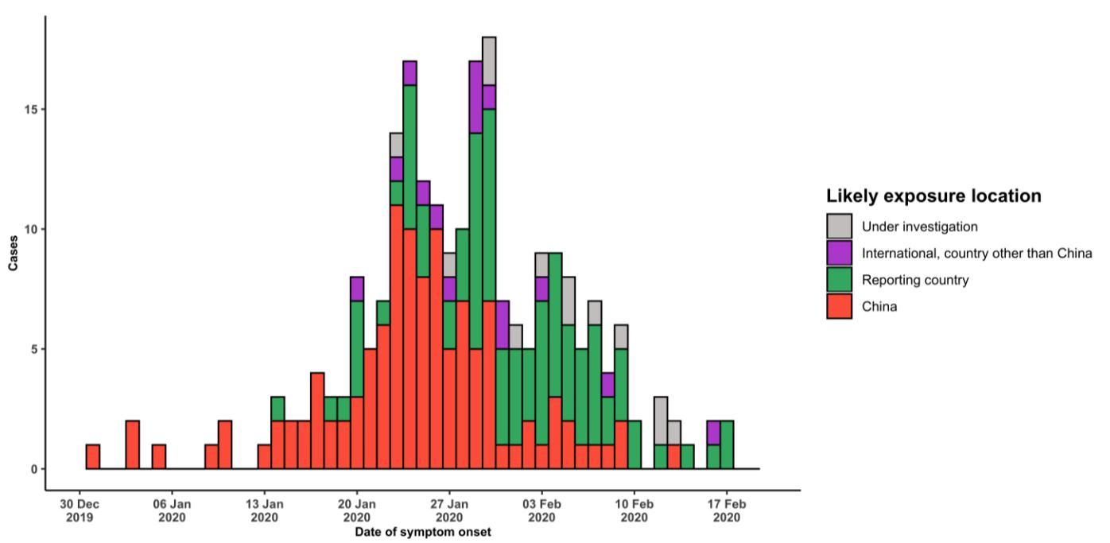

Note for figure 2: Of the 924 cases reported outside China, 29 were detected while apparently asymptomatic. For the remaining 895 cases, information on date of onset is available only for the 231 cases presented in the epidemiologic curve.

**Figure 3. Epidemic curve of COVID-19 cases (n=924) identified outside of China, by date of report and likely exposure location, 19 February 2020**

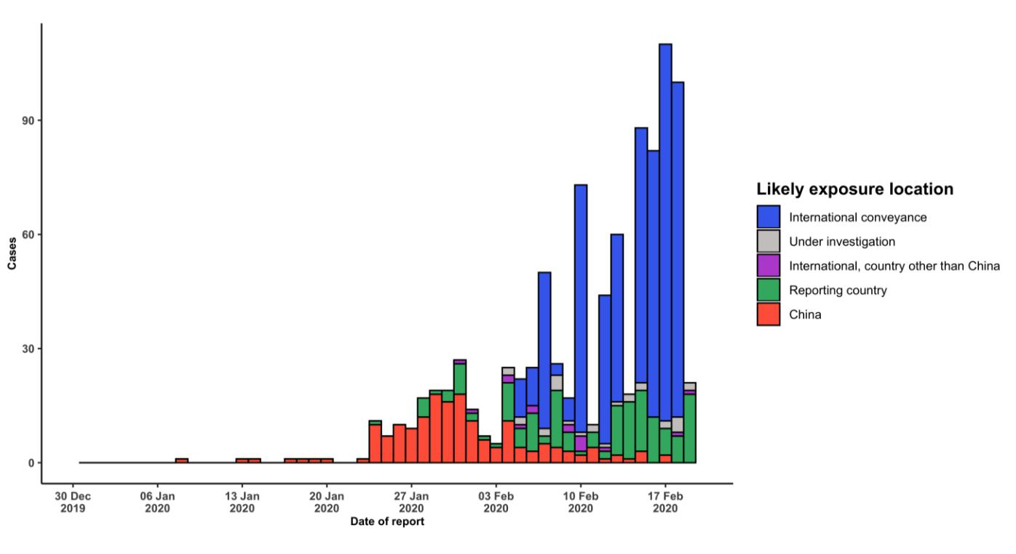

**STRATEGIC OBJECTIVES**

WHO’s strategic objectives for this response are to:

* Limit human-to-human transmission including reducing secondary infections among close contacts and health care workers, preventing transmission amplification events, and preventing further international spread from China*;
* Identify, isolate and care for patients early, including providing optimized care for infected patients;
* Identify and reduce transmission from the animal source;
* Address crucial unknowns regarding clinical severity, extent of transmission and infection, treatment options, and accelerate the development of diagnostics, therapeutics and vaccines;
* Communicate critical risk and event information to all communities and counter misinformation;
* Minimize social and economic impact through multisectoral partnerships.

*This can be achieved through a combination of public health measures, such as rapid identification, diagnosis and management of the cases, identification and follow up of the contacts, infection prevention and control in health care settings, implementation of health measures for travelers, awareness-raising in the population and risk communication.

**PREPAREDNESS AND RESPONSE**

* To view all technical guidance documents regarding COVID-19, please go to [this webpage.](https://www.who.int/emergencies/diseases/novel-coronavirus-2019/technical-guidance)
* WHO is working closely with International Air Transport Association (IATA) and have jointly developed a guidance document to provide advice to cabin crew and airport workers, based on country queries. The guidance can be found on the [IATA webpage.](https://www.iata.org/en/programs/safety/health/diseases/#tab-2)
* WHO has developed a protocol for the investigation of early cases (the “[First Few X (FFX) Cases and contact](https://www.who.int/publications-detail/the-first-few-x-(ffx)-cases-and-contact-investigation-protocol-for-2019-novel-coronavirus-(2019-ncov)-infection) [investigation protocol for 2019-novel coronavirus (2019-nCoV) infection](https://www.who.int/publications-detail/the-first-few-x-(ffx)-cases-and-contact-investigation-protocol-for-2019-novel-coronavirus-(2019-ncov)-infection)”). The protocol is designed to gain an early understanding of the key clinical, epidemiological and virological characteristics of the first cases of COVID-19 infection detected in any individual country, to inform the development and updating of public health guidance to manage cases and reduce potential spread and impact of infection.
* WHO has been in regular and direct contact with Member States where cases have been reported. WHO is also informing other countries about the situation and providing support as requested.
* WHO has developed interim guidance for [laboratory diagnosis,](https://www.who.int/emergencies/diseases/novel-coronavirus-2019/technical-guidance/laboratory-guidance) [advice on the use of masks during home care and](https://www.who.int/publications-detail/advice-on-the-use-of-masks-in-the-community-during-home-care-and-in-healthcare-settings-in-the-context-of-the-novel-coronavirus-(2019-ncov)-outbreak) [in health care settings in the context of the novel coronavirus (2019-nCoV) outbreak,](https://www.who.int/publications-detail/advice-on-the-use-of-masks-in-the-community-during-home-care-and-in-healthcare-settings-in-the-context-of-the-novel-coronavirus-(2019-ncov)-outbreak) [clinical management](https://www.who.int/publications-detail/clinical-management-of-severe-acute-respiratory-infection-when-novel-coronavirus-(ncov)-infection-is-suspected)[,](https://www.who.int/emergencies/diseases/novel-coronavirus-2019/technical-guidance/infection-prevention-and-control) [infection prevention and control in health care settings,](https://www.who.int/emergencies/diseases/novel-coronavirus-2019/technical-guidance/infection-prevention-and-control) [home care for patients with suspected novel](https://www.who.int/publications-detail/home-care-for-patients-with-suspected-novel-coronavirus-(ncov)-infection-presenting-with-mild-symptoms-and-management-of-contacts) [coronavirus,](https://www.who.int/publications-detail/home-care-for-patients-with-suspected-novel-coronavirus-(ncov)-infection-presenting-with-mild-symptoms-and-management-of-contacts) [risk communication and community engagement](https://www.who.int/publications-detail/risk-communication-and-community-engagement-readiness-and-initial-response-for-novel-coronaviruses-(-ncov)) and [Global Surveillance for human infection with](https://www.who.int/publications-detail/global-surveillance-for-human-infection-with-novel-coronavirus-(2019-ncov)) [novel coronavirus (2019-nCoV).](https://www.who.int/publications-detail/global-surveillance-for-human-infection-with-novel-coronavirus-(2019-ncov))
* WHO has prepared [disease commodity package](https://www.who.int/publications-detail/disease-commodity-package---novel-coronavirus-(ncov)) that includes an essential list of biomedical equipment, medicines and supplies necessary to care for patients with 2019-nCoV.
* WHO has provided recommendations to reduce risk of [transmission from animals to humans.](https://www.who.int/health-topics/coronavirus/who-recommendations-to-reduce-risk-of-transmission-of-emerging-pathogens-from-animals-to-humans-in-live-animal-markets)
* WHO has published an [updated advice for international traffic in relation to the outbreak of the novel](https://www.who.int/ith/2019-nCoV_advice_for_international_traffic/en/) [coronavirus 2019-nCoV.](https://www.who.int/ith/2019-nCoV_advice_for_international_traffic/en/)
* WHO has activated of R&D blueprint to accelerate diagnostics, vaccines, and therapeutics.
* WHO has developed online courses on the following topics: [A general introduction to emerging respiratory](https://openwho.org/courses/introduction-to-ncov) [viruses,](https://openwho.org/courses/introduction-to-ncov) including novel coronaviruses (available in [French,](https://openwho.org/courses/introduction-au-ncov) [Simplified Chinese,](https://openwho.org/courses/introduction-to-ncov-ZH) and [Spanish](https://openwho.org/courses/introduccion-al-ncov) as well); [Critical Care](https://openwho.org/courses/severe-acuterespiratory-infection) [of Severe Acute Respiratory Infections;](https://openwho.org/courses/severe-acuterespiratory-infection) and [Health and safety briefing for respiratory diseases - ePROTECT](https://openwho.org/courses/eprotect-acute-respiratory-infections)
* WHO is providing guidance on early investigations, which are critical to carry out early in an outbreak of a new virus. The data collected from the protocols can be used to refine recommendations for surveillance and case definitions, to characterize the key epidemiological transmission features of COVID-19, help understand spread,

severity, spectrum of disease, impact on the community and to inform operational models for implementation of countermeasures such as case isolation, contact tracing and isolation. Several protocols are available here: <https://www.who.int/emergencies/diseases/novel-coronavirus-2019/technical-guidance/early-investigations>

* WHO is working with its networks of researchers and other experts to coordinate global work on surveillance, epidemiology, modelling, diagnostics, clinical care and treatment, and other ways to identify, manage the disease and limit onward transmission. WHO has issued interim guidance for countries, which are updated regularly.
* WHO is working with global expert networks and partnerships for laboratory, infection prevention and control, clinical management and mathematical modelling.

**RECOMMENDATIONS AND ADVICE FOR THE PUBLIC**

During previous outbreaks due to other coronavirus (Middle-East Respiratory Syndrome (MERS) and Severe Acute Respiratory Syndrome (SARS), human-to-human transmission occurred through droplets, contact and fomites, suggesting that the transmission mode of the COVID-19 can be similar. The basic principles to reduce the general risk of transmission of acute respiratory infections include the following:

* Avoiding close contact with people suffering from acute respiratory infections.
* Frequent hand-washing, especially after direct contact with ill people or their environment.
* Avoiding unprotected contact with farm or wild animals.
* People with symptoms of acute respiratory infection should practice cough etiquette (maintain distance, cover coughs and sneezes with disposable tissues or clothing, and wash hands).
* Within health care facilities, enhance standard infection prevention and control practices in hospitals, especially in emergency departments.

WHO does not recommend any specific health measures for travellers. In case of symptoms suggestive of respiratory illness either during or after travel, travellers are encouraged to seek medical attention and share their travel history with their health care provider.

1. Liu T, Hu J, Kang M, Lin L, Zhong H, Xiao J, et al. Transmission dynamics of 2019 novel coronavirus (2019-nCoV), <https://www.biorxiv.org/content/10.1101/2020.01.25.919787v1.full.pdf>
2. Backer J, Klinkenberg D, Wallinga J, Incubation period of 2019 novel coronavirus (2019-nCov) infections among travellers from Wuhan, China, 20-28 January. Eurosurveillance 25(5), 2020
3. Linton N et al, Epidemiological characteristics of novel coronavirus infection: A statistical analysis of publicly available case data, <https://www.medrxiv.org/content/10.1101/2020.01.26.20018754v1>
4. Li Q, Guan X, Wu P, Wang X, Zhou L, Tong Y, et al. Early Transmission Dynamics in Wuhan, China, of Novel Coronavirus–Infected Pneumonia, NEJM January 29, 2020
5. Guan WJ, Ni ZY, Hu Y, Liang WH, Ou CQ, He JX, et al. Clinical characteristics of 2019 novel coronavirus infection in
6. Lauer S, Grantz K, Bi Q, Jones F, Zheng Q, Meredith H, et al. The incubation period of 2019-nCoV from publicly reported confirmed cases: estimation and application. <https://www.medrxiv.org/content/10.1101/2020.02.02.20020016v1.full.pdf>
7. Yang Y, Lu QB, Liu MJ, Wang YX, Zhang AR, Jalali N, et al. Epidemiological and clinical features of the 2019 novel coronavirus outbreak in China. <https://www.medrxiv.org/content/10.1101/2020.02.10.20021675v1.full.pdf>
8. You C, Deng Y, Hu W, Sun J, Lin Q, Zhou F, et al. Estimation of the Time-Varying Reproduction Number of 2019-nCoV Outbreak in China, <https://www.medrxiv.org/content/10.1101/2020.02.08.20021253v1>
9. The Novel Coronavirus Pneumonia Emergency Response Epidemiology Team, The Epidemiological Characteristics of an Outbreak of 2019 Novel Coronavirus Diseases (COVID-19) — China, 2020, CCDC Weekly / Vol. 2 / No. x
10. Jung S, Akhmetzhanov A, Hayashi K , Linton N, Yang Y , Yuan B, et al. Real-Time Estimation of the Risk of Death from Novel Coronavirus (COVID-19) Infection: Inference Using Exported Cases, *J. Clin. Med.* **2020**, *9*(2), 523
11. Dorigatti I, Okell L, Cori A, Imai N, Baguelin M, Bhatia S, et al. Report 4: Severity of 2019-novel coronavirus (nCoV), <https://www.imperial.ac.uk/mrc-global-infectious-disease-analysis/news--wuhan-coronavirus/>
12. Famulare M. 2019-nCoV: preliminary estimates of the confirmed-case-fatality-ratio and infection-fatality-ratio, and initial pandemic risk assessment, <https://institutefordiseasemodeling.github.io/nCoV-public/analyses/first_adjusted_mortality_estimates_and_risk_assessment/2019-nCoV-preliminary_age_and_time_adjusted_mortality_rates_and_pandemic_risk_assessment.html>
13. Chinazzi M, Davis J, Ajelli M, Gioannini C, Litvinova M, Merler S, et al. The effect of travel restrictions on the spread of the 2019 novel coronavirus (2019-nCoV) outbreak; <https://www.medrxiv.org/content/10.1101/2020.02.09.20021261v1.full.pdf>
14. Tian H; Li Y, Liu Y, Kraemer M, Chen B, Cai J, Li B, Early evaluation of Wuhan City travel restrictions in response to the 2019 novel coronavirus outbreak <https://www.medrxiv.org/content/10.1101/2020.01.30.20019844v3>accessed 19 February 2020.
15. Ryu S, Gao H, Wong J. Shiu E, Xiao J, Fong M, and Cowling B, Nonpharmaceutical Measures for Pandemic Influenza in Nonhealthcare Settings—International Travel-Related Measures, EID, Volume 6, number 5 – May 2020