**Coronavirus disease 2019 (COVID-19)**

**Situation Report – 31**

**Data as reported by 20 February 2020\***

**HIGHLIGHTS**

* One new country (Islamic Republic of Iran) reported cases of COVID-19 in the past 24 hours.
* China has revised their [guidance](http://www.chinacdc.cn/jkzt/crb/zl/szkb_11803/jszl_11815/202002/W020200219516971614358.pdf) on case classification for COVID-19, removing the classification of “clinically diagnosed” previously used for Hubei province, and retaining only “suspected” and “confirmed” for all areas, the latter requiring laboratory confirmation. Some previously reported “clinically diagnosed” cases are thus expected to be discarded over the coming days as laboratory testing is conducted and some are found to be COVID-19-negative.
* In early January, following the notification of the occurrence of cases of COVID-19 among travelers from Wuhan, China, WHO established a Global Surveillance System to collect and organize essential information to describe and monitor COVID-19. All WHO regions have implemented the reporting of COVID-19 cases either through existing or newly-established data collection systems. Please see the Subject in Focus section for more information.

**SITUATION IN NUMBERS**

**total and new cases in last 24 hours**

**Globally**

75 748 confirmed (548 new)

**China †**

74 675 confirmed (399 new)

2121 deaths (115 new)

**Outside of China**

1073 confirmed (149 new)

26 countries (1 new)

8 deaths (5 new)

**WHO RISK ASSESSMENT**

China Very High

Regional Level High

Global Level High

**Figure 1. Countries, territories or areas with reported confirmed cases of COVID-19, 20 February 2020**

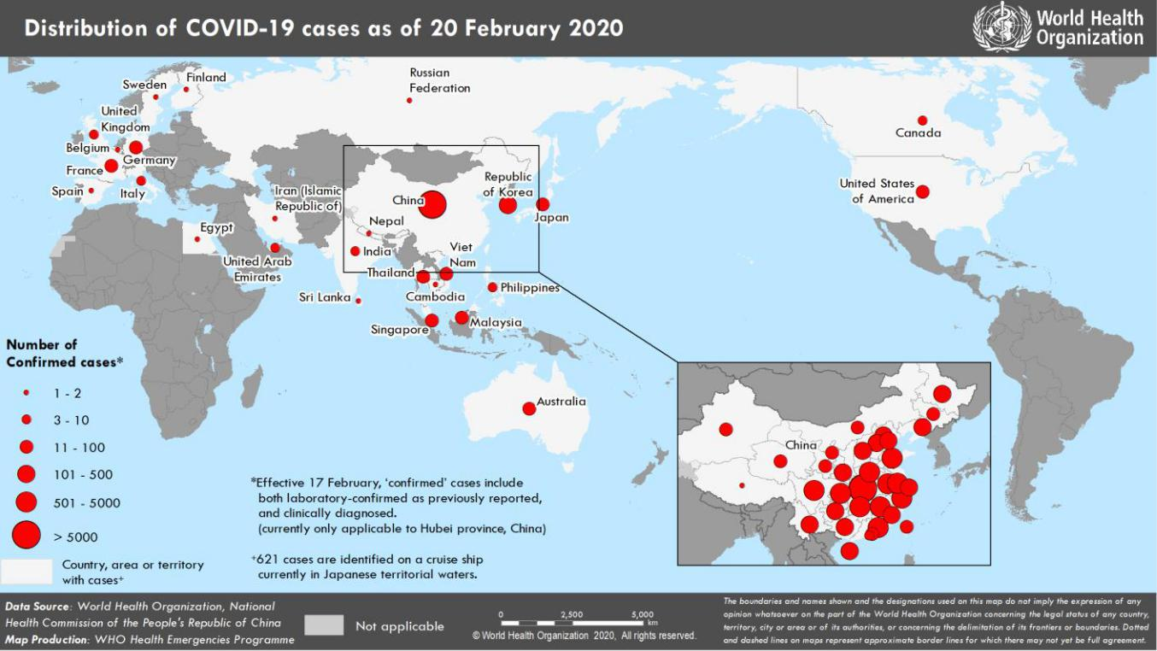

*The situation report includes information provided by national authorities as of 10 AM Central European Time

†As reported by China, which includes both laboratory confirmed and clinically diagnosed cases (currently only applicable to Hubei province, China)

**SUBJECT IN FOCUS: WHO Global Surveillance for Human Infection with COVID-19 Occurring Outside China**

Following the notification of the occurrence of cases of COVID-19 among travelers from Wuhan, China in early January, WHO set up a Global Surveillance System to collect and organize essential information to describe and monitor the extent of the global outbreak. The goals of global surveillance are to: 1) Monitor the global extent of the epidemic; 2) Provide early epidemiological information to support risk assessment at the national, regional and global levels; 3) Rapidly detect new cases in countries where the virus was not previously circulating; 4) Monitor trends of the disease after a first case is imported and; 5) Provide epidemiological information to guide response measures. In line with the International Health Regulations (2005), all Member States’ IHR National Focal Points were requested to immediately report any new confirmed case of COVID-19 and, within 48 hours, provide information related to clinical, epidemiological, and travel history using the WHO standardized case reporting form. The current version of the case reporting form can be found [here](https://www.who.int/publications-detail/global-surveillance-for-human-infection-with-novel-coronavirus-(2019-ncov)) in Arabic, Chinese, English, French, Russian, Spanish and Portuguese.

WHO regions implemented immediate reporting of COVID-19 cases through systems already in place – such as The European Surveillance Systemin the European Region, EMFLU in the Eastern Mediterranean Region, and FluNet in the Americas Region; or by setting up a new electronic data collection system (South-East Asia region).The flow of data from WHO Regional Offices to WHO HQ was organized using the existing Global Influenza Surveillance system, allowing regions to rapidly transfer information. A Global Surveillance COVID-19 database centralizing all COVID-19 cases reported from outside China is maintained at WHO HQ, and data analysis is conducted daily to: follow the transmission of the disease between countries; describe the characteristics of human- to- human transmission within clusters of cases; describe the characteristics of affected persons and their exposure history; and support the evaluation of public health measures implemented in response to the epidemic .

**SUBJECT IN FOCUS (UPDATE): Advanced Analytics and Mathematical Modelling**

Since the publication of modeling estimates in yesterday’s ‘Subject in Focus’, one research group (Ref. 12) has provided a correction of their estimate of the Infection-Fatality Ratio (IFR), with the new estimate being 0.94% (95% confidence interval 0.37-2.9). This replaces the lowest estimate of IFR of 0.33%, but remains below the highest estimate of 1.0% (Ref. 11).

**SURVEILLANCE**

**Table 1. Confirmed and suspected cases of COVID-19 acute respiratory disease reported by provinces, regions and cities in China, 20 February 2020**

|  |  |  |  |  |  |  |  |  |  |  |  |  |  |  |  |  |  |  |  |  |  |
| --- | --- | --- | --- | --- | --- | --- | --- | --- | --- | --- | --- | --- | --- | --- | --- | --- | --- | --- | --- | --- | --- |
|  | **Province/** |  |  | **Population** |  |  |  |  |  | **Daily** | |  |  |  |  | **Cumulative** | | | |  |  |
|  |  |  |  |  |  |  |  |  |  |  |  |  |  |  |  |  |  |  |  |
|  | **Region/** |  |  |  |  | **Confirmed** |  |  | **Suspected** |  |  |  |  |  | **Confirmed** |  |  |  |  |  |
|  |  |  | **(10,000s)** |  |  |  |  |  |  | **Deaths** |  |  |  |  | **Deaths** |  |  |
|  | **City** |  |  |  |  | **cases** |  |  | **cases** |  |  |  |  |  |  |  |  |
|  |  |  |  |  |  |  |  |  |  |  |  | **cases** |  |  |  |  |
|  |  |  |  |  |  |  |  |  |  |  |  |  |  |  |  |  |  |  |  |  |
|  |  |  |  |  |  |  |  |  |  |  |  |  |  |  |  |  |  |  |  |  |  |
|  | Hubei |  |  | 5917 |  |  | 349 |  |  | 880 |  |  | 108 |  |  | 62031 |  |  | 2029 |  |  |
|  | Guangdong | | 11346 | |  | 1 | |  | 1 | |  | 0 | |  | 1332 | |  | 5 | |  |  |
|  | Henan |  |  | 9605 |  |  | 4 |  |  | 66 |  |  | 0 |  |  | 1265 |  |  | 19 |  |  |
|  | Zhejiang | | 5737 | |  | 2 | |  | 6 | |  | 0 | |  | 1175 | |  | 0 | |  |  |
|  | Hunan |  |  | 6899 |  |  | 2 |  |  | 5 |  |  | 0 |  |  | 1010 |  |  | 4 |  |  |
|  | Anhui | | 6324 | |  | 1 | |  | 0 | |  | 0 | |  | 987 | |  | 6 | |  |  |
|  | Jiangxi |  |  | 4648 |  |  | 1 |  |  | 0 |  |  | 0 |  |  | 934 |  |  | 1 |  |  |
|  | Jiangsu | | 8051 | |  | 0 | |  | 1 | |  | 0 | |  | 631 | |  | 0 | |  |  |
|  | Chongqing |  |  | 3102 |  |  | 5 |  |  | 45 |  |  | 0 |  |  | 560 |  |  | 5 |  |  |
|  | Shandong | | 10047 | |  | 2 | |  | 10 | |  | 1 | |  | 546 | |  | 4 | |  |  |
|  | Sichuan |  |  | 8341 |  |  | 6 |  |  | 21 |  |  | 0 |  |  | 520 |  |  | 3 |  |  |
|  | Heilongjiang | | 3773 | |  | 6 | |  | 4 | |  | 0 | |  | 476 | |  | 12 | |  |  |
|  | Beijing |  |  | 2154 |  |  | 2 |  |  | 25 |  |  | 0 |  |  | 395 |  |  | 4 |  |  |
|  | Shanghai | | 2424 | |  | 0 | |  | 56 | |  | 1 | |  | 333 | |  | 2 | |  |  |
|  | Hebei |  |  | 7556 |  |  | 1 |  |  | 0 |  |  | 1 |  |  | 307 |  |  | 5 |  |  |
|  | Fujian | | 3941 | |  | 0 | |  | 0 | |  | 1 | |  | 293 | |  | 1 | |  |  |
|  | Guangxi |  |  | 4926 |  |  | 1 |  |  | 17 |  |  | 0 |  |  | 245 |  |  | 2 |  |  |
|  | Shaanxi | | 3864 | |  | 3 | |  | 8 | |  | 1 | |  | 245 | |  | 1 | |  |  |
|  | Yunnan |  |  | 4830 |  |  | 0 |  |  | 21 |  |  | 1 |  |  | 172 |  |  | 1 |  |  |
|  | Hainan | | 934 | |  | 5 | |  | 16 | |  | 0 | |  | 168 | |  | 4 | |  |  |
|  | Guizhou |  |  | 3600 |  |  | 0 |  |  | 2 |  |  | 0 |  |  | 146 |  |  | 2 |  |  |
|  | Shanxi | | 3718 | |  | 0 | |  | 1 | |  | 0 | |  | 131 | |  | 0 | |  |  |
|  | Tianjin |  |  | 1560 |  |  | 2 |  |  | 57 |  |  | 0 |  |  | 130 |  |  | 3 |  |  |
|  | Liaoning | | 4359 | |  | 0 | |  | 26 | |  | 0 | |  | 121 | |  | 1 | |  |  |
|  | Gansu |  |  | 2637 |  |  | 1 |  |  | 9 |  |  | 0 |  |  | 91 |  |  | 1 |  |  |
|  | Jilin | | 2704 | |  | 0 | |  | 0 | |  | 0 | |  | 91 | |  | 2 | |  |  |
|  | Xinjiang |  |  | 2487 |  |  | 0 |  |  | 0 |  |  | 0 |  |  | 76 |  |  | 1 |  |  |
|  | Inner Mongolia | | 2534 | |  | 0 | |  | 0 | |  | 0 | |  | 75 | |  | 0 | |  |  |
|  | Ningxia |  |  | 688 |  |  | 0 |  |  | 0 |  |  | 0 |  |  | 71 |  |  | 0 |  |  |
|  | Hong Kong SAR | | 745 | |  | 3 | |  | 0 | |  | 1 | |  | 65 | |  | 2 | |  |  |
|  | Taipei and environs |  |  | 2359 |  |  | 2 |  |  | 0 |  |  | 0 |  |  | 24 |  |  | 1 |  |  |
|  | Qinghai | | 603 | |  | 0 | |  | 0 | |  | 0 | |  | 18 | |  | 0 | |  |  |
|  | Macao SAR |  |  | 66 |  |  | 0 |  |  | 0 |  |  | 0 |  |  | 10 |  |  | 0 |  |  |
|  | Xizang | | 344 | |  | 0 | |  | 0 | |  | 0 | |  | 1 | |  | 0 | |  |  |
|  | **Total** |  |  | **142823** |  |  | **399** |  |  | **1277** |  |  | **115** |  |  | **74675** |  |  | **2121** |  |  |
|  |  |  |  |  |  |  |  |  |  |  |  |  |  |  |  |  |  |  |  |  |  |

**Table 2. Countries, territories or areas outside China with reported laboratory-confirmed COVID-19 cases and deaths. Data as of 20 February 2020**

|  |  |  |  |  |  |  |  |  |  |  |  |  |  |  |  |  |  |  |  |  |  |  |  |  |
| --- | --- | --- | --- | --- | --- | --- | --- | --- | --- | --- | --- | --- | --- | --- | --- | --- | --- | --- | --- | --- | --- | --- | --- | --- |
|  |  |  |  |  |  |  |  | **Likely place of exposure†** | | | | | | |  |  |  |  |  |  |  |  |  |  |
|  |  |  |  |  |  |  |  |  |  |  |  |  |  |  |  |  |  |  |  |  |  |  |  |  |
|  | **Country/Territory/** |  |  | **Confirmed\*** | |  |  |  |  |  | **Outside** |  |  | **In** | |  |  | **Total cases with site of** | |  |  | **Total** |  |  |
|  |  |  |  |  |  |  |  | **reporting** |  |  |  |  | **transmission under** | |  |  | **deaths** |  |  |
|  | **Area** |  |  | **cases (new)** | |  |  | **China** |  |  |  |  | **reporting** | |  |  |  |  |  |  |
|  |  |  |  |  |  |  | **country and** |  |  |  |  | **investigation (new)** | |  |  | **(new)** |  |  |
|  |  |  |  |  |  |  |  | **(new)** |  |  |  |  | **country** | |  |  |  |  |  |  |
|  |  |  |  |  |  |  |  |  |  | **outside** |  |  |  |  |  |  |  |  |  |  |  |
|  |  |  |  |  |  |  |  |  |  |  |  |  | **(new)** | |  |  |  |  |  |  |  |  |  |
|  |  |  |  |  |  |  |  |  |  |  | **China (new)** |  |  |  |  |  |  |  |  |  |  |  |
|  |  |  |  |  |  |  |  |  |  |  |  |  |  |  |  |  |  |  |  |  |  |  |  |
|  | **Western Pacific Region** | | | |  |  |  |  |  |  |  |  |  |  |  |  |  |  |  |  |  |  |  |  |
|  | Republic of Korea | | 104 (53) | | |  | 13 (0) | |  | 4 (0) | |  | 72 | | (43) |  | 15 | | (10) |  | 1 (1) | |  |  |
|  | Japan | | 85 | | (12) |  | 26 (0) | |  | 5 (2) | |  | 46 (7) | | |  | 8 | | (3) |  | 1 (0) | |  |  |
|  | Singapore | | 84 (3) | | |  | 23 (0) | |  | 0 (0) | |  | 54 (3) | | |  | 7 | | (0) |  | 0 (0) | |  |  |
|  | Malaysia | | 22 (0) | | |  | 17 (0) | |  | 1 (0) | |  | 2 | | (0) |  | 2 | | (0) |  | 0 (0) | |  |  |
|  | Viet Nam | | 16 (0) | | |  | 8 (0) | |  | 0 (0) | |  | 8 | | (0) |  | 0 | | (0) |  | 0 (0) | |  |  |
|  | Australia | | 15 (0) | | |  | 12 (0) | |  | 0 (0) | |  | 3 | | (0) |  | 0 | | (0) |  | 0 (0) | |  |  |
|  | Philippines | | 3 | | (0) |  | 3 (0) | |  | 0 (0) | |  | 0 | | (0) |  | 0 | | (0) |  | 1 (0) | |  |  |
|  | Cambodia | | 1 | | (0) |  | 1 (0) | |  | 0 (0) | |  | 0 | | (0) |  | 0 | | (0) |  | 0 (0) | |  |  |
|  | **South-East Asia Region** | | | |  |  |  |  |  |  |  |  |  |  |  |  |  |  |  |  |  |  |  |  |
|  | Thailand | | 35 (0) | | |  | 23 (0) | |  | 0 (0) | |  | 5 | | (0) |  | 7 | | (0) |  | 0 (0) | |  |  |
|  |  | |  | |  |  |  | |  |  | |  |  | |  |  |  | |  |  |  | |  |  |
|  | India | | 3 | | (0) |  | 3 (0) | |  | 0 (0) | |  | 0 | | (0) |  | 0 | | (0) |  | 0 (0) | |  |  |
|  |  | |  | |  |  |  | |  |  | |  |  | |  |  |  | |  |  |  | |  |  |
|  | Nepal | | 1 | | (0) |  | 1 (0) | |  | 0 (0) | |  | 0 | | (0) |  | 0 | | (0) |  | 0 (0) | |  |  |
|  |  | |  | |  |  |  | |  |  | |  |  | |  |  |  | |  |  |  | |  |  |
|  | Sri Lanka | | 1 | | (0) |  | 1 (0) | |  | 0 (0) | |  | 0 | | (0) |  | 0 | | (0) |  | 0 (0) | |  |  |
|  |  | |  | |  |  |  |  |  |  |  |  |  |  |  |  |  |  |  |  |  |  |  |  |
|  | **Region of the Americas** | | | |  |  |  |  |  |  |  |  |  |  |  |  |  |  |  |  |  |  |  |  |
|  | United States of | | 15 (0) | | |  | 13 (0) | |  | 0 (0) | |  | 2 | | (0) |  | 0 | | (0) |  | 0 (0) | |  |  |
|  | America | |  |  |  |  |  |  |  |
|  |  |  |  |  |  |  |  |  |  |  |  |  |  |  |  |  |  |  |  |  |  |  |
|  | Canada | | 8 | | (0) |  | 7 (0) | |  | 0 (0) | |  | 0 | | (0) |  | 1 | | (0) |  | 0 (0) | |  |  |
|  | **European Region** | |  |  |  |  |  |  |  |  |  |  |  |  |  |  |  |  |  |  |  |  |  |  |
|  | Germany | | 16 (0) | | |  | 2 (0) | |  | 0 (0) | |  | 14 (0) | | |  | 0 | | (0) |  | 0 (0) | |  |  |
|  | France | | 12 (0) | | |  | 5 (0) | |  | 0 (0) | |  | 7 | | (0) |  | 0 | | (0) |  | 1 (0) | |  |  |
|  | The United | |  |  |  |  |  |  |  |  |  |  |  |  |  |  |  |  |  |  |  |  |  |  |
|  | Kingdom | | 9 | | (0) |  | 2 (0) | |  | 6 (0) | |  | 1 | | (0) |  | 0 | | (0) |  | 0 (0) | |  |  |
|  | Italy | | 3 | | (0) |  | 3 (0) | |  | 0 (0) | |  | 0 | | (0) |  | 0 | | (0) |  | 0 (0) | |  |  |
|  | Russian Federation | | 2 | | (0) |  | 2 (0) | |  | 0 (0) | |  | 0 | | (0) |  | 0 | | (0) |  | 0 (0) | |  |  |
|  | Spain | | 2 | | (0) |  | 0 (0) | |  | 2 (0) | |  | 0 | | (0) |  | 0 | | (0) |  | 0 (0) | |  |  |
|  | Belgium | | 1 | | (0) |  | 1 (0) | |  | 0 (0) | |  | 0 | | (0) |  | 0 | | (0) |  | 0 (0) | |  |  |
|  | Finland | | 1 | | (0) |  | 1 (0) | |  | 0 (0) | |  | 0 | | (0) |  | 0 | | (0) |  | 0 (0) | |  |  |
|  | Sweden | | 1 | | (0) |  | 1 (0) | |  | 0 (0) | |  | 0 | | (0) |  | 0 | | (0) |  | 0 (0) | |  |  |
|  | **Eastern Mediterranean Region** | | | | | |  |  |  |  |  |  |  |  |  |  |  |  |  |  |  |  |  |  |
|  | United Arab | | 9 | | (0) |  | 6 (0) | |  | 0 (0) | |  | 2 | | (0) |  | 1 | | (0) |  | 0 (0) | |  |  |
|  | Emirates | |  |  |  |  |  |  |  |
|  |  |  |  |  |  |  |  |  |  |  |  |  |  |  |  |  |  |  |  |  |  |  |
|  | Iran (Islamic | | 2 | | (2) |  | 0 (0) | |  | 0 (0) | |  | 0 | | (0) |  | 2 | | (2) |  | 2 (2) | |  |  |
|  | Republic of) | |  |  |  |  |  |  |  |
|  |  |  |  |  |  |  |  |  |  |  |  |  |  |  |  |  |  |  |  |  |  |  |
|  | Egypt | | 1 | | (0) |  | 0 (0) | |  | 0 (0) | |  | 1 | | (0) |  | 0 | | (0) |  | 0 (0) | |  |  |
|  | **Other** | |  |  |  |  |  |  |  |  |  |  |  |  |  |  |  |  |  |  |  |  |  |  |
|  | International | |  |  |  |  |  |  |  |  |  |  |  |  |  |  |  |  |  |  |  |  |  |  |
|  | conveyance‡ | | 621 (79) | | |  | 0 (0) | |  | 0 (0) | |  | 0 | | (0) |  | 621 (79) | | |  | 2 (2) | |  |  |
|  | (Diamond Princess) | |  |  |  |  |  |  |  |  |  |  |  |  |  |  |  |  |  |  |  |  |  |  |

*Case classifications are based on [WHO case definitions](https://www.who.int/publications-detail/global-surveillance-for-human-infection-with-novel-coronavirus-(2019-ncov)) for COVID-19.

**†**Location of transmission is classified based on WHO analysis of available official data and may be subject to reclassification as additional data become available.

‡Cases identified on a cruise ship currently in Japanese territorial waters.

**Figure 2. Epidemic curve of COVID-19 cases (n=233) identified outside of China, by date of onset of symptoms and likely exposure location, 20 February 2020**

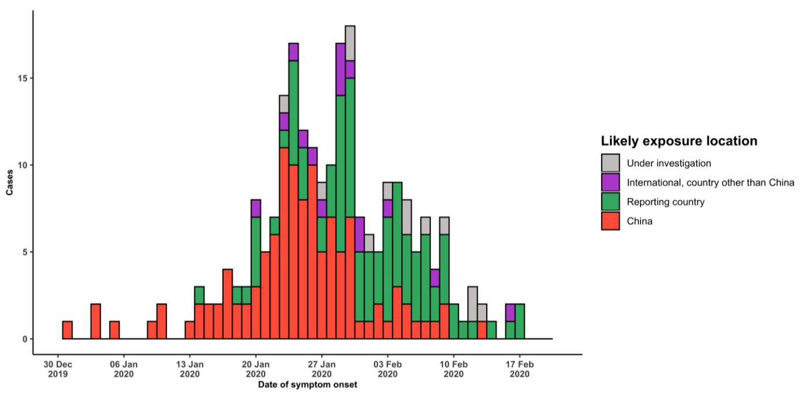

Note for figure 2: Of the 1073 cases reported outside China, 30 were detected while apparently asymptomatic. For the remaining 1043 cases, information on date of onset is available only for the 233 cases presented in the epidemiologic curve.

**Figure 3. Epidemic curve of COVID-19 cases (n=1073) identified outside of China, by date of report and likely exposure location, 20 February 2020**

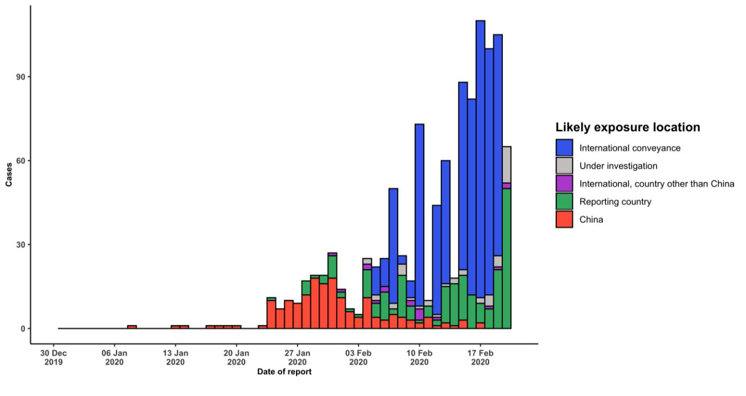

**STRATEGIC OBJECTIVES**

WHO’s strategic objectives for this response are to:

* Limit human-to-human transmission including reducing secondary infections among close contacts and health care workers, preventing transmission amplification events, and preventing further international spread from China*;
* Identify, isolate and care for patients early, including providing optimized care for infected patients;
* Identify and reduce transmission from the animal source;
* Address crucial unknowns regarding clinical severity, extent of transmission and infection, treatment options, and accelerate the development of diagnostics, therapeutics and vaccines;
* Communicate critical risk and event information to all communities and counter misinformation;
* Minimize social and economic impact through multisectoral partnerships.

*This can be achieved through a combination of public health measures, such as rapid identification, diagnosis and management of the cases, identification and follow up of the contacts, infection prevention and control in health care settings, implementation of health measures for travelers, awareness-raising in the population and risk communication.

**PREPAREDNESS AND RESPONSE**

* To view all technical guidance documents regarding COVID-19, please go to [this webpage.](https://www.who.int/emergencies/diseases/novel-coronavirus-2019/technical-guidance)
* WHO is working closely with International Air Transport Association (IATA) and have jointly developed a guidance document to provide advice to cabin crew and airport workers, based on country queries. The guidance can be found on the [IATA webpage.](https://www.iata.org/en/programs/safety/health/diseases/#tab-2)
* WHO has developed a protocol for the investigation of early cases (the “[First Few X (FFX) Cases and contact](https://www.who.int/publications-detail/the-first-few-x-(ffx)-cases-and-contact-investigation-protocol-for-2019-novel-coronavirus-(2019-ncov)-infection) [investigation protocol for 2019-novel coronavirus (2019-nCoV) infection](https://www.who.int/publications-detail/the-first-few-x-(ffx)-cases-and-contact-investigation-protocol-for-2019-novel-coronavirus-(2019-ncov)-infection)”). The protocol is designed to gain an early understanding of the key clinical, epidemiological and virological characteristics of the first cases of COVID-19 infection detected in any individual country, to inform the development and updating of public health guidance to manage cases and reduce potential spread and impact of infection.
* WHO has been in regular and direct contact with Member States where cases have been reported. WHO is also informing other countries about the situation and providing support as requested.
* WHO has developed interim guidance for [laboratory diagnosis,](https://www.who.int/emergencies/diseases/novel-coronavirus-2019/technical-guidance/laboratory-guidance) [advice on the use of masks during home care and](https://www.who.int/publications-detail/advice-on-the-use-of-masks-in-the-community-during-home-care-and-in-healthcare-settings-in-the-context-of-the-novel-coronavirus-(2019-ncov)-outbreak) [in health care settings in the context of the novel coronavirus (2019-nCoV) outbreak,](https://www.who.int/publications-detail/advice-on-the-use-of-masks-in-the-community-during-home-care-and-in-healthcare-settings-in-the-context-of-the-novel-coronavirus-(2019-ncov)-outbreak) [clinical management](https://www.who.int/publications-detail/clinical-management-of-severe-acute-respiratory-infection-when-novel-coronavirus-(ncov)-infection-is-suspected)[,](https://www.who.int/emergencies/diseases/novel-coronavirus-2019/technical-guidance/infection-prevention-and-control) [infection prevention and control in health care settings,](https://www.who.int/emergencies/diseases/novel-coronavirus-2019/technical-guidance/infection-prevention-and-control) [home care for patients with suspected novel](https://www.who.int/publications-detail/home-care-for-patients-with-suspected-novel-coronavirus-(ncov)-infection-presenting-with-mild-symptoms-and-management-of-contacts) [coronavirus,](https://www.who.int/publications-detail/home-care-for-patients-with-suspected-novel-coronavirus-(ncov)-infection-presenting-with-mild-symptoms-and-management-of-contacts) [risk communication and community engagement](https://www.who.int/publications-detail/risk-communication-and-community-engagement-readiness-and-initial-response-for-novel-coronaviruses-(-ncov)) and [Global Surveillance for human infection with](https://www.who.int/publications-detail/global-surveillance-for-human-infection-with-novel-coronavirus-(2019-ncov)) [novel coronavirus (2019-nCoV).](https://www.who.int/publications-detail/global-surveillance-for-human-infection-with-novel-coronavirus-(2019-ncov))
* WHO has prepared [disease commodity package](https://www.who.int/publications-detail/disease-commodity-package---novel-coronavirus-(ncov)) that includes an essential list of biomedical equipment, medicines and supplies necessary to care for patients with 2019-nCoV.
* WHO has provided recommendations to reduce risk of [transmission from animals to humans.](https://www.who.int/health-topics/coronavirus/who-recommendations-to-reduce-risk-of-transmission-of-emerging-pathogens-from-animals-to-humans-in-live-animal-markets)
* WHO has published an [updated advice for international traffic in relation to the outbreak of the novel](https://www.who.int/ith/2019-nCoV_advice_for_international_traffic/en/) [coronavirus 2019-nCoV.](https://www.who.int/ith/2019-nCoV_advice_for_international_traffic/en/)
* WHO has activated of R&D blueprint to accelerate diagnostics, vaccines, and therapeutics.
* WHO has developed online courses on the following topics: [A general introduction to emerging respiratory](https://openwho.org/courses/introduction-to-ncov) [viruses,](https://openwho.org/courses/introduction-to-ncov) including novel coronaviruses (available in [French,](https://openwho.org/courses/introduction-au-ncov) [Chinese,](https://openwho.org/courses/introduction-to-ncov-ZH) and [Spanish](https://openwho.org/courses/introduccion-al-ncov) as well); [Critical Care of Severe](https://openwho.org/courses/severe-acuterespiratory-infection) [Acute Respiratory Infections;](https://openwho.org/courses/severe-acuterespiratory-infection) and [Health and safety briefing for respiratory diseases - ePROTECT](https://openwho.org/courses/eprotect-acute-respiratory-infections)
* WHO is providing guidance on early investigations, which are critical to carry out early in an outbreak of a new virus. The data collected from the protocols can be used to refine recommendations for surveillance and case definitions, to characterize the key epidemiological transmission features of COVID-19, help understand spread,

severity, spectrum of disease, impact on the community and to inform operational models for implementation of countermeasures such as case isolation, contact tracing and isolation. Several protocols are available here: <https://www.who.int/emergencies/diseases/novel-coronavirus-2019/technical-guidance/early-investigations>

* WHO is working with its networks of researchers and other experts to coordinate global work on surveillance, epidemiology, modelling, diagnostics, clinical care and treatment, and other ways to identify, manage the disease and limit onward transmission. WHO has issued interim guidance for countries, which are updated regularly.
* WHO is working with global expert networks and partnerships for laboratory, infection prevention and control, clinical management and mathematical modelling.

**RECOMMENDATIONS AND ADVICE FOR THE PUBLIC**

During previous outbreaks due to other coronavirus (Middle-East Respiratory Syndrome (MERS) and Severe Acute Respiratory Syndrome (SARS), human-to-human transmission occurred through droplets, contact and fomites, suggesting that the transmission mode of the COVID-19 can be similar. The basic principles to reduce the general risk of transmission of acute respiratory infections include the following:

* Avoiding close contact with people suffering from acute respiratory infections.
* Frequent hand-washing, especially after direct contact with ill people or their environment.
* Avoiding unprotected contact with farm or wild animals.
* People with symptoms of acute respiratory infection should practice cough etiquette (maintain distance, cover coughs and sneezes with disposable tissues or clothing, and wash hands).
* Within health care facilities, enhance standard infection prevention and control practices in hospitals, especially in emergency departments.

WHO does not recommend any specific health measures for travellers. In case of symptoms suggestive of respiratory illness either during or after travel, travellers are encouraged to seek medical attention and share their travel history with their health care provider.