**Coronavirus disease 2019 (COVID-19)**

**Situation Report – 33**

**Data as reported by 10AM CET 22 February 2020\***

**HIGHLIGHTS**

* Two new countries (Lebanon and Israel) reported cases of COVID-19 in the past 24 hours.
* The role of environmental contamination in the transmission of COVID-19 is not yet clear. On 18 February, a new protocol entitled “[Surface sampling of](https://www.who.int/emergencies/diseases/novel-coronavirus-2019/technical-guidance/early-investigations) [coronavirus disease (COVID-19): A practical “how to” protocol for health](https://www.who.int/emergencies/diseases/novel-coronavirus-2019/technical-guidance/early-investigations) [care and public health professionals”](https://www.who.int/emergencies/diseases/novel-coronavirus-2019/technical-guidance/early-investigations) was published. This protocol was designed to determine viable virus presence and persistence on fomites in various locations where a COVID-19 patient is receiving care or isolated, and to understand how fomites may play a role in the transmission of the virus.
* The WHO Director-General briefed the emergency ministerial meeting on COVID-19 organized by the African Union and the Africa Centres for Disease Control and Prevention. Details can be found [here.](https://www.who.int/dg/speeches/detail/emergency-ministerial-meeting-on-covid-19-organized-by-the-african-union-and-the-africa-centres-for-disease-control-and-prevention)

**SITUATION IN NUMBERS**

**total and new cases in last 24 hours**

**Globally**

77 794 confirmed (599 new)

**China**

76 392 confirmed (397 new)

2348 deaths (109 new)

**Outside of China**

1402 confirmed (202 new)

28 countries (2 new)

11 deaths (3 new)

**WHO RISK ASSESSMENT**

China Very High

Regional Level High

Global Level High

**Figure 1. Countries, territories or areas with reported confirmed cases of COVID-19, 22 February 2020**

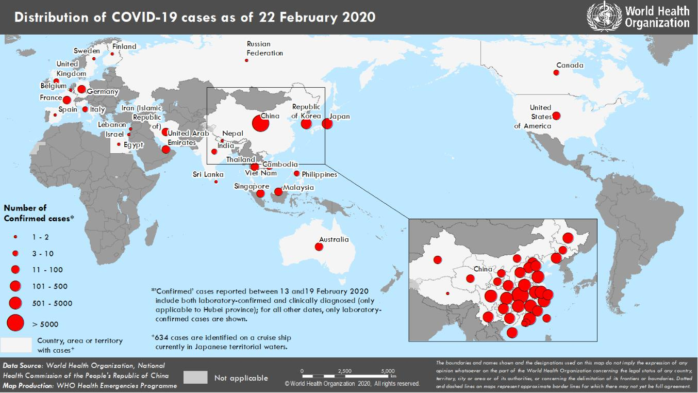

*The situation report includes information provided by national authorities as of 10 AM Central European Time

**SUBJECT IN FOCUS: New protocol for Early Epidemiologic and Clinical Investigations for Public Health Response**

The **understanding of transmission patterns, severity, clinical features and risk factors for COVID-19 is currently** **limited** among the general population, among health care workers, in households and inother “closed” settings.

On 18 February, a new master protocol entitled “[**Surface sampling of coronavirus disease (COVID-19): A practical**](https://www.who.int/emergencies/diseases/novel-coronavirus-2019/technical-guidance/early-investigations) [**“how to” protocol for health care and public health professionals**](https://www.who.int/emergencies/diseases/novel-coronavirus-2019/technical-guidance/early-investigations)”was published.

The role of environmental contamination in the transmission of COVID-19 is not yet clear. This protocol was designed to determine viable virus presence and persistence on fomites in various locations where a COVID-19 patient is receiving care or isolated, and to understand how fomites may play a role in the transmission of the virus in these settings. It is important that surface sampling is done as part of a comprehensive outbreak investigation, and that information obtained by environmental studies is combined with findings from epidemiological and laboratory investigations.

As a reminder, several early investigation **master protocols** and **master forms** for COVID-19 are available:

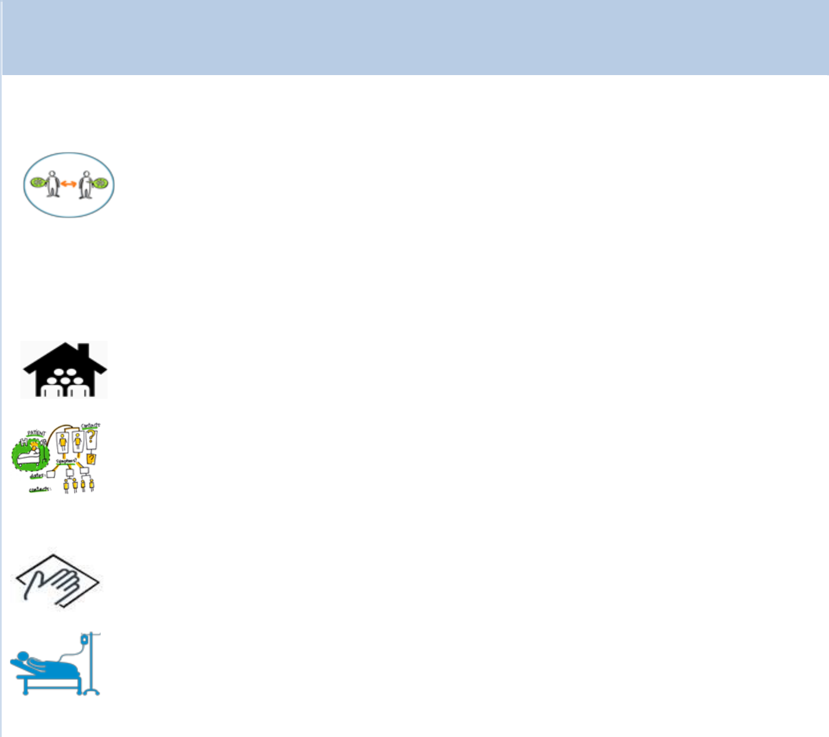

**Early Epidemiologic and Clinical Investigations**

**for Public Health Response**

|  |  |  |  |  |  |  |  |  |  |  |  |  |  |  |  |  |  |  |
| --- | --- | --- | --- | --- | --- | --- | --- | --- | --- | --- | --- | --- | --- | --- | --- | --- | --- | --- |
|  |  |  |  |  |  |  |  |  |  |  |  |  |  |  |  |  |  |  |
|  |  |  |  |  |  | Setting |  |  | For whom? |  | Which protocol should be |  | Contact details for further | | | |  |  |
|  |  |  |  |  |  |  |  |  |  |  | used? |  | information | | | |  |  |
|  |  |  |  |  |  | Community |  |  | Cases and close |  | The First Few COVID-19 X |  | [EarlyInvestigations-2019-](mailto:EarlyInvestigations-2019-nCoV@who.int) | | |  | |  |
|  |  |  |  |  |  | transmission |  |  | contacts **in the** |  | cases and contacts |  | [nCoV@who.int](mailto:EarlyInvestigations-2019-nCoV@who.int) | | | | |  |
|  |  |  |  |  |  | mainly (or |  |  | **general** |  | transmission investigation |  |  |  |  |  |  |  |
|  |  |  |  |  |  | closed settings) |  |  | **population** |  | protocol (FFX) |  |  |  |  |  |  |  |
|  |  |  |  |  |  |  |  |  | or can be |  |  |  |  |  |  |  |  |  |
|  |  |  |  |  |  |  |  |  | restricted **to close** |  |  |  |  |  |  |  |  |  |
|  |  |  |  |  |  |  |  |  | **settings** (like |  |  |  |  |  |  |  |  |  |
|  |  |  |  |  |  |  |  |  | households, health |  |  |  |  |  |  |  |  |  |
|  |  |  |  |  |  |  |  |  | care settings, |  |  |  |  |  |  |  |  |  |
|  |  |  |  |  |  |  |  |  | schools). |  |  |  |  |  |  |  |  |  |
|  |  |  |  |  |  | Households |  |  | Cases and close |  | Households transmission of |  | [EarlyInvestigations-2019-](mailto:EarlyInvestigations-2019-nCoV@who.int) | | |  | |  |
|  |  |  |  |  |  | transmission |  |  | contacts **in** |  | COVID-19 investigation |  | [nCoV@who.int](mailto:EarlyInvestigations-2019-nCoV@who.int) | | | | |  |
|  |  |  |  |  |  |  |  |  | **households** |  | protocol (HH) |  |  |  |  |  |  |  |
|  |  |  |  |  |  |  |  |  | **setting** |  |  |  |  |  |  |  |  |  |
|  |  |  |  |  |  |  |  |  |  |  |  |  |  | |  | |  |  |
|  |  |  |  |  |  | Health facilities |  |  | **For health** |  | Assessment of COVID-19 |  | [EarlyInvestigations-2019-](mailto:EarlyInvestigations-2019-nCoV@who.int) | | |  | |  |
|  |  |  |  |  |  | transmission |  |  | **workers** in a |  | risk factors among Health |  | [nCoV@who.int](mailto:EarlyInvestigations-2019-nCoV@who.int) | | | | |  |
|  |  |  |  |  |  |  |  |  | health-care setting |  | workers (HW) protocol |  |  |  |  |  |  |  |
|  |  |  |  |  |  |  |  |  | in which a |  |  |  |  |  |  |  |  |  |
|  |  |  |  |  |  |  |  |  | confirmed case |  |  |  |  |  |  |  |  |  |
|  |  |  |  |  |  |  |  |  | has received care |  |  |  |  |  |  |  |  |  |
|  |  |  |  |  |  | Surface |  |  | **For environmental** |  | Surface sampling of COVID- |  | [EarlyInvestigations-2019-](mailto:EarlyInvestigations-2019-nCoV@who.int) | | |  | |  |
|  |  |  |  |  |  | contamination |  |  | **surfaces** |  | 19: A practical “how to” |  | [nCoV@who.int](mailto:EarlyInvestigations-2019-nCoV@who.int) | | | | |  |
|  |  |  |  |  |  | and |  |  |  |  | protocol for health care and |  |  |  |  |  |  |  |
|  |  |  |  |  |  | transmission |  |  |  |  | public health professionals |  |  |  |  |  |  |  |
|  |  |  |  |  |  | Clinical |  |  | **For hospitalized** |  | [Global COVID-19 clinical](https://www.who.int/docs/default-source/coronaviruse/who-ncov-crf.pdf?sfvrsn=84766e69_2) |  | [EDCARN@who.int](mailto:EDCARN@who.int) | | | | |  |
|  |  |  |  |  |  | characterization |  |  | **cases** |  | [characterization case](https://www.who.int/docs/default-source/coronaviruse/who-ncov-crf.pdf?sfvrsn=84766e69_2) |  |  |  |  |  |  |  |
|  |  |  |  |  |  |  |  |  |  |  | [record form,](https://www.who.int/docs/default-source/coronaviruse/who-ncov-crf.pdf?sfvrsn=84766e69_2) and data |  |  |  |  |  |  |  |
|  |  |  |  |  |  |  |  |  |  |  | platform for anonymized |  |  |  |  |  |  |  |
|  |  |  |  |  |  |  |  |  |  |  | COVID-19 clinical data |  |  |  |  |  |  |  |

For more information, visit: <https://www.who.int/emergencies/diseases/novel-coronavirus-2019/technical-guidance/early-investigations>

**SURVEILLANCE**

**Table 1. Confirmed and suspected cases of COVID-19 acute respiratory disease reported by provinces, regions and cities in China, 22 February 2020**

|  |  |  |  |  |  |  |  |  |  |  |  |  |  |  |  |  |  |  |  |  |  |  |  |
| --- | --- | --- | --- | --- | --- | --- | --- | --- | --- | --- | --- | --- | --- | --- | --- | --- | --- | --- | --- | --- | --- | --- | --- |
|  | **Province/** |  |  | **Population** |  |  |  |  |  |  | **Daily** | |  |  |  |  |  | **Cumulative** | | | |  |  |
|  | **Region/** |  |  |  |  |  |  |  |  |  |  |  |  |  |  |  |  |  |  |  |  |  |
|  |  |  | **(10,000s)** |  |  |  | **Confirmed** |  |  | **Suspected** |  |  |  |  |  |  | **Confirmed** |  |  |  |  |  |
|  | **City** |  |  |  |  |  |  |  |  |  | **Deaths** |  |  |  |  |  | **Deaths** |  |  |
|  |  |  |  |  |  |  | **cases** |  |  | **cases** |  |  |  |  |  | **cases** |  |  |  |  |
|  |  |  |  |  |  |  |  |  |  |  |  |  |  |  |  |  |  |  |  |  |
|  | Hubei |  |  | 5917 |  |  |  | 366 |  |  | 1125 |  |  | 106 |  |  |  | 63454 |  |  | 2250 |  |  |
|  | Guangdong | | 11346 | |  | 6 | | |  | 1 | |  | 0 | |  | 1339 | | |  | 5 | |  |  |
|  | Henan |  |  | 9605 |  |  |  | 3 |  |  | 25 |  |  | 0 |  |  |  | 1270 |  |  | 19 |  |  |
|  | Zhejiang | | 5737 | |  | 2 | | |  | 4 | |  | 0 | |  | 1205 | | |  | 1 | |  |  |
|  | Hunan |  |  | 6899 |  |  |  | 2 |  |  | 2 |  |  | 0 |  |  |  | 1013 |  |  | 4 |  |  |
|  | Anhui | | 6324 | |  | 1 | | |  | 0 | |  | 0 | |  | 989 | | |  | 6 | |  |  |
|  | Jiangxi |  |  | 4648 |  |  |  | 0 |  |  | 0 |  |  | 0 |  |  |  | 934 |  |  | 1 |  |  |
|  | Shandong | | 10047 | |  | 2 | | |  | 3 | |  | 0 | |  | 750 | | |  | 4 | |  |  |
|  | Jiangsu |  |  | 8051 |  |  |  | 0 |  |  | 0 |  |  | 0 |  |  |  | 631 |  |  | 0 |  |  |
|  | Chongqing | | 3102 | |  | 5 | | |  | 15 | |  | 0 | |  | 572 | | |  | 6 | |  |  |
|  | Sichuan |  |  | 8341 |  |  |  | 1 |  |  | 21 |  |  | 0 |  |  |  | 526 |  |  | 3 |  |  |
|  | Heilongjiang | | 3773 | |  | 0 | | |  | 0 | |  | 0 | |  | 479 | | |  | 12 | |  |  |
|  | Beijing |  |  | 2154 |  |  |  | 3 |  |  | 26 |  |  | 0 |  |  |  | 399 |  |  | 4 |  |  |
|  | Shanghai | | 2424 | |  | 0 | | |  | 48 | |  | 1 | |  | 334 | | |  | 3 | |  |  |
|  | Hebei |  |  | 7556 |  |  |  | 1 |  |  | 0 |  |  | 1 |  |  |  | 309 |  |  | 6 |  |  |
|  | Fujian | | 3941 | |  | 0 | | |  | 0 | |  | 0 | |  | 293 | | |  | 1 | |  |  |
|  | Guangxi |  |  | 4926 |  |  |  | 3 |  |  | 6 |  |  | 0 |  |  |  | 249 |  |  | 2 |  |  |
|  | Shaanxi | | 3864 | |  | 0 | | |  | 3 | |  | 0 | |  | 245 | | |  | 1 | |  |  |
|  | Yunnan |  |  | 4830 |  |  |  | 0 |  |  | 14 |  |  | 0 |  |  |  | 174 |  |  | 2 |  |  |
|  | Hainan | | 934 | |  | 0 | | |  | 11 | |  | 0 | |  | 168 | | |  | 4 | |  |  |
|  | Guizhou |  |  | 3600 |  |  |  | 0 |  |  | 2 |  |  | 0 |  |  |  | 146 |  |  | 2 |  |  |
|  | Tianjin | | 1560 | |  | 2 | | |  | 31 | |  | 0 | |  | 133 | | |  | 3 | |  |  |
|  | Shanxi |  |  | 3718 |  |  |  | 0 |  |  | 2 |  |  | 0 |  |  |  | 132 |  |  | 0 |  |  |
|  | Liaoning | | 4359 | |  | 0 | | |  | 14 | |  | 0 | |  | 121 | | |  | 1 | |  |  |
|  | Jilin |  |  | 2704 |  |  |  | 0 |  |  | 7 |  |  | 0 |  |  |  | 91 |  |  | 1 |  |  |
|  | Gansu | | 2637 | |  | 0 | | |  | 0 | |  | 0 | |  | 91 | | |  | 2 | |  |  |
|  | Xinjiang |  |  | 2487 |  |  |  | 0 |  |  | 0 |  |  | 1 |  |  |  | 76 |  |  | 2 |  |  |
|  | Inner Mongolia | | 2534 | |  | 0 | | |  | 0 | |  | 0 | |  | 75 | | |  | 0 | |  |  |
|  | Ningxia |  |  | 688 |  |  |  | 0 |  |  | 1 |  |  | 0 |  |  |  | 71 |  |  | 0 |  |  |
|  | Hong Kong SAR | | 745 | |  | 0 | | |  | 0 | |  | 0 | |  | 68* | | |  | 2 | |  |  |
|  | Taipei and environs |  |  | 2359 |  |  |  | 0 |  |  | 0 |  |  | 0 |  |  |  | 26 |  |  | 1 |  |  |
|  | Qinghai | | 603 | |  | 0 | | |  | 0 | |  | 0 | |  | 18 | | |  | 0 | |  |  |
|  | Macao SAR |  |  | 66 |  |  |  | 0 |  |  | 0 |  |  | 0 |  |  |  | 10 |  |  | 0 |  |  |
|  | Xizang | | 344 | |  | 0 | | |  | 0 | |  | 0 | |  | 1 | | |  | 0 | |  |  |
|  | **Total** |  |  | **142823** |  |  |  | **397** |  |  | **1361** |  |  | **109** |  |  |  | **76392** |  |  | **2348** |  |  |

*Subject to change due to discrepant information.

**Table 2. Countries, territories or areas outside China with reported laboratory-confirmed COVID-19 cases and deaths. Data as of 22 February 2020**

|  |  |  |  |  |  |  |  |  |  |  |  |  |  |  |  |  |  |  |  |  |  |  |  |  |  |
| --- | --- | --- | --- | --- | --- | --- | --- | --- | --- | --- | --- | --- | --- | --- | --- | --- | --- | --- | --- | --- | --- | --- | --- | --- | --- |
|  |  |  |  |  |  |  |  | **Likely place of exposure†** | | | | | | | | |  |  |  |  |  |  |  |  |  |
|  |  |  |  |  |  |  |  |  |  |  |  |  |  |  |  |  |  |  |  |  |  |  |  |  |  |
|  |  |  |  | **Confirmed\*** | |  |  |  |  |  | **Outside** | |  |  |  | **In** |  |  | **Total cases with site of** | |  |  | **Total** |  |  |
|  | **Country/Territory/Area** |  |  |  |  |  |  |  | **reporting** | |  |  |  |  |  | **transmission under** | |  |  | **deaths** |  |  |
|  |  |  | **cases (new)** | |  |  | **China** |  |  |  |  | **reporting** | |  |  |  |  |  |  |
|  |  |  |  |  |  |  |  | **country and** | |  |  |  |  | **investigation (new)** | |  |  | **(new)** |  |  |
|  |  |  |  |  |  |  |  | **(new)** |  |  |  |  | **country** | |  |  |  |  |  |  |
|  |  |  |  |  |  |  |  |  |  | **outside** | |  |  |  |  |  |  |  |  |  |  |  |
|  |  |  |  |  |  |  |  |  |  |  |  |  | **(new)** | |  |  |  |  |  |  |  |  |  |
|  |  |  |  |  |  |  |  |  |  |  | **China (new)** | |  |  |  |  |  |  |  |  |  |  |  |
|  |  |  |  |  |  |  |  |  |  |  |  |  |  |  |  |  |  |  |  |  |  |  |  |
|  | **Western Pacific Region** | |  |  |  |  |  |  |  |  |  |  |  |  |  |  |  |  |  |  |  |  |  |  |  |
|  | Republic of Korea | | 346 |  | (142) |  | 13 (0) | |  | 4 | | (0) |  | 288 | | (130) |  | 41 | | (12) |  | 2 (1) | |  |  |
|  | Japan | | 105 | | (12) |  | 28 (1) | |  | 5 | | (0) |  | 68 | | (11) |  | 4 | | (0) |  | 1 (0) | |  |  |
|  | Singapore | | 86 | | (1) |  | 23 (0) | |  | 0 | | (0) |  | 56 (1) | | |  | 7 | | (0) |  | 0 (0) | |  |  |
|  | Malaysia | | 22 | | (0) |  | 17 (0) | |  | 1 | | (0) |  | 2 | | (0) |  | 2 | | (0) |  | 0 (0) | |  |  |
|  | Australia | | 21 | | (4) |  | 12 (0) | |  | 6 | | (4) |  | 3 | | (0) |  | 0 | | (0) |  | 0 (0) | |  |  |
|  | Viet Nam | | 16 | | (0) |  | 8 (0) | |  | 0 | | (0) |  | 8 | | (0) |  | 0 | | (0) |  | 0 (0) | |  |  |
|  | Philippines | | 3 |  | (0) |  | 3 (0) | |  | 0 | | (0) |  | 0 | | (0) |  | 0 | | (0) |  | 1 (0) | |  |  |
|  | Cambodia | | 1 |  | (0) |  | 1 (0) | |  | 0 | | (0) |  | 0 | | (0) |  | 0 | | (0) |  | 0 (0) | |  |  |
|  | **South-East Asia Region** | |  |  |  |  |  |  |  |  |  |  |  |  |  |  |  |  |  |  |  |  |  |  |  |
|  | Thailand | | 35 | | (0) |  | 23 (0) | |  | 0 | | (0) |  | 5 | | (0) |  | 7 | | (0) |  | 0 (0) | |  |  |
|  | India | | 3 |  | (0) |  | 3 (0) | |  | 0 | | (0) |  | 0 | | (0) |  | 0 | | (0) |  | 0 (0) | |  |  |
|  | Nepal | | 1 |  | (0) |  | 1 (0) | |  | 0 | | (0) |  | 0 | | (0) |  | 0 | | (0) |  | 0 (0) | |  |  |
|  | Sri Lanka | | 1 |  | (0) |  | 1 (0) | |  | 0 | | (0) |  | 0 | | (0) |  | 0 | | (0) |  | 0 (0) | |  |  |
|  | **Region of the Americas** | |  |  |  |  |  |  |  |  |  |  |  |  |  |  |  |  |  |  |  |  |  |  |  |
|  | United States of | |  |  |  |  |  |  |  |  |  |  |  |  |  |  |  |  |  |  |  |  |  |  |  |
|  | America | | 35 |  | (20) |  | 14 (1) | |  | 18 | | (18) |  | 2 | | (0) |  | 1 | | (1) |  | 0 (0) | |  |  |
|  | Canada | | 8 |  | (0) |  | 7 (0) | |  | 0 | | (0) |  | 0 | | (0) |  | 1 | | (0) |  | 0 (0) | |  |  |
|  | **European Region** | |  |  |  |  |  |  |  |  |  |  |  |  |  |  |  |  |  |  |  |  |  |  |  |
|  | Germany | | 16 | | (0) |  | 2 (0) | |  | 0 | | (0) |  | 14 (0) | | |  | 0 | | (0) |  | 0 (0) | |  |  |
|  | France | | 12 | | (0) |  | 5 (0) | |  | 0 | | (0) |  | 7 | | (0) |  | 0 | | (0) |  | 1 (0) | |  |  |
|  | Italy | | 9 |  | (6) |  | 3 (0) | |  | 0 | | (0) |  | 6 | | (6) |  | 0 | | (0) |  | 0 (0) | |  |  |
|  | The United Kingdom | | 9 |  | (0) |  | 2 (0) | |  | 6 | | (0) |  | 1 | | (0) |  | 0 | | (0) |  | 0 (0) | |  |  |
|  | Russian Federation | | 2 |  | (0) |  | 2 (0) | |  | 0 | | (0) |  | 0 | | (0) |  | 0 | | (0) |  | 0 (0) | |  |  |
|  | Spain | | 2 |  | (0) |  | 0 (0) | |  | 2 | | (0) |  | 0 | | (0) |  | 0 | | (0) |  | 0 (0) | |  |  |
|  | Belgium | | 1 |  | (0) |  | 1 (0) | |  | 0 | | (0) |  | 0 | | (0) |  | 0 | | (0) |  | 0 (0) | |  |  |
|  | Finland | | 1 |  | (0) |  | 1 (0) | |  | 0 | | (0) |  | 0 | | (0) |  | 0 | | (0) |  | 0 (0) | |  |  |
|  | Israel | | 1 |  | (1) |  | 0 (0) | |  | 1 | | (1) |  | 0 | | (0) |  | 0 | | (0) |  | 0 (0) | |  |  |
|  | Sweden | | 1 |  | (0) |  | 1 (0) | |  | 0 | | (0) |  | 0 | | (0) |  | 0 | | (0) |  | 0 (0) | |  |  |
|  | **Eastern MediterraneanRegion** | | |  |  |  |  |  |  |  |  |  |  |  |  |  |  |  |  |  |  |  |  |  |  |
|  | Iran (Islamic Republic of) | | 18 |  | (13) |  | 0 (0) | |  | 0 | | (0) |  | 18 | | (13) |  | 0 | | (0) |  | 4 (2) | |  |  |
|  | United Arab Emirates | | 11 | | (2) |  | 6 (0) | |  | 0 | | (0) |  | 5 | | (2) |  | 0 | | (0) |  | 0 (0) | |  |  |
|  | Egypt | | 1 |  | (0) |  | 0 (0) | |  | 0 | | (0) |  | 1 | | (0) |  | 0 | | (0) |  | 0 (0) | |  |  |
|  | Lebanon | | 1 |  | (1) |  | 0 (0) | |  | 1 | | (1) |  | 0 | | (0) |  | 0 | | (0) |  | 0 (0) | |  |  |
|  |  | |  |  |  |  |  | |  |  | |  |  | | |  |  |  | |  |  | | |  |  |
|  | **Subtotal for all regions** |  |  |  | (202) |  |  | 177 (2) |  |  | 44 | (24) |  |  | 484 | (163) |  |  | 63 | (13) |  |  | 9 (0) |  |  |
|  | International | |  |  |  |  |  |  |  |  |  |  |  |  |  |  |  |  |  |  |  |  |  |  |  |
|  | conveyance‡ (Diamond | |  |  |  |  |  |  |  |  |  |  |  |  |  |  |  |  |  |  |  |  |  |  |  |
|  | Princess) | | 634 (0) | | |  | 0 (0) | |  | 0 | | (0) |  | 0 | | (0) |  | 634 (0) | | |  | 2 (0) | |  |  |
|  | **Grand total** |  |  | **1402** | **(202)** |  |  | **177 (2)** |  |  | **44** | **(24)** |  |  | **484** | **(163)** |  |  | **697 (13)** | |  |  | **11 (3)** |  |  |

*Case classifications are based on [WHO case definitions](https://www.who.int/publications-detail/global-surveillance-for-human-infection-with-novel-coronavirus-(2019-ncov)) for COVID-19.

**†**Location of transmission is classified based on WHO analysis of available official data and may be subject to reclassification as additional data become available.

‡Cases identified on a cruise ship currently in Japanese territorial waters.

**Figure 2. Epidemic curve of COVID-19 cases (n=261) identified outside of China, by date of onset of symptoms and likely exposure location, 22 February 2020**

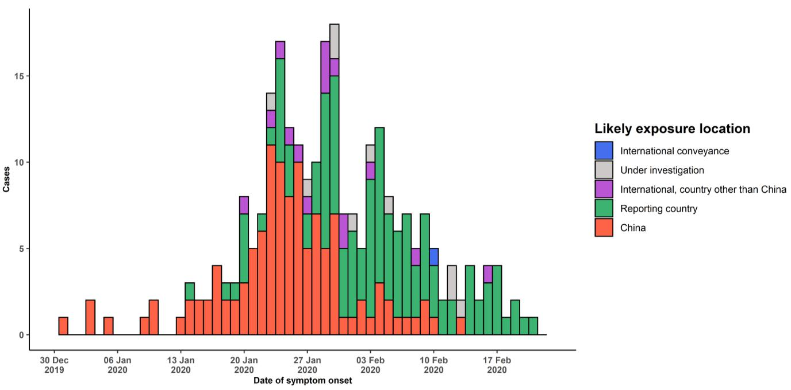

Note for figure 2: Of the 1402 cases reported outside China, 30 were detected while apparently asymptomatic. For the remaining 1372 cases, information on date of onset is available only for the 261 cases presented in the epidemiologic curve.

**Figure 3. Epidemic curve of COVID-19 cases (n=1402) identified outside of China, by date of report and likely exposure location, 22 February 2020**

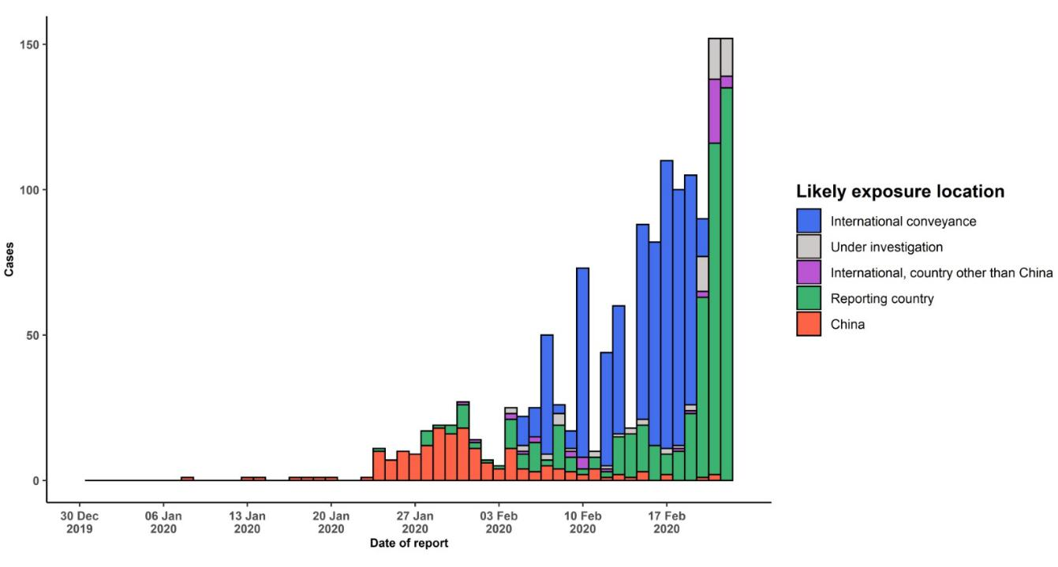

**STRATEGICOBJECTIVES**

WHO’s strategic objectives for this response are to:

* Limit human-to-human transmission including reducing secondary infections among close contacts and health care workers, preventing transmission amplification events, and preventing further international spread from China*;
* Identify, isolate and care for patients early, including providing optimized care for infected patients;
* Identify and reduce transmission from the animal source;
* Address crucial unknowns regarding clinical severity, extent of transmission and infection, treatment options, and accelerate the development of diagnostics, therapeutics and vaccines;
* Communicate critical risk and event information to all communities and counter misinformation;
* Minimize social and economic impact through multisectoral partnerships.

*This can be achieved through a combination of public health measures, such as rapid identification, diagnosis and management of the cases, identification and follow up of the contacts, infection prevention and control in health care settings, implementation of health measures for travelers, awareness-raising in the population and risk communication.

**PREPAREDNESS AND RESPONSE**

* To view all technical guidance documents regarding COVID-19, please go to [this webpage](https://www.who.int/emergencies/diseases/novel-coronavirus-2019/technical-guidance).
* WHO is working closely with International Air Transport Association (IATA) and have jointly developed a guidance document to provide advice to cabin crew and airport workers, based on country queries. The guidance can be found on the [IATA webpage](https://www.iata.org/en/programs/safety/health/diseases/#tab-2).
* WHO has developed a protocol for the investigation of early cases (the [“First Few X (FFX) Cases and contact](https://www.who.int/publications-detail/the-first-few-x-(ffx)-cases-and-contact-investigation-protocol-for-2019-novel-coronavirus-(2019-ncov)-infection) [investigation protocol for 2019-novel coronavirus (2019-nCoV) infection](https://www.who.int/publications-detail/the-first-few-x-(ffx)-cases-and-contact-investigation-protocol-for-2019-novel-coronavirus-(2019-ncov)-infection)”). The protocol is designed to gain an early understanding of the key clinical, epidemiological and virological characteristics of the first cases of COVID-19 infection detected in any individual country, to inform the development and updating of public health guidance to manage cases and reduce potential spread and impact of infection.
* WHO has been in regular and direct contact with Member States where cases have been reported. WHO is also informing other countries about the situation and providing support as requested.
* WHO has developed interim guidance for [laboratory diagnosis,](https://www.who.int/emergencies/diseases/novel-coronavirus-2019/technical-guidance/laboratory-guidance) [advice on the use of masks during home care and](https://www.who.int/publications-detail/advice-on-the-use-of-masks-in-the-community-during-home-care-and-in-healthcare-settings-in-the-context-of-the-novel-coronavirus-(2019-ncov)-outbreak) [in health care settings in the context of the novel coronavirus (2019-nCoV) outbreak,](https://www.who.int/publications-detail/advice-on-the-use-of-masks-in-the-community-during-home-care-and-in-healthcare-settings-in-the-context-of-the-novel-coronavirus-(2019-ncov)-outbreak) [clinical management](https://www.who.int/publications-detail/clinical-management-of-severe-acute-respiratory-infection-when-novel-coronavirus-(ncov)-infection-is-suspected)[,](https://www.who.int/emergencies/diseases/novel-coronavirus-2019/technical-guidance/infection-prevention-and-control) [infection prevention and control in health care settings,](https://www.who.int/emergencies/diseases/novel-coronavirus-2019/technical-guidance/infection-prevention-and-control) [home care for patients with suspected novel](https://www.who.int/publications-detail/home-care-for-patients-with-suspected-novel-coronavirus-(ncov)-infection-presenting-with-mild-symptoms-and-management-of-contacts) [coronavirus,](https://www.who.int/publications-detail/home-care-for-patients-with-suspected-novel-coronavirus-(ncov)-infection-presenting-with-mild-symptoms-and-management-of-contacts) [risk communication and community engagement](https://www.who.int/publications-detail/risk-communication-and-community-engagement-readiness-and-initial-response-for-novel-coronaviruses-(-ncov)) and [Global Surveillance for human infection with](https://www.who.int/publications-detail/global-surveillance-for-human-infection-with-novel-coronavirus-(2019-ncov)) [novel coronavirus (2019-nCoV).](https://www.who.int/publications-detail/global-surveillance-for-human-infection-with-novel-coronavirus-(2019-ncov))
* WHO has prepared [disease commodity package](https://www.who.int/publications-detail/disease-commodity-package---novel-coronavirus-(ncov)) that includes an essential list of biomedical equipment, medicines and supplies necessary to care for patients with 2019-nCoV.
* WHO has provided recommendations to reduce risk of [transmission from animals to humans.](https://www.who.int/health-topics/coronavirus/who-recommendations-to-reduce-risk-of-transmission-of-emerging-pathogens-from-animals-to-humans-in-live-animal-markets)
* WHO has published an [updated advice for international traffic in relation to the outbreak of the novel](https://www.who.int/ith/2019-nCoV_advice_for_international_traffic/en/) [coronavirus 2019-nCoV.](https://www.who.int/ith/2019-nCoV_advice_for_international_traffic/en/)
* WHO has activated of R&D blueprint to accelerate diagnostics, vaccines, and therapeutics.
* WHO has developed online courses on the following topics: [A general introduction to emerging respiratory](https://openwho.org/courses/introduction-to-ncov) [viruses,](https://openwho.org/courses/introduction-to-ncov) including novel coronaviruses (available in [French,](https://openwho.org/courses/introduction-au-ncov) [Chinese,](https://openwho.org/courses/introduction-to-ncov-ZH) and [Spanish](https://openwho.org/courses/introduccion-al-ncov)); [Critical Care of Severe Acute](https://openwho.org/courses/severe-acuterespiratory-infection) [Respiratory Infections;](https://openwho.org/courses/severe-acuterespiratory-infection) and [Health and safety briefing for respiratory diseases - ePROTECT](https://openwho.org/courses/eprotect-acute-respiratory-infections)
* WHO is providing guidance on early investigations, which are critical to carry out early in an outbreak of a new virus. The data collected from the protocols can be used to refine recommendations for surveillance and case definitions, to characterize the key epidemiological transmission features of COVID-19, help understand spread,

severity, spectrum of disease, impact on the community and to inform operational models for implementation of countermeasures such as case isolation, contact tracing and isolation. Several protocols are available here: <https://www.who.int/emergencies/diseases/novel-coronavirus-2019/technical-guidance/early-investigations>

* WHO is working with its networks of researchers and other experts to coordinate global work on surveillance, epidemiology, modelling, diagnostics, clinical care and treatment, and other ways to identify, manage the disease and limit onward transmission. WHO has issued interim guidance for countries, which are updated regularly.
* WHO is working with global expert networks and partnerships for laboratory, infection prevention and control, clinical management and mathematical modelling.

**RECOMMENDATIONS AND ADVICE FOR THE PUBLIC**

During previous outbreaks due to other coronavirus (Middle-East Respiratory Syndrome (MERS) and Severe Acute Respiratory Syndrome (SARS), human-to-human transmission occurred through droplets, contact and fomites, suggesting that the transmission mode of the COVID-19 can be similar. The basic principles to reduce the general risk of transmission of acute respiratory infections include the following:

* Avoiding close contact with people suffering from acute respiratory infections.
* Frequent hand-washing, especially after direct contact with ill people or their environment.
* Avoiding unprotected contact with farm or wild animals.
* People with symptoms of acute respiratory infection should practice cough etiquette (maintain distance, cover coughs and sneezes with disposable tissues or clothing, and wash hands).
* Within health care facilities, enhance standard infection prevention and control practices in hospitals, especially in emergency departments.

WHO does not recommend any specific health measures for travellers. In case of symptoms suggestive of respiratory illness either during or after travel, travellers are encouraged to seek medical attention and share their travel history with their health care provider.