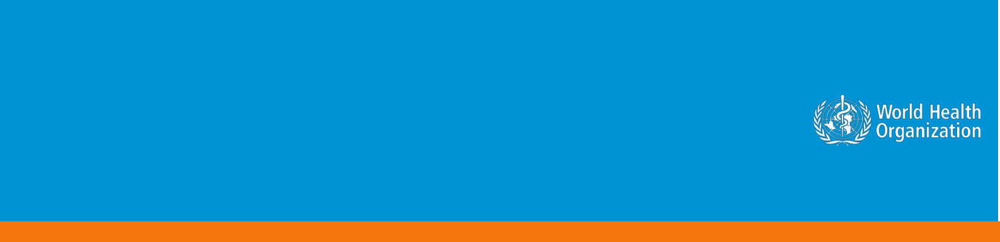

**Coronavirus disease 2019 (COVID-19)**

**Situation Report – 36**

**Data as reported by 10AM CET 25 February 2020\***

**HIGHLIGHTS**

* Four new Member States (Afghanistan, Bahrain, Iraq, and Oman) reported cases of COVID-19 in the past 24 hours.
* For healthcare workers and public health professionals, WHO has an online course titled *Infection Prevention and Control (IPC) for Novel Coronavirus* *(COVID-19).* You can access the course through the following link:[https://openwho.org/courses/COVID-19-IPC-EN.](https://openwho.org/courses/COVID-19-IPC-EN) This course provides information on what facilities should be doing to prepare to respond to a case of an emerging respiratory virus such as the novel coronavirus.
* The WHO-China joint mission concluded on 24 February. The team has made a range of findings about the transmissibility of the virus, the severity of disease and the impact of the measures taken. Please see [here](https://www.who.int/dg/speeches/detail/who-director-general-s-opening-remarks-at-the-media-briefing-on-covid-19---24-february-2020) for more information regarding the findings of the mission.
* A joint WHO and European Centre for Disease Prevention and Control (ECDC) mission arrived in Italy on 24 February to support Italian authorities on the COVID-19 situation. More information can be found [here.](http://www.euro.who.int/en/health-topics/health-emergencies/coronavirus-covid-19/news/news/2020/2/joint-who-and-ecdc-mission-in-italy-to-support-covid-19-control-and-prevention-efforts)

**SITUATION IN NUMBERS**

**total and new cases in last 24 hours**

**Globally**

80 239 confirmed (908 new)

**China**

77 780 confirmed (518 new)

2666 deaths (71 new)

**Outside of China**

2459 confirmed (390 new)

33 countries (4 new)

34 deaths (11 new)

**WHO RISK ASSESSMENT**

China Very High

Regional Level High

Global Level High

**Figure 1. Countries, territories or areas with reported confirmed cases of COVID-19, 25 February 2020**

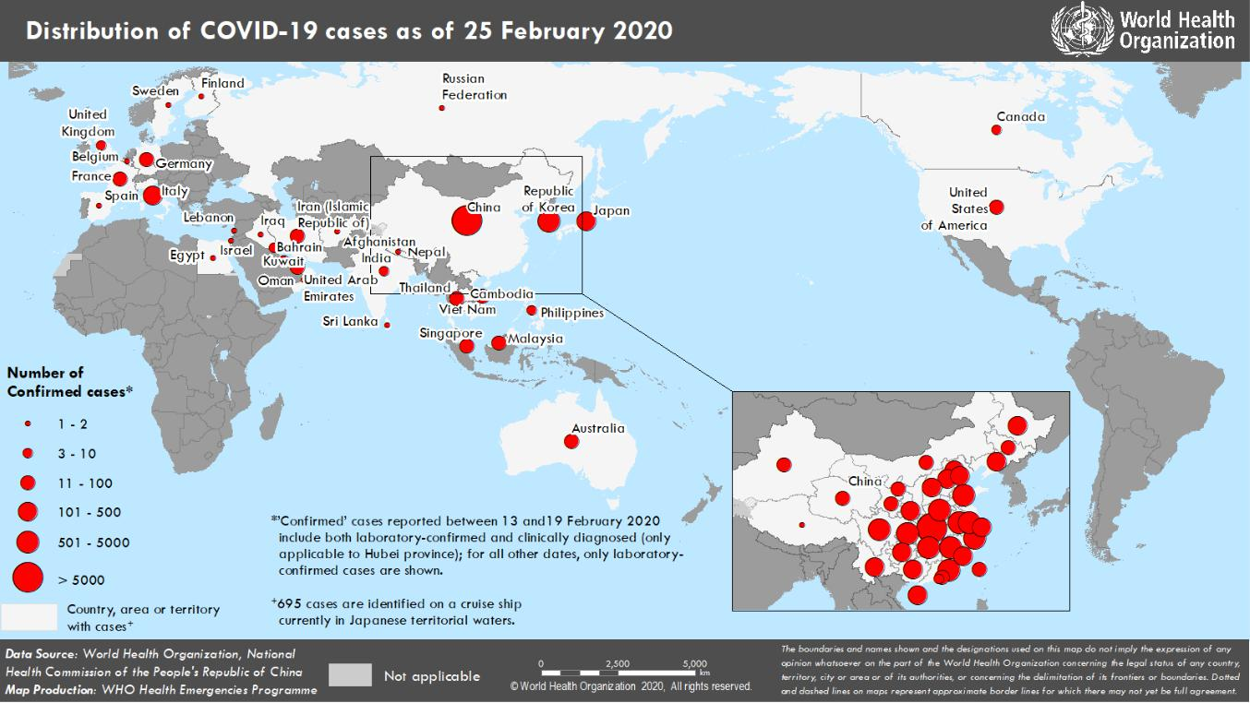

**SURVEILLANCE**

**Table 1. Confirmed and suspected cases of COVID-19 acute respiratory disease reported by provinces, regions and cities in China, 25 February 2020**

|  |  |  |  |  |  |  |  |  |  |  |  |  |  |  |  |  |  |  |  |  |  |
| --- | --- | --- | --- | --- | --- | --- | --- | --- | --- | --- | --- | --- | --- | --- | --- | --- | --- | --- | --- | --- | --- |
|  | **Province/** |  |  | **Population** |  |  |  |  |  | **Daily** | |  |  |  |  | **Cumulative** | | | |  |  |
|  |  |  |  |  |  |  |  |  |  |  |  |  |  |  |  |  |  |  |  |
|  | **Region/** |  |  |  |  | **Confirmed** |  |  | **Suspected** |  |  |  |  |  | **Confirmed** |  |  |  |  |  |
|  |  |  | **(10,000s)** |  |  |  |  |  |  | **Deaths** |  |  |  |  | **Deaths** |  |  |
|  | **City** |  |  |  |  | **cases** |  |  | **cases** |  |  |  |  |  |  |  |  |
|  |  |  |  |  |  |  |  |  |  |  |  | **cases** |  |  |  |  |
|  |  |  |  |  |  |  |  |  |  |  |  |  |  |  |  |  |  |  |  |  |
|  |  |  |  |  |  |  |  |  |  |  |  |  |  |  |  |  |  |  |  |  |  |
|  | Hubei |  |  | 5917 |  |  | 499 |  |  | 373 |  |  | 68 |  |  | 64786 |  |  | 2563 |  |  |
|  | Guangdong | | 11346 | |  | 2 | |  | 0 | |  | 1 | |  | 1347 | |  | 7 | |  |  |
|  | Henan |  |  | 9605 |  |  | 0 |  |  | 5 |  |  | 0 |  |  | 1271 |  |  | 19 |  |  |
|  | Zhejiang | | 5737 | |  | 0 | |  | 1 | |  | 0 | |  | 1205 | |  | 1 | |  |  |
|  | Hunan |  |  | 6899 |  |  | 0 |  |  | 1 |  |  | 0 |  |  | 1016 |  |  | 4 |  |  |
|  | Anhui | | 6324 | |  | 0 | |  | 0 | |  | 0 | |  | 989 | |  | 6 | |  |  |
|  | Jiangxi |  |  | 4648 |  |  | 0 |  |  | 0 |  |  | 0 |  |  | 934 |  |  | 1 |  |  |
|  | Shandong | | 10047 | |  | 0 | |  | 0 | |  | 2 | |  | 755 | |  | 6 | |  |  |
|  | Jiangsu |  |  | 8051 |  |  | 0 |  |  | 0 |  |  | 0 |  |  | 631 |  |  | 0 |  |  |
|  | Chongqing | | 3102 | |  | 1 | |  | 13 | |  | 0 | |  | 576 | |  | 6 | |  |  |
|  | Sichuan |  |  | 8341 |  |  | 2 |  |  | 7 |  |  | 0 |  |  | 529 |  |  | 3 |  |  |
|  | Heilongjiang | | 3773 | |  | 0 | |  | 0 | |  | 0 | |  | 480 | |  | 12 | |  |  |
|  | Beijing |  |  | 2154 |  |  | 1 |  |  | 18 |  |  | 0 |  |  | 400 |  |  | 4 |  |  |
|  | Shanghai | | 2424 | |  | 0 | |  | 30 | |  | 0 | |  | 335 | |  | 3 | |  |  |
|  | Hebei |  |  | 7556 |  |  | 0 |  |  | 0 |  |  | 0 |  |  | 311 |  |  | 6 |  |  |
|  | Fujian | | 3941 | |  | 1 | |  | 0 | |  | 0 | |  | 294 | |  | 1 | |  |  |
|  | Guangxi |  |  | 4926 |  |  | 1 |  |  | 3 |  |  | 0 |  |  | 252 |  |  | 2 |  |  |
|  | Shaanxi | | 3864 | |  | 0 | |  | 0 | |  | 0 | |  | 245 | |  | 1 | |  |  |
|  | Yunnan |  |  | 4830 |  |  | 0 |  |  | 9 |  |  | 0 |  |  | 174 |  |  | 2 |  |  |
|  | Hainan | | 934 | |  | 0 | |  | 9 | |  | 0 | |  | 168 | |  | 5 | |  |  |
|  | Guizhou |  |  | 3600 |  |  | 0 |  |  | 0 |  |  | 0 |  |  | 146 |  |  | 2 |  |  |
|  | Tianjin | | 1560 | |  | 0 | |  | 38 | |  | 0 | |  | 135 | |  | 3 | |  |  |
|  | Shanxi |  |  | 3718 |  |  | 1 |  |  | 0 |  |  | 0 |  |  | 133 |  |  | 0 |  |  |
|  | Liaoning | | 4359 | |  | 0 | |  | 9 | |  | 0 | |  | 121 | |  | 1 | |  |  |
|  | Jilin |  |  | 2704 |  |  | 0 |  |  | 14 |  |  | 0 |  |  | 93 |  |  | 1 |  |  |
|  | Gansu | | 2637 | |  | 0 | |  | 0 | |  | 0 | |  | 91 | |  | 2 | |  |  |
|  | Hong Kong SAR |  |  | 745 |  |  | 7 |  |  | 0 |  |  | 0 |  |  | 81 |  |  | 2 |  |  |
|  | Xinjiang | | 2487 | |  | 0 | |  | 0 | |  | 0 | |  | 76 | |  | 2 | |  |  |
|  | Inner Mongolia |  |  | 2534 |  |  | 0 |  |  | 0 |  |  | 0 |  |  | 75 |  |  | 0 |  |  |
|  | Ningxia | | 688 | |  | 0 | |  | 0 | |  | 0 | |  | 71 | |  | 0 | |  |  |
|  | Taipei and environs |  |  | 2359 |  |  | 3 |  |  | 0 |  |  | 0 |  |  | 31 |  |  | 1 |  |  |
|  | Qinghai | | 603 | |  | 0 | |  | 0 | |  | 0 | |  | 18 | |  | 0 | |  |  |
|  | Macao SAR |  |  | 66 |  |  | 0 |  |  | 0 |  |  | 0 |  |  | 10 |  |  | 0 |  |  |
|  | Xizang | | 344 | |  | 0 | |  | 0 | |  | 0 | |  | 1 | |  | 0 | |  |  |
|  | **Total** |  |  | **142823** |  |  | **518** |  |  | **530** |  |  | **71** |  |  | **77780** |  |  | **2666** |  |  |
|  |  |  |  |  |  |  |  |  |  |  |  |  |  |  |  |  |  |  |  |  |  |

**Table 2. Countries, territories or areas outside China with reported laboratory-confirmed COVID-19 cases and deaths. Data as of 25 February 2020**

|  |  |  |  |  |  |  |  |  |  |  |  |  |  |  |  |  |  |  |  |  |  |  |  |  |  |
| --- | --- | --- | --- | --- | --- | --- | --- | --- | --- | --- | --- | --- | --- | --- | --- | --- | --- | --- | --- | --- | --- | --- | --- | --- | --- |
|  |  |  |  |  |  |  |  |  | **Likely place of exposure**‡ | | | | | | | |  |  |  |  |  |  |  |  |  |
|  |  |  |  | **Confirmed†** | | |  |  |  |  |  | **Outside** | |  |  | **In** |  |  | **Total cases with site of** | |  |  | **Total** |  |  |
|  |  |  |  |  |  |  |  |  | **reporting** | |  |  |  |  |  |  |  |  |
|  | **Country/Territory/Area** |  |  |  |  | **China** |  |  |  |  | **reporting** |  |  | **transmission under** | |  |  | **deaths** |  |  |
|  |  |  | **cases (new)** | | |  |  |  |  | **country and** | |  |  |  |  |  |  |  |  |
|  |  |  |  |  |  | **(new)** |  |  |  |  | **country** |  |  | **investigation (new)** | |  |  | **(new)** |  |  |
|  |  |  |  |  |  |  |  |  |  |  | **outside** | |  |  |  |  |  |  |  |  |
|  |  |  |  |  |  |  |  |  |  |  |  |  |  | **(new)** |  |  |  |  |  |  |  |  |  |
|  |  |  |  |  |  |  |  |  |  |  |  | **China (new)** | |  |  |  |  |  |  |  |  |  |  |  |
|  |  |  |  |  |  |  |  |  |  |  |  |  |  |  |  |  |  |  |  |  |  |  |  |
|  | **Western Pacific Region** | |  |  |  |  |  |  |  |  |  |  |  |  |  |  |  |  |  |  |  |  |  |  |  |
|  | Republic of Korea | | 977 | | (214) | |  | 13 (0) | |  | 4 | | (0) |  | 605 (0) | |  | 355 | | (214) |  | 10 (3) | |  |  |
|  | Japan | | 157 | | | (13) |  | 28 (0) | |  | 7 | | (2) |  | 110 (3) | |  | 12 (8) | | |  | 1 (0) | |  |  |
|  | Singapore | | 90 | | | (1) |  | 24 (0) | |  | 0 | | (0) |  | 66 (1) | |  | 0 | | (0) |  | 0 (0) | |  |  |
|  | Australia | | 22 | | | (0) |  | 12 (0) | |  | 7 | | (0) |  | 3 (0) | |  | 0 | | (0) |  | 0 (0) | |  |  |
|  | Malaysia | | 22 | | | (0) |  | 18 (0) | |  | 2 | | (0) |  | 2 (0) | |  | 0 | | (0) |  | 0 (0) | |  |  |
|  | Viet Nam | | 16 | | | (0) |  | 8 (0) | |  | 0 | | (0) |  | 8 (0) | |  | 0 | | (0) |  | 0 (0) | |  |  |
|  | Philippines | | 3 | | (0) | |  | 3 (0) | |  | 0 | | (0) |  | 0 (0) | |  | 0 | | (0) |  | 1 (0) | |  |  |
|  | Cambodia | | 1 | | (0) | |  | 1 (0) | |  | 0 | | (0) |  | 0 (0) | |  | 0 | | (0) |  | 0 (0) | |  |  |
|  | **South-East Asia Region** | |  |  |  |  |  |  |  |  |  |  |  |  |  |  |  |  |  |  |  |  |  |  |  |
|  | Thailand | | 37 | | | (2) |  | 23 (0) | |  | 0 | | (0) |  | 7 (1) | |  | 7 | | (1) |  | 0 (0) | |  |  |
|  | India | | 3 | | (0) | |  | 3 (0) | |  | 0 | | (0) |  | 0 (0) | |  | 0 | | (0) |  | 0 (0) | |  |  |
|  | Nepal | | 1 | | (0) | |  | 1 (0) | |  | 0 | | (0) |  | 0 (0) | |  | 0 | | (0) |  | 0 (0) | |  |  |
|  | Sri Lanka | | 1 | | (0) | |  | 1 (0) | |  | 0 | | (0) |  | 0 (0) | |  | 0 | | (0) |  | 0 (0) | |  |  |
|  | **Region of the Americas** | |  |  |  |  |  |  |  |  |  |  |  |  |  |  |  |  |  |  |  |  |  |  |  |
|  | United States of America | | 53 | | (18) | |  | 14 (0) | |  | 36 | | (18) |  | 2 (0) | |  | 1 | | (0) |  | 0 (0) | |  |  |
|  | Canada | | 10 | | | (1) |  | 7 (0) | |  | 1 | | (0) |  | 1 (0) | |  | 1 | | (1) |  | 0 (0) | |  |  |
|  | **European Region** | |  |  |  |  |  |  |  |  |  |  |  |  |  |  |  |  |  |  |  |  |  |  |  |
|  | Italy | | 229 | | (105) | |  | 3 (0) | |  | 0 | | (0) |  | 121 (0) | |  | 105 | | (105) |  | 6 (4) | |  |  |
|  | Germany | | 16 | | | (0) |  | 2 (0) | |  | 0 | | (0) |  | 14 (0) | |  | 0 | | (0) |  | 0 (0) | |  |  |
|  | France | | 12 | | | (0) |  | 5 (0) | |  | 0 | | (0) |  | 7 (0) | |  | 0 | | (0) |  | 1 (0) | |  |  |
|  | The United Kingdom* | | 13 | | | (0) |  | 2 (0) | |  | 10 (0) | | |  | 1 (0) | |  | 0 | | (0) |  | 0 (0) | |  |  |
|  | Israel | | 2 | | (1) | |  | 0 (0) | |  | 2 | | (1) |  | 0 (0) | |  | 0 | | (0) |  | 0 (0) | |  |  |
|  | Russian Federation | | 2 | | (0) | |  | 2 (0) | |  | 0 | | (0) |  | 0 (0) | |  | 0 | | (0) |  | 0 (0) | |  |  |
|  | Spain | | 2 | | (0) | |  | 0 (0) | |  | 2 | | (0) |  | 0 (0) | |  | 0 | | (0) |  | 0 (0) | |  |  |
|  | Belgium | | 1 | | (0) | |  | 1 (0) | |  | 0 | | (0) |  | 0 (0) | |  | 0 | | (0) |  | 0 (0) | |  |  |
|  | Finland | | 1 | | (0) | |  | 1 (0) | |  | 0 | | (0) |  | 0 (0) | |  | 0 | | (0) |  | 0 (0) | |  |  |
|  | Sweden | | 1 | | (0) | |  | 1 (0) | |  | 0 | | (0) |  | 0 (0) | |  | 0 | | (0) |  | 0 (0) | |  |  |
|  | **Eastern Mediterranean Region** | | | |  |  |  |  |  |  |  |  |  |  |  |  |  |  |  |  |  |  |  |  |  |
|  | Iran (Islamic Republic of) | | 61 | | (18) | |  | 0 (0) | |  | 0 | | (0) |  | 28 (0) | |  | 33 | | (18) |  | 12 (4) | |  |  |
|  | United Arab Emirates | | 13 | | | (0) |  | 6 (0) | |  | 2 | | (0) |  | 5 (0) | |  | 0 | | (0) |  | 0 (0) | |  |  |
|  | Bahrain | | 8 | | (8) | |  | 0 (0) | |  | 8 | | (8) |  | 0 (0) | |  | 0 | | (0) |  | 0 (0) | |  |  |
|  | Kuwait | | 8 | | (5) | |  | 0 (0) | |  | 8 | | (5) |  | 0 (0) | |  | 0 | | (0) |  | 0 (0) | |  |  |
|  | Oman | | 2 | | (2) | |  | 0 (0) | |  | 2 | | (2) |  | 0 (0) | |  | 0 | | (0) |  | 0 (0) | |  |  |
|  | Afghanistan | | 1 | | (1) | |  | 0 (0) | |  | 1 | | (1) |  | 0 (0) | |  | 0 | | (0) |  | 0 (0) | |  |  |
|  | Egypt | | 1 | | (0) | |  | 0 (0) | |  | 0 | | (0) |  | 1 (0) | |  | 0 | | (0) |  | 0 (0) | |  |  |
|  | Iraq | | 1 | | (1) | |  | 0 (0) | |  | 1 | | (1) |  | 0 (0) | |  | 0 | | (0) |  | 0 (0) | |  |  |
|  | Lebanon | | 1 | | (0) | |  | 0 (0) | |  | 1 | | (0) |  | 0 (0) | |  | 0 | | (0) |  | 0 (0) | |  |  |
|  |  | |  | | | |  |  | |  |  | | |  |  | |  |  | | |  |  | |  |  |
|  | **Subtotal for all regions** |  |  | **1768 (390)** | | |  |  | **0 (0)** |  |  | **94 (38)** | |  |  | **981 (5)** |  |  | **514 (347)** | |  |  | **31 (11)** |  |  |
|  | International conveyance§ | | 691 (0) | | | |  | 0 (0) | |  | 0 | | (0) |  | 0 (0) | |  | 691 (0) | | |  | 3 (0) | |  |  |
|  | (Diamond Princess) | |  |  |  |  |  |  |  |
|  |  |  |  |  |  |  |  |  |  |  |  |  |  |  |  |  |  |  |  |  |  |  |  |
|  | **Grand total** |  |  | **2459 (390)** | | |  |  | **179 (0)** |  |  | **94 (38)** | |  |  | **981 (5)** |  |  | **1205 (347)** | |  |  | **34 (11)** |  |  |

**†**Case classifications are based on [WHO case definitions](https://www.who.int/publications-detail/global-surveillance-for-human-infection-with-novel-coronavirus-(2019-ncov)) for COVID-19.

‡Location of transmission is classified based on WHO analysis of available official data and may be subject to reclassification as additional data become available.

*Four UK cases from yesterday were included under the international conveyance. Based on the practice of categorizing cases based on reporting country, the four cases are re-categorized under UK cases.

§Cases identified on a cruise ship currently in Japanese territorial waters.

**Figure 2. Epidemic curve of COVID-19 cases (n=303) identified outside of China, by date of onset of symptoms and likely exposure location, 25 February 2020**

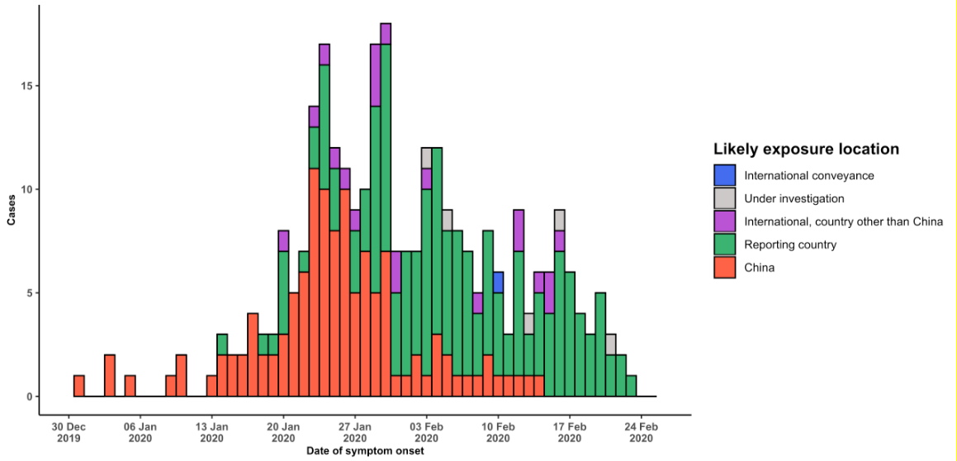

Note for figure 2: Of the 2459 cases reported outside China, 86 were detected while apparently asymptomatic. For the remaining 2373 cases, information on date of onset is available only for the 303 cases presented in the epidemiologic curve.

**Figure 3. Epidemic curve of COVID-19 cases (n=2459) identified outside of China, by date of report and likely exposure location, 25 February 2020**

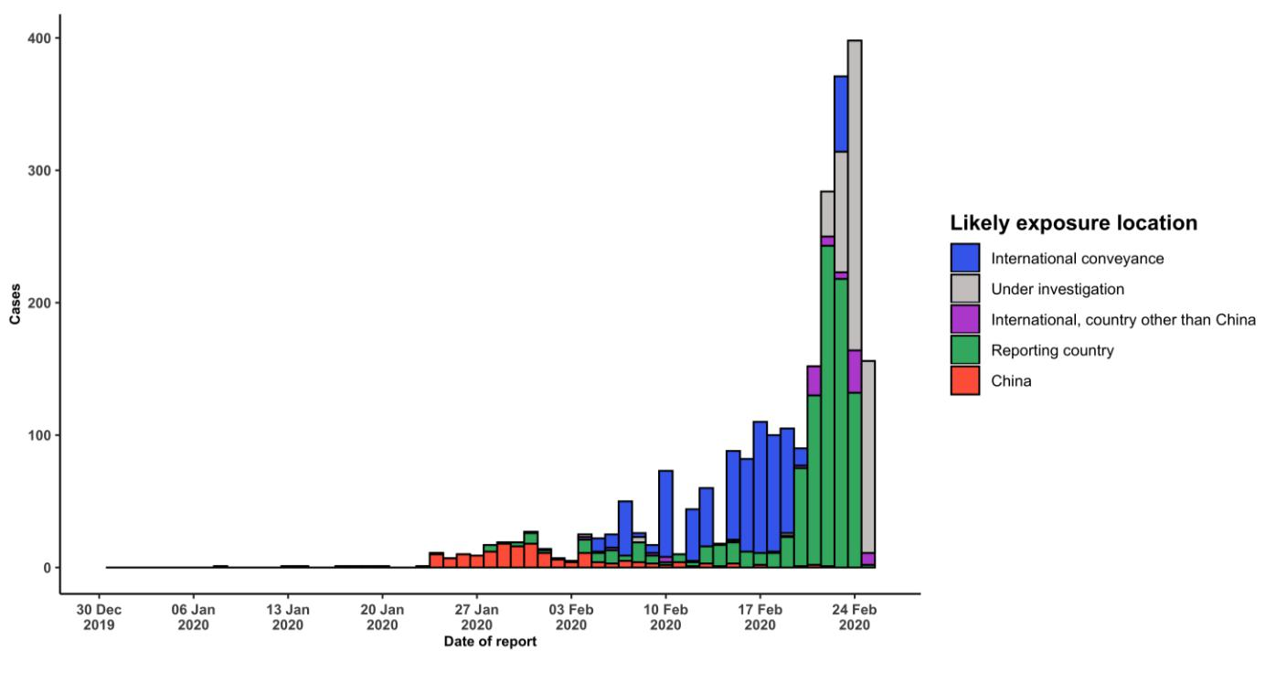

**STRATEGIC OBJECTIVES**

WHO’s strategic objectives for this response are to:

* Limit human-to-human transmission including reducing secondary infections among close contacts and health care workers, preventing transmission amplification events, and preventing further international spread from China*;
* Identify, isolate and care for patients early, including providing optimized care for infected patients;
* Identify and reduce transmission from the animal source;
* Address crucial unknowns regarding clinical severity, extent of transmission and infection, treatment options, and accelerate the development of diagnostics, therapeutics and vaccines;
* Communicate critical risk and event information to all communities and counter misinformation;
* Minimize social and economic impact through multisectoral partnerships.

*This can be achieved through a combination of public health measures, such as rapid identification, diagnosis and management of the cases, identification and follow up of the contacts, infection prevention and control in health care settings, implementation of health measures for travelers, awareness-raising in the population and risk communication.

**PREPAREDNESS AND RESPONSE**

* To view all technical guidance documents regarding COVID-19, please go to [this webpage.](https://www.who.int/emergencies/diseases/novel-coronavirus-2019/technical-guidance)
* WHO is working closely with International Air Transport Association (IATA) and have jointly developed a guidance document to provide advice to cabin crew and airport workers, based on country queries. The guidance can be found on the [IATA webpage.](https://www.iata.org/en/programs/safety/health/diseases/#tab-2)
* WHO has developed a protocol for the investigation of early cases (the “[First Few X (FFX) Cases and contact](https://www.who.int/publications-detail/the-first-few-x-(ffx)-cases-and-contact-investigation-protocol-for-2019-novel-coronavirus-(2019-ncov)-infection) [investigation protocol for 2019-novel coronavirus (2019-nCoV) infection](https://www.who.int/publications-detail/the-first-few-x-(ffx)-cases-and-contact-investigation-protocol-for-2019-novel-coronavirus-(2019-ncov)-infection)”). The protocol is designed to gain an early understanding of the key clinical, epidemiological and virological characteristics of the first cases of COVID-19 infection detected in any individual country, to inform the development and updating of public health guidance to manage cases and reduce potential spread and impact of infection.
* WHO has been in regular and direct contact with Member States where cases have been reported. WHO is also informing other countries about the situation and providing support as requested.
* WHO has developed interim guidance for [laboratory diagnosis,](https://www.who.int/emergencies/diseases/novel-coronavirus-2019/technical-guidance/laboratory-guidance) [advice on the use of masks during home care and](https://www.who.int/publications-detail/advice-on-the-use-of-masks-in-the-community-during-home-care-and-in-healthcare-settings-in-the-context-of-the-novel-coronavirus-(2019-ncov)-outbreak) [in health care settings in the context of the novel coronavirus (2019-nCoV) outbreak,](https://www.who.int/publications-detail/advice-on-the-use-of-masks-in-the-community-during-home-care-and-in-healthcare-settings-in-the-context-of-the-novel-coronavirus-(2019-ncov)-outbreak) [clinical management](https://www.who.int/publications-detail/clinical-management-of-severe-acute-respiratory-infection-when-novel-coronavirus-(ncov)-infection-is-suspected)[,](https://www.who.int/emergencies/diseases/novel-coronavirus-2019/technical-guidance/infection-prevention-and-control) [infection prevention and control in health care settings,](https://www.who.int/emergencies/diseases/novel-coronavirus-2019/technical-guidance/infection-prevention-and-control) [home care for patients with suspected novel](https://www.who.int/publications-detail/home-care-for-patients-with-suspected-novel-coronavirus-(ncov)-infection-presenting-with-mild-symptoms-and-management-of-contacts) [coronavirus,](https://www.who.int/publications-detail/home-care-for-patients-with-suspected-novel-coronavirus-(ncov)-infection-presenting-with-mild-symptoms-and-management-of-contacts) [risk communication and community engagement](https://www.who.int/publications-detail/risk-communication-and-community-engagement-readiness-and-initial-response-for-novel-coronaviruses-(-ncov)) and [Global Surveillance for human infection with](https://www.who.int/publications-detail/global-surveillance-for-human-infection-with-novel-coronavirus-(2019-ncov)) [novel coronavirus (2019-nCoV).](https://www.who.int/publications-detail/global-surveillance-for-human-infection-with-novel-coronavirus-(2019-ncov))
* WHO has prepared [disease commodity package](https://www.who.int/publications-detail/disease-commodity-package---novel-coronavirus-(ncov)) that includes an essential list of biomedical equipment, medicines and supplies necessary to care for patients with 2019-nCoV.
* WHO has provided recommendations to reduce risk of [transmission from animals to humans.](https://www.who.int/health-topics/coronavirus/who-recommendations-to-reduce-risk-of-transmission-of-emerging-pathogens-from-animals-to-humans-in-live-animal-markets)
* WHO has published an [updated advice for international traffic in relation to the outbreak of the novel](https://www.who.int/ith/2019-nCoV_advice_for_international_traffic/en/) [coronavirus 2019-nCoV.](https://www.who.int/ith/2019-nCoV_advice_for_international_traffic/en/)
* WHO has activated of R&D blueprint to accelerate diagnostics, vaccines, and therapeutics.
* WHO has developed online courses on the following topics: [A general introduction to emerging respiratory](https://openwho.org/courses/introduction-to-ncov) [viruses,](https://openwho.org/courses/introduction-to-ncov) including novel coronaviruses (available in [French,](https://openwho.org/courses/introduction-au-ncov) [Chinese,](https://openwho.org/courses/introduction-to-ncov-ZH) and [Spanish](https://openwho.org/courses/introduccion-al-ncov)); [Critical Care of Severe Acute](https://openwho.org/courses/severe-acuterespiratory-infection) [Respiratory Infections;](https://openwho.org/courses/severe-acuterespiratory-infection) and [Health and safety briefing for respiratory diseases - ePROTECT](https://openwho.org/courses/eprotect-acute-respiratory-infections)
* WHO is providing guidance on early investigations, which are critical to carry out early in an outbreak of a new virus. The data collected from the protocols can be used to refine recommendations for surveillance and case

definitions, to characterize the key epidemiological transmission features of COVID-19, help understand spread, severity, spectrum of disease, impact on the community and to inform operational models for implementation of countermeasures such as case isolation, contact tracing and isolation. Several protocols are available here: <https://www.who.int/emergencies/diseases/novel-coronavirus-2019/technical-guidance/early-investigations>

* WHO is working with its networks of researchers and other experts to coordinate global work on surveillance, epidemiology, modelling, diagnostics, clinical care and treatment, and other ways to identify, manage the disease and limit onward transmission. WHO has issued interim guidance for countries, which are updated regularly.
* WHO is working with global expert networks and partnerships for laboratory, infection prevention and control, clinical management and mathematical modelling.

**RECOMMENDATIONS AND ADVICE FOR THE PUBLIC**

If you are not in an area where COVID-19 is spreading, or if you have not travelled from one of those areas or have not been in close contact with someone who has and is feeling unwell, your chances of getting it are currently low. However, it’s understandable that you may feel stressed and anxious about the situation. It’s a good idea to get the facts to help you accurately determine your risks so that you can take reasonable precautions. (See [Frequently Asked](https://www.who.int/news-room/q-a-detail/q-a-coronaviruses) [Questions)](https://www.who.int/news-room/q-a-detail/q-a-coronaviruses) Your healthcare provider, your national public health authority and your employer are all potential sources of accurate information on COVID-19 and whether it is in your area. It is important to be informed of the situation where you live and take appropriate measures to protect yourself. (See Protection measures for everyone).

If you are in an area where there is an outbreak of COVID-19 you need to take the risk of infection seriously. Follow the advice issued by national and local health authorities. Although for most people COVID-19 causes only mild illness, it can make some people very ill. More rarely, the disease can be fatal. Older people, and those with pre-existing medical conditions (such as high blood pressure, heart problems or diabetes) appear to be more vulnerable. (See Protection measures for persons who are in or have recently visited (past 14 days) areas where COVID-19 is spreading).