**Coronavirus disease 2019 (COVID-19)**

**Situation Report – 41**

**Data as reported by 10AM CET 01 March 2020**

**HIGHLIGHTS**

* Five new Member States (Azerbaijan, Ecuador, Ireland, Monaco and Qatar) reported cases of COVID-19 in the past 24 hours.
* Working with clinicians is crucial to understanding the clinical presentation, natural history and treatment interventions for COVID-19. WHO has published interim clinical guidance, clinical training materials and has launched a global clinical data platform to gather data and improve care for COVID-19 patients. This information is critical to inform the public health response. More information can be found in the Subject in Focus.
* The number of confirmed cases in Hubei province, China, has increased for two successive days after a period of decline. WHO is monitoring the situation and working to understand its possible significance.
* WHO has published updated recommendations for international traffic in relation to COVID-19 outbreak. They can be found [here.](https://www.who.int/ith/2019-nCoV_advice_for_international_traffic-rev/en/)

**SITUATION IN NUMBERS**

**total and new cases in last 24 hours**

**Globally**

87 137 confirmed (1739 new)

**China**

79 968 confirmed (579 new)

2873 deaths (35 new)

**Outside of China**

7169 confirmed (1160 new)

58 countries (5 new)

104 deaths (18 new)

**WHO RISK ASSESSMENT**

China Very High

Regional Level Very High

Global Level Very High

**Figure 1. Countries, territories or areas with reported confirmed cases of COVID-19, 01 March 2020**

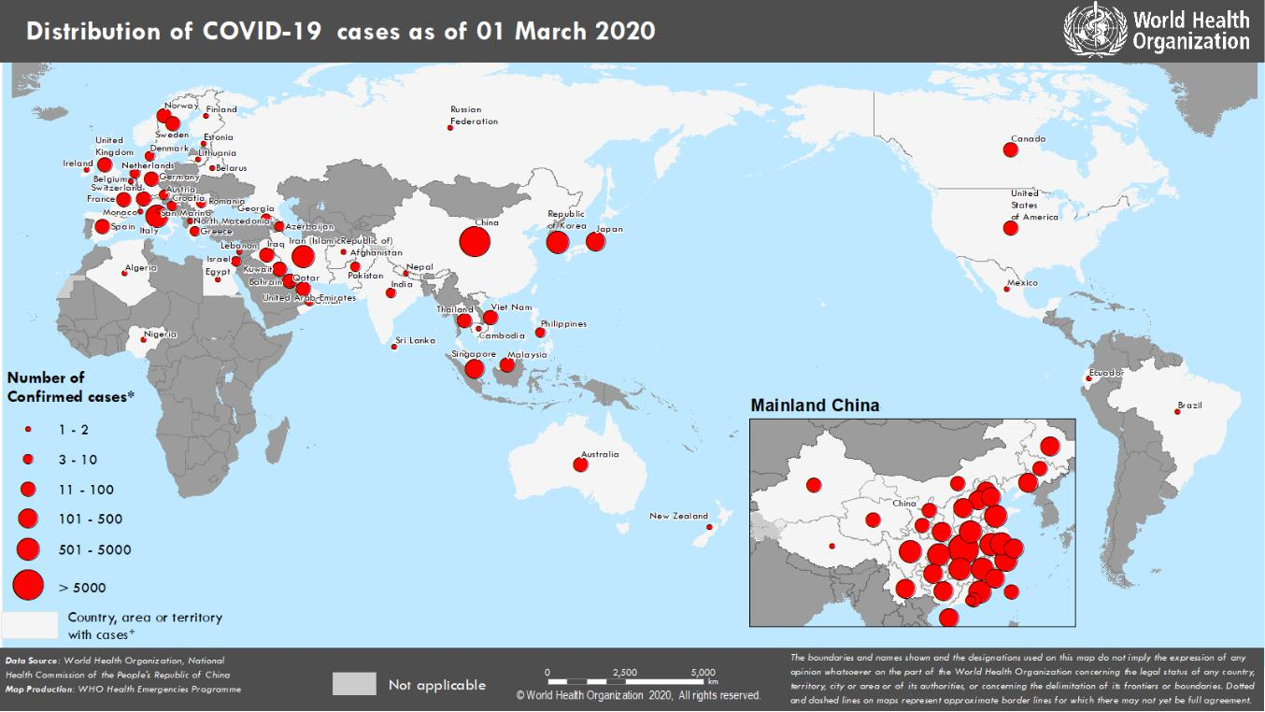

**SUBJECT IN FOCUS: CLINICAL MANAGEMENT OF PATIENTS WITH COVID-19**

WHO is working closely with clinicians caring for patients with COVID-19, in China and across the globe and international experts on infectious disease to better understand, in real time, the clinical presentation, natural history and treatment interventions for COVID-19.

A majority of patients with COVID-19 are adults. Among 44 672 patients in China with confirmed infection, 2.1% were below the age of 201. The most commonly reported symptoms included fever, dry cough, and shortness of breath, and most patients (80%) experienced mild illness. Approximately 14% experienced severe disease and 5% were critically ill. Early reports suggest that illness severity is associated with age (>60 years old) and co-morbid disease.

Clinical care of patients with COVID-19 focuses on early recognition, immediate isolation and implementation of appropriate infection prevention and control (IPC) measures; provision of symptomatic care for those with mild illness; and optimized supportive care for those with severe disease. WHO has published [patient management](https://www.who.int/emergencies/diseases/novel-coronavirus-2019/technical-guidance/patient-management) [guidance,](https://www.who.int/emergencies/diseases/novel-coronavirus-2019/technical-guidance/patient-management) including interim clinical care guidance for hospitalized patients and home care guidance for those with mild disease that may be treated at home in isolation when the health system is strained.

Oxygen therapy is the major treatment intervention for patients with severe COVID-19. All countries should work to optimize the availability of pulse oximeters and medical oxygen systems. Mortality in those with critical illness has been reported as over 50%, thus implementation of proven critical care interventions such as lung protective ventilation should be optimized. COVID-19 critical care clinical training materials are available on [https://openwho.org/courses/severe-acute-respiratory-infection.](https://openwho.org/courses/severe-acute-respiratory-infection) The first regional COVID-19 Clinical Case Management training was conducted in Brazzaville from 25-28 February 2020 with representatives from 18 countries of the WHO African region. WHO will continue to conduct such trainings to increase global knowledge on the management and care of patients with COVID-19.

WHO launched the [Global COVID-19 Clinical Data Platform](https://www.who.int/emergencies/diseases/novel-coronavirus-2019/technical-guidance/early-investigations) to aggregate and report on clinical severity to inform the public health response. Member States are encouraged to contribute by contacting [EDCARN@who.int](mailto:EDCARN@who.int) for log-in information.

As there is currently no known effective antiviral therapy for COVID-19, the WHO R&D Blueprint has prioritized investigational therapeutics and developed a [master randomized clinical trial protocol](https://www.who.int/blueprint/priority-diseases/key-action/multicenter-adaptive-RCT-of-investigational-therapeutics-for-COVID-19.pdf?ua=1) that can be used and adapted at the national level. There are many ongoing ethics-approved clinical trials evaluating a number of different therapeutic interventions globally including priority agents such as ritonavir/lopinavir and remdesivir.

1. Wu, Z. et al. Characteristics of and Important Lessons From the Coronavirus Disease 2019 (COVID-19) Outbreak in China; Summary of a Report of 72,314 Cases From the Chinese Center for Disease Control and Prevention. JAMA. Feb 24, 2020.

**SURVEILLANCE**

**Table 1. Confirmed and suspected cases of COVID-19 acute respiratory disease reported by provinces, regions and cities in China, Data as 01 March 2020**

|  |  |  |  |  |  |  |  |  |  |  |  |  |  |  |  |  |  |  |  |  |  |
| --- | --- | --- | --- | --- | --- | --- | --- | --- | --- | --- | --- | --- | --- | --- | --- | --- | --- | --- | --- | --- | --- |
|  | **Province/** |  |  | **Population** |  |  |  |  |  | **Daily** | |  |  |  |  | **Cumulative** | | | |  |  |
|  |  |  |  |  |  |  |  |  |  |  |  |  |  |  |  |  |  |  |  |
|  | **Region/** |  |  |  |  | **Confirmed** |  |  | **Suspected** |  |  |  |  |  | **Confirmed** |  |  |  |  |  |
|  |  |  | **(10,000s)** |  |  |  |  |  |  | **Deaths** |  |  |  |  | **Deaths** |  |  |
|  | **City** |  |  |  |  | **cases** |  |  | **cases** |  |  |  |  |  |  |  |  |
|  |  |  |  |  |  |  |  |  |  |  |  | **cases** |  |  |  |  |
|  |  |  |  |  |  |  |  |  |  |  |  |  |  |  |  |  |  |  |  |  |
|  |  |  |  |  |  |  |  |  |  |  |  |  |  |  |  |  |  |  |  |  |  |
|  | Hubei |  |  | 5917 |  |  | 570 |  |  | 64 |  |  | 34 |  |  | 66907 |  |  | 2761 |  |  |
|  | Guangdong | | 11346 | | | 0 | | | 1 | | | 0 | | | 1349 | | | 7 | | |  |
|  | Henan |  |  | 9605 |  |  | 0 |  |  | 0 |  |  | 1 |  |  | 1272 |  |  | 22 |  |  |
|  | Zhejiang | | 5737 | | | 0 | | | 0 | | | 0 | | | 1205 | | | 1 | | |  |
|  | Hunan |  |  | 6899 |  |  | 0 |  |  | 0 |  |  | 0 |  |  | 1018 |  |  | 4 |  |  |
|  | Anhui | | 6324 | | | 0 | | | 0 | | | 0 | | | 990 | | | 6 | | |  |
|  | Jiangxi |  |  | 4648 |  |  | 0 |  |  | 0 |  |  | 0 |  |  | 935 |  |  | 1 |  |  |
|  | Shandong | | 10047 | | | 0 | | | 0 | | | 0 | | | 756 | | | 6 | | |  |
|  | Jiangsu |  |  | 8051 |  |  | 0 |  |  | 0 |  |  | 0 |  |  | 631 |  |  | 0 |  |  |
|  | Chongqing | | 3102 | | | 0 | | | 6 | | | 0 | | | 576 | | | 6 | | |  |
|  | Sichuan |  |  | 8341 |  |  | 0 |  |  | 1 |  |  | 0 |  |  | 538 |  |  | 3 |  |  |
|  | Heilongjiang | | 3773 | | | 0 | | | 0 | | | 0 | | | 480 | | | 13 | | |  |
|  | Beijing |  |  | 2154 |  |  | 2 |  |  | 18 |  |  | 0 |  |  | 413 |  |  | 8 |  |  |
|  | Shanghai | | 2424 | | | 0 | | | 10 | | | 0 | | | 337 | | | 3 | | |  |
|  | Hebei |  |  | 7556 |  |  | 0 |  |  | 0 |  |  | 0 |  |  | 318 |  |  | 6 |  |  |
|  | Fujian | | 3941 | | | 0 | | | 0 | | | 0 | | | 296 | | | 1 | | |  |
|  | Guangxi |  |  | 4926 |  |  | 0 |  |  | 0 |  |  | 0 |  |  | 252 |  |  | 2 |  |  |
|  | Shaanxi | | 3864 | | | 0 | | | 0 | | | 0 | | | 245 | | | 1 | | |  |
|  | Yunnan |  |  | 4830 |  |  | 0 |  |  | 0 |  |  | 0 |  |  | 174 |  |  | 2 |  |  |
|  | Hainan | | 934 | | | 0 | | | 3 | | | 0 | | | 168 | | | 5 | | |  |
|  | Guizhou |  |  | 3600 |  |  | 0 |  |  | 0 |  |  | 0 |  |  | 146 |  |  | 2 |  |  |
|  | Tianjin | | 1560 | | | 0 | | | 11 | | | 0 | | | 136 | | | 3 | | |  |
|  | Shanxi |  |  | 3718 |  |  | 0 |  |  | 0 |  |  | 0 |  |  | 133 |  |  | 0 |  |  |
|  | Liaoning | | 4359 | | | 1 | | | 11 | | | 0 | | | 122 | | | 1 | | |  |
|  | Hong Kong SAR |  |  | 745 |  |  | 1 |  |  | 0 |  |  | 0 |  |  | 95 |  |  | 2 |  |  |
|  | Jilin | | 2704 | | | 0 | | | 6 | | | 0 | | | 93 | | | 1 | | |  |
|  | Gansu |  |  | 2637 |  |  | 0 |  |  | 0 |  |  | 0 |  |  | 91 |  |  | 2 |  |  |
|  | Xinjiang | | 2487 | | | 0 | | | 0 | | | 0 | | | 76 | | | 3 | | |  |
|  | Inner Mongolia |  |  | 2534 |  |  | 0 |  |  | 0 |  |  | 0 |  |  | 75 |  |  | 0 |  |  |
|  | Ningxia | | 688 | | | 0 | | | 1 | | | 0 | | | 73 | | | 0 | | |  |
|  | Taipei and environs |  |  | 2359 |  |  | 5 |  |  | 0 |  |  | 0 |  |  | 39 |  |  | 1 |  |  |
|  | Qinghai | | 603 | | | 0 | | | 0 | | | 0 | | | 18 | | | 0 | | |  |
|  | Macao SAR |  |  | 66 |  |  | 0 |  |  | 0 |  |  | 0 |  |  | 10 |  |  | 0 |  |  |
|  | Xizang | | 344 | | | 0 | | | 0 | | | 0 | | | 1 | | | 0 | | |  |
|  | **Total** |  |  | **142823** |  |  | **579** |  |  | **132** |  |  | **35** |  |  | **79968** |  |  | **2873** |  |  |
|  |  |  |  |  |  |  |  |  |  |  |  |  |  |  |  |  |  |  |  |  |  |

**Table 2. Countries, territories or areas outside China with reported laboratory-confirmed COVID-19 cases and deaths. Data as of 01 March 2020**

|  |  |  |  |  |  |  |  |  |  |  |  |  |  |  |  |  |  |
| --- | --- | --- | --- | --- | --- | --- | --- | --- | --- | --- | --- | --- | --- | --- | --- | --- | --- |
|  | **Country** |  |  | **Total confirmed\*** | | |  |  | **Total deaths** |  |  | **Transmission** |  |  | **Days since last** |  |  |
|  |  |  | **cases (new)** | | |  |  | **(new)** |  |  | **classification†** |  |  | **reported case** |  |  |
|  |  |  |  |  |  |  |  |  |  |  |  |
|  | **Western Pacific Region** | |  |  |  |  |  |  |  |  |  |  |  |  |  |  |  |
|  | Republic of Korea | | 3736 | | | (586) |  | 18 (1) | |  |  | Local transmission | | 0 | |  |  |
|  | Japan | | 239 (9) | | | |  | 5 (0) | |  |  | Local transmission | | 0 | |  |  |
|  | Singapore | | 102 (4) | | | |  | 0 (0) | |  |  | Local transmission | | 0 | |  |  |
|  | Australia | | 25 | | | (1) |  | 0 (0) | |  |  | Local transmission | | 0 | |  |  |
|  | Malaysia | | 24 | | | (0) |  | 0 (0) | |  |  | Local transmission | | 2 | |  |  |
|  | Viet Nam | | 16 | | | (0) |  | 0 (0) | |  |  | Local transmission | | 17 | |  |  |
|  | Philippines | | 3 | | (0) | |  | 1 (0) | |  |  | Imported cases only | | 26 | |  |  |
|  | Cambodia | | 1 | | (0) | |  | 0 (0) | |  |  | Imported cases only | | 34 | |  |  |
|  | New Zealand | | 1 | | (0) | |  | 0 (0) | |  |  | Imported cases only | | 2 | |  |  |
|  | **European Region** | |  |  |  |  |  |  |  |  |  |  |  |  |  |  |  |
|  | Italy | | 1128 | | | (240) |  | 29 (8) | |  |  | Local transmission | | 0 | |  |  |
|  | France | | 100 | | | (43) |  | 2 (0) | |  |  | Local transmission | | 0 | |  |  |
|  | Germany | | 57 | | | (0) |  | 0 (0) | |  |  | Local transmission | | 1 | |  |  |
|  | Spain | | 45 | | (13) | |  | 0 (0) | |  |  | Local transmission | | 0 | |  |  |
|  | The United Kingdom | | 23 | | | (3) |  | 0 (0) | |  |  | Local transmission | | 0 | |  |  |
|  | Switzerland | | 18 | | | (8) |  | 0 (0) | |  |  | Imported cases only | | 0 | |  |  |
|  | Norway | | 15 | | | (9) |  | 0 (0) | |  |  | Local transmission | | 0 | |  |  |
|  | Sweden | | 13 | | | (1) |  | 0 (0) | |  |  | Imported cases only | | 0 | |  |  |
|  | Austria | | 10 | | | (5) |  | 0 (0) | |  |  | Imported cases only | | 0 | |  |  |
|  | Croatia | | 7 | | (2) | |  | 0 (0) | |  |  | Local transmission | | 0 | |  |  |
|  | Israel | | 7 | | (2) | |  | 0 (0) | |  |  | Imported cases only | | 0 | |  |  |
|  | Netherlands | | 7 | | (5) | |  | 0 (0) | |  |  | Local transmission | | 0 | |  |  |
|  | Azerbaijan | | 3 | | (3) | |  | 0 (0) | |  |  | Imported cases only | | 0 | |  |  |
|  | Denmark | | 3 | | (1) | |  | 0 (0) | |  |  | Imported cases only | | 0 | |  |  |
|  | Georgia | | 3 | | (1) | |  | 0 (0) | |  |  | Imported cases only | | 0 | |  |  |
|  | Greece | | 3 | | (0) | |  | 0 (0) | |  |  | Imported cases only | | 2 | |  |  |
|  | Romania | | 3 | | (0) | |  | 0 (0) | |  |  | Imported cases only | | 1 | |  |  |
|  | Finland | | 2 | | (0) | |  | 0 (0) | |  |  | Imported cases only | | 4 | |  |  |
|  | Russian Federation | | 2 | | (0) | |  | 0 (0) | |  |  | Imported cases only | | 30 | |  |  |
|  | Belarus | | 1 | | (0) | |  | 0 (0) | |  |  | Imported cases only | | 2 | |  |  |
|  | Belgium | | 1 | | (0) | |  | 0 (0) | |  |  | Imported cases only | | 26 | |  |  |
|  | Estonia | | 1 | | (0) | |  | 0 (0) | |  |  | Imported cases only | | 3 | |  |  |
|  | Ireland | | 1 | | (1) | |  | 0 (0) | |  |  | Imported cases only | | 0 | |  |  |
|  | Lithuania | | 1 | | (0) | |  | 0 (0) | |  |  | Imported cases only | | 2 | |  |  |
|  | Monaco | | 1 | | (1) | |  | 0 (0) | |  |  | Under investigation | | 0 | |  |  |
|  | North Macedonia | | 1 | | (0) | |  | 0 (0) | |  |  | Imported cases only | | 4 | |  |  |
|  | San Marino | | 1 | | (0) | |  | 0 (0) | |  |  | Local transmission | | 1 | |  |  |
|  | **South-East Asia Region** | |  |  |  |  |  |  |  |  |  |  |  |  |  |  |  |
|  | Thailand | | 42 | | | (0) |  | 0 (0) | |  |  | Local transmission | | 1 | |  |  |
|  | India | | 3 | | (0) | |  | 0 (0) | |  |  | Imported cases only | | 27 | |  |  |
|  | Nepal | | 1 | | (0) | |  | 0 (0) | |  |  | Imported cases only | | 48 | |  |  |
|  | Sri Lanka | | 1 | | (0) | |  | 0 (0) | |  |  | Imported cases only | | 34 | |  |  |
|  | **Eastern Mediterranean Region** | | | |  |  |  |  |  |  |  |  |  |  |  |  |  |
|  | Iran (Islamic Republic of) | | 593 | | (205) | |  | 43 (9) | |  |  | Local transmission | | 0 | |  |  |
|  | Kuwait | | 45 | | | (0) |  | 0 (0) | |  |  | Imported cases only | | 1 | |  |  |
|  | Bahrain | | 40 | | | (2) |  | 0 (0) | |  |  | Imported cases only | | 0 | |  |  |
|  | United Arab Emirates | | 19 | | | (0) |  | 0 (0) | |  |  | Local transmission | | 1 | |  |  |
|  | Iraq | | 13 | | | (5) |  | 0 (0) | |  |  | Imported cases only | | 0 | |  |  |

|  |  |  |  |  |  |  |  |  |  |  |  |  |
| --- | --- | --- | --- | --- | --- | --- | --- | --- | --- | --- | --- | --- |
|  | Oman | 6 | (0) |  | 0 | (0) |  |  | Imported cases only | 2 |  |  |
|  | Pakistan | 4 | (2) |  | 0 | (0) |  |  | Imported cases only | 0 |  |  |
|  | Lebanon | 2 | (0) |  | 0 | (0) |  |  | Imported cases only | 4 |  |  |
|  | Afghanistan | 1 | (0) |  | 0 | (0) |  |  | Imported cases only | 6 |  |  |
|  | Egypt | 1 | (0) |  | 0 | (0) |  |  | Imported cases only | 16 |  |  |
|  | Qatar | 1 | (1) |  | 0 | (0) |  |  | Imported cases only | 0 |  |  |
|  | **Region of the Americas** |  |  |  |  |  |  |  |  |  |  |  |
|  | United States of America | 62 (0) | |  | 0 | (0) |  |  | Local transmission | 1 |  |  |
|  | Canada | 19 (5) | |  | 0 | (0) |  |  | Local transmission | 0 |  |  |
|  | Brazil | 2 | (1) |  | 0 | (0) |  |  | Imported cases only | 0 |  |  |
|  | Mexico | 2 | (0) |  | 0 | (0) |  |  | Imported cases only | 1 |  |  |
|  | Ecuador | 1 | (1) |  | 0 | (0) |  |  | Imported cases only | 0 |  |  |
|  | **African Region** |  |  |  |  |  |  |  |  |  |  |  |
|  | Algeria | 1 | (0) |  | 0 | (0) |  |  | Imported cases only | 5 |  |  |
|  | Nigeria | 1 | (0) |  | 0 | (0) |  |  | Imported cases only | 2 |  |  |
|  | **Subtotal for all regions** | **6464** | **(1160)** |  | **98** | **(18)** |  |  |  |  |  |  |
|  | International conveyance | 705 (0) | |  | 6 | (0) |  |  | Local transmission | 4 |  |  |
|  | (Diamond Princess) ‡ |  |  |  |  |  |
|  |  |  |  |  |  |  |  |  |  |  |  |
|  | **Grand total§** | **7169** | **(1160)** |  | **104 (18)** | |  |  |  |  |  |  |

*Case classifications are based on [WHO case definitions](https://www.who.int/publications-detail/global-surveillance-for-human-infection-with-novel-coronavirus-(2019-ncov)) for COVID-19.

**†**Transmission classification is based on WHO analysis of available official data and may be subject to reclassification as additional data become available. Countries/territories/areas experiencing multiple types of transmission are classified in the highest category for which there is evidence; they may be removed from a given category if interruption of transmission can be demonstrated. It should be noted that even within categories, different countries/territories/areas may have differing degrees of transmission as indicated by the differing numbers of cases and other factors. Not all locations within a given country/territory/area are equally affected. Terms:

* **Community transmission** is evidenced by the inability to relate confirmed cases through chains of transmission for a large number of cases, or byincreasing positive tests through routine screening of sentinel samples.
* **Local transmission** indicates locations where the source of infection is within the reporting location.
* **Imported cases only** indicates locations where all cases have been acquired outside the location of reporting.

-

-

**Under investigation** indicates locations where type of transmission has not been determined for any cases.

**Interrupted transmission** indicates locations where interruption of transmission has been demonstrated (details to be determined)

‡Cases identified on a cruise ship currently in Japanese territorial waters.

§278 female/393 male/6498 unknown. 31 healthcare workers (7 female/12 male/ 12 unknown).

**Figure 2. Epidemic curve of confirmed COVID-19 cases (n=6567) reported outside of China, by date of report and WHO region with complete days of reporting through 29 February 2020**

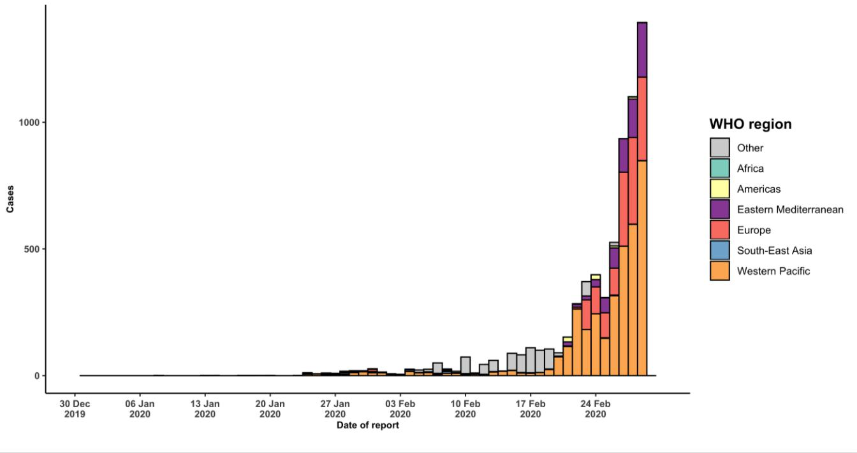

**STRATEGIC OBJECTIVES**

WHO’s strategic objectives for this response are to:

* Interrupt human-to-human transmission including reducing secondary infections among close contacts and health care workers, preventing transmission amplification events, and preventing further international spread*;
* Identify, isolate and care for patients early, including providing optimized care for infected patients;
* Identify and reduce transmission from the animal source;
* Address crucial unknowns regarding clinical severity, extent of transmission and infection, treatment options, and accelerate the development of diagnostics, therapeutics and vaccines;
* Communicate critical risk and event information to all communities and counter misinformation;
* Minimize social and economic impact through multisectoral partnerships.

*This can be achieved through a combination of public health measures, such as rapid identification, diagnosis and management of the cases, identification and follow up of the contacts, infection prevention and control in health care settings, implementation of health measures for travelers, awareness-raising in the population and risk communication.

**PREPAREDNESS AND RESPONSE**

* To view all technical guidance documents regarding COVID-19, please go to [this webpage.](https://www.who.int/emergencies/diseases/novel-coronavirus-2019/technical-guidance)
* WHO is working closely with International Air Transport Association (IATA) and have jointly developed a guidance document to provide advice to cabin crew and airport workers, based on country queries. The guidance can be found on the [IATA webpage.](https://www.iata.org/en/programs/safety/health/diseases/#tab-2)
* WHO has been in regular and direct contact with Member States where cases have been reported. WHO is also informing other countries about the situation and providing support as requested.
* WHO has developed interim guidance for [laboratory diagnosis,](https://www.who.int/emergencies/diseases/novel-coronavirus-2019/technical-guidance/laboratory-guidance) [advice on the use of masks during home care and](https://www.who.int/publications-detail/advice-on-the-use-of-masks-in-the-community-during-home-care-and-in-healthcare-settings-in-the-context-of-the-novel-coronavirus-(2019-ncov)-outbreak) [in health care settings in the context of the novel coronavirus (2019-nCoV) outbreak,](https://www.who.int/publications-detail/advice-on-the-use-of-masks-in-the-community-during-home-care-and-in-healthcare-settings-in-the-context-of-the-novel-coronavirus-(2019-ncov)-outbreak) [clinical management](https://www.who.int/publications-detail/clinical-management-of-severe-acute-respiratory-infection-when-novel-coronavirus-(ncov)-infection-is-suspected)[,](https://www.who.int/emergencies/diseases/novel-coronavirus-2019/technical-guidance/infection-prevention-and-control) [infection prevention and control in health care settings,](https://www.who.int/emergencies/diseases/novel-coronavirus-2019/technical-guidance/infection-prevention-and-control) [home care for patients with suspected novel](https://www.who.int/publications-detail/home-care-for-patients-with-suspected-novel-coronavirus-(ncov)-infection-presenting-with-mild-symptoms-and-management-of-contacts) [coronavirus,](https://www.who.int/publications-detail/home-care-for-patients-with-suspected-novel-coronavirus-(ncov)-infection-presenting-with-mild-symptoms-and-management-of-contacts) [risk communication and community engagement](https://www.who.int/publications-detail/risk-communication-and-community-engagement-readiness-and-initial-response-for-novel-coronaviruses-(-ncov)) and [Global Surveillance for human infection with](https://www.who.int/publications-detail/global-surveillance-for-human-infection-with-novel-coronavirus-(2019-ncov)) [novel coronavirus (2019-nCoV).](https://www.who.int/publications-detail/global-surveillance-for-human-infection-with-novel-coronavirus-(2019-ncov))
* WHO is working with its networks of researchers and other experts to coordinate global work on surveillance, epidemiology, mathematical modelling, diagnostics and virology, clinical care and treatment, infection prevention and control, and risk communication. WHO has issued interim guidance for countries, which are updated regularly.
* WHO has prepared a [disease commodity package](https://www.who.int/publications-detail/disease-commodity-package---novel-coronavirus-(ncov)) that includes an essential list of biomedical equipment, medicines and supplies necessary to care for patients with 2019-nCoV.
* WHO has provided recommendations to reduce risk of [transmission from animals to humans.](https://www.who.int/health-topics/coronavirus/who-recommendations-to-reduce-risk-of-transmission-of-emerging-pathogens-from-animals-to-humans-in-live-animal-markets)
* WHO has published an [updated advice for international traffic in relation to the outbreak of the novel](https://www.who.int/ith/2019-nCoV_advice_for_international_traffic-rev/en/) [coronavirus 2019-nCoV.](https://www.who.int/ith/2019-nCoV_advice_for_international_traffic-rev/en/)
* WHO has activated the R&D blueprint to accelerate diagnostics, vaccines, and therapeutics.
* WHO has developed online courses on the following topics: [A general introduction to emerging respiratory](https://openwho.org/courses/introduction-to-ncov) [viruses,](https://openwho.org/courses/introduction-to-ncov) including novel coronaviruses (available in [French,](https://openwho.org/courses/introduction-au-ncov) [Chinese,](https://openwho.org/courses/introduction-to-ncov-ZH) [Spanish,](https://openwho.org/courses/introduccion-al-ncov) and [Portuguese](https://openwho.org/courses/introducao-ao-ncov)); [Critical Care of](https://openwho.org/courses/severe-acuterespiratory-infection) [Severe Acute Respiratory Infections;](https://openwho.org/courses/severe-acuterespiratory-infection) and [Health and safety briefing for respiratory diseases - ePROTECT](https://openwho.org/courses/eprotect-acute-respiratory-infections) (available in [French](https://openwho.org/courses/eprotect-infections-respiratoires-aigues)); [Infection Prevention and Control for Novel Coronavirus (COVID-19);](https://openwho.org/courses/COVID-19-IPC-EN) [Critical Care Severe](https://openwho.org/courses/severe-acute-respiratory-infection) [Acute Respiratory Infection](https://openwho.org/courses/severe-acute-respiratory-infection)

* WHO is providing guidance on early investigations, which are critical to carry out early in an outbreak of a new virus. The data collected from the protocols can be used to refine recommendations for surveillance and case definitions, to characterize the key epidemiological transmission features of COVID-19, help understand spread, severity, spectrum of disease, impact on the community and to inform operational models for implementation of countermeasures such as case isolation, contact tracing and isolation. Several protocols are available here: <https://www.who.int/emergencies/diseases/novel-coronavirus-2019/technical-guidance/early-investigations> One such protocol is for the investigation of early COVID-19 cases and contacts (the “[First Few X (FFX) Cases and](https://www.who.int/publications-detail/the-first-few-x-(ffx)-cases-and-contact-investigation-protocol-for-2019-novel-coronavirus-(2019-ncov)-infection) [contact investigation protocol for 2019-novel coronavirus (2019-nCoV) infection](https://www.who.int/publications-detail/the-first-few-x-(ffx)-cases-and-contact-investigation-protocol-for-2019-novel-coronavirus-(2019-ncov)-infection)”). The protocol is designed to gain an early understanding of the key clinical, epidemiological and virological characteristics of the first cases of COVID-19 infection detected in any individual country, to inform the development and updating of public health guidance to manage cases and reduce the potential spread and impact of infection.

**RECOMMENDATIONS AND ADVICE FOR THE PUBLIC**

If you are not in an area where COVID-19 is spreading, or have not travelled from an area where COVID-19 is spreading, or have not been in contact with an infected patient, your risk of infection is low. It is understandable that you may feel anxious about the outbreak. It’s a good idea to get the facts from reliable sources to help you accurately determine your risks so that you can take reasonable precautions (See [Frequently Asked Questions)](https://www.who.int/news-room/q-a-detail/q-a-coronaviruses). Seek guidance from WHO, your healthcare provider, your national public health authority or your employer for accurate information on COVID-19 and whether COVID-19 is circulating where you live. It is important to be informed of the situation and take appropriate measures to protect yourself and your family (see Protection measures for everyone).

If you are in an area where there are cases of COVID-19 you need to take the risk of infection seriously. Follow the advice of WHO and guidance issued by national and local health authorities. For most people, COVID-19 infection will cause mild illness however, it can make some people very ill and, in some people, it can be fatal. Older people, and those with pre-existing medical conditions (such as cardiovascular disease, chronic respiratory disease or diabetes) are at risk for severe disease (See Protection measures for persons who are in or have recently visited (past 14 days) areas where COVID-19 is spreading).