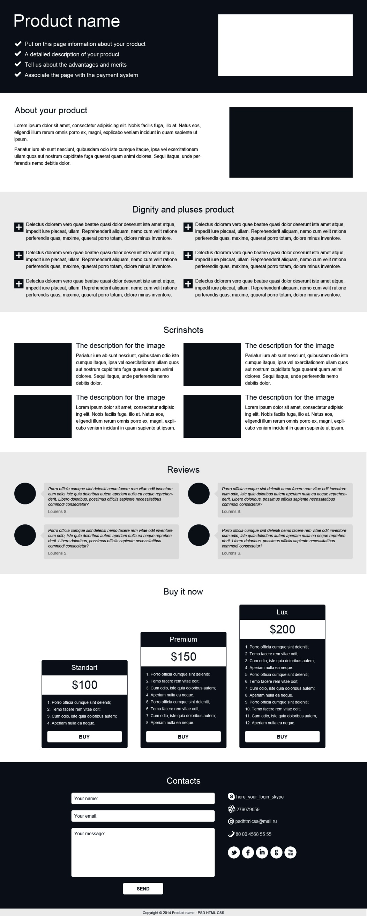<html> <h1>

<head> <ul> + li\*4

<body> <figure>

<header>

<main>

<article class="a">>

<h2> <p> <figure>

<section

class="plus">

<ul> <p>

<h2>

<section

class="screen">

<h3> <h2>

<figure> + <img> <p>

<article class="b"> <img>

<h2> <p>

<aside> <h2>

<div class="stand"> <button>

<div class="prem"> <ol>

<div class="lux"> <h3>

<footer> <h2>

<form> <textarea>

<input> <p>

<button> <img>