2012 AUDI A7

Начало формы

Конец формы

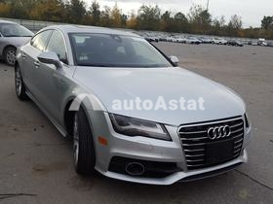

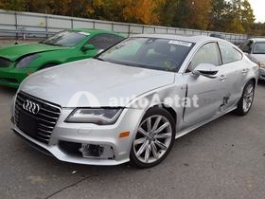

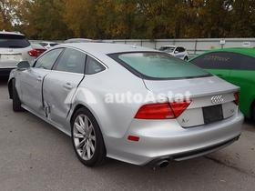

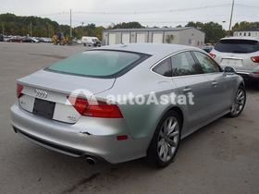

BID

<https://autoastat.com/en/vehicle/WAUSGAFC7CN009679-16271934>

FINAL BID:

$8 600 USDAUCTION

41% of retail value $22 411 USD

[Price with fee](https://autoastat.com/en/vehicle/WAUSGAFC7CN009679-16271934#fee-pricing-modal)

Lot #:

51752800

VIN:

WAUSGAFC7CN009679

Date:

06/01/2021

Seller:

INSURANCE Insurance Company

Location:

North Billerica

Retail value:

$22 411 USD

Repair value:

$17 729 USD

 PHOTOS

Buy VIN report and learn more about your car

Best VIN reports available at special prices to our users.

VEHICLE

Odometer, mi.:

93500 A

Engine:

3.0L

Fuel:

Gasoline

Drive line:

All-wheel drive

Transmission:

Automatic

Color:

Silver

Trim:

Prestig

ACCIDENT

Loss:

Collision

Damage:

Frame damage, Side

Run and Drive:

Yes

Starts:

Car starts

Keys:

Yes

AUCTION

Date:

06/01/2021

Location:

North Billerica

Buyer country:

 Ukraine

SaleDoc:

MA - Cert of title-salvage

Who can bid:

All

Sale status:

Min bid

Min bid met:

No

<https://autoastat.com/en/vehicle/5NPE24AFXGH365129-15193111>

2016 HYUNDAI SONATA

Начало формы

Конец формы

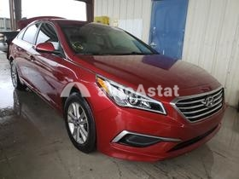

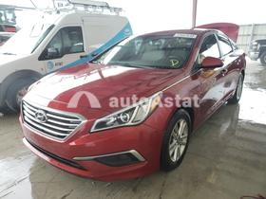

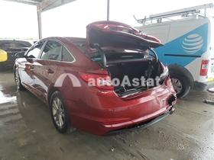

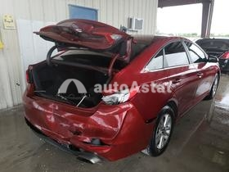

BID

FINAL BID:

$3 550 USDAUCTION

40% of retail value $10 173 USD

[Price with fee](https://autoastat.com/en/vehicle/5NPE24AFXGH365129-15193111#fee-pricing-modal)

Lot #:

52852630

VIN:

5NPE24AFXGH365129

Date:

11/11/2020

Seller:

INSURANCE State Farm Insurance

Location:

Homestead

Retail value:

$10 173 USD

Repair value:

$11 074 USD

 PHOTOS

Buy VIN report and learn more about your car

Best VIN reports available at special prices to our users.

VEHICLE

Odometer, mi.:

60939 A

Engine:

2.4L

Fuel:

Gasoline

Drive line:

Front wheel drive

Transmission:

Automatic

Color:

Red

Trim:

Se

ACCIDENT

Loss:

Collision

Damage:

Rear end

Run and Drive:

Yes

Starts:

Car starts

Keys:

Yes

AUCTION

Date:

11/11/2020

Location:

Homestead

Buyer country:

 Canada

SaleDoc:

FL - Certificate of Destruction

Who can bid:

All

Sale status:

Min bid

Min bid met:

No

<https://autoastat.com/en/vehicle/1HGCR2F80FA086992-15799075>

2015 HONDA ACCORD

Начало формы

Конец формы

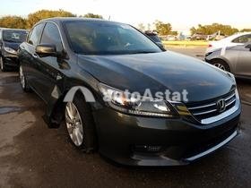

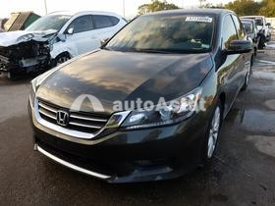

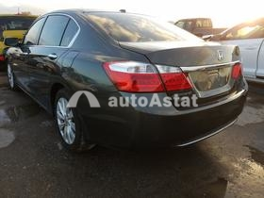

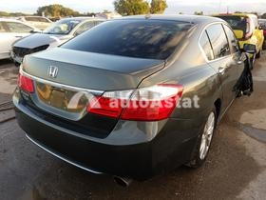

BID

FINAL BID:

$4 650 USDAUCTION

39% of retail value $13 443 USD

[Price with fee](https://autoastat.com/en/vehicle/1HGCR2F80FA086992-15799075#fee-pricing-modal)

Lot #:

57134090

VIN:

1HGCR2F80FA086992

Date:

11/12/2020

Seller:

INSURANCE State Farm Insurance

Location:

Riverview

Retail value:

$13 443 USD

Repair value:

$10 044 USD

 PHOTOS

Buy VIN report and learn more about your car

Best VIN reports available at special prices to our users.

VEHICLE

Odometer, mi.:

70328 A

Engine:

2.4L

Fuel:

Gasoline

Drive line:

Front wheel drive

Transmission:

Automatic

Color:

Gray

Trim:

Exl

ACCIDENT

Loss:

Collision

Damage:

Side, Undercarriage

Run and Drive:

No

Starts:

Car starts

Keys:

Yes

AUCTION

Date:

11/12/2020

Location:

Riverview

Buyer country:

 Canada

SaleDoc:

FL - Cert of title slvg rebuildable

Who can bid:

All

Sale status:

Min bid

Min bid met:

Yes