**中国科学技术大学计算机学院**

**《计算机组成原理实验》报告**



实验题目：____多周期CPU_____

学生姓名：_______李昱祁______

学生学号：_____PB18071496____

完成日期：_____2020/05/25____

计算机实验教学中心制

2019年09月

【实验目的】

1.理解计算机硬件的基本组成、结构和工作原理；

2.掌握数字系统的设计和调试方法；

3.熟练掌握数据通路和控制器的设计和描述方法。

【实验环境】

1. Vivado
2. PC一台
3. Linux操作系统

【实验过程】

1. 多周期 CPU 设计
2. ***逻辑设计：***

多周期 CPU 在单周期的基础上改进而成，主要根据不同的指令，设计了不同的状态来完成。控制状态图如下：

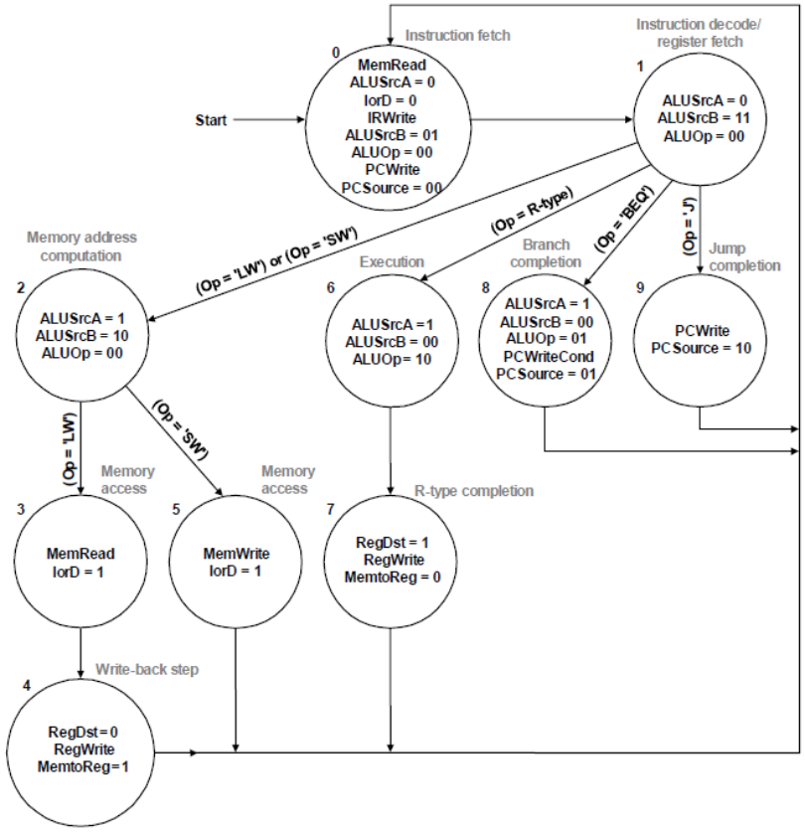

此外，为了实现addi 指令，我们还要额外设计其状态转换如下：

IF -> ID -> MAC -> AIC

其中 MAC 阶段（实际上是 lw/sw的“Memory address computation”状态）可以实现寄存器内容与立即数相加，符合 addi 指令的要求；新设一个上图中不存在的状态“AIC”，完成数据写回寄存器堆的操作。

本次实验中，指令与数据放在同一个存储器中，因此在该存储器的“读地址”端口需要加入选择器以确定我们读的是指令段还是数据段内容；并且，PC 的自增需要通过主 ALU 来完成，所以 ALU 的第一个操作数来源也要通过选择器来判断。

1. ***核心代码：***

（其中 isIF，done 信号和 pc_out 信号用于仿真检查，分别表示当前状态是否为取指令、最终存储器0x08地址的值、以及指令指针 pc 的值）

`timescale 1ns / 1ps

module *cpu_multi_cycle*( //多周期CPU

input clk,

input rst,

output isIF,

output [31:0] done,

output [31:0] pc_out

);

// 状态机信号

localparam IF = 4'b0000,

ID = 4'b0001,

MAC = 4'b0010,

MAL = 4'b0011,

WB = 4'b0100,

MAS = 4'b0101,

EX = 4'b0110,

RC = 4'b0111,

BC = 4'b1000,

JC = 4'b1001,

AIC = 4'b1010;

//指令

localparam ADD = 6'b000000,

ADDI = 6'b001000,

LW = 6'b100011,

SW = 6'b101011,

BEQ = 6'b000100,

J = 6'b000010;

//内部信号

reg PCwe,IorD,MemRead,MemWrite,MemtoReg,IRWrite,ALUSrcA,RegWrite,RegDst;

reg [1:0] PCSource,ALUSrcB;

reg [2:0] alu_m;

reg [3:0] state,next_state;

reg [32:0] pc,mdr,a,b,alu_out,instr;

wire zf;

wire [31:0] pc_in,pc_jump,MemData;

wire [31:0] rd1,rd2;

wire [31:0] alu_result;

wire [31:0] mem_addr;

wire [31:0] wd_rf;

wire [31:0] alu_a,alu_b;

wire [4:0] wa_rf;

wire [31:0] signed_extend_imm,s_e_shift_imm;

dist_mem_gen_0 ram(

.a(mem_addr[10:2]),

.d(b),

.clk(clk),

.we(MemWrite),

.spo(MemData),

.dpra(2),

.dpo(done)

);

register_file rf(

.clk(clk),

.rst(rst),

.we(RegWrite),

.ra1(instr[25:21]),

.ra2(instr[20:16]),

.wa(wa_rf),

.wd(wd_rf),

.rd1(rd1),

.rd2(rd2)

);

alu ALU(

.a(alu_a),

.b(alu_b),

.m(alu_m),

.y(alu_result),

.zf(zf)

);

assign isIF = (state == IF);

assign mem_addr = IorD ? alu_out : pc;

assign wa_rf = RegDst ? instr[15:11] : instr[20:16];

assign wd_rf = MemtoReg ? mdr : alu_out;

assign alu_a = ALUSrcA ? a : pc;

assign alu_b = ALUSrcB[1] ?

(ALUSrcB[0] ? s_e_shift_imm : signed_extend_imm) : (ALUSrcB[0] ? 4 :b );

assign pc_in = PCSource[1] ?

(PCSource[0] ? 0 : pc_jump) : (PCSource[0] ? alu_out : alu_result);

assign pc_out = pc;

assign signed_extend_imm = instr[15] ? {{16{1'b1}},instr[15:0]} : {{16{1'b0}},instr[15:0]};

assign s_e_shift_imm = {signed_extend_imm[29:0],2'b00};

assign pc_jump = {pc[31:28],instr[25:0],2'b00};

always@(posedge clk,posedge rst)

begin

if(rst)

begin

pc = 0;

instr = 0;

mdr = 0;

a = 0;

b = 0;

alu_out = 0;

end

else

begin

if(PCwe)

pc = pc_in;

if(IRWrite)

instr = MemData;

mdr = MemData;

a = rd1;

b = rd2;

alu_out = alu_result;

end

end

always@(posedge clk,posedge rst)

begin

if(rst)

begin

state = IF;

end

else

begin

state = next_state;

end

end

//next_state logic

always@(*)

begin

case(state)

IF: next_state = ID;

ID:

begin

case(instr[31:26])

ADD:next_state = EX;

ADDI:next_state = MAC;

LW:next_state = MAC;

SW:next_state = MAC;

BEQ:next_state =BC;

J:next_state = JC;

default:next_state = IF;

endcase

end

MAC:

begin

case(instr[31:26])

ADDI:next_state = AIC;

LW:next_state = MAL;

SW:next_state = MAS;

default:next_state = IF;

endcase

end

MAL:next_state = WB;

WB:next_state = IF;

MAS:next_state = IF;

EX:next_state = RC;

RC:next_state = IF;

BC:next_state = IF;

JC:next_state = IF;

AIC:next_state = IF;

default:next_state = IF;

endcase

end

//output logic

always@(*)

begin

ALUSrcA = 0;

ALUSrcB = 2'b00;

alu_m = 3'b000;

MemRead = 0;

IorD = 0;

IRWrite = 0;

MemWrite = 0;

MemtoReg = 0;

RegWrite = 0;

RegDst = 0;

PCwe = 0;

PCSource = 2'b00;

case(state)

IF:

begin

MemRead = 1'b1;

IorD = 1'b0;

IRWrite = 1'b1;

ALUSrcA = 1'b0;

ALUSrcB = 2'b01;

alu_m = 3'b000;

PCwe =1'b1;

PCSource = 2'b00;

end

ID:

begin

ALUSrcA = 1'b0;

ALUSrcB = 2'b11;

alu_m = 3'b000;

end

MAC:

begin

ALUSrcA = 1;

ALUSrcB = 2'b10;

alu_m = 3'b000;

end

MAL:

begin

MemRead = 1;

IorD = 1;

end

WB:

begin

RegDst = 0;

RegWrite = 1;

MemtoReg = 1;

end

MAS:

begin

MemWrite = 1;

IorD = 1;

end

EX:

begin

ALUSrcA = 1;

ALUSrcB = 2'b00;

alu_m = 3'b000;

end

RC:

begin

RegDst = 1;

RegWrite = 1;

MemtoReg = 0;

end

BC:

begin

ALUSrcA = 1;

ALUSrcB = 2'b00;

alu_m = 3'b001;

PCSource = 2'b01;

PCwe = (zf==1);

end

JC:

begin

PCwe = 1;

PCSource = 2'b10;

end

AIC:

begin

RegDst = 0;

RegWrite = 1;

MemtoReg = 0;

end

default: ;

endcase

end

endmodule

1. ***仿真结果：***

首先我们来看几次周期跳转。没有经历取指令 IF 阶段的 pc 值对应的指令都是被跳过的指令，对应地址从 0 到 44、68 到 76、92 到 100、104 到 116等跳转，如下面几张图所示：

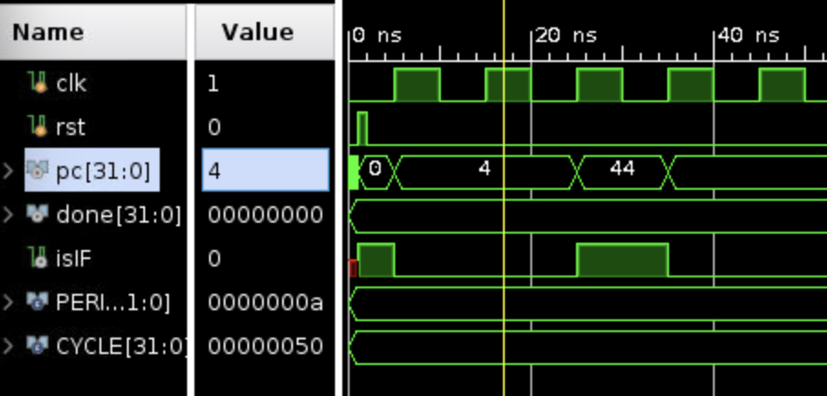

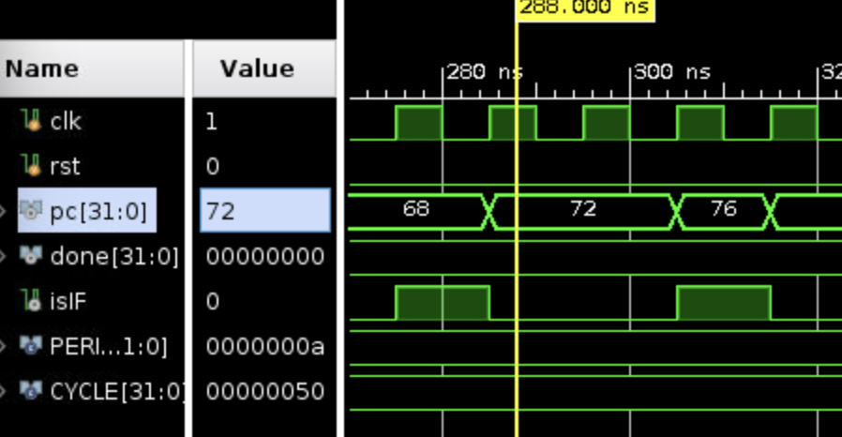

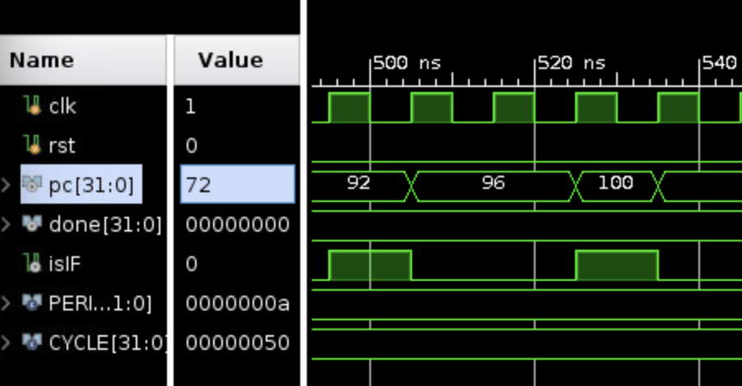

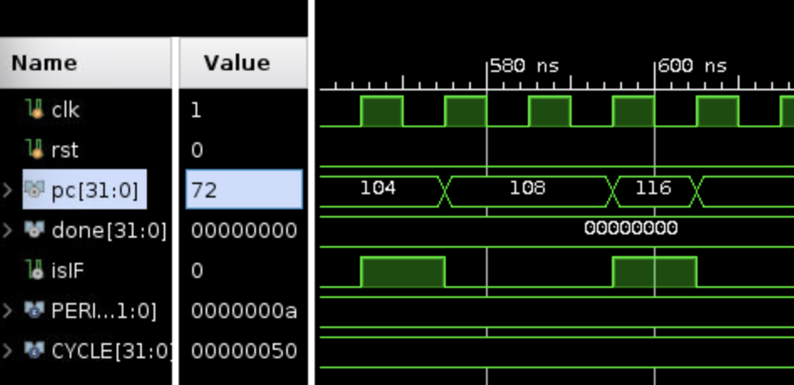

之后再查看存储器地址 0x08 的内容，最终在执行完 116 对应的 sw 指令后，由0变为1：

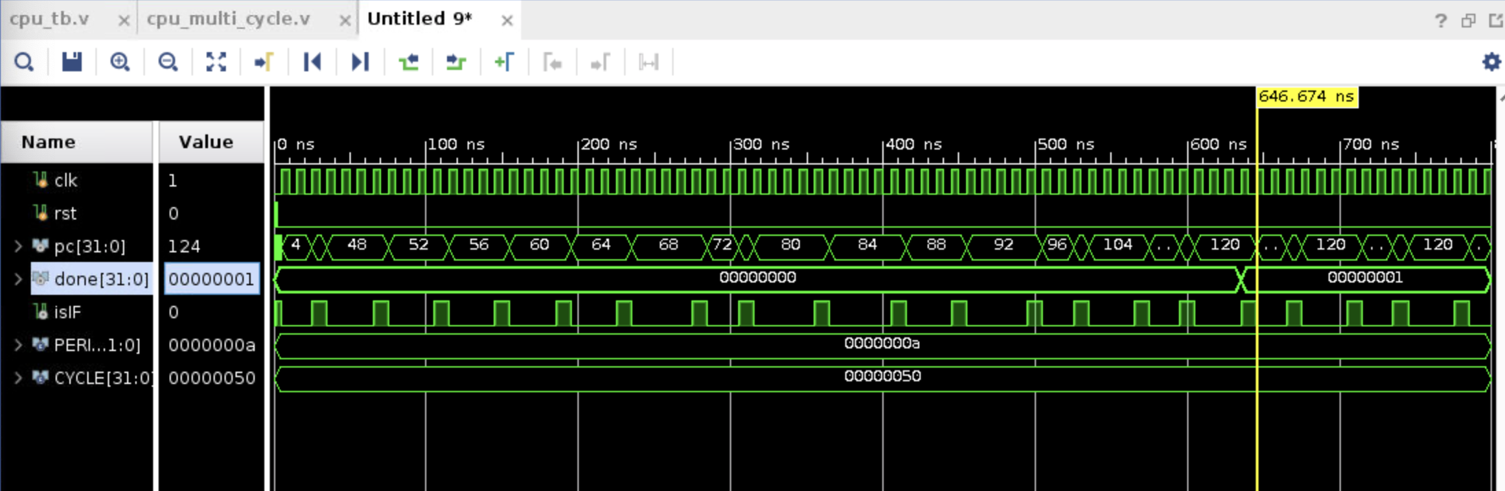

顺利通过了测试，验证了 CPU 设计的正确性。

1. Debug 模块
2. ***逻辑设计：***

根据实验讲义中的要求，类比上一次实验直接修改即可

1. ***核心代码：***

module *dbu*(

input succ , step ,inc , m_rf , dec,clk,rst,

input [2:0] sel,

output run ,

output reg [15:0] led,

output reg [31:0] display

);

reg [7:0] SSEG_CA ;

reg [7:0] SSEG_AN ;

reg succ_r1,succ_r2,step_r1,step_r2,inc_r1,inc_r2 , dec_r1,dec_r2;

wire inc_edg,dec_edg,step_edg;

reg [14:0] cnt;

wire clk10 ;

reg [2:0] sel_SSEG;

wire [7:0] a,b,c,d,e,f,g,h;

reg [31:0] m_rf_addr ;

wire en_m_rf_addr;

wire PC_we,PC_write,PCwritecond,IorD ,MemtoReg, MemWrite,IRWrite,RegDst,RegWrite,ALUop,ALUsrcA, zf;

wire [1:0] ALUsrcB ,PCsource;

wire [5:0] op;

wire [4:0] rs , rt;

wire [15:0] imm;

wire [31:0] pc_in ,pc_out, rd0 , rd1,alu_rslt,alu_reg_data ,memdata, mem_reg_data,rd0_tmp,rd1_tmp ;

cpu_multi_cycle_debug cpu(.clk(clk),.rst(rst),.run(run),.m_rf_addr(m_rf_addr),.en_m_rf_addr(en_m_rf_addr),.PC_write(PC_write),.PCwritecond(PCwritecond),.IorD(IorD) ,.MemtoReg(MemtoReg) ,.MemWrite(MemWrite),.IRWrite(IRWrite),.RegDst(RegDst),.RegWrite(RegWrite),.ALUop(ALUop),.ALUsrcA (ALUsrcA), .zf(zf),.imm(imm), .op(op),.rs(rs),.rt(rt) ,.PC_we(PC_we), .ALUsrcB (ALUsrcB),.PCsource(PCsource),.pc_in(pc_in) ,.pc_out(pc_out), .rd0(rd0) , .rd1(rd1),.rd0_tmp(rd0_tmp) , .rd1_tmp(rd1_tmp),.alu_rslt(alu_rslt),.alu_reg_data(alu_reg_data) ,.memdata(memdata), .mem_reg_data(mem_reg_data));

assign run = succ | (~succ & step_edg);

assign en_m_rf_addr = (~sel[2])&(~sel[1])&(~sel[0]) ;

always@(negedge clk)

step_r1 <= step;

always@(negedge clk)

step_r2 <= step_r1;

assign step_edg = step_r1 & (~step_r2);

always@(posedge clk)

inc_r1 <= inc;

always@(posedge clk)

inc_r2 <= inc_r1;

assign inc_edg = inc_r1 & (~inc_r2);

always@(posedge clk)

dec_r1 <= dec;

always@(posedge clk)

dec_r2 <= dec_r1;

assign dec_edg = dec_r1 & (~dec_r2);

always@(posedge clk,posedge rst)

begin

case (sel)

3'b000:begin

if(m_rf)

begin

display <= memdata;

end

else begin

display <= rd0_tmp;

end

led <= {2'b00, ALUsrcB ,PCsource, PC_we, IorD ,MemtoReg, MemWrite,IRWrite,RegDst,RegWrite,ALUop,ALUsrcA, zf};

end

3'b001:begin

display <= pc_out ;

led <= {2'b00, ALUsrcB ,PCsource, PC_we, IorD ,MemtoReg, MemWrite,IRWrite,RegDst,RegWrite,ALUop,ALUsrcA, zf};

end

3'b010:begin

display <= {op,rs,rt,imm} ;

led <= {2'b00, ALUsrcB ,PCsource, PC_we, IorD ,MemtoReg, MemWrite,IRWrite,RegDst,RegWrite,ALUop,ALUsrcA, zf};

end

3'b011:begin

led <= {2'b00, ALUsrcB ,PCsource, PC_we, IorD ,MemtoReg, MemWrite,IRWrite,RegDst,RegWrite,ALUop,ALUsrcA, zf};

display <= mem_reg_data ;

end

3'b100:begin

display <= rd0 ;

led <= {2'b00, ALUsrcB ,PCsource, PC_we, IorD ,MemtoReg, MemWrite,IRWrite,RegDst,RegWrite,ALUop,ALUsrcA, zf};

end

3'b101:begin

display <= rd1 ;

led <= {2'b00, ALUsrcB ,PCsource, PC_we, IorD ,MemtoReg, MemWrite,IRWrite,RegDst,RegWrite,ALUop,ALUsrcA, zf};

end

3'b110:begin

display <= alu_reg_data ;

led <= {2'b00, ALUsrcB ,PCsource, PC_we, IorD ,MemtoReg, MemWrite,IRWrite,RegDst,RegWrite,ALUop,ALUsrcA, zf};

end

default: begin

display <= 0;

led <= 0;

end

endcase

end

always@(posedge clk ,posedge rst)

begin

if (rst) begin

m_rf_addr <= 0;

end

else if (inc_edg)

begin

m_rf_addr <= m_rf_addr + 4;

end

else if (dec_edg)

begin

m_rf_addr <= m_rf_addr - 4;

end

end

endmodule

【实验总结】

1. 复习了多周期 CPU 的相关知识，并且进行了实践设计
2. 在根据数据通路，用 Verilog 编写 CPU 模块时，深切体会到了数据通路的电路级描述和 Verilog 语言级描述的区别：后者抽象程度更高

【附录】

本次提交目录结构组织如下：