20250507作業繳交 file:///C:/Users/User/Desktop/0501/40_%E4%BD%9C%E6%A5%AD_ERP_%E8%A1%A8%E6%A0%BC%E8%99%95%E7%90%86.html

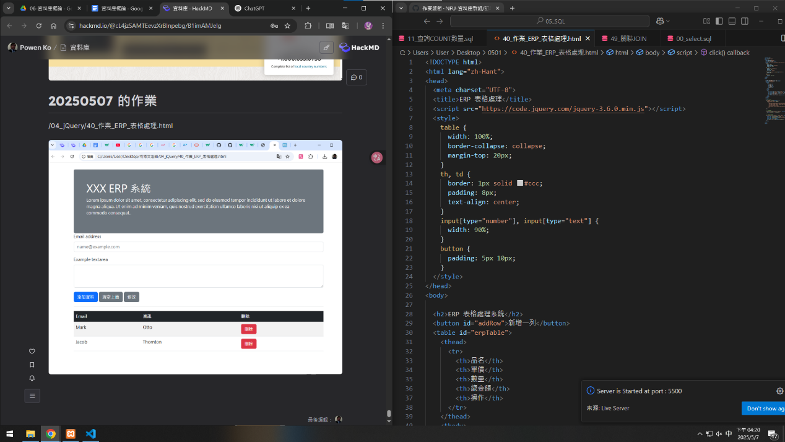

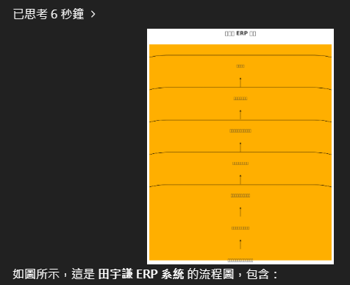

<!DOCTYPE html>

<html lang="zh-Hant">

<head>

<meta charset="UTF-8">

<title>ERP 表格處理</title>

<script src="https://code.jquery.com/jquery-3.6.0.min.js"></script>

<style>

table {

width: 100%;

border-collapse: collapse;

margin-top: 20px;

}

th, td {

border: 1px solid #ccc;

padding: 8px;

text-align: center;

}

input[type="number"], input[type="text"] {

width: 90%;

}

button {

padding: 5px 10px;

}

</style>

</head>

<body>

<h2>ERP 表格處理系統</h2>

<button id="addRow">新增一列</button>

<table id="erpTable">

<thead>

<tr>

<th>品名</th>

<th>單價</th>

<th>數量</th>

<th>總金額</th>

<th>操作</th>

</tr>

</thead>

<tbody>

<tr>

<td><input type="text" class="item"></td>

<td><input type="number" class="price" min="0"></td>

<td><input type="number" class="qty" min="0"></td>

<td class="total">0</td>

<td><button class="remove">刪除</button></td>

</tr>

</tbody>

</table>

<script>

// 新增列功能

$('#addRow').click(function () {

$('#erpTable tbody').append(`

<tr>

<td><input type="text" class="item"></td>

<td><input type="number" class="price" min="0"></td>

<td><input type="number" class="qty" min="0"></td>

<td class="total">0</td>

<td><button class="remove">刪除</button></td>

</tr>

`);

});

// 刪除列功能

$('#erpTable').on('click', '.remove', function () {

$(this).closest('tr').remove();

});

// 自動計算總金額

$('#erpTable').on('input', '.price, .qty', function () {

const row = $(this).closest('tr');

const price = parseFloat(row.find('.price').val()) || 0;

const qty = parseFloat(row.find('.qty').val()) || 0;

const total = price * qty;

row.find('.total').text(total.toFixed(2));

});

</script>

</body>

</html>