NY TIMES FACEBOOK EXAMPLE POST DATA

[
{
"picture": "http://external.ak.fbcdn.net/safe_image.php?d=AQArxakOLNHZea6z&w=90&h=90&url=http%3A%2F%2Fgraphics8.nytimes.com%2Fgfx%2Fblogs%2Fbits%2Fbits75.gif",
"likes": {
"count": 19,
},
"from": {
"category": "Media/news/publishing",
"name": "The New York Times",
"id": "5281959998"
},
"name": "Live Updates From the Apple iPhone Event",
"comments": {
"count": 1,
"data": [
{
"created_time": "2012-09-12T17:03:12+0000",
"message": "When iPhone receives local, free digital TV stations, I will rush out to buy one -- not a moment sooner.",
"from": {
"name": "Vic Livingston",
"id": "100000996034144"
},
"id": "5281959998_401325726589661_84544878"
}
]
},
"updated_time": "2012-09-12T17:03:12+0000",
"caption": "bits.blogs.nytimes.com",
"link": "http://nyti.ms/Q2MB3t",
"shares": {
"count": 2
},
"created_time": "2012-09-12T17:02:26+0000",
"message": "Ready for a new iPhone? Follow along here for updates and commentary from Apple's unveiling.",
"icon": "http://static.ak.fbcdn.net/rsrc.php/v2/yq/r/SC2ZmEkfI-X.png",
"type": "link",
"id": "5281959998_401325726589661",
"status_type": "shared_story",
"description": "It's almost here, whatever \"it\" is. Timothy D. Cook, the chief executive of Apple, is expected to take the stage on Wednesday at the Yerba Buena Center for the Arts in San Francisco to unveil the company's highly anticipated, next-generation iPhone. We'll have live updates from the event."
},

NY TIMES FACEBOOK EXAMPLE POST DATA
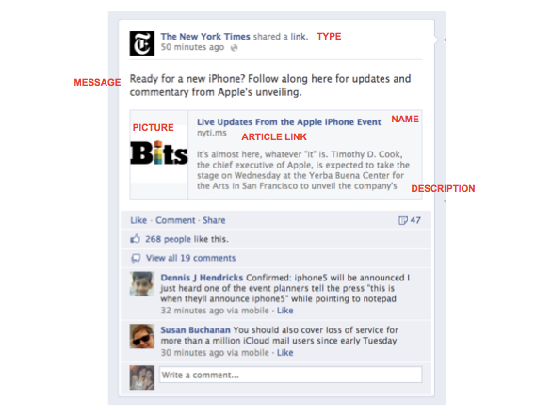
original article

