目录
1.Demo介绍 2
2. SDK使用 3
2.1 sdk接入步骤 3
1. 连接设备 3
2. 断开设备 3
3. 开启读写 3
4. 结束读写 3
5. 设置参数 4
3.API说明 4
3.1.ReaderConfig 4
3.2 ReaderManager 4

1.Demo介绍
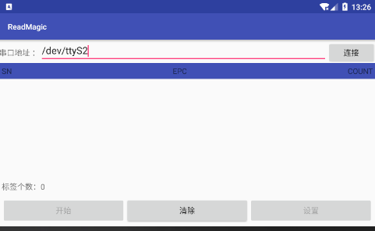
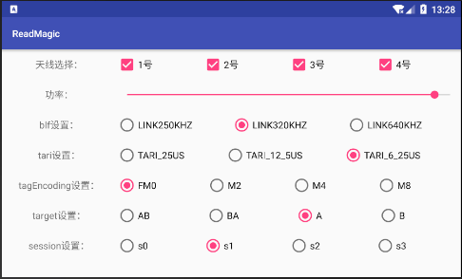
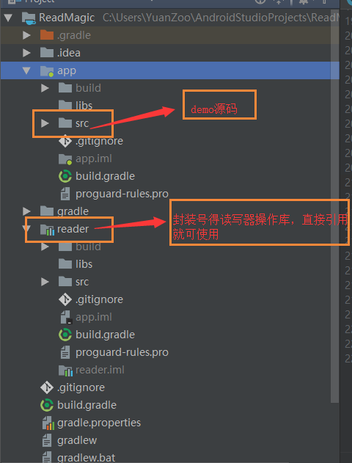
- 输入读写器设备连接后得串口地址（如：/dev/ttyS2）。这里得ttyS2根据具体得设备会有所不同，请根据具体设备情况具体填写，在此示例中ttyS2表示连接得是2号串口。
- 点击“连接”按钮，设备进入连接状态。（注意：在此操作前请确认设备已成功连接）
- 设备在连接成功后“开始”、“设置”按钮便可点击。
- 点击“开始”按钮 读写器开始读写。
- 点击“设置”按钮进入读写器配置界面。（读写器开始读写之后是不能设置参数得）

SDK使用

2.1 sdk接入步骤

连接设备
//得到readerManager实例
ReaderManager readerManager = ReaderManager.getInstance();
//通过串口地址连接设备
String query = "fuwit://"+"串口地址";
//连接设备
Reader reader = readerManager.connect(query);

断开设备
//断开连接
readerManager.closeReader();

开启读写
//开启读写
readerManager.startReading();

结束读写
//结束读写
readerManager.stopReader();

设置参数
//设置参数
ReaderConfig readerConfig = readerManager.getReaderConfig();//通过set方法设置参数
... ...
readerConfig.setTarget(Gen2.Target.B);
readerConfig.setSession(Gen2.Session.S1);
... ...
readerManager.setReaderParam(reader, readerConfig);//传入连接成功返回得reader对象

3.API说明
对外接口主要涉及到两个类：ReaderConfig，ReaderManager。
ReaderConfig封装得是读写器得一些配置参数，ReaderManager封装得是对读写器得一些操作和结果回调。

3.1.ReaderConfig
//天线设置（默认全开，根据天线得连接情况自行配置
如 1号 3号天线开启则传入{1，3}）
private int[] antennaList = {1, 2, 3, 4};
//读写器读的功率（0~3150 默认值3000）
private int readPower = 3000;
//波特率（此参数会自动匹配）
private int baudRate;
//设置blf频率
private Gen2.LinkFrequency blf = Gen2.LinkFrequency.LINK320KHZ;
//设置 tari
private Gen2.Tari tari = Gen2.Tari.TARI_6_25US;
//设置TagEncoding
private Gen2.TagEncoding tagEncoding = Gen2.TagEncoding.FM0;
//设置target
private Gen2.Target target = Gen2.Target.A;
//设置Session
private Gen2.Session session = Gen2.Session.S1;

3.2 ReaderManager
/**
* 功能：读写器管理类
*
* @author yu
* @version 1.0
* @date 2018/8/8
*/
public class ReaderManager {

private ReaderConfig readerConfig = new ReaderConfig();

private Handler mHandler = new Handler() {
@Override
public void handleMessage(Message msg) {
super.handleMessage(msg);
switch (msg.what) {
case 0:
String epcStr = (String) msg.obj;
mOnReaderListener.onReadEpc(epcStr);
break;
}
}
};

private ReaderManager() {

}

private static class InstanceHolder {
public static ReaderManager INSTANCE = new ReaderManager();
}

public static ReaderManager getInstance() {
return InstanceHolder.INSTANCE;
}

private Reader reader;

private boolean isConnected = false;

/**
* 读写器是否已经连接
*
* @return
*/
public boolean isConnected() {
return isConnected;
}

/**
* 读写器是否已经开始读取
*/
private boolean isReaderStarted = false;

public boolean isReaderStarted() {

return isReaderStarted;
}

public Reader connect(String query) {

return connect(query, readerConfig);
}

/**
* 连接读写器
*
* @param query
* @param readerConfig
*/
public Reader connect(String query, ReaderConfig readerConfig) {
try {
Reader.setSerialTransport("fuwit", new SerialTransportAndroid.Factory());
Reader.setSerialTransport("tcp", new SerialTransportTCP.Factory());
reader = Reader.create(query);
reader.connect();
setReaderParam(reader, readerConfig);
if (mOnReaderListener != null) {
mOnReaderListener.onSuccess();
}
isConnected = true;
return reader;
} catch (Exception ex) {
if (mOnReaderListener != null) {
mOnReaderListener.onFailed(ex);
}
return null;
}
}

/**
* 开始读取
*/
public void startReading() {
if (reader == null) {
throw new UnsupportedOperationException("请先初始化Reader，或初始化Reader失败");
} else {
reader.startReading();
reader.addReadListener(new ReadListener() {
@Override
public void tagRead(Reader r, TagReadData t) {
if (mOnReaderListener != null) {
Message msg = new Message();
msg.what = 0;
msg.obj = t.epcString();
mHandler.sendMessage(msg);
//mOnReaderListener.onReadEpc(t.epcString());
}
}
});
}
isReaderStarted = true;
}

/**
* 结束读取
*/
public void stopReader() {
reader.stopReading();
isReaderStarted = false;
}

/**
* 关闭单个Reader相关资源
*/
public void closeReader() {
if (reader != null) {
reader.stopReading();
reader.destroy();
}
isConnected = false;
}

/**
* 设置天线参数
*
* @param r
* @throws ReaderException
*/
public void setReaderParam(Reader r, ReaderConfig readerConfig) throws Exception {
this.readerConfig = readerConfig;
System.out.println("天线参数1===" + readerConfig);
//---设置频点（NA：美标）
String readerModel = (String) reader.paramGet("/reader/version/model");
if (readerModel.equalsIgnoreCase("M6e Micro")) {
reader.paramSet("/reader/region/id", Reader.Region.NA);
int power = 3000;
reader.paramSet(TMConstants.TMR_PARAM_RADIO_READPOWER, power);
} else if (readerModel.equalsIgnoreCase("M6e Nano")) {
reader.paramSet("/reader/region/id", Reader.Region.NA2);
int power = 2700;
reader.paramSet(TMConstants.TMR_PARAM_RADIO_READPOWER, power);
} else {
reader.paramSet("/reader/region/id", Reader.Region.NA);
int power = 3000;
reader.paramSet(TMConstants.TMR_PARAM_RADIO_READPOWER, power);
}
//---设置天线
SimpleReadPlan plan = new SimpleReadPlan(readerConfig.getAntennaList(), TagProtocol.GEN2, null, null, 1000);
r.paramSet(TMConstants.TMR_PARAM_READ_PLAN, plan);
//---设置功率
r.paramSet(TMConstants.TMR_PARAM_RADIO_READPOWER, readerConfig.getReadPower());
//--设置波特率
// r.paramSet(TMConstants.TMR_PARAM_BAUDRATE, readerConfig.getBaudRate());
//--设置blf
Gen2.LinkFrequency blf = readerConfig.getBlf();
r.paramSet(TMConstants.TMR_PARAM_GEN2_BLF, blf);

//--设置tari
Gen2.Tari tari = readerConfig.getTari();
r.paramSet(TMConstants.TMR_PARAM_GEN2_TARI, tari);

//--设置tagCoding
Gen2.TagEncoding tagenCoding = readerConfig.getTagEncoding();
r.paramSet(TMConstants.TMR_PARAM_GEN2_TAGENCODING, tagenCoding);

//--设置target
Gen2.Target target = readerConfig.getTarget();
//--设置Session
Gen2.Session session = readerConfig.getSession();
r.paramSet(TMConstants.TMR_PARAM_GEN2_SESSION, session);

}

public ReaderConfig getReaderConfig() {
return readerConfig;
}

private OnReaderListener mOnReaderListener;

public void setmOnReaderListener(OnReaderListener mOnReaderListener) {
this.mOnReaderListener = mOnReaderListener;
}

public interface OnReaderListener {
void onReadEpc(String epc);

void onSuccess();

void onFailed(Exception ex);
}

}

