# **4G/5G 模块锁频段方法**

# **快速判断延迟：**

ping 114.114.114.114 -I ppp15 -i 0.01 -c 100

# **一、NL668-CN**

##### **1、CPE型号：LW2308-MAPN**

##### **2、频段方法**

|  |  |
| --- | --- |
| 1）查看当前频段 | cat /dev/ttyUSB1 & |

echo -e "at+gtccinfo?\r\n" > /dev/ttyUSB1

killall cat

例如:

[root@cpe ~]# cat /dev/ttyUSB1 &  
[1] 18610  
[root@cpe ~]# echo -e "at+gtccinfo?\r\n" > /dev/ttyUSB1  
  
+GTCCINFO:  
  
LTE service cell:  
  
1,4,460,11,18A1,E48ED01,64,141,101,100,40,40,40,28 //第9位，表示当前注册为101频段  
  
  
  
LTE neighbor cell:  
  
2,4,,,,,4B,1D1,,24,24,4  
  
  
  
OK  
  
  
[root@cpe ~]# killall cat  
[1]+ 已终止 cat /dev/ttyUSB1

###### **2）优先4G（包含3G频段） 2100频段，对应频段参数101和134**

cat /dev/ttyUSB1 &

echo -e "at+gtact=10,3,,101,134\r\n" > /dev/ttyUSB1

echo -e "at+gtact?\r\n" > /dev/ttyUSB1

echo -e "at+gtccinfo?\r\n" > /dev/ttyUSB1

killall cat

例如：

[root@cpe ~]# cat /dev/ttyUSB1 &  
[1] 20689  
[root@cpe ~]# echo -e "at+gtact=10,3,2,101,134\r\n" > /dev/ttyUSB1  
  
OK  
  
  
[root@cpe ~]# echo -e "at+gtact?\r\n" > /dev/ttyUSB1  
  
+GTACT: 10,3,2,101,134  
  
  
  
OK  
  
  
[root@cpe ~]# echo -e "at+gtccinfo?\r\n" > /dev/ttyUSB1  
  
+GTCCINFO:  
  
LTE service cell:  
  
1,4,460,11,18A1,E48ED01,64,141,101,100,40,40,40,28 //通过gtccinfo查看注册到101上（第九位）  
  
  
  
LTE neighbor cell:  
  
2,4,,,,,4B,1D1,,26,26,2  
  
  
  
OK  
  
  
[root@cpe ~]# killall cat

###### **或锁定4G 2100频段，对应频段参数101和134**

cat /dev/ttyUSB1 &

echo -e "at+gtact=2,,,101,134\r\n" > /dev/ttyUSB1

echo -e "at+gtact?\r\n" > /dev/ttyUSB1

echo -e "at+gtccinfo?\r\n" > /dev/ttyUSB1

###### **3）恢复自动频段**

cat /dev/ttyUSB1 &

echo -e "at+gtact=10,3,2\r\n" > /dev/ttyUSB1

echo -e "at+gtact?\r\n" > /dev/ttyUSB1

echo -e "at+gtccinfo?\r\n" > /dev/ttyUSB1

killall cat

例如：

[root@cpe ~]# cat /dev/ttyUSB1 &  
[1] 18896  
[root@cpe ~]# echo -e "at+gtact=10,3,2\r\n" > /dev/ttyUSB1  
  
OK  
  
  
[root@cpe ~]# echo -e "at+gtact?\r\n" > /dev/ttyUSB1  
  
+GTACT: 10,3,2,900,1800,1,8,101,103,105,108,134,138,139,140,141,201,206,300  
  
  
  
OK  
  
  
[root@cpe ~]# echo -e "at+gtccinfo?\r\n" > /dev/ttyUSB1  
  
+GTCCINFO:  
  
LTE service cell:  
  
1,4,460,11,18A1,E48ED01,64,141,101,100,36,40,40,28  
  
  
  
LTE neighbor cell:  
  
2,4,,,,,4B,1D1,,25,25,0  
  
  
  
OK  
  
  
[root@cpe ~]# killall cat  
[1]+ 已终止 cat /dev/ttyUSB1

4）判断频段是否可用（MAPN拨号）

最简单是判断接口ip掉了或者有ip

或通过messages日志， cat /var/log/messages | grep fibocom

例如：

Apr 28 15:15:44 cpe fibocom-dial[16928]: [ppp15.1][requestRegistrationState2-2097]requestRegistrationState2 MCC: 460, MNC: 11, PS: Attached, DataCap: LTE  
Apr 28 15:15:44 cpe fibocom-dial[16928]: [ppp15.1][requestSetupDataCall-2311]requestSetupDataCall QMUXResult = 0x1, QMUXError = 0xe  
Apr 28 15:15:44 cpe fibocom-dial[16928]: [ppp15.1][requestSetupDataCall-2321]call_end_reason is 3  
Apr 28 15:15:44 cpe fibocom-dial[16928]: [ppp15.1][requestSetupDataCall-2330]call_end_reason_type is 3  
Apr 28 15:15:44 cpe fibocom-dial[16928]: [ppp15.1][requestSetupDataCall-2331]call_end_reason_verbose is 2001  
Apr 28 15:15:44 cpe fibocom-dial[16928]: [ppp15.1][main-1874]epoll fd = 7, events = 0x0000  
Apr 28 15:15:44 cpe fibocom-dial[16928]: [ppp15.1][qmidevice_send_event_to_main-684]write triger_event: 4100 to qmidevice_control_fd  
Apr 28 15:15:44 cpe fibocom-dial[16928]: [ppp15.1][main-1874]epoll fd = 6, events = 0x0000  
Apr 28 15:15:44 cpe fibocom-dial[16928]: [ppp15.1][main-1874]epoll fd = 7, events = 0x0001  
Apr 28 15:15:44 cpe fibocom-dial[16928]: [ppp15.1][qmidevice_send_event_to_main-684]write triger_event: 4100 to qmidevice_control_fd  
Apr 28 15:15:44 cpe fibocom-dial[16928]: [ppp15.1][requestRegistrationState2-2097]requestRegistrationState2 MCC: 0, MNC: 0, PS: Detached, DataCap: UNKNOW  
Apr 28 15:15:44 cpe fibocom-dial[16928]: [ppp15.1][main-1874]epoll fd = 6, events = 0x0000  
Apr 28 15:15:44 cpe fibocom-dial[16928]: [ppp15.1][main-1874]epoll fd = 7, events = 0x0001  
Apr 28 15:15:44 cpe fibocom-dial[16928]: [ppp15.1][requestRegistrationState2-2097]requestRegistrationState2 MCC: 0, MNC: 0, PS: Detached, DataCap: UNKNOW  
Apr 28 15:15:44 cpe fibocom-dial[16928]: [ppp15.1][qmidevice_send_event_to_main-684]write triger_event: 4100 to qmidevice_control_fd  
Apr 28 15:15:44 cpe fibocom-dial[16928]: [ppp15.1][main-1874]epoll fd = 6, events = 0x0000  
Apr 28 15:15:44 cpe fibocom-dial[16928]: [ppp15.1][main-1874]epoll fd = 7, events = 0x0001  
Apr 28 15:15:44 cpe fibocom-dial[16928]: [ppp15.1][requestRegistrationState2-2097]requestRegistrationState2 MCC: 460, MNC: 11, PS: Detached, DataCap: UNKNOW  
Apr 28 15:15:46 cpe fibocom-dial[16928]: [ppp15.1][qmidevice_send_event_to_main-684]write triger_event: 4100 to qmidevice_control_fd  
Apr 28 15:15:46 cpe fibocom-dial[16928]: [ppp15.1][main-1874]epoll fd = 6, events = 0x0000  
Apr 28 15:15:46 cpe fibocom-dial[16928]: [ppp15.1][main-1874]epoll fd = 7, events = 0x0001  
Apr 28 15:15:46 cpe fibocom-dial[16928]: [ppp15.1][qmidevice_send_event_to_main-684]write triger_event: 4100 to qmidevice_control_fd  
Apr 28 15:15:46 cpe fibocom-dial[16928]: [ppp15.1][requestRegistrationState2-2097]requestRegistrationState2 MCC: 460, MNC: 11, PS: Detached, DataCap: UNKNOW  
Apr 28 15:15:46 cpe fibocom-dial[16928]: [ppp15.1][main-1874]epoll fd = 6, events = 0x0000  
Apr 28 15:15:46 cpe fibocom-dial[16928]: [ppp15.1][main-1874]epoll fd = 7, events = 0x0001  
Apr 28 15:15:46 cpe fibocom-dial[16928]: [ppp15.1][requestRegistrationState2-2097]requestRegistrationState2 MCC: 460, MNC: 11, PS: Detached, DataCap: UNKNOW  
Apr 28 15:15:47 cpe fibocom-dial[16928]: [ppp15.1][qmidevice_send_event_to_main-684]write triger_event: 4100 to qmidevice_control_fd  
Apr 28 15:15:47 cpe fibocom-dial[16928]: [ppp15.1][main-1874]epoll fd = 6, events = 0x0000  
Apr 28 15:15:47 cpe fibocom-dial[16928]: [ppp15.1][main-1874]epoll fd = 7, events = 0x0001  
Apr 28 15:15:47 cpe fibocom-dial[16928]: [ppp15.1][qmidevice_send_event_to_main-684]write triger_event: 4100 to qmidevice_control_fd  
Apr 28 15:15:47 cpe fibocom-dial[16928]: [ppp15.1][requestRegistrationState2-2097]requestRegistrationState2 MCC: 460, MNC: 11, PS: Attached, DataCap: LTE  
Apr 28 15:15:47 cpe fibocom-dial[16928]: [ppp15.1][send_signo_to_main-678]write signo: 10 to signal_control_fd  
Apr 28 15:15:47 cpe fibocom-dial[16928]: [ppp15.1][main-1874]epoll fd = 6, events = 0x0001  
Apr 28 15:15:47 cpe fibocom-dial[16928]: [ppp15.1][main-1890]get signo: 10   
Apr 28 15:15:47 cpe fibocom-dial[16928]: [ppp15.1][usbnet_link_change-582]usbnet_link_change :link:0   
Apr 28 15:15:47 cpe fibocom-dial[16928]: [ppp15.1][requestRegistrationState2-2097]requestRegistrationState2 MCC: 460, MNC: 11, PS: Attached, DataCap: LTE  
Apr 28 15:15:47 cpe fibocom-dial[16928]: [ppp15.1][requestSetupDataCall-2342]requestSetupDataCall WdsConnectionIPv4Handle: 0xe1683eb0  
Apr 28 15:15:47 cpe fibocom-dial[16928]: [ppp15.1][qmidevice_send_event_to_main-684]write triger_event: 4101 to qmidevice_control_fd  
Apr 28 15:15:47 cpe fibocom-dial[16928]: [ppp15.1][requestGetIPAddress-2415]IPv4 DNS1: 219.141.136.10  
Apr 28 15:15:47 cpe fibocom-dial[16928]: [ppp15.1][requestGetIPAddress-2428]IPv4 DNS2: 219.141.140.10  
Apr 28 15:15:47 cpe fibocom-dial[16928]: [ppp15.1][requestGetIPAddress-2441]IPv4 Gateway: 10.10.5.60  
Apr 28 15:15:47 cpe fibocom-dial[16928]: [ppp15.1][requestGetIPAddress-2454]IPv4 Netmask: 29  
Apr 28 15:15:47 cpe fibocom-dial[16928]: [ppp15.1][requestGetIPAddress-2467]IPv4 Address: 10.10.5.59  
Apr 28 15:15:47 cpe fibocom-dial[16928]: [ppp15.1][main-1874]epoll fd = 7, events = 0x0001  
Apr 28 15:15:47 cpe fibocom-dial[16928]: [ppp15.1][requestRegistrationState2-2097]requestRegistrationState2 MCC: 460, MNC: 11, PS: Attached, DataCap: LTE

其中”DataCap: UNKNOW“时网络不可用，”DataCap: LTE“时可用；一般在AT指令gtact锁定频段后，messages日志中会刷新IP

5）参考文档

**FIBOCOM NL668 & MC116 & LC116** **AT Commands**

Version: V3.5.21

Date: 2022-7-27

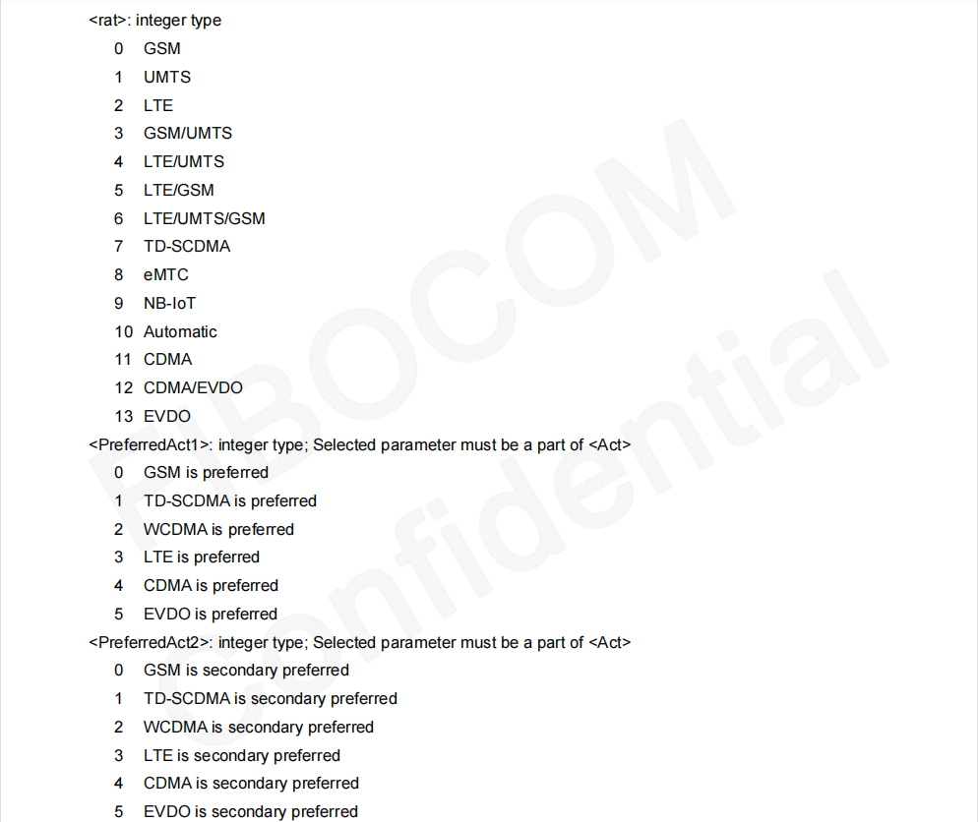

##### **3、注意：**

1、上述方法主要介绍锁4G 2100频段，锁其他频段方式请联系研发/QA补充

2、记得最后执行killall cat

3、在设备已经拨号时执行

# **二、 ME909s**

1、CPE型号：LW2301（已废弃）

2、频段方法

1）锁定4G频段2100 对应频点1920

cat /dev/ttyUSB2 &

echo -e "at^freqlock?\r\n" > /dev/ttyUSB2

echo -e "at^freqlock=1,\"04\",1920,,,2\r\n" > /dev/ttyUSB2

echo -e "at^freqlock?\r\n" > /dev/ttyUSB2

killall cat

# **三、ME3630**

1、CPE 型号： LW2302\LW2308\LW2303V2

2、查看当前支持的频段

cat /dev/ttyUSB1 &

echo -e "AT+ZBAND?\r\n" > /dev/ttyUSB1

3、锁定某个 4G 频段：AT+ZBAND=0,0,0,X

锁定 LTE Band 5——重启设备生效

root@OpenWrt:~# echo -e "AT+zband=0,0,0,10\r\n" >/dev/ttyUSB1

root@OpenWrt:~#

OK

查看当前的频段确认锁频生效

root@OpenWrt:~# echo -e "AT+zband?\r\n" >/dev/ttyUSB1

root@OpenWrt:~#

+ZBAND:

LTE: 5

OK

频段和 X 值的对应关系

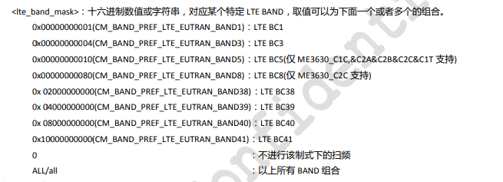

4、恢复总动锁频

echo -e "AT+ZBAND=all,all,all,all\r\n" >/dev/ttyUSB1——重启设备生效

# **四、 FM150-AE 锁频**

1、FM150 锁 4G B103 频段

echo -e "at+gtact=2,,,103"

2、FM150 锁 5G N28 频段

echo -e "at+gtact=14,,,5028\r\n" > /dev/ttyUSB1

查看锁频是否生效

echo -e "at+gtact?\r\n" > /dev/ttyUSB1

查看当前频段

echo -e "at+gtccinfo?\r\n" > /dev/ttyUSB1

3、强制注册 SA/NSA

cat /dev/ttyUSB1 &

echo -e "AT+GTACT=14\r\n" > /dev/ttyUSB1——强制注册SA

echo -e "AT+GTACT=10\r\n" > /dev/ttyUSB1——强制注册NSA

4、参数说明

