LLLL

[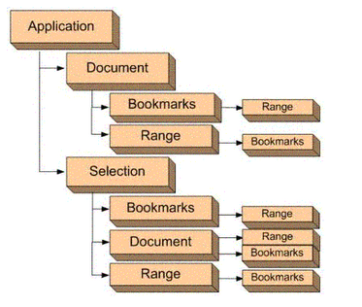](https://www.baidu.com)

[jjjjjjjjjjjjjjjjjjjjj](http://www.jxnu.edu.cn)

中文编码测试