哈尔滨工业大学

<<大数据分析>>
实验报告之二

(2024年度秋季学期)

姓名： | 郁清方
学号： | 2022110900
学院： | 计算机技术与科学
教师： | 杨东华

实验二 聚类分析和分类分析

实验目的
·掌握对数据进行聚类分析和分类分析的方法；
·理解其在大数据环境下的实现方式。

实验环境
操作系统：Linux-Ubuntu 16.04
框架：采用多开虚拟机实现的“真”分布式Hadoop环境，版本为3.1.3，java版本为1.8
编程语言：Java

实验过程及结果
为了方便管理代码的进行调试，我将执行不同任务的Mapper和Reducer分离了出来，即成为单独的.java文件：
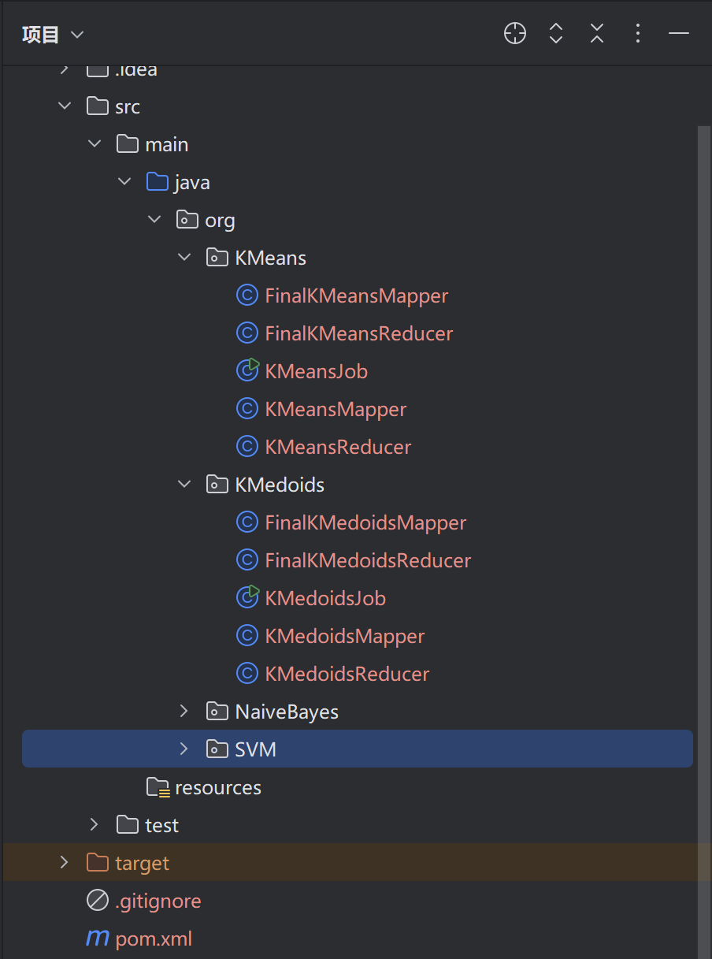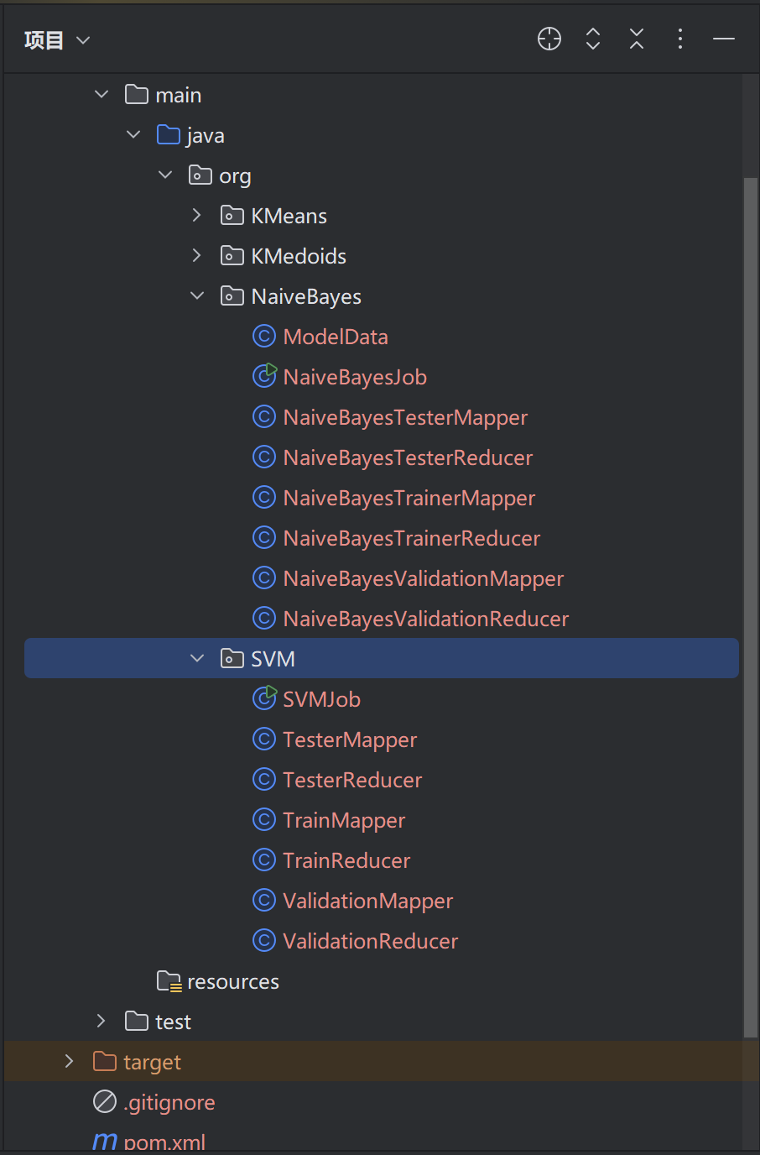

1 聚类分析

KMeans
各自类的说明：
KMeansJob.java:
初始化聚类中心，初始化的方法为从文件当中随机抽取K个点作为K个聚类中心；内置循环，迭代执行KMeans，并检查是否收敛，如果收敛则调用FinalKMeans的Mapper和Reducer。
KMeansMapper.java、KMeansReducer.java:
Mapper负责读取上一次迭代产生的聚类中心，并计算各个点到各个聚类中心的距离，产生标签并按照<标签，点坐标>写入Reducer，Reducer则根据这些点重新计算聚类中心（采用坐标平均化）。
FinalKMeansMapper.java、FinalKMeansReducer.java:
Mapper直接按照<空， 原始点>写入同一个Reducer当中，Reducer读取最终迭代产生的收敛中心，计算点到聚类中心的距离，并按照最近距离聚类。
代码如下：
KMeansJob.java:
package org.KMeans;
import org.apache.hadoop.conf.Configuration;
import org.apache.hadoop.fs.FileSystem;
import org.apache.hadoop.fs.Path;
import org.apache.hadoop.io.Text;
import org.apache.hadoop.mapreduce.Job;
import org.apache.hadoop.mapreduce.lib.input.FileInputFormat;
import org.apache.hadoop.mapreduce.lib.output.FileOutputFormat;
import java.io.BufferedReader;
import java.io.InputStreamReader;
import java.io.OutputStreamWriter;
import java.net.URI;
import java.util.*;
public class KMeansJob {
public static void main(String[] args) throws Exception {
if (args.length < 5) {
System.err.println("输入: KMeansJob <输入> <输出> <分类> <最大迭代次数> <收敛值>");
System.exit(-1);
}
String inputPath = args[0];
String outputPath = args[1];
int K = Integer.parseInt(args[2]); //
int maxIterations = Integer.parseInt(args[3]); // 指定最大
double convergeIndex = Double.parseDouble(args[4]); // 收敛值，即聚类中心的坐标变化均小于这个值，认为收敛——Yu
Configuration conf = new Configuration();
// 生成初始中心点，我是选择从点当中随机抽取K个——Yu
String centroidsPath = generateInitialCentroids(conf, inputPath, K);
conf.set("centroids.path", centroidsPath);
boolean converged = false;
int iteration = 0;
while (iteration < maxIterations && !converged) {
Job job = Job.getInstance(conf, "K-Means Clustering - Iteration " + iteration);
job.setJarByClass(KMeansJob.class);
job.setMapperClass(KMeansMapper.class);
job.setReducerClass(KMeansReducer.class);
job.setMapOutputKeyClass(Text.class);
job.setMapOutputValueClass(Text.class);
job.setOutputKeyClass(Text.class);
job.setOutputValueClass(Text.class);
FileInputFormat.addInputPath(job, new Path(inputPath));
FileOutputFormat.setOutputPath(job, new Path(outputPath + "/centroids" + iteration));
job.addCacheFile(new URI(centroidsPath));
job.getConfiguration().setInt("iteration", iteration);
job.getConfiguration().set("outputPath", String.valueOf(new Path(outputPath + "/centroids" + iteration)));
if (!job.waitForCompletion(true)) {
System.err.println("Job failed at iteration " + iteration);
System.exit(1);
}
String newCentroidsPath = "hdfs:///LAB2/KMeansCentroids" + "/centroids" + iteration;
// 检查是否收敛
if (iteration != 0) { // 第一次迭代我认为只有很小概率会直接收敛，所以就不检查了——Yu
converged = checkConvergence(conf, centroidsPath, newCentroidsPath, convergeIndex);
}
centroidsPath = newCentroidsPath;
conf.set("centroids.path", centroidsPath);
iteration++;
}
System.out.println("========================================");
System.out.println("K-Means 在 " + iteration + " 次迭代时收敛/已经达到最大迭代次数");
System.out.println("========================================");
// 收敛后或达到最大收敛次数时进行数据聚类并输出结果
Job finalJob = Job.getInstance(conf, "Final Clustering");
finalJob.setJarByClass(KMeansJob.class);
finalJob.setMapperClass(FinalKMeansMapper.class);
finalJob.setReducerClass(FinalKMeansReducer.class);
finalJob.setMapOutputKeyClass(Text.class);
finalJob.setMapOutputValueClass(Text.class);
finalJob.setOutputKeyClass(Text.class);
finalJob.setOutputValueClass(Text.class);
FileInputFormat.addInputPath(finalJob, new Path(inputPath));
FileOutputFormat.setOutputPath(finalJob, new Path(outputPath + "/final_results"));
finalJob.addCacheFile(new URI(centroidsPath));//结束迭代时候的最终聚类中心文件路径，在Reducer读取，进行分类——Yu
if (!finalJob.waitForCompletion(true)) {
System.err.println("Final Job failed");
System.exit(1);
}
}
private static String generateInitialCentroids(Configuration conf, String inputPath, int K) throws Exception {
FileSystem fs = FileSystem.get(conf);
Path centroidsPath = new Path("hdfs:///LAB2/KMeansCentroids/initial_centroids.txt");
Random rand = new Random();
List<String> selectedCentroids = new ArrayList<>(K);
try (BufferedReader reader = new BufferedReader(new InputStreamReader(fs.open(new Path(inputPath))))) {
String line;
int count = 0;
while ((line = reader.readLine()) != null) {
count++;
if (count <= K) {
selectedCentroids.add(line);
} else {
int replace = rand.nextInt(count);
if (replace < K) {
selectedCentroids.set(replace, line);
}
}
}
}
try (OutputStreamWriter writer = new OutputStreamWriter(fs.create(centroidsPath, true))) {
int count = 0;
for (String centroid : selectedCentroids) {
writer.write(count + "\t" + centroid + "\n");
count++;
}
}
return centroidsPath.toString();
}
private static boolean checkConvergence(Configuration conf, String oldCentroidsPath, String newCentroidsPath, double convergeIndex) throws Exception {
FileSystem fs = FileSystem.get(conf);
Map<String, double[]> oldCentroids = readCentroidsFromHDFS(fs, new Path(oldCentroidsPath));
Map<String, double[]> newCentroids = readCentroidsFromHDFS(fs, new Path(newCentroidsPath));
for (String centroidId : newCentroids.keySet()) {
double[] oldPoint = oldCentroids.get(centroidId);
double[] newPoint = newCentroids.get(centroidId);
if (oldPoint == null || newPoint == null) {
return false;
}
double distance = calculateDistance(oldPoint, newPoint);
if (distance > convergeIndex) {
return false;
}
}
return true;
}
private static Map<String, double[]> readCentroidsFromHDFS(FileSystem fs, Path path) throws Exception {
Map<String, double[]> centroids = new HashMap<>();
try (BufferedReader reader = new BufferedReader(new InputStreamReader(fs.open(path)))) {
String line;
while ((line = reader.readLine()) != null) {
String[] parts = line.split("\t");
String centroidId = parts[0];
double[] vector = parseVector(parts[1]);
centroids.put(centroidId, vector);
}
}
return centroids;
}
private static double[] parseVector(String data) {
String[] parts = data.split(",");
double[] vector = new double[parts.length];
for (int i = 0; i < parts.length; i++) {
vector[i] = Double.parseDouble(parts[i]);
}
return vector;
}
private static double calculateDistance(double[] point1, double[] point2) {
double sum = 0.0;
for (int i = 0; i < point1.length; i++) {
sum += Math.pow(point1[i] - point2[i], 2);
}
return Math.sqrt(sum);
}
}

KMeansMapper.java：
package org.KMeans;
import org.apache.hadoop.io.LongWritable;
import org.apache.hadoop.io.Text;
import org.apache.hadoop.mapreduce.Mapper;
import java.io.*;
import java.net.URI;
import java.util.HashMap;
import java.util.Map;
import org.apache.hadoop.fs.FileSystem;
import org.apache.hadoop.fs.Path;
public class KMeansMapper extends Mapper<LongWritable, Text, Text, Text> {
private Map<String, double[]> centroids = new HashMap<>();
@Override
protected void setup(Context context) throws IOException {
// 从分布式缓存加载聚类中心
URI[] cacheFiles = context.getCacheFiles();
if (cacheFiles != null && cacheFiles.length > 0) {
Path centroidsPath = new Path(cacheFiles[0].toString());
FileSystem fs = FileSystem.get(context.getConfiguration());
try (BufferedReader reader = new BufferedReader(new InputStreamReader(fs.open(centroidsPath)))) {
String line;
while ((line = reader.readLine()) != null) {
String[] parts = line.split("\t");
String centroidId = parts[0];
double[] vector = parseVector(parts[1]);
centroids.put(centroidId, vector);
}
}
} else {
throw new IOException("Centroids file not found in distributed cache.");
}
}
@Override
protected void map(LongWritable key, Text value, Context context) throws IOException, InterruptedException {
// 处理输入数据点
String line = value.toString().trim();
try {
double[] point = parseVector(line);
String closestCentroid = null;
double minDistance = Double.MAX_VALUE;
// 计算数据点到各聚类中心的距离
for (Map.Entry<String, double[]> entry : centroids.entrySet()) {
double distance = calculateDistance(point, entry.getValue());
if (distance < minDistance) {
minDistance = distance;
closestCentroid = entry.getKey();
}
}
// 输出最近的聚类中心及数据点
if (closestCentroid != null) {
context.write(new Text(closestCentroid), value); // <聚类中心ID, 数据点>
}
} catch (IllegalArgumentException e) {
System.err.println("Invalid input point: " + line);
}
}
private static double[] parseVector(String data) {
// 将逗号分隔的字符串解析为向量
String[] parts = data.split(",");
double[] vector = new double[parts.length];
for (int i = 0; i < parts.length; i++) {
try {
vector[i] = Double.parseDouble(parts[i].trim());
} catch (NumberFormatException e) {
throw new IllegalArgumentException("Invalid vector format: " + data, e);
}
}
return vector;
}
private double calculateDistance(double[] point, double[] centroid) {
// 计算欧几里得距离
double sum = 0.0;
for (int i = 0; i < point.length; i++) {
sum += Math.pow(point[i] - centroid[i], 2);
}
return Math.sqrt(sum);
}
}

KMeansReducer.java:
package org.KMeans;
import org.apache.hadoop.io.Text;
import org.apache.hadoop.mapreduce.Reducer;
import java.io.BufferedWriter;
import java.io.IOException;
import java.io.OutputStreamWriter;
import java.util.*;
import org.apache.hadoop.fs.FileSystem;
import org.apache.hadoop.fs.Path;
public class KMeansReducer extends Reducer<Text, Text, Text, Text> {
private static final int DIMENSIONS = 20; // 数据维度为20
private Map<String, double[]> newCentroids = new HashMap<>();
private int iteration;
@Override
protected void setup(Context context) {
// 获取当前迭代次数
this.iteration = context.getConfiguration().getInt("iteration", 0);
}
@Override
protected void reduce(Text key, Iterable<Text> values, Context context) throws IOException, InterruptedException {
List<double[]> points = new ArrayList<>();
// 收集所有属于该簇的点
for (Text value : values) {
double[] point = parseVector(value.toString());
points.add(point);
}
// 更新聚类中心
double[] newCentroid = calculateNewCentroid(points);
// 存储新的聚类中心
newCentroids.put(key.toString(), newCentroid);
}
private double[] calculateNewCentroid(List<double[]> points) {
double[] centroid = new double[DIMENSIONS];
int count = points.size();
// 计算该簇的新的聚类中心
for (double[] point : points) {
for (int i = 0; i < point.length; i++) {
centroid[i] += point[i];
}
}
// 平均化坐标
for (int i = 0; i < centroid.length; i++) {
centroid[i] /= count;
}
return centroid;
}
private double[] parseVector(String data) {
String[] parts = data.split(",");
double[] vector = new double[parts.length];
for (int i = 0; i < parts.length; i++) {
vector[i] = Double.parseDouble(parts[i]);
}
return vector;
}
@Override
protected void cleanup(Context context) throws IOException {
// 在 cleanup 中根据当前的迭代次数保存新的聚类中心到 HDFS
String centroidsPath = "hdfs:///LAB2/KMeansCentroids" + "/centroids" + iteration;
FileSystem fs = FileSystem.get(context.getConfiguration());
Path outputPath = new Path(centroidsPath);
try (BufferedWriter writer = new BufferedWriter(new OutputStreamWriter(fs.create(outputPath, true)))) {
for (Map.Entry<String, double[]> entry : newCentroids.entrySet()) {
String centroidId = entry.getKey();
double[] centroid = entry.getValue();
writer.write(centroidId + "\t" + vectorToString(centroid) + "\n");
}
}
}
private String vectorToString(double[] vector) {
StringJoiner joiner = new StringJoiner(",");
for (double v : vector) {
joiner.add(String.valueOf(v));
}
return joiner.toString();
}
}

FinalKMeansMapper.java：
package org.KMeans;
import org.apache.hadoop.io.Text;
import org.apache.hadoop.mapreduce.Mapper;
import java.io.IOException;
public class FinalKMeansMapper extends Mapper<Object, Text, Text, Text> {
@Override
protected void map(Object key, Text value, Context context) throws IOException, InterruptedException {
context.write(new Text(""), value);
}
}

FinalKMeansReducer.java:
package org.KMeans;
import org.apache.hadoop.io.Text;
import org.apache.hadoop.mapreduce.Reducer;
import java.io.*;
import java.net.URI;
import java.util.*;
import org.apache.hadoop.fs.FileSystem;
import org.apache.hadoop.fs.Path;
public class FinalKMeansReducer extends Reducer<Text, Text, Text, Text> {
private Map<String, double[]> centroids = new HashMap<>();
@Override
protected void setup(Context context) throws IOException {
// 加载最新的聚类中心
URI[] cacheFiles = context.getCacheFiles();
if (cacheFiles != null && cacheFiles.length > 0) {
Path path = new Path(cacheFiles[0].toString());
FileSystem fs = FileSystem.get(context.getConfiguration());
try (BufferedReader reader = new BufferedReader(new InputStreamReader(fs.open(path)))) {
String line;
while ((line = reader.readLine()) != null) {
String[] parts = line.split("\t");
String centroidId = parts[0];
double[] vector = parseVector(parts[1]);
centroids.put(centroidId, vector);
}
}
} else {
throw new IOException("Centroids file not found in distributed cache.");
}
}
@Override
protected void reduce(Text key, Iterable<Text> values, Context context) throws IOException, InterruptedException {
// 计算每个点与聚类中心的距离
for (Text value : values) {
String line = value.toString().trim();
if (line.isEmpty()) continue;
double[] point = parseVector(line);
String closestCentroid = null;
double minDistance = Double.MAX_VALUE;
for (Map.Entry<String, double[]> entry : centroids.entrySet()) {
double distance = calculateDistance(point, entry.getValue());
if (distance < minDistance) {
minDistance = distance;
closestCentroid = entry.getKey();
}
}
if (closestCentroid != null) {
context.write(new Text(""), new Text(closestCentroid)); // 按照<空, 聚类标签>输出
} else {
System.err.println("No valid centroid found for point: " + line);
}
}
}
private double[] parseVector(String data) {
String[] parts = data.split(",");
double[] vector = new double[parts.length];
for (int i = 0; i < parts.length; i++) {
vector[i] = Double.parseDouble(parts[i].trim());
}
return vector;
}
private double calculateDistance(double[] point, double[] centroid) {
double sum = 0.0;
for (int i = 0; i < point.length; i++) {
sum += Math.pow(point[i] - centroid[i], 2);
}
return Math.sqrt(sum);
}
}

KMedoids
其实KMedoids和KMeans十分相似，只是使用的聚类中心不再是平均值。
我的算法实现了PAM方法，但是由于计算量过大，导致在hadoop认为作业超时并重启作业之前没法算完，所以采用了抽样PAM，但是按照比例抽样（我尝试了10%，1%以及0.1%），但还是没能在hadoop认为作业超时之前算完任务，尝试了计算距离时候的并行计算，仍旧无法按时完成计算，所以对抽样PAM算法做了更改，限制PAM抽样个数而非比例（这也引入了非常大的随机性，进而导致很难收敛！）。
KMedoidsJob.java:
初始化聚类中心，初始化的方法为从文件当中随机抽取K个点作为K个聚类中心；内置循环，迭代执行KMedoids，并检查是否收敛，如果收敛则调用FinalKMedoid的Mapper和Reducer。
KMedoidsMapper.java、KMedoidsReducer.java:
Mapper负责读取上一次迭代产生的聚类中心，并计算各个点到各个聚类中心的距离，产生标签并按照<标签，点坐标>写入Reducer，Reducer则根据这些点重新计算聚类中心（采用限制抽样数量的PAM方法）。
KMedoidsMapper.java、KMedoidsReducer.java:
Mapper直接按照<空， 原始点>写入同一个Reducer当中，Reducer读取最终迭代产生的收敛中心，计算点到聚类中心的距离，并按照最近距离聚类。

代码如下：
KMedoidsJob.java:
package org.KMedoids;
import org.apache.hadoop.conf.Configuration;
import org.apache.hadoop.fs.FileSystem;
import org.apache.hadoop.fs.Path;
import org.apache.hadoop.io.Text;
import org.apache.hadoop.mapreduce.Job;
import org.apache.hadoop.mapreduce.lib.input.FileInputFormat;
import org.apache.hadoop.mapreduce.lib.output.FileOutputFormat;
import java.io.BufferedReader;
import java.io.InputStreamReader;
import java.io.OutputStreamWriter;
import java.net.URI;
import java.util.*;
public class KMedoidsJob {
public static void main(String[] args) throws Exception {
if (args.length < 5) {
System.err.println("输入: KMedoidsJob <输入> <输出> <分类> <最大迭代次数> <收敛值> <PAM抽样个数>");
System.exit(-1);
}
String inputPath = args[0];
String outputPath = args[1];
int K = Integer.parseInt(args[2]);
int maxIterations = Integer.parseInt(args[3]);
double convergeIndex = Double.parseDouble(args[4]);
int PAMIndex = Integer.parseInt(args[5]);
Configuration conf = new Configuration();
// 生成初始中心点，我是选择从点当中随机抽取K个——Yu
String centroidsPath = generateInitialCentroids(conf, inputPath, K);
conf.set("centroids.path", centroidsPath);
boolean converged = false;
int iteration = 0;
while (iteration < maxIterations && !converged) {
Job job = Job.getInstance(conf, "KMedoids Clustering - Iteration " + iteration);
job.setJarByClass(org.KMedoids.KMedoidsJob.class);
job.setMapperClass(KMedoidsMapper.class);
job.setReducerClass(KMedoidsReducer.class);
job.setMapOutputKeyClass(Text.class);
job.setMapOutputValueClass(Text.class);
job.setOutputKeyClass(Text.class);
job.setOutputValueClass(Text.class);
FileInputFormat.addInputPath(job, new Path(inputPath));
FileOutputFormat.setOutputPath(job, new Path(outputPath + "/centroids" + iteration));
job.addCacheFile(new URI(centroidsPath));
job.getConfiguration().setInt("iteration", iteration);
job.getConfiguration().setInt("PAMIndex", PAMIndex);
job.getConfiguration().set("outputPath", String.valueOf(new Path(outputPath + "/centroids" + iteration)));
if (!job.waitForCompletion(true)) {
System.err.println("Job failed at iteration " + iteration);
System.exit(1);
}
String newCentroidsPath = "hdfs:///LAB2/KMedoidsCentroids" + "/centroids" + iteration;
// 检查是否收敛
if (iteration != 0) { // 第一次迭代我认为只有很小概率会直接收敛，所以就不检查了——Yu
converged = checkConvergence(conf, centroidsPath, newCentroidsPath, convergeIndex);
}
centroidsPath = newCentroidsPath;
conf.set("centroids.path", centroidsPath);
iteration++;
}
System.out.println("========================================");
System.out.println("KMedoids 在 " + iteration + " 次迭代时收敛");
System.out.println("========================================");
// 收敛后或达到最大收敛次数时进行数据聚类，输出结果
Job finalJob = Job.getInstance(conf, "Final Clustering");
finalJob.setJarByClass(org.KMedoids.KMedoidsJob.class);
finalJob.setMapperClass(FinalKMedoidsMapper.class);
finalJob.setReducerClass(FinalKMedoidsReducer.class);
finalJob.setMapOutputKeyClass(Text.class);
finalJob.setMapOutputValueClass(Text.class);
finalJob.setOutputKeyClass(Text.class);
finalJob.setOutputValueClass(Text.class);
FileInputFormat.addInputPath(finalJob, new Path(inputPath));
FileOutputFormat.setOutputPath(finalJob, new Path(outputPath + "/final_results"));
finalJob.addCacheFile(new URI(centroidsPath));
if (!finalJob.waitForCompletion(true)) {
System.err.println("Final Job failed");
System.exit(1);
}
}
private static String generateInitialCentroids(Configuration conf, String inputPath, int K) throws Exception {
FileSystem fs = FileSystem.get(conf);
Path centroidsPath = new Path("hdfs:///LAB2/KMedoidsCentroids/initial_centroids.txt");
Random rand = new Random();
List<String> selectedCentroids = new ArrayList<>(K);
try (BufferedReader reader = new BufferedReader(new InputStreamReader(fs.open(new Path(inputPath))))) {
String line;
int count = 0;
while ((line = reader.readLine()) != null) {
count++;
if (count <= K) {
selectedCentroids.add(line);
} else {
int replace = rand.nextInt(count);
if (replace < K) {
selectedCentroids.set(replace, line);
}
}
}
}
try (OutputStreamWriter writer = new OutputStreamWriter(fs.create(centroidsPath, true))) {
int count = 0;
for (String centroid : selectedCentroids) {
writer.write(count + "\t" + centroid + "\n");
count++;
}
}
return centroidsPath.toString();
}
private static boolean checkConvergence(Configuration conf, String oldCentroidsPath, String newCentroidsPath, double convergeIndex) throws Exception {
FileSystem fs = FileSystem.get(conf);
Map<String, double[]> oldCentroids = readCentroidsFromHDFS(fs, new Path(oldCentroidsPath));
Map<String, double[]> newCentroids = readCentroidsFromHDFS(fs, new Path(newCentroidsPath));
for (String centroidId : newCentroids.keySet()) {
double[] oldPoint = oldCentroids.get(centroidId);
double[] newPoint = newCentroids.get(centroidId);
if (oldPoint == null || newPoint == null) {
return false;
}
double distance = calculateDistance(oldPoint, newPoint);
if (distance > convergeIndex) {
return false;
}
}
return true;
}
private static Map<String, double[]> readCentroidsFromHDFS(FileSystem fs, Path path) throws Exception {
Map<String, double[]> centroids = new HashMap<>();
try (BufferedReader reader = new BufferedReader(new InputStreamReader(fs.open(path)))) {
String line;
while ((line = reader.readLine()) != null) {
String[] parts = line.split("\t");
String centroidId = parts[0];
double[] vector = parseVector(parts[1]);
centroids.put(centroidId, vector);
}
}
return centroids;
}
private static double[] parseVector(String data) {
String[] parts = data.split(",");
double[] vector = new double[parts.length];
for (int i = 0; i < parts.length; i++) {
vector[i] = Double.parseDouble(parts[i]);
}
return vector;
}
private static double calculateDistance(double[] point1, double[] point2) {
double sum = 0.0;
for (int i = 0; i < point1.length; i++) {
sum += Math.pow(point1[i] - point2[i], 2);
}
return Math.sqrt(sum);
}
}

KMedoidsMapper.java：
package org.KMedoids;
import org.apache.hadoop.io.LongWritable;
import org.apache.hadoop.io.Text;
import org.apache.hadoop.mapreduce.Mapper;
import java.io.*;
import java.net.URI;
import java.util.HashMap;
import java.util.Map;
import org.apache.hadoop.fs.FileSystem;
import org.apache.hadoop.fs.Path;
public class KMedoidsMapper extends Mapper<LongWritable, Text, Text, Text> {
private Map<String, double[]> centroids = new HashMap<>();
@Override
protected void setup(Context context) throws IOException {
// 加载聚类中心
URI[] cacheFiles = context.getCacheFiles();
if (cacheFiles != null && cacheFiles.length > 0) {
Path centroidsPath = new Path(cacheFiles[0].toString());
FileSystem fs = FileSystem.get(context.getConfiguration());
try (BufferedReader reader = new BufferedReader(new InputStreamReader(fs.open(centroidsPath)))) {
String line;
while ((line = reader.readLine()) != null) {
String[] parts = line.split("\t");
String centroidId = parts[0];
double[] vector = parseVector(parts[1]);
centroids.put(centroidId, vector);
}
}
} else {
throw new IOException("Centroids file not found in distributed cache.");
}
}
@Override
protected void map(LongWritable key, Text value, Context context) throws IOException, InterruptedException {
String line = value.toString().trim();
try {
double[] point = parseVector(line);
String closestCentroid = null;
double minDistance = Double.MAX_VALUE;
// 计算数据点到各聚类中心的距离
for (Map.Entry<String, double[]> entry : centroids.entrySet()) {
double distance = calculateDistance(point, entry.getValue());
if (distance < minDistance) {
minDistance = distance;
closestCentroid = entry.getKey();
}
}
// 输出最近的聚类中心及数据点
if (closestCentroid != null) {
context.write(new Text(closestCentroid), value); // <聚类中心ID, 数据点>
}
} catch (IllegalArgumentException e) {
System.err.println("Invalid input point: " + line);
}
}
private static double[] parseVector(String data) {
String[] parts = data.split(",");
double[] vector = new double[parts.length];
for (int i = 0; i < parts.length; i++) {
try {
vector[i] = Double.parseDouble(parts[i].trim());
} catch (NumberFormatException e) {
throw new IllegalArgumentException("Invalid vector format: " + data, e);
}
}
return vector;
}
private double calculateDistance(double[] point, double[] centroid) {
double sum = 0.0;
for (int i = 0; i < point.length; i++) {
sum += Math.pow(point[i] - centroid[i], 2);
}
return Math.sqrt(sum);
}
}

KMedoidsReducer.java:
package org.KMedoids;
import org.apache.hadoop.fs.FileSystem;
import org.apache.hadoop.fs.Path;
import org.apache.hadoop.io.Text;
import org.apache.hadoop.mapreduce.Reducer;
import java.io.BufferedWriter;
import java.io.IOException;
import java.io.OutputStreamWriter;
import java.util.*;
public class KMedoidsReducer extends Reducer<Text, Text, Text, Text> {
private Map<String, double[]> newCentroids = new HashMap<>();
private int iteration;
private int PAMIndex; // 抽样总数
@Override
protected void setup(Context context) {
// 获取当前迭代次数
this.iteration = context.getConfiguration().getInt("iteration", 0);
// 获取抽样总数限制，默认1000
this.PAMIndex = context.getConfiguration().getInt("PAMIndex", 1000);
}
@Override
protected void reduce(Text key, Iterable<Text> values, Context context) throws IOException, InterruptedException {
List<double[]> points = new ArrayList<>();
// 收集所有属于该簇的点
for (Text value : values) {
double[] point = parseVector(value.toString());
points.add(point);
}
// 更新聚类中心，使用基于抽样的 PAM 方法
double[] newCentroid = findMedoidWithSampling(points);
// 存储新的聚类中心
newCentroids.put(key.toString(), newCentroid);
}
private double[] findMedoidWithSampling(List<double[]> points) {
double minTotalDistance = Double.MAX_VALUE;
double[] medoid = null;
// 根据抽样比例选择候选 Medoid
List<double[]> sampledPoints = samplePoints(points, PAMIndex);
// 对于每个候选点，计算它到其他所有点的总距离，选择距离最小的点作为中心
for (double[] candidate : sampledPoints) {
double totalDistance = 0.0;
for (double[] otherPoint : points) {
totalDistance += calculateDistance(candidate, otherPoint);
}
if (totalDistance < minTotalDistance) {
minTotalDistance = totalDistance;
medoid = candidate;
}
}
return medoid;
}
private List<double[]> samplePoints(List<double[]> points, int maxSamples) {
List<double[]> sampled = new ArrayList<>();
Random random = new Random();
int totalPoints = points.size();
for (int i = 0; i < Math.min(maxSamples, totalPoints); i++) {
sampled.add(points.get(random.nextInt(totalPoints)));
}
return sampled.isEmpty() ? points : sampled;
}
private double calculateDistance(double[] point, double[] centroid) {
double sum = 0.0;
for (int i = 0; i < point.length; i++) {
sum += Math.pow(point[i] - centroid[i], 2);
}
return Math.sqrt(sum);
}
private double[] parseVector(String data) {
String[] parts = data.split(",");
double[] vector = new double[parts.length];
for (int i = 0; i < parts.length; i++) {
vector[i] = Double.parseDouble(parts[i]);
}
return vector;
}
@Override
protected void cleanup(Context context) throws IOException {
// 在 cleanup 中根据当前的迭代次数保存新的聚类中心到 HDFS
String centroidsPath = "hdfs:///LAB2/KMedoidsCentroids" + "/centroids" + iteration;
FileSystem fs = FileSystem.get(context.getConfiguration());
Path outputPath = new Path(centroidsPath);
try (BufferedWriter writer = new BufferedWriter(new OutputStreamWriter(fs.create(outputPath, true)))) {
for (Map.Entry<String, double[]> entry : newCentroids.entrySet()) {
String centroidId = entry.getKey();
double[] centroid = entry.getValue();
writer.write(centroidId + "\t" + vectorToString(centroid) + "\n");
}
}
}
private String vectorToString(double[] vector) {
StringJoiner joiner = new StringJoiner(",");
for (double v : vector) {
joiner.add(String.valueOf(v));
}
return joiner.toString();
}
}

KMedoidsMapper.java、KMedoidsReducer.java:
和KMeans的一样，只是改个类名，这里就不重复粘贴了。

2 分类分析

2.1 朴素贝叶斯
主要由这么几类构成：
ModelData.java：
专门存储贝叶斯模型参数的类，我这里采用的是高斯朴素贝叶斯模型（其实就是正态分布那玩意）
package org.NaiveBayes;
public class ModelData {
private double prior;
private double[] means;
private double[] variances;
public ModelData(double prior, double[] means, double[] variances) {
this.prior = prior;
this.means = means;
this.variances = variances;
}
public double getPrior() {
return prior;
}
public double[] getMeans() {
return means;
}
public double[] getVariances() {
return variances;
}
}

NaiveBayesJob.java：
根据输入的mode来选择是训练、验证还是测试模型。
NaiveBayesTrainerMapper.java、NaiveBayesTrainerReducer.java：
负责使用训练数据来训练朴素贝叶斯模型（计算先验概率、均值和方差），保存模型参数。
NaiveBayesValidationMapper.java、NaiveBayesValidationReducer.java：
负责利用验证数据来评估训练的贝叶斯模型的精确度。
NaiveBayesTesterMapper.java、NaiveBayesTseterReducer.java：
负责读取测试数据，进行分类并输出对应的分类标签。
代码如下：
NaiveBayesJob.java：
package org.NaiveBayes;
import org.apache.hadoop.conf.Configuration;
import org.apache.hadoop.fs.Path;
import org.apache.hadoop.io.Text;
import org.apache.hadoop.mapreduce.Job;
import org.apache.hadoop.mapreduce.lib.input.FileInputFormat;
import org.apache.hadoop.mapreduce.lib.output.FileOutputFormat;
public class NaiveBayesJob {
public static void main(String[] args) throws Exception {
if (args.length != 3) {
System.err.println("Usage: NaiveBayesJob <input path> <output path> <mode>");
System.exit(-1);
}
Configuration conf = new Configuration();
Job job = Job.getInstance(conf, "NaiveBayes");
job.setJarByClass(NaiveBayesJob.class);
switch (args[2]) {
case "train":
job.setMapperClass(NaiveBayesTrainerMapper.class);
job.setReducerClass(NaiveBayesTrainerReducer.class);
job.setOutputKeyClass(Text.class);
job.setOutputValueClass(Text.class);
break;
case "test":
job.setMapperClass(NaiveBayesTesterMapper.class);
job.setReducerClass(NaiveBayesTesterReducer.class);
job.setOutputKeyClass(Text.class);
job.setOutputValueClass(Text.class);
break;
case "validate":
job.setMapperClass(NaiveBayesValidationMapper.class);
job.setReducerClass(NaiveBayesValidationReducer.class);
job.setOutputKeyClass(Text.class);
job.setOutputValueClass(Text.class);
break;
}
FileInputFormat.addInputPath(job, new Path(args[0]));
FileOutputFormat.setOutputPath(job, new Path(args[1]));
System.exit(job.waitForCompletion(true) ? 0 : 1);
}
}

NaiveBayesTrainerMapper.java：
package org.NaiveBayes;
import org.apache.hadoop.io.Text;
import org.apache.hadoop.mapreduce.Mapper;
import java.io.IOException;
public class NaiveBayesTrainerMapper extends Mapper<Object, Text, Text, Text> {
private static final int NUM_FEATURES = 20;
@Override
public void map(Object key, Text value, Context context) throws IOException, InterruptedException {
String line = value.toString();
String[] tokens = line.split(",");
int ClassLabel = Integer.parseInt(tokens[NUM_FEATURES]);
// 按照不同类别传递给Reducer
context.write(new Text("class_" + ClassLabel), new Text(line));
}
}

NaiveBayesTrainerReducer.java：
package org.NaiveBayes;
import org.apache.hadoop.io.Text;
import org.apache.hadoop.mapreduce.Reducer;
import java.io.IOException;
import java.util.*;
public class NaiveBayesTrainerReducer extends Reducer<Text, Text, Text, Text> {
private static final int NUM_FEATURES = 20;
@Override
public void reduce(Text key, Iterable<Text> values, Context context) throws IOException, InterruptedException {
// 统计数据的数量
int totalCount = 900000;
// 收集每个类别的所有数据
List<double[]> classDataList = new ArrayList<>();
for (Text value : values) {
String line = value.toString();
String[] tokens = line.split(",");
// 提取特征
double[] features = new double[NUM_FEATURES];
for (int i = 0; i < NUM_FEATURES; i++) {
features[i] = Double.parseDouble(tokens[i]);
}
// 将数据添加到类别数据列表
classDataList.add(features);
}
// 计算先验概率
double prior = (double) classDataList.size() / totalCount;

double[] means = new double[NUM_FEATURES];
double[] variances = new double[NUM_FEATURES];
// 计算均值
for (double[] features : classDataList) {
for (int i = 0; i < NUM_FEATURES; i++) {
means[i] += features[i];
}
}
for (int i = 0; i < NUM_FEATURES; i++) {
means[i] /= classDataList.size();
}
// 计算方差
for (double[] features : classDataList) {
for (int i = 0; i < NUM_FEATURES; i++) {
variances[i] += Math.pow(features[i] - means[i], 2);
}
}
for (int i = 0; i < NUM_FEATURES; i++) {
variances[i] /= classDataList.size();
}
// 构建输出字符串
StringBuilder output = new StringBuilder();
output.append(prior).append(",");
for (int i = 0; i < NUM_FEATURES; i++) {
output.append(means[i]).append(",").append(variances[i]).append(",");
}
context.write(new Text("class_" + key.toString().split("_")[1]), new Text(output.toString()));
}
}

NaiveBayesValidationMapper.java：
package org.NaiveBayes;
import org.apache.hadoop.io.Text;
import org.apache.hadoop.mapreduce.Mapper;
import java.io.IOException;
public class NaiveBayesValidationMapper extends Mapper<Object, Text, Text, Text> {
private static final int NUM_FEATURES = 20;
@Override
public void map(Object key, Text value, Context context) throws IOException, InterruptedException {
String line = value.toString();
// 直接传递给Reducer
context.write(new Text("validation_data"), new Text(line));
}
}

NaiveBayesValidationReducer.java：
package org.NaiveBayes;
import org.apache.hadoop.conf.Configuration;
import org.apache.hadoop.fs.FSDataInputStream;
import org.apache.hadoop.fs.FileSystem;
import org.apache.hadoop.fs.Path;
import org.apache.hadoop.io.Text;
import org.apache.hadoop.mapreduce.Reducer;
import java.io.BufferedReader;
import java.io.IOException;
import java.io.InputStreamReader;
import java.util.HashMap;
import java.util.Map;
public class NaiveBayesValidationReducer extends Reducer<Text, Text, Text, Text> {
private static final int NUM_FEATURES = 20;
@Override
public void reduce(Text key, Iterable<Text> values, Context context) throws IOException, InterruptedException {
// 加载训练阶段的模型数据
Map<Integer, ModelData> modelDataMap = loadModelData();
int correctCount = 0;
int totalCount = 0;
for (Text value : values) {
String line = value.toString();
String[] tokens = line.split(",");
double[] features = new double[NUM_FEATURES];
int trueLabel = Integer.parseInt(tokens[NUM_FEATURES]);
for (int i = 0; i < NUM_FEATURES; i++) {
features[i] = Double.parseDouble(tokens[i]);
}
// 计算每个类别的后验概率
double maxPosterior = Double.NEGATIVE_INFINITY;
int predictedClass = -1;
for (int classLabel : modelDataMap.keySet()) {
ModelData modelData = modelDataMap.get(classLabel);
double prior = modelData.getPrior();
double likelihood = calculateLikelihood(features, modelData.getMeans(), modelData.getVariances());
// 计算后验概率
double posterior = Math.log(likelihood) + Math.log(prior);
// 选择概率大的作为预测结果
if (posterior > maxPosterior) {
maxPosterior = posterior;
predictedClass = classLabel;
}
}
// 统计正确分类的数量
if (predictedClass == trueLabel) {
correctCount++;
}
totalCount++;
}
// 输出验证集上的分类准确率
double accuracy = (double) correctCount / totalCount * 100;
context.write(new Text("Accuracy"), new Text(String.format("%.2f%%", accuracy)));
}
private double calculateLikelihood(double[] features, double[] means, double[] variances) {
double likelihood = 1.0;
// 使用高斯朴素贝叶斯计算
for (int i = 0; i < features.length; i++) {
double exponent = Math.exp(-(Math.pow(features[i] - means[i], 2) / (2 * variances[i])));
likelihood *= exponent / Math.sqrt(2 * Math.PI * variances[i]);
}
return likelihood;
}
private Map<Integer, ModelData> loadModelData() {
Map<Integer, ModelData> modelDataMap = new HashMap<>();
try {
Configuration conf = new Configuration();
FileSystem fs = FileSystem.get(conf);
// 模型文件路径
Path modelPath = new Path("hdfs:///LAB2/NaiveBayesModel/part-r-00000");
FSDataInputStream fsDataInputStream = fs.open(modelPath);
// 读取文件
BufferedReader reader = new BufferedReader(new InputStreamReader(fsDataInputStream));
String line;
while ((line = reader.readLine()) != null) {
// 使用空格分隔字段
String[] parts = line.split("\\s+");
// 获取标签
String classLabelStr = parts[0];
int classLabel = Integer.parseInt(classLabelStr.split("_")[1]); // 获取数字标签，比如 class_0 -> 0
// 获取先验概率
String[] stats = parts[1].split(",");
double prior = Double.parseDouble(stats[0]);
// 获取均值和方差
double[] means = new double[NUM_FEATURES];
double[] variances = new double[NUM_FEATURES];
// 解析均值和方差（逗号分隔的部分）
for (int i = 0; i < NUM_FEATURES; i++) {
means[i] = Double.parseDouble(stats[2 * i + 1]); // 均值
variances[i] = Double.parseDouble(stats[2 * i + 2]); // 方差
}
// 将数据封装到 ModelData 中
ModelData modelData = new ModelData(prior, means, variances);
// 存入 Map
modelDataMap.put(classLabel, modelData);
}
reader.close();
} catch (IOException e) {
e.printStackTrace();
}
return modelDataMap;
}
}

NaiveBayesTesterMapper.java：
package org.NaiveBayes;
import org.apache.hadoop.io.Text;
import org.apache.hadoop.mapreduce.Mapper;
import java.io.IOException;
public class NaiveBayesTesterMapper extends Mapper<Object, Text, Text, Text> {
private static final int NUM_FEATURES = 20;
@Override
public void map(Object key, Text value, Context context) throws IOException, InterruptedException {
String line = value.toString();
String[] tokens = line.split(",");
// 将数据写到Reducer
context.write(new Text("test_data"), new Text(value.toString()));
}
}

NaiveBayesTseterReducer.java：
package org.NaiveBayes;
import org.apache.hadoop.conf.Configuration;
import org.apache.hadoop.fs.FSDataInputStream;
import org.apache.hadoop.fs.FileSystem;
import org.apache.hadoop.fs.Path;
import org.apache.hadoop.io.Text;
import org.apache.hadoop.mapreduce.Reducer;
import java.io.BufferedReader;
import java.io.IOException;
import java.io.InputStreamReader;
import java.util.HashMap;
import java.util.Map;
public class NaiveBayesTesterReducer extends Reducer<Text, Text, Text, Text> {
private static final int NUM_FEATURES = 20;
@Override
public void reduce(Text key, Iterable<Text> values, Context context) throws IOException, InterruptedException {
// 加载训练阶段得到的模型（先验概率和每个特征的均值和方差）
Map<Integer, ModelData> modelDataMap = loadModelData(); // Pseudo code, implement actual loading
for (Text value : values) {
String line = value.toString();
String[] tokens = line.split(",");
double[] features = new double[NUM_FEATURES];
for (int i = 0; i < NUM_FEATURES; i++) {
features[i] = Double.parseDouble(tokens[i]);
}
// 计算每个类别的后验概率
double maxPosterior = Double.NEGATIVE_INFINITY;
int predictedClass = -1;
for (int classLabel : modelDataMap.keySet()) {
ModelData modelData = modelDataMap.get(classLabel);
double prior = modelData.getPrior();
double likelihood = calculateLikelihood(features, modelData.getMeans(), modelData.getVariances());
// Bayes' Rule: P(C|X) = P(X|C) * P(C)
double posterior = Math.log(likelihood) + Math.log(prior);
if (posterior > maxPosterior) {
maxPosterior = posterior;
predictedClass = classLabel;
}
}
// 输出预测的类别标签
context.write(new Text(""), new Text(Integer.toString(predictedClass)));
}
}
private double calculateLikelihood(double[] features, double[] means, double[] variances) {
double likelihood = 1.0;
for (int i = 0; i < features.length; i++) {
double exponent = Math.exp(-(Math.pow(features[i] - means[i], 2) / (2 * variances[i])));
likelihood *= exponent / Math.sqrt(2 * Math.PI * variances[i]);
}
return likelihood;
}
private Map<Integer, ModelData> loadModelData() {
Map<Integer, ModelData> modelDataMap = new HashMap<>();
try {
Configuration conf = new Configuration();
FileSystem fs = FileSystem.get(conf);
// 模型文件路径
Path modelPath = new Path("hdfs:///LAB2/NaiveBayesModel/part-r-00000");
FSDataInputStream fsDataInputStream = fs.open(modelPath);
// 使用 BufferedReader 逐行读取文件
BufferedReader reader = new BufferedReader(new InputStreamReader(fsDataInputStream));
String line;
while ((line = reader.readLine()) != null) {
// 使用空格分隔字段
String[] parts = line.split("\\s+");
// 获取类别标签（如 class_0, class_1 等）
String classLabelStr = parts[0];
int classLabel = Integer.parseInt(classLabelStr.split("_")[1]); // 获取数字标签，如 class_0 -> 0
// 获取先验概率
String[] stats = parts[1].split(",");
double prior = Double.parseDouble(stats[0]);
// 获取均值和方差
double[] means = new double[NUM_FEATURES];
double[] variances = new double[NUM_FEATURES];
// 解析均值和方差（逗号分隔的部分）
for (int i = 0; i < NUM_FEATURES; i++) {
means[i] = Double.parseDouble(stats[2 * i + 1]); // 均值
variances[i] = Double.parseDouble(stats[2 * i + 2]); // 方差
}
// 将数据封装到 ModelData 对象中
ModelData modelData = new ModelData(prior, means, variances);
// 存入 Map
modelDataMap.put(classLabel, modelData);
}
reader.close();
} catch (IOException e) {
e.printStackTrace();
}
return modelDataMap;
}
}

2.2 SVM支持向量机
SVM和朴素贝叶斯的结构类似，只不过在训练的时候需要加循环不断迭代，使用梯度下降法使得整个模型逐渐收敛。
主要有以下几类：
SVMJob：
根据输入的mode来选择是训练、验证还是测试模型。
TrainMapper、TrainReducer：
训练SVM模型，损失函数采用Hinge函数，梯度下降法，学习率和最大迭代次数可由用户指定。
ValidationMapper、ValidationReducer：
和朴素贝叶斯类似。
TesterMapper、TesterReducer：
和朴素贝叶斯类似。
代码如下：
SVMJob：
package org.SVM;
import org.apache.hadoop.conf.Configuration;
import org.apache.hadoop.fs.*;
import org.apache.hadoop.io.Text;
import org.apache.hadoop.mapreduce.Job;
import org.apache.hadoop.mapreduce.lib.input.FileInputFormat;
import org.apache.hadoop.mapreduce.lib.output.FileOutputFormat;
import java.io.BufferedReader;
import java.io.InputStreamReader;
public class SVMJob {
public static void main(String[] args) throws Exception {
if (args.length != 5) {
System.err.println("Usage: SVMJob <input path> <output path> <mode> <learning rate> <max iterations>");
System.exit(-1);
}
double learningRate = Double.parseDouble(args[3]);
int maxIterations = Integer.parseInt(args[4]);
int iteration = 0;
boolean converged = false;
switch (args[2]) {
case "train":
while (iteration < maxIterations && !converged) {
Configuration conf_train = new Configuration();
Job job_train = Job.getInstance(conf_train, "SVM-train" + iteration);
job_train.setJarByClass(SVMJob.class);
job_train.getConfiguration().setDouble("learningRate", learningRate);
job_train.getConfiguration().setInt("iterations", iteration);
job_train.getConfiguration().setInt("max_iterations", maxIterations);
job_train.setMapperClass(TrainMapper.class);
job_train.setReducerClass(TrainReducer.class);
job_train.setOutputKeyClass(Text.class);
job_train.setOutputValueClass(Text.class);
FileInputFormat.addInputPath(job_train, new Path(args[0]));
FileOutputFormat.setOutputPath(job_train, new Path(args[1] + "/iteration" + iteration));
if (!job_train.waitForCompletion(true)) {
break;
}
// 打印当前损失
Path LossPath = new Path(args[1] + "/iteration" + iteration + "/part-r-00000");
try {
FileSystem fs = FileSystem.get(conf_train);
FSDataInputStream inputStream = fs.open(LossPath);
BufferedReader reader = new BufferedReader(new InputStreamReader(inputStream));
String line = reader.readLine();
line = reader.readLine(); // Loss被存在第2行，读两次
System.out.println("==============================");
System.out.println("Iteration: " + iteration);
System.out.println("Loss: " + line);
System.out.println("==============================");
reader.close();
inputStream.close();
fs.close();
} catch (Exception e) {
e.printStackTrace();
}
iteration++;
Path convergenceFlagPath = new Path(args[1] + "/ModelWeights");
FileSystem fs = FileSystem.get(conf_train);
if (fs.exists(convergenceFlagPath)) {
converged = true; // 发现模型标志
System.out.println("============================================================");
System.out.println("检测到SVM收敛/达到最大迭代次数，停止训练。");
System.out.println("============================================================");
}
}
break;
case "test":
// If it's the testing phase, use LogisticRegressionTesterMapper and LogisticRegressionTesterReducer
Configuration conf_test = new Configuration();
Job job_test = Job.getInstance(conf_test, "SVM-test");
job_test.setJarByClass(org.SVM.SVMJob.class);
job_test.setMapperClass(TesterMapper.class);
job_test.setReducerClass(TesterReducer.class);
job_test.setOutputKeyClass(Text.class);
job_test.setOutputValueClass(Text.class);
FileInputFormat.addInputPath(job_test, new Path(args[0]));
FileOutputFormat.setOutputPath(job_test, new Path(args[1]));
System.exit(job_test.waitForCompletion(true) ? 0 : 1);
break;
case "validate":
Configuration conf_validation = new Configuration();
Job job_validation = Job.getInstance(conf_validation, "SVM-validation");
job_validation.setJarByClass(org.SVM.SVMJob.class);
job_validation.setMapperClass(ValidationMapper.class);
job_validation.setReducerClass(ValidationReducer.class);
job_validation.setOutputKeyClass(Text.class);
job_validation.setOutputValueClass(Text.class);
FileInputFormat.addInputPath(job_validation, new Path(args[0]));
FileOutputFormat.setOutputPath(job_validation, new Path(args[1]));
System.exit(job_validation.waitForCompletion(true) ? 0 : 1);
break;
}
}
}

TrainMapper：
package org.SVM;
import org.apache.hadoop.io.*;
import org.apache.hadoop.mapreduce.Mapper;
import java.io.IOException;
public class TrainMapper extends Mapper<Object, Text, Text, Text> {
@Override
protected void map(Object key, Text value, Context context) throws IOException, InterruptedException {
// 直接写给reducer，写入同一个reducer
context.write(new Text("train"), value);
}
}

TrainReducer：
package org.SVM;
import org.apache.hadoop.fs.FSDataOutputStream;
import org.apache.hadoop.io.*;
import org.apache.hadoop.mapreduce.Reducer;
import org.apache.hadoop.conf.Configuration;
import org.apache.hadoop.fs.FileSystem;
import org.apache.hadoop.fs.Path;
import java.io.*;
import java.util.*;
public class TrainReducer extends Reducer<Text, Text, Text, Text> {
private static double[] weights; // 假设权重数组
private static double bias; // 偏置
private static double learningRate; // 学习率
private static double previousLoss;
private int iterations;
private int max_iterations;
@Override
protected void setup(Context context) throws IOException, InterruptedException {
// 获取配置中的学习率和初始化权重
Configuration conf = context.getConfiguration();
learningRate = conf.getDouble("learningRate", 0.001); // 设置默认学习率为 0.001
iterations = conf.getInt("iterations", 0);
max_iterations = conf.getInt("max_iterations", 10);
Random rand = new Random();
weights = new double[20];
if (iterations == 0) { // 如果是第一次迭代，那么需要初始化SVM的权重和偏置，这里我采用的是均匀分布随机化
for (int i = 0; i < 20; i++) {
weights[i] = rand.nextDouble() * 0.1 - 0.05; // 产生在-0.05~0.05之间的均匀分布随机值
}
bias = rand.nextDouble() - 0.5;
} else { // 否则，读取上一次MapReduce产生的相关参数
String weightsFilePath = "hdfs:///LAB2/SVMTrain/iteration" + (iterations - 1) + "/part-r-00000"; // 从上一次迭代输出的文件位置读取
FileSystem fs = FileSystem.get(conf);
Path path = new Path(weightsFilePath);
if (fs.exists(path)) {
BufferedReader reader = new BufferedReader(new InputStreamReader(fs.open(path)));
String line = reader.readLine();
if (line != null) {
String[] WeightAndBiasStrings = line.split(","); // w1,w2,...,w20,b
for (int i = 0; i < WeightAndBiasStrings.length - 1; i++) {
weights[i] = Double.parseDouble(WeightAndBiasStrings[i]);
}
bias = Double.parseDouble(WeightAndBiasStrings[WeightAndBiasStrings.length - 1]); // weight后面紧跟着bias，直接读第20个
}
line = reader.readLine();
if (line != null) {
previousLoss = Double.parseDouble(line);
}
reader.close();
} else {
System.err.println("权重文件不存在！");
}
}
}
@Override
protected void reduce(Text key, Iterable<Text> values, Context context) throws IOException, InterruptedException {
// 将梯度初始化
double[] weightGradients = new double[weights.length];
double biasGradient = 0.0;
double loss = 0.0;
// 遍历每个输入样本并更新梯度
for (Text value : values) {
// x1,x2,...,x20,label
String[] parts = value.toString().split(",");
double[] features = new double[weights.length];
double label = Double.parseDouble(parts[features.length]);
// 将标签0转换为-1，标签1保持为1
if (label == 0) {
label = -1; // 将标签0转换为-1
}
// 提取特征
for (int i = 0; i < features.length; i++) {
features[i] = Double.parseDouble(parts[i]);
}
// 计算模型的线性输出 z = w * x + b
double z = dotProduct(weights, features) + bias;
// 计算Hinge损失
loss += hingeLoss(label, z);
// 计算梯度，只有在分类错误时才更新权重
if (label * z < 1) { // 如果是错误分类或者间隔小于1
for (int i = 0; i < weights.length; i++) {
weightGradients[i] += -label * features[i]; // 对应Hinge损失的梯度
}
biasGradient += -label; // 偏置梯度
}
}
// 梯度裁剪
double maxGradient = 1.0; // 设定一个阈值
for (int i = 0; i < weightGradients.length; i++) {
if (weightGradients[i] > maxGradient) {
weightGradients[i] = maxGradient;
} else if (weightGradients[i] < -maxGradient) {
weightGradients[i] = -maxGradient;
}
}
if (biasGradient > maxGradient) {
biasGradient = maxGradient;
} else if (biasGradient < -maxGradient) {
biasGradient = -maxGradient;
}
// 更新权重和偏置
for (int i = 0; i < weights.length; i++) {
weights[i] -= learningRate * weightGradients[i];
}
bias -= learningRate * biasGradient;
// 计算损失差，判断是否收敛
double lossDifference = Math.abs(previousLoss - loss);
if ((iterations + 1) == max_iterations || lossDifference < 0.01) { // 如果损失差小于某个阈值，认为收敛或者达到最大迭代次数
// 将权重写入model的最终文件
System.out.println("Saving final model weights to HDFS...");
Path FinalModelPath = new Path("hdfs:///LAB2/SVMTrain/ModelWeights");
FileSystem fs = FileSystem.get(context.getConfiguration());
FSDataOutputStream outStream = fs.create(FinalModelPath);
StringBuilder FinalModelBuilder = new StringBuilder();
for (int i = 0; i < weights.length; i++) {
if (i > 0) {
FinalModelBuilder.append(",");
}
FinalModelBuilder.append(weights[i]);
}
FinalModelBuilder.append(",").append(bias);
outStream.writeBytes(FinalModelBuilder.toString());
outStream.close();
}
System.out.println("========================================");
System.out.println("Iteration: " + iterations);
System.out.println("Loss: " + loss);
System.out.println("Weight gradients: " + Arrays.toString(weightGradients));
System.out.println("Bias gradient: " + biasGradient);
System.out.println("Updated weights: " + Arrays.toString(weights));
System.out.println("========================================");
// 将权重和偏置拼接成一个字符串，权重之间用逗号分隔，最后加上偏置
StringBuilder modelBuilder = new StringBuilder();
for (int i = 0; i < weights.length; i++) {
if (i > 0) {
modelBuilder.append(",");
}
modelBuilder.append(weights[i]);
}
modelBuilder.append(",").append(bias); // 将偏置直接追加到权重后面
context.write(new Text(""), new Text(modelBuilder.toString()));
context.write(new Text(""), new Text(Double.toString(loss))); // 第二行写loss
}
// 计算 Hinge 损失
private double hingeLoss(double label, double z) {
return Math.max(0, 1 - label * z);
}
// 计算权重和特征的点积
private double dotProduct(double[] weights, double[] features) {
double result = 0.0;
for (int i = 0; i < weights.length; i++) {
result += weights[i] * features[i];
}
return result;
}
}

ValidationMapper：
package org.SVM;
import org.apache.hadoop.conf.Configuration;
import org.apache.hadoop.fs.*;
import org.apache.hadoop.io.*;
import org.apache.hadoop.mapreduce.Mapper;
import java.io.*;
public class ValidationMapper extends Mapper<Object, Text, Text, Text> {
private double[] weights; // 权重数组
private double bias; // 偏置
@Override
protected void setup(Context context) throws IOException, InterruptedException {
Configuration conf = context.getConfiguration();
String modelPath = "hdfs:///LAB2/SVMTrain/ModelWeights";
// 从HDFS中读取模型参数
FileSystem fs = FileSystem.get(conf);
Path path = new Path(modelPath);
if (fs.exists(path)) {
BufferedReader reader = new BufferedReader(new InputStreamReader(fs.open(path)));
String line = reader.readLine();
if (line != null) {
String[] params = line.split(",");
weights = new double[params.length - 1];
for (int i = 0; i < weights.length; i++) {
weights[i] = Double.parseDouble(params[i]);
}
bias = Double.parseDouble(params[params.length - 1]);
}
reader.close();
} else {
throw new IOException("模型参数文件不存在: " + modelPath);
}
}
@Override
protected void map(Object key, Text value, Context context) throws IOException, InterruptedException {
// 读取验证数据，每行格式：x1,x2,...,x20,label
String[] parts = value.toString().split(",");
double[] features = new double[weights.length];
double label = Double.parseDouble(parts[weights.length]); // 最后一列是标签
// 提取特征
for (int i = 0; i < weights.length; i++) {
features[i] = Double.parseDouble(parts[i]);
}
// 计算模型预测值
double z = dotProduct(weights, features) + bias;
double predictedProb = sigmoid(z);
int predictedLabel = predictedProb >= 0.5 ? 1 : 0;
// 输出格式: key为真实标签，value为预测标签
context.write(new Text(Double.toString(label)), new Text(Integer.toString(predictedLabel)));
}
// 计算Sigmoid函数
private double sigmoid(double z) {
return 1.0 / (1.0 + Math.exp(-z));
}
// 计算点积
private double dotProduct(double[] weights, double[] features) {
double result = 0.0;
for (int i = 0; i < weights.length; i++) {
result += weights[i] * features[i];
}
return result;
}
}

ValidationReducer：
package org.SVM;
import org.apache.hadoop.io.*;
import org.apache.hadoop.mapreduce.Reducer;
import java.io.IOException;
public class ValidationReducer extends Reducer<Text, Text, Text, Text> {
private int totalSamples = 0;
private int correctPredictions = 0;
@Override
protected void reduce(Text key, Iterable<Text> values, Context context) throws IOException, InterruptedException {
double label = Double.parseDouble(key.toString());
int labelInt = (int) label;
for (Text value : values) {
int predictedLabel = Integer.parseInt(value.toString());
totalSamples++;
if (label == predictedLabel) {
correctPredictions++;
}
}
}
@Override
protected void cleanup(Context context) throws IOException, InterruptedException {
double accuracy = (double) correctPredictions / totalSamples * 100;
context.write(new Text("Accuracy"), new Text(String.format("%.2f%%", accuracy)));
}
}

TesterMapper：
package org.SVM;
import org.apache.hadoop.io.*;
import org.apache.hadoop.mapreduce.Mapper;
import org.apache.hadoop.conf.Configuration;
import org.apache.hadoop.fs.FileSystem;
import org.apache.hadoop.fs.Path;
import java.io.BufferedReader;
import java.io.IOException;
import java.io.InputStreamReader;
public class TesterMapper extends Mapper<Object, Text, Text, Text> {
private double[] weights; // 权重数组
private double bias; // 偏置
@Override
protected void setup(Context context) throws IOException, InterruptedException {
Configuration conf = context.getConfiguration();
String modelPath = "hdfs:///LAB2/SVMTrain/ModelWeights";
// 从HDFS中读取模型参数
FileSystem fs = FileSystem.get(conf);
Path path = new Path(modelPath);
if (fs.exists(path)) {
BufferedReader reader = new BufferedReader(new InputStreamReader(fs.open(path)));
String line = reader.readLine();
if (line != null) {
String[] params = line.split(",");
weights = new double[params.length - 1];
for (int i = 0; i < weights.length; i++) {
weights[i] = Double.parseDouble(params[i]);
}
bias = Double.parseDouble(params[params.length - 1]);
}
reader.close();
} else {
throw new IOException("模型参数文件不存在: " + modelPath);
}
}
@Override
protected void map(Object key, Text value, Context context) throws IOException, InterruptedException {
// 读取测试数据，每行格式：x1,x2,...,x20
String[] parts = value.toString().split(",");
double[] features = new double[weights.length];
for (int i = 0; i < weights.length; i++) {
features[i] = Double.parseDouble(parts[i]);
}
// 计算模型预测值
double z = dotProduct(weights, features) + bias;
double predictedProb = sigmoid(z);
int predictedLabel = predictedProb >= 0.5 ? 1 : 0;
// value为预测标签
context.write(new Text(""), new Text(Integer.toString(predictedLabel)));
}
// 计算Sigmoid函数
private double sigmoid(double z) {
return 1.0 / (1.0 + Math.exp(-z));
}
// 计算点积
private double dotProduct(double[] weights, double[] features) {
double result = 0.0;
for (int i = 0; i < weights.length; i++) {
result += weights[i] * features[i];
}
return result;
}
}

TesterReducer：
package org.SVM;
import org.apache.hadoop.io.Text;
import org.apache.hadoop.mapreduce.Reducer;
import java.io.IOException;
public class TesterReducer extends Reducer<Text, Text, Text, Text> {
@Override
protected void reduce(Text key, Iterable<Text> values, Context context) throws IOException, InterruptedException {
// key 是行号，value 是预测标签
for (Text value : values) {
context.write(new Text(""), value); // 每行输出一个标签
}
}
}

3 实验结果
每个算法我同样各自写了一个自动化脚本

3.1 KMeans算法
KMeans.sh:
#!/bin/bash
echo "初始化"
hdfs dfs -rm -r /LAB2/KMeansCentroids
hdfs dfs -rm -r /LAB2/KMeansResult
echo "开始KMeans聚类"
# KMeans算法参数：输入文件路径，输出文件路径，K值，最大迭代次数，收敛阈值
hadoop jar ~/LAB2/BigDataAnalysis.LAB2-4.0-FinalVersion.jar org.KMeans.KMeansJob hdfs:///LAB2/聚类数据.txt hdfs:///LAB2/KMeansResult 2 10 0.1
echo "KMeans聚类已完成，即将获取结果"
hdfs dfs -ls /LAB2
hdfs dfs -get /LAB2/KMeansCentroids ~/LAB2/KMeans
hdfs dfs -get /LAB2/KMeansResult ~/LAB2/KMeans
# yarn logs -applicationId application_1728958313375_0004 > temp1.log

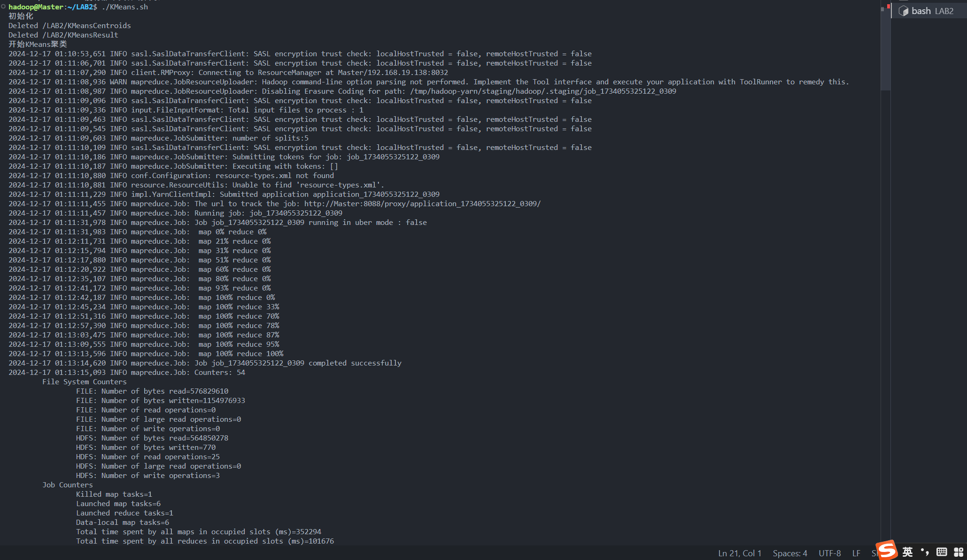
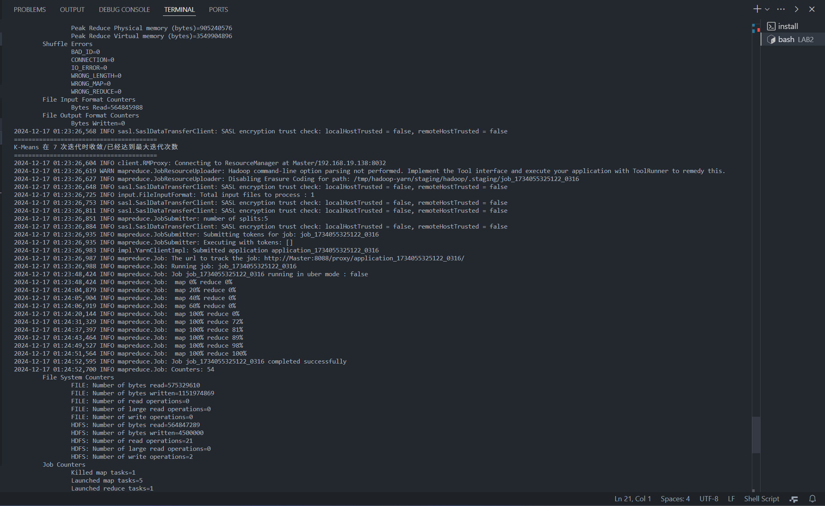
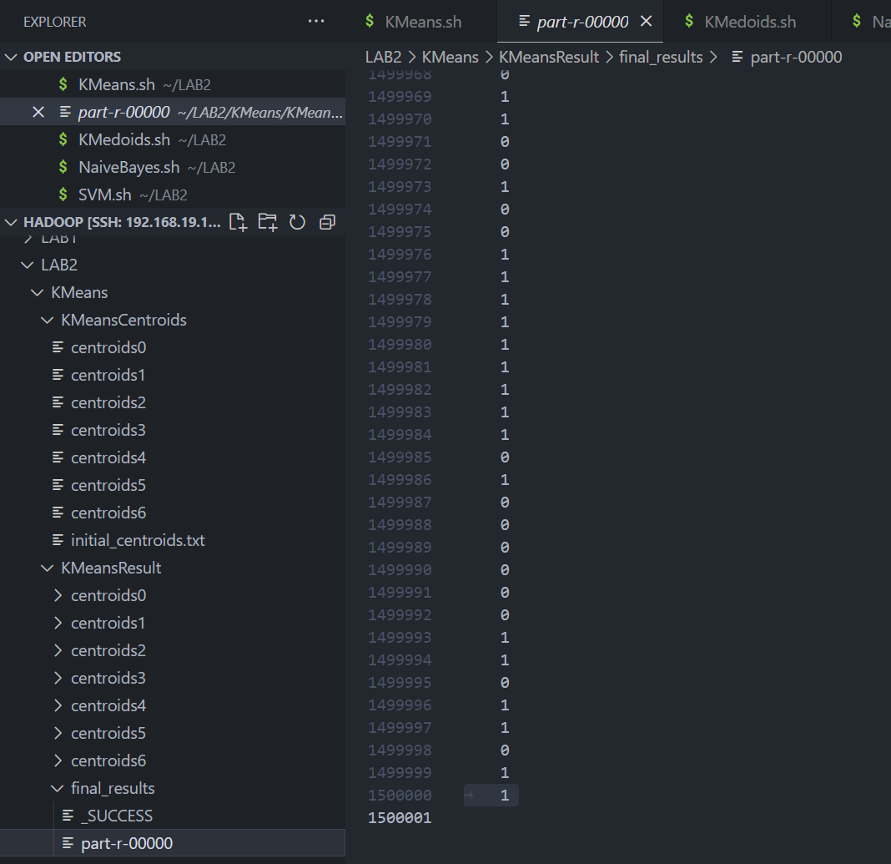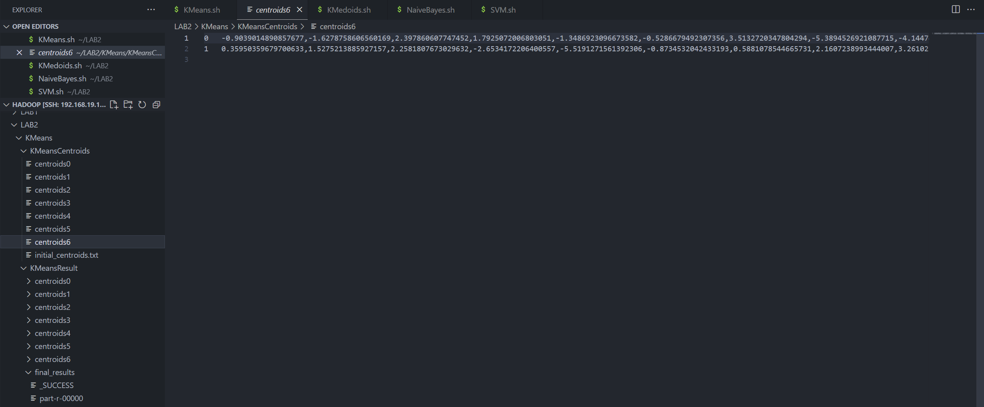

3.2 KMedoids算法
KMedoids.sh：
#!/bin/bash
echo "初始化"
hdfs dfs -rm -r /LAB2/KMedoidsResult
hdfs dfs -rm -r /LAB2/KMedoidsCentroids
echo "开始KMedoids聚类"
# 输入路径 输出路径 K值 最大迭代次数 收敛阈值 PAM抽样个数（按照比例抽的话，尝试了10%、1%、0.1%以及0.05%，还是难以在hadoop认为任务超时之前完成计算）
hadoop jar ~/LAB2/BigDataAnalysis.LAB2-4.0-FinalVersion.jar org.KMedoids.KMedoidsJob hdfs:///LAB2/聚类数据.txt hdfs:///LAB2/KMedoidsResult 2 10 0.1 1000
echo "KMedoids聚类完成"
hdfs dfs -ls /LAB2
hdfs dfs -get /LAB2/KMedoidsCentroids ~/LAB2/KMedoids
hdfs dfs -get /LAB2/KMedoidsResult ~/LAB2/KMedoids
# yarn logs -applicationId application_1733723983930_0001 > temp1.log
因为跑起来比较费时，所以下面的截图用的是当时写完跑的截图：
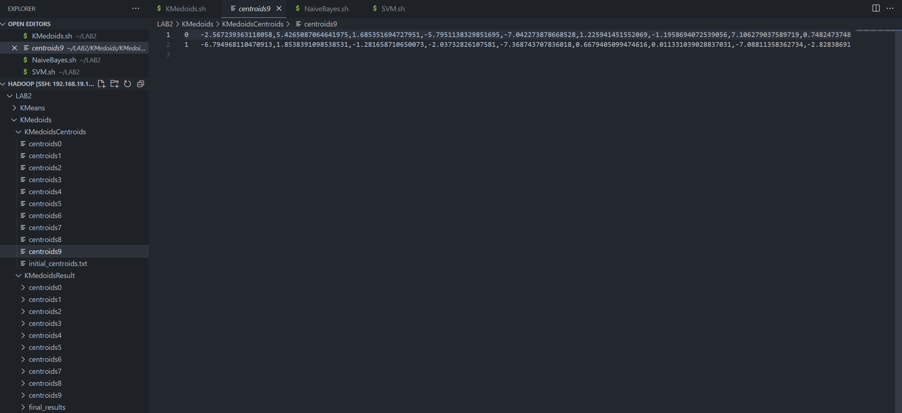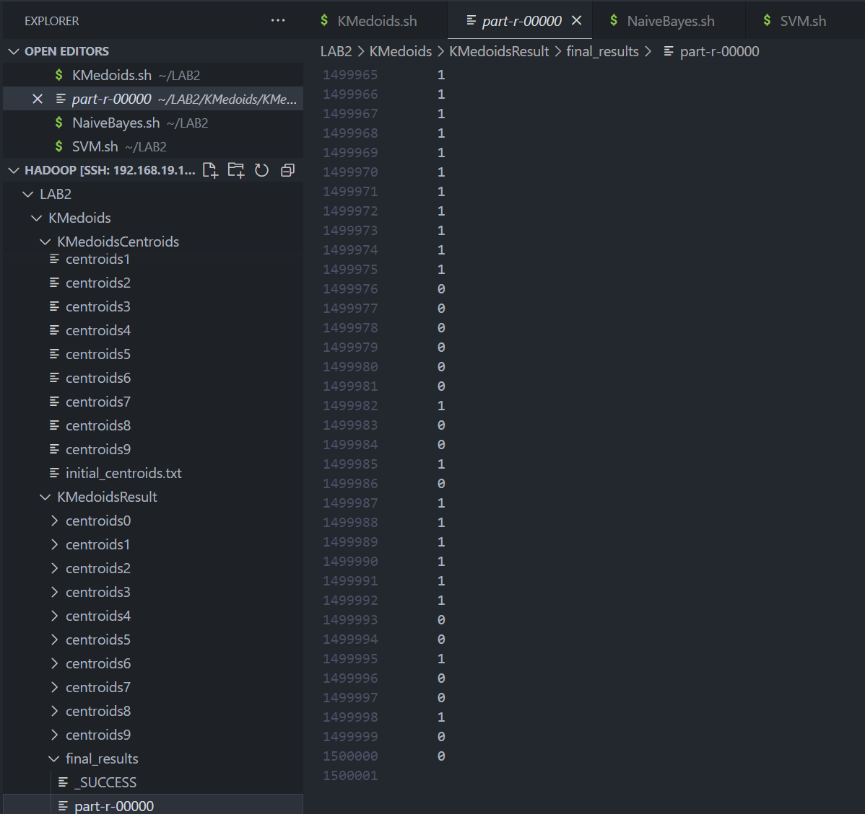

3.3 朴素贝叶斯算法
NaiveBayes.sh：
#!/bin/bash
echo "初始化"
# hdfs dfs -rm -r /LAB2/NaiveBayesModel
hdfs dfs -rm -r /LAB2/NaiveBayesValidationResult
hdfs dfs -rm -r /LAB2/NaiveBayesTestResult
# echo "开始训练NaiveBayes模型"
# hadoop jar ~/LAB2/BigDataAnalysis.LAB2-4.0-FinalVersion.jar org.NaiveBayes.NaiveBayesJob hdfs:///LAB2/训练数据.txt hdfs:///LAB2/NaiveBayesModel train
# echo "NaiveBayes模型训练完成"
echo "开始验证NavieBayes模型"
hadoop jar ~/LAB2/BigDataAnalysis.LAB2-4.0-FinalVersion.jar org.NaiveBayes.NaiveBayesJob hdfs:///LAB2/验证数据.txt hdfs:///LAB2/NaiveBayesValidationResult validate
echo "NaiveBayes模型验证完成"
echo "开始测试NaiveBayes模型"
hadoop jar ~/LAB2/BigDataAnalysis.LAB2-4.0-FinalVersion.jar org.NaiveBayes.NaiveBayesJob hdfs:///LAB2/测试数据.txt hdfs:///LAB2/NaiveBayesTestResult test
echo "NaiveBayes模型测试完成"
echo "正在获取结果"
hdfs dfs -ls /LAB2
hdfs dfs -get /LAB2/NaiveBayesModel ~/LAB2/NaiveBayes
hdfs dfs -get /LAB2/NaiveBayesValidationResult ~/LAB2/NaiveBayes
hdfs dfs -get /LAB2/NaiveBayesTestResult ~/LAB2/NaiveBayes
运行结果：
模型参数、验证结果
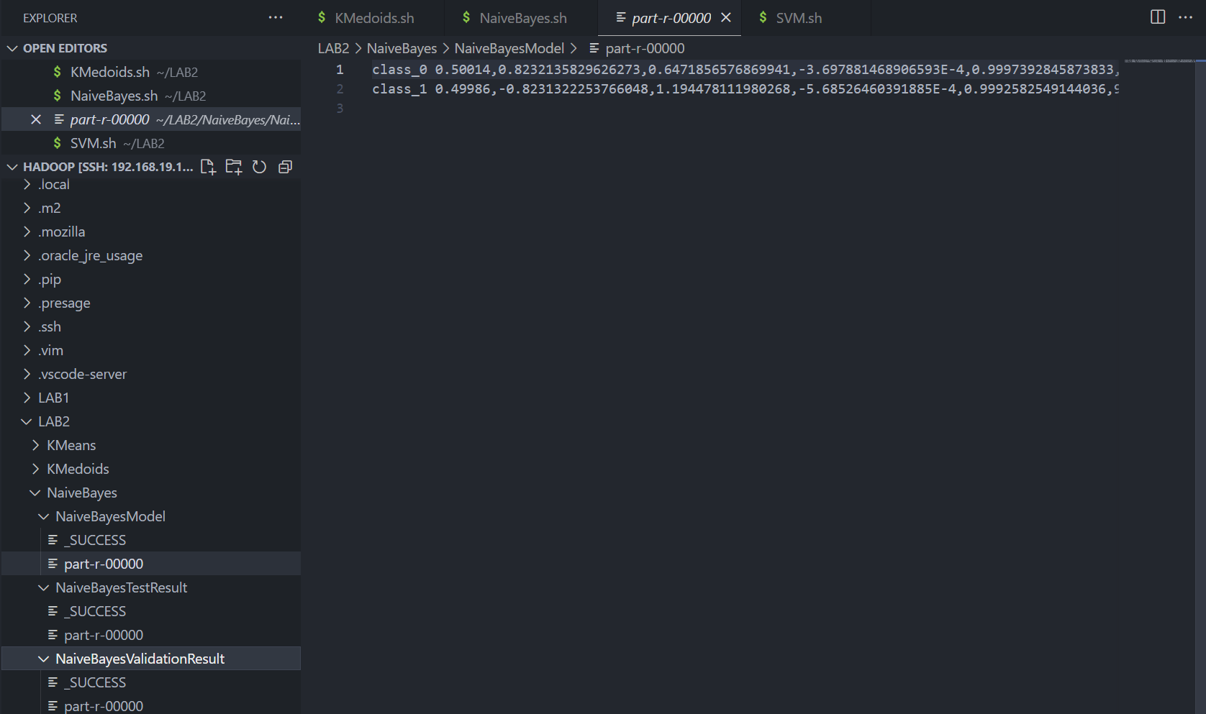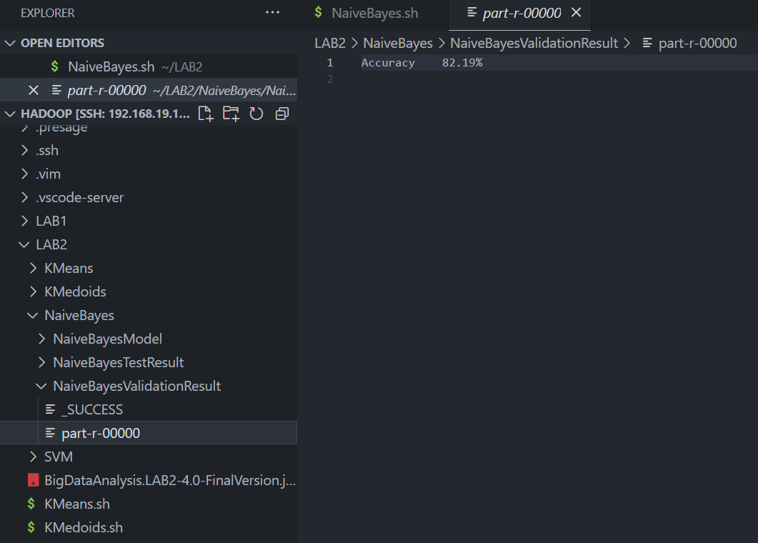
测试结果：
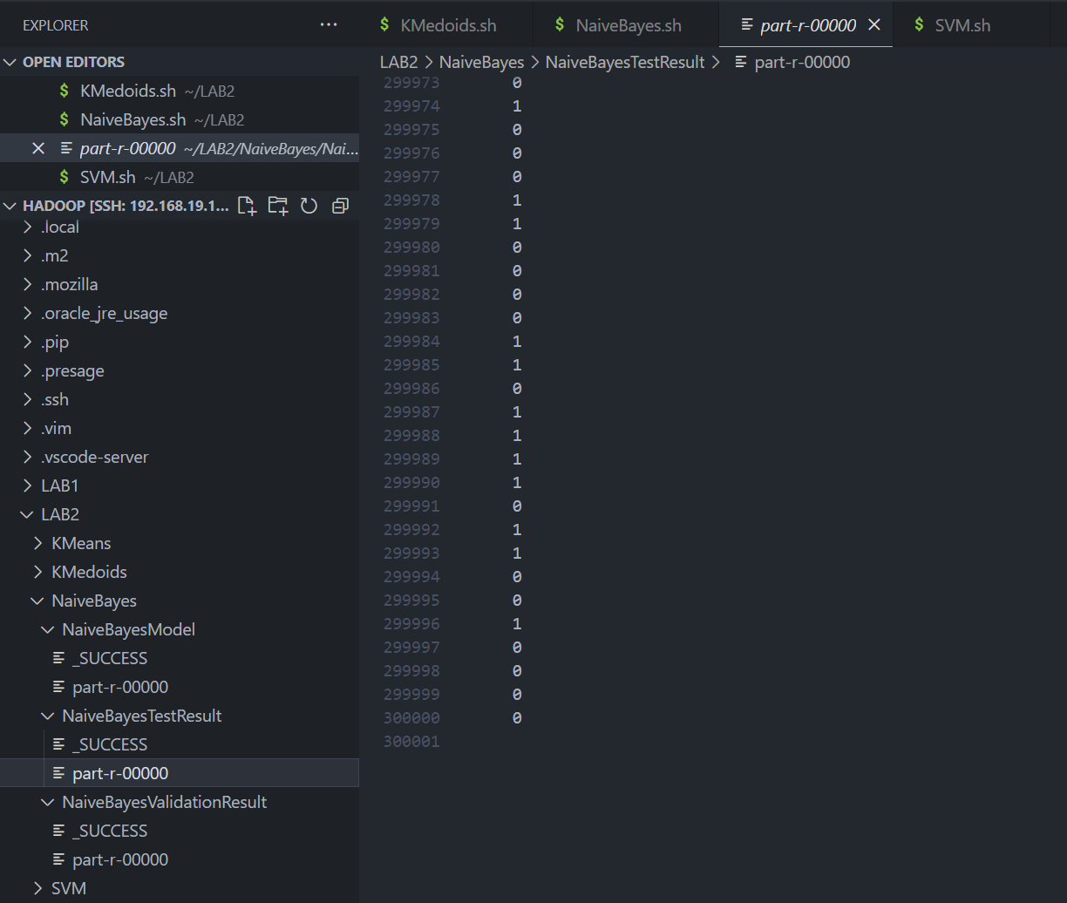

3.4 SVM支持向量机
SVM.sh：
echo "初始化"
# hdfs dfs -rm -r /LAB2/SVMTrain
hdfs dfs -rm -r /LAB2/SVMValidationResult
hdfs dfs -rm -r /LAB2/SVMTestResult
hdfs dfs -ls /LAB2
# echo "开始训练SVM"
# hadoop jar ~/LAB2/BigDataAnalysis.LAB2-4.0-FinalVersion.jar org.SVM.SVMJob hdfs:///LAB2/训练数据.txt hdfs:///LAB2/SVMTrain train 0.005 100
# echo "SVM训练完成"
echo "开始验证SVM"
hadoop jar ~/LAB2/BigDataAnalysis.LAB2-4.0-FinalVersion.jar org.SVM.SVMJob hdfs:///LAB2/验证数据.txt hdfs:///LAB2/SVMValidationResult validate 0.001 10
echo "SVM验证完成"
echo "开始测试SVM"
hadoop jar ~/LAB2/BigDataAnalysis.LAB2-4.0-FinalVersion.jar org.SVM.SVMJob hdfs:///LAB2/测试数据.txt hdfs:///LAB2/SVMTestResult test 0.001 10
echo "SVM测试完成"
echo "正在获取结果"
hdfs dfs -ls /LAB2
hdfs dfs -get /LAB2/SVMTrain ~/LAB2/SVM
hdfs dfs -get /LAB2/SVMValidationResult ~/LAB2/SVM
hdfs dfs -get /LAB2/SVMTestResult ~/LAB2/SVM
# 日志调试调取(调试用)
# yarn logs -applicationId application_1734055325122_0003 > temp1.log
运行结果：
模型参数、验证结果：
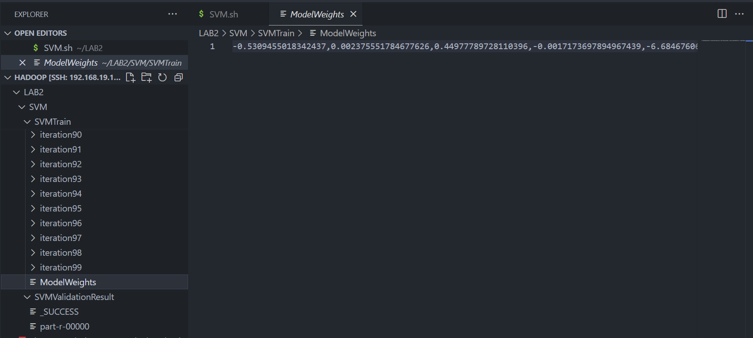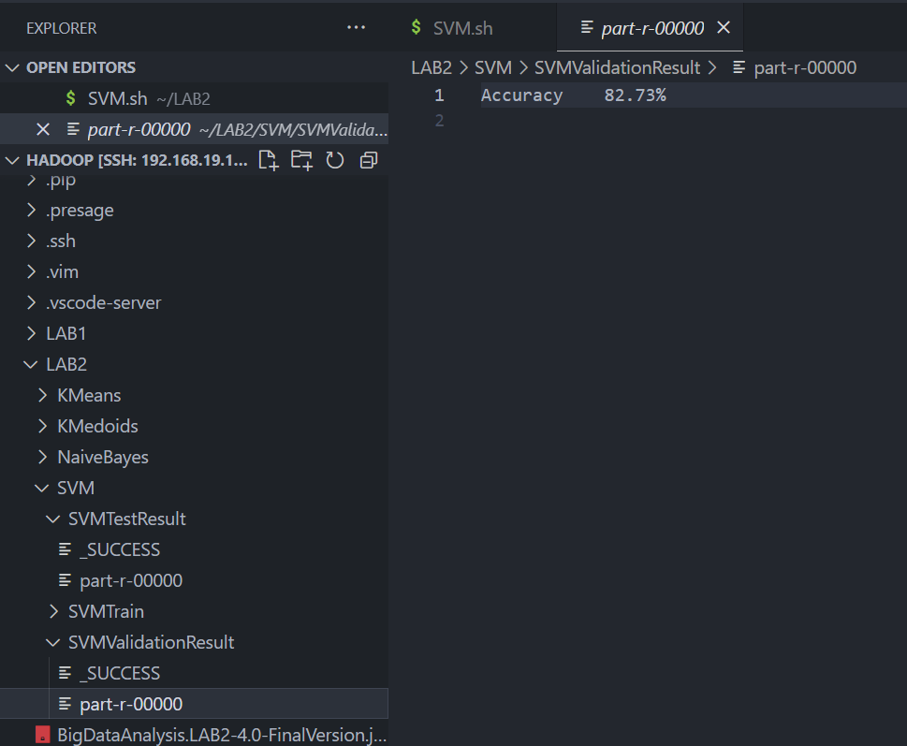
测试结果：

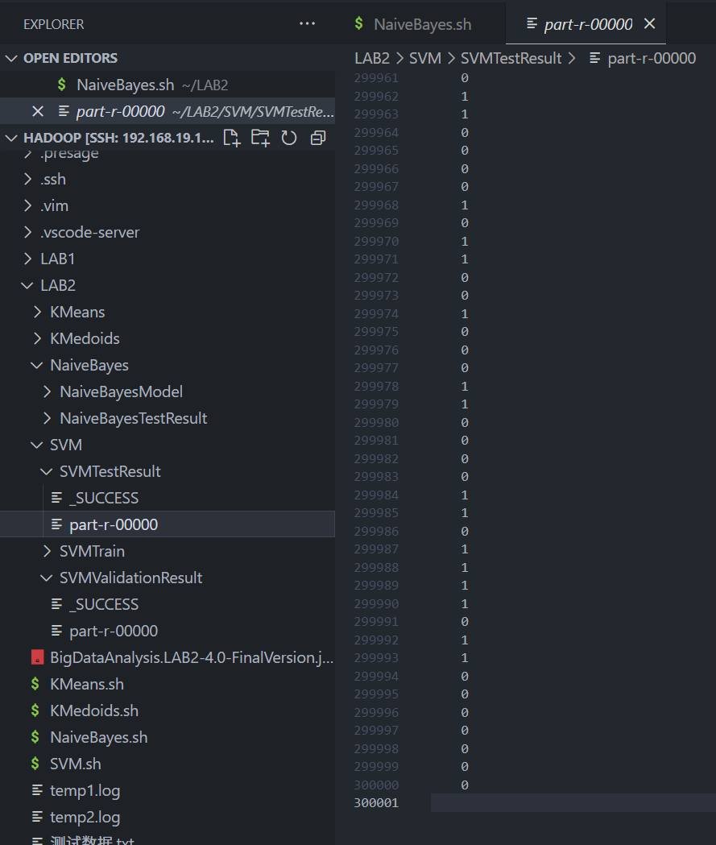

四、实验心得
这个实验主要遇到了两个问题：一个是计算规模问题，还有一个是SVM的训练（这个不算是问题，但是我想拿出来讨论）
- 计算规模：
主要出在聚类算法基于MapReduce的实现上面，我当时做的时候其实是有点怀疑的——除了KMeans之外，KMedoids、DIANA以及AGNES这三个聚类算法真的适合基于MapReduce框架实现吗？这三个算法都涉及每个数据点的重复利用——这导致数据读进来之后因为后面还有用的地方，使得Java没法内存回收，进而导致最后把整个数据集都读进内存里面了，那这和没有基于MapReduce框架实现的算法有什么区别？（大家都把整个数据集读到内存里面处理了，我认为MapReduce框架最理想的就是“流”式，数据进来处理完后面不再引用，就被回收内存了，使得执行过程当中数据集没有整个同时存在内存里面）
我本来是实现DIANA的，但是DIANA需要对每个点计算到新的簇和旧的簇的平均相异度的，这导致计算量异常大，尝试了多线程加速计算过程，但是还是没能够在hadoop认为作业超时，重启作业之前计算完成。
后来实现了KMedoids，使用PAM方法，也是遇到了上述的情况，后面选择随机PAM方法，抽样比例从1%-0.1%-0.05%，都会超时，最后选择限制抽样数量为1000，最后能算，但是因为抽样样本很少，导致随机性比较大，很难收敛。

- SVM训练
我尝试了两种方法来训练SVM：一，较大的学习率（1%-0.5%），较少的迭代次数（上限：10）；二，较小的学习率（0.01%-0.005%），较多的迭代次数（上限：100）。最终都发现Hinge函数的loss在30w左右，但是因为使用的是Java，所以图省事没有实现一个优化器，我认为一个学习率逐步衰减的优化器或许可以让结果更好。

