|  |  |  |
| --- | --- | --- |
| *p* | *q* | *p* v *q* |
| F | F | F |
| F | T | T |
| T | F | T |
| T | T | T |

Logical OR Table

Step #2 (Set Input Data)

F = 0 / T = 1

|  |  |  |
| --- | --- | --- |
| *p* | *q* | *p* v *q* |
| 0 | 0 | 0 |
| 0 | 1 | 1 |
| 1 | 0 | 1 |
| 1 | 1 | 1 |

Step #3 (Set Actual Labels)

|  |  |  |
| --- | --- | --- |
| *p* | *q* | *p* v *q* |
| 0 | 0 | 0 |
| 0 | 1 | 1 |
| 1 | 0 | 1 |
| 1 | 1 | 1 |

Step #5 (Define the Connections Weight Matrix)

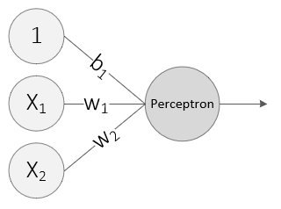

Step #6 (Create the Variable for the Bias)



Step #7 (Create the Perceptron)

