**Headline: Over-50000 acres burned wildfire since 1984**

Data: fire-events.csv

wildfire.csv

**Part one:**

**All the wildfire since 1984**

**Data: fire-events.csv**

sketch 1

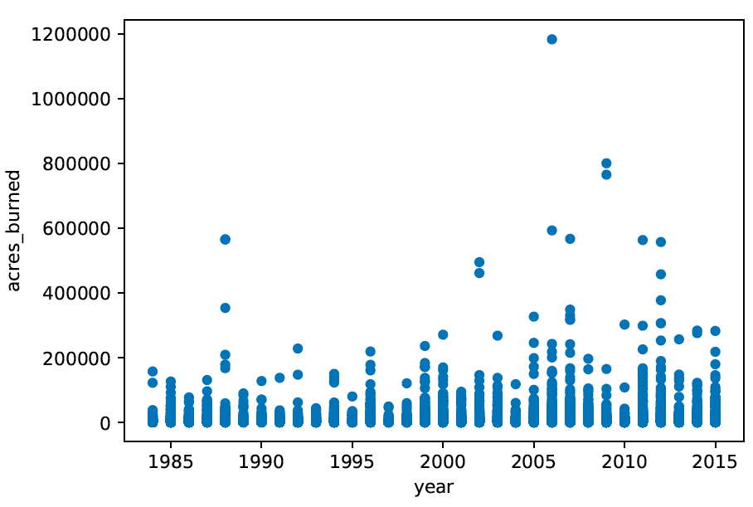

xPositionScale: (d.year)

yPositionScale: (d.acres_burned)

sketch 2

line chart

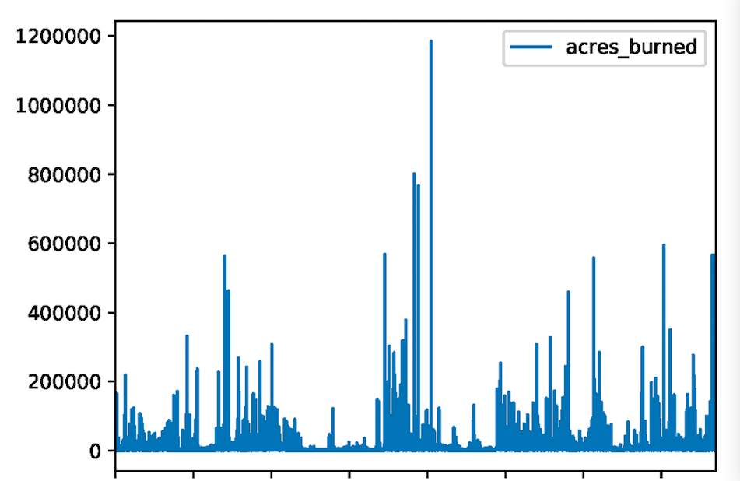

xPositionScale: (d. na_l3name)

yPositionScale: (d.acres_burned)

I prefer sketch 1, it’s easier to see the trend with year.

**Part 2:**

**Over-50000 acres burned wildfire**

**Data: wildfire.csv**

Sketch 1

Like <https://www.nytimes.com/interactive/2017/09/01/upshot/cost-of-hurricane-harvey-only-one-storm-comes-close.html?_r=0>

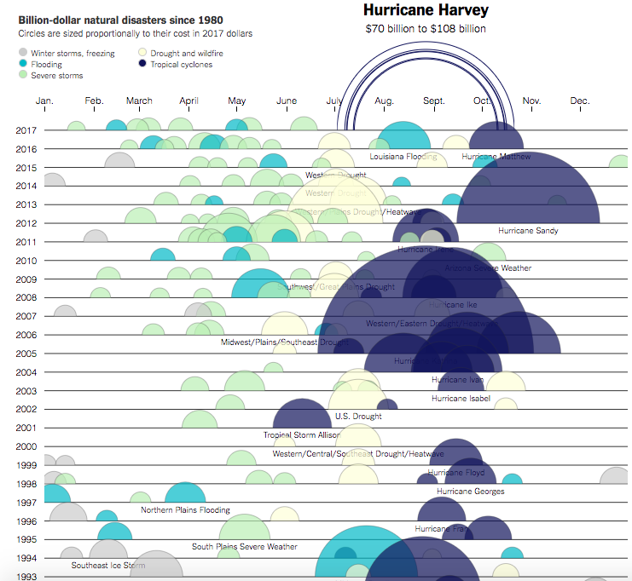

xPositionScale(d.month)

yPositionScale(d.year)

radiusScale(d.acres_burned)

legend is number of acres burned (from light to dark red)

when hover, give tip like:

**level 3 ecoregion names(na_l3name)**

**number of acres burned(acres_burned)**

mean daily maximum air temperature (max_air_temp)

mean daily wind speed (mean_wind_speed).

sketch 2

**mapping the incidents**

like one part of reporting about mass shooting from Washington post: <https://www.washingtonpost.com/graphics/national/mass-shootings-in-america/?tid=pm_graphics_pop_b>

in the top of map, set a time slider(from 1984-2015) to show the change

when hover, give tip like:

**level 3 ecoregion names(na_l3name)**

**number of acres burned(acres_burned)**

mean daily maximum air temperature (max_air_temp)

mean daily wind speed (mean_wind_speed).

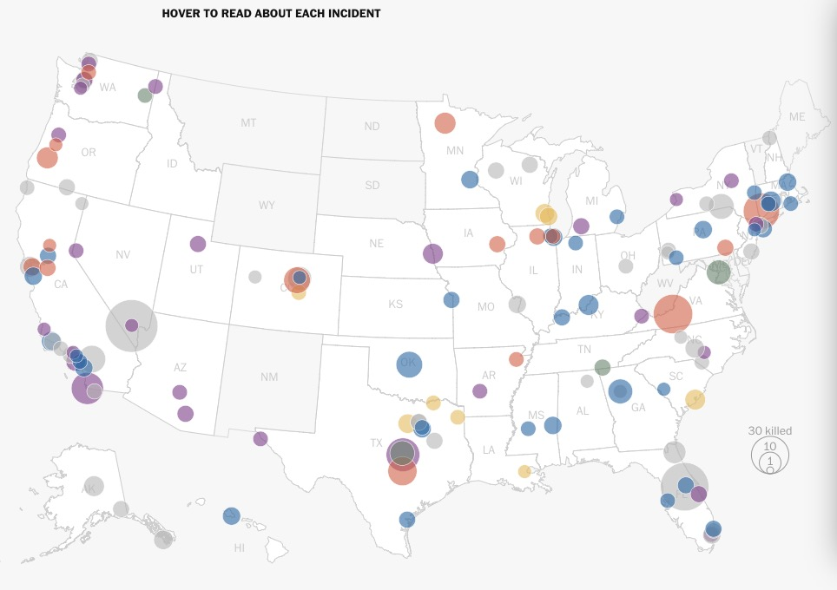

I prefer sketch 1, give more direct impression and more creative(maybe)