COMP0028 Computational Photography and Capture

Coursework 1: Restoration of Old Movies

This report will demonstrate the algorithms implemented for the restoration of old movies. There are five main tasks included in this coursework, scene cut detection, global flicker correction, blotch correction, vertical artefact reduction and camera shake calibration. The demonstration will contain both images and source codes.

Scene Cut Detection
The basic idea of detecting whether the scene has been cut from the perspective of image processing is to check how much the current frame changes compared with the previous or next frame. One potential way to do so is to count how many pixels have changed given specific threshold value; however, this may produce errors when situations such as sudden intensity change happen between two frames. Therefore, here we focus on how much the value changes rather than the number of pixels by comparing current frame with both previous frame and next frame (if available) since their difference will not be large given that they are all it a continuous sequence. If the difference between the previous and current frame is suspiciously larger than the difference between the current frame and next frame, we mark such a transition as the scene cut. The algorithm is provided below:

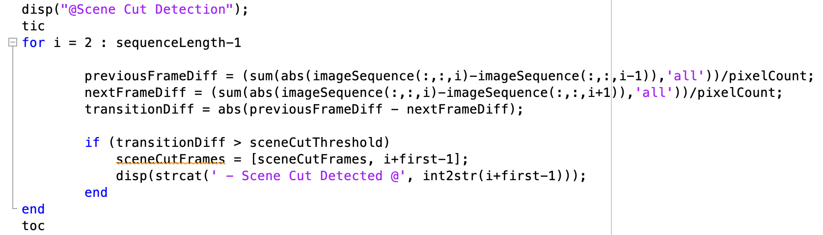

This method will detect the frame before the change, and after the change thus the returned value will be a pair. We can simply remove frames at odd index if we only need the frame after the scene cut. The limitation here is that the threshold is highly dependent on the content of the movie. The textual notification of scene cut will be overlayed to the detected frame after all tasks are completed:

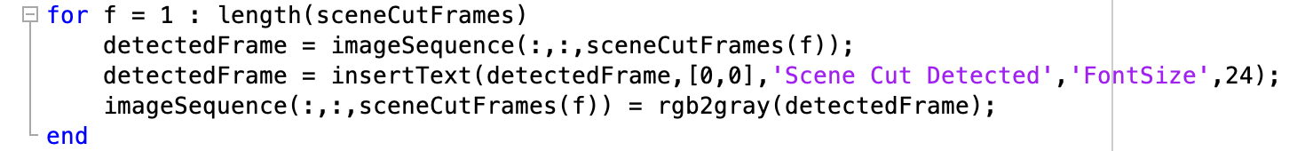

Global Flicker Correction
The global flicker happens when the frame has a sudden intensity change that can be easily observed. The main idea to alleviate or correct it is to adjust the contrast of the target frame so that it matches those unaffected frames. This becomes tricky because errors will occur if we randomly select a frame as the reference image for intensity/contrast matching. If we pick a frame that already has intensity flicker, then use it as the reference image, all the other frames will be incorrectly adjusted. Therefore, we choose to take the average intensity value of neighbouring frames as the reference value and use it to adjust the target frame.

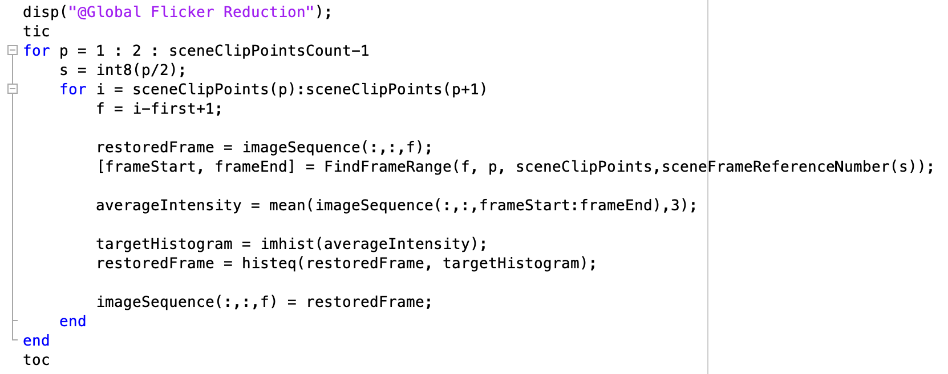

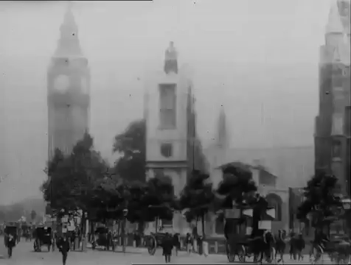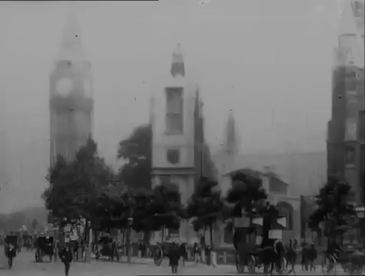
Original image and corrected image at frame 257

Blotch Correction
The blotch is one of common types of artefacts that suddenly appears as dark or bright spots in the sequence. The blotch can be detected by comparing the pixel value between two frames; this can be done by taking the absolute value of their difference and checking against the threshold. If the change of pixel value is too big, then we can mark this pixel as the blotch. However, the moving objects in the scene can also trigger the detection since the neighbour pixels of moving objects are continuously changing frame by frame thus they introduce false blotches. Therefore, the motion detection is a necessary step for correctly detecting blotches and correcting them.

It takes a few steps to generate the motion mask. The first step is to find the moving objects in the scene. This can be done by summing up the difference between every two frames and then using a threshold to extract their rough boundaries. Next is to fill the area by blurring the boundary and expand it using filters and dilate operations. The result can be seen here:

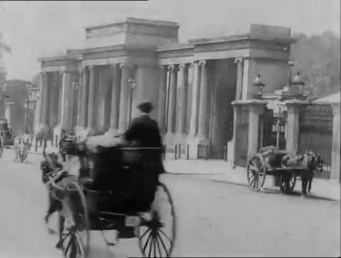
Original image and its motion mask at frame 25

The shape is not exactly same as the moving object however it does have a good coverage of it. The refined blotch mask can then be computed by subtracting motion mask from the unprocessed blotch mask, and blotches therefore can be corrected by replacing the blotch area with average pixel values from its neighbouring frames. Here are some results:

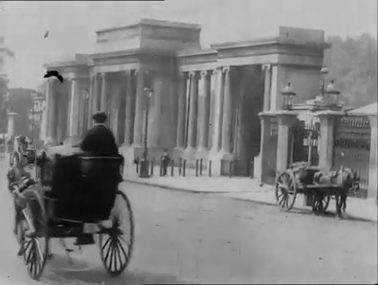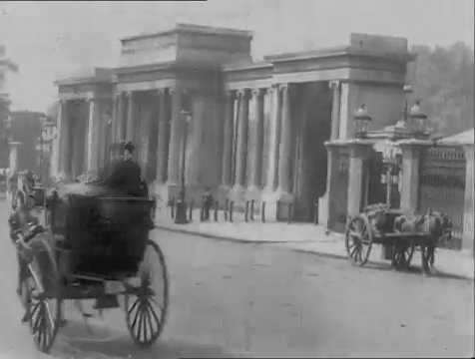
Original image and corrected image at frame 39

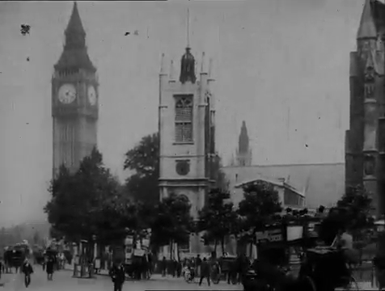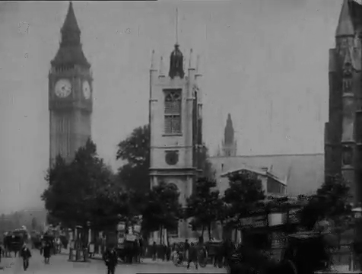
Original image and corrected image at frame 402

Vertical Artefact Reduction
vert

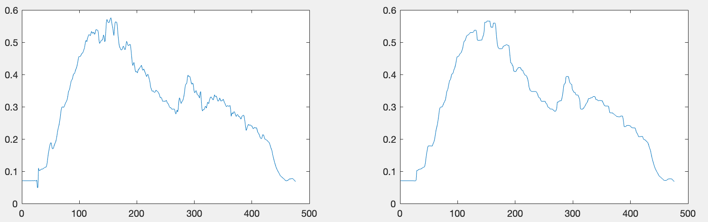
Original curve and smoothed curve at frame 497

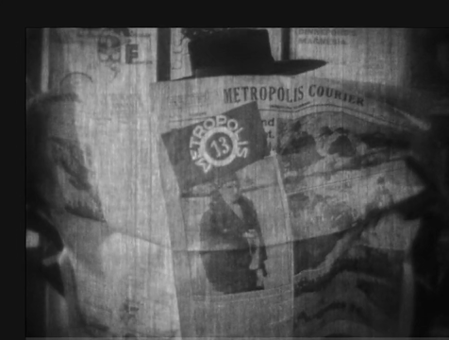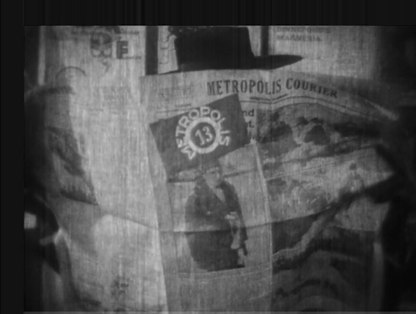
Original image and artefact reduced image at frame 497

Camera Shake Calibration
Camera shake will produce unstable video footage. In order to correct it, frames that are in the same scene need to be correctly aligned so that the camera can appear as static. The basic idea here is to find the reference points in the previous frame and current frame and then shift the current frame so that these reference points are well overlapped. After doing some background study, we have figured out that there can be many ways to perform such a task: phase correlation, block matching and feature matching, and all of them require reference images to process frames that contains camera shake.

Similar to global flicker correction, the selection of reference frame is very important because if the reference image contains camera shake then the adjustment will be incorrect. Therefore, here we generate the reference image by computing the average of all frames within the current scene.

The result can be seen here:
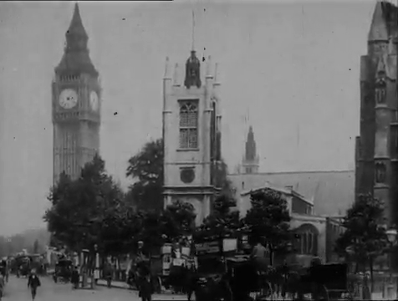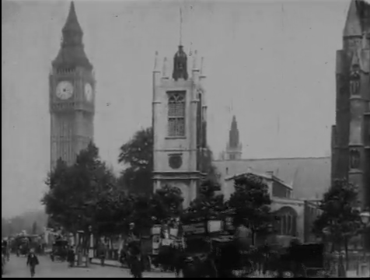
Original image and shifted image at frame 463

The image has been shifted to the top and right a little bit to match the original camera spot.

