COMP0028 Computational Photography and Capture

Class Project (Part 1): Structured Light Depth Acquisition

This report will demonstrate the implementation of the algorithms and the result analysis of the structured light depth acquisition. The given tasks are categorised by the dataset type under three main sections: synthetic dataset, provided real dataset and captured dataset. The demonstration will contain both images and core code segments. Full documentation is available in source files.

Synthetic Dataset
This task requires us to implement core functions for 3D reconstruction and camera calibration, starting with simple synthetic datasets. Because these implemented functions are the standard of the following tasks, this section will demonstrate the steps and strategies we take and as detailed as possible.

Reconstruction with Provided Matrix
The first task of reconstructing the scene is to decode light patterns so that we can obtain the UV information for following computations. To do so, we need to load image sequences that have structured light information and convert them into grayscale, since we aim to deal with binary grey codes. Given the fact that loading such a number of coloured images (especially for real-life photos) will use too much memory, thus for each image in the image sequence, we turn it into grayscale before storing it into the variable. The modified load_sequence.m is included under the project folder.

The next step is to decode the light patterns using the image difference of 20 pairs of images that contain structured light information for U and V. The information will first be stored as binary codewords, which have ten digits. We will convert them to decimal values later. The basic algorithm is that for each pair of U and V, we compute the image difference and determine the binary codeword based on the obtained value. For a pixel (x,y) on the image, if the difference is a positive value, it means that at this pixel, the first image has a higher intensity than the second image, thus we assign the 1 to the codeword. If it is negative, then we assign 0. As suggested in the coursework instruction, we need to eliminate unreliable pixels based on the grey code. If the image difference at a pixel is not significant, for example, black – white → high contrast, grey – white/black → not significant contrast. If the value is lower than a threshold, we mark this pixel as unreliable and set it to negative 1 as the background. As suggested in Scharstein & Szeliski’s paper ^{[3]}, it is not reliable to distinguish light patterns on the surface with varying albedos using difference and inverse. One better way to solve this issue is to sum up the absolute difference of 10 results and if the sum is still below a specific threshold, then we mark this pixel as unreliable and assign a value of negative 1.

The last step is to convert binary codewords to decimal values. This can be easily done by multiplying the codeword with a matrix that defines the value for each digit of a binary sequence: $[2^{0} 2^{1} 2^{2} 2^{3} 2^{4} 2^{5} 2^{6} 2^{7} 2^{8} 2^{9} ]$. The algorithm demonstrated above is available in DecodeUV.m and here we have the result below:
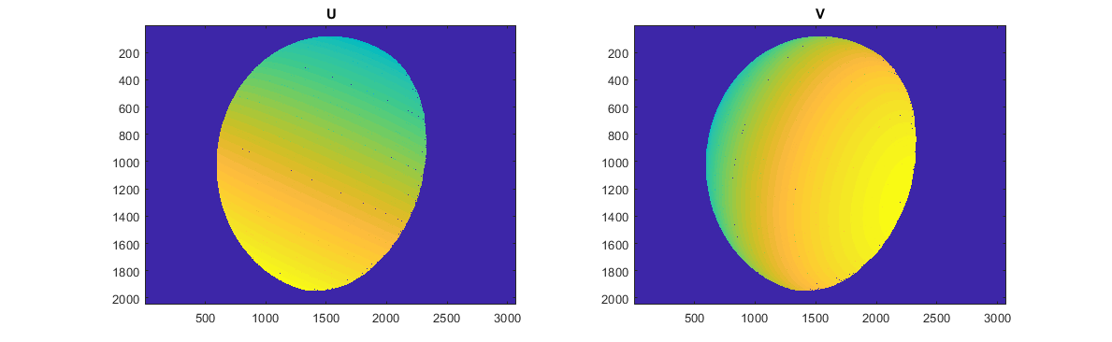
Figure 1.1 Decoded UV information of “sphere_T”

As shown in Figure 1.1, the UV information is successfully extracted from the light patterns and some unreliable pixels are rejected (they are artefact-looking pixels on the surface in the graph). The result is not quite obvious when we apply it to synthetic datasets; however, it makes a huge difference when it comes to real-life datasets and we will discuss this in next two tasks.

The next task of the reconstruction is to generate the depth map with our UV information using calibration matrix, which is provided in this task. As described in week2’s lab session, the position of 3D point in the world can be computed by minimising the reprojection error of the distance between the projected 3D point and measured 2D point:
$$\hat{w}={argmin}_{ω}\left[\sum_{j=1}^{J}{{(x_{j}-pinhole[ω,Λ_{j},Ω_{j},τ_{j}])}^{T}(x_{j}-pinhole[ω,Λ_{j},Ω_{j},τ_{j}])}\right]$$
And the corresponding w is given by:

$$λ_{j}\left[\begin{matrix}x_{j} \\ y_{j} \\ 1\end{matrix}\right]={=Λ}_{j}\left[\begin{matrix}Ω_{j3×3} & τ_{j3×1} \\ 0_{1×3} & 1\end{matrix}\right]\left[\begin{matrix}x_{3×1} \\ 1\end{matrix}\right]$$
Where $x=\left[\begin{matrix}u \\ v \\ w\end{matrix}\right]$, and this can be treated as a SLE that solves $Ax=b$. Detail algorithm can be found in Simon Prince’s algorithms booklet, Page 45, Algorithm 14.3: Inferring 3D world points (reconstruction) and our implementation is based on this algorithm.

The last task of the reconstruction is to convert obtained data into point cloud so that we can actually visualise them. To do so, we need to first determine how many points the output file requires. This can be done by counting the number of reliable pixels in the UV information. Then we need to generate a n-by-3 matrix to store point cloud, where the 3 slots will be used to store the coordinates of the point (vertex). Afterwards, we simply use MATLAB’s built-in function fprintf() to write our data as a text file and save it as a .ply format for visualisation using external software like MeshLab. The full implementation of depth map and point cloud generation is available in ComputeDepthMap.m. The results are provided below:
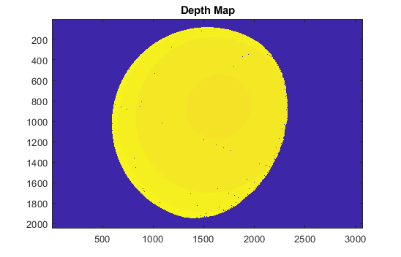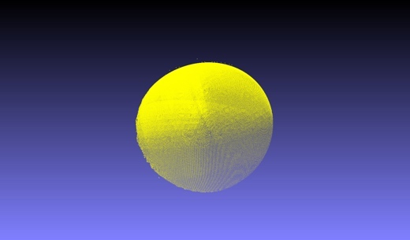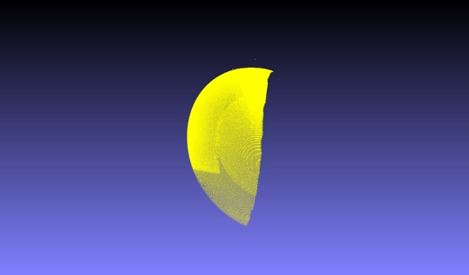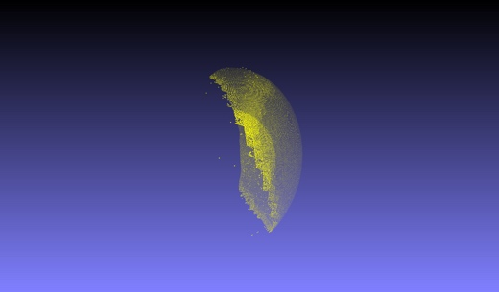
Figure 1.2 “Sphere_T1” depth map and reconstruction results

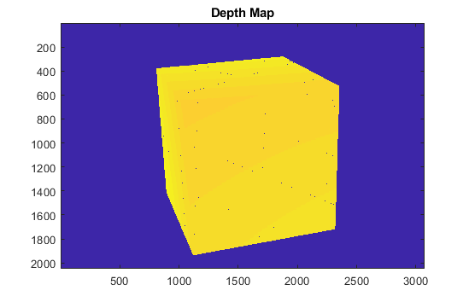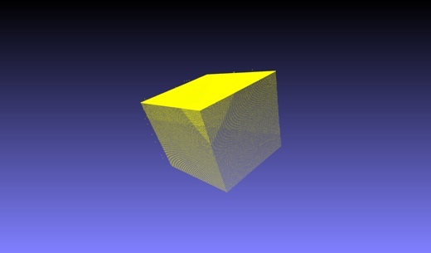
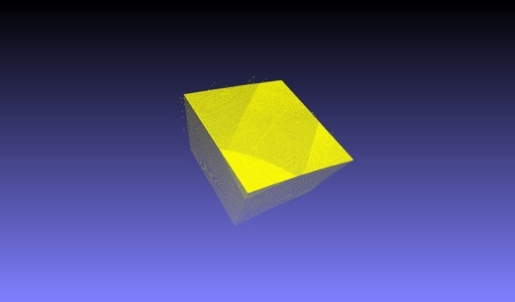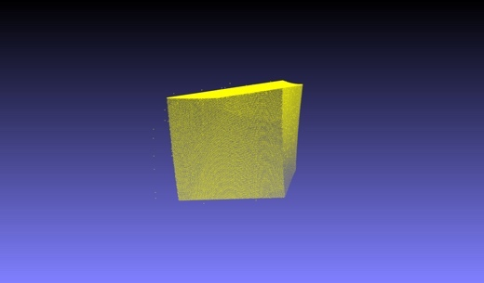
Figure 1.3 “Cube_T1” depth map and reconstruction results

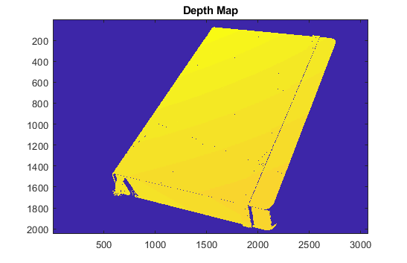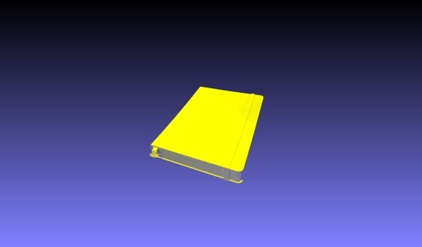
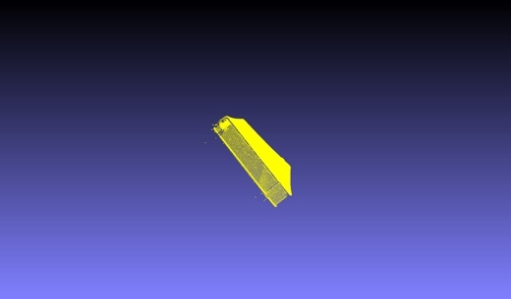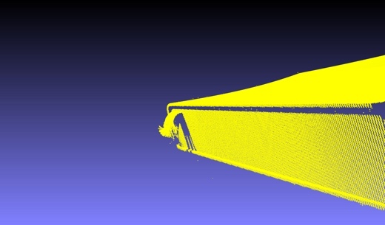
Figure 1.3 “Notebook_T1” depth map and reconstruction results
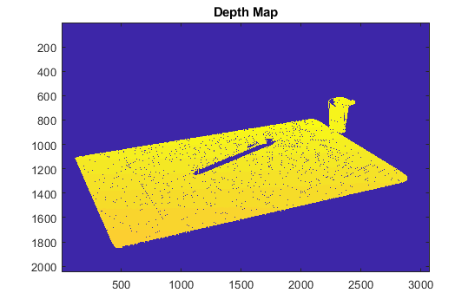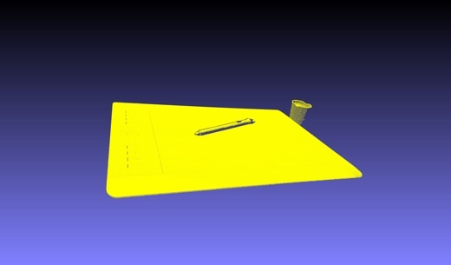
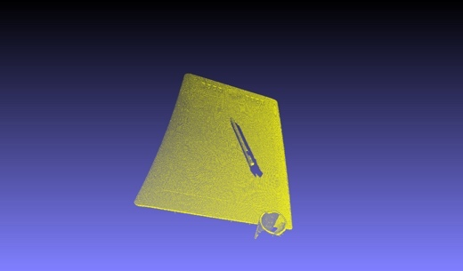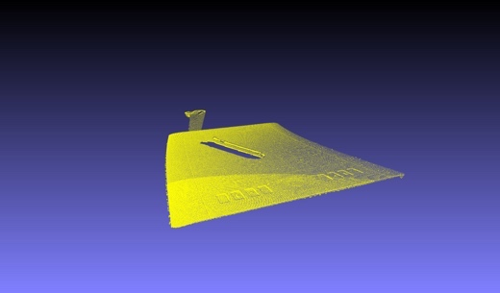
Figure 1.4 “Tablet_T1” depth map and reconstruction results

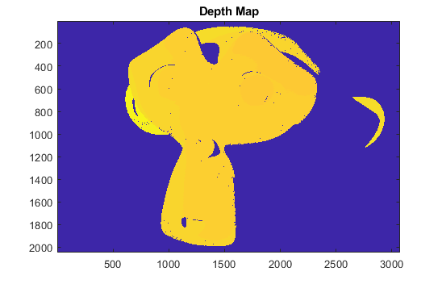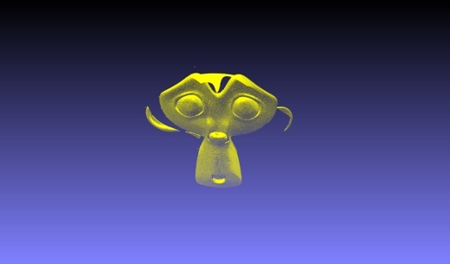
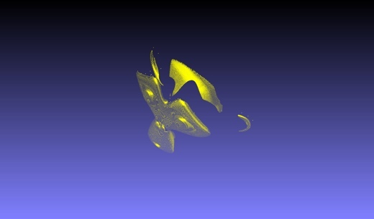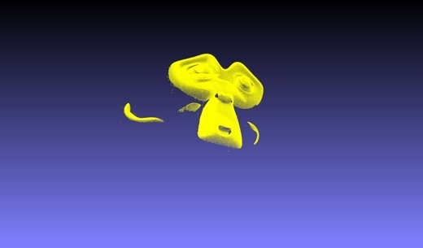
Figure 1.5 “Monkey_T1” depth map and reconstruction results

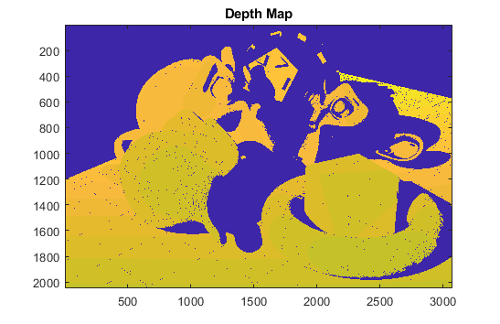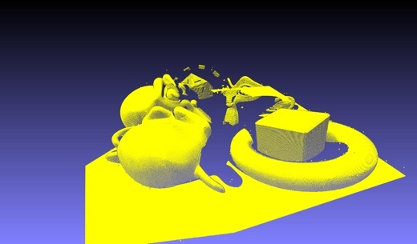
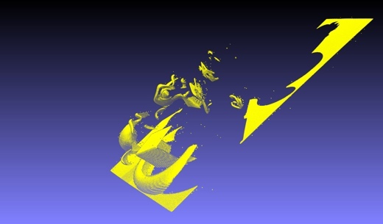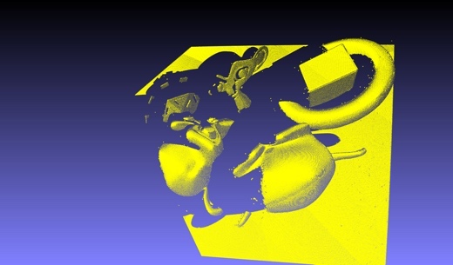
Figure 1.6 “Red_T1” depth map and reconstruction results
Camera Calibration
The camera calibration involves calibrations for camera view and projector view which give us access to their projection matrix for the reconstruction. The projection matrix of the camera view can be easily obtained from provided images with some tools while the projector view needs to be estimated. To retrieve the view from the projector, we need to first determine the transform from the flat checkerboard image to the distorted checkerboard image captured by a camera so that we can reproject the checkerboard for calibrating the projector. This can be done using the homography. Since we are given the coordinates of the checkerboard in a screen and its height and weight, it is possible to compute the coordinates of its four corners. With the same order, e.g. clockwise: top-left, top-right, bottom-right, bottom-left, we manually select four corners from images taken by the camera to establish the point correspondence. Given each pair of correspondence points $(p_{c},p_{s})$ , we construct a matrix $P_{i}$:

$$P_{i}=\left[\begin{matrix}\begin{matrix}0 & 0 & 0\end{matrix} & \begin{matrix}-x_{c} & -y_{c} & -1\end{matrix} & \begin{matrix}x_{c}y_{s} & y_{c}y_{s} & y_{s}\end{matrix} \\ \begin{matrix}-x_{c} & -y_{c} & -1\end{matrix} & \begin{matrix}0 & 0 & 0\end{matrix} & \begin{matrix}x_{c}x_{s} & y_{c}x_{s} & x_{s}\end{matrix}\end{matrix}\right]$$

We stack each $P_{i}$ together to construct a $2i×9$ matrix $P$, and aim to solve the SLE $PH=0$, where H is the homography we need to estimate. This can be done using SVD which gives $SVD\left(P\right)=USV^{T}$, and the last singular vectors of V will be the solution of H. This algorithm is implemented in EstimateHomography.m. The result is provided below:

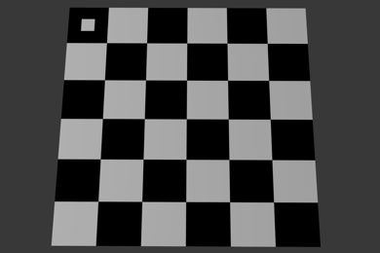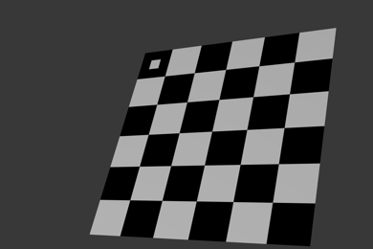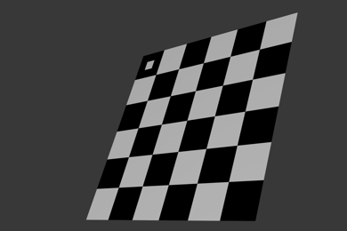
Figure 2.1 Checkerboards that need to be reprojected

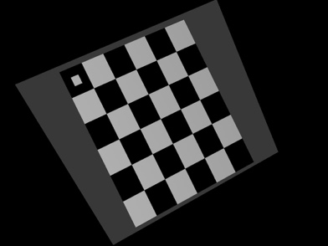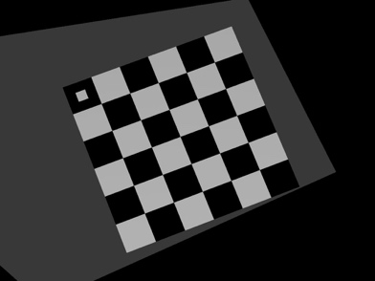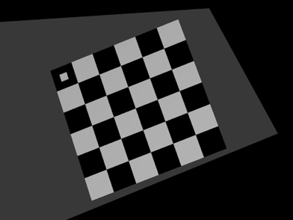
Figure 2.2 Reprojected checkerboard of the projector view

Since we have obtained checkerboard images from the camera view and the projector view, we can then utilise the MATLAB calibration toolbox introduced in week2’s lab to compute the intrinsic and extrinsic matrix, which are required for the reconstruction. This process has been explained in detail in the given lab tutorial thus here we only briefly demonstrate the steps. We simply load the checkerboards, mark the corners and specify the square number and its size if required, and then the toolbox will compute all related values for us. Once we save the calibrated data, we can extract the intrinsic matrix by inspecting the “KK” variable, and extrinsic matrix by combining pairs of “Rc_#” (rotation) and “Tc_#” (translation).

Reconstruction with Calibrated Matrix
The process is the same as reconstruction with provided matrix except that this time we use the calibrated matrix obtained from the previous step. Since the UV information has already been computed, we simply pass those two variables into our ComputerDepthMap() to get the new depth map and cloud point. Here we pick three results (notebook_T, tablet_T, monkey_T):

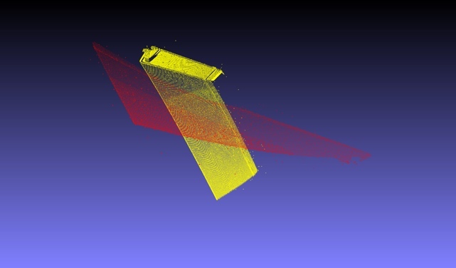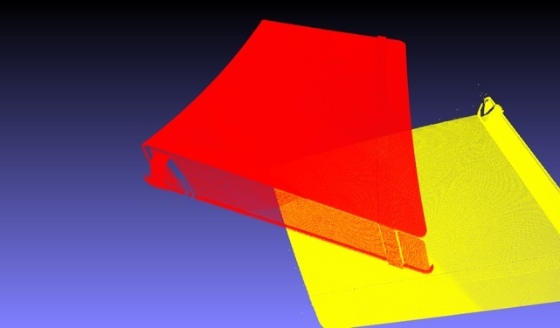
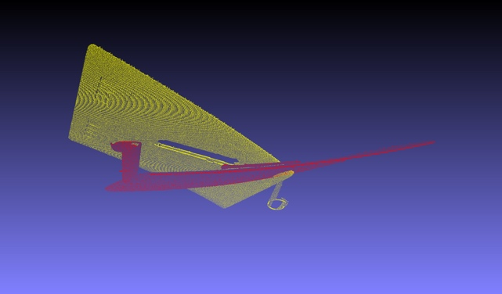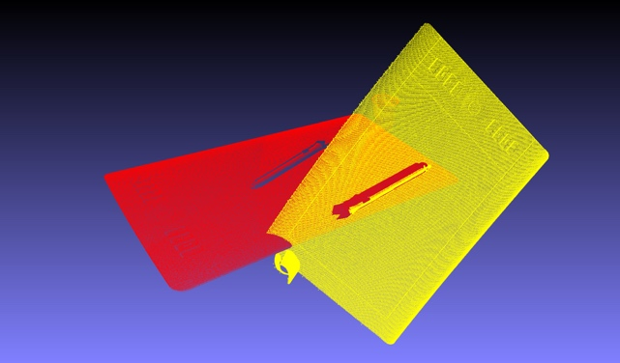
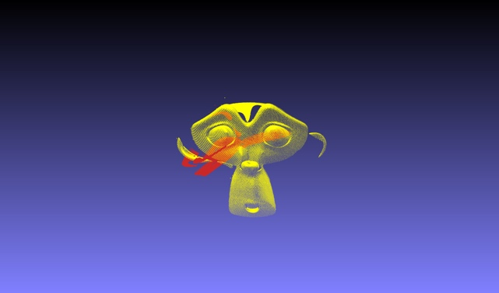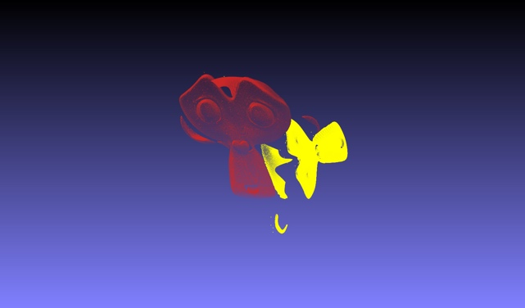
Figure 2.3 Result comparison

By comparing the point clouds obtained from different calibration matrix, we can notice that the rotation is not quite matching the provided matrix, though this can be manually adjusted. The reconstructed point cloud looks fine from some viewpoints, but it still suffers from distortion (like the cube_T from the previous task), for example, the surface of notebook and tablet, they look very curvy if we view them from the opposite side of the viewpoints in the right images. Additionally, it takes a lot of time to estimate the size of checkerboard since the default size is set as 100mm in calibration toolbox which returns us a gigantic point cloud. By inspecting the coordinate values, we noticed that the scale is about 400 times bigger than the result obtained with provided matrix, thus we need to set the checkerboard square size to approximately 0.025mm in order to compare both results. The distorted result may be caused by the bad calibration that occurs in three possible scenarios.

First, a slightly inaccurate reprojection may lead to such a result because we have to manually pick four corners from the image rather than the computer automatically detect them for us, thus we may not be able to reach the pinpoint accuracy for the homography estimation which also has the influence on the following reprojection process.

Secondly, calibrating and calculating using calibration toolbox also introduces some errors that give us incorrect result. For instance, we have tried calculating the intrinsic and extrinsic matrix many times but every time the calibration toolbox returns us different results and it is very inconsistent since we still have to manually mark the corner for corner extraction, and in some case, the calibration toolbox refuses to work because it thinks the image is not good enough for calibration (ill-conditioned error).

Thirdly, the calibration and reconstruction heavily rely on the camera view and projector view, as well as the mesh itself. If the image produced by camera and projector does not match well, more noises will be introduced to the scene and this has a very high chance of affecting the calibration and reconstruction process. Additionally, we are only provided with limited reference image for performing the given task, thus there is no chance to cherry pick some good images for a better calibration.

Real Dataset
This task requires us to use provided real-life images for the calibration and reconstruction.

Calibration
The calibration process is same as the method we use for synthetic datasets, except the combined calibration images. In previous task, the calibration images are split to still process them individually. First, we load all the calibration images and select four corners of the checkerboard on the right side. Then we calculate the homography and apply it to the same image (we make a copy of the image sequence named as target images). Then we will get a reprojected image for the projector view.

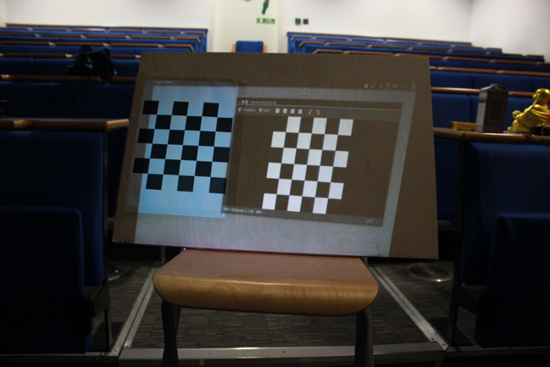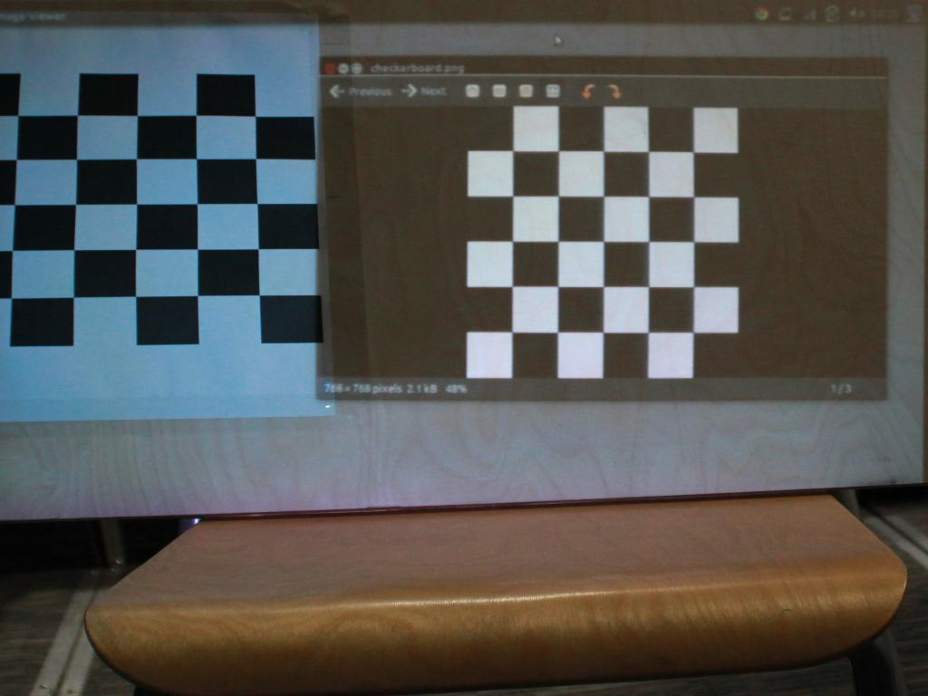
Figure 2.1 The reprojected checkerboard

As we can observe from the figure 2.1, the affixed checkerboard on the left side has been cropped out a bit because those parts are outside of the actual projector window. Therefore, for the following calibration, we will choose the bottom right 3(width) x 4(height) part of the checkerboard for corner extraction because they appear in all the reprojected images:

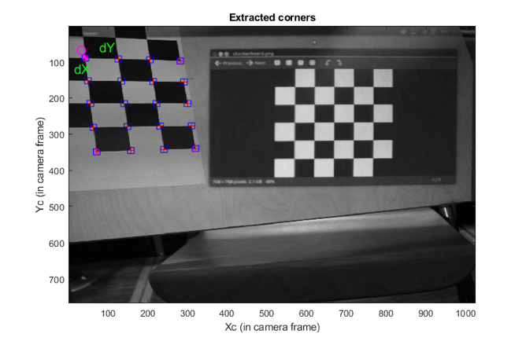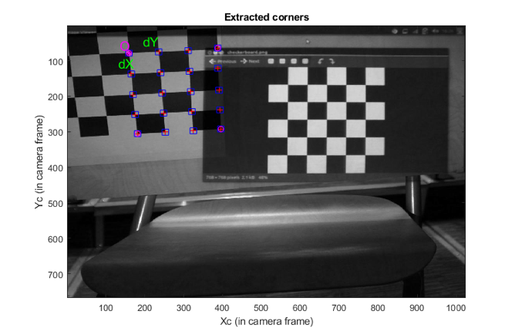
Figure 2.2 Corner extractions (camera) using calibration toolbox

Reconstruction
The reconstruction process is exactly same as the one in the previous task. First, we need to decode the light patterns in order to get the UV. As motioned in previous section, the unreliable pixel rejection makes a big difference for real-life images, and here is the comparison:
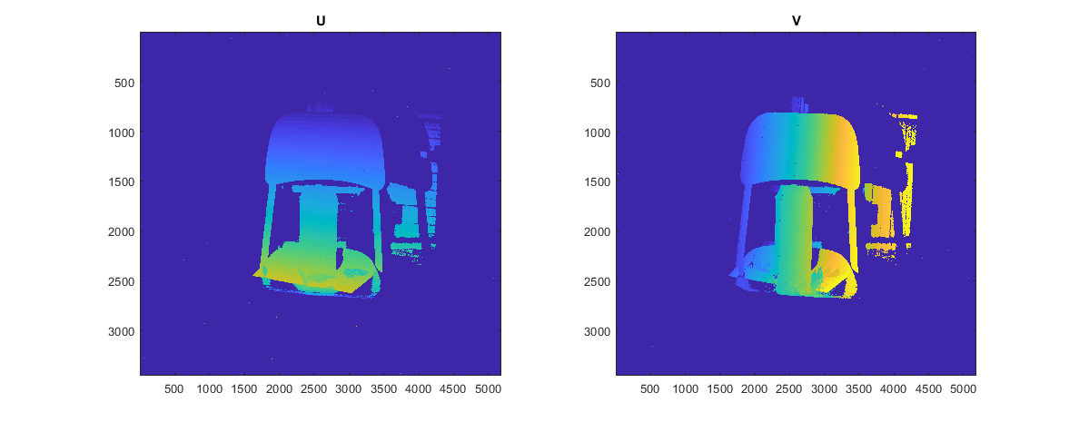
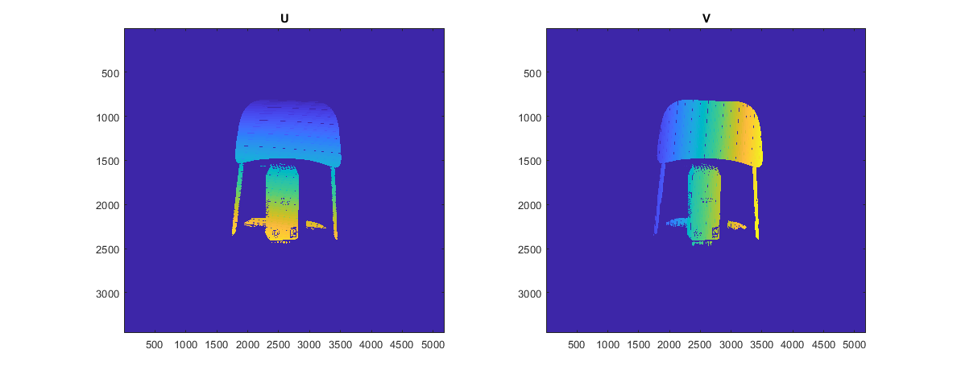
Figure 2.3 “Real_tea” UV with unreliable pixel rejection

As we can see from the Figure 2.3, we are able to remove a lot of irrelevant pixels in both foreground and background with a suitable threshold. If the defined threshold is too large, we may reject too many pixels and as a result, lose a lot of details. The decoded UV of “real_crayon_dalek” is also provided below:

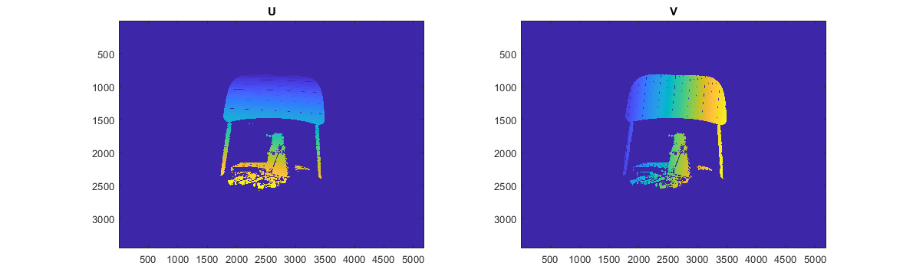
Figure 2.4 “Real_crayon_dalek” UV

The next step to reconstruct the scene is to calculate the depth map using obtained UV information and computed calibration matrix in previous steps. The results are provided below:

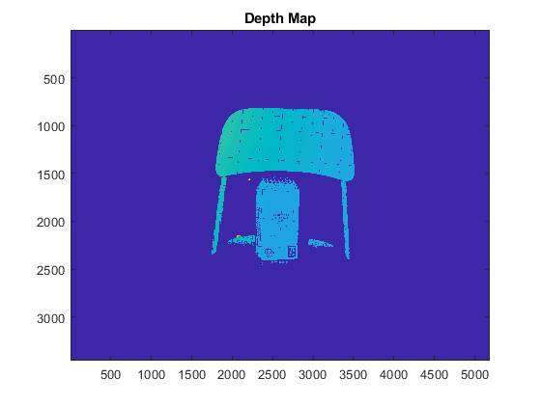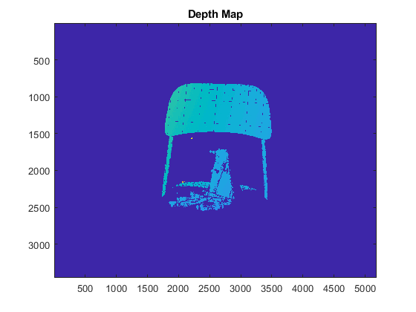
Figure 2.5 Depth map of two selected real datasets

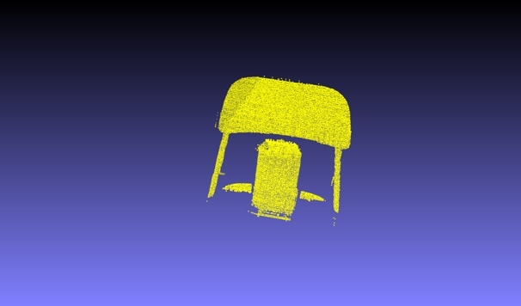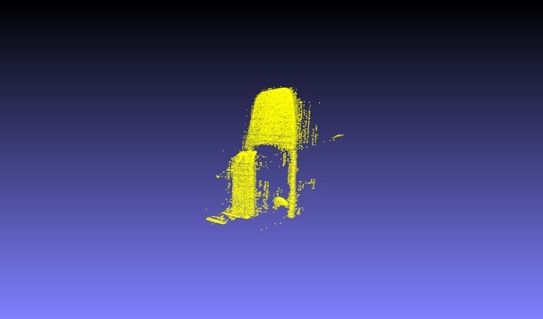
Figure 2.6 Reconstruction result of “real_tea”

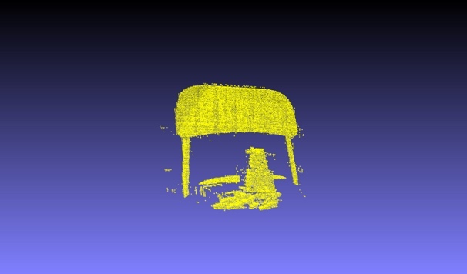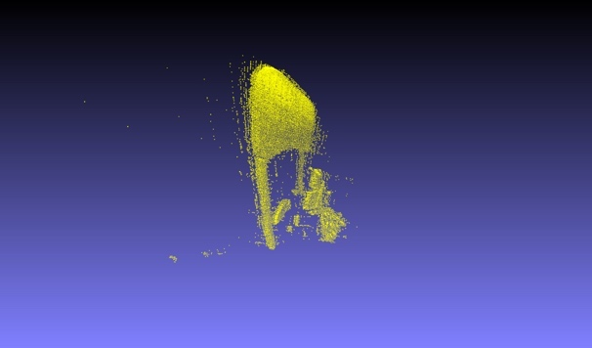
Figure 2.7 Reconstruction result of “real_crayon_dalek”

From these two pairs of results, we may notice that even though we perform the calibration process very carefully, the reconstructed scene still does not reach our exception and contains obvious distortions. There are still some floating vertex around our target object which means the threshold for unreliable pixels rejection needs to be increased a bit.

Captured Dataset
This task requires us to capture real-life images with techniques demonstrated in the coursework instruction. The data was obtained cooperatively with Jinghuai Lin and Fei Huang. In case of data corruption, two sets of photos were taken, a scene with a head model and a cup of coffee, and a scene with a book, a sponge and a can of air spray (a backup dataset, also with different camera and projector distance). Since one projector uses a VGA input and there was no video adaptor available at that moment, we borrow the laptop from the other group to use the newer projector, thus we have the same checkerboard information on screen (credit to Dayi Huang’s group). Apart from this, captured datasets are only shared with our own group mates.

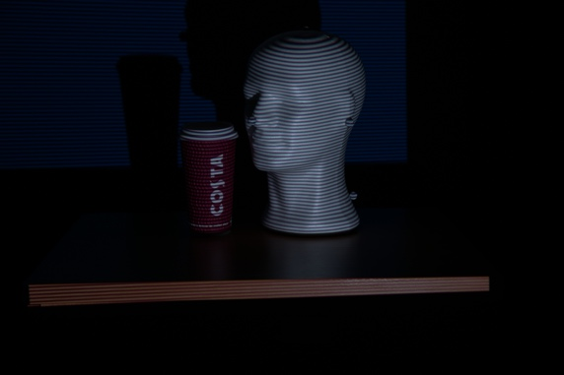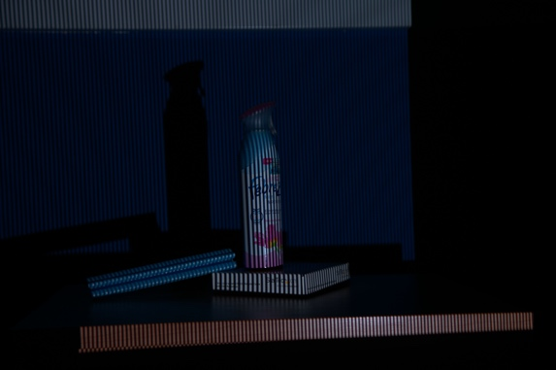
Figure 3.1 Two captured datasets

Calibration
The calibration process is the same as the previous tasks, except this time we need to measure the coordinate and size of the checkerboard on screen. The centre of our checkerboard is located at (434, 236) and is 232 pixels across in both dimensions, and the resolution is 864x539.

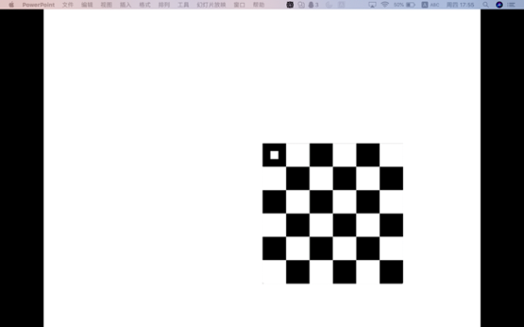
Figure 3.2 The checkerboard position on computer screen

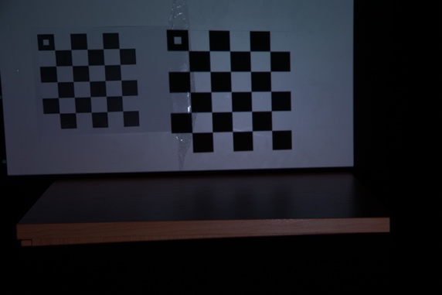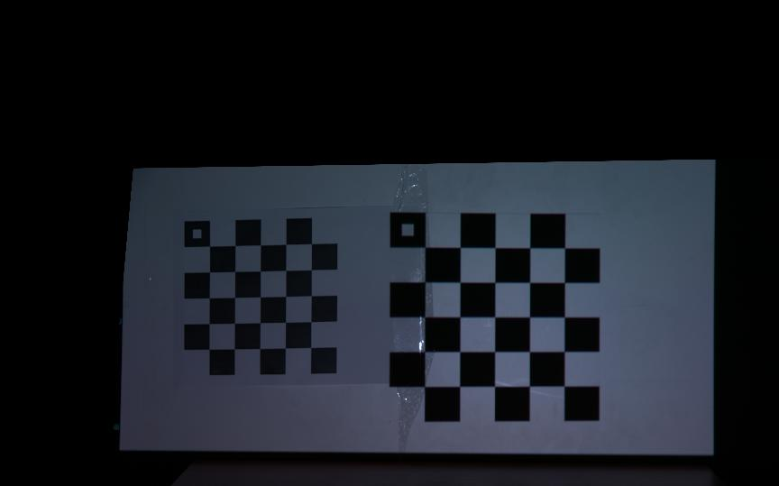
Figure 3.3 The reprojected checkerboard

We again load these images into calibration toolbox to retrieve the intrinsic and extrinsic matrix of both camera and projector for the reconstruction:

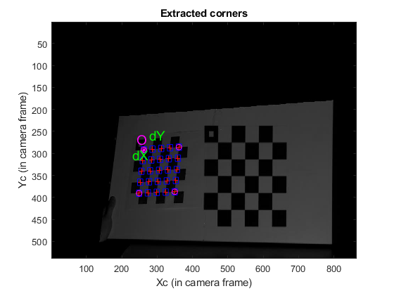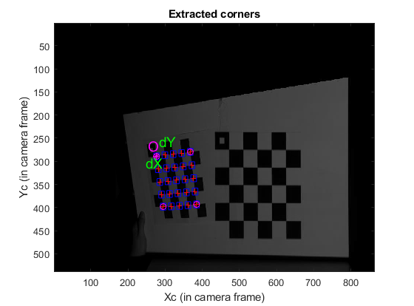
Figure 3.4 Corner extractions (camera) using calibration toolbox

Reconstruction
The reconstruction process is also similar with the previous tasks. In order to remove more floating vertex, we increase the threshold. However, as a trade-off, we also lose a lot of details of the cup of coffee, only the logo and the hat get preserved.

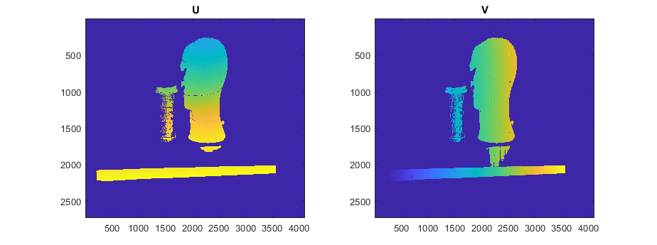
Figure 3.5 “head_coffee” UV

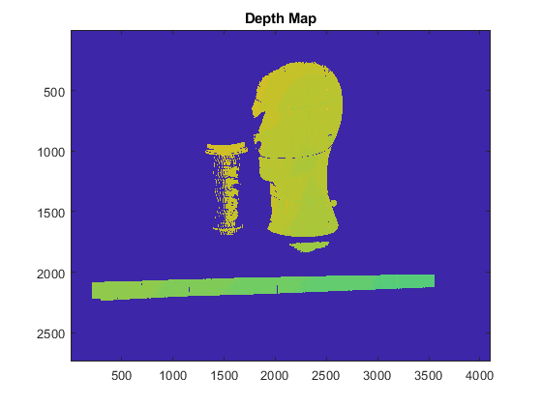
Figure 3.6 Depth map of “head_coffee”

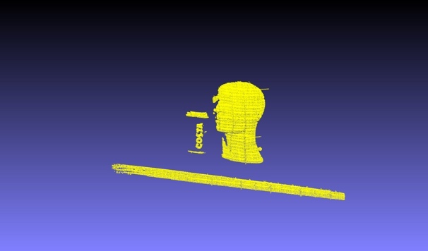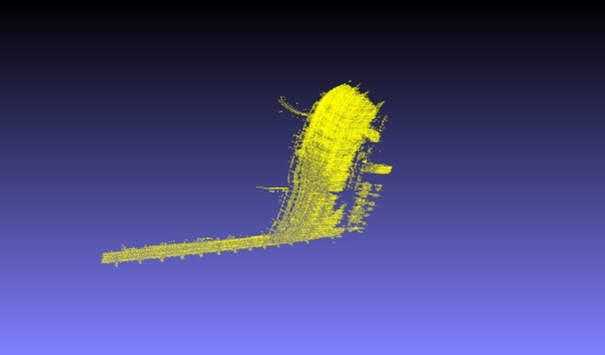
Figure 3.7 Reconstruction result of “head_coffee”

As we can see from the result, if we view the reconstructed object from certain viewpoints like we did in the task 1, it looks completely fine. However, if we change the viewpoints a little bit, we can notice that there is actually a lot of noise floating around the object, because their colour is same as the object, we cannot detect them immediately.
Reference
[1] Anwar, H., Din, I. & Park, K. (2012). Projector Calibration for 3D Scanning Using Virtual Target Images. International Journal of Precision Engineering and Manufacturing, 13(1), 125-131.

[2] Gerig, G. (2013). Structured Light II. The University of Utah. Retrieved from http://www.sci.utah.edu/~gerig/CS6320-S2013/Materials/CS6320-CV-S2013-StructuredLight-II.pdf

[3] Prince, S. (2013). Algorithms booklet. Retrieved from http://www0.cs.ucl.ac.uk/external/s.prince/book/Algorithms.pdf

[4] Scharstein, D. & Szeliski, R. (2003). High-Accuracy Stereo Depth Maps Using Structured Light. CVPR'03 Proceedings of the 2003 IEEE Computer Society Conference on Computer Vision and Pattern Recognition, 195-202.

