COMP0028 Computational Photography and Capture

Coursework 2: Controllable Heliotrope Video

This report will demonstrate the algorithms implemented for the controllable heliotrope video. There are two sections included in this coursework and each has its own subtasks. The demonstration will contain both images and code segments. Full documentations are available in source files. Though the coursework instruction only requires the demonstration of advanced section, we believe that including the basic section can better help us understand the entire workflow of this coursework. (Jump to Advanced Section)

Basic Section
The basic section contains five subtasks specified in coursework instruction: computer a distance matrix, convert the distance matrix into a graph, compute the shortest path, compute the advected location and generate the image sequence based on closest advected location. For ease of demonstration, we combine last two subtasks together.

In this section, we use image sequence gjbLookAtTarget and 3GB optical flows provided by the coursework. All loaded images are downscaled to 30% in order to match the dimension of optical flow data. This section requires user to specify a start frame and draw a path on the image in order to perform the tasks.

Compute Distance Matrix
Computing the distance matrix is the first step to create a video texture. Here we only consider the frame-to-frame distance thus the computation is rather simple: for each two frames i and j we compute their Euclidian distance and store the value in the matrix.^{[1]} The distance matrix only needs to be computed once upon initialisation.

$$M_{i,j}=\sqrt{{(F_{i}-F_{j})}^{2}}$$

Visualise Distance Matrix
As suggested by the coursework instruction, the MATLAB provides a built-in function called biograph() that can turn the matrix into a graph represented by nodes. We need to convert the distance matrix into sparse before using this function.

The arrow between different nodes will be hidden, and we want the layout as compact as possible due to the display space limitation. In addition, we can add ‘showWeights’, ‘on’ to the function if we want to know the weight between connected nodes.

Since the graph should only include nodes that are one-connected instead of fully-connected, we need to define a threshold that can reject distant nodes. We choose to compute the mean weight for each connected node and any weight that is larger than the mean value will be set to zero.

The result graph is provided below:

Calculate Shortest Path
Because we have the weight from the distance matrix, the shortest path can be easily computed by using the built-in function graphshortestpath() by passing in the sparse matrix and the index of frame we want to start with. For example, assume that we are using 10 frames for testing purpose, the distance matrix will be a 10 by 10 sparse matrix with the cost of going to each node. If we choose 5 as start point, then it will return a list of paths which include the index sequence from the start point to each target point. (5 → 1 may give a unique traversal such as [5,4,3,1] or [5,2,1])

The paths will be calculated once based on the selected start point before performing the iterative calculation using user defined curve; it will be updated in the iteration every time when the next closest node is found. We will see how it actually works on provided data set in next two subtasks.

Compute Advected Location and Pick Shortest Path

The advected location can be computed with the help of optical flow data.

The image below shows the user defined curve (green) and estimated closest points from the computation. Because the point is estimated between each two given coordinates, the last point cannot be correctly found…

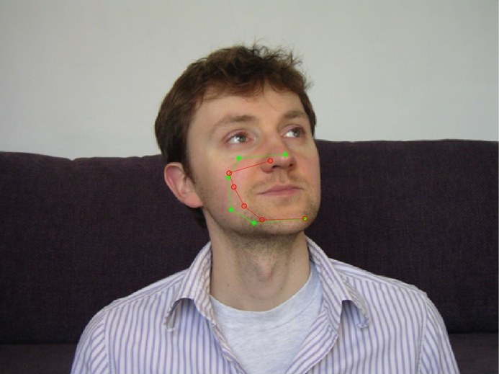
User defined curve and estimated closest points at the 53rd frame

The output sequence is provided below:
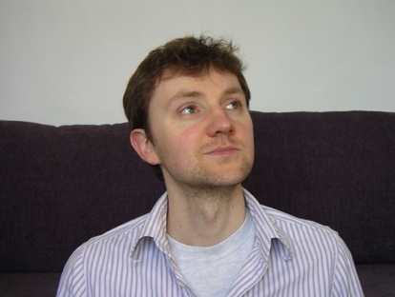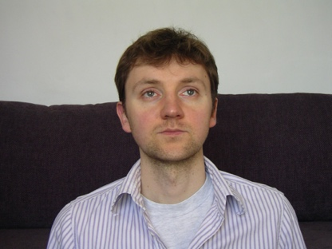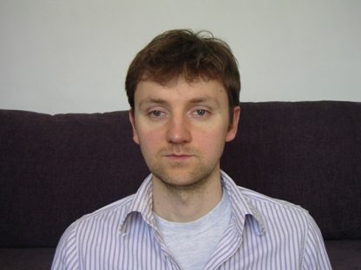
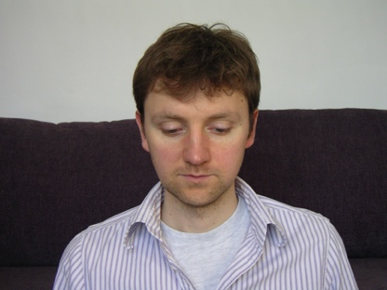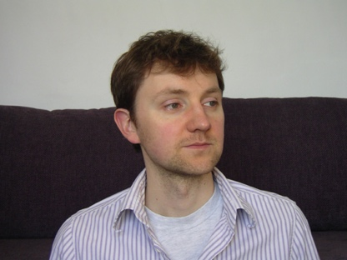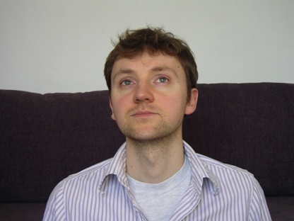
Image sequence generated by each closest advected location

From the results we can clearly notice that the first 5 frames follow the defined path however the last one seems not related to the sequence at all. As mentioned before, because the last point does not have its next point to perform the estimation, thus it will be incorrect in most cases. However, this does not mean we cannot fix it. The method of correcting this step will be explained in the advanced section where we utilise multiple-nodes interpolation. Before that, we also want to improve the accuracy of our estimation by optimising the path. Additionally, we want to add frame compensation in order to make the output sequence smoother.

Advanced Section
The advanced section contains three subtasks: compute better paths, produce own data and perform motion interpolation.

Compute Better Path
The better path be obtained from a distance matrix that takes both image difference and trajectory-similarity into consideration. This can be expanded from the matrix we use in basic section. Since we have the access to flow data, we c.. Both parts need to be normalised before adding together:

$${M2}_{i,j}=\sqrt{{(F_{i}-F_{j})}^{2}}+\sqrt{{({Flow}_{i}-{Flow}_{j})}^{2}}$$

And we can compare the result here:

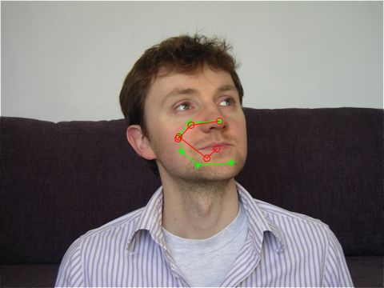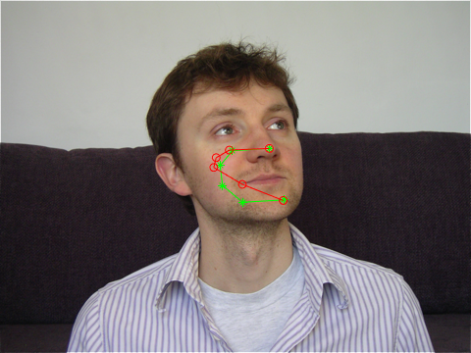
Estimated path from basic and advanced distance matrix at the 53rd frame

The estimated path looks better.

Produce Own Data

Render Slow Motion Interpolation
This optional task requires us to render slow motion interpolation based initially on the optical flow between images in the collection. The intermediate frame of two images can be estimated with optical flow using the following equation: ^{[2]}

$$I_{t}=α_{0}⨀g\left(I_{0},F_{t→0}\right)+(1-α_{0})⨀g\left(I_{1},F_{t→1}\right)$$

The parameter $α_{0}$ is the contribution of the two images, and $g\left(Image,Flow\right)$ is a backward warping function which is identical to imwarp() in MATLAB. The symbol $⨀$denotes element-wise multiplication. This equation can be implemented in MATLAB with the following code:

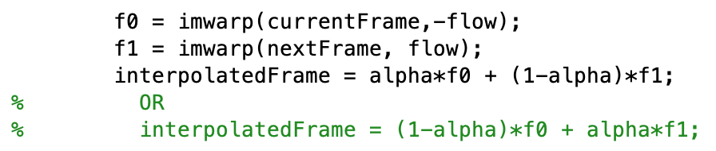

However, we want to add more than one frame between two images to smooth the motion, thus the equation above needs to be modified. If n frames are required between two frames, we then start with the contribution $α_{1}=\frac{1}{n+1}$ , which will also be accumulated to weight the optical flow; shaky images will be produced without weighted flow. The first interpolated frame is closest to the start frame and furthest to the end frame. Therefore, the contribution for it will be:

$I_{1}=(1-α_{1})⨀g\left(I_{start},{α_{1}F}_{end→start}\right)+α_{1}⨀g\left(I_{end},{{(1-α}_{1})F}_{start→end}\right)$,

When the interpolated frame number goes up, the contribution $α_{n}$ will also increase, for example, if we have 5 interpolated frames, then $α_{5}=\frac{5}{5+1}$. It is closest to the end frame; thus, the latter part gets most distribution:

$I_{5}=(1-\frac{5}{6})⨀g\left(I_{start},{\frac{5}{6}F}_{end→start}\right)+\frac{5}{6}⨀g\left(I_{end},{(1-\frac{5}{6})F}_{start→end}\right)$

The equation then can be implemented as:

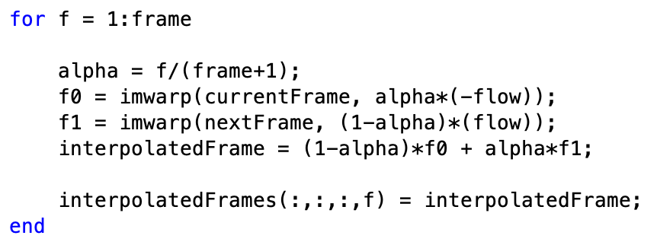

The results:

Reference
[1] Schödl, A., Szeliski, R., Salesin, D. & Essa, I. (2000). Video Textures. Proceeding of ACM SIGGRAPH 2000. doi: 10.1145/344779.345012

[2] Jiang, H., Sun, D., Jampani, V., Yang, M., Learned-Miller, E. & Kautz, J. (2017). Super SloMo: High Quality Estimation of Multiple Intermediate Frames for Video Interpolation. Retrieved from https://arxiv.org/pdf/1712.00080.pdf

