2016

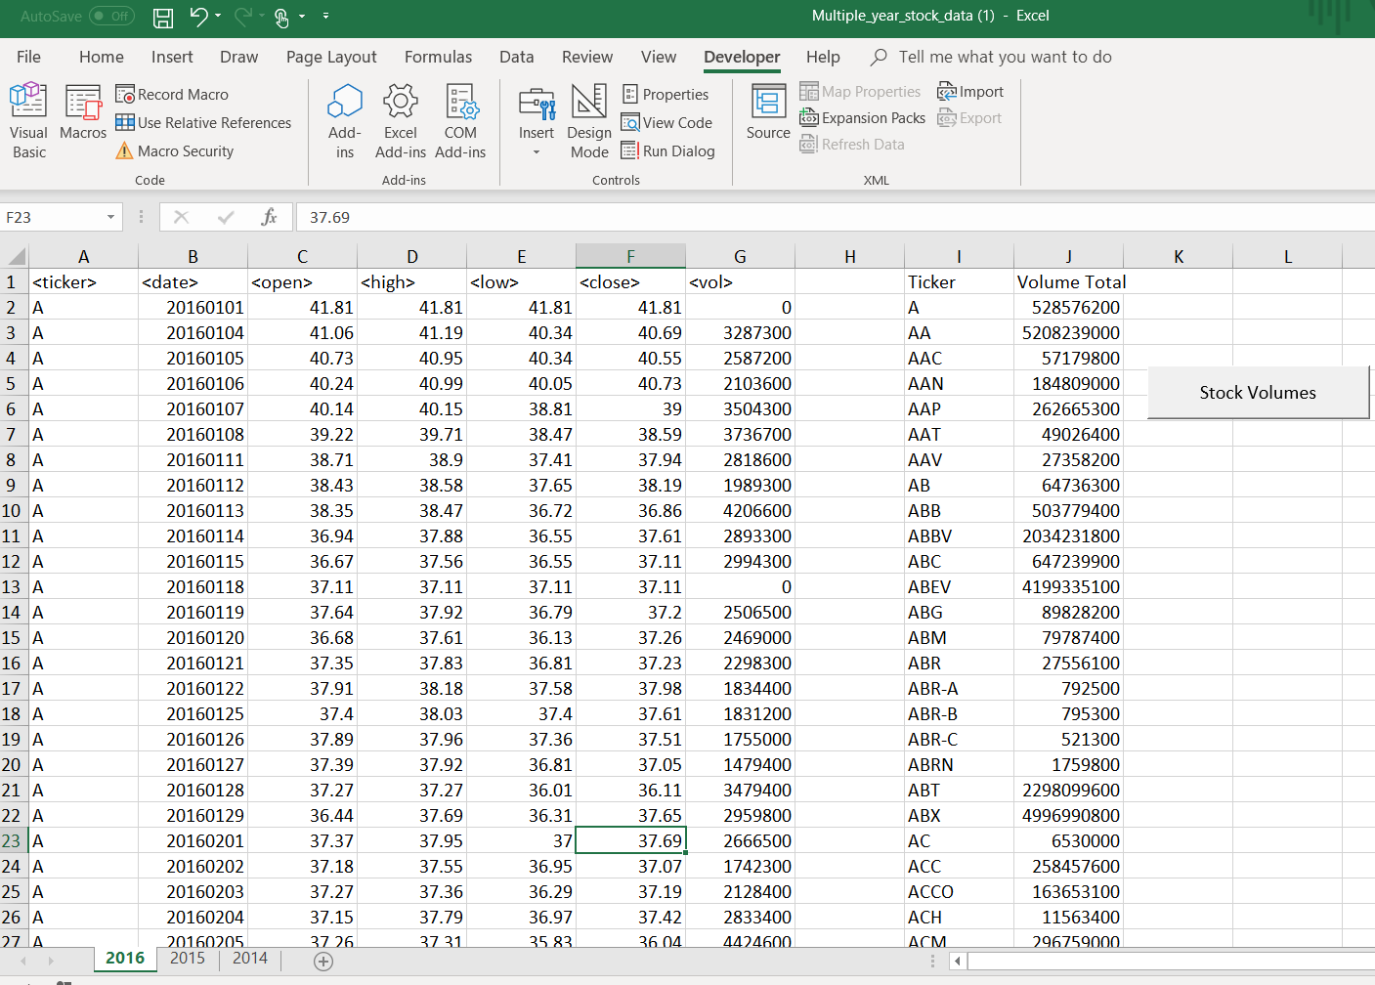

2015

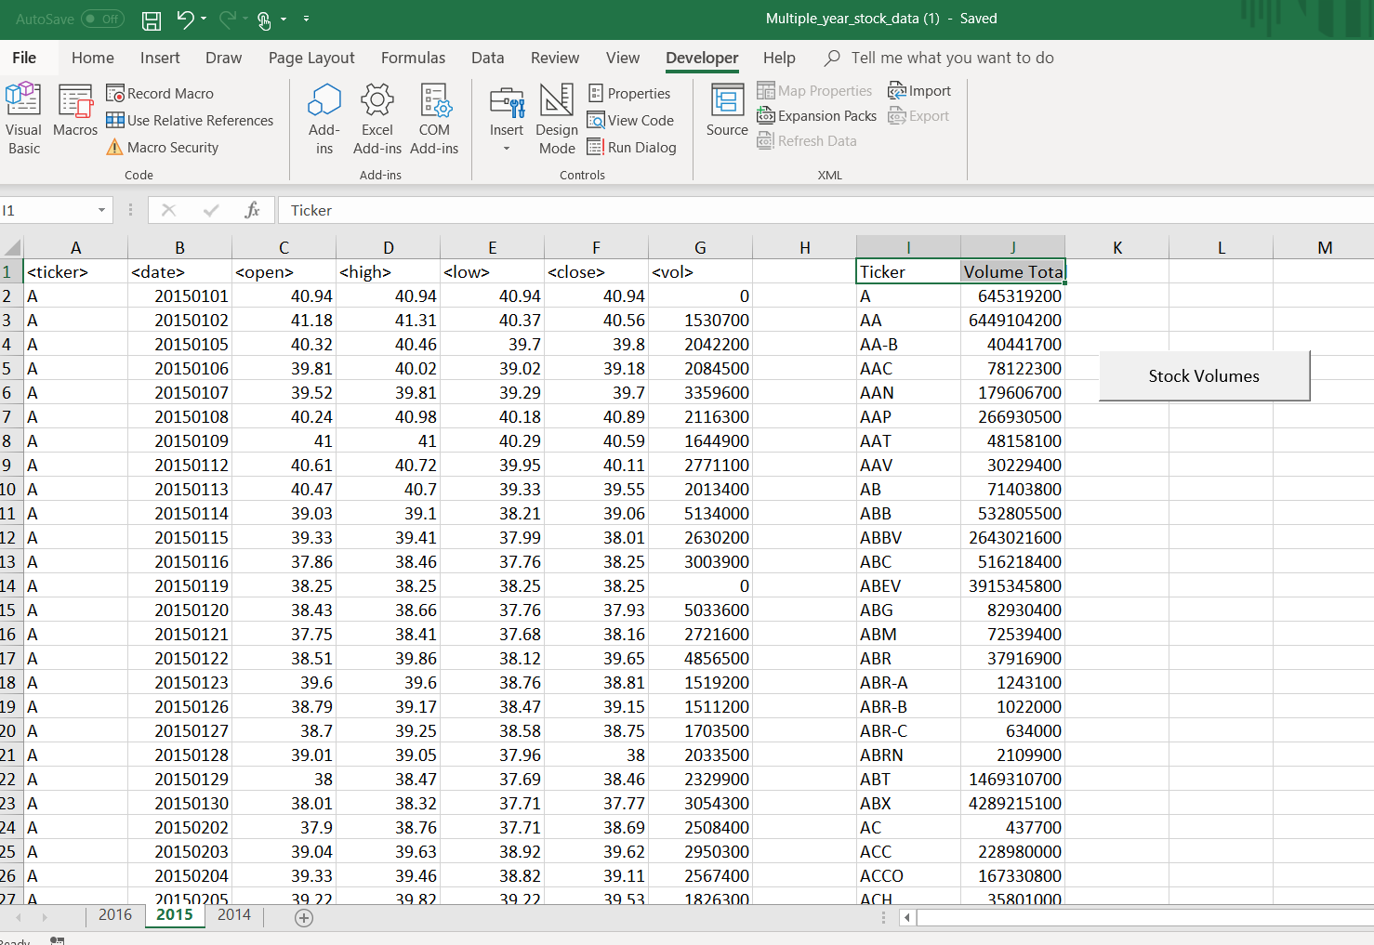

2014

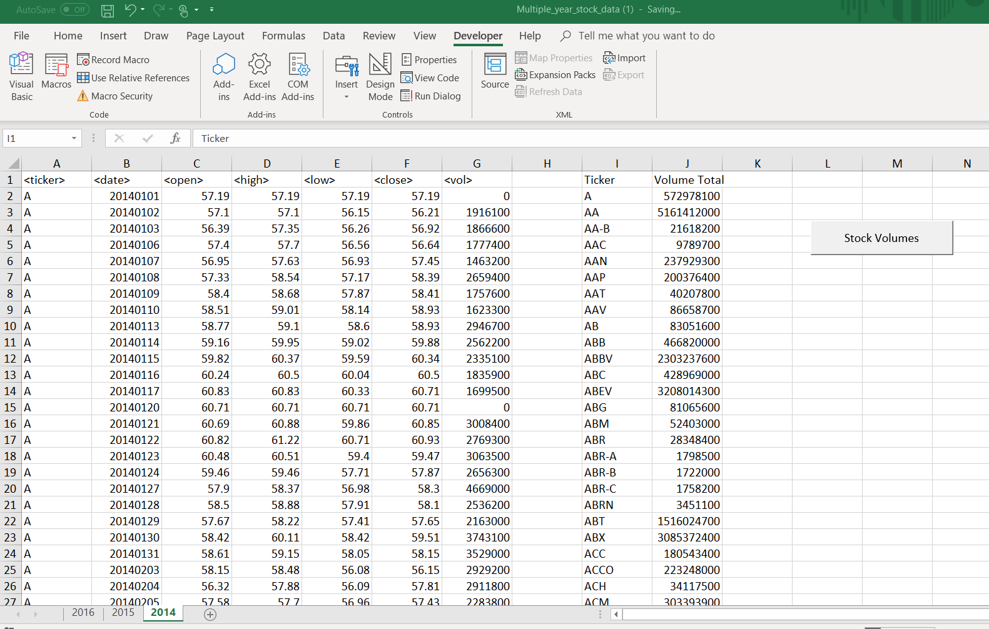

Sub stock_mkt()

' Set an initial variable for holding the brand name

Dim Ticker_Name As String

' Set an initial variable for holding the total per ticker brand

Dim Ticker_Total As Double

Ticker_Total = 0

' Keep track of the location for each ticker brand in the summary table

Dim Summary_Table_Row As Integer

Summary_Table_Row = 2

NumRows = Application.CountA(Range("A:A"))

' Loop through all ticker purchases

For i = 2 To NumRows

' Check if we are still within the same ticker brand, if it is not...

If Cells(i + 1, 1).Value <> Cells(i, 1).Value Then

' Set the Brand name

Ticker_Name = Cells(i, 1).Value

Ticker_Open = Cells(i, 3).Value

' Add to the Brand Total

Ticker_Total = Ticker_Total + Cells(i, 7).Value

' Print the ticker Brand in the Summary Table

Range("I" & Summary_Table_Row).Value = Ticker_Name

' Print the Brand Amount to the Summary Table

Range("J" & Summary_Table_Row).Value = Ticker_Total

' Add one to the summary table row

Summary_Table_Row = Summary_Table_Row + 1

' Reset the Brand Total

Ticker_Total = 0

' If the cell immediately following a row is the same brand...

Else

' Add to the Brand Total

Ticker_Total = Ticker_Total + Cells(i, 7).Value

End If

Next i

End Sub