Resource Control and Monitoring Software for
OCTEON-based Interface Masters's Hardware Modules
• Specification •

Version: draft
Date: 21 July 2014
Author: Y.Tolstov

Contents

1. Definitions and Terminology
2. Requirements
3. Approaches
4. Use Cases
5. API and User Interface
6. Software components and Deployment Diagram
7. Sources and Build/Release Procedure
8. Internal architecture and interfaces
9. Roadmap and Software Releases.

1. Definitions and Terminology

1. The main goal of this document is to define a software layer and components for control and monitoring of all IMT-specific resources (e.g. bypass relays, CPLD and AVR access) and all those resources which are not covered by the OCTEON-SDK on the OCTEON-based hardware modules. Consider this software as an extention to the OCTEON CVMX Library, Host Remote Library, and other elements of the OCTEON-SDK. It is provided to Users more like a software toolkit (libararies, utilities) for Users rather than as a software with fixed, integrated, and complete functionality. The integration of functions is performed by the User Control Programs or by IMT engineers upon Users requests.

2. The Software targets, primarily, the IMT-manufactured OCTEON-based hardware products, which are shipped as components (e.g. NIC) rather than as complete systems.

Terminology used in this document:
• OSE = OCTEON Simple Executive runtime environment.
• IMH = Interface Master's OCTEON-based Niagara series hardware, which is covered by the considered
software. Also, referred as Hardware.or Hardware Module (HWM).
• IMS = Interface Masters Interface & Control Software – a collection of libararies, utilities, and API files
controllling or allowing to control the IMT-specific hardware resources on HWM. Also, referred as
Software.
• IMI = Interface portion of IMS (Libararies + Interface definition files).
• IMC = Control/Monitoring portion of IMS – Utilities, User programs which use IMI and so on.

2. Requirements

R1. The IMS software consists of two main parts:
a) IMI = Library + API provided from both OSE and Linux User-Space layers.
b) IMC = Utilities, which control the hardware using the IMI Library.
The minimum set of utilities consists of reference and test code, which shows how to use the IMI.
Upon costomers request, new utilities may be created be become parts of their product.

R2. OCTEON-Local (on-HWM) control.
User Control Program(s) runs locally on HWM. The runtime environment may be one of these -- Linux or Simple Executive (OSE). The IMI software provides API to the Control Program(s).

R3. OCTEON-Remote over PCIe control.
User Control Program(s) runs on Remote Linux Host and communicates with HWM over PCIe. The IMI software provides API to the Control Program(s).

R4. OCTEON-Remote over Network Interface control.
User Control Program(s) runs on Remote Linux Host and communicates with HWM over network interface (data or manangement). The IMI software provides API to the Control Program(s).

R5. The IMS is built outside of original OCTEON-SDK, or in dedicated directories of SDK, and suppose to be as much independent on different versions of SDK as possible, thus, easy portable between different versions of SDK.

R6. The software should distinguish and adjust itself to different OCTEON processors automatically (at runtime) whenever possible. In other cases – use OCTEON_MODEL environment variable.

R7. The IMS should distinguish and adjust itself to different IMTH models automatically (at runtime) whenever possible. In other cases – use IMH_MODEL environment variable.

R8. There may be more than one copy the the Control Program using IMI interface and accessing the same hardware resources.

R9. The Software may run only in the Linux or OCTEON Simple Executive runtime environments.

R10. The specific requirements for particular HWM functionality are provided in separate documents dedicated to those hardware.

3. Approaches

A1. The Software sources are installed either as a part of the OCTEON-SDK tree or outside of SDK and use a set of environment variables (such as OCTEON_ROOT, OCTEON_MODEL, and so on) to navigate to SDK and operate in its build environment.

A2. The IMS is a standalone software which is not connected or being part of the other IMT software modules and/or frameworks. The anchor for the IMS – the OCTEON-SDK.
Reasoning – This software is passed to customers who work/aware only with the OCTEON-SDK and not IMT software frameworks or build systems.

A3. The IMS is OCTEON-SDK-centric (vs. being Niagara-product-line centric).
Reasoing – The Software is provided to custmers as an update/addition to the OCTEON-SDK specifically rather than as a generic software for different SDKs.

A4. Being OCTEON-SDK-centric, the IMS uses as much as possible the methods (sources layout, build system, and libraries) provided by the SDK.
Reasoning – Avoid forcing customers having two or more different approaching in origanizing and building the software from the same SDK.

4. Use Cases and Usage

The following cases are applied to all scenario.
1. There may be more than one copy/type of Control Program running locally or remotely and accessing the same hardware resources on HWM.

4.1. Use Case 1 = Local (On-HWM) Control in Simple-Executive runtime environment
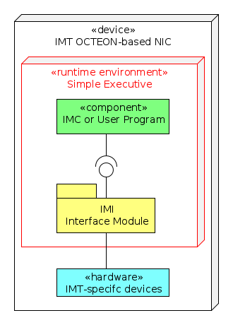
N1. Control Program accesses the underlying hardware either directly or using the CVMX libarary provided by the OCTEON-SDK.

4.2. Use Case 2 = Local (On-HWM) Control in Linux runtime environment
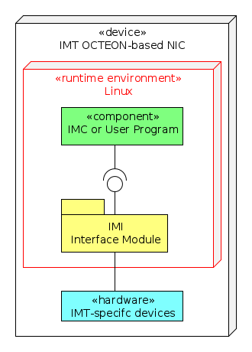
N1. Control Program runs in Linux User Space and accesses HWM using interface provided by IMI.

N2. IMI may operate in the Linux Kernel or User space communicating with the hardware using Linux Driver model, or (encouraged) relying on the CVMX library or Host Remote libarary provided by the SDK.

4.3. Use Case 3 = Remote Control over PCIe in Simple-Executive runtime environment
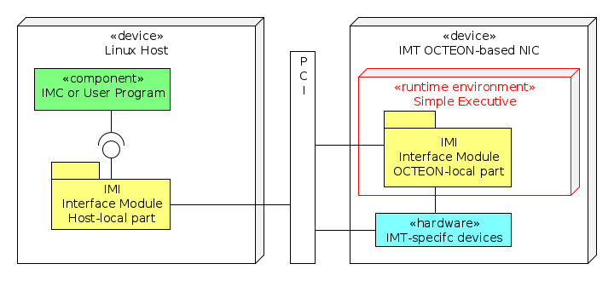
N1. The Control Program runs in the Linux User space.

N2. Host-Local portion of the IMI is operating in the Linux Kernel space (as a Driver) or in the Linux User space (using Linux Driver model or OCTEON Host Remote Library) and providing its interface to the Control Program.

For communication with the hardware resources, the IMI may use either direct PCIe access to the device registers, or use assistance of OCTEON-Local portion of the IMI module. The first approach is always prefferable over the one which involves two parts of the IMI. In latter case, two portions of IMI communicate over PCIe using their own protocol.

4.4. Use Case 4 = Remote Control over PCIe in Linux runtie environment
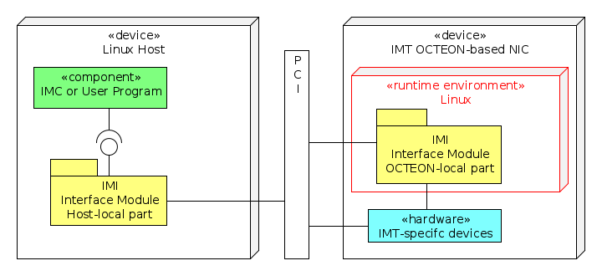
N1. The same appllied to this sceanrio as in UC3:N1,N2.

N2. If used, the OCTEON-Local portion of the IMI module operates in the kernel space. Two portions of IMI communicate over PCIe using their own protocol.

N3. The alternative approaches, for those cases when it is not possible to use HWM as PCI device.
a) IP-over-PCI for communication between Host-Linux and OCTEON-Linux.

4.5. Use Case 5 = Remote Control over IP Network in Simple-Executive runtime environment
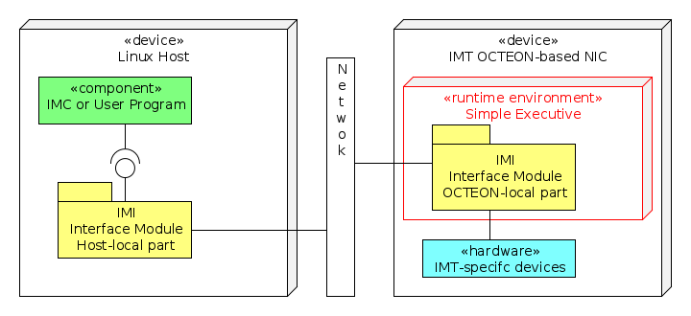
N1. OSE runtime library doesn't provide the Networking Stack, thus, it will be necessary to implement two parts of the IMI module – Host-Local and OCTEON-Local. The communication between them is performed by means of IP packets and internal protocol.

N2. The biggest advantange of this Use Case – the uniform control may be applied to any type of HWM – the one which is implemented as standalone module (e.g. N805) or the one which is installed in the PCIe slot (e.g. N804).

4.6. Use Case 6 = Remote Control over IP Network in Linux runtime environment
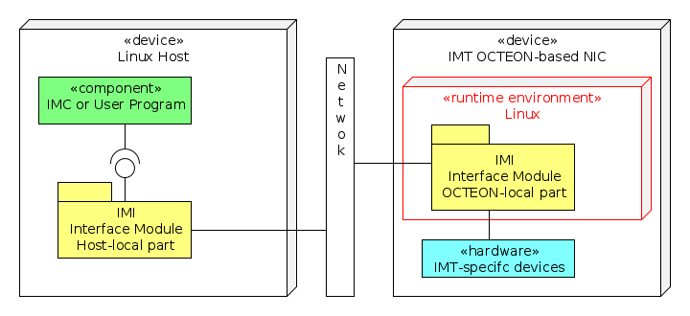
N1. Host-Linux and OCTEON-Linux allow to connect easily two parts using "standard" Linux protocols (e.g. NFS, telnet, ssh). Thus, OCTEON part of IMI module may be split on two parts as well – one is running in the Linux User Space, and the other – in the Kernel Space.

N2. Similar to UC5, this case provides the uniform control of HWMs.

5. API and User Interface

The generic/common approach will be provided in the IMS Version 2.
The version specific details are provided in Chapter 9.

6. Software Components and Deployment Diagram

1. The IMS Software is distributed/shipped, primarily, as a source package which is generated from the nigara.octeon.git repository (see Chapther 7). The customer/user installs this source on the top of the existing OCTEON-SDK by just unpacking the package archive from the root of the SDK directory.

2. The case of distributing the binary package is not considered here. It will be defined in the IMS Version 2 or further. (if there will be requests for it).

3. The IMS Software Release Package is named as "niagara" and the release file name follows the convention described in Chapter 7 (7.5).

4. The IMS Release includes (come as part of the release archive):
a) IMI software layer = Libraries + API definition header files.
b) IMC software layer = Reference, Test, and Control programs showing how tu use IMI and IMC.
c) Documents = API and software components description, Release notes.

7. Sources and Build/Release Procedure

7.1. Repository
niagara.octeon.git

For IMT internal use (software development and releases), the repository can be used either as a standalone directory, linked to the OCTEON-SDK by means of environment variables, or as a Git submodule named "niagara", installed in the root of octeon-sdk.git superproject.

7.2. Internal organization of Git repository
niagara.octeon.git
|
docs/* -- Documentation
env-setup.sh -- Build environment setup script (it calls env-setup script from OCTEON-SDK)
Makefile -- Top-level makefile
include/* -- IMI API header files
lib/* -- IMI API libarary (there may be more than one libarary modules)
<prog1>/* -- Reference or Product Control/Monitoring Program 1
<prog2>/* -- Reference or Product Control/Monitoring Program 2
...

There are no special requirements related to sources organization and makefile system, though,
the main idea is -- try to be close to the methods, procedures, and makefile system provided by the SDK (see Chapter 3, Appr. 4).

7.3. Requirements for the makefile system:
R1. All components should be build from the top level and individually (e.g. from <prog1> or lib directories).
R2. The make files should implement and following rules: all, clean, install, uninstall

7.3. Build/Release Procedure
1. Setup build environmet using env-setup.sh script.
As a minimum, this script sets up the following environment variables.
OCTEON_ROOT -- navigation to the OCTEON-SDK
OCTEON_MODEL -- OCTEON processor type.
IMH_MODEL -- IMT hardware type.

2. From the build window created in Step 1,
a) go to the root of the repository or to individual component and
b) type "make".

7.4. Output files format
The generated files may run on the Target System, which can be powered by different CPU types and Linux or OSE OS environment (see Req. 10). This needs to be reflected in the generated binary files.

The general format of the binary executable files:
<program-name>.<runtime-environment>.<hardware>
where,
• runtime environment = linux | ose
• hardware = <hardware-module>.<cpu-type>.<cpu-core-architecture>
hardware-module = IMT produced product model (e.g. n804, n821, ...)
cpu-type = CPU type (e.g. cn66xx, cn63xx ...)
cpu-core-arch = mips64 | x86_64 | ppc | ...
Both parameters are optional.

Normally, the software (binary files) are build by customers or distributed as a part of the bigger release package. In those cases the file may use simple names – program-name only. To avoid name collisions the files should be installed in the OS and hardware releated folders. E.g.
<output-directory>/mips64/bin/<filename>
or
<output-directory>linux/bin/mips64/<filename>

If the files are taken out of the context and distributed separately, the file name should specify the program name, version, and the runtime environment as well.

Examples:
1. hbtol -- hbtool program (in the package release).
2. hbtool-1.0.linux.n804.cn66xx -- hbool program (having board- and CPU-level dependencies)
running on OCTEON Linux.
3. hbtool-1.1.linux.mips64 -- hbool program (having CPU Core Arch dependency only)
running on linux.
4. hbtool-2.0.ose.cn63xx -- hbtool program running on CN63XX processor
in OSE environment.

7.5. The file format for the generated package
niagara-<version>.octeon-sdk-<sdk-version>.<release-type>.tgz
where,
release type = src | bin

Example:
1. niagara-1.0.0.octeon-sdk-3.1.bin.tgz

NOTE: In most of the cases, the Software will be distributed in form of sources. Thus, the name
niagara-1.0.0.octeon-sdk-3.1.src.tgz

8. Internal Organization and Interfaces

The generic/common approach will be provided in the IMS Version 2.
The version specific details are provided in Chapter 9.

9. Roadmap and Software Releases

9.1. IMS Version 1.0

1. Implement the IMS for Use Case 2

2. Only one program is provided – hbtool, which is based on the existing utility and adapted to Use Case 2.

3. The niagara.octeon.git repository organization (at this point):
niagara.octeon.git
|
docs/* -- Documentation
env-setup.sh -- Build environment setup script (it calls env-setup script from OCTEON-SDK)
Makefile -- Top-level makefile
hbtool/* -- Bypass relay control utility running on OCTEON Linux.

4. The IMS Package is distributed on form of sources:
niagara-1.0.0.octeon-sdk-3.1.src.tgz

When unpacked, it put everyting under "niagara" directory created locally.

5. The release notes and description of User interface provided by hbtool program are included in the release and located in the docs directory.

9.2. IMS Version 2.0

1. Implement the IMS for Use Cases 1, 3, 4
2. Divide the software on the Libary and Utilities (Control Programs).

9.3. IMS Version 3.0

Implement the IMS for Use Cases 5 and 6

Notes, Questions, Open issues

N1. Some Use Cases may requrie to implement pretty complicated set of software modules interacting with each other using proprietary protocols. Thus, consider to eliminate them.

