OCTEON-SDK-based Platform Software
•Specification•

Version: 1.0
Date: 26-July-2014
Author: Y.Tolstov

Contents

1. Terminology and Definitions
2. Software Components and Deployment Diagram
3. Software Development and Release Flow
4. Policies and Conventions
5. Software Release Procedure
6. Initial Software installation Procedure

1. Terminology and Definitions

• Platform Software = Bootloader + Linux and Simple Executive runtime environments from SDK.
This software includes those modules which are already part of the SDK (as they coming from Cavium) or additional basic software created by Interface Masters to make a particular OCTEON-based board operational and running SE or Linux runtime environments. This way, all application-level software, any software framework or middleware, or any device driver, which doesn't follow the software model imposed by the SDK and not using its build system, are not parts of the Platform Software. Differently – the Platform Software is SDK-dependent.

• IMT = Interface Masters Technologies

2. Software Components and Deployment Diagram

2.1. Components

1. Bootloader = U-Boot – Provided by IMT in form of archive of binary file(s).
2. Patch for OCTEON-SDK – Provided by IMT in form of a Patch for a Host required by SDK.
3. OCTEON-SDK-x.y.z -- SDK from Cavium. Customers get it directly from Cavium.

2.2. Deployment Diagram

1. The componet file naming follows the General Release File Naming Format (See Ch. 4).

2. IMT Patch includes all changes available in the SDK at the moment of patch release.

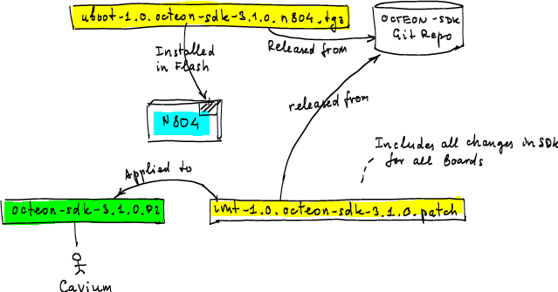

NOTE: Here for clarity, particular versions of SDK and IMT releases are used.

3. Software Development and Release Flow

1. The original OCTEON-SDK from Cavium is installed in the dedicated set of repositories on the vendor branch, on top of the previous version of SDK, and tagged as SDK-x.y.z, where x.y.z is OCTEON-SDK release version as provided by Cavium.

2. All development is done on sdk-x.y.z-im branch originated from SDK-x.y.z tag. Normal work flow is used, with feature branches, etc.

3. When we need to release a patch set version m.n, sdk-x.y.z-im-m.n branch is branched off of vendor branch at the point of SDK-x.y.z tag. All development work is copied from the sdk-x.y.x-im branch (using git rebase), merging patches that need merging in the process.

4. Patch set is generated (git format-patch SDK-x.y.z..sdk-r-x.y.z-im-m.n), plus possibly post-processed (to handle submodules). Patch name follows the convention of software release file naming (see Ch.4). In this case, it will be, for example, imt-1.0.octeon-sdk-3.0.1.n804.patch (for N804 only) or imt-1.0.octeon-sdk-3.0.1.patch (for all boards and software modules).

5. The release tag SDK-x.y.x-IM-m.n is applied and sdk-x.y.z-im-m.n branch is closed.
NOTE: The tag in this case is not having much value, but, it is consistent with the release model – every software release is tagged.

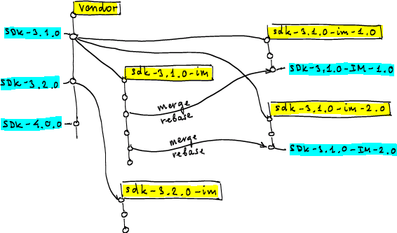

4. Policies and Conventions

1. The software releases (patches) are performed by the Release Engineer or dedicated software developer (not by random people and nobody outside of the software group).

2. The release procedure is automated as much as possilbe.

3. The same branches and tags are created (atomically) in all OCTEON-SDK related repositories (even though there may be no changes done in some of them).
Git branch names use lower case letters and tags – capital letters.

4. The release file name format follows the Generic Software Release file name format
See this IMT Wiki page: https://50.0.45.248/mediawiki/index.php/SW:Conventions_and_Policies

5. Software Release Procedure

TBD.
The procedure describes:
a) How to setup the SDK
b) How to generate the components of the Platform Software.

6. Initial Software Installtion Procedure

TBD.
The procedure describes:
a) How to install the Platform Software on the OCTEON-based product.
b) How to setup SDK and apply the SDK patch.

