Slakshna Cross-Country Joint Training Report
Experiment date: 14 August 2026 Reporting date: 17 August 2026 Scope: Joint integration exercise between the Australian and Indian teams

Executive Summary
The joint exercise brought two independently operated Slakshna nodes into the same cross-country Iroh Gossip mesh and ran real TinyLlama LoRA fine-tuning at both sites. The Australian node remained connected to the Indian endpoint for approximately 41 minutes, received four complete remote delta messages, and successfully decoded the most recent Indian update. The Australian node completed eight 50-step local training rounds and began a ninth; the Indian delta metadata and loss curve show that the Indian node reached Round 5 before it was stopped. Both local loss curves decreased during the session.
The exercise therefore validated public-Internet peer connectivity, sustained Gossip operation, bidirectional participation in a common federation, real local training, and transport-level serialization and decoding of model updates. It did not, however, validate effective cross-site parameter aggregation. Post-run inspection found that Australia trained a rank-8 LoRA adapter while India sent rank-16 LoRA deltas. All 88 corresponding tensor names were present, but all 88 shapes differed. The current receiver accepted the remote payload because it passed format, finite-value, and norm checks; the aggregator then silently skipped every incompatible tensor. Consequently, the loss reduction at each site is evidence of local learning, not evidence that the other site's update influenced its model.
This distinction is the principal result of the exercise. The network and delta transport path worked, but a configuration mismatch and insufficient schema enforcement prevented the run from becoming a valid federated model fusion experiment.

Framework Architecture and Training Flow
Slakshna divides responsibility between a Rust orchestration layer and a Python machine-learning layer. The Rust process owns the persistent node identity, peer discovery, Iroh QUIC/Gossip transport, the federation clock, update history, peer reviews, and the HTTP and WebSocket interfaces. The Python ML engine prepares a node-specific Bhaskera configuration, tokenizes data when a cache is unavailable, launches Ray workers for distributed training, extracts the learned LoRA delta, compresses it, loads cached peer deltas, performs local aggregation, and saves the adapter used to initialize the next round. The managed UDP ingress used in this exercise only made the Iroh endpoint reachable across institutional network boundaries; it did not participate in the learning algorithm.
One local federated cycle follows the sequence below.
Wait for the next wall-clock federation boundary
|
v
Stage each known peer's most recent update from Gossip history
|
v
Launch Bhaskera and train locally for a fixed number of optimizer steps
|
v
Compute local LoRA delta = trained adapter - previous LoRA base
|
v
Clip, add error feedback, sparsify, and INT8-quantize the local delta
|
v
Decode and validate the staged peer deltas
|
v
Compute the locally weighted aggregate and save the next LoRA base
|
v
Broadcast this node's own compressed delta and peer reviews over Gossip
|
v
Apply the participant/deadline barrier, rank peers, and await the next boundary
The update broadcast by a node is its own compressed local delta, rather than the aggregate it has just constructed. Each receiver independently combines its own new delta with the most recent peer deltas available in its local history. As a result, two peers can construct different next-round bases when they have different update histories, weights, configurations, or timing. There is no central aggregation server that publishes one authoritative global checkpoint.

Time and round semantics
The release used in this exercise is primarily wall-clock driven. Each node computes the next UTC timestamp divisible by epoch_duration_secs, sleeps until that boundary, and then invokes one local training job. In the Australian configuration the boundary interval was 300 seconds and each invocation was limited to 50 optimizer steps. The word epoch in the runtime log and loss CSV therefore identifies a federated invocation; it does not mean one complete pass over the 9,846-example tokenized dataset.
There is no mode in this release that exchanges an update after a configured number of dataset epochs, and nodes do not wait until they share the same round counter. A slow node can train across one or more clock boundaries and then join the next future boundary, while a faster node may execute more local rounds in the same wall-clock interval. Gossip delivery is asynchronous. The receiver stages the latest update known for each peer at the beginning of its next local round, regardless of whether that update was produced in the same round. Although the compressed envelope carries a sender-side round number, the current aggregation path does not use it to reject stale, future, or out-of-round updates. A disconnected peer's last update can therefore be reused by later local rounds.
expected_peers and sync_deadline_secs implement a limited post-training barrier. The implementation counts participants represented in local history; it does not count fresh updates for the current round. It also checks the deadline only after local training and broadcast preparation. In this run the deadline was 100 seconds after each epoch boundary, while a warm Australian training round took roughly 172 seconds. The deadline had therefore already passed when it was checked, producing the repeated warning that execution was continuing with two participants. These warnings were also expected because expected_peers was configured as three although only two nodes participated.

Delta construction, transport, and aggregation
For LoRA fine-tuning, the Python engine loads the previous aggregated adapter as the next training base and calculates a tensor-wise difference after local training. It applies a global L2 norm cap of 100. The configured noise multiplier was zero, so this should be described as clipping rather than an active differential-privacy guarantee. The engine then adds the residual left by the previous round's lossy compression. This error-feedback mechanism is intended to allow omitted information to re-enter a later update.
Compression is performed independently for every floating-point tensor. The encoder deterministically retains approximately the largest 10% of values by absolute magnitude, stores their flattened INT32 indices, and quantizes the selected values with symmetric INT8 quantization and one scale per tensor. The versioned envelope also records tensor shapes, the logical sender, and the sender's local round. It is serialized with PyTorch, Base64 encoded, embedded inside a hash-chained Slakshna ModelUpdate, and broadcast on the federation's Iroh Gossip topic.
The decoder enforces format and version fields, payload and tensor limits, index validity, finite scales, and the expected quantizer before reconstructing dense FP32 tensors. The ML engine subsequently rejects NaN/Inf values and remote deltas whose total norm exceeds 10. In this release, however, this validation does not compare the received tensor schema with the local adapter schema. Schema compatibility is considered only inside the weighted-sum loop, where incompatible tensors are skipped without an error.
Aggregation is not conventional sample-weighted FedAvg. Every node maintains local alpha values, converts them to weights with a softmax, and computes a weighted sum of the locally available deltas. Afterward it compares local and peer deltas with cosine similarity and adjusts the alpha values using trust_beta. Peer reviews are broadcast and accumulated into a trust ranking, from which the four highest-ranked peers form a reported cohort. In the current implementation cohort membership is informational: it changes the status log but does not gate subsequent training, broadcast, or aggregation.

Joint Exercise Configuration
The Australian node ran the tagged release source at commit 9f93ec45ae0d3eb9c901aff3b50d4325b5050488. The exact Indian source revision, hardware allocation, random seed, and complete effective configuration were not retained with the Australian artifacts. Values confirmed from the local configuration and received delta are separated from unknown remote values below.
Configuration item | Australian node | Indian node / received update
Base model | TinyLlama/TinyLlama-1.1B-intermediate-step-1431k-3T | TinyLlama tensor schema observed; exact revision not recorded
Dataset | timdettmers/openassistant-guanaco | Reported as the shared dataset; effective data state not independently audited
Available examples | 9,846 tokenized records from a 10,000-record cap | Not recorded
Sequence length | 512 | Intended to be 512; not independently audited
Precision | BF16 training | Not recorded
LoRA targets | q_proj, v_proj | Same 88 tensor names observed
LoRA rank | 8 | 16, confirmed from every received tensor shape
LoRA alpha / dropout | 16 / 0.05 | Not recoverable from the delta
LoRA parameter count | 1,126,400 across 88 tensors | 2,252,800 across 88 tensors
Local batch / accumulation | 4 / 2 | Not recorded
Optimizer / peak learning rate | AdamW / 1e-4 | Not recorded
Local budget per invocation | 50 optimizer steps | Curve and payload reach Round 5; per-round steps not independently audited
Local distributed execution | Two Ray DDP workers | Not recorded
Federation boundary | 300 seconds | Not recorded
Sync deadline | 100 seconds from boundary | Not recorded
Expected participants | 3 configured; 2 observed | Not recorded
Delta sparsity / quantization | Top 10% per tensor / symmetric INT8 | Top 10% and symmetric INT8 confirmed from received envelope
Peer transport | Iroh QUIC/Gossip through managed UDP ingress | Compatible Iroh QUIC/Gossip peer

For each completed Australian round, the dense FP32 LoRA delta represented 4,505,600 bytes. Sparsification retained 112,596 values. The serialized binary envelope was approximately 615 KB, and Base64 expansion produced an 820,268-byte payload; the complete Gossip message was approximately 820,677 bytes. This was about 5.5 times smaller than the dense FP32 representation at the wire-payload level. The latest Indian delta contained 225,214 selected values and produced a 1,570,756-byte Base64 payload. Its near-twofold size was consistent with its rank-16 adapter containing twice as many parameters.

Execution Timeline and Communication Evidence
The Australian launcher started at approximately 19:18 local time. Its Iroh mesh reported the Indian endpoint as a neighbor within a few seconds. The first Australian federated boundary occurred at 19:20. The local node completed eight rounds and broadcast eight full compressed updates before the Indian endpoint left the Gossip mesh at 19:59:55. Australia then began a ninth invocation at 20:00 and was stopped later, after logging 49 of its planned 50 steps.
Four complete rank-16 Indian model-update payloads arrived locally at approximately 19:27, 19:36, 19:46, and 19:56. The latest persisted envelope identifies itself as Indian Round 5, which agrees with the five points in the Indian loss curve. The available local evidence does not establish why no Round-1 payload appears in the Australian receive log; it may have been produced before the relevant Gossip subscription was ready. Indian-side logs would be required to determine that precisely. The Indian team stopped its node first, while the Australian node continued briefly, explaining why the two sites recorded different numbers of local invocations.
Observed event | Result
Cross-country peer discovery | Successful; Indian endpoint joined the Australian Gossip mesh
Sustained mesh lifetime | Approximately 41 minutes before the Indian peer disconnected
Complete Australian local rounds | 8, each with 50 optimizer steps
Additional Australian work | Round 9 reached step 49 before interruption
Indian round evidence | Received envelope records Round 5; curve contains five round starts
Australian full model-update broadcasts | 8 payloads of approximately 0.78 MiB each
Indian full model-update receives | 4 payloads of approximately 1.50 MiB each
Remote envelope decoding | Successful
Remote finite-value and norm validation | Successful
Remote tensor schema compatibility | Failed: 88 of 88 common tensors had different shapes
Effective Indian contribution to Australian weighted sum | None; all incompatible tensors were skipped
Clean coordinated termination | Not performed; India stopped before Australia

Training-Loss Results
The supplied plotting script selects the row where step == 1 from every locally numbered invocation. Despite the plot title, this is a local single-batch training loss, not a global loss evaluated on a common validation set. Absolute values should not be compared directly across sites because the batch contents, shuffle order, distributed layout, random state, adapter rank, and effective model state can differ. The curves are useful as evidence that each local training process was progressing, but they cannot demonstrate that the two nodes converged to a common model.
Site | Plotted invocations | First step-1 loss | Last step-1 loss | Relative reduction
Australia | 9 | 1.8751 | 1.5129 | 19.3%
India | 5 | approximately 2.418 | approximately 2.260 | 6.5%

The Australian CSV contains 449 rows: eight complete 50-step rounds and 49 rows from the interrupted ninth round. Across the eight complete rounds, mean per-step loss decreased from 1.7588 to 1.5643, an 11.1% reduction. The round-ending score reported by the ML engine decreased from 1.8330 to 1.7016. These metrics describe the Australian training trajectory before a held-out evaluation and should not be presented as validation loss.

Australian node
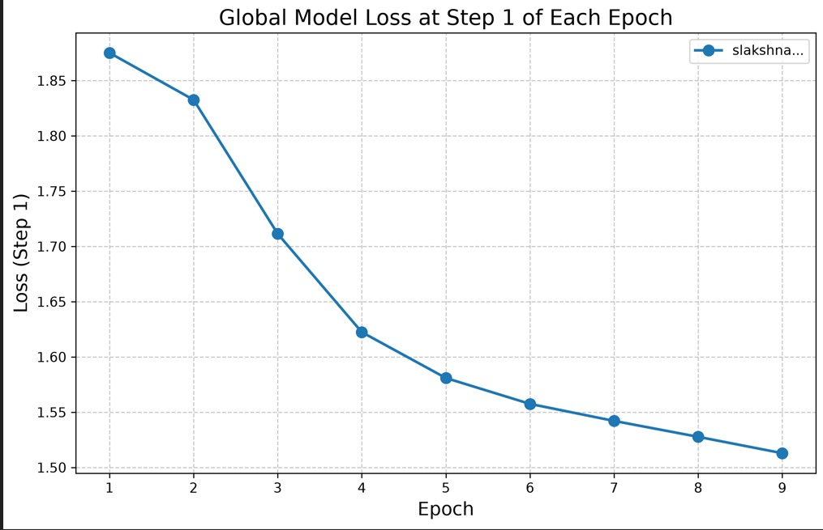
Australian step-1 loss by local invocation

Indian node
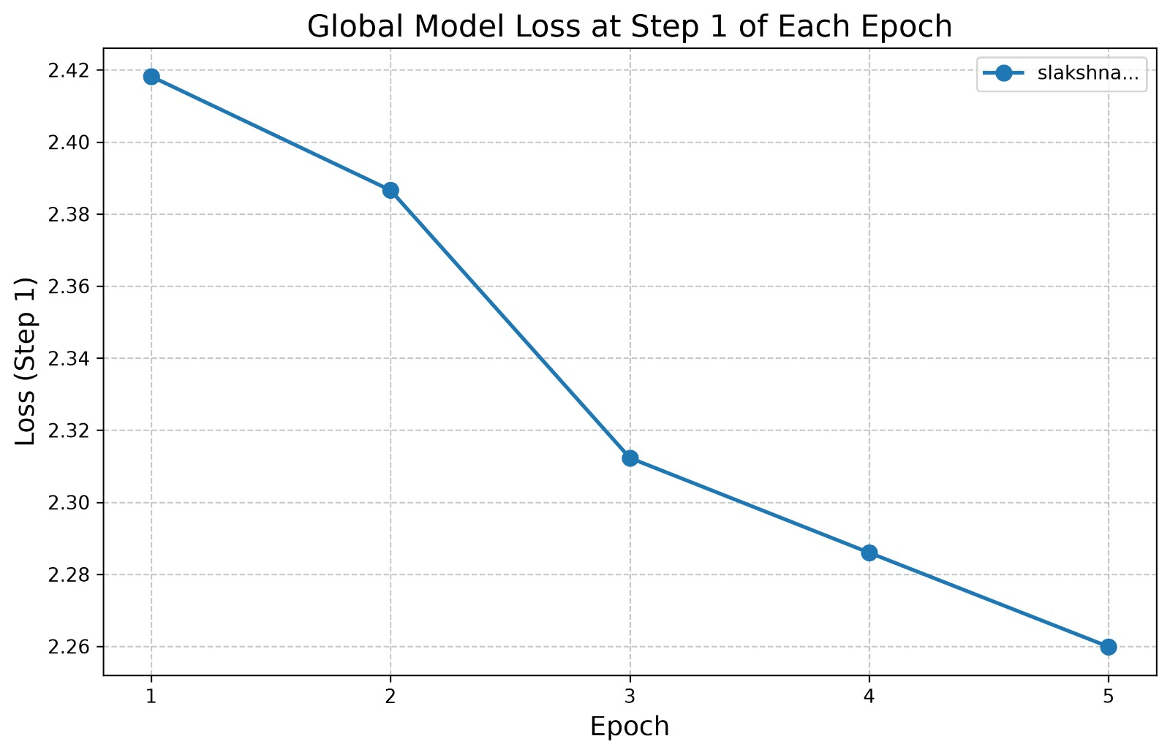
Indian step-1 loss by local invocation
The difference in scale is not, by itself, evidence of an algorithmic error: each point represents one locally sampled batch. The post-run delta inspection does, however, establish that the sites were not training the same adapter contract. The rank-8/rank-16 mismatch is therefore an additional concrete reason not to interpret the two lines as measurements of one shared global model.

Compatibility Finding and Claim Boundary
The local rank-8 adapter and the last received rank-16 envelope contained the same 88 parameter names, confirming that both targeted TinyLlama query and value projection adapters. Their parameter counts differed exactly by a factor of two. Every lora_A and lora_B tensor carried rank in one dimension, so none of the received shapes matched its local counterpart.
The receiver logged that the network delta had been “successfully verified and applied” after decoding and norm validation. The actual aggregation function first allocated its output tensors from the local delta, then added another tensor only when its shape equaled the existing output shape. It produced no warning or failure for a mismatch. Because the local delta is inserted first, all 88 Indian tensors were skipped. The persisted trust state could still list the Indian node, and the Rust layer could still place both nodes in the trusted cohort, but neither fact demonstrates numerical participation in the adapter update.
Accordingly, this run supports the following claims:
- independently operated cross-country nodes can discover one another and
sustain an authenticated Iroh Gossip connection through public UDP ingress;
- both sites can execute real local LLM fine-tuning for multiple rounds;
- Slakshna can broadcast, receive, deserialize, and perform basic safety checks
on versioned sparse-INT8 LoRA delta envelopes across sites; and
- the loss and model artifacts required for post-run analysis are produced.
It does not support the claim that the sites constructed a common global adapter, that either site's loss reduction resulted from the other site's training, or that the current runtime rejects incompatible participants before training begins.

Conclusion and Minimum Follow-Up
The exercise was a successful cross-country systems-integration and transport test, but an incomplete federated-learning validation. It demonstrated that the native Slakshna release can establish a real international peer mesh, keep both local trainers active, and exchange structurally valid compressed model messages without a shared filesystem or central coordinator. The investigation also showed why connectivity and a peer_delta_loaded event are insufficient acceptance criteria for federated training.
A minimal repeat does not require a larger experiment. Both teams should first use one shared effective model contract, including base-model revision, LoRA rank and targets, tensor schema, sequence length, and compression settings. The runtime should compare a contract or tensor-schema fingerprint before training and fail a received update when any name or shape differs. It should also distinguish “decoded,” “schema-compatible,” and “numerically aggregated” events, and should bind update freshness to a declared federation-round policy if synchronized rounds are intended. With those checks in place, a short two-round rerun would be sufficient to determine whether both nodes construct the same aggregated adapter and whether remote learning actually affects the next local initialization.

