# Student: Yuri Almeida Cunha

# Instance_ID:

1. Create a virtual instance and set the Ireland Region (“eu-west-1”)

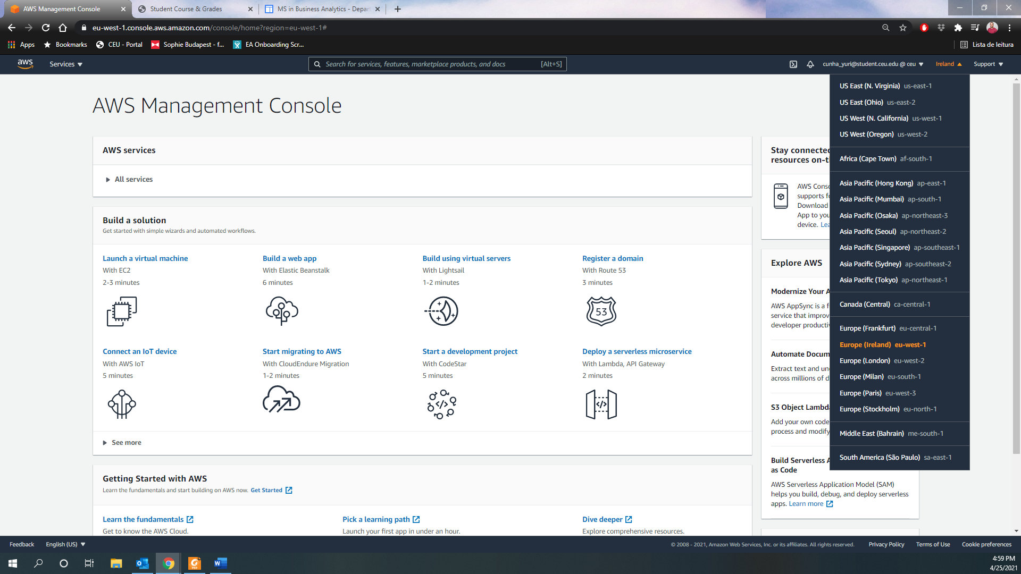

1. Choose a previous AMI (de5-week2) / Check AMI Characteristics

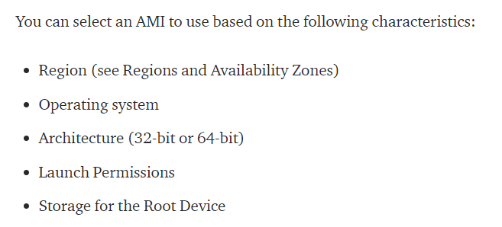

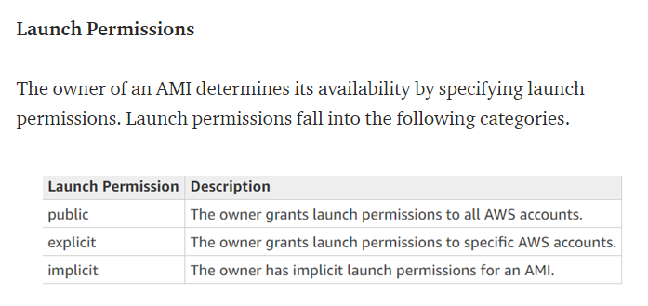

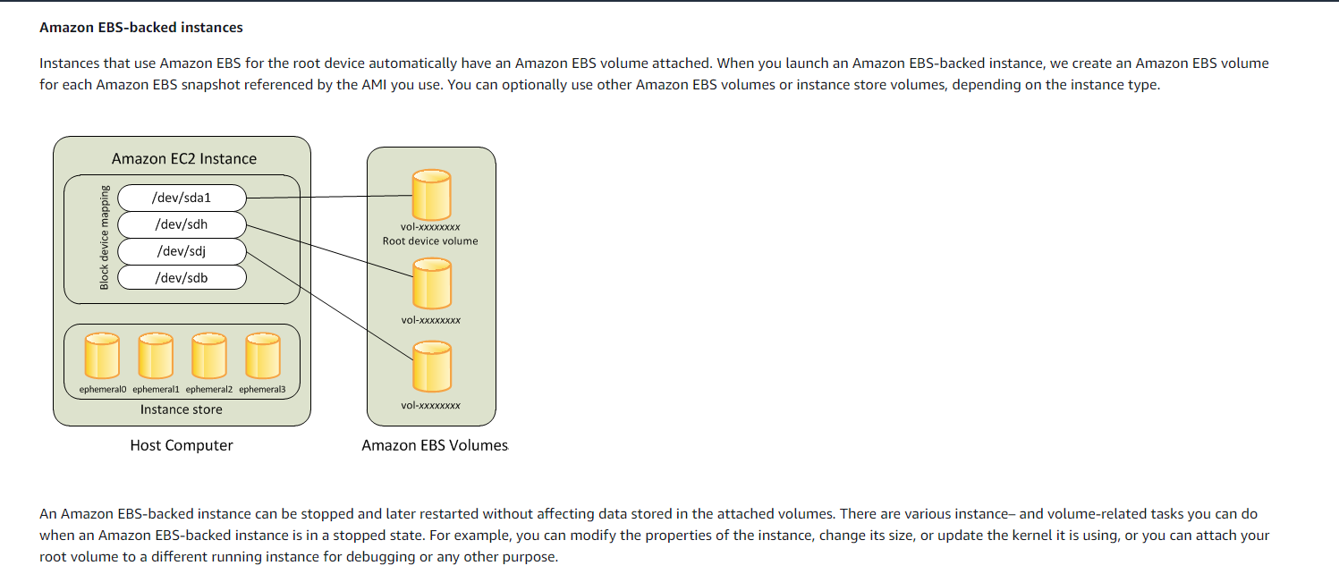

## AMI Characteristics – de5-week2

Region: Ireland

Operating System: Linux/Unix

Architecture: 64-bit

Launch Permissions: Private (implicit)

Storage for the Root Device: EBS (Amazon EC2 Instance)

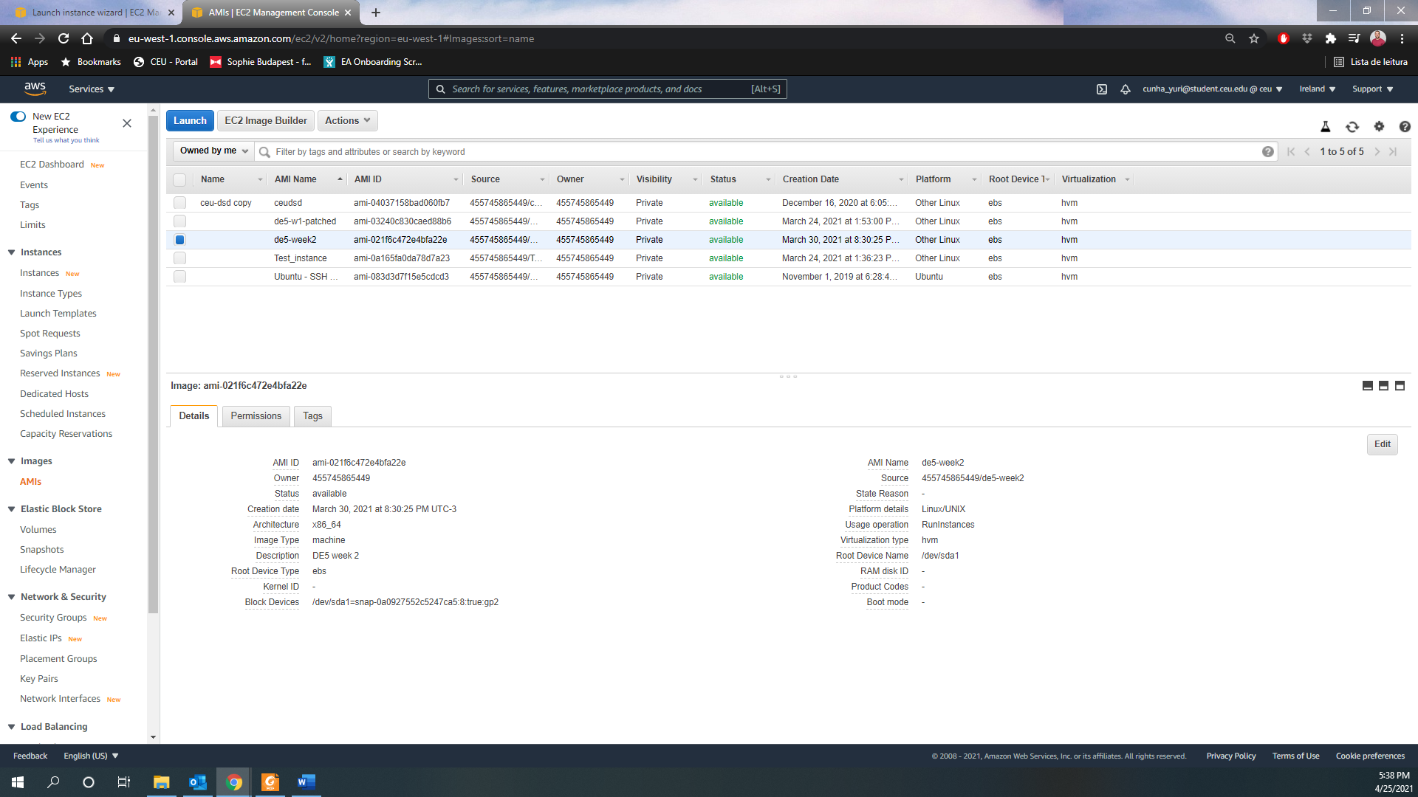

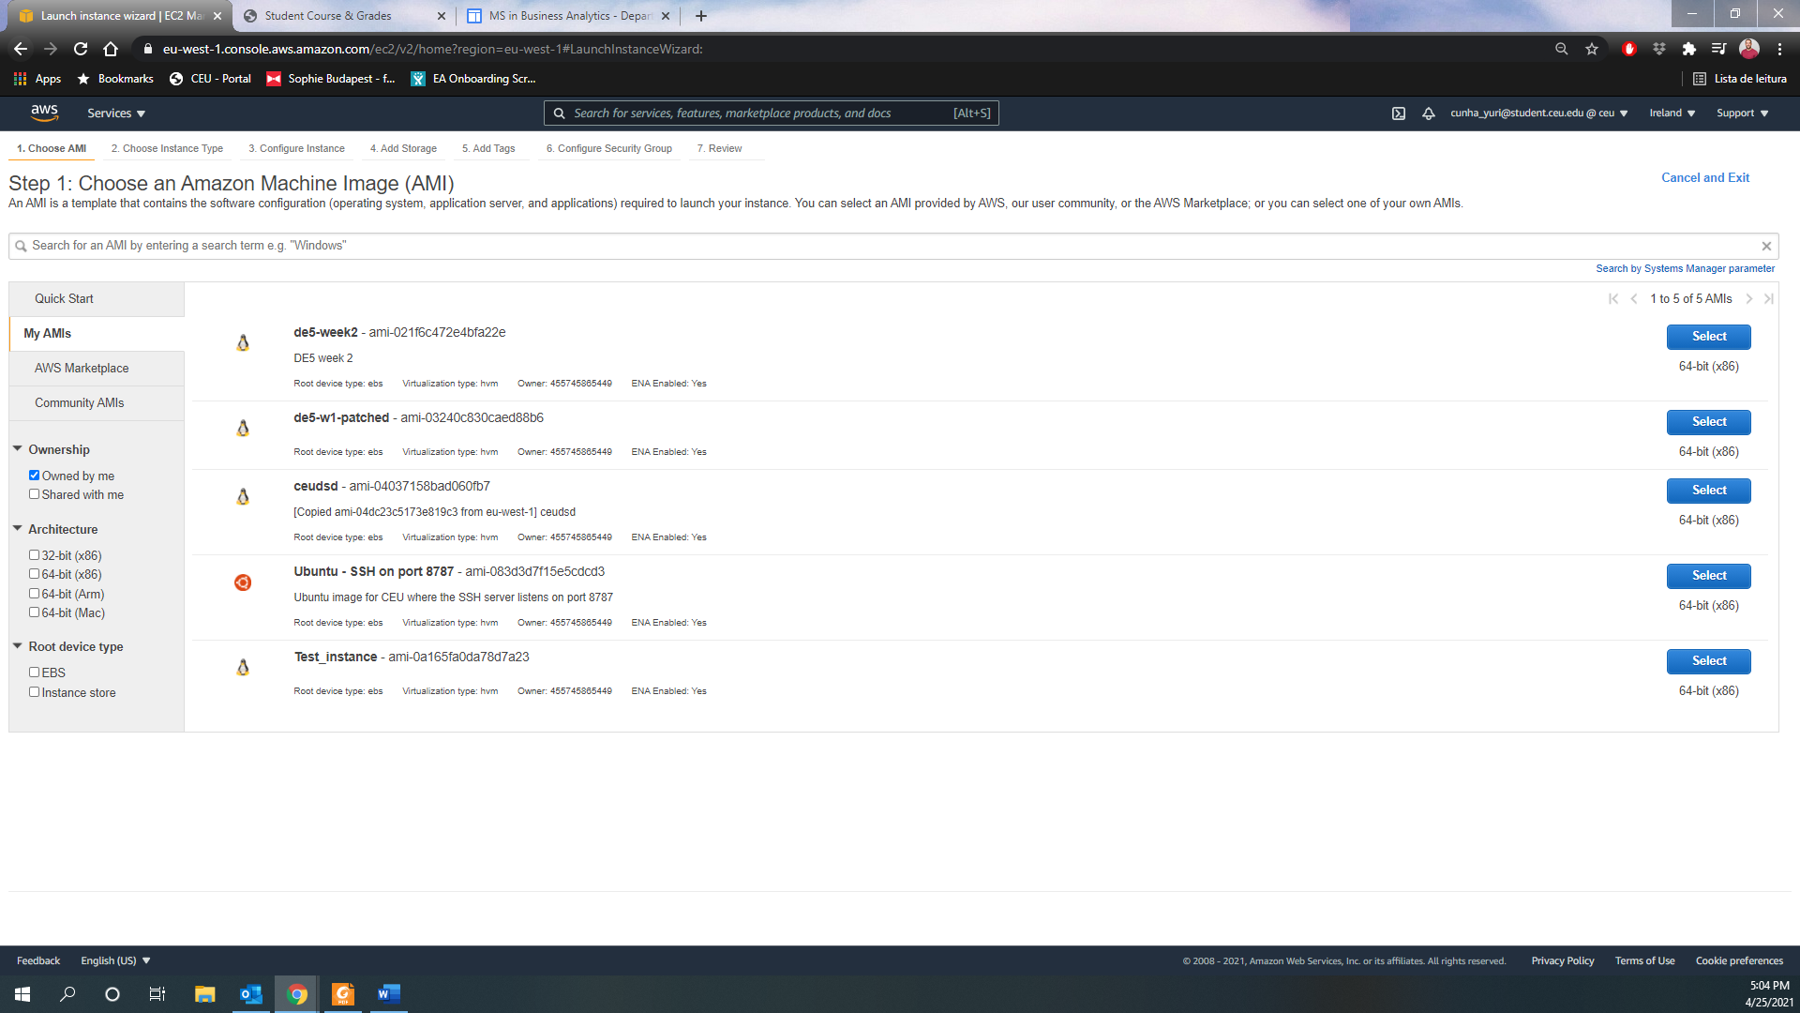

1. Choose an Instance Type (“t3.small”) – Same as class

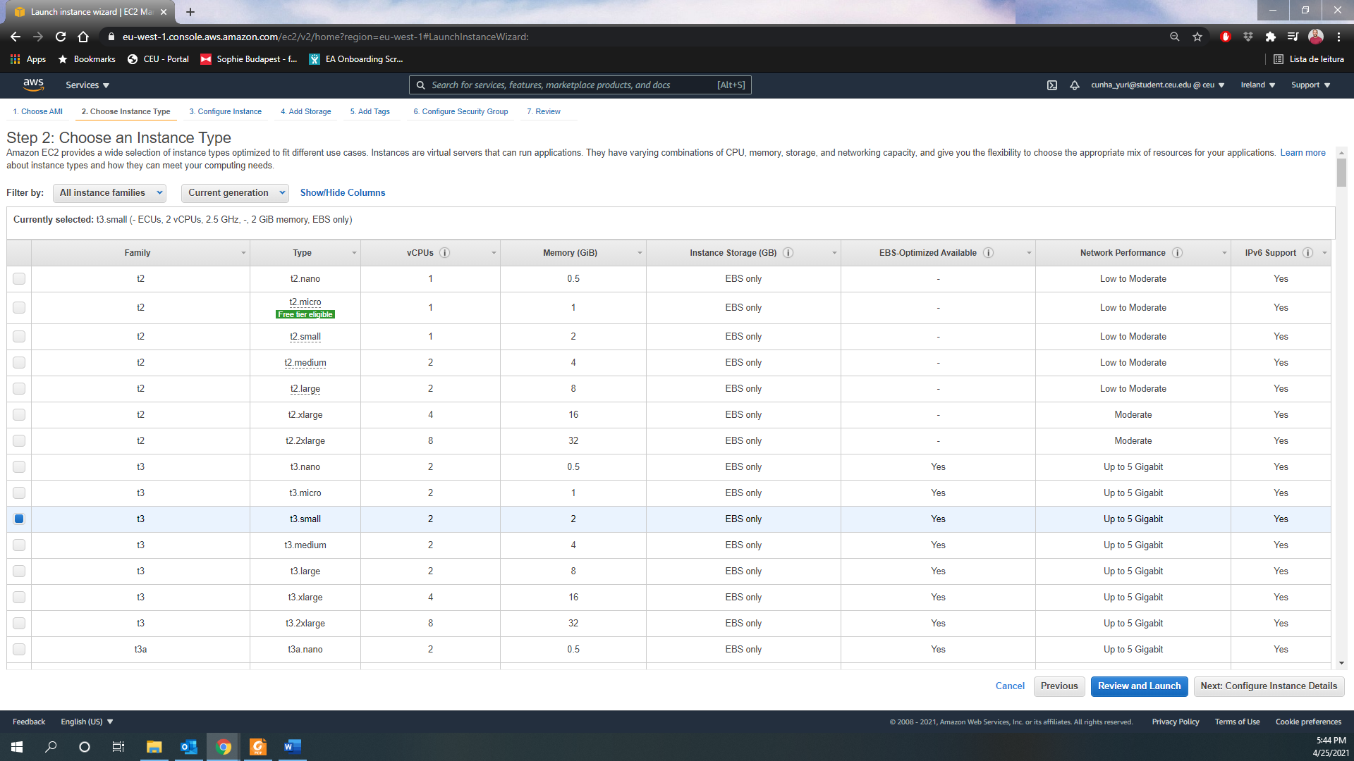

1. Choose the IAM Role (“t3.small”)

IAM role with full access to:

* Kinesis: AmazonKinesisFullAccess
* Dynamodb: AmazonDynamoDBFullAccess
* Cloudwatch: cloudwatch-putmetrics (CloudWatch)
* Slack token in the Parameter Store: AmazonSSMReadOnlyAccess

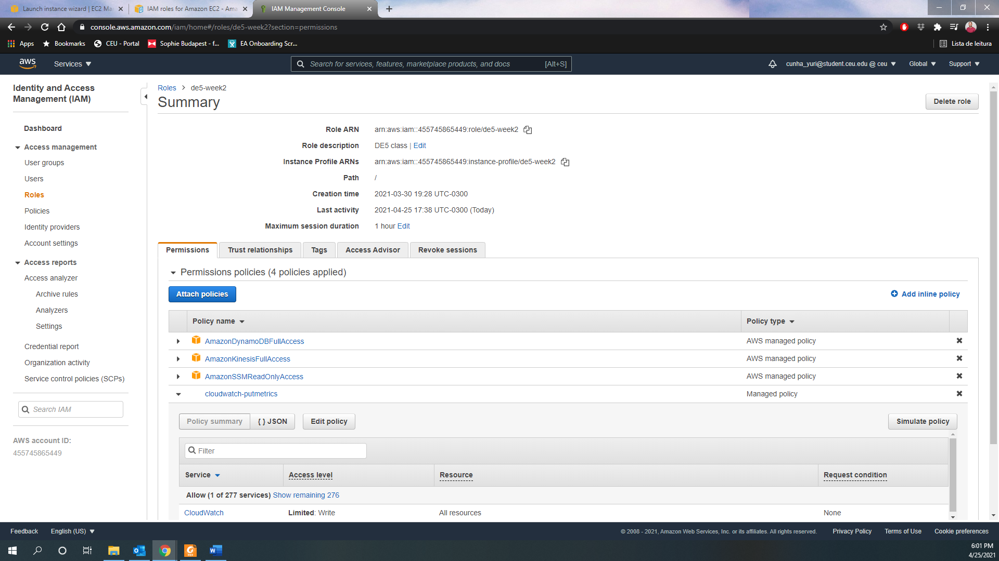

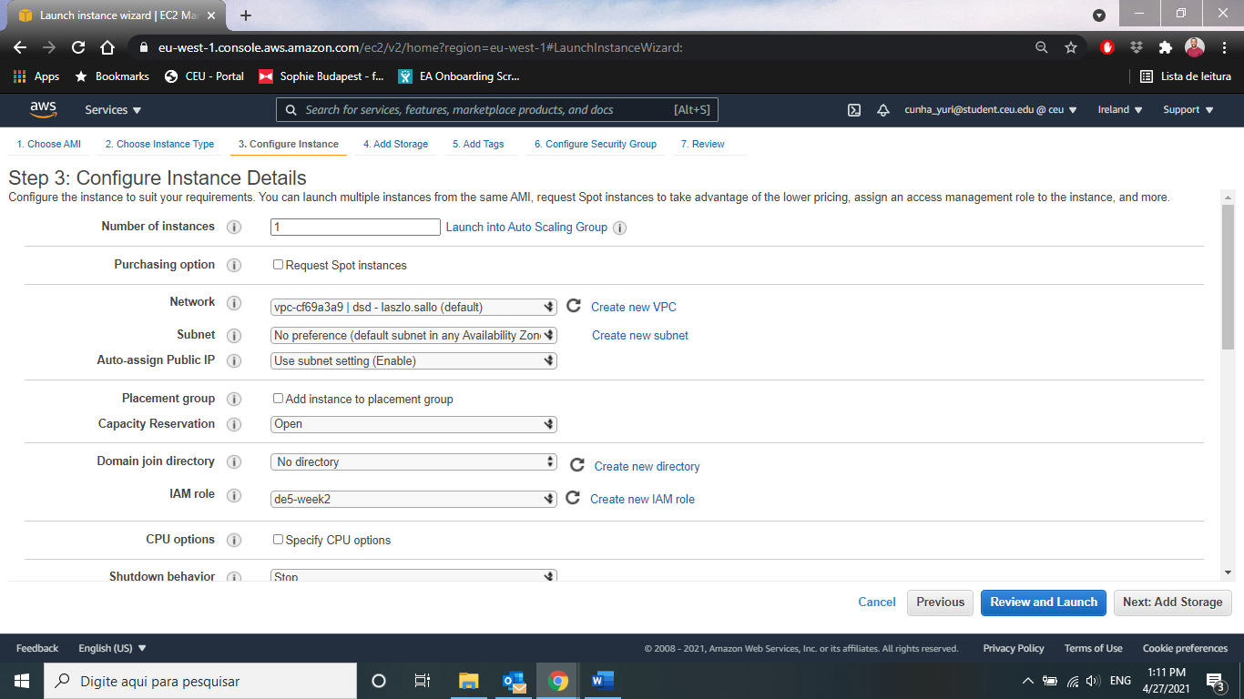

1. Define Storage

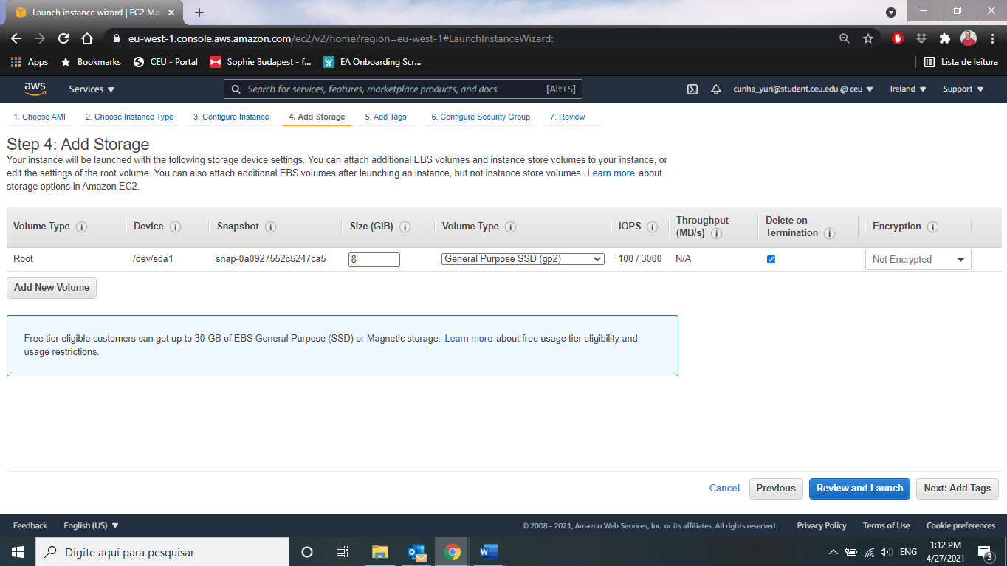

1. Add tag = Name Instance

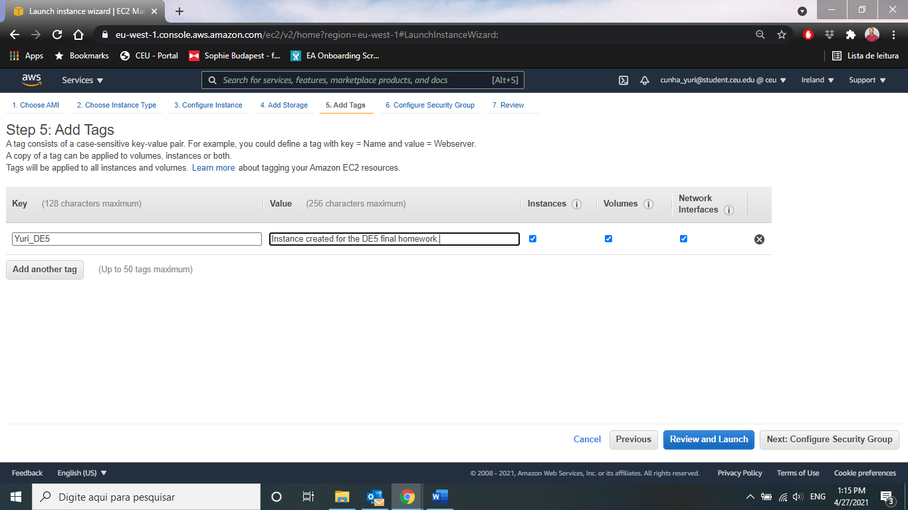

1. Define Security Group

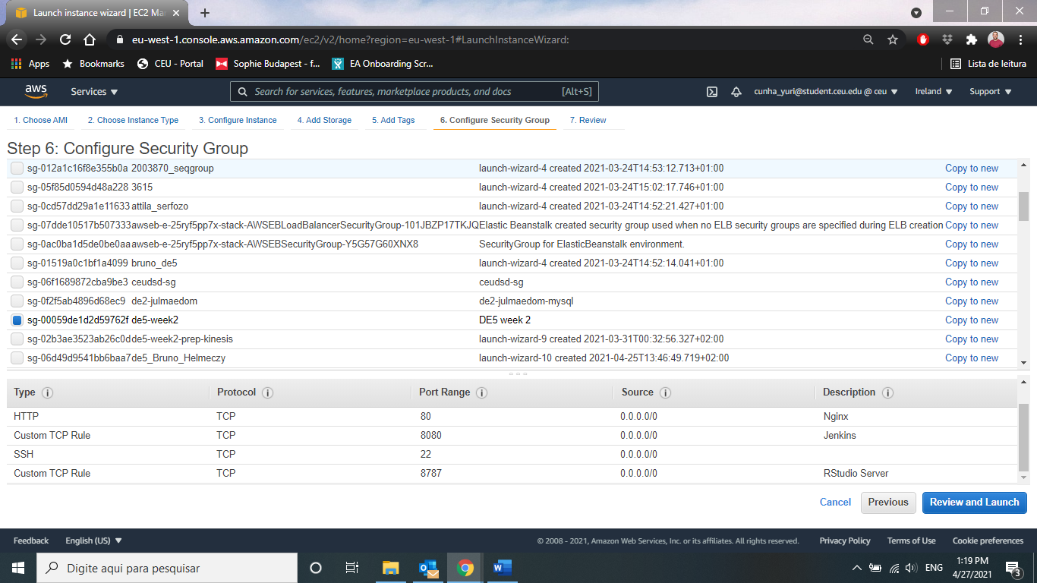

1. Launch Instance with your own key pair

