

Book Store Data Base

## 

User Information & Guidelines

## 

## Data Engineering 1

Table of Contents

Content Description 3

Overview 3

Data Sources (db_) 3

Table Content (tbl) 3

Components description 5

Analysis 6

## Content Description

### Overview

The database model contains information about a bookstore that works **selling** and **lending** books. The company has 3 departments (the **layers** were created based on them) :

* Book_Information: Department responsible for registration and controlling the information regarding the authors, books, and publishers.
* Sales: Department responsible to update the information related to the book sales
* Library: Department responsible to update the information related to the book checkouts

### Data Sources (db_)

Db_bookshop - the data source was found on a tableau exercise demonstration and it is completely fictional. It doesn´t have any connection with any known bookstore and its books

### Table Content (tbl)

#### Tblauthors

* AuthID: Primary Key – Author unique identifier
* First_Name: Author´s first name
* Last_Name: Author´s last Name
* Birthday: Author´s birthday
* Residence_Country: Author´s residence country

#### Tblbooks

* BookID: Primary Key – Book unique identifier
* Title: Book Title
* AuthID: Primary Key – Author unique identifier
* Genre: Book genre
* Volume_number: Book Volume Number
* Staff_Comment: Staff review about the book

#### Tblpublisher

* PublisherID: Primary Key – Publisher unique identifier
* Publishing_House: Name of the company
* City: City where the company is located
* State: State where the company is located
* Country: Country where the company is located
* Establish Year: Company foundation year
* Marketing investment: Marketing Investment for the year (USD)

#### Tbledition

* ISBN: Primary Key – Edition unique identifier
* BookID: Primary Key – Book unique identifier
* Book Format
* PublisherID: Primary Key – Publisher unique identifier
* Publication Date
* Pages: Number of pages
* PrintRunSize: Printer configuration size
* Price: Edition Price (USD)

#### Tblsales

* Sales_ID: Primary Key – item sold unique line
* ISBN: Primary Key – Edition unique identifier
* Sales Date: Date of the sale
* OrderID: Order Number

#### Tblcheckout

Important: this dataset came with a month aggregation, so I don’t have the information checkout per day

* Checkout_ID: Primary Key – item checkout in a specific month
* ISBN: Primary Key – Edition unique identifier
* CheckOutMonth: Month number
* CheckOutNumbers: Number of checkout on the following month

### Components description

#### Layers

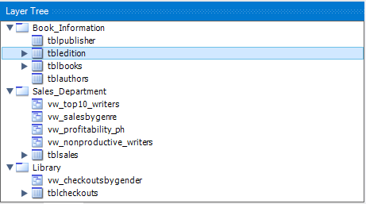

#### Relations

All the relations are (1:n)

#### Triggers

Only used on the foreign keys, all of them were set like: **UPDATE: CASCADE**

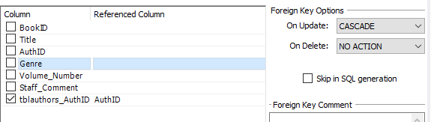

#### Users

One for each layer:

Book_Staff, Library_Staff and Sales_Staff

With the following roles:

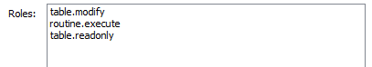

### Analysis

#### Views (vw_)

* Library Layer - vw_checkoutsbygender: number of checkouts by gender, and possibly market loss if the books were sold
* Sales Layer - vw_nonproductive_writers: what were the writers that sold less than 100 copies in the year and their books
* Sales Layer - vw_profitability_ph: what was the sales results by each publisher and the comparison with their marketing investment for the year
* Sales Layer - vw_profitability_ph: number of sales by gender, total value generated by them, average earnings per each book.
* Sales Layer - vw_top10_writers: Top 10 sales writers and the number of their sales, including also the average earned by book sold.

#### Store Procedures (sp_)

* Library Layer - sp_TOP10BooksbyGender: Top 10 checkout books - input variables: gender.
* Library Layer - sp_CheckoutsbyPH: Quantity book checkouts and possible market loss by month and publisher – input variables: publisher.
* Sales Layer - sp_BookswithDiscount: On the month that the authors complete their birthdays, the bookstore includes a 15% discount on all of their books. With this store procedure, the sales department can check what are the books in discount by each month using a month variable.