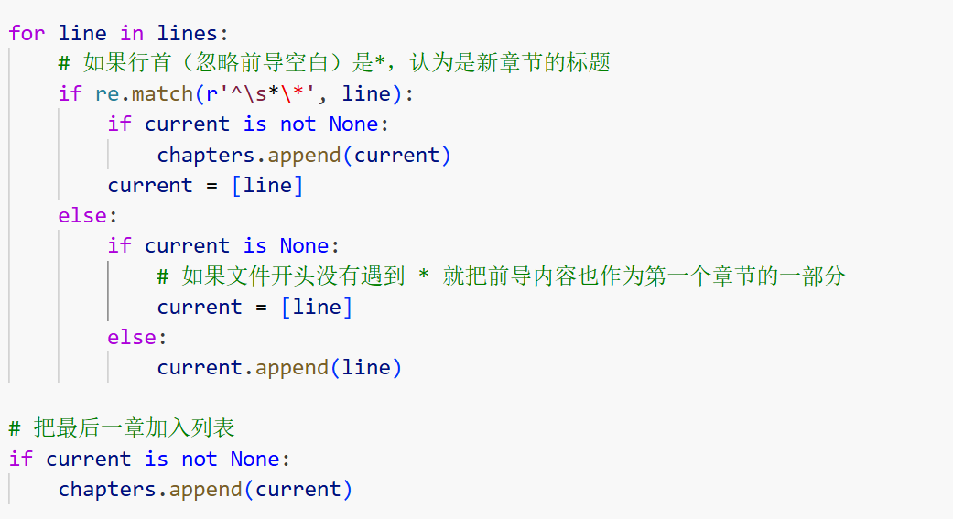
First, I download The Scholars from Ctext using a computer in the PolyU library and then split it into different chapters. I notice that all chapter titles start with star mark and use it to split.

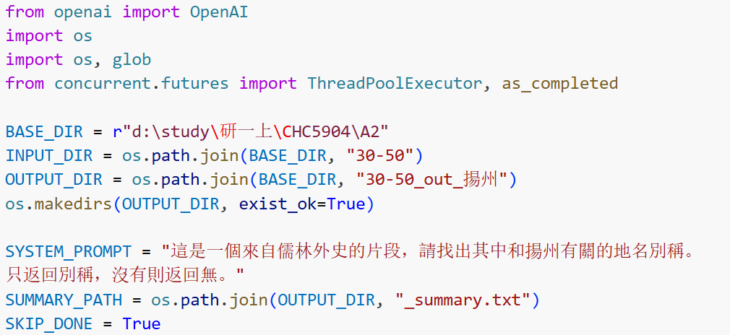
Then I use Qwen-max to extract terms related to the five cities from Chapter 30-50 of The Scholars. The simple model rather than the thinking version is adopted because the thinking version is too time consuming. The result has some mistakes, so I double-check it to make sure the terms are related to the cities. It still has some problems. For example, it is hard to determine 京refers to Beijing or Nanjing.

Then I use Hanlp to segment the words. Then use the NER tool in Hanlp to get the names of the characters. I delete those one-character name for simpler and accurate analysis. Because those one-character names maybe the surname of characters and are counted repeatedly. Hanlp is said to be the most accurate tool for Chinese related work like segmenting and NER.

Then I use the basic search functions in Python to analyze the correlation between city-related terms, chapters and characters. The frequency of each terms in different chapters is calculated. Characters appear in the same line with the terms are also extracted. I get the final analysis table for two reasearch question. There is one detail. I use the unsegmented text to do the search, because the errors in segmenting may cause errors in the final analysis. For example, using unsegmented texts, I can use 蘇州 to search for 蘇州府。

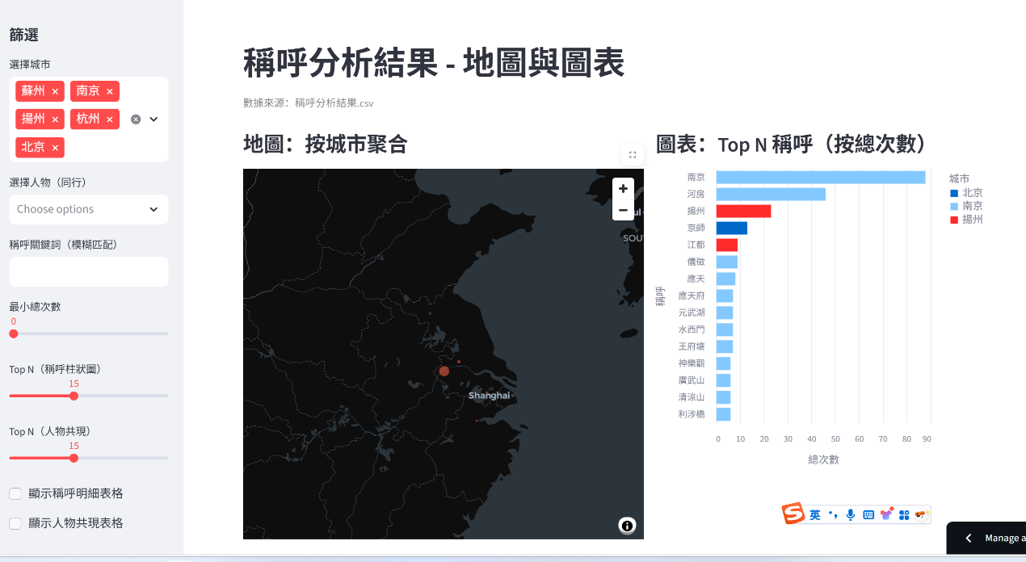
At last, I use the GIS in streamlit to demonstrate my results, including bar charts and responsive tables. It is very convenient for data demonstration using LLM to generate the code.
