Methodology SDLC is a framework that development teams use to produce high-quality software in a systematic and cost-effective way.(https://www.productplan.com/learn/software-development-lifecycle/)

There are different types of software development methodologies. At the present stage of technology development, there is no universal approach to creating a project, so a logical question arises: which approach to choose and what problems exist? The method of development is chosen based on the tasks of the business, the amount of work, time and budget. The most popular are Waterfall - cascading, and Agile - flexible.

Waterfall

The waterfall methodology is a linear project management approach, where stakeholder and customer requirements are gathered at the beginning of the project, and then a sequential project plan is created to accommodate those requirements. The waterfall model is so named because each phase of the project cascades into the next, following steadily down like a waterfall.

When the waterfall approach is used, at least five to seven different phases follow in an exact linear order. The first one can be initiated after finishing the previous stage of the phase before the next step has been completed.

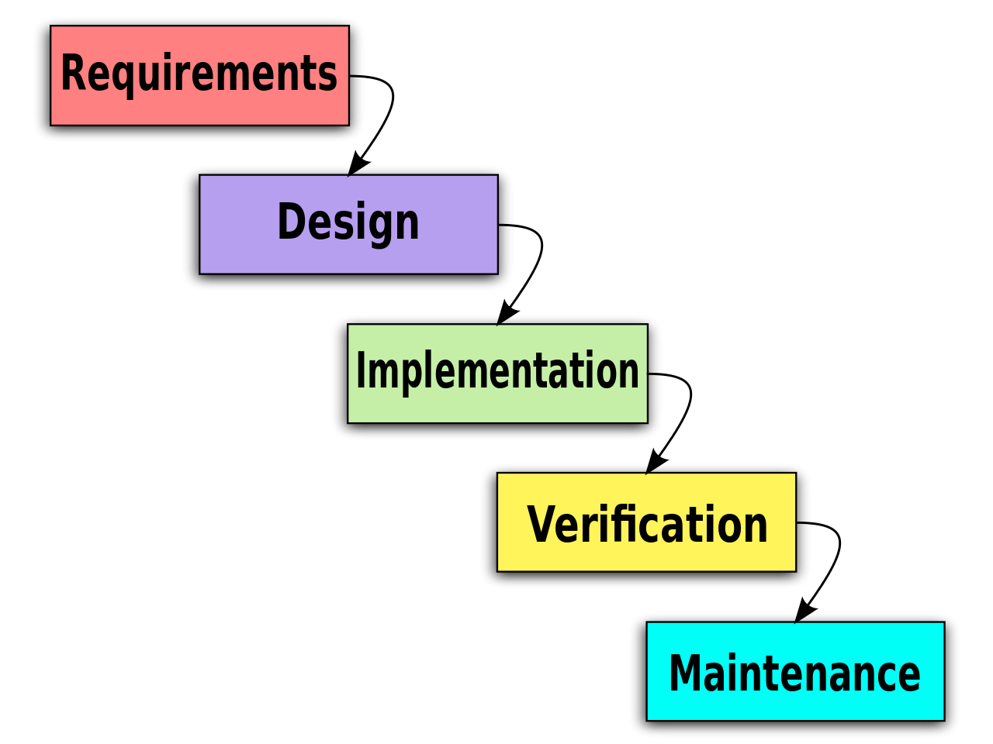
Requirements: The key aspect of the waterfall methodology is that all customer requirements are gathered at the beginning of the project, allowing every other phase to be planned without further customer correspondence until the product is complete.

Design: The design phase of the waterfall process is best broken up into two subphases: logical design and physical design. The logical design subphase is when possible solutions are brainstormed and theorized. The physical design subphase is when those theoretical ideas and schemas are made into concrete specifications

Implementation: The implementation phase is when programmers assimilate the requirements and specifications from the previous phases and produce actual code.

Verification: This phase is when the customer reviews the product to make sure that it meets the requirements laid out at the beginning of the waterfall project. This is done by releasing the completed product to the customer.

Maintenance: The customer is regularly using the product during the maintenance phase, discovering bugs, inadequate features and other errors that occurred during production. The production team applies these fixes as necessary until the customer is satisfied.

The cascade process is well suited for projects where the requirements are clearly defined and there is no doubt about what the final product should look like.

Agile

Agile is a methodology for managing projects in a flexible and adaptive way. The main idea of Agile is to prioritize flexibility and continuous improvement over following a strict plan. Agile methodologies are designed to be adaptive and responsive to changing requirements and priorities, allowing teams to deliver working software quickly and efficiently. Agile also emphasizes collaboration between teams, customers, and stakeholders, and encourages open communication and transparency throughout the project lifecycle. (https://www.simplilearn.com/tutorials/agile-scrum-tutorial/what-is-agile/)

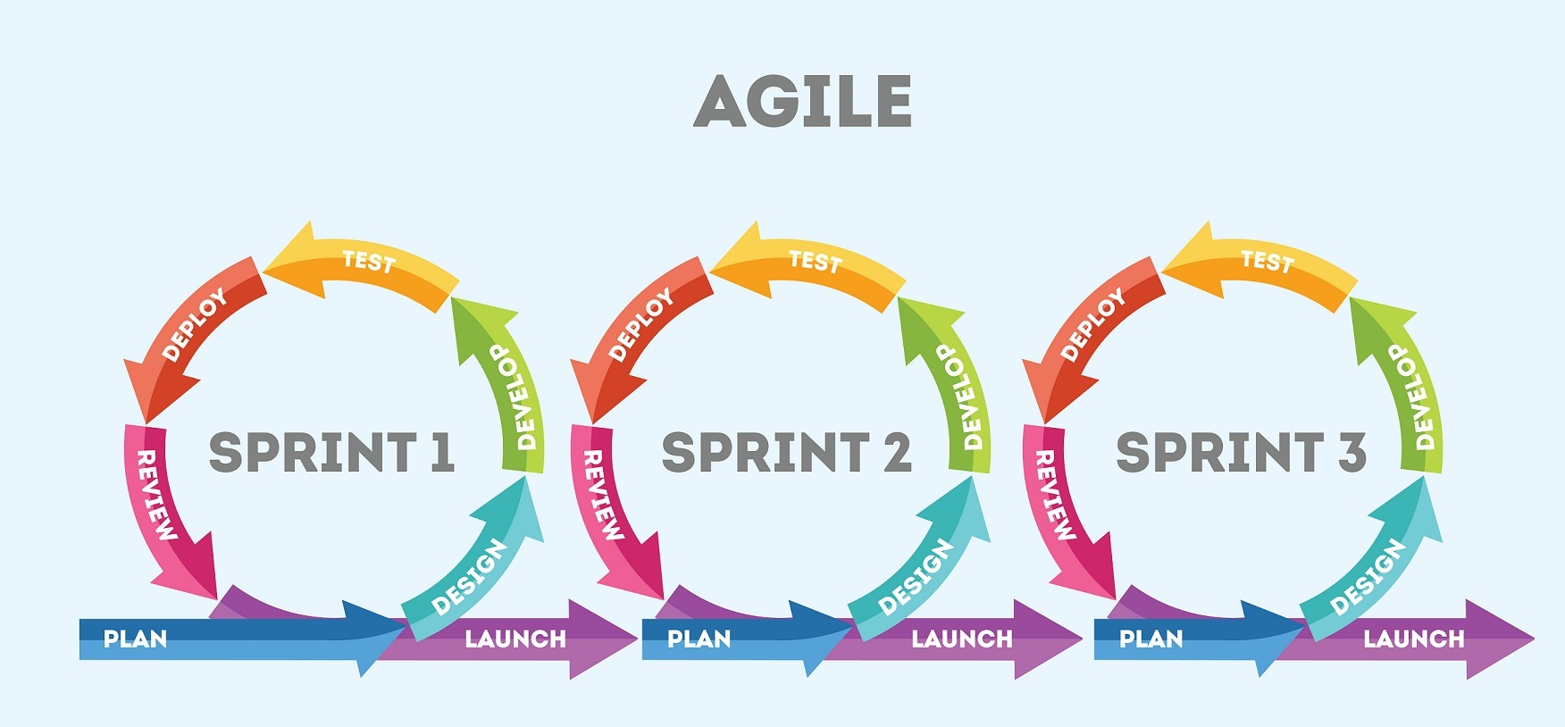

The four principles of Agile are: individuals and interactions, working software, customer collaboration, and responding to change. An example of an Agile method is Scrum.
(https://www.simplilearn.com/tutorials/agile-scrum-tutorial/what-is-agile/)

An example of an Agile method is Scrum. It is a framework for managing and completing complex projects. Scrum is based on the Agile principles of flexibility and continuous improvement, and it uses short iterations called sprints to manage and track progress.
(https://www.simplilearn.com/tutorials/agile-scrum-tutorial/what-is-agile/)

The Agile process is ideal for projects where the requirements are constantly changing or evolving, or where there is a need to quickly adapt to new information. It is also well-suited in case of project development with large demands and complexity.

When choosing a software development methodology, several factors must be taken into account, such as the size and complexity of the project, the amount of available resources, the level of acceptable risk and the timing of the project.

The following tips can help us make a choice:

- Requirements Flexibility – Before deciding on a methodology, teams should consider the requirements of the project.
- Project Size – Some methodologies work best for large-scale projects, while others are more suitable for smaller projects. Teams should evaluate the size of the project as a factor in deciding the right methodology.
- Time Required – Some methodologies help reduce the time to market for projects. If the project is on a strict time schedule, that’s definitely something to keep in mind while deciding.

Looking at the provided requirements, you can clearly see that they are at the initial stage and they need to be expanded. A number of methods can be used to extend requirements, including. (https://uk.indeed.com/career-advice/career-development/requirement-gathering-techniques):
- Interviews: Conducting interviews with stakeholders can help to gather more information about the requirements. This can be done in person, by phone or through email.
- Use Cases: Use cases can be used to identify specific scenarios in which the software will be used. They help to identify the various actors involved, the actions that will be performed and the expected results.
- Prototyping: Prototyping can be used to create a working model of the software. This can be used to test the requirements and identify any issues before proceeding with development.
- User stories: User stories are short, simple descriptions of a feature told from the perspective of the end user. They can be used to capture the user's perspective and to help ensure that the requirements are aligned with their needs.

Based on the previous information, in my opinion, the flexible model is more suitable for this project than Waterfall. Since in this project we do not fully know what our final product should be and the requirements may change. We will also need flexibility to combine development and testing. At this stage, I would divide this project into two sprints, the first of which would be the creation of the Employee entity and the implementation of its methods and testing of all new functionality, in the second sprint the Company entity with its methods will be created and we will also test these methods. Also, the use of Agile will contribute to the continuous improvement of our software.

In this scenario, it is obvious that the Waterfall methodology may not be the best fit for the project. Due to the fact that we do not have exact requirements. This approach is inflexible and is not the best fit for our project, which requires frequent testing or changes to requirements throughout the development process. Which means we need to complete the previous process before starting the next one. Which clearly proves that this methodology is not suitable for us.

Prototyping Model is a software development model in which a prototype is built, tested, and reworked until an acceptable prototype is achieved. It also creates a base to produce the final system or software. It works best in scenarios where the project’s requirements are not known in detail. It is an iterative, trial and error method which takes place between developer and client.(https://www.guru99.com/software-engineering-prototyping-model.html)

In the case of our software, the prototyping process can be useful as we are not sure about the final features that our software should include since we have very few requirements at this stage and a process such as prototyping will help us extract, verify and validate the requirements at this stage.
In the future, on the basis of already well-defined requirements, we will be able to develop a preliminary prototype of our program. This prototype will be a simplified model of the final product with the main features. With this prototype, we will be able to test our design to identify any issues that need improvement. The results of prototype testing will be used to refine requirements and improve functionality. All these steps will help us create better software.

In conclusion, the prototyping process is well suited and will benefit our software development. We will be able to combine the prototyping model with the Agile model. In the hybrid Agile-Prototyping approach, it will be possible to work in short sprints, each sprint will focus on the development of a functional prototype demonstrating a specific set of functions. This approach will provide rapid integration and feedback, as well as incorporate the benefits of the prototype model, such as early design and functionality validation. The hybrid approach will be especially effective in our situation, since the requirements are not fully understood and complete.

