Yurii Hehediush
Instructor: Nandhini Gulasingam
DSC 323
Final Report on Seoul Bike Sharing Demand
June 2, 2024

I. Introduction
One of the big challenges for urban communities is managing commute and traffic. Large cities require being able to provide sufficient transportation options for everyone's invaluable time. This project will analyze the dataset on Seoul Bike Sharing Demand to learn under what conditions one can predict bike rental counts. Chosen dataset provides a comprehensive view of the usage of bikes throughout the city, where major variables that explain the hourly rental number are highlighted. Forecasting the number of bikes is necessary to satisfy demand, enhance mobility, and bring ease of living to a busy urban metropolitan area. This helps in keeping the supply of rented bikes consistent, thus reducing the waiting time and improving the users' satisfaction.Note that all variables in the dataset, like temperature measured in Celsius and bike count, can be measured in different units. The methodology sheet contains more detailed measurement forms. The most important part of the project would be to predict the count of bikes required every hour to maintain stability in the supply of rental bikes. This would allow cities like Seoul to understand the demand of bikes on certain days and under what weather conditions.
A-II. Data Preprocessing
Several important steps were made in preparing the dataset of Seоul Bike Sharing Demand for analysis. First and foremost, the integrity of the dataset was checked for missing values, which might possibly render results inaccurate or erroneous in analysis. Fоrtunately all 8760 observations constituting the dataset were intact, with no missing values. This was a very crucial step in maintaining the data for a full set of observations.
Further, data cleaning was carried out by standardizing the names of variables through the removal of special characters and spaces. This ensured consistency in the dataset, making it more easily manageable and subject to a reduced chance of errors in further steps. The standardization of variable names is a commonplace in data preprocessing; it keeps the dataset clean and professional, hence more amenable to data handling and processing. The categorical variables Seasons and Holiday were converted into dummy variables. Such transformation was necessary to enable the inclusion of categorical data in the regression model. We are able to include categorical data in our analysis without introducing any bias by representing each category as a binary variable, where a 1 shows the 'presence' and a 0 shows 'absence'. For instance, the 'Seasons' variable was divided into four dummy variables: Winter, Spring, Summer, and Autumn, each indicating the presence or absence of a particular season
These preprocessing steps were necessary in several ways: the cleaning of the data set, especially from missing values and standardization of variable names because SAS cannot read special character. The conversion of categorical variables to dummy variables allowed their effective inclusion in the regression model. The first steps of preparing data allow us to ensure that the data is clean, consistent, and ready for the further research.
A-III. Exploratory Data Analysis
The exploratory data analysis reveals key insights into the relationships and patterns within the dataset. The scatter plot matrix shows that certain variables have clear linear relationships. For example, there is a noticeable positive linear relationship between temperature and the number of rented bikes. Additionally, clusters and patterns are evident, suggesting potential multicollinear-rity, particularly between Dew Point Temperature and Temperature.
The Pearson correlation matrix further supports these findings. It highlights that temperature has a strong positive correlation (r = 0.53856) with the rented bike count, indicating that higher temperatures are associated with more bike rentals. Conversely, humidity shows a negative correlation (r = -0.19978) with bike rentals, suggesting that higher humidity levels might deter people from renting bikes. Wind speed also has a positive correlation (r = 0.12111) but is weaker compared to temperature. Other weather variables like rainfall and snowfall exhibit weaker correlations with bike rentals. The dummy variables were removed to avoid any confusion in the data.
The histogram of the rented bike count illustrates that the distribution is right-skewed, indicating that there are more instances of lower bike rentals, with fewer occurrences of very high rental counts. This skewness in data highlights the variability in bike demand, which can be influenced by various factors captured in the dataset.
Overall, the anylysis provides a foundational understanding of the dataset, showing which variables are likely to be significant predictors in our model and where potential issues like multicollinearity might arise. These insights guide further analysis and model building to predict bike rental demand accurately.
A-IV. Initial Regression Model
The Initial regression model has an R-Square of 0.4568 which tell us that approximately 45.67% of the bike rental count can be predicted using the independent variables included in the model.
Based on the output we can say that the model is statistically significant. The high F-value of 668.61 with a p-value of less than 0.0001. This indicates that the model is better than a model with no predictors and that the relationship between the predictors and the bike count is strong.
The Root Mean Square Error of 475.70 and a Coefficient of Variation of 67.51% suggest that there is considerable variability in the data that the model does not capture. This highlights the potential for further improvement in the model to better explain the variance in bike rentals.
The parameter estimates indicate the influence of each variable on the bike rental count. For instance, temperature positively impacts the bike rentals, while humidity and rainfall have a negative effect. Some variables, such as Visibility and Dew Point Temperature, were found to be insignificant in this initial model, with high p-values and non-influential t-values.
A-V. Residual / Multicollinearity Check for Initial Model
The residual analysis of the initial model provides insights into the model fit by examining the residuals, which are the differences between observed and predicted values . In this initial model, the residuals for most predictors are randomly scattered around zero, indicating a generally good fit. This suggests that the model captures the main trends in the data. However, some variables, such as humidity and temperature, show patterns in the residuals that could indicate issues like heteroscedasticity or unmodeled relationships. These patterns suggest that the variability in bike rentals might not be constant across all values of these predictors, pointing to potential areas for model improvement.
By checking multicollinearity we can see some concerns, particularly with variables such as temperature and dew point temperature. Both of the exhibited high variance inflation factors. This indicates that these variables are highly correlated and could impact the stability and interpretability of the regression coefficients. Addressing multicollinearity by potentially removing or combining correlated predictors can further improve the model's performance.
Overall, while the model fits the data reasonably well, the residual analysis and multicollinearity check highlight areas where the model could be refined to better capture the relationships between the predictors and bike rental counts.
A- VI. Influential Points and Diagnostics
The analysis of influential points and diagnostics aimed to identify and address data points that might disproportionately affect the regression model's results. Tools such as Cook's distance, leverage, and studentized residuals were used to pinpoint these influential points. By examining these diagnostics, we found and addressed 964 influential points, improving the model's accuracy.
To refine the model further we identified predictors like Visibility, Dew Point Temperature, and Snowfall as insignificant due to their high p-values (> 0.5) and removed them from the model. Residual plots were used to visualize the residuals versus predicted values, helping to assess the model fit and identify potential issues. These steps ensured a more reliable and accurate predictive model for bike rentals.
A-VII. Model Refinement
The refined regression model, excluding outliers and influential points, shows a notable improvement. The Adj R-Square value increased to 0.4788, indicating a better fit and explaining approximately 47.88% of the variance in the bike count.
Key predictors include Temperature, Humidity, Wind Speed, Solar Radiation, Rainfall, Warm Season, and Holiday Flag. These variables significantly impact bike rentals, as evidenced by their parameter estimates and p-values.
The model refinement process has enhanced predictive accuracy, providing a more reliable tool for forecasting bike rental demand.
A-VIII. Final Model Selection
Further on we tested both STEPWISE and CP methods to identify the best model for predicting the bike rental count. The STEPWISE method, anyway, was identified as the best model for our use. Our model's Adjusted R-Square improved from the initial 0.4561 to 0.4788, hence a better fit and model accuracy. And what is more important we see an improvement on R-Square of 0.4792. Final model includes only significant predictors such as Temperature, Humidity, Wind Speed, Solar Radiation, Rainfall, Holiday Flag, and Warm Season. This refined model demonstrates enhanced explanatory power and reliability in predicting bike rentals.
The Final Model equation:
Rented_Bike_Count = 858.84 + 37.16452 × Temperature − 10.14321 × Humidity + 55.61556 × Wind_speed − 113.43990 × Solar_Radiation − 159.79655× Rainfall − 281.12724 × d_Holiday_Flag − 102.04291 × d_Warm_Season
To break everything down, let's explain what our equation does. Rented_Bike_Count predicts the number of bikes rented per hour. For each unit increase in Temperature in Celsius, the bike count increases by 37.16452 units. For each unit increase in Humidity %, the bike count decreases by 10.14321 units. For each unit increase in Wind Speed m/s, the bike count increases by 55.61556 units. For each unit increase in Solar Radiation mj/m², the bike count decreases by 113.43990 units. For each unit increase in Rainfall mm, the bike count decreases by 159.79655 units. On holidays d_Holiday_Flag= 1, the bike count decreases by 281.12724 units compared to non-holidays. During the warm season d_Warm_Season= 1, the bike count decreases by 102.04291 units compared to other seasons.
A- IX. Train-Test Split for Model Validation
For the train/test we are using 70/30 split. With 70% of the data used for training, the model achieved an R-Square of 0.4792 and an Adjusted R-Square of 0.4788. Which explains about 48% of the variance in the rented bike count. This indicates that the model captures a significant portion of the data variability.
Remaining 30% is used for testing performance or in other words how it will behave in the future. Based on R-Square of 0.5022 and an Adjusted R-Square of 0.5007 we can see goo improvements on testing. It suggests that our model generalizes well to new, unseen data, proving its robustness and reliability in predicting bike rentals.
A- X. Predictions
The main purpose of prediction is to put all the puzzles tother and see how out data will behave in the future. After generating final SAS code, we can see:
Observation 1: Based on our prediction, on a day when the temperature is 25C with 60% humidity, wind speed at 3 m/s, solar radiation of 1.2 MJ/m², zero rainfall, no holiday, and during the warm season (spring and summer), the predicted bike count is 1108.04 bikes.
Observation 2: Tell us that on a day with a temperature of 30С, humidity at 55%, wind speed of 2 m/s, solar radiation of 1.8 MJ/m², no rainfall, no holiday, and during the warm season, the predicted bike count is 1220.90 bikes.
These predictions offer a reasonable estimate of bike rentals under given weather and seasonal conditions. They demonstrate the mоdel practical applicability and its ability to assist in decision making processes. Predicting bike rentals based on weather conditions can significantly aid in resource planning and operational decision-making for bike-sharing services, optimizing bike availability, maintenance schedules, and distribution logistics to meet user needs effectively. This predictive capability can enhance user satisfaction and operational efficiency.
A- XI. Summary of Findings
The analysis of the Seoul Bike Sharing Demand dataset aimed to predict the number of bikes rented per hour based on various weather and seasonal factors. The dataset was meticulously preprocessed to ensure no missing values and standardized for consistency. Initial exploratory data analysis revealed significant linear relationships, particularly between temperature and bike rentals, highlighting temperature as a strong positive predictor. Our initial regression model explained 45.67% of the variance in bike rentals, with temperature, humidity, and rainfall emerging as key predictors. Residual analysis and multicollinearity checks indicated areas for improvement, prompting the removal of insignificant predictors like visibility and dew point temperature. Refining the model by excluding influential points improved the adjusted R-Square to 0.4788. Using the STEPWISE method for model selection, we identified temperature, humidity, wind speed, solar radiation, rainfall, holiday flag, and warm season as significant predictors, further enhancing the model's explanatory power. A 70/30 train-test split validated the model, with the training set achieving an R-Square of 0.4792 and the testing set showing an improved R-Square of 0.5022, indicating robust performance and good generalizability to unseen data. The model's predictions, such as estimating bike rentals based on specific weather conditions, can significantly aid in resource planning and operational decision-making for bike sharing services in Seoul.

Appendix
- II. Data Preprocessing
A- II 1. Initial Data Sample:
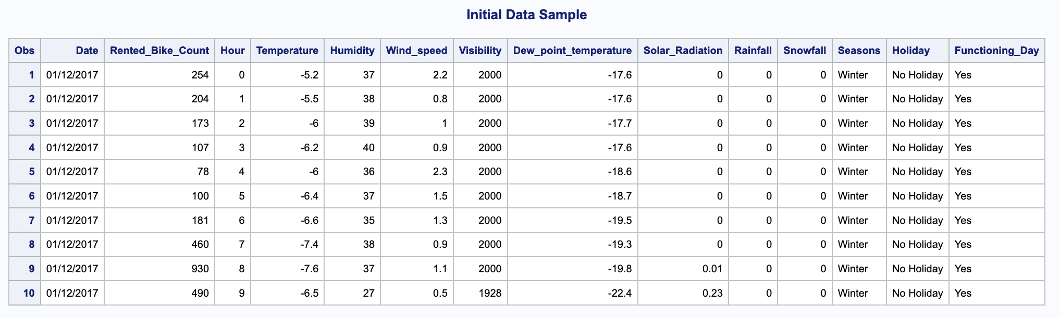

A- II 2. Data with Dummy Variables:
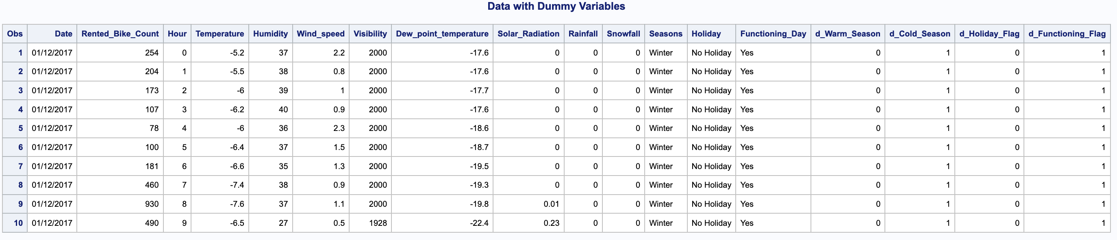

A-III. Exploratory Data Analysis
A- III 1. Scatter Plot Matrix:
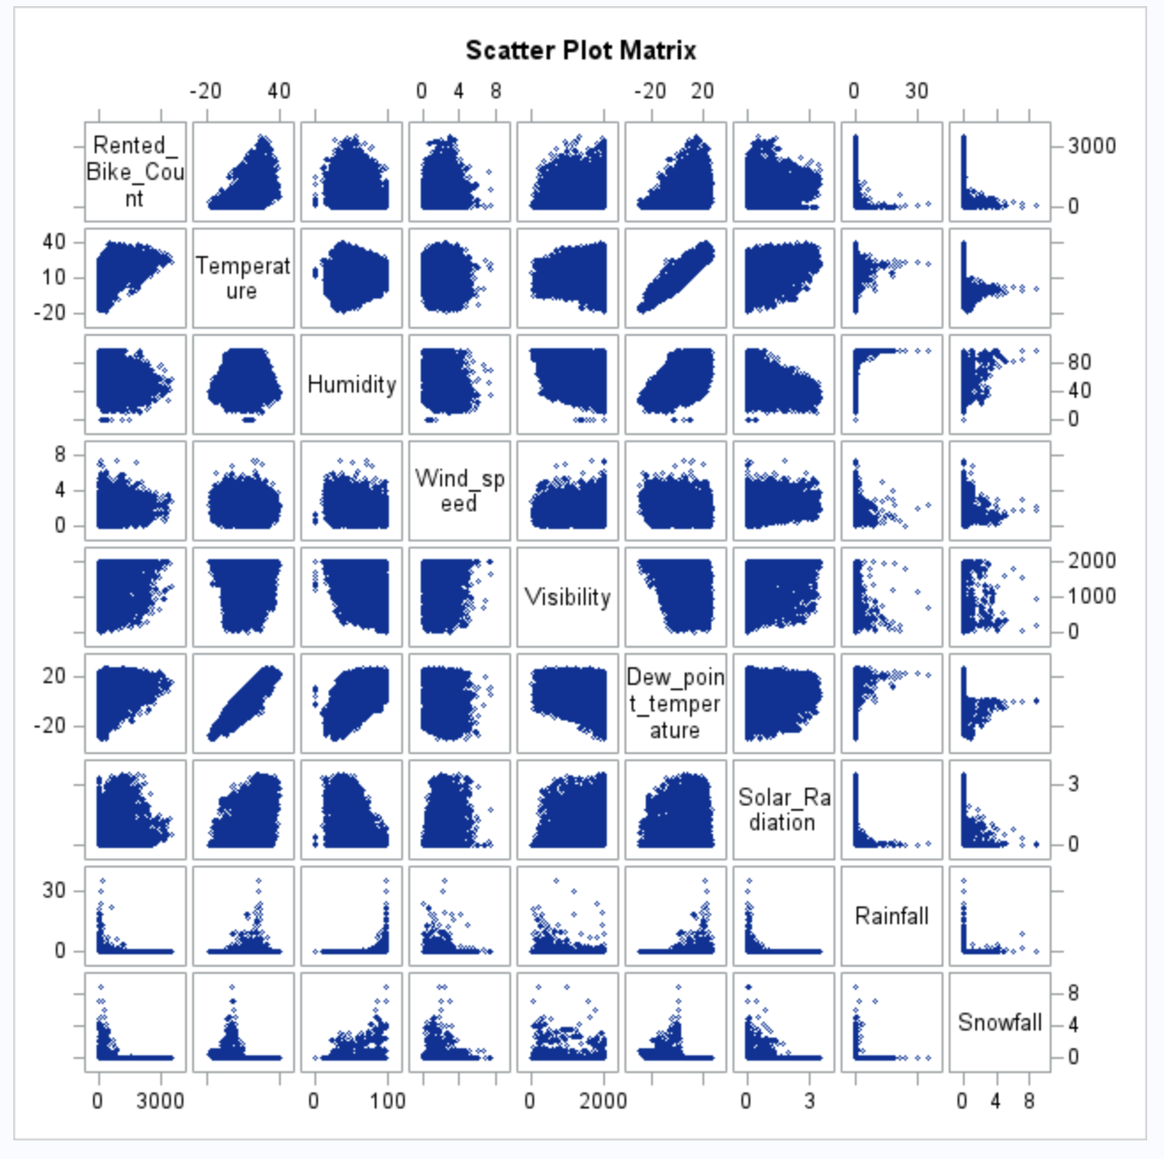

A-III 2. Pearson Correlation:
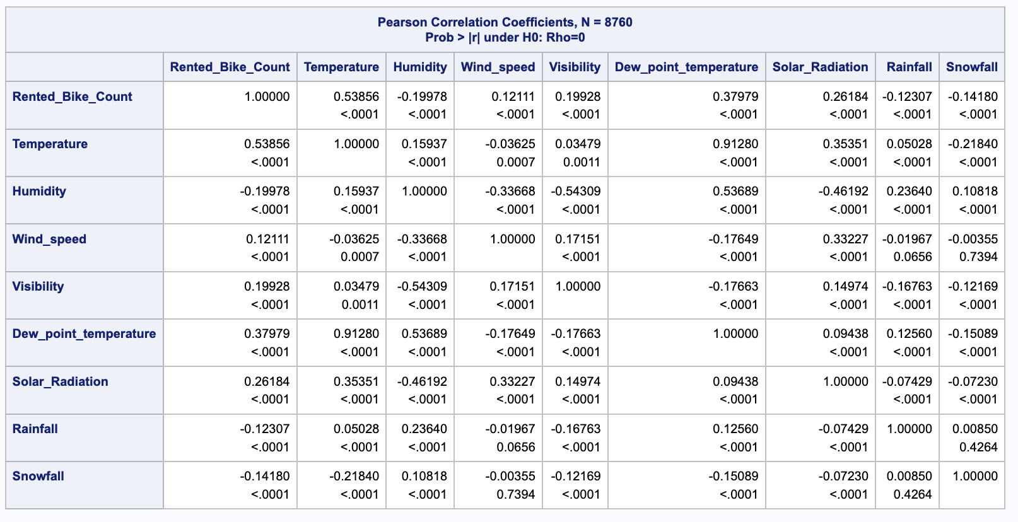
A-III 3. Histogram of Rented Bike Count:
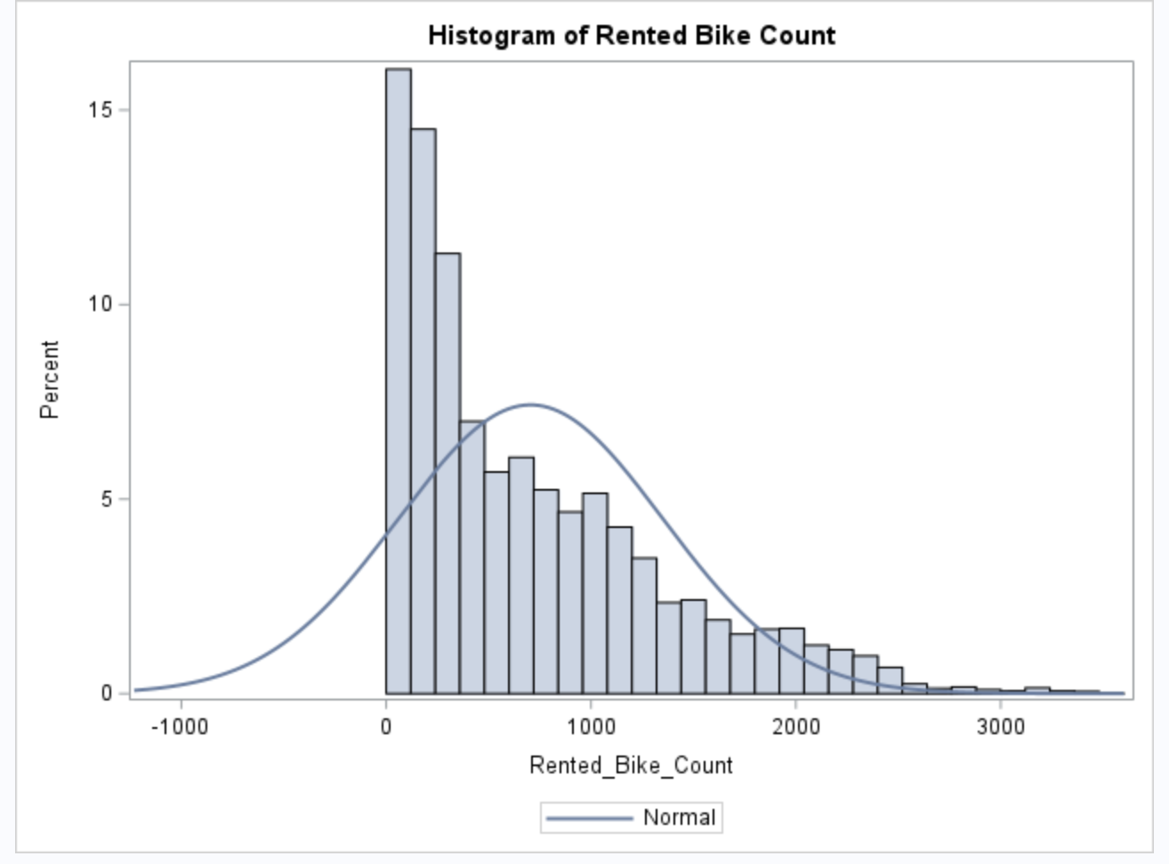

A-IV. Initial Regression Model
A- IV 1. Initial Regression Model:
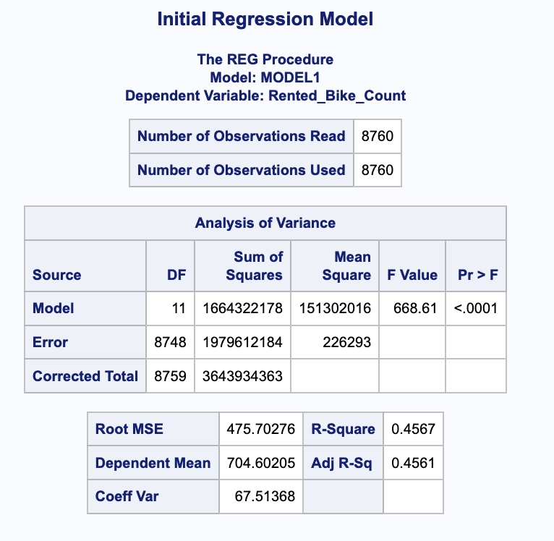
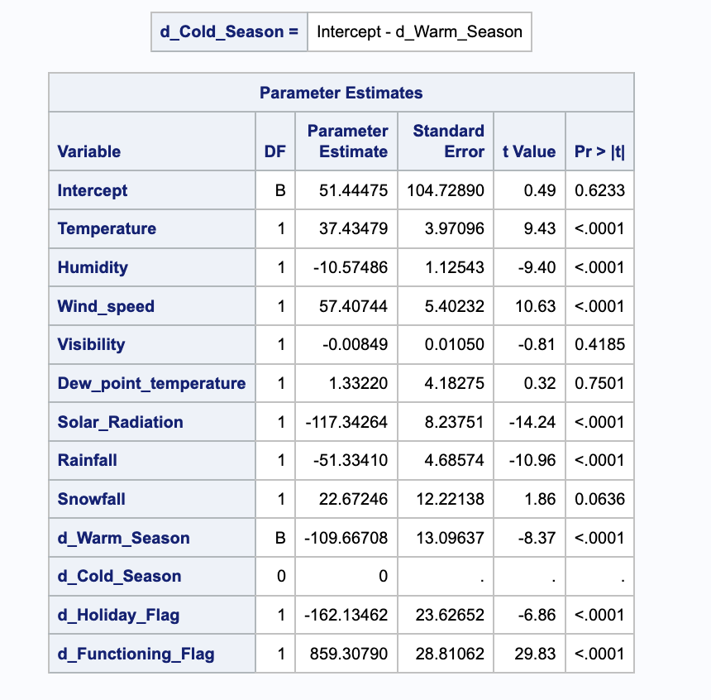

A-V. Residual Analysis for Initial Model
A-V 1. Residual by Regressor for Rented Bike Count:
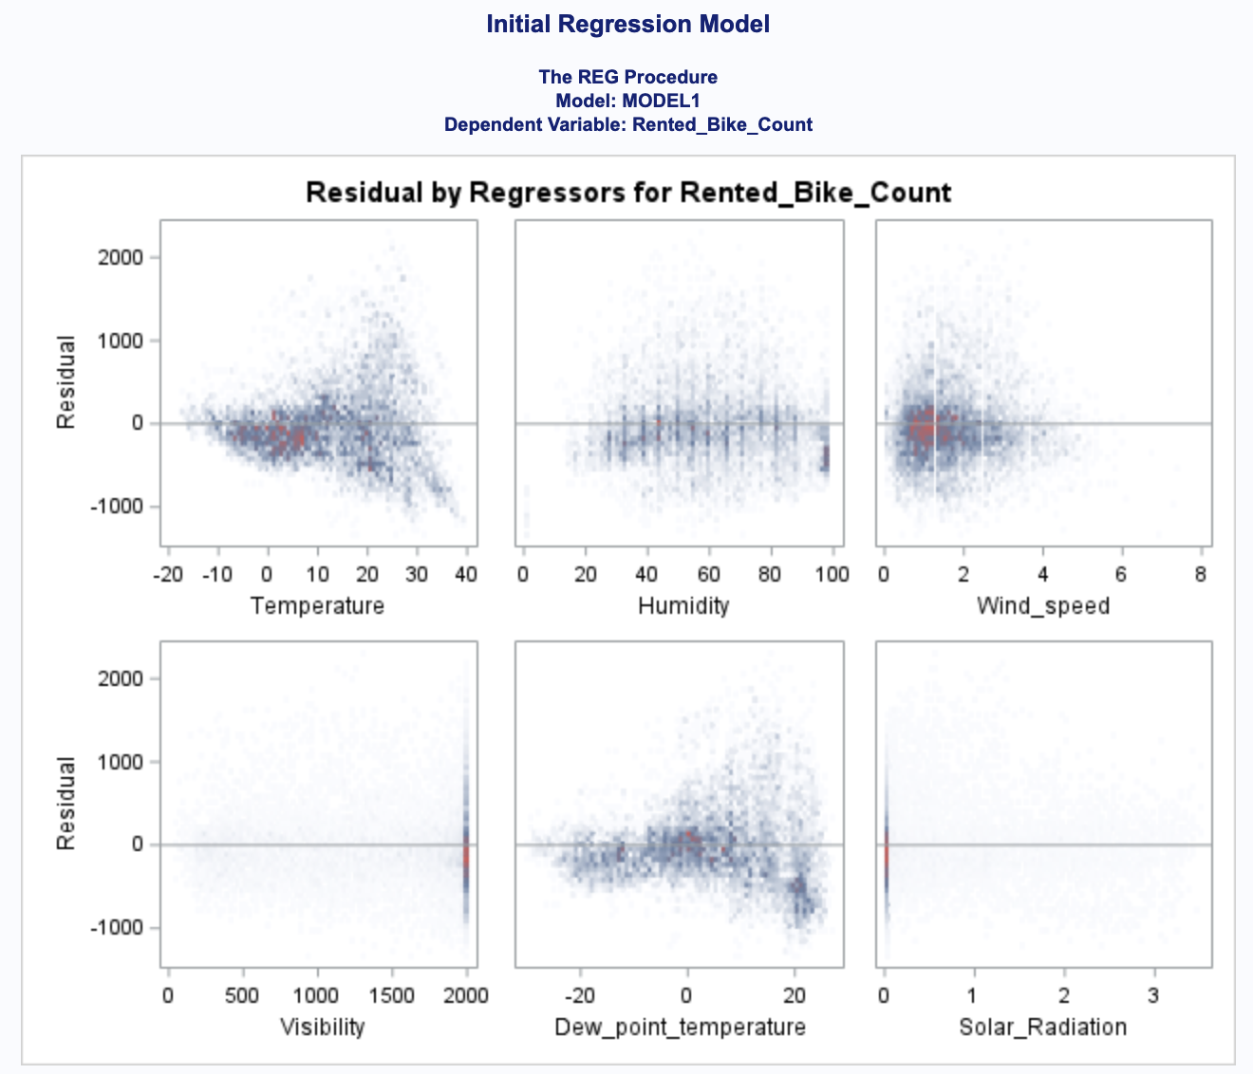
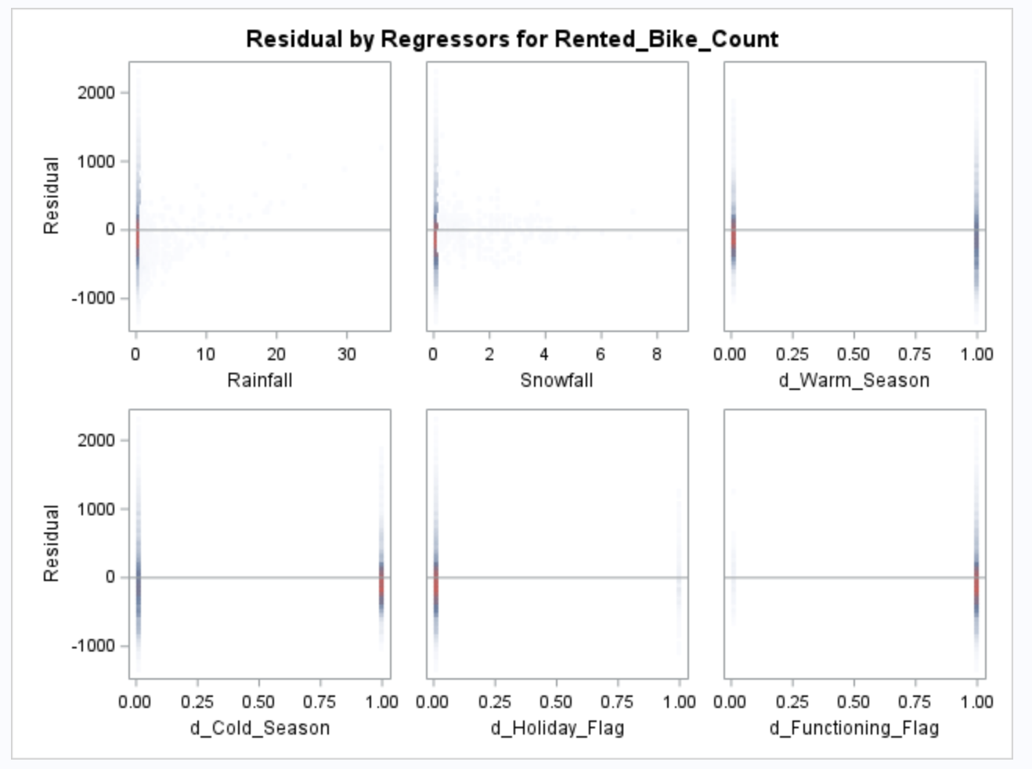
A- V 2. Multicollinearity Check:
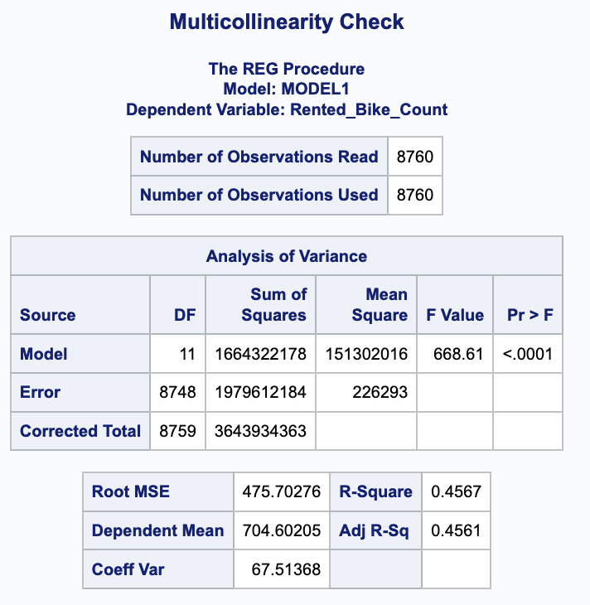
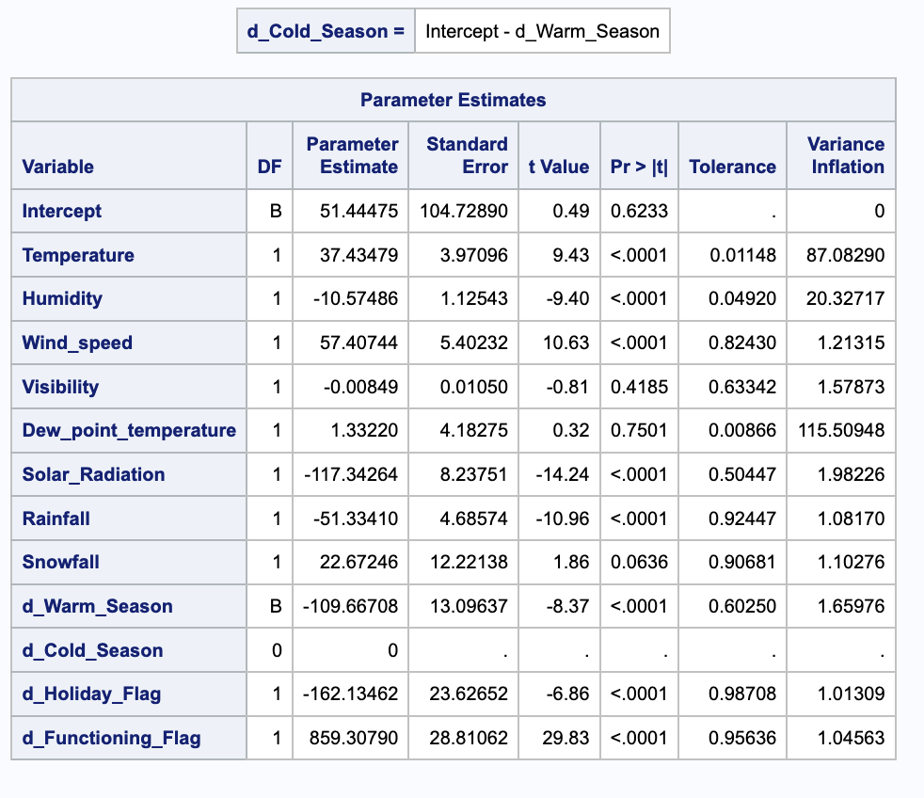

A-VI. Influential Points and Diagnostics
A-VI 1. Influential Point and Diagnostics:


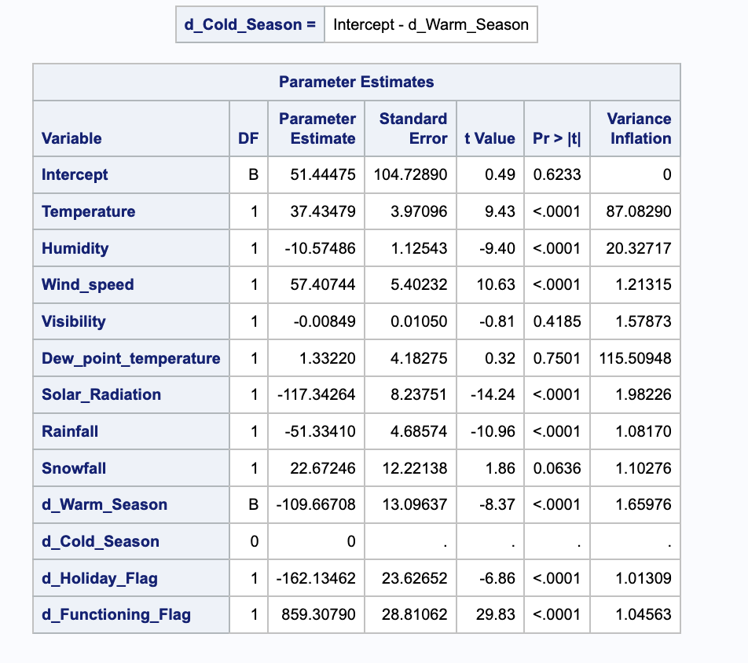
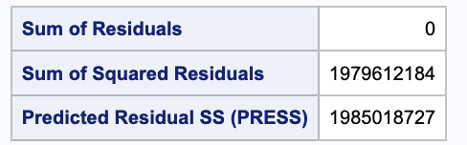
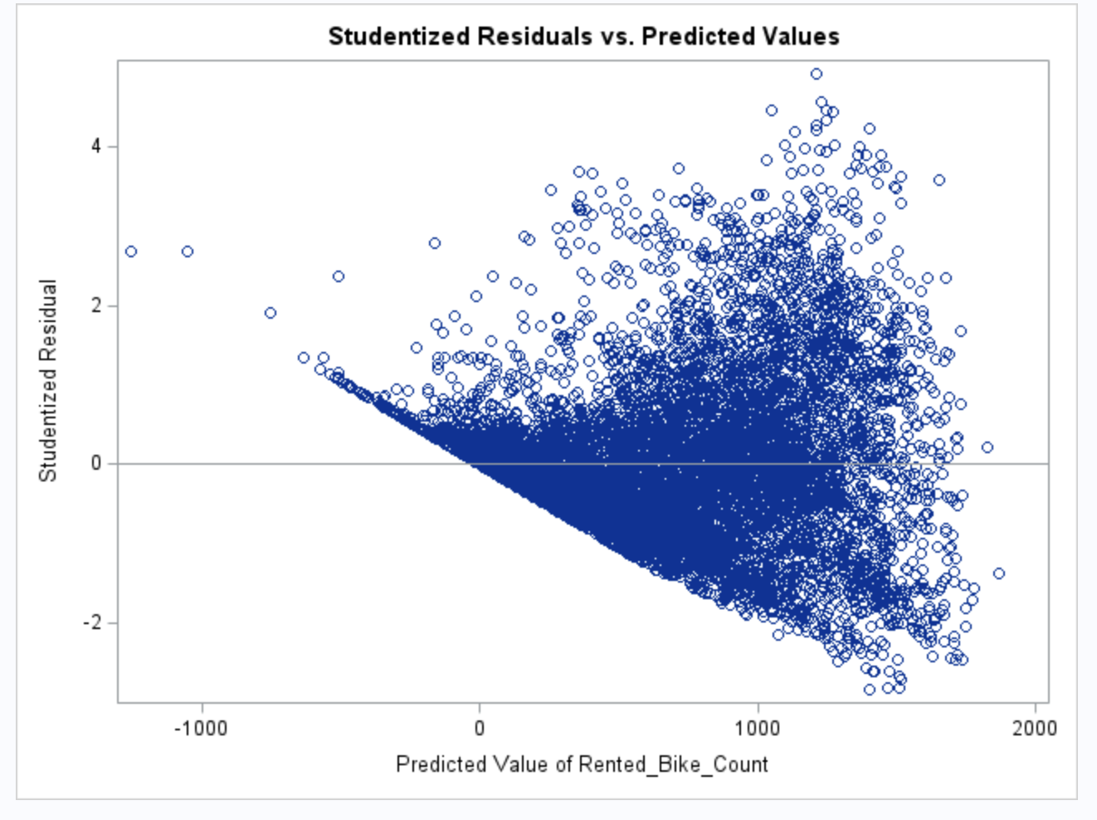
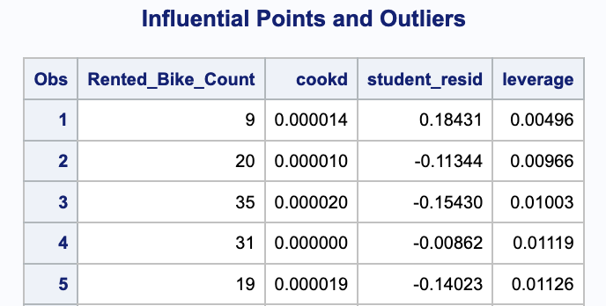
… (because the size of the output of the data was cut. See full code report for full output)


A-VII. Model Refinement:
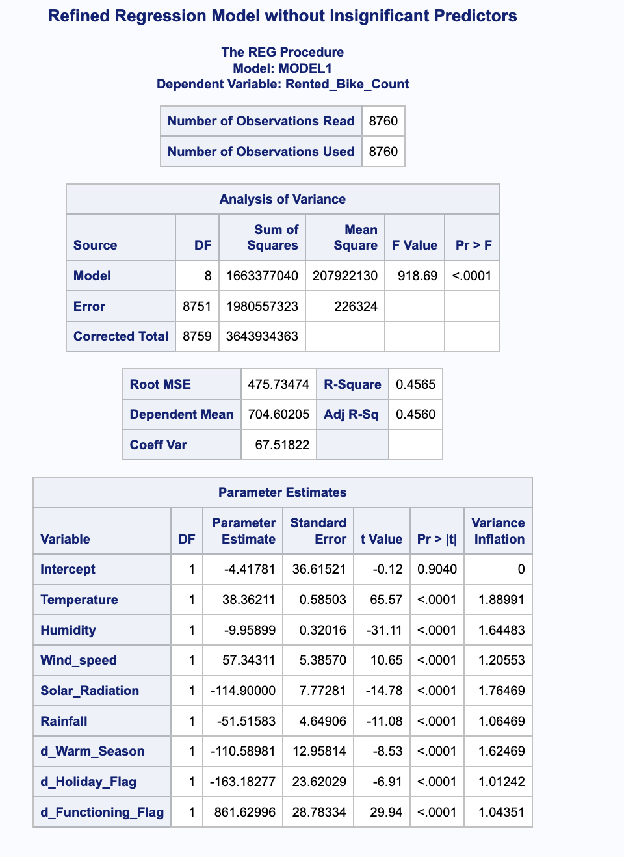
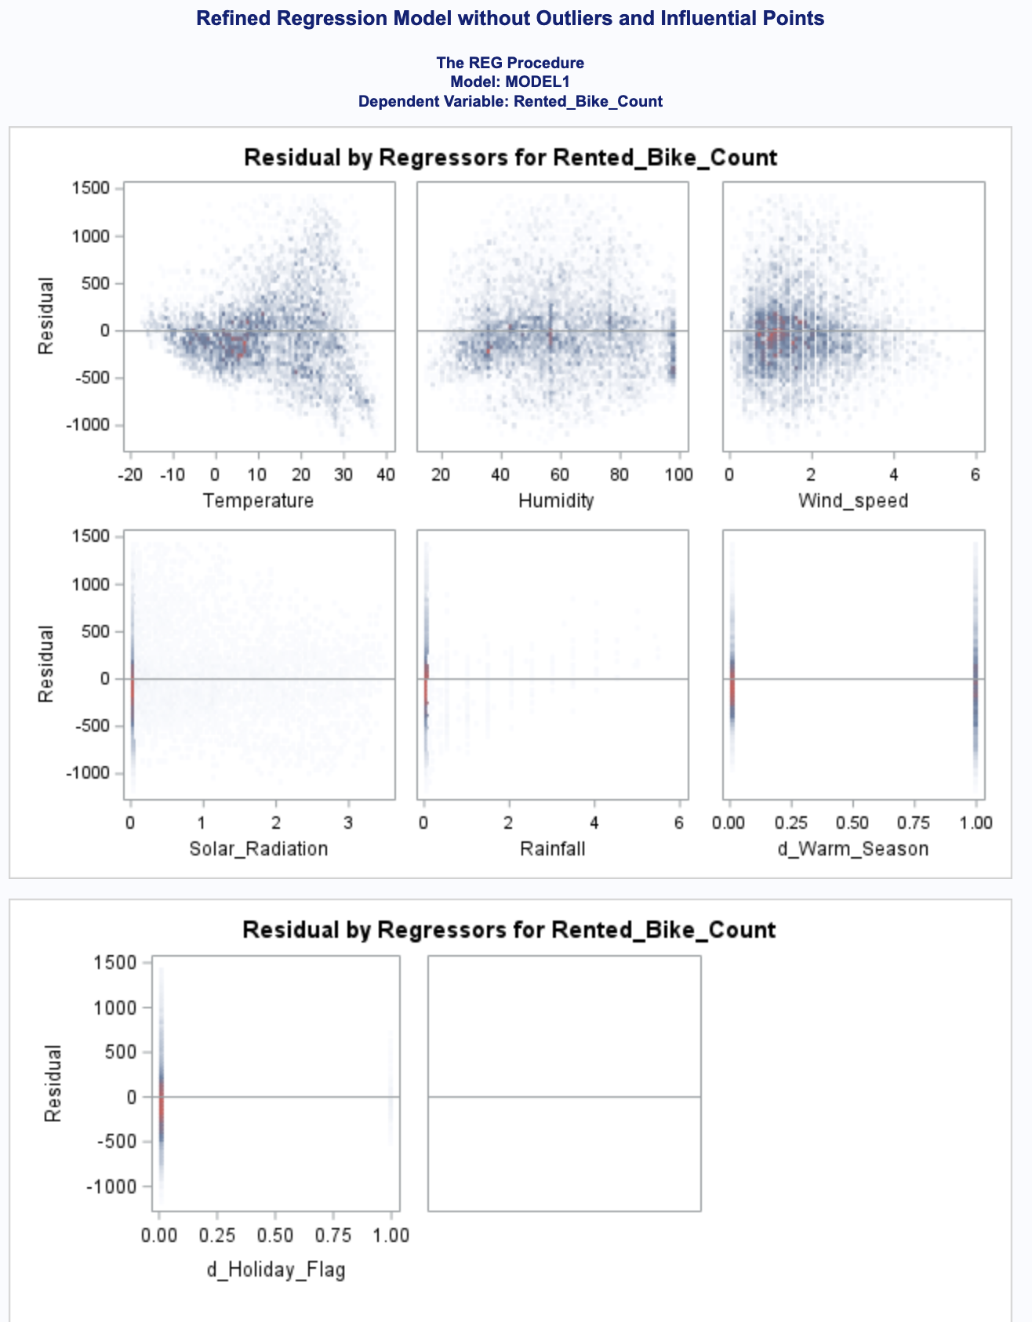

A-VIII. Final Model Selection
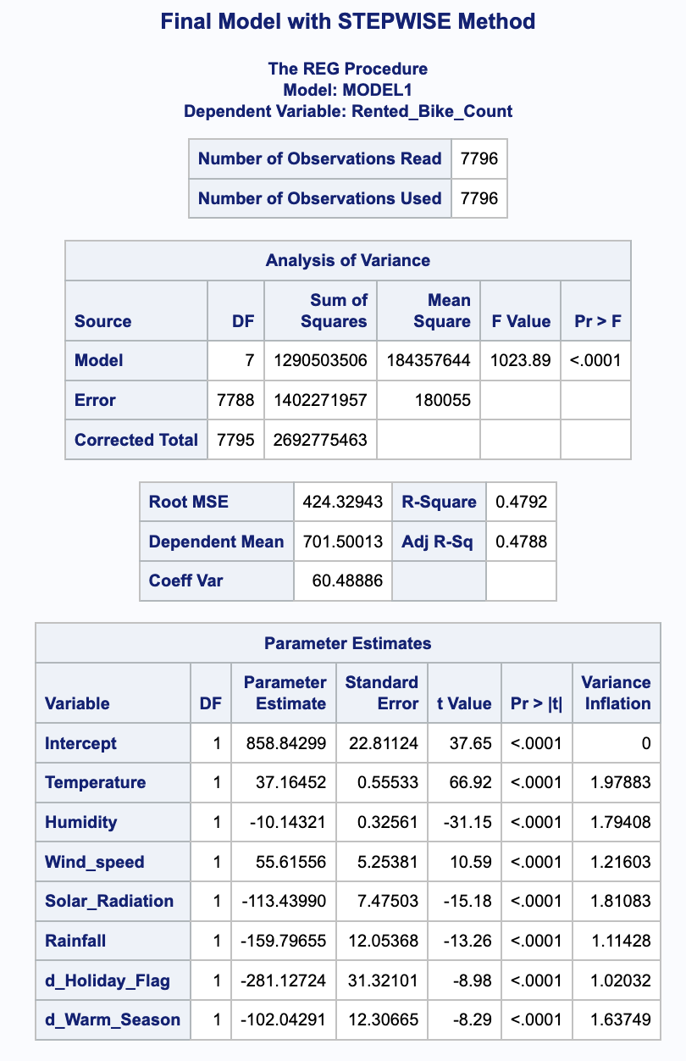
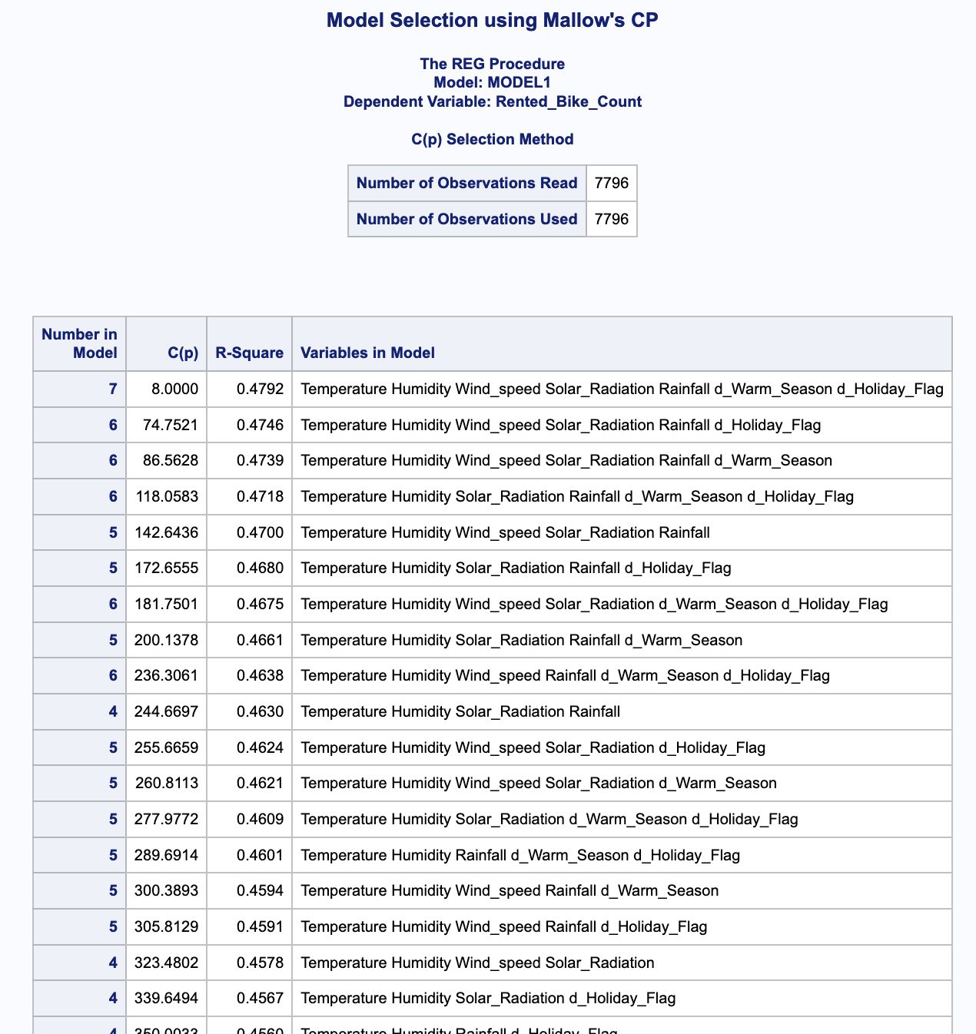

A- IX. Train-Test Split for Model Validation:
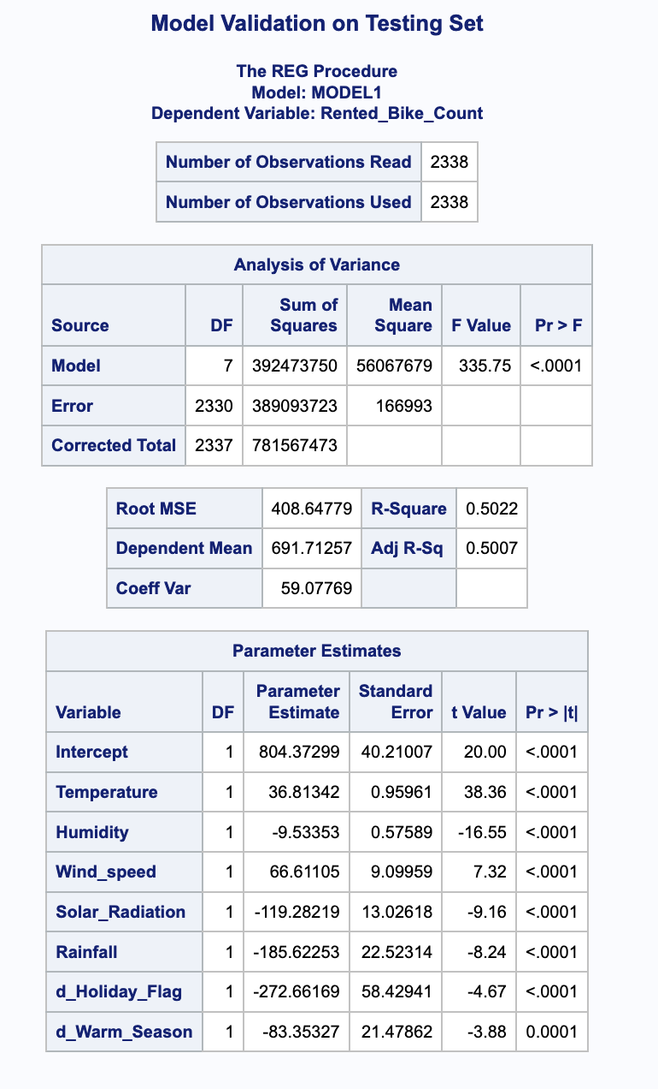
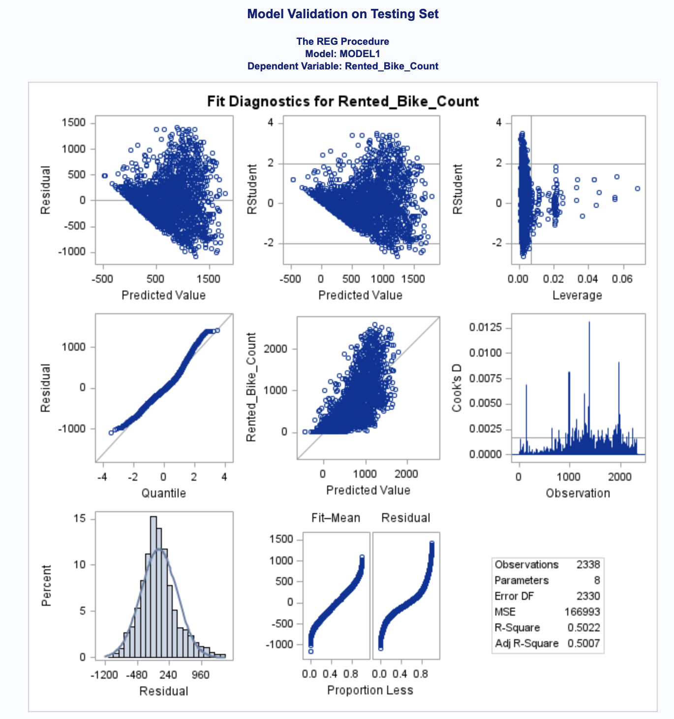

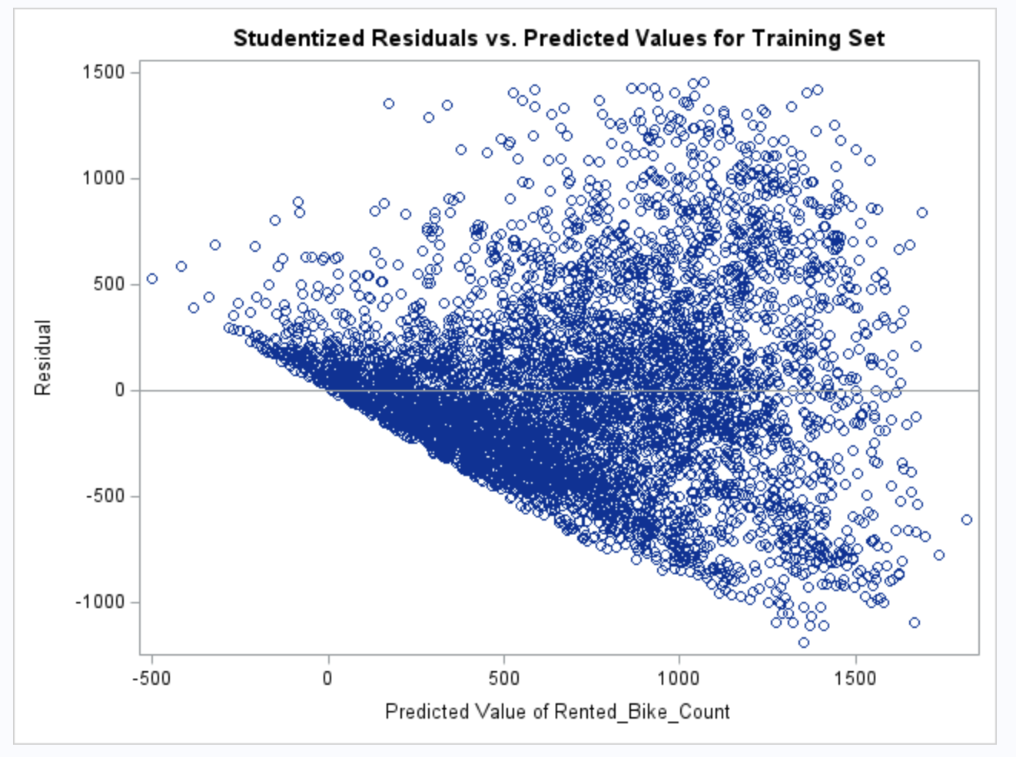
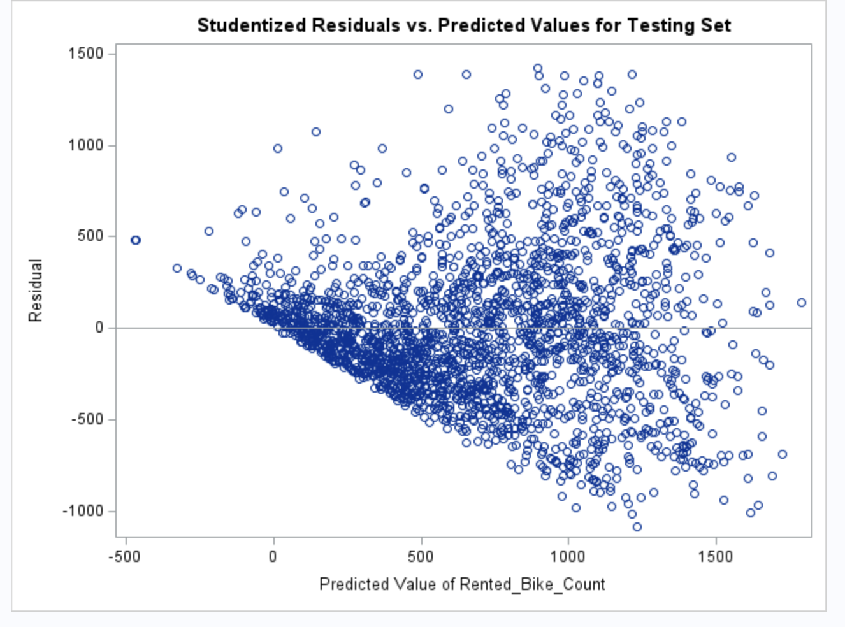

A-X. Predictions:
