**Solution Design Document (SDD)**

**Calculator**

# Automated process details

|  |  |
| --- | --- |
| ITEM NAME | DESCRIPTION |
| Master Project Name | **Calculator** |
| Robot Type | **Attended** |
| Scalable (# of Bots that can be executed parallelly) | **1** |
| Number of Bots used | **1** |
| UiPath version used | **UiPath Studio 2021.10.0** |
| Environment prerequisites  (OS details, libraries, required apps) | **Windows 10, Calculator app** |
| Repository for project  (where is the developed project stored) | <https://github.com/yuriii7/assignment_1_yurii_zborivets/tree/main/Calculator> |
| Number of Reusable Components | **2** |
| Reusable Components Name | **IsNumericValues.xaml**  **UseApplicationCalculator.xaml** |

* **the main workflow is Calculator.xaml**

# Process Flowchart

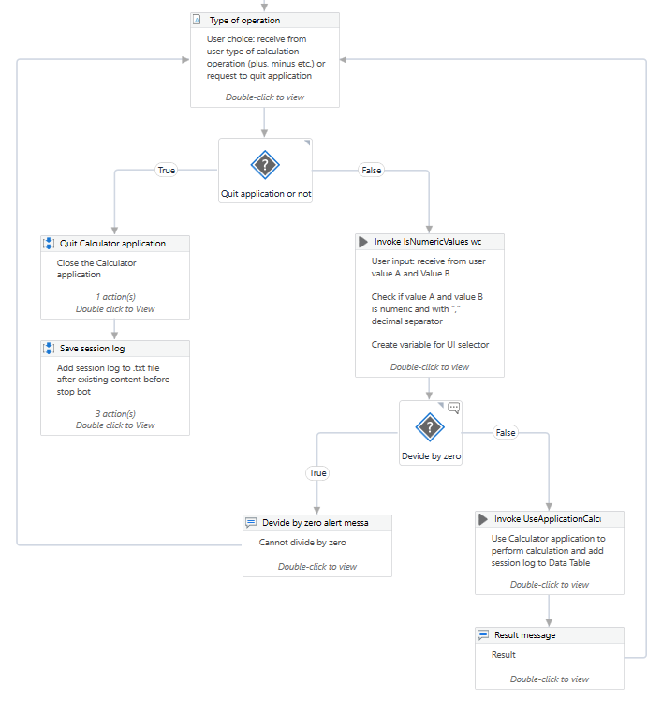

# Project Runtime Details

|  |  |
| --- | --- |
| ITEM NAME | DESCRIPTION |
| Prerequisites to run | **Having a Calculator application on the machine** |
| Input Data | **3 string values: type of operation, Value A and Value B** |
| Expected output | **Message box with 1 integer value** |
| Reporting | **\Calculator\Math_Operation_dd-mm-yyyy.txt file** |
| Stored credentials | **N/A** |
| Schedule Details | **N/A** |

# Solution Modularity

|  |  |  |  |  |
| --- | --- | --- | --- | --- |
| Step ID | Proposed Solution Step | Input | Output | Owner (Bot/Manual/System) |
| 1 | **Operation** | N/A | Type of calculation operation | Manual |
| 2 | **Value A and Value B** | Value A and Value B | Calculation values | Manual |
| 3 | **Use Calculator Application** | Type of calculation operation / calculation values | Result of calculation operation | Bot |
| 4 | **Save Calculation History** | Result of calculation operation | File of reporting | Bot |

**Step 1 Name:** Operation

**Step 1 Description:** Create input dialog with multiple choice to receive from user type of calculation operation (plus, minus, multiply or divide) or request to quit application

**Step 2 Name:** Value A and Value B

**Step 2 Description:** Create input dialog with text box to receive from user value A and value B

**Step 3 Name:** Use Calculator Application

**Step 3 Description:** Open Calculator application and perform calculation operation

**Step 4 Name:** Save Calculation History

**Step 4 Description:** Create Math_Operation_dd-mm-yyyy.txt file and save all calculation operations history during 1 session

# Solution Design Details

5.1. Data Table

Build a simple data table to save all the performed calculation operations during 1 session

# 

5.2. Input Dialog “Operation”

Receive from user the following instruction: type of calculation operation (plus, minus, multiply or divide) or request to quit the application

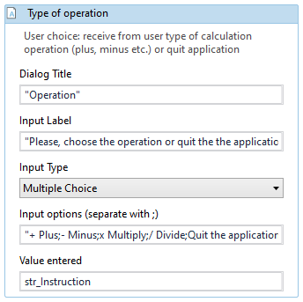

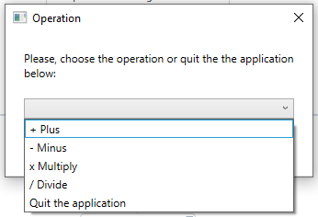

5.3. Flow Decision “Quit application or not” False

User input: receive from user value A and Value B

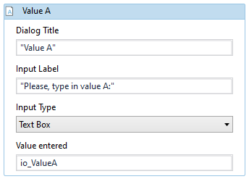

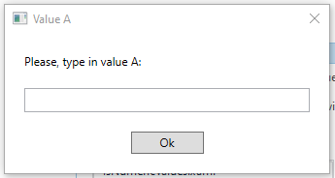

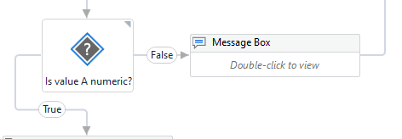

Check if value A and value B is numeric and with "," decimal separator

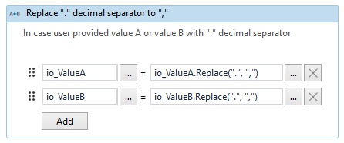

Create variable for UI selector

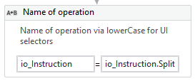

io_Instruction.Split( )(1).ToString.Trim.ToLower

5.4. Flow Decision “Quit application or not” True

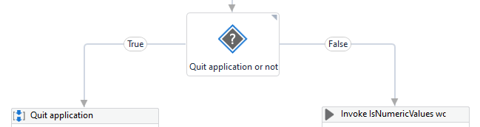

5.4.1. Check State “Calculator application”

If Calculator application is open - close it

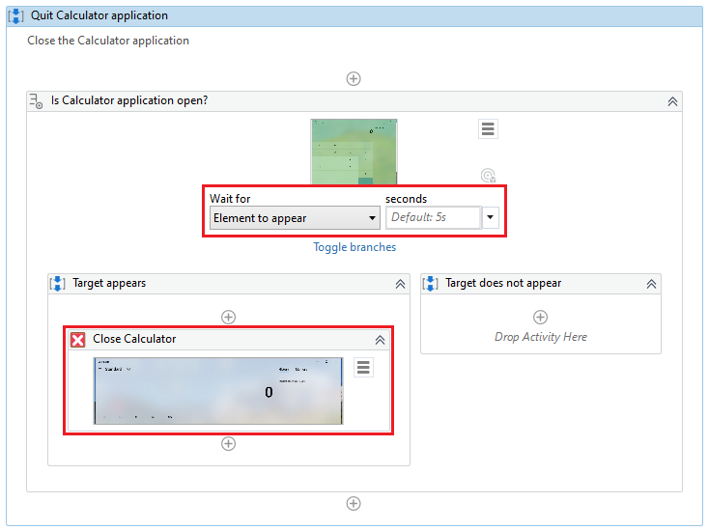

5.4.2. Sequence “Save session log”

Write Data Table to a string outputOperationHistory

Set .txt file name to the following format = "Math_Operation_" + DateTime.Now.ToString("dd-MM-yyyy") + ".txt"

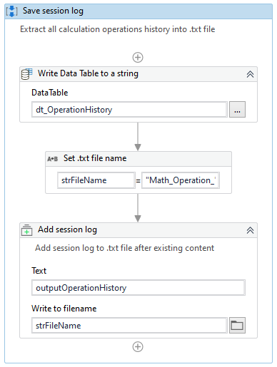

Add session log to .txt file after existing content. .txt file creates automatically if not exists

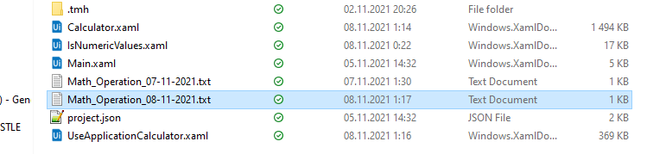

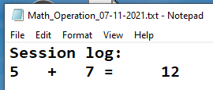

5.5. Flow Decision “Divide by zero” True

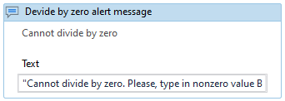

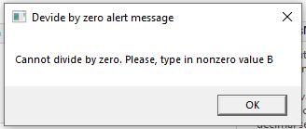

5.6. Flow Decision “Divide by zero” False

Use Calculator application to perform calculation and add session log to Data Table

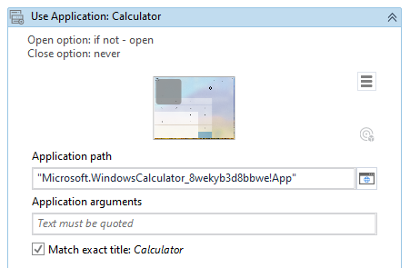

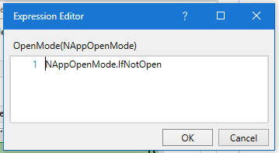

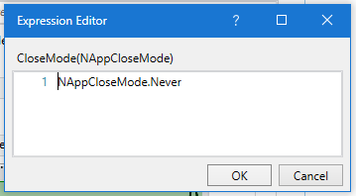

5.6.1. Type Into “Value A / Value B”

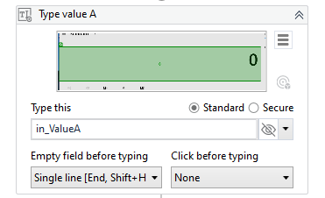

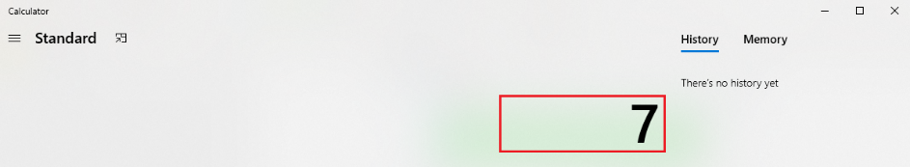

5.6.2. Click “Calculation operation”

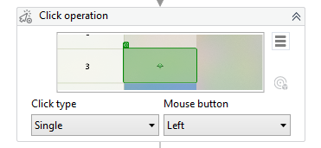

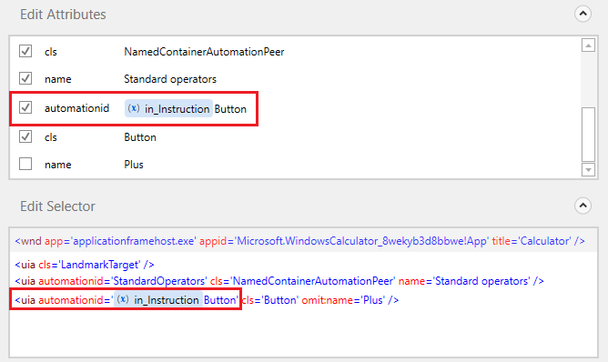

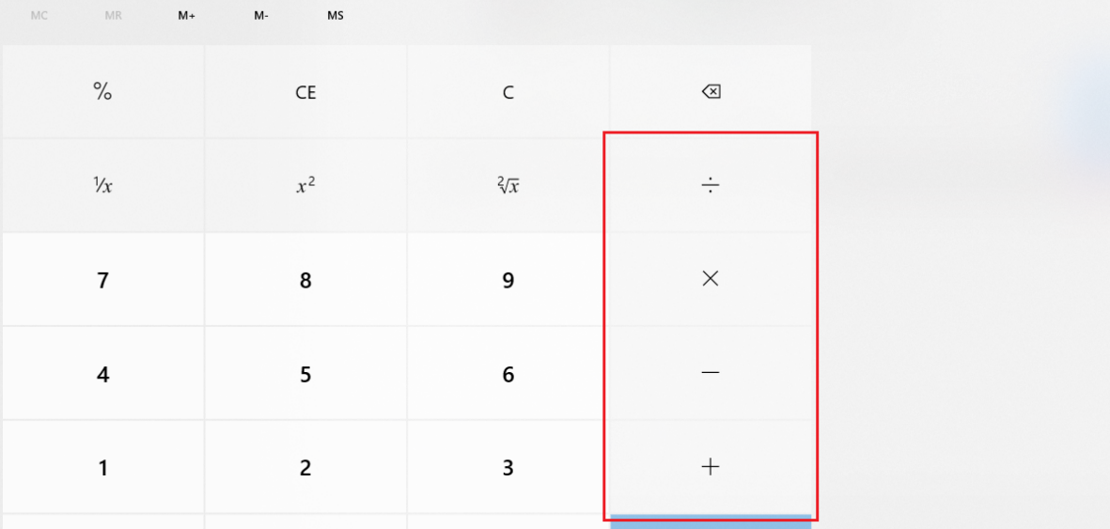

5.6.3. Click “Equal”

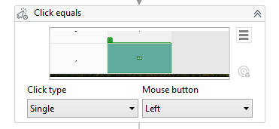

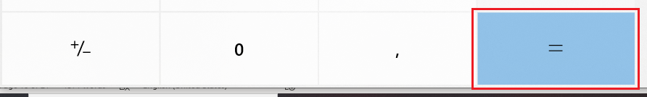

5.6.4. Get Text “Result”

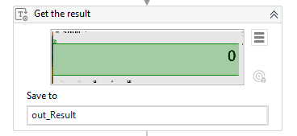

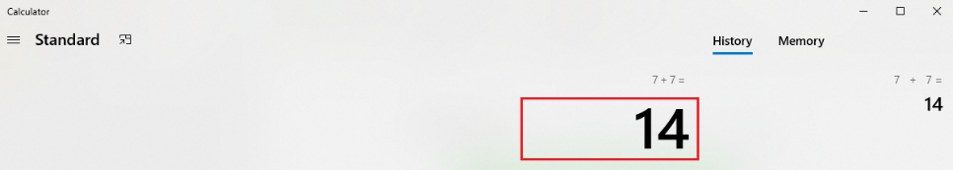

5.6.5. Click “Reset calculation”

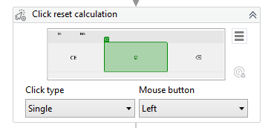



5.6.4. Get Text “Operation history”

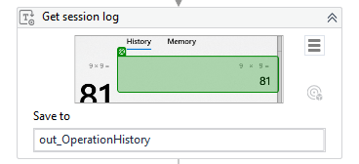

5.6.6. Add Data Row “History”

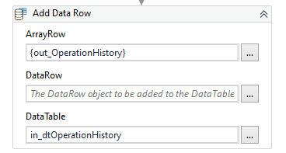

5.6.7. Message Box “Result of calculation operation”

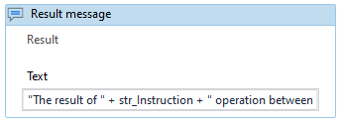

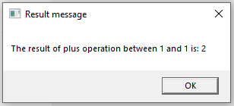

# Alerts and notifications

|  |  |
| --- | --- |
| Business Exception | Notification |
| Value A / Value B is no numeric |  |
| Divide by zero |  |

# Recordings

\Materials\Calculator_Recordings.7z