**Solution Design Document (SDD)**

**Google Trends for RPA Vendors**

# Automated process details

|  |  |
| --- | --- |
| ITEM NAME | DESCRIPTION |
| Master Project Name | **Google Trends for RPA Vendors** |
| Robot Type | **Attended** |
| Scalable (# of Bots that can be executed parallelly) | **1** |
| Number of Bots used | **1** |
| UiPath version used | **UiPath Studio 2021.10.0** |
| Environment prerequisites  (OS details, libraries, required apps) | **Windows 10**  **Mozilla Firefox**  **Microsoft Photos application (default)**  **Microsoft Excel**  **Gmail account (or other, use another Port and Server)**  **Orchestrator Queue: RPAVendrosQueue**  **Orchestrator Asset (Credential type): GmailCredentials** |
| Repository for project  (where is the developed project stored) | <https://github.com/yuriii7/assignment_1_yurii_zborivets/tree/main/Calculator> |
| Number of Reusable Components | **4** |
| Reusable Components Name | **Process.xaml**  **GetRPAVendorsDataTable.xaml**  **GetGoogleTrendsData.xaml**  **CreateReportFile.xaml** |

**Project Dependencies**

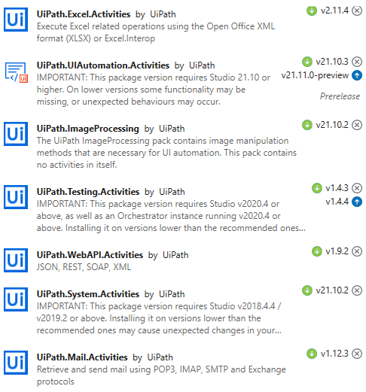

# Process Flowchart

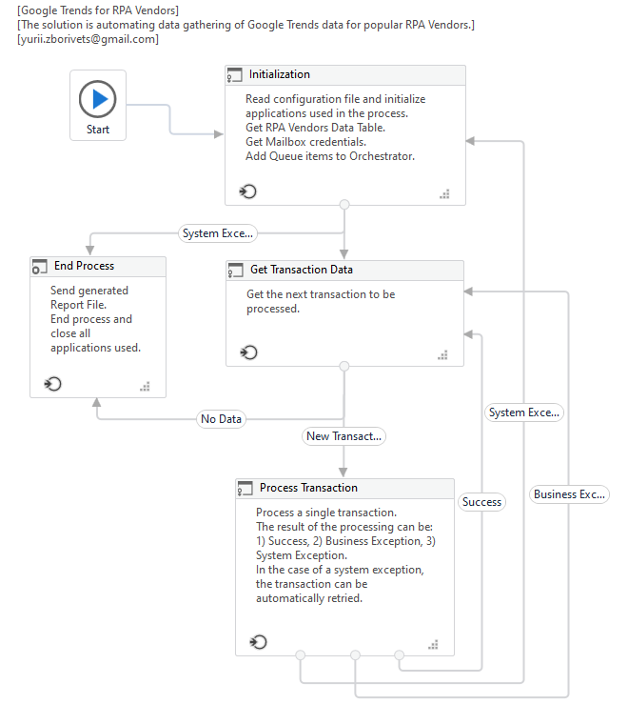

# Project Runtime Details

|  |  |
| --- | --- |
| ITEM NAME | DESCRIPTION |
| Prerequisites to run | **Orchestrator Queue: RPAVendrosQueue**  **Orchestrator Asset (Credential type): GmailCredentials** |
| Input Data | **N/A** |
| Expected output | **Generated E-Mail message with the following attached Excel file:**  **RPA_Vendors_TOP10_interest_city.xlsx** |
| Reporting | **Generated E-Mail message with the following attached Excel file:**  **Process data\RPA_Vendors_TOP10_interest_city.xlsx** |
| Stored credentials | **N/A** |
| Schedule Details | **N/A** |
|  |  |

# Solution Modularity

|  |  |  |  |  |
| --- | --- | --- | --- | --- |
| Step ID | Proposed Solution Step | Input | Output | Owner (Bot/Manual/System) |
| 1 | **Initialization** | Website data | Data Table, Orchestrator Queue item | Bot |
| 2 | **Get Transaction Data** | begin the new cycle | | Bot |
| 3 | **Process Transaction** | Orchestrator Queue item | Google Trends CSV report | Bot |
| 4 | **End Process** | Google Trends CSV reports | Mail message with attached complex report | Bot |

**Step 1 Name:** Initialization

**Step 1 Description:**

Read configuration file and initialize applications used in the process.

Get RPA Vendors Data Table.

Get Mailbox credentials.

Add Queue items to Orchestrator.

**Step 2 Name:** Get Transaction Data

**Step 2 Description:**

Get the next transaction to be processed.

**Step 3 Name:** Process Transaction

**Step 3 Description:**

Process a single transaction.

The result of the processing can be: 1) Success, 2) Business Exception, 3) System Exception.

In the case of a system exception, the transaction can be automatically retried.

**Step 4 Name:** End Process

**Step 4 Description:**

Send generated Report File.

End process and close all applications used.

# Solution Design Details

5.1. Initialization

5.1.1. Kill All Processes

Close Internet Explorer, Microsoft Photo application (default), Mozila Firefox, Command Prompt

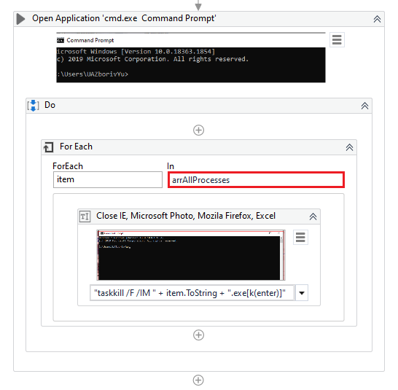

"taskkill /F /IM " + item.ToString + ".exe[k(enter)]"



5.1.2. Delete All Process Data Files

Delete all files from "Process data\" folder

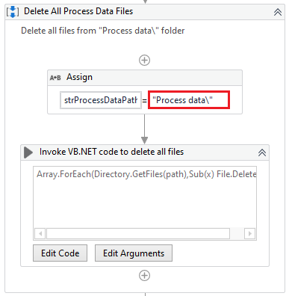

5.1.3. Delete All Downloads Files

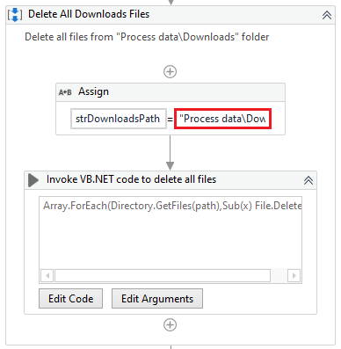

5.1.4. Find an Image URL

Find an Image URL by Image name (gartner-magic-quadrant-rpa-2021) with WebSite HTML code and RegEx

https://www.uipath.com/company/rpa-analyst-reports/gartner-magic-quadrant-robotic-process-automation

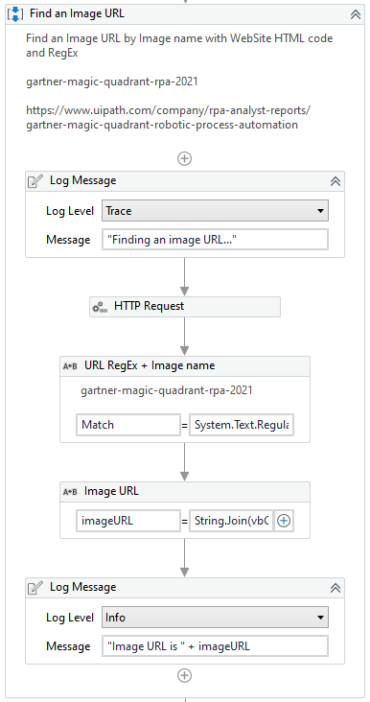

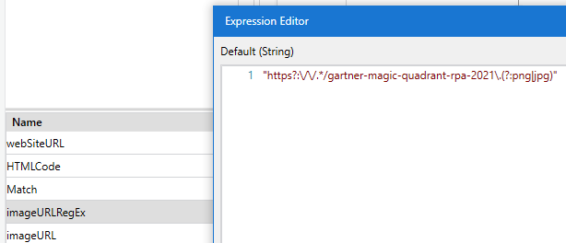

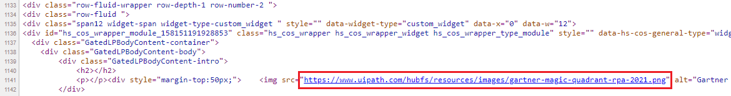

5.1.5. Download an Image

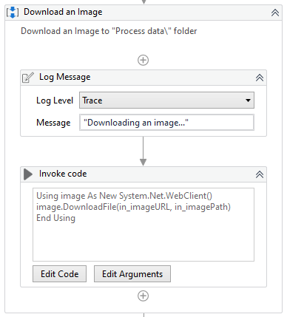

5.1.6. Scrape Data

Scrape RPA Vendors and add to Data Date per each block (to receive best text quality): Challengers, Leaders, Niche Players and Visionaries.

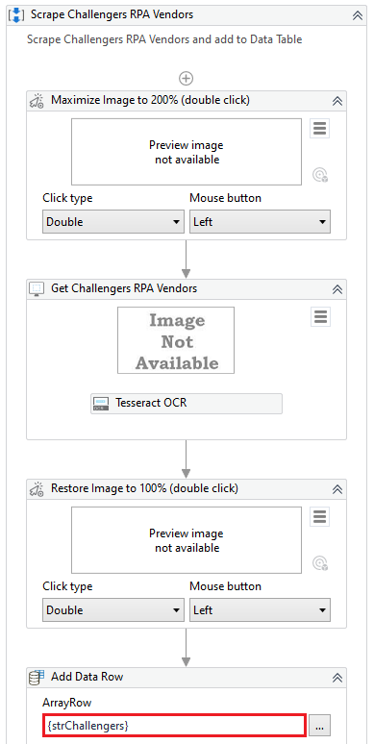

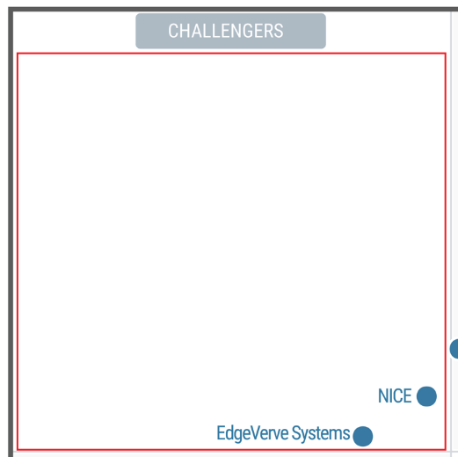

5.1.7. Clear Text

Clear Data Table from any symbols with RegEx

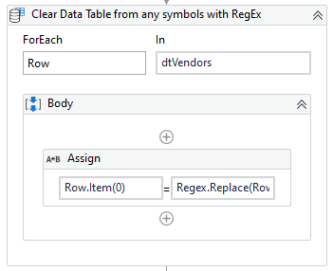

5.1.8. Separate Data Table with [newline] Separator

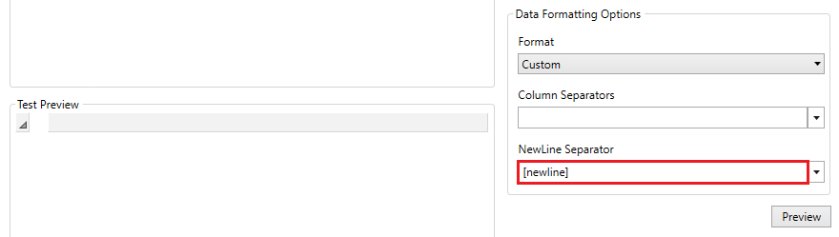

5.1.9. Add Data to Orchestrator Queue

|  |  |  |
| --- | --- | --- |
| **Name** | **Value** | **Description** |
| OrchestratorQueueName | RPAVendorsQueue | Orchestrator queue Name. The value must match with the queue name defined on Orchestrator. |

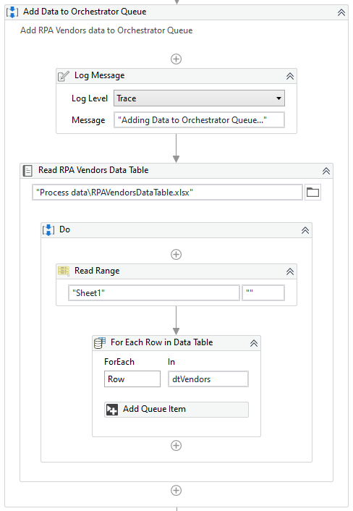

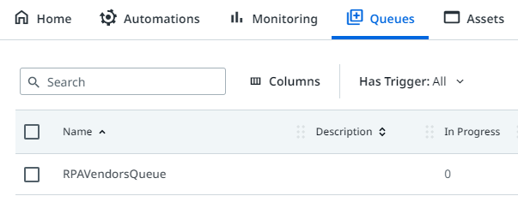

5.1.10. Initialize Mozila Firefox

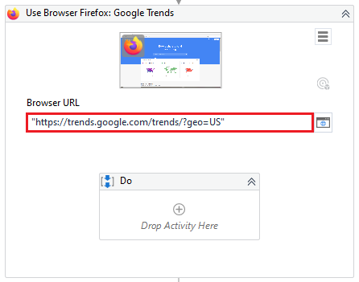

5.2. Process Transaction

5.2.1. Attach Mozila Firefox

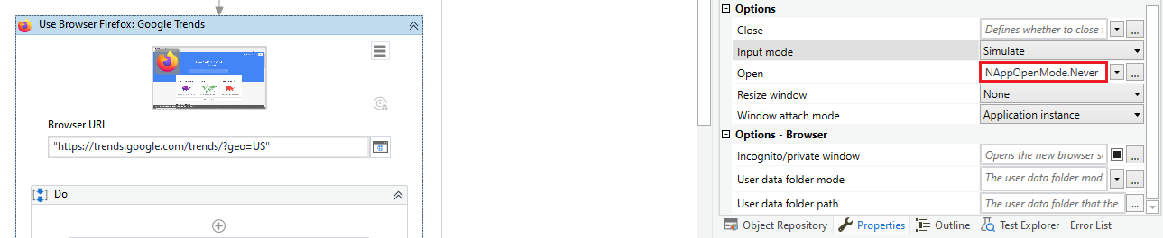

5.2.2. Search term

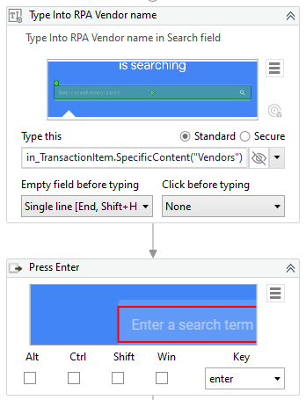

5.2.3. Set Search parameters

**Timeout 20 seconds per each UI activity**

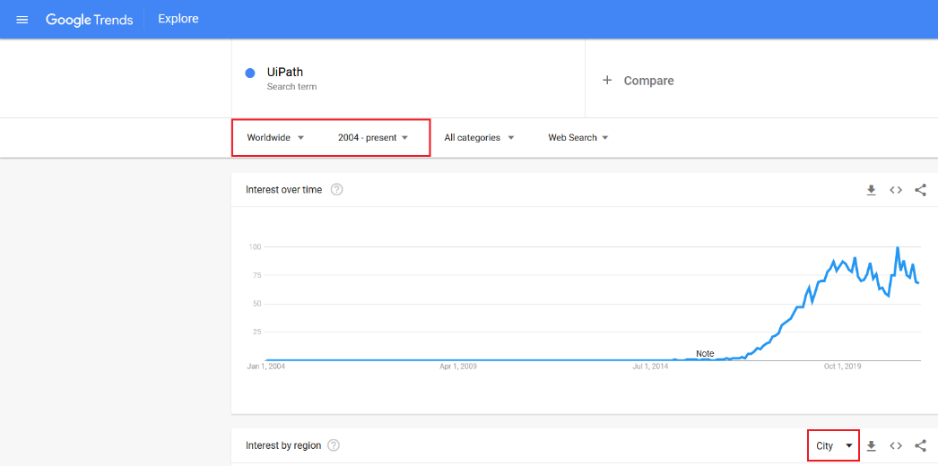

5.2.4. Download report (CSV) file

“**Downloads**” path like default destination

Delay 2 seconds for file downloading

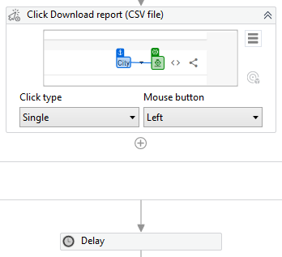

5.2.5. Move geoMap.csv

Move geoMap.csv from “Downloads” (default) to “Process data\Downloads\” folder and Overwrite if file exists (for some reasons)

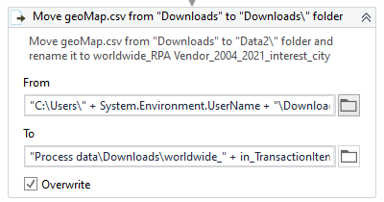

5.3. End Process

CreateReportFile.xaml

If at least one geoMap.csv has been downloaded and copied to “Process data\Downloads”, then create a Report file and send it

5.3.1. Create a blank Excel file

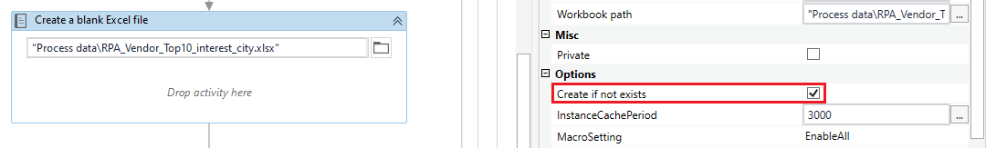

5.3.2. Modify each downloaded file via invoked VBA Script (VBAScript.txt) and copy sheet to the Report file

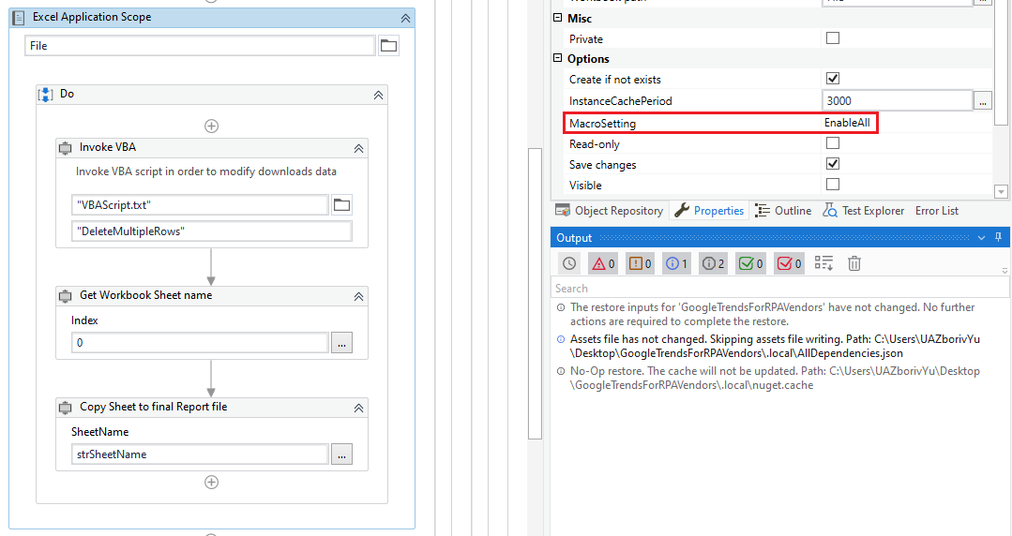

5.3.3. Send an E-Mail with attached Report file

Please, create your mail credentials.

In case you use any other mailbox, **please change Port and Server**

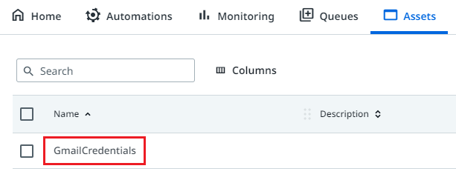

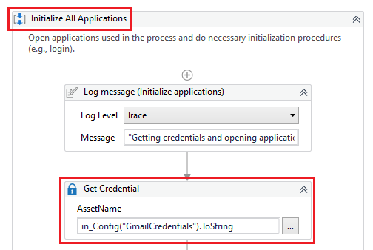

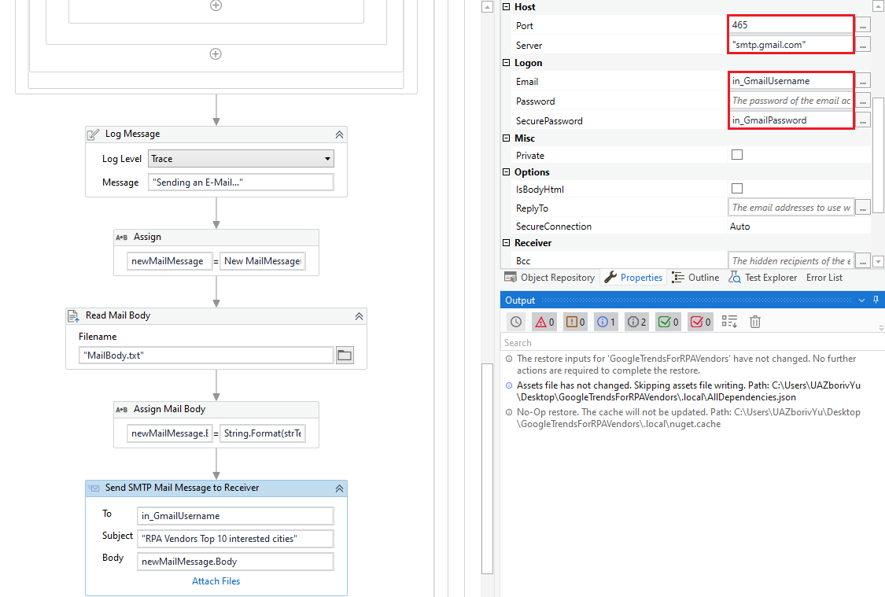

# Business Exceptions

|  |  |
| --- | --- |
| Business Exception | Notification |
| Cannot process an Item |  |

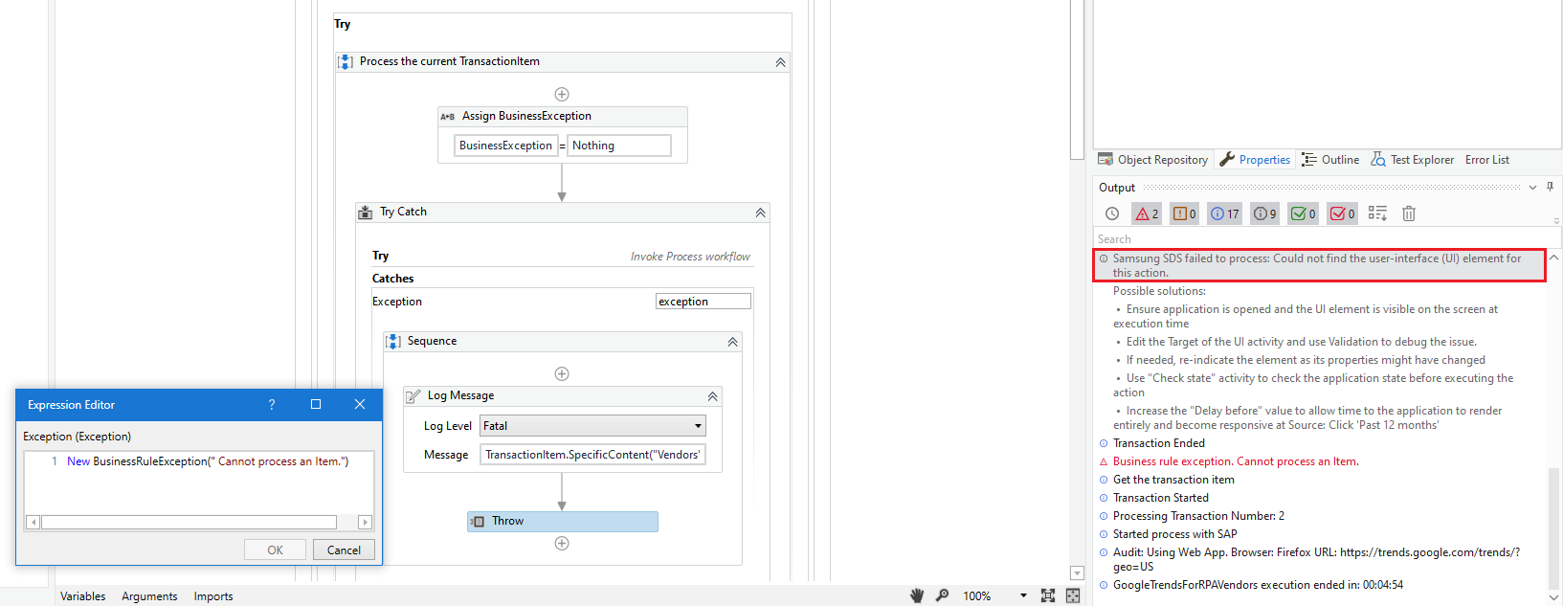

# Recordings

\Materials\**2021-12-04_23-11-48.mp4**