Міністерство освіти і науки України

Національний університет „Львівська політехніка”

Кафедра ЕОМ



**Звіт**

з лабораторної роботи №3

з дисципліни: “Моделювання комп’ютерних систем”

на тему: “ Структурний опис цифрового автомата Перевірка роботи автомата за допомогою стенда ***Elbert V2 – Spartan 3A FPGA.***”

Варіант 21

Виконав: ст. гр. КІ-22

Проць Ю.В.

Прийняв:

Козак Н.Б.

Львів – 2021

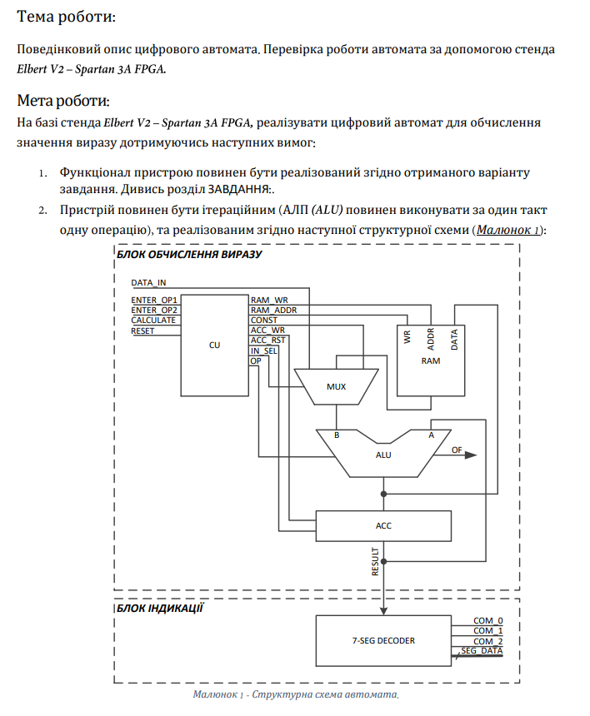

**Завдання:**



**Хід роботи:**

1. **VHDL код MUX.vhd.**

library IEEE;

use IEEE.STD_LOGIC_1164.ALL;

entity my_MuX_intf is

port(

DATA_IN : in std_logic_vector(7 downto 0);

IN_SEL : in std_logic_vector(1 downto 0);

CONSTANT_BUS1 : in std_logic_vector(7 downto 0);

CONSTANT_BUS2 : in std_logic_vector(7 downto 0);

RAM_DATA_OUT_BUS : in std_logic_vector(7 downto 0);

IN_SEL_OUT_BUS : out std_logic_vector(7 downto 0)

);

end my_MuX_intf;

architecture my_MuX_arch of my_MuX_intf is

begin

INSEL_A_MUX : process(DATA_IN, CONSTANT_BUS1, CONSTANT_BUS2, RAM_DATA_OUT_BUS, IN_SEL)

begin

if(IN_SEL = "00") then

IN_SEL_OUT_BUS <= DATA_IN;

elsif(IN_SEL = "01") then

IN_SEL_OUT_BUS <= RAM_DATA_OUT_BUS;

elsif(IN_SEL = "10") then

IN_SEL_OUT_BUS <= CONSTANT_BUS1;

else

IN_SEL_OUT_BUS <= CONSTANT_BUS2;

end if;

end process INSEL_A_MUX;

end my_MuX_arch;

1. **VHDL код ACC.vhd.**

library IEEE;

use IEEE.STD_LOGIC_1164.ALL;

entity my_ACC_intf is

port(

CLOCK : in std_logic;

ACC_WR : in std_logic;

ACC_RST : in std_logic;

ACC_DATA_IN_BUS : in std_logic_vector(7 downto 0);

ACC_DATA_OUT_BUS : out std_logic_vector(7 downto 0)

);

end my_ACC_intf;

architecture my_ACC_arch of my_ACC_intf is

signal ACC_DATA : std_logic_vector(7 downto 0);

begin

ACC : process(CLOCK, ACC_DATA)

begin

if (rising_edge(CLOCK)) then

if(ACC_RST = '1') then

ACC_DATA <= "00000000";

elsif (ACC_WR = '1') then

ACC_DATA <= ACC_DATA_IN_BUS;

end if;

end if;

ACC_DATA_OUT_BUS <= ACC_DATA;

end process ACC;

end my_ACC_arch;

1. **VHDL код ALU.vhd.**

library IEEE;

use IEEE.STD_LOGIC_1164.ALL;

use IEEE.NUMERIC_STD.ALL;

use IEEE.STD_LOGIC_UNSIGNED.ALL;

entity my_ALU_intf is

port(

OP_CODE_BUS : in std_logic_vector(1 downto 0);

IN_SEL_OUT_BUS : in std_logic_vector(7 downto 0);

ACC_DATA_OUT_BUS : in std_logic_vector(7 downto 0);

ACC_DATA_IN_BUS : out std_logic_vector(7 downto 0)

);

end my_ALU_intf;

architecture my_ALU_arch of my_ALU_intf is

begin

ALU : process(OP_CODE_BUS, IN_SEL_OUT_BUS, ACC_DATA_OUT_BUS)

variable A : unsigned(7 downto 0);

variable B : unsigned(7 downto 0);

begin

A := unsigned(ACC_DATA_OUT_BUS);

B := unsigned(IN_SEL_OUT_BUS);

case(OP_CODE_BUS) is

when "00" => ACC_DATA_IN_BUS <= STD_LOGIC_VECTOR(B);

when "01" => ACC_DATA_IN_BUS <= STD_LOGIC_VECTOR(A + B);

when "10" => ACC_DATA_IN_BUS <= STD_LOGIC_VECTOR(A - B);

when "11" => ACC_DATA_IN_BUS <= STD_LOGIC_VECTOR(A or B);

when others => ACC_DATA_IN_BUS <= "00000000";

end case;

end process ALU;

end my_ALU_arch;

library IEEE;

use IEEE.STD_LOGIC_1164.ALL;

entity my_CU_intf is

port(

CLOCK : in std_logic;

ENTER_OP1 : in std_logic;

ENTER_OP2 : in std_logic;

CALCULATE : in std_logic;

RESET : in std_logic;

RAM_WR : out std_logic;

RAM_ADDR_BUS : out std_logic_vector(1 downto 0);

CONSTANT_BUS1 : out std_logic_vector(7 downto 0);

CONSTANT_BUS2 : out std_logic_vector(7 downto 0);

ACC_WR : out std_logic;

ACC_RST : out std_logic;

IN_SEL : out std_logic_vector(1 downto 0);

OP_CODE_BUS : out std_logic_vector(1 downto 0)

);

end my_CU_intf;

architecture my_CU_arch of my_CU_intf is

type cu_state_type is (cu_rst, cu_idle, cu_load_op1, cu_load_op2, cu_run_calc0, cu_run_calc1, cu_run_calc2, cu_run_calc3, cu_finish);

signal cu_cur_state : cu_state_type;

signal cu_next_state : cu_state_type;

begin

CONSTANT_BUS1 <= "00000100";

CONSTANT_BUS2 <= "00000010";

CU_SYNC_PROC: process (CLOCK)

begin

if (rising_edge(CLOCK)) then

if (RESET = '1') then

cu_cur_state <= cu_rst;

else

cu_cur_state <= cu_next_state;

end if;

end if;

end process;

CUNEXT_STATE_DECODE: process (cu_cur_state, ENTER_OP1, ENTER_OP2, CALCULATE)

begin

--declare default state for next_state to avoid latches

cu_next_state <= cu_cur_state; --default is to stay in current state

--insert statements to decode next_state

--below is a simple example

case(cu_cur_state) is

when cu_rst =>

cu_next_state <= cu_idle;

when cu_idle =>

if (ENTER_OP1 = '1') then

cu_next_state <= cu_load_op1;

elsif (ENTER_OP2 = '1') then

cu_next_state <= cu_load_op2;

elsif (CALCULATE = '1') then

cu_next_state <= cu_run_calc0;

else

cu_next_state <= cu_idle;

end if;

when cu_load_op1 =>

cu_next_state <= cu_idle;

when cu_load_op2 =>

cu_next_state <= cu_idle;

when cu_run_calc0 =>

cu_next_state <= cu_run_calc1;

when cu_run_calc1 =>

cu_next_state <= cu_run_calc2;

when cu_run_calc2 =>

cu_next_state <= cu_run_calc3;

when cu_run_calc3 =>

cu_next_state <= cu_finish;

when cu_finish =>

cu_next_state <= cu_finish;

when others =>

cu_next_state <= cu_idle;

end case;

end process;

1. **VHDL код CU.vhd.**

CU_OUTPUT_DECODE: process (cu_cur_state)

begin

case(cu_cur_state) is

when cu_rst =>

IN_SEL <= "00";

OP_CODE_BUS <= "00";

RAM_ADDR_BUS <= "00";

RAM_WR <= '0';

ACC_RST <= '1';

ACC_WR <= '0';

when cu_idle =>

IN_SEL <= "00";

OP_CODE_BUS <= "00";

RAM_ADDR_BUS <= "00";

RAM_WR <= '0';

ACC_RST <= '0';

ACC_WR <= '0';

when cu_load_op1 =>

IN_SEL <= "00";

OP_CODE_BUS <= "00";

RAM_ADDR_BUS <= "00";

RAM_WR <= '1';

ACC_RST <= '0';

ACC_WR <= '1';

when cu_load_op2 =>

IN_SEL <= "00";

OP_CODE_BUS <= "00";

RAM_ADDR_BUS <= "01";

RAM_WR <= '1';

ACC_RST <= '0';

ACC_WR <= '1';

when cu_run_calc0 =>

IN_SEL <= "01";

OP_CODE_BUS <= "00";

RAM_ADDR_BUS <= "01";

RAM_WR <= '0';

ACC_RST <= '0';

ACC_WR <= '1';

when cu_run_calc1 =>

IN_SEL <= "10";

OP_CODE_BUS <= "10";

RAM_ADDR_BUS <= "00";

RAM_WR <= '0';

ACC_RST <= '0';

ACC_WR <= '1';

when cu_run_calc2 =>

IN_SEL <= "01";

OP_CODE_BUS <= "01";

RAM_ADDR_BUS <= "00";

RAM_WR <= '0';

ACC_RST <= '0';

ACC_WR <= '1';

when cu_run_calc3 =>

IN_SEL <= "11";

OP_CODE_BUS <= "11";

RAM_ADDR_BUS <= "00";

RAM_WR <= '0';

ACC_RST <= '0';

ACC_WR <= '1';

when cu_finish =>

IN_SEL <= "00";

OP_CODE_BUS <= "00";

RAM_ADDR_BUS <= "00";

RAM_WR <= '0';

ACC_RST <= '0';

ACC_WR <= '0';

when others =>

IN_SEL <= "00";

OP_CODE_BUS <= "00";

RAM_ADDR_BUS <= "00";

RAM_WR <= '0';

ACC_RST <= '0';

ACC_WR <= '0';

end case;

end process;

end my_CU_arch;

1. **VHDL код RAM.vhd.**

library IEEE;

use IEEE.STD_LOGIC_1164.ALL;

use IEEE.STD_LOGIC_UNSIGNED.ALL;

entity my_RAM_intf is

port(

CLOCK : in std_logic;

RAM_WR : in std_logic;

RAM_ADDR_BUS : in STD_LOGIC_VECTOR(1 downto 0);

RAM_DATA_IN_BUS : in STD_LOGIC_VECTOR(7 downto 0);

RAM_DATA_OUT_BUS : out STD_LOGIC_VECTOR(7 downto 0)

);

end my_RAM_intf;

architecture my_RAM_arch of my_RAM_intf is

type ram_type is array (3 downto 0) of STD_LOGIC_VECTOR(7 downto 0);

signal RAM_UNIT : ram_type;

begin

--when reset will init const

RAM : process(CLOCK, RAM_ADDR_BUS, RAM_UNIT)

begin

if (rising_edge(CLOCK)) then

if (RAM_WR = '1') then

RAM_UNIT(conv_integer(RAM_ADDR_BUS)) <= RAM_DATA_IN_BUS;

end if;

end if;

RAM_DATA_OUT_BUS <= RAM_UNIT(conv_integer(RAM_ADDR_BUS));

end process RAM;

end my_RAM_arch;

1. **VHDL код OUT_PUT_DECODER.vhd.**

library IEEE;

use IEEE.STD_LOGIC_1164.ALL;

use IEEE.NUMERIC_STD.ALL;

use IEEE.STD_LOGIC_UNSIGNED.ALL;

entity OUT_PUT_DECODER_intf is

port(

CLOCK : IN STD_LOGIC;

RESET : IN STD_LOGIC;

ACC_DATA_OUT_BUS : IN std_logic_vector(7 downto 0);

COMM_ONES : OUT STD_LOGIC;

COMM_DECS : OUT STD_LOGIC;

COMM_HUNDREDS : OUT STD_LOGIC;

SEG_A : OUT STD_LOGIC;

SEG_B : OUT STD_LOGIC;

SEG_C : OUT STD_LOGIC;

SEG_D : OUT STD_LOGIC;

SEG_E : OUT STD_LOGIC;

SEG_F : OUT STD_LOGIC;

SEG_G : OUT STD_LOGIC;

DP : OUT STD_LOGIC

);

end OUT_PUT_DECODER_intf;

architecture OUT_PUT_DECODER_arch of OUT_PUT_DECODER_intf is

signal ONES_BUS : STD_LOGIC_VECTOR(3 downto 0) := "0000";

signal DECS_BUS : STD_LOGIC_VECTOR(3 downto 0) := "0001";

signal HONDREDS_BUS : STD_LOGIC_VECTOR(3 downto 0) := "0000";

begin

BIN_TO_BCD : process (ACC_DATA_OUT_BUS)

variable hex_src : STD_LOGIC_VECTOR(7 downto 0) ;

variable bcd : STD_LOGIC_VECTOR(11 downto 0) ;

begin

bcd := (others => '0') ;

hex_src := ACC_DATA_OUT_BUS;

for i in hex_src'range loop

if bcd(3 downto 0) > "0100" then

bcd(3 downto 0) := bcd(3 downto 0) + "0011" ;

end if ;

if bcd(7 downto 4) > "0100" then

bcd(7 downto 4) := bcd(7 downto 4) + "0011" ;

end if ;

if bcd(11 downto 8) > "0100" then

bcd(11 downto 8) := bcd(11 downto 8) + "0011" ;

end if ;

bcd := bcd(10 downto 0) & hex_src(hex_src'left) ; -- shift bcd + 1 new entry

hex_src := hex_src(hex_src'left - 1 downto hex_src'right) & '0' ; -- shift src + pad with 0

end loop ;

HONDREDS_BUS <= bcd (11 downto 8);

DECS_BUS <= bcd (7 downto 4);

ONES_BUS <= bcd (3 downto 0);

end process BIN_TO_BCD;

INDICATE : process(CLOCK)

type DIGIT_TYPE is (ONES, DECS, HUNDREDS);

variable CUR_DIGIT : DIGIT_TYPE := ONES;

variable DIGIT_VAL : STD_LOGIC_VECTOR(3 downto 0) := "0000";

variable DIGIT_CTRL : STD_LOGIC_VECTOR(6 downto 0) := "0000000";

variable COMMONS_CTRL : STD_LOGIC_VECTOR(2 downto 0) := "000";

begin

if (rising_edge(CLOCK)) then

if(RESET = '0') then

case CUR_DIGIT is

when ONES =>

DIGIT_VAL := ONES_BUS;

CUR_DIGIT := DECS;

COMMONS_CTRL := "001";

when DECS =>

DIGIT_VAL := DECS_BUS;

CUR_DIGIT := HUNDREDS;

COMMONS_CTRL := "010";

when HUNDREDS =>

DIGIT_VAL := HONDREDS_BUS;

CUR_DIGIT := ONES;

COMMONS_CTRL := "100";

when others =>

DIGIT_VAL := ONES_BUS;

CUR_DIGIT := ONES;

COMMONS_CTRL := "000";

end case;

case DIGIT_VAL is --abcdefg

when "0000" => DIGIT_CTRL := "1111110";

when "0001" => DIGIT_CTRL := "0110000";

when "0010" => DIGIT_CTRL := "1101101";

when "0011" => DIGIT_CTRL := "1111001";

when "0100" => DIGIT_CTRL := "0110011";

when "0101" => DIGIT_CTRL := "1011011";

when "0110" => DIGIT_CTRL := "1011111";

when "0111" => DIGIT_CTRL := "1110000";

when "1000" => DIGIT_CTRL := "1111111";

when "1001" => DIGIT_CTRL := "1111011";

when others => DIGIT_CTRL := "0000000";

end case;

else

DIGIT_VAL := ONES_BUS;

CUR_DIGIT := ONES;

COMMONS_CTRL := "000";

end if;

COMM_ONES <= COMMONS_CTRL(0);

COMM_DECS <= COMMONS_CTRL(1);

COMM_HUNDREDS <= COMMONS_CTRL(2);

SEG_A <= DIGIT_CTRL(6);

SEG_B <= DIGIT_CTRL(5);

SEG_C <= DIGIT_CTRL(4);

SEG_D <= DIGIT_CTRL(3);

SEG_E <= DIGIT_CTRL(2);

SEG_F <= DIGIT_CTRL(1);

SEG_G <= DIGIT_CTRL(0);

DP <= '0';

end if;

end process INDICATE;

end OUT_PUT_DECODER_arch;

1. **Схема Top_level.sch.**

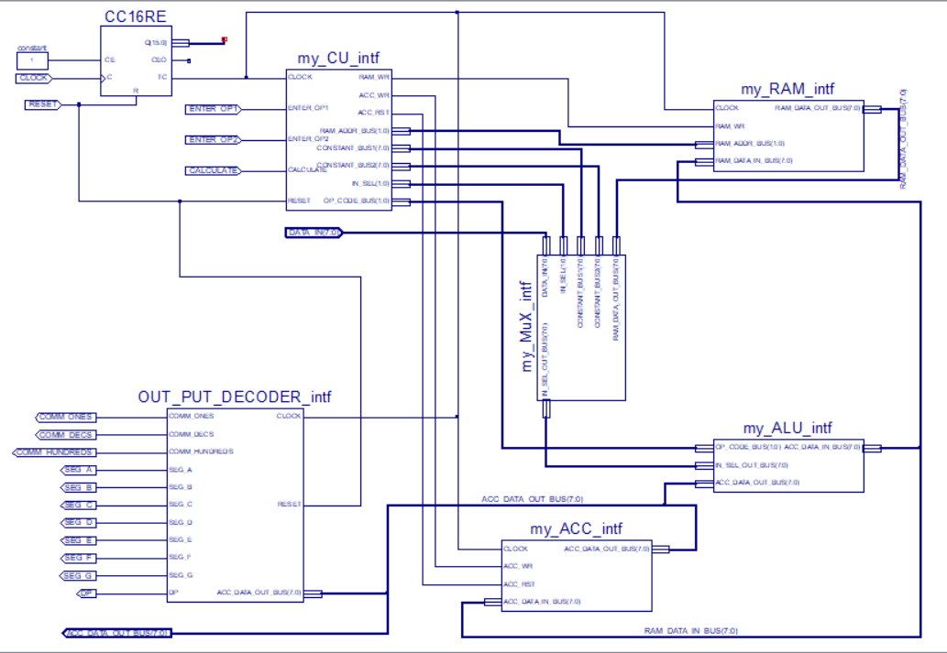

1. **Test bench TB_TOPLEVEL.vhd.**

LIBRARY ieee;

USE ieee.std_logic_1164.ALL;

USE ieee.numeric_std.ALL;

LIBRARY UNISIM;

USE UNISIM.Vcomponents.ALL;

use std.textio.all;

use ieee.std_logic_textio.all;

use IEEE.std_logic_signed.all;

ENTITY Top_level_Top_level_sch_tb IS

END Top_level_Top_level_sch_tb;

ARCHITECTURE behavioral OF Top_level_Top_level_sch_tb IS

COMPONENT Top_level

PORT( RESET : IN STD_LOGIC;

CLOCK : IN STD_LOGIC;

ENTER_OP1 : IN STD_LOGIC;

ENTER_OP2 : IN STD_LOGIC;

CALCULATE : IN STD_LOGIC;

DATA_IN : IN STD_LOGIC_VECTOR (7 DOWNTO 0);

COMM_ONES : OUT STD_LOGIC;

COMM_DECS : OUT STD_LOGIC;

COMM_HUNDREDS : OUT STD_LOGIC;

SEG_A : OUT STD_LOGIC;

SEG_B : OUT STD_LOGIC;

SEG_C : OUT STD_LOGIC;

SEG_D : OUT STD_LOGIC;

SEG_E : OUT STD_LOGIC;

SEG_F : OUT STD_LOGIC;

SEG_G : OUT STD_LOGIC;

DP : OUT STD_LOGIC;

ACC_DATA_OUT_BUS : OUT STD_LOGIC_VECTOR(7 DOWNTO 0));

END COMPONENT;

signal op1 : STD_LOGIC_VECTOR(7 DOWNTO 0):="00000001";

signal op2 : STD_LOGIC_VECTOR(7 DOWNTO 0):="00000100";

signal RESET : STD_LOGIC;

signal CLOCK : STD_LOGIC;

signal ENTER_OP1 : STD_LOGIC;

signal ENTER_OP2 : STD_LOGIC;

signal CALCULATE : STD_LOGIC;

signal DATA_IN : STD_LOGIC_VECTOR (7 DOWNTO 0);

signal COMM_ONES : STD_LOGIC;

signal COMM_DECS : STD_LOGIC;

signal COMM_HUNDREDS : STD_LOGIC;

signal SEG_A : STD_LOGIC;

signal SEG_B : STD_LOGIC;

signal SEG_C : STD_LOGIC;

signal SEG_D : STD_LOGIC;

signal SEG_E : STD_LOGIC;

signal SEG_F : STD_LOGIC;

signal SEG_G : STD_LOGIC;

signal DP : STD_LOGIC;

signal ACC_DATA_OUT_BUS : STD_LOGIC_VECTOR(7 DOWNTO 0);

constant CLK_period: time := 1 us;

constant TC_period: time := 65536 us;

BEGIN

UUT: Top_level

PORT MAP(

RESET => RESET,

CLOCK => CLOCK,

ENTER_OP1 => ENTER_OP1,

ENTER_OP2 => ENTER_OP2,

CALCULATE => CALCULATE,

DATA_IN => DATA_IN,

COMM_ONES => COMM_ONES,

COMM_DECS => COMM_DECS,

COMM_HUNDREDS => COMM_HUNDREDS,

SEG_A => SEG_A,

SEG_B => SEG_B,

SEG_C => SEG_C,

SEG_D => SEG_D,

SEG_E => SEG_E,

SEG_F => SEG_F,

SEG_G => SEG_G,

DP => DP,

ACC_DATA_OUT_BUS => ACC_DATA_OUT_BUS

);

CLK_process : process

begin

CLOCK <= '1';

wait for CLK_period/2;

CLOCK <= '0';

wait for CLK_period/2;

end process CLK_process;

stim_proc: process

begin

RESET <= '1';

ENTER_OP1 <= '0';

ENTER_OP2 <= '0';

CALCULATE <= '0';

DATA_IN <=(others => '0');

wait for 2*CLK_period;

RESET <='0';

wait for 4*TC_period;

ENTER_OP1 <='1';

DATA_IN <= op1;

wait for 2*TC_period;

ENTER_OP1 <='0';

wait for 4*TC_period;

ENTER_OP2 <='1';

DATA_IN <= op2;

wait for 2*TC_period;

ENTER_OP2 <='0';

wait for 4*TC_period;

CALCULATE <= '1';

wait for 8*TC_period;

wait;

end process stim_proc; --1.835 s

END ;

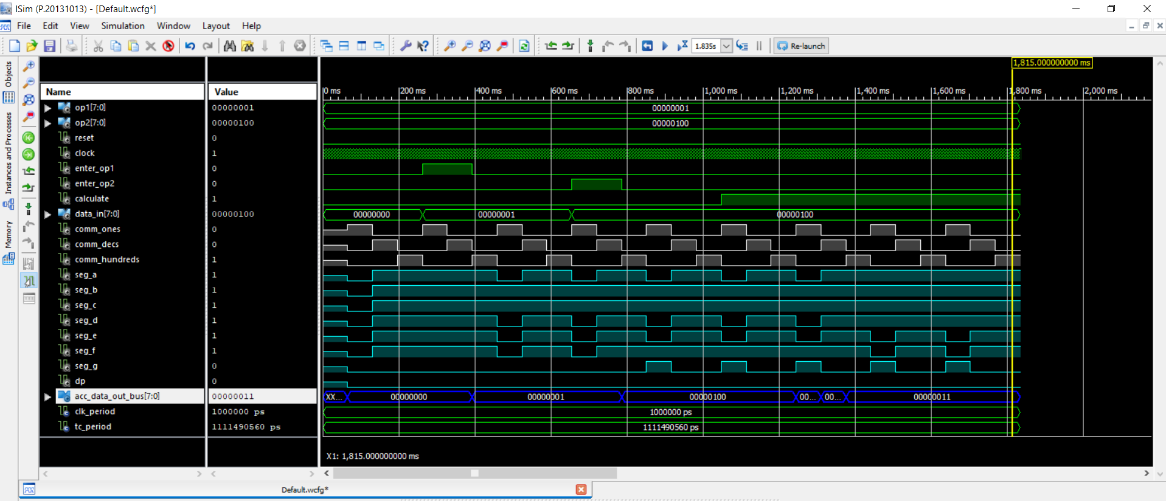

Рис.1. Часова діаграма.

**Висновок:** на цій лабораторній роботі я реалізував цифровий автомат для обчислення значення виразу.