Montemayor, Yuri C.

IT-3C

**Hands-On Activity**: Web Portfolio Development & Hosting on GitHub

**Objective**: Students will create a web portfolio to showcase their quizzes, projects, and other works. The portfolio will be hosted on GitHub Pages, demonstrating their skills in web development, usability, and version control.

**Step 1: Plan Your Portfolio**

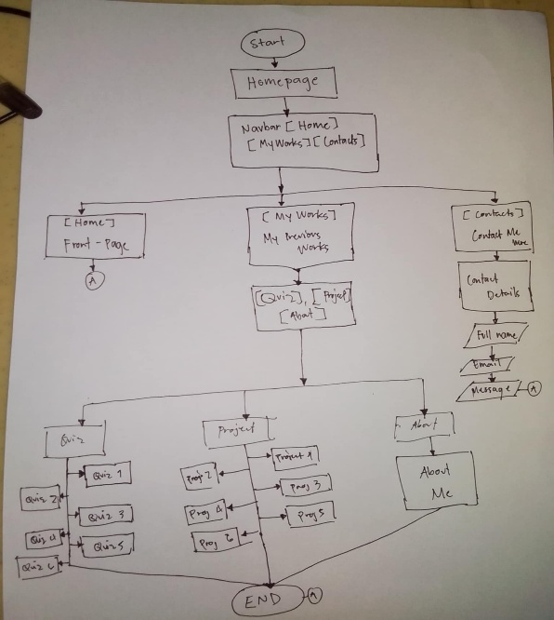(Sketch a site structure using a simple flowchart (Homepage, About, Projects, Quizzes, Contact)

Screenshots of Portfolio Pages – (5 pts)

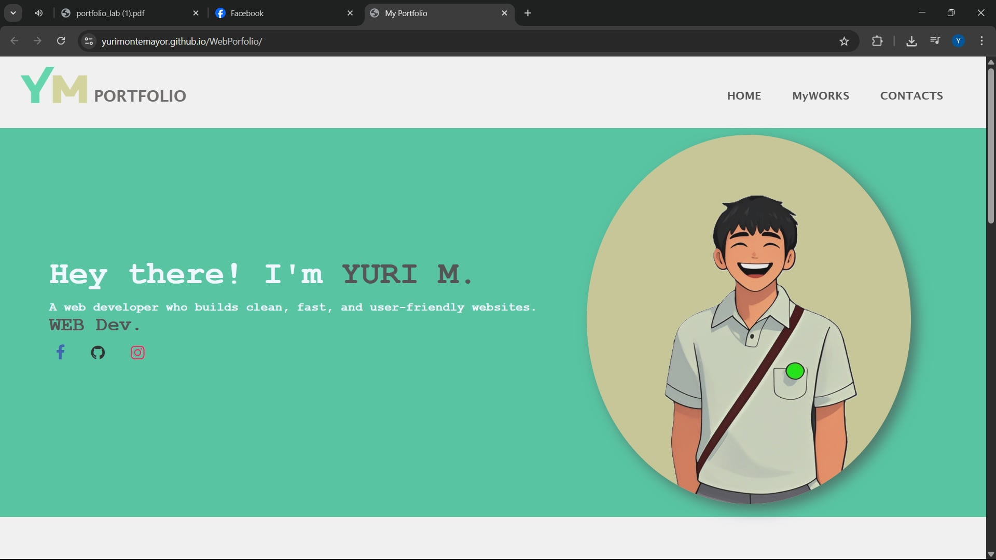

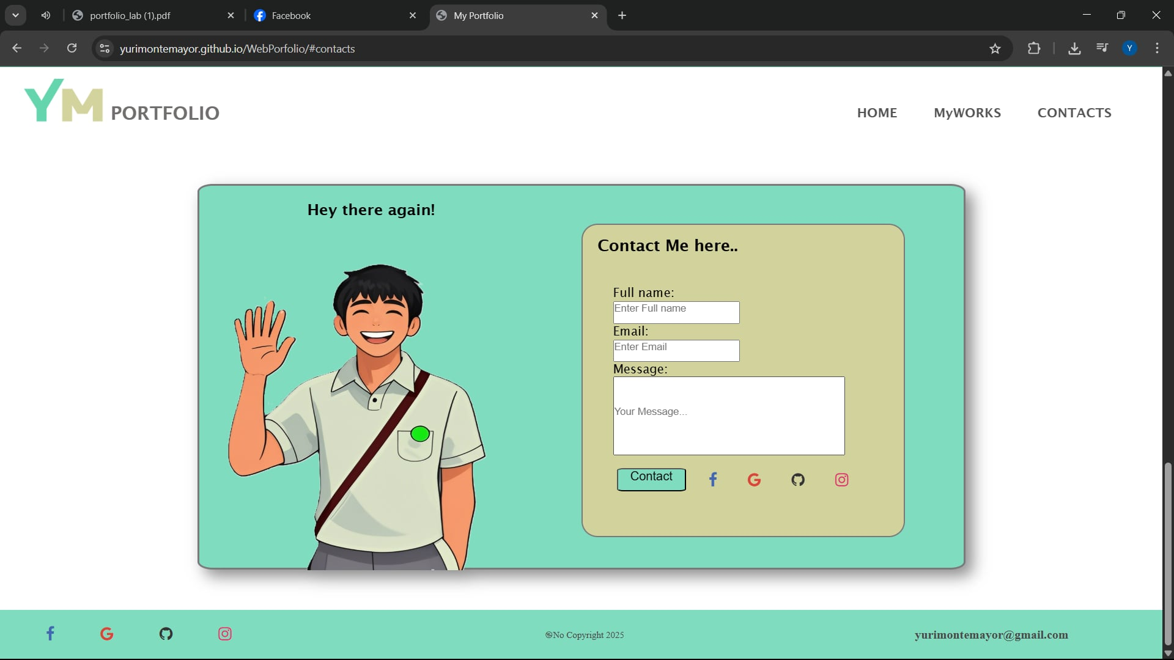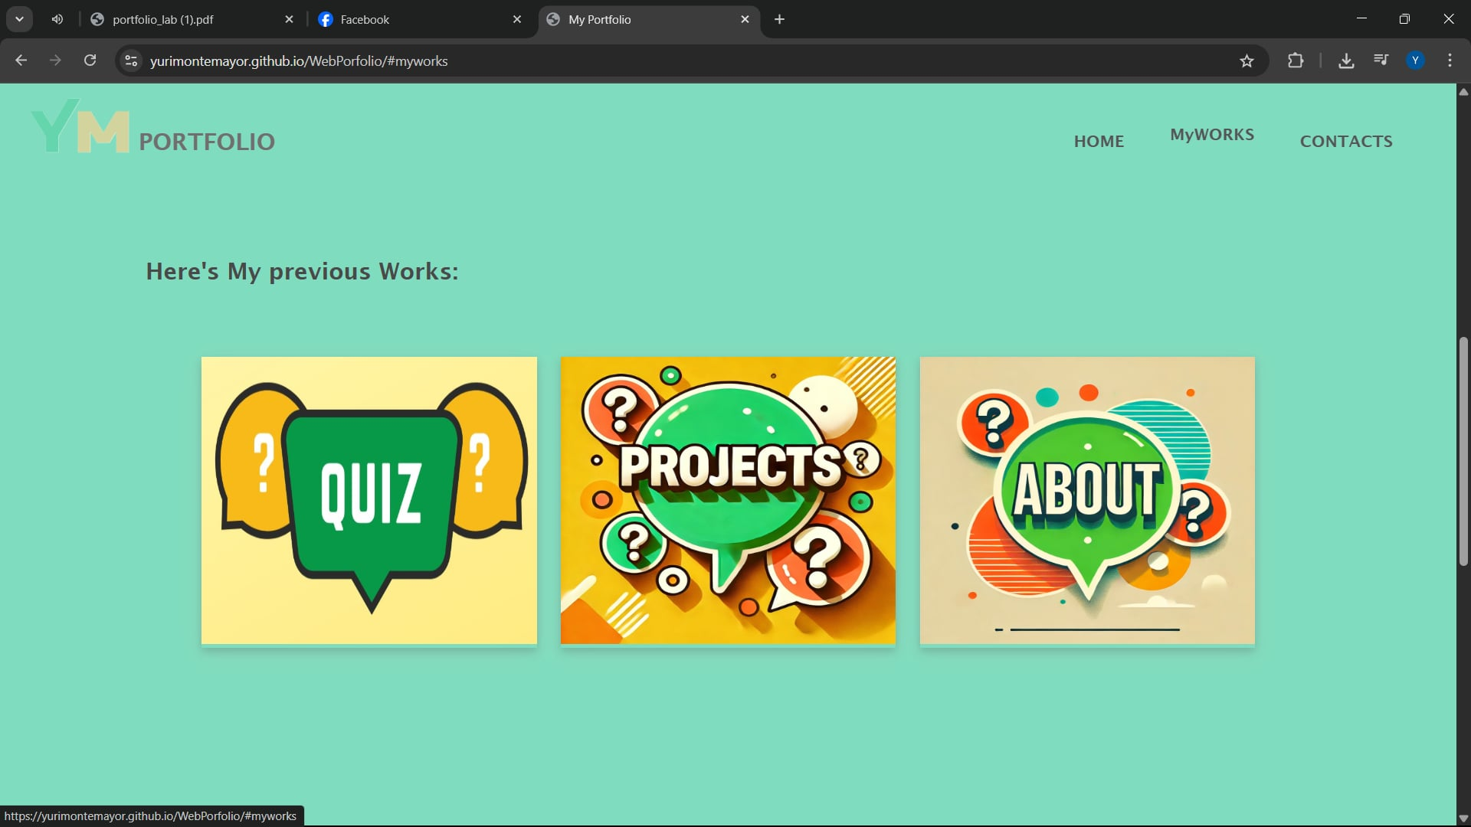

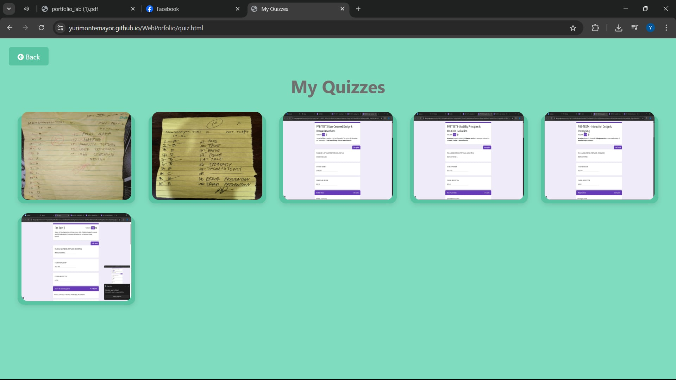

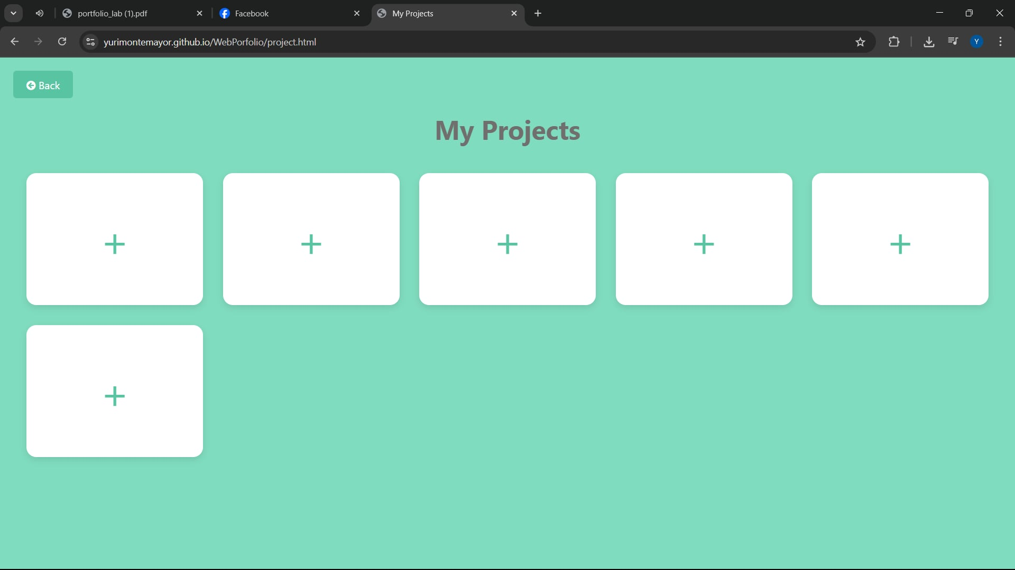

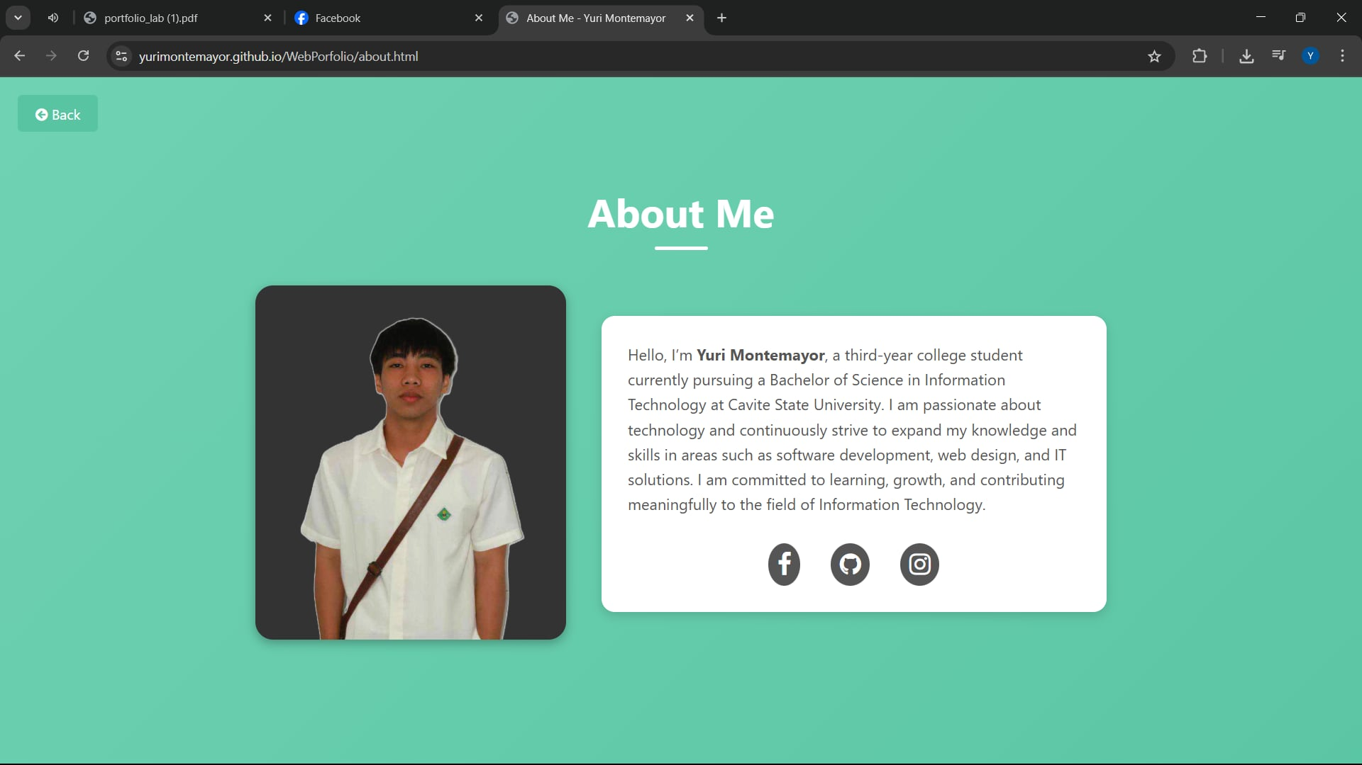

**Short Reflection**: What did you learn from this activity?

From this project, I learned how to build a responsive and interactive portfolio site that looks great on both phones and desktop. I also found out how to pull down my project on GitHub and share the links via repository. And GitHub has been great for me to learn how to manage my code and store it online. It also reminded me that the way people work together and collaborate on their work as developers is a craft unto its own. I learned a lot about the importance of creating websites that work on any device.” In general, this is an exercise that helped me to strenghten both my coding and problem-solving skills.