**Индексы: оптимизация запросов**

**Запрос**

EXPLAIN SELECT u.id, u.name, surname, age, sex, info, c.name

FROM public.users u

LEFT OUTER JOIN public.cities c on c.ID = u.city_id

WHERE **u.name LIKE 'Юрий' and surname LIKE 'Воробьев'**

ORDER BY id

**1. EXPLAIN до индексов**

"Gather Merge (cost=37343.13..37343.83 rows=6 width=93)"

" Workers Planned: 2"

" -> Sort (cost=36343.11..36343.12 rows=3 width=93)"

" Sort Key: u.id"

" -> Nested Loop Left Join (cost=0.15..36343.08 rows=3 width=93)"

" -> Parallel Seq Scan on users u (cost=0.00..36334.00 rows=3 width=79)"

" Filter: (((name)::text = 'Юрий'::text) AND ((surname)::text = 'Воробьев'::text))"

" -> Index Scan using cities_pkey on cities c (cost=0.15..3.02 rows=1 width=22)"

" Index Cond: (id = u.city_id)"

**2. Btree Индексы**

**Раздельные индексы**

CREATE INDEX IF NOT EXISTS idx_name

ON public.users USING btree

(name COLLATE pg_catalog."default" ASC NULLS LAST)

WITH (deduplicate_items=True)

TABLESPACE pg_default;

CREATE INDEX IF NOT EXISTS idx_surname

ON public.users USING btree

(surname COLLATE pg_catalog."default" ASC NULLS LAST)

WITH (deduplicate_items=True)

TABLESPACE pg_default;

"Sort (cost=103.75..103.77 rows=7 width=93)"

" Sort Key: u.id"

" -> Hash Left Join (cost=75.85..103.65 rows=7 width=93)"

" Hash Cond: (u.city_id = c.id)"

" -> Bitmap Heap Scan on users u (cost=65.60..93.39 rows=7 width=79)"

" Recheck Cond: (((name)::text = 'Юрий'::text) AND ((surname)::text = 'Воробьев'::text))"

" -> BitmapAnd (cost=65.60..65.60 rows=7 width=0)"

" -> Bitmap Index Scan on idx_name (cost=0.00..31.42 rows=2533 width=0)"

" Index Cond: ((name)::text = 'Юрий'::text)"

" -> Bitmap Index Scan on idx_surname (cost=0.00..33.93 rows=2867 width=0)"

" Index Cond: ((surname)::text = 'Воробьев'::text)"

" -> Hash (cost=6.22..6.22 rows=322 width=22)"

" -> Seq Scan on cities c (cost=0.00..6.22 rows=322 width=22)"

**Сложный индекс**

CREATE INDEX IF NOT EXISTS idx_names

ON public.users USING btree

(surname COLLATE pg_catalog."default" ASC NULLS LAST, name COLLATE pg_catalog."default" ASC NULLS LAST)

WITH (deduplicate_items=True)

TABLESPACE pg_default;

"Sort (cost=29.43..29.44 rows=7 width=93)"

" Sort Key: u.id"

" -> Hash Left Join (cost=10.67..29.33 rows=7 width=93)"

" Hash Cond: (u.city_id = c.id)"

" -> Index Scan using idx_names on users u (cost=0.42..19.07 rows=7 width=79)"

" Index Cond: (((surname)::text = 'Воробьев'::text) AND ((name)::text = 'Юрий'::text))"

" -> Hash (cost=6.22..6.22 rows=322 width=22)"

" -> Seq Scan on cities c (cost=0.00..6.22 rows=322 width=22)"

**2. Gin Индексы**

**Раздельные индексы**

CREATE INDEX IF NOT EXISTS trgm_idx_name

ON public.users USING gin

(name COLLATE pg_catalog."default" gin_trgm_ops)

TABLESPACE pg_default;

CREATE INDEX IF NOT EXISTS trgm_idx_surname

ON public.users USING gin

(surname COLLATE pg_catalog."default" gin_trgm_ops)

TABLESPACE pg_default;

"Sort (cost=290.90..290.92 rows=7 width=93)"

" Sort Key: u.id"

" -> Hash Left Join (cost=263.00..290.80 rows=7 width=93)"

" Hash Cond: (u.city_id = c.id)"

" -> Bitmap Heap Scan on users u (cost=252.75..280.54 rows=7 width=79)"

" Recheck Cond: (((name)::text = 'Юрий'::text) AND ((surname)::text = 'Воробьев'::text))"

" -> BitmapAnd (cost=252.75..252.75 rows=7 width=0)"

" -> Bitmap Index Scan on trgm_idx_name (cost=0.00..119.00 rows=2533 width=0)"

" Index Cond: ((name)::text = 'Юрий'::text)"

" -> Bitmap Index Scan on trgm_idx_surname (cost=0.00..133.50 rows=2867 width=0)"

" Index Cond: ((surname)::text = 'Воробьев'::text)"

" -> Hash (cost=6.22..6.22 rows=322 width=22)"

" -> Seq Scan on cities c (cost=0.00..6.22 rows=322 width=22)"

**Сложный индекс**

CREATE INDEX IF NOT EXISTS trgm_idx_names

ON public.users USING gin

(surname COLLATE pg_catalog."default" gin_trgm_ops, name COLLATE pg_catalog."default" gin_trgm_ops)

WITH (fastupdate=True)

TABLESPACE pg_default;

"Sort (cost=254.22..254.24 rows=7 width=93)"

" Sort Key: u.id"

" -> Hash Left Join (cost=226.32..254.12 rows=7 width=93)"

" Hash Cond: (u.city_id = c.id)"

" -> Bitmap Heap Scan on users u (cost=216.07..243.86 rows=7 width=79)"

" Recheck Cond: (((surname)::text = 'Воробьев'::text) AND ((name)::text = 'Юрий'::text))"

" -> Bitmap Index Scan on trgm_idx_names (cost=0.00..216.07 rows=7 width=0)"

" Index Cond: (((surname)::text = 'Воробьев'::text) AND ((name)::text = 'Юрий'::text))"

" -> Hash (cost=6.22..6.22 rows=322 width=22)"

" -> Seq Scan on cities c (cost=0.00..6.22 rows=322 width=22)"

**Вывод**: Для запросов с точным совпадением наилучшим является **btree сложный индекс**

**Запрос**

EXPLAIN SELECT u.id, u.name, surname, age, sex, info, c.name

FROM public.users u

LEFT OUTER JOIN public.cities c on c.ID = u.city_id

**WHERE u.name LIKE '%Юри%' and surname LIKE '%Воробье%'**

ORDER BY id

**2. Btree Индексы**

**Раздельные индексы**

CREATE INDEX IF NOT EXISTS idx_name

ON public.users USING btree

(name COLLATE pg_catalog."default" ASC NULLS LAST)

WITH (deduplicate_items=True)

TABLESPACE pg_default;

CREATE INDEX IF NOT EXISTS idx_surname

ON public.users USING btree

(surname COLLATE pg_catalog."default" ASC NULLS LAST)

WITH (deduplicate_items=True)

TABLESPACE pg_default;

"Gather Merge (cost=37344.03..37345.67 rows=14 width=93)"

" Workers Planned: 2"

" -> Sort (cost=36344.01..36344.03 rows=7 width=93)"

" Sort Key: u.id"

" -> Nested Loop Left Join (cost=0.15..36343.91 rows=7 width=93)"

" -> Parallel Seq Scan on users u (cost=0.00..36334.00 rows=7 width=79)"

" Filter: (((name)::text ~~ '%Юри%'::text) AND ((surname)::text ~~ '%Воробье%'::text))"

" -> Index Scan using cities_pkey on cities c (cost=0.15..1.41 rows=1 width=22)"

" Index Cond: (id = u.city_id)"

**Сложный индекс**

CREATE INDEX IF NOT EXISTS idx_names

ON public.users USING btree

(surname COLLATE pg_catalog."default" ASC NULLS LAST, name COLLATE pg_catalog."default" ASC NULLS LAST)

WITH (deduplicate_items=True)

TABLESPACE pg_default;

"Gather Merge (cost=37344.03..37345.67 rows=14 width=93)"

" Workers Planned: 2"

" -> Sort (cost=36344.01..36344.03 rows=7 width=93)"

" Sort Key: u.id"

" -> Nested Loop Left Join (cost=0.15..36343.91 rows=7 width=93)"

" -> Parallel Seq Scan on users u (cost=0.00..36334.00 rows=7 width=79)"

" Filter: (((name)::text ~~ '%Юри%'::text) AND ((surname)::text ~~ '%Воробье%'::text))"

" -> Index Scan using cities_pkey on cities c (cost=0.15..1.41 rows=1 width=22)"

" Index Cond: (id = u.city_id)"

**2. Gin Индексы**

**Раздельные индексы**

CREATE INDEX IF NOT EXISTS trgm_idx_name

ON public.users USING gin

(name COLLATE pg_catalog."default" gin_trgm_ops)

TABLESPACE pg_default;

CREATE INDEX IF NOT EXISTS trgm_idx_surname

ON public.users USING gin

(surname COLLATE pg_catalog."default" gin_trgm_ops)

TABLESPACE pg_default;

"Sort (cost=224.79..224.83 rows=16 width=93)"

" Sort Key: u.id"

" -> Hash Left Join (cost=161.29..224.47 rows=16 width=93)"

" Hash Cond: (u.city_id = c.id)"

" -> Bitmap Heap Scan on users u (cost=151.05..214.18 rows=16 width=79)"

" Recheck Cond: (((name)::text ~~ '%Юри%'::text) AND ((surname)::text ~~ '%Воробье%'::text))"

" -> BitmapAnd (cost=151.05..151.05 rows=16 width=0)"

" -> Bitmap Index Scan on trgm_idx_name (cost=0.00..39.07 rows=2543 width=0)"

" Index Cond: ((name)::text ~~ '%Юри%'::text)"

" -> Bitmap Index Scan on trgm_idx_surname (cost=0.00..111.72 rows=6362 width=0)"

" Index Cond: ((surname)::text ~~ '%Воробье%'::text)"

" -> Hash (cost=6.22..6.22 rows=322 width=22)"

" -> Seq Scan on cities c (cost=0.00..6.22 rows=322 width=22)"

**Сложный индекс**

CREATE INDEX IF NOT EXISTS trgm_idx_names

ON public.users USING gin

(surname COLLATE pg_catalog."default" gin_trgm_ops, name COLLATE pg_catalog."default" gin_trgm_ops)

WITH (fastupdate=True)

TABLESPACE pg_default;

"Sort (cost=165.91..165.95 rows=16 width=93)"

" Sort Key: u.id"

" -> Hash Left Join (cost=102.41..165.59 rows=16 width=93)"

" Hash Cond: (u.city_id = c.id)"

" -> Bitmap Heap Scan on users u (cost=92.17..155.30 rows=16 width=79)"

" Recheck Cond: (((surname)::text ~~ '%Воробье%'::text) AND ((name)::text ~~ '%Юри%'::text))"

" -> Bitmap Index Scan on trgm_idx_names (cost=0.00..92.16 rows=16 width=0)"

" Index Cond: (((surname)::text ~~ '%Воробье%'::text) AND ((name)::text ~~ '%Юри%'::text))"

" -> Hash (cost=6.22..6.22 rows=322 width=22)"

" -> Seq Scan on cities c (cost=0.00..6.22 rows=322 width=22)"

**Вывод**: Для запросов с поиском подстрок наилучшим является **gin сложный индекс**

**ВЫВОД: Учитывая что нам неизвестно будет ли использоваться поиск по подстрокам, оптимальным индексом является gin сложный индекс**

**Графики**

Графики получены из Jmeter

**графики latency до индекса**

**10 юзеров**

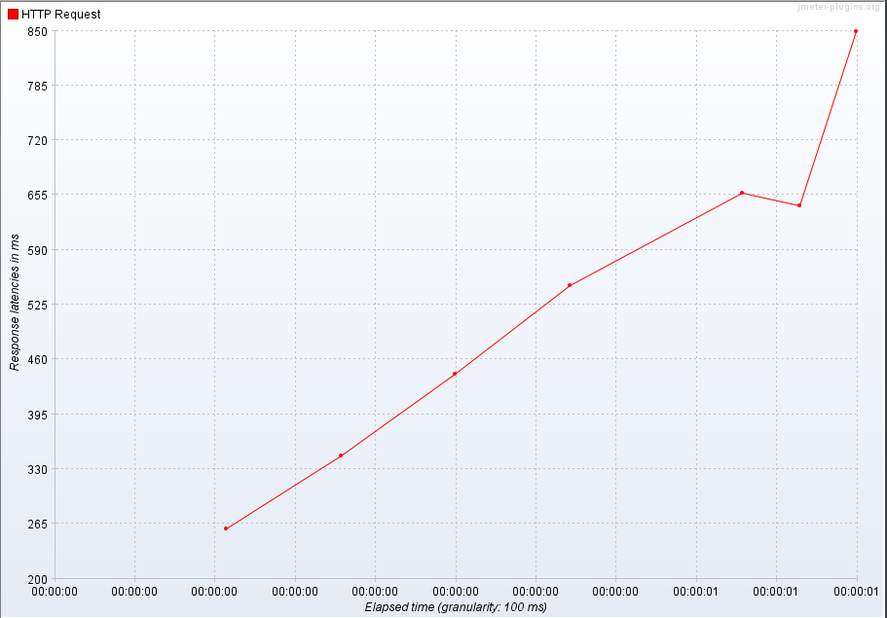

**100 юзеров**

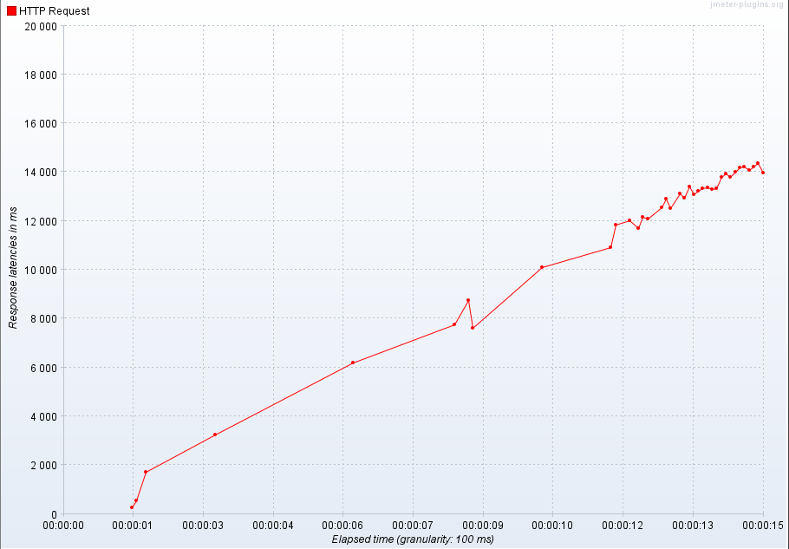

**графики throughput до индекса**

**10 юзеров**

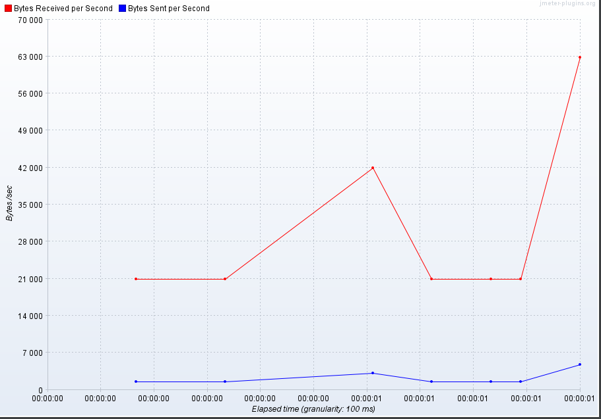

**100 юзеров**

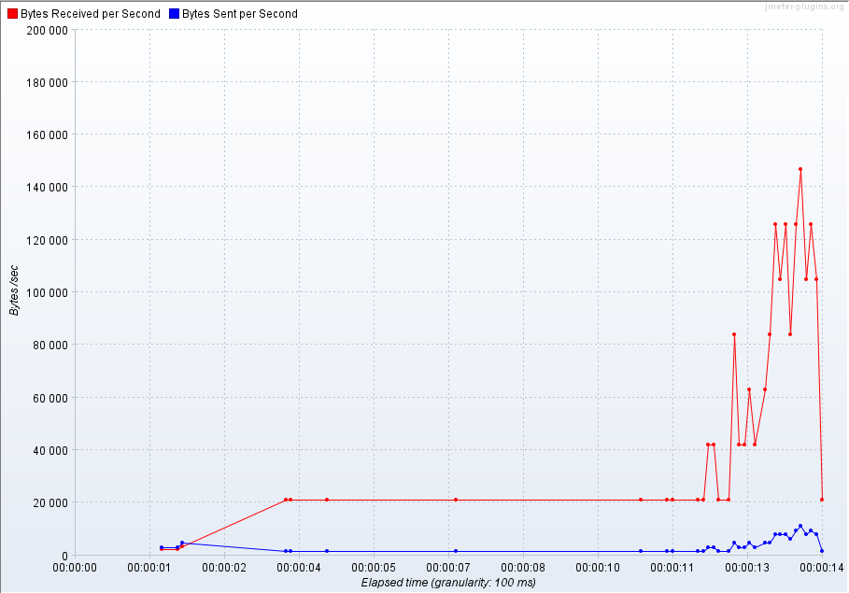

**графики latency после индекса gin**

**10 юзеров**

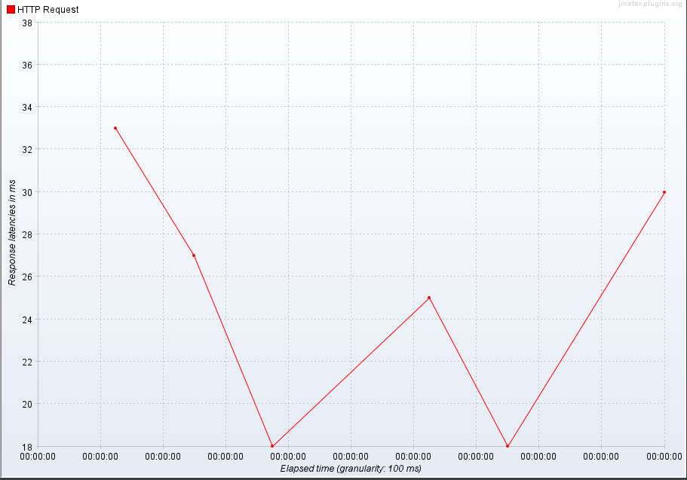

**100 юзеров**

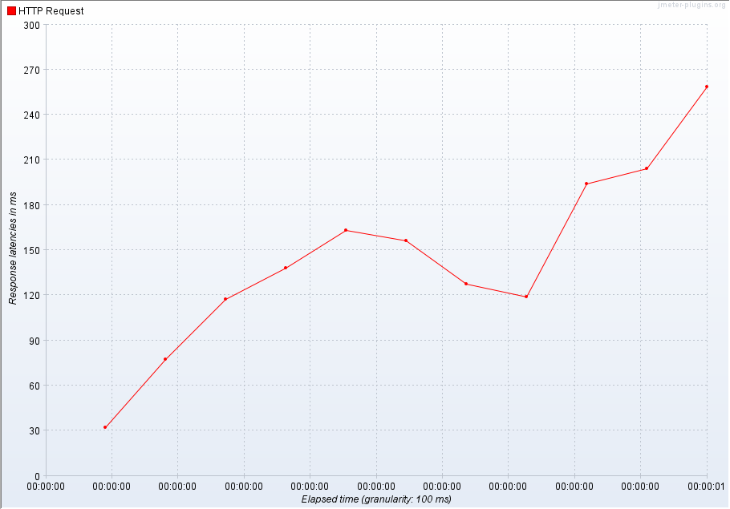

**графики throughput после индекса gin**

**10 юзеров**

* 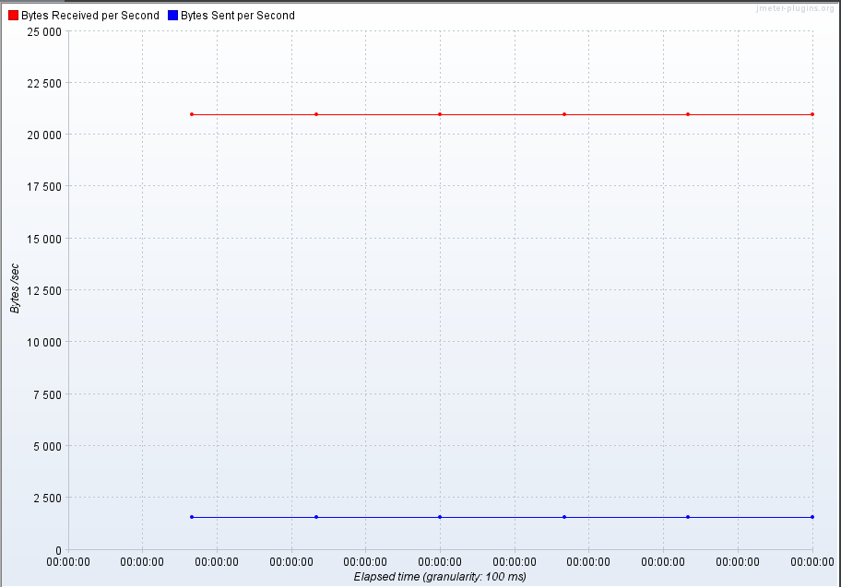

**100 юзеров**

