Benefits of distributed systems over centralized systems

* Scalability:

More machines can be added

* Rudundancy:

Different machines provide the same services -> doesn’t matter if one server is unavailable

Tasks of a Centralized Coordination Service

* Maintaining configuration information
* Naming
* Providing distributed synchronisation (locks,…)
* Providing group services (leader election,…)

Replicated Mode

* A replicated group of servers in the same application is called a quorum
* all servers in the quorum have copies of the same configuration file.

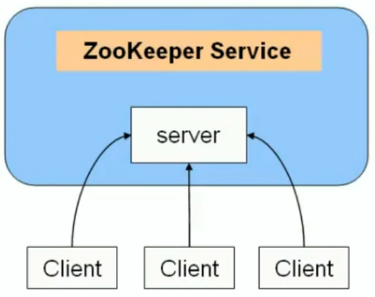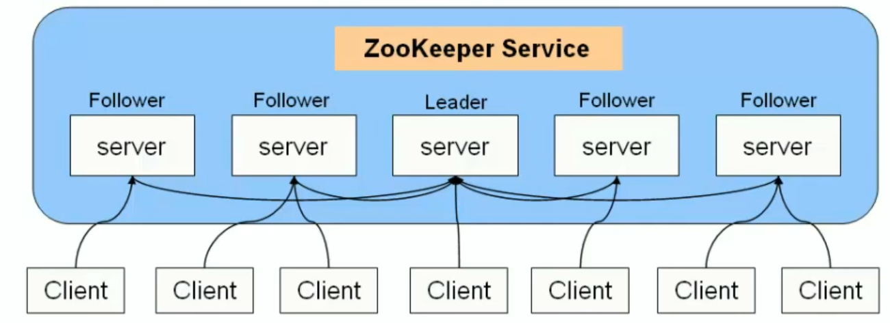

Standalone Mode

* Only one single server

Consitancy Garantees

* Sequential Consitancy: Client updated are applied in ordner
* Atomicity
* Single system image: Client sees the same view regardless of server
* Reliability: Succeeded update persists
* Timeliness: Client view is garaneed up-to-date withina time bound

Hierarchical namespace

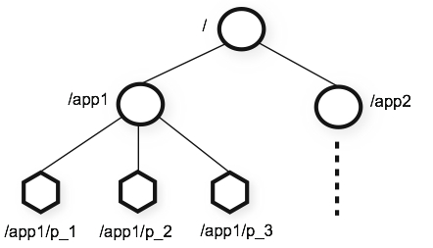

znode

* Includes
  + version numbers for data changes
  + ACL (Access control list) changes
  + Timestamps

Supported opperations

* create: creates a node at a location in the tree
* delete: deletes a node
* exists: tests if a node exists at a location
* get data: reads the data from a znode
* set data: writes data to a znode
* get acl: reads acl from a znode
* set acl: writes acl to a znode
* get children: retrieves a list of children of a znode
* sync: waits for data to be propagated

ZooKeeper Access Control List

* ACL schemes
  + world
  + auth
  + digest
  + ip
* Permissions
  + CREATE
  + READ
  + WRITE
  + DELETE
  + ADMIN
* Example: ip:19.23.0.0/16, READ

ZooKeeper Recipes

* Barriers
* Queues
* Locks
* 2PC (Two Phase Commit)
* Leader Election

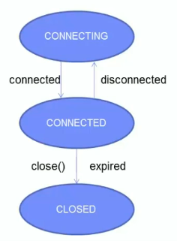ZooKeeper Sessions