Error. Storages

**DEADLINE:** 26/05/2021

## FOLDER STRUCTURE

|  |  |
| --- | --- |
| FL16_HW11/ *  ├─ task  ├─ homework/ *  ├─ index.html *  ├─ pipe.html *  ├─ page_1.html *  ├─ page_2.html *  ├─ page_3.html *  ├─ css/ *  ├─ main.css *  ├─ js/ *  ├─ index.js *  ├─ pipe.js * | *  - required |

TASKS

**Task 1.**

* You need to implement two functions in *index.js* – visitLink and viewResults.
* visitLink function should save to localStorage how many times each link was clicked (visited).
* viewResults should display a list how many times each link was visited (see example below) and afterwards clear the storage

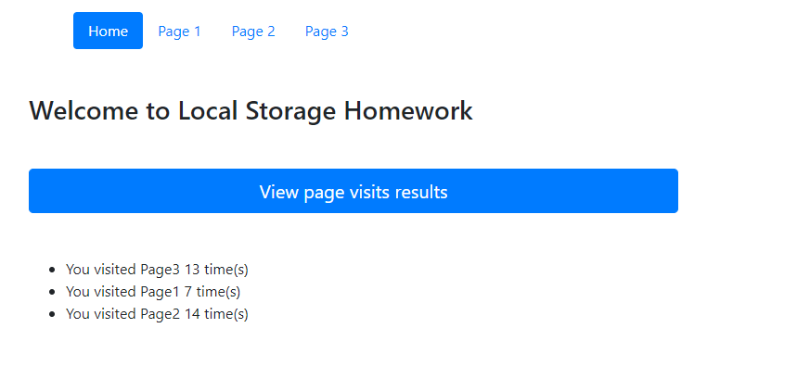

**Task 2.**

* Implement PIPE function.
* The function is supposed to accept the following arguments: value and a sequence of functions.
* Each of the functions should operate on the provided value and pass the output to the other function in a sequence.
* In case provided argument is not a function, pipe should immediately throw an error and stop the execution.

Example:

const result = pipe(

  "john_doe",

  replaceUnderscoreWithSpace,

  capitalize,

  appendGreeting,

);

alert(result); // Hello, John Doe!

const result = pipe(

  "john_doe",

  replaceUnderscoreWithSpace,

  capitalize,

  "",

);

alert(result); // Provided argument at position 2 is not a function!

RESTRICTIONS

* Editing index.html is forbidden.
* Adding **task/** folder is forbidden. Do not push it to repository. (Only **homework/** should be pushed)

## BEFORE SUBMIT

* Code should be clean, without comments, readable, and tested
* Make sure your GitLab folder structure meets folder structure from this document (without **task** folder)

## SUBMIT

* The **FL16_HW11** folder without **task** folder should be uploaded to GitLab repository “**FL-15**” into **master** branch.

## USEFUL LINKS

* <https://developer.mozilla.org/ru/docs/Web/API/Storage>