**CSS Basics**

**DEADLINE:** 01/05/2021

## **FOLDER STRUCTURE** * ­­­- required

FL-16_HW2/*

├─ task/

     └─ FL_HW2.docx

   └─ homework/*

        └─ css/*

            └─ bootstrap.min.css*

└─ general.css*

└─ style.css*

        └─ img/*

     └─ index.html*

## **TASK**

1) You need to create a print version of the web-page. In the following pictures, you will see mock-ups which represent almost finished site (this is what you need to achieve). In case, you don’t know how to open print version of the page, you should follow the next steps:

* Open index.html file in a browser
* press ctrl+p (or cmd+p for Mac)

Now you can see the first printed page looking like this (see Figure 1):

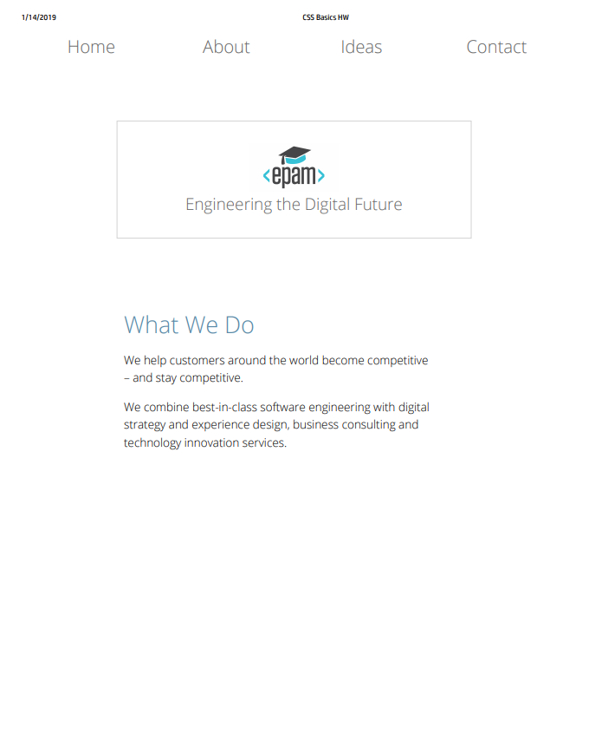

**Figure 1 — Print version**

As you can see, the preview looks not so good and we should improve it. The result should look close (not pixel perfect) to the provided example in Figure 2. Pay attention, only the first section should be available for print (“What we do”)

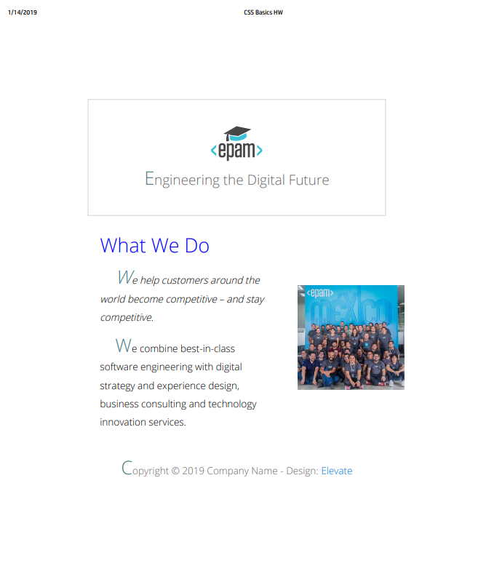

##### **Figure 2 — Print version (mockup)**

2) Lets look closer at this part of site. Tiles with text should have hover effect (see Figure 3).

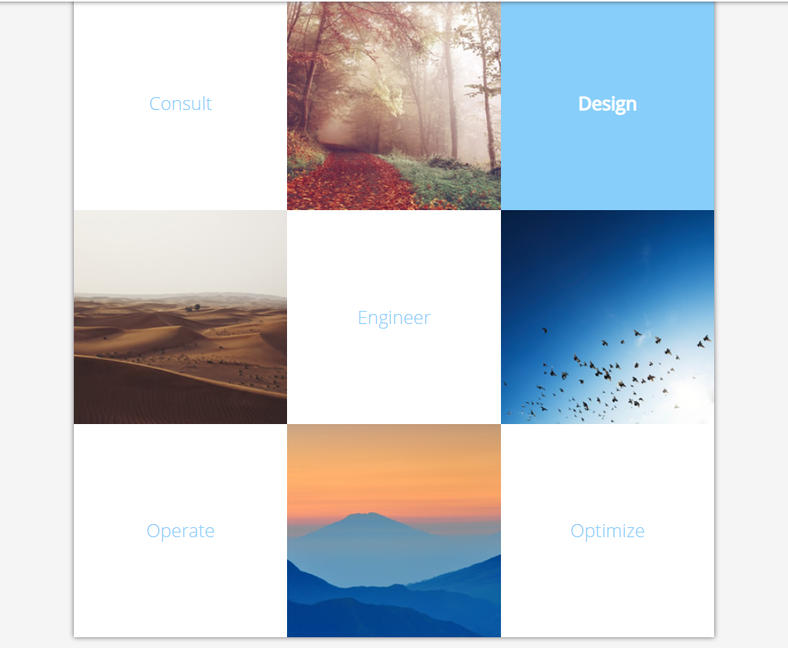

##### **Figure 3 — Gallery block (mockup)**

3) Change color of first letter in each paragraphs to lightskyblue (#87CEFA) and font size to 30px. (see Figure 4).



##### **Figure 4 — First Letter (mockup)**

4) Add box shadow to navigation and each content block. Add grey border to the banner

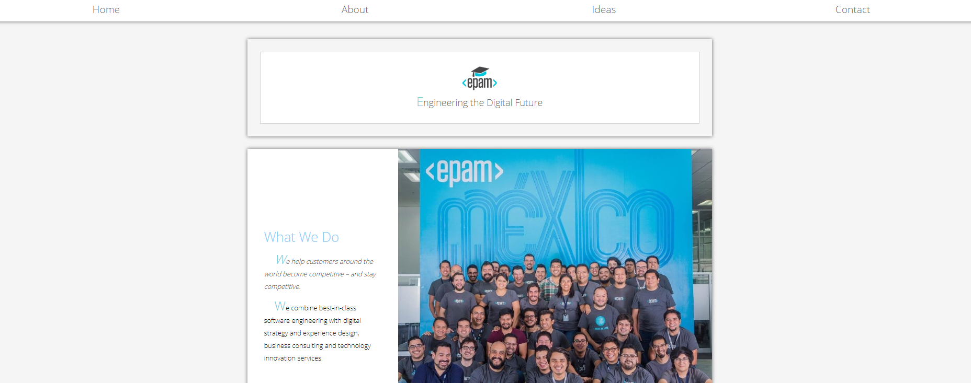

##### **Figure 5 — Blocks shadow and banner’s border(mockup)**

5) Add triangle to each section on the page using pseudo elements. (see left top corner in Figure 6)

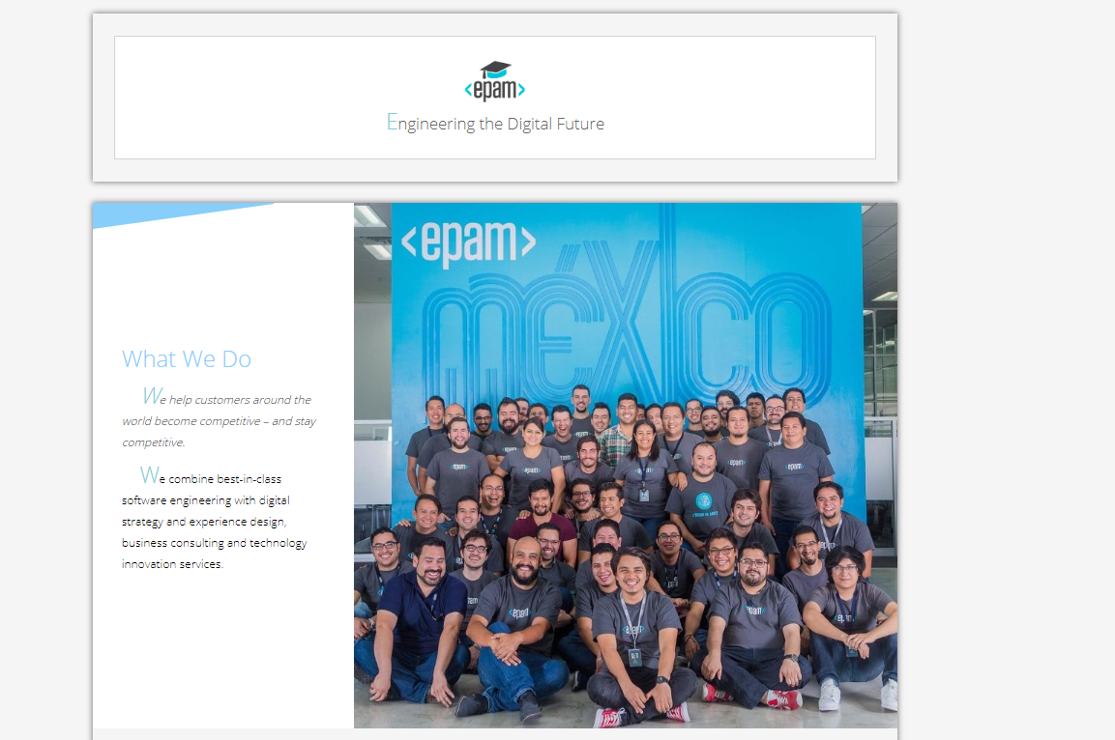

##### **Figure 6 —Triangle (mockup)**

6) Change color of ‘How We Do It’ to gainsboro and add letter spacing 5px.

7) Each first paragraph which placed after h2 tag should have italic font style.

8) Text in the paragraph should look like in Figure 7. (vertical space between lines is increased, there is some free space at the start of the first line).

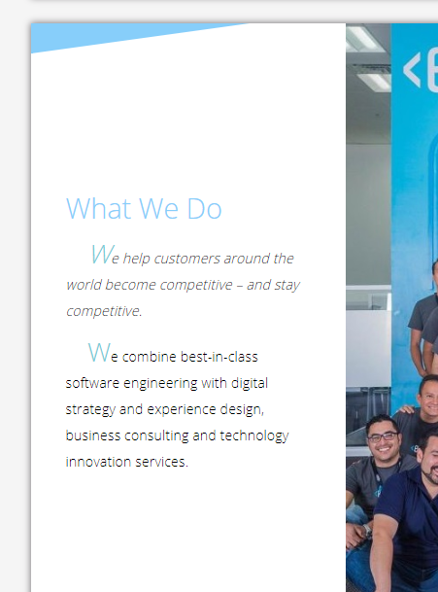

##### **Figure 7 —Text alignment (mockup)**

Pay attentions, that the text in first banner block should not have such styles (see Figure 8):



##### **Figure 8 —Text alignment on first banner (mockup)**

9) Apply the following styles in “We are” section:

* already visited links should become underlined
* the hovered links should look like “2. Consultants” item
* add ‘new’ label to the end of words. It should be applied only for ‘Designers’ and ‘Strategists’ items.

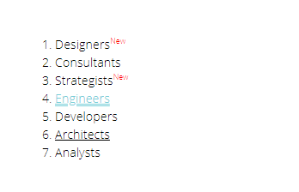

**Figure 9 —List styling (mockup)**

10) Add layout and styles for following block.

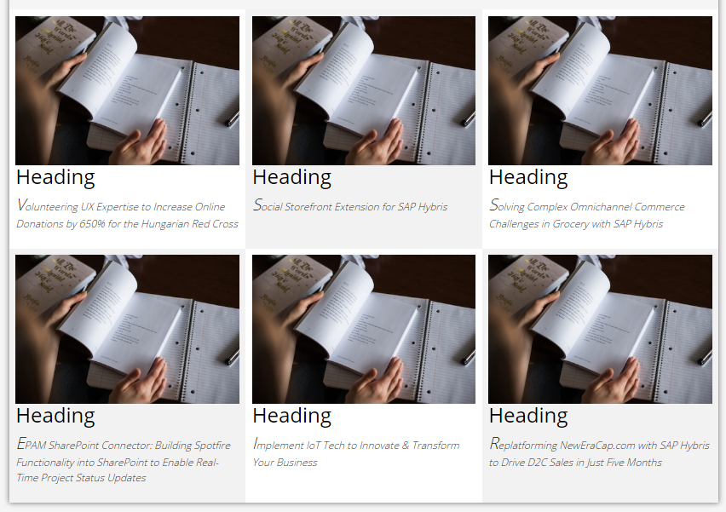

**Figure 10 —Block styling (mockup)**

11) Change submit button styles. Add asterisk to email field (Figure 11 and Figure 12).

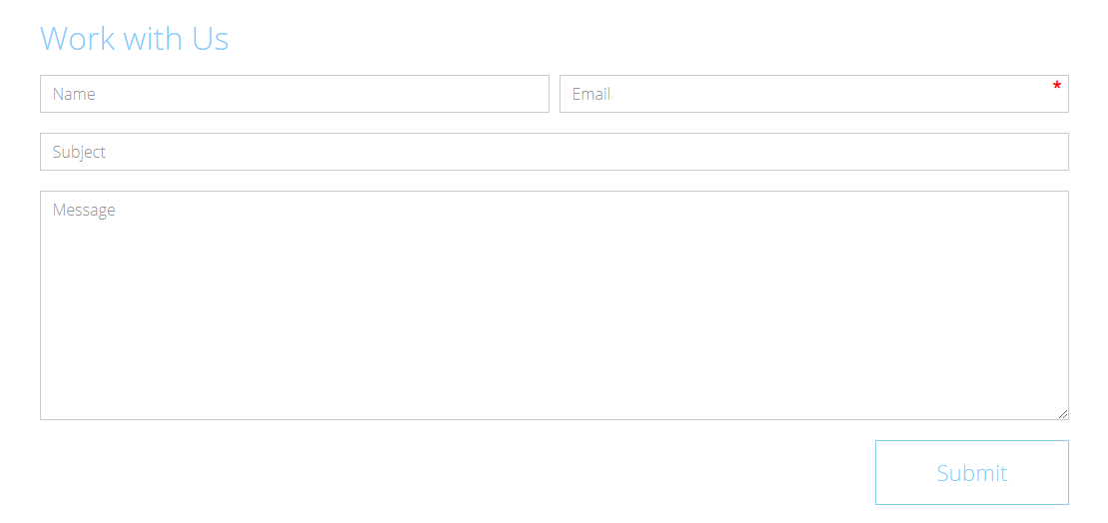

**Figure 11 —Work with Us form (mockup)**

The submit button should have a hover effect:

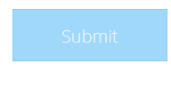

**Figure 12 —Submit button in hover state (mockup)**

12) Add hover effect for navigation items (grey background) (Figure 13).

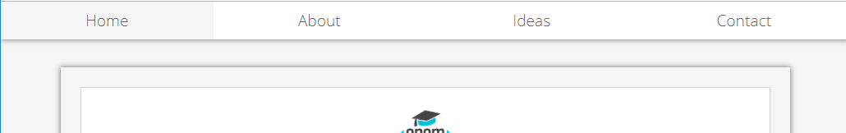

**Figure 13 —** **Hover effect for navigation items (mockup)**

## **RESTRICTIONS**

* Adding/editing styles in the **general.css** file is forbidden

## **BEFORE SUBMIT**

* Read requirements and compare to your homework result
* Format the code (remove unnecessary lines of code)
* Remove all unnecessary files that you might have included by mistake

## **SUBMIT**

* The folder should be uploaded to gitlab repository **“FL-16**” into **master** branch