**Web debugging and profiling tools**

**DEADLINE:** 23.05.2021

**FOLDER STRUCTURE**

|  |  |
| --- | --- |
| FL16_HW9/*  └─ homework/*     └─ src/*  └─ js/*  └─ app.js*  └─ .eslintrc.js*  └─ index.html*  └─ style.css* | * ­­­- required |

**TASK**

Your task is to write a simple application which helps to organize an event and also can convert currency.

Workflow:

1. On page load, user inputs event name (use “prompt” function, “meeting” is default value).
2. When user clicks ok, form with fields (name, time, place) should be shown. It is allowed to implement any UI design that covers required functionality.

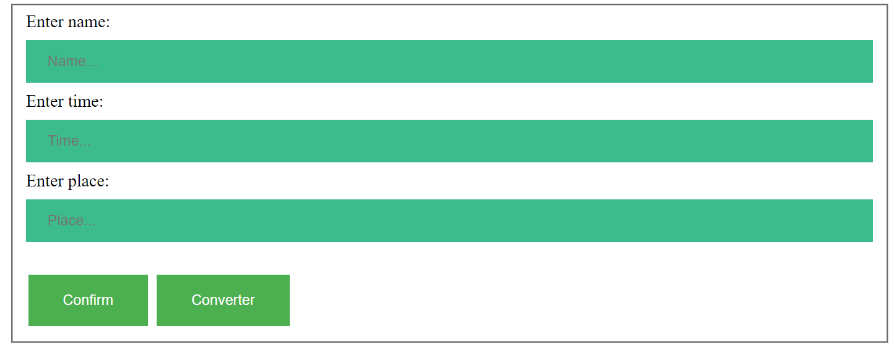

1. User should fill in all fields.
2. You need to validate the input data on click confirm button: each value can't be empty and you need to validate time to format HH:MM (to do that please use the following regular expression **/^(2[0-3]|[01]?[0-9]):([0-5]?[0-9])$/**).
3. If input data is empty, you should show message “Input all data”. If time format is invalid, you should show message “Enter time in format hh:mm”. (Use “alert” function for both messages).
4. If all data are valid, show message in console:(example).

John has a meeting today at 17:30 somewhere in London

1. On click converter button user inputs amount of euro. (Use “prompt” function).
2. User inputs amount of dollar. (Use “prompt” function).
3. You need to validate the input data: both values should be positive numbers. You need to convert both currency to hryvnia.
4. Show message: (example). Use “alert” function

35 euros are equal 1173.20hrns, 100 dollars are equal 2776.00hrns

You should show only 2 numbers after comma.

**BEFORE SUBMIT**

* Remove all unnecessary files that you might have included by mistake
* Read requirements and compare to your homework result
* Format the code (remove unnecessary lines of code)
* In order to use npm package manager you should install nodejs (https://nodejs.org/ )
* Install eslint to check your code (npm install -g eslint)
* Open a terminal(or cmd)
* Go to ‘homework’ folder
* Run eslint (i.e. eslint ./js/app.js), code should be without ‘errors’

## RESTRICTIONS

* External libraries usage is forbidden

**HOW TO**

Use linter :

* In order to use npm package manager you should install nodejs (https://nodejs.org/ )
* Install eslint to check your code (npm install -g eslint)

- open a terminal (or cmd)

- run eslint (i.e. eslint ./js/app.js)

Code should be without ‘errors’

**SUBMIT**

* The folder should be uploaded to GitLab repository 'FL-16' into master branch