Acumatica Inventory Scanner
User Manual

Developed by AcuPower LTD

Table of Contents
1. Introduction
2. Prerequisites
3. Acumatica Configuration
3.1. Navigating to Connected Applications
3.2. Creating an OAuth Application
3.3. Adding a Client Secret
3.4. Saving Your Credentials
4. Using the Mobile App
5. Troubleshooting

1. Introduction
The Acumatica Inventory Scanner is a modern mobile barcode scanning application designed for Acumatica ERP inventory management. Built with .NET MAUI, it provides cross-platform deployment on Android and iOS devices.

Key Features:
• Real-time Barcode Scanning - Fast camera-based barcode detection
• Inventory Lookup - Instantly search and view stock item details
• OAuth 2.0 Authentication - Secure API access to Acumatica
• Settings Persistence - Save credentials for quick re-login
• Modern Dark Theme - Industrial-inspired UI design
• Cross-Platform - Works on Android and iOS

2. Prerequisites
Before using this app, ensure you have:
1. Acumatica ERP Instance (version 20.2 or later)
2. User Account with API access permissions
3. OAuth Connected Application configured in Acumatica

3. Acumatica Configuration
This section guides you through configuring Acumatica to allow the mobile app to connect using OAuth 2.0 authentication.

3.1. Navigating to Connected Applications
Step 1: Log in to your Acumatica instance as an administrator.


Figure 1: Acumatica Login Page - Enter your administrator credentials

Step 2: Click on "More Items" in the left navigation menu.

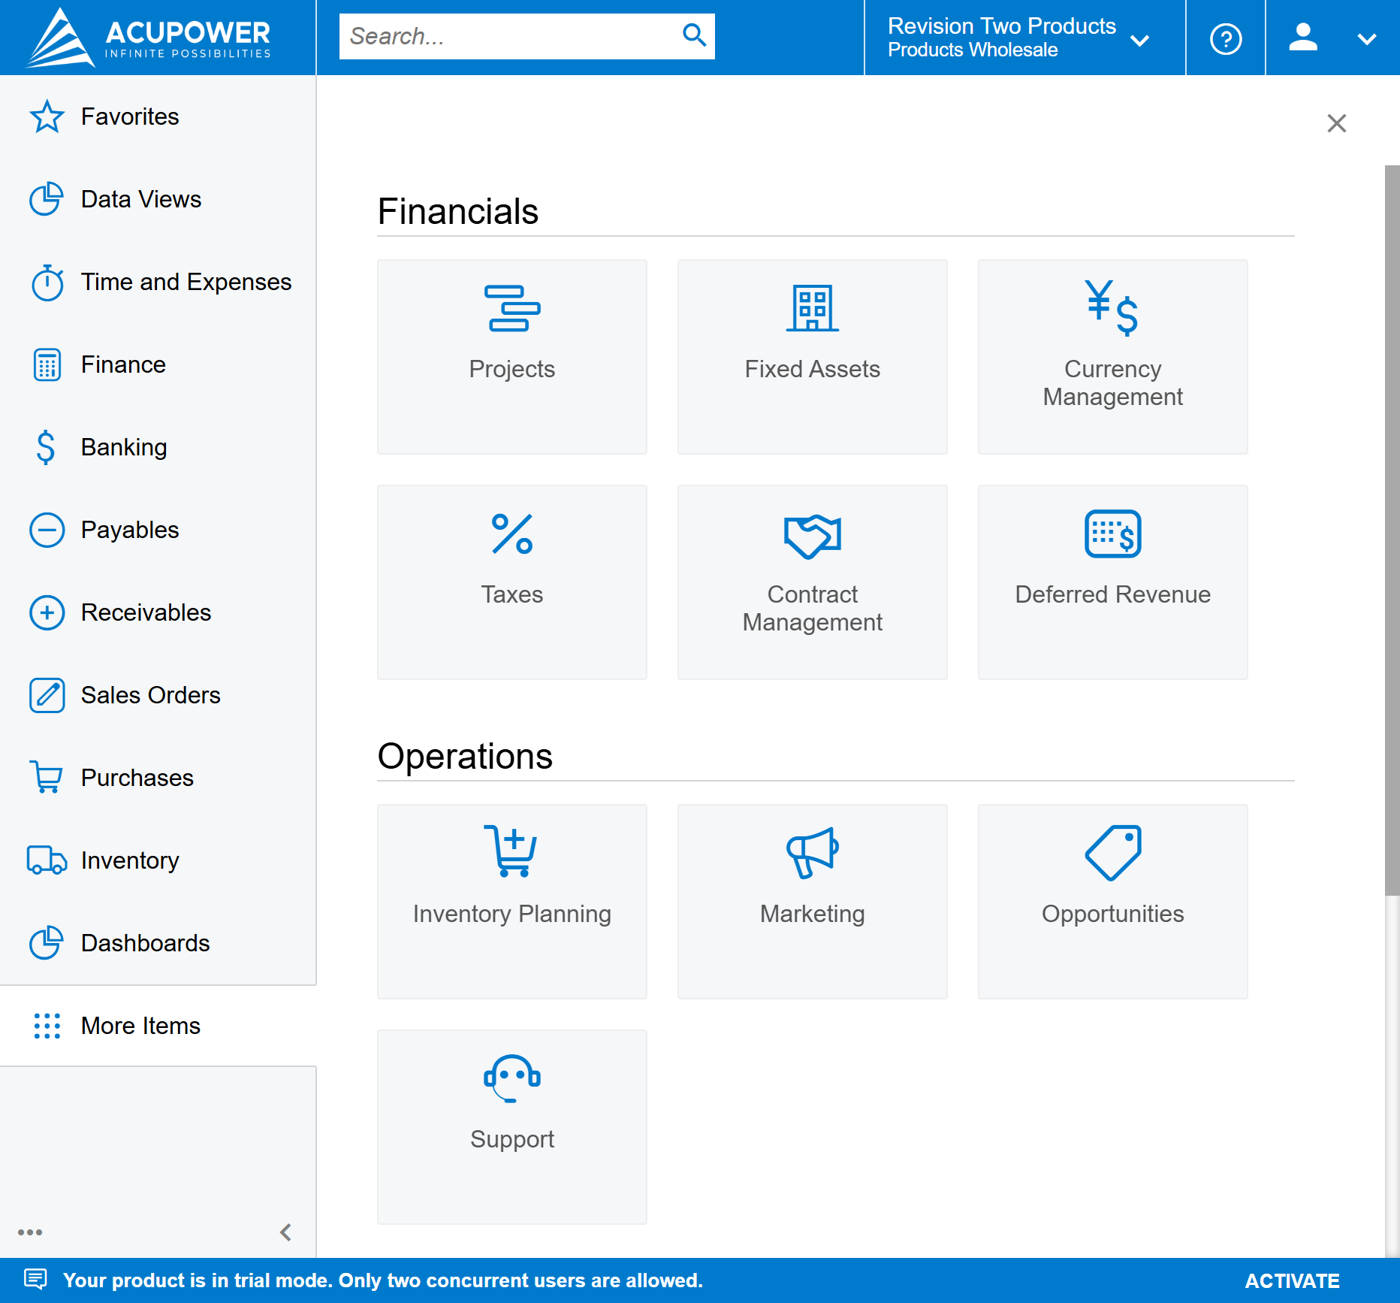
Figure 2: Main Navigation Menu - The "More Items" option is at the bottom of the left sidebar

Step 3: Select "Integration" from the expanded menu.

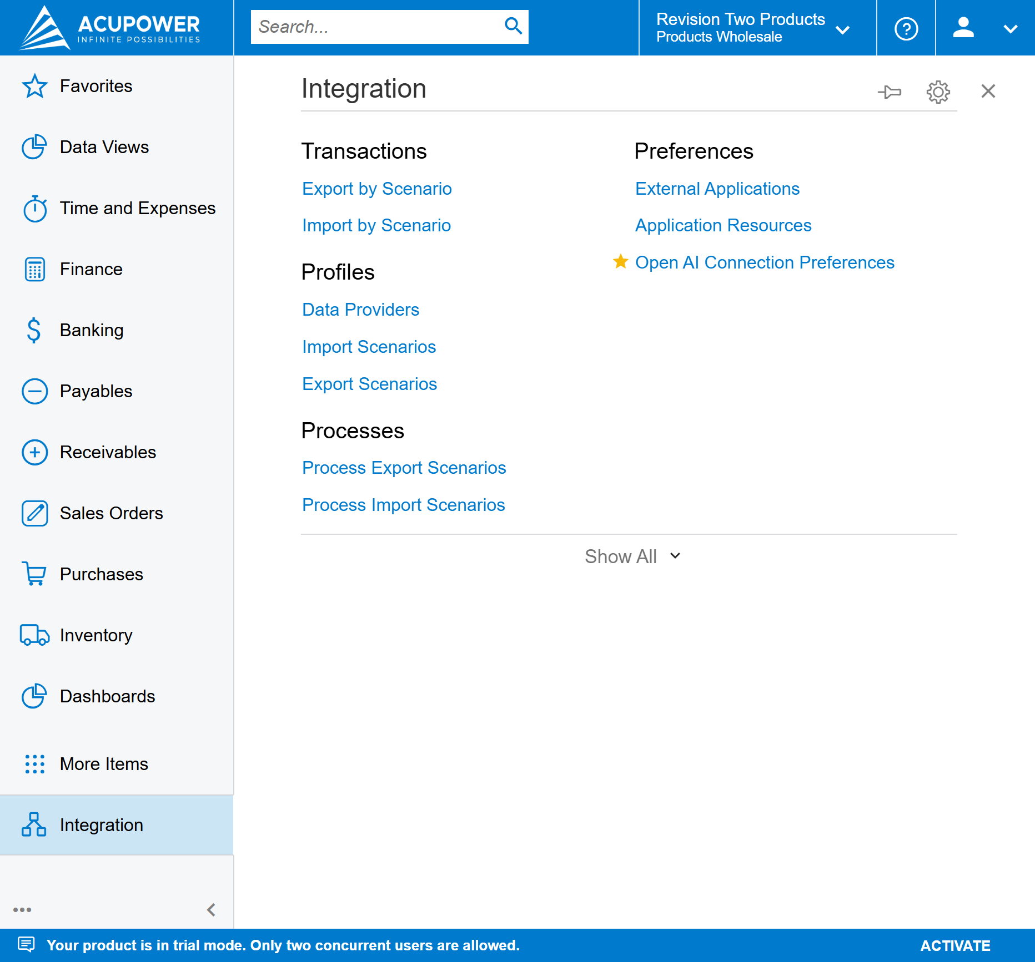
Figure 3: Integration Menu - Shows various integration options

Step 4: Click on "Connected Applications" under Preferences.

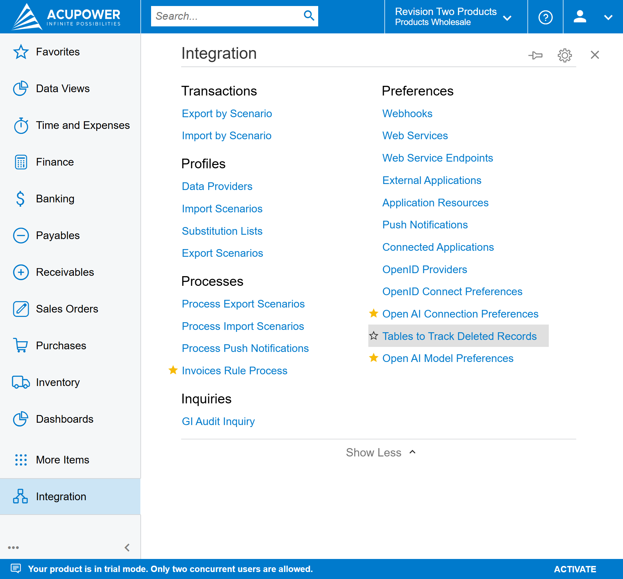
Figure 4: Full Integration Menu - Connected Applications is under Preferences

3.2. Creating an OAuth Application
Step 1: In the Connected Applications screen, click the "+" button to create a new record.

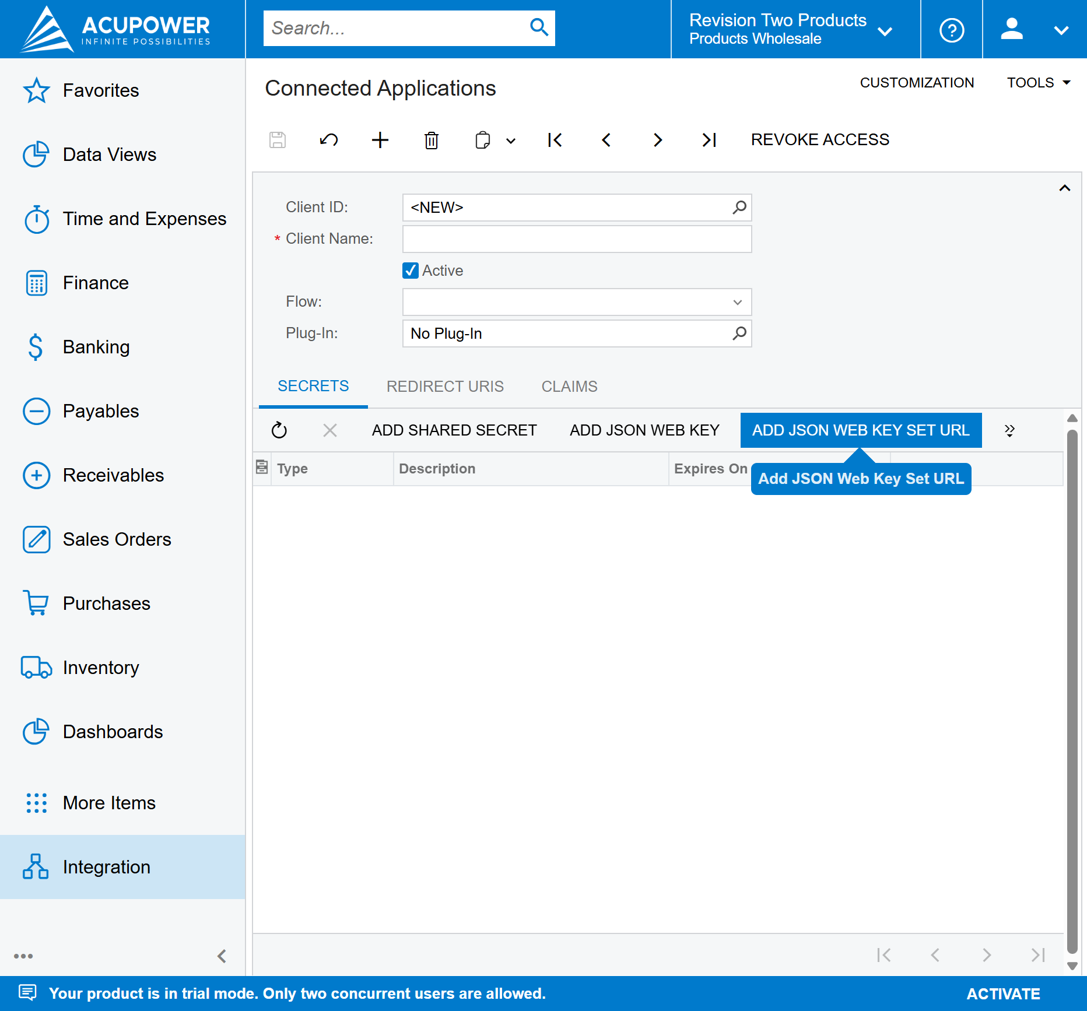
Figure 5: Connected Applications Screen - Click "+" to add a new application

Fill in the following fields:
Field | Value
Client Name | InventoryScanner (or your preferred name)
Active | Checked ✓
Flow | Resource Owner Password Credentials
Plug-In | No Plug-In

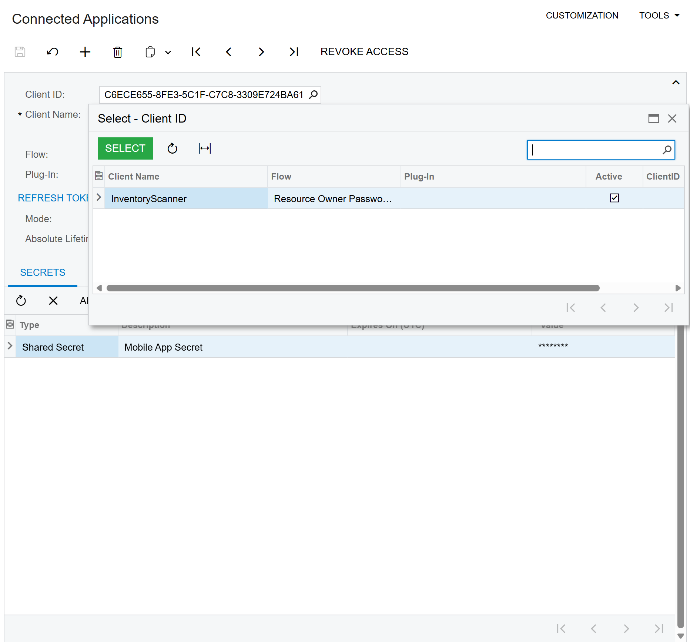
Figure 6: Creating the InventoryScanner OAuth Application

3.3. Adding a Client Secret
Step 1: Click on the "SECRETS" tab in the Connected Applications form.

Step 2: Click "ADD SHARED SECRET" button.

Step 3: Enter a description (e.g., "Mobile App Secret").

⚠️ IMPORTANT: Copy and save the generated secret value immediately! The secret is only shown once and cannot be retrieved later.

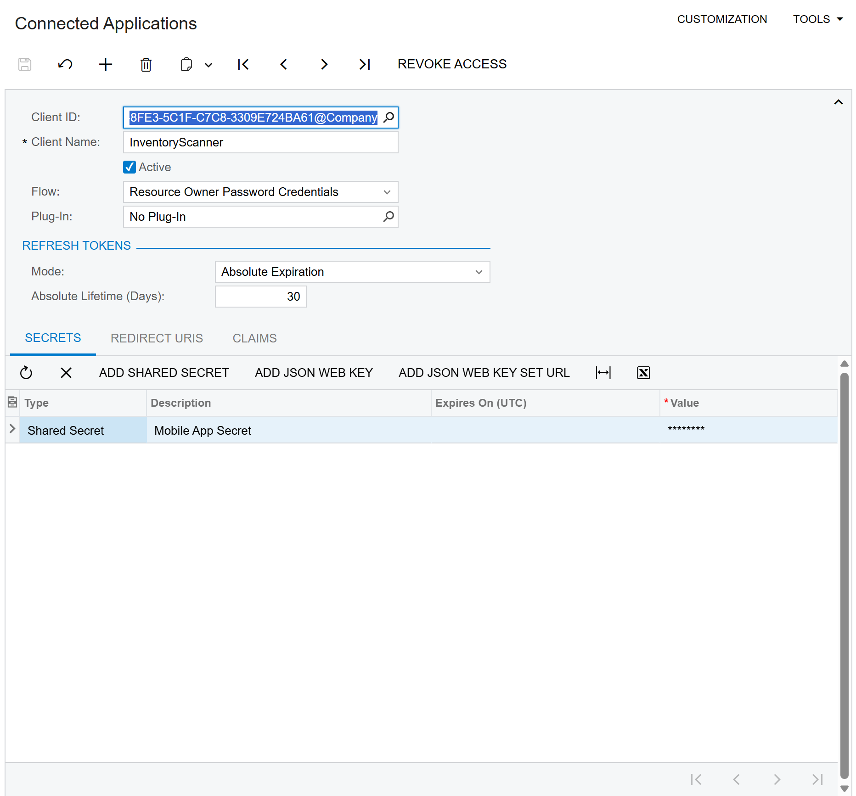
Figure 7: Adding a Shared Secret - Note the masked value in the Secrets grid

3.4. Saving Your Credentials
Step 1: Press Ctrl+S to save the Connected Application.

Step 2: Note down the following values for the mobile app:

Credential | Example
Client ID | C6ECE655-8FE3-5C1F-C7C8-3309E724BA61@Company
Client Secret | (The value you copied when creating the secret)

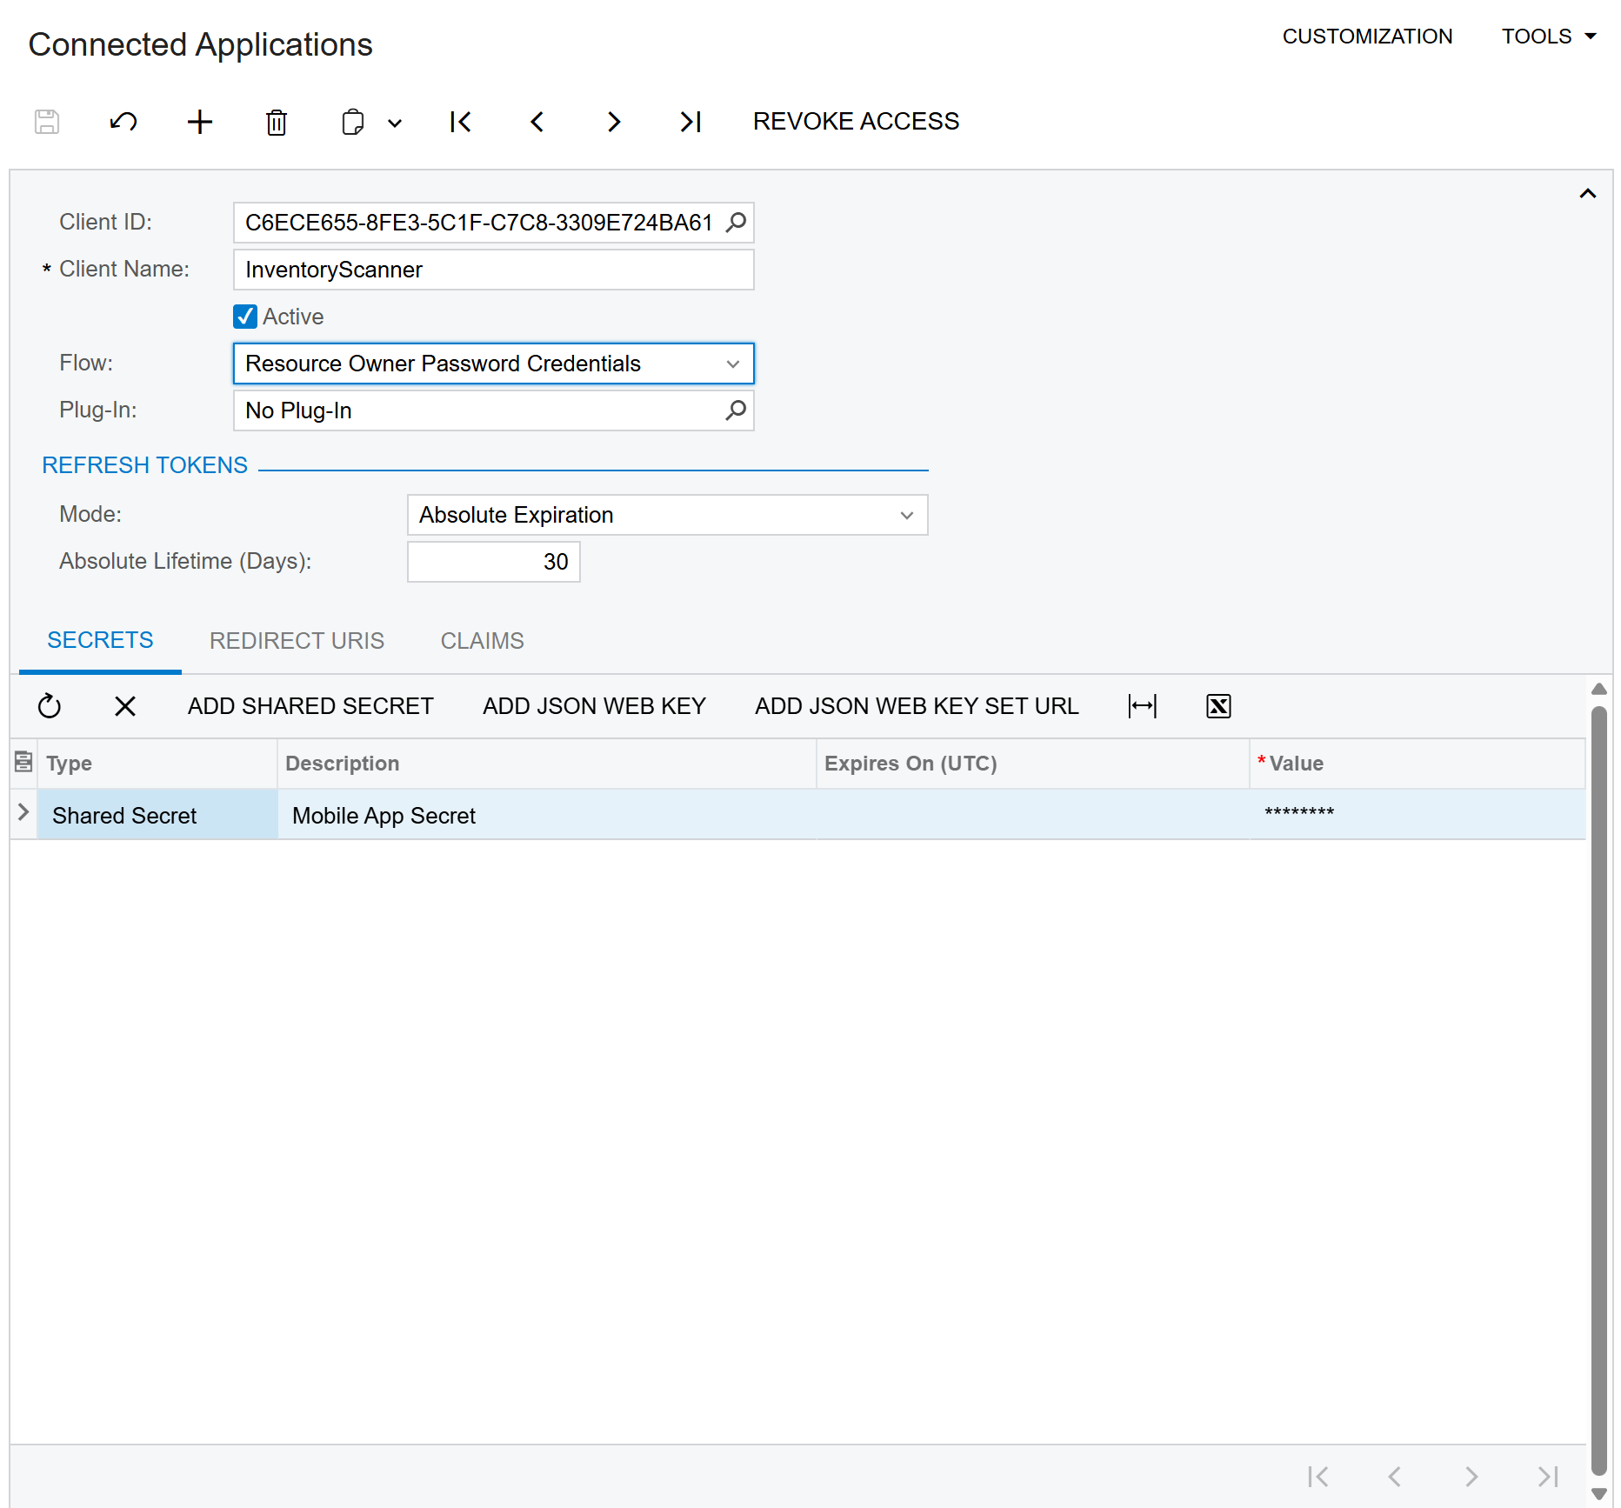
Figure 8: Completed OAuth Application with Client ID and Secret configured

4. Using the Mobile App

4.1. First Launch Setup
When you first open the app, you need to configure the connection settings:
Field | Description | Example
Instance URL | Your Acumatica site URL | https://mycompany.acumatica.com/MySite
Username | Your Acumatica username | admin
Password | Your Acumatica password | ****
Tenant | Optional - leave empty for single-tenant
API Version | From the /entity endpoint | 24.200.001
Client ID | OAuth Client ID from Step 3.4 | GUID@Company
Client Secret | OAuth Secret from Step 3.3 | your-secret-key

4.2. Scanning Barcodes
To scan inventory items:
1. Point the camera at a barcode - Position it within the scanning frame
2. Hold steady - The red scanning line indicates the detection area
3. Automatic detection - The barcode is recognized and searched automatically

4.3. Search Results
After scanning, the app displays:
• Item ID - Acumatica Inventory ID
• Description - Item description
• Availability - Current stock levels
• Warehouse Location - Where the item is stored

5. Troubleshooting
"401 Unauthorized" Error
• OAuth credentials may be incorrect or expired
• Verify Client ID and Secret in Acumatica
• Check that the Connected Application is Active

"404 Not Found" Error
• API version mismatch
• The endpoint uses StockItem, not InventoryItem
• Try a different API version from the /entity endpoint

"Connection Failed"
• Check network connectivity
• Verify the instance URL is correct
• Ensure no VPN or firewall is blocking access

Scanner Not Detecting
• Ensure camera permissions are granted
• Hold device steady with good lighting
• Barcode must be within the scanning frame

Support
Created by AcuPower LTD
Website: https://acupowererp.com
Email: support@acupowererp.com

