MINISTRY OF EDUCATION AND TRAINING

**CAN THO UNIVERSITY**

**COLLEGE OF INFORMATION AND COMMUNICATION**

**TECHNOLOGY**

**DEPARTMENT OF INFORMATION TECHNOLOGY**

**FINAL PROJECT REPORT**

**.NET PROGRAMMING (CT310H - M04)**

**SEMESTER 2, ACADEMIC YEAR: 2024-2025**



**Topic**

**CINEMA APPLICATION**

**Advisor:**

**Dr. Nguyen Nhi Gia Vinh**

**Student:**

**Truong Dang Truc Lam – B2111933**

**Le Xuan Thanh - B2111952**

**Le Anh Quan - B2105684**

**Tran Trung Nguyen - B211199**

***Can Tho, 3/2025***

**TABLE OF CONTENTS**

INTRODUCTION 3

1. Problem Description 3

2. Object 3

3. Research Scope 3

4. Research Method 3

MAIN CONTENTS 4

I. Requirement Specification 4

1. Functional Requirements 4

2. Non-Functional Requirements 4

II. Database 5

III. Task Assignment 7

IV. Result 8

1. Login Form 8

2. Staff Forms 10

2.1. General Design 10

2.2. Booking Preparation 11

2.3. Booking Confirmation 15

3. Admin Forms 16

3.1. Admin Dashboard 16

3.2. Movies Management 17

3.3. Showtimes Management 20

CONCLUSION 23

1. Result 23

2. Development Orientation 23

REFERENCES 24

**TABLE OF IMAGES**

Figure 1: Database Diagram 5

Figure 2: Login Form 9

Figure 3: Login attempt has success 9

Figure 4: Login attempt has failed 10

Figure 5: Booking Form 11

Figure 6: Seat category filters 11

Figure 7: Select movie information 12

Figure 8: The movie that has not been scheduled for showtime yet 12

Figure 9: Select seats for booking 13

Figure 10: Apply discount for booking 14

Figure 11: Refresh booking data 14

Figure 12: Summary section before booking 15

Figure 13: The Ticket after booking 16

Figure 14: Admin Dashboard 17

Figure 15: Movies Management Form 17

Figure 16: Prepare to add a new movie 18

Figure 17: The added movie 18

Figure 18: The updated movie 19

Figure 19: Prepare to delete a movie 19

Figure 20: The movie has been deleted 19

Figure 21: Showtimes Management Form 20

Figure 22: Added new showtime 20

Figure 23: The result after added new showtime 21

Figure 24: Edited a showtime 21

Figure 25: Prepare to delete a showtime 22

Figure 26: Deleted a showtime 22

# INTRODUCTION

## 1. Problem Description

Cinemas often need a simple and efficient system to manage movie screenings, seat bookings, and customer reservations. Traditional methods often cause problems like double bookings, slow payments, and difficulty in updating seat availability. A better system is needed to make the process smoother for both staff and customers.

With our system, Cinema staff can help customers by selecting movies, showtimes, and seats. The system should update seat availability to prevent overbooking. Staff should also be able to apply discounts and process payments easily.

Different staff members will have different levels of access. Administrators can manage movie schedules, choose theaters for screenings, and handle other settings, while regular staff focus on bookings. The system must also be secure, protecting customer data and ensuring safe payments.

## 2. Object

The application allows users to browse movies, select showtimes, and book seats while applying discounts and choosing payment methods. It also includes employee management with role-based access control for administrators and staff.

The application is designed for Cinema staff to efficiently manage movie screenings, handle seat reservations, process customer bookings, and assist with payment transactions. Administrators have access to system-wide controls, including movie scheduling and theater management.

## 3. Research Scope

Application Development Platform: Windows Forms (WinForms) [1]

Database Management System: Microsoft SQL Server (T-SQL) [2]

## 4. Research Method

This research will focus on building a Cinema management system using Windows Forms (WinForms) and Microsoft SQL Server (T-SQL). First, we study existing booking systems [3-5] to understand common problems and requirements. After that, we will design and develop a simple prototype with a user-friendly interface and a well-organized database.

# MAIN CONTENTS

## I. Requirement Specification

### 1. Functional Requirements

* **User Roles and Access**
  + Admins manage movie schedules and choose theaters for movies.
  + Staff handle seat bookings, apply discounts, and process payments.
* **Movie and Showtime Management**
  + Add, edit, or remove movies.
  + Schedule movies with showtimes and theaters.
  + Prevent double bookings in the same theater.
* **Seat Reservation and Booking**
  + Select and lock seats during booking.
  + Prevent overbooking and release unpaid seats.
* **Payment and Discounts**
  + Apply promotions and membership discounts.
  + Support multiple payment methods.

### 2. Non-Functional Requirements

* **Security**
  + Role-based access control for admins and staff.
  + Secure customer and payment data.
* **Performance**
  + Real-time seat availability updates.
  + Fast and smooth booking process.
* **Reliability**
  + Ensure accurate booking records.
  + Prevent system crashes during peak times.

## II. Database

We will use Microsoft SQL Server (T-SQL) to create the database for our Cinema. First, we will design tables for employee, movies, showtimes, seats, bookings,... Each table will have the necessary columns, such as movie title, showtime, theater name, seat number, and payment status. The database will be optimized to update seat availability and prevent double bookings. Finally, we can test our database by adding sample data and checking if the booking process works correctly.This database structure is shown in Figure 1.

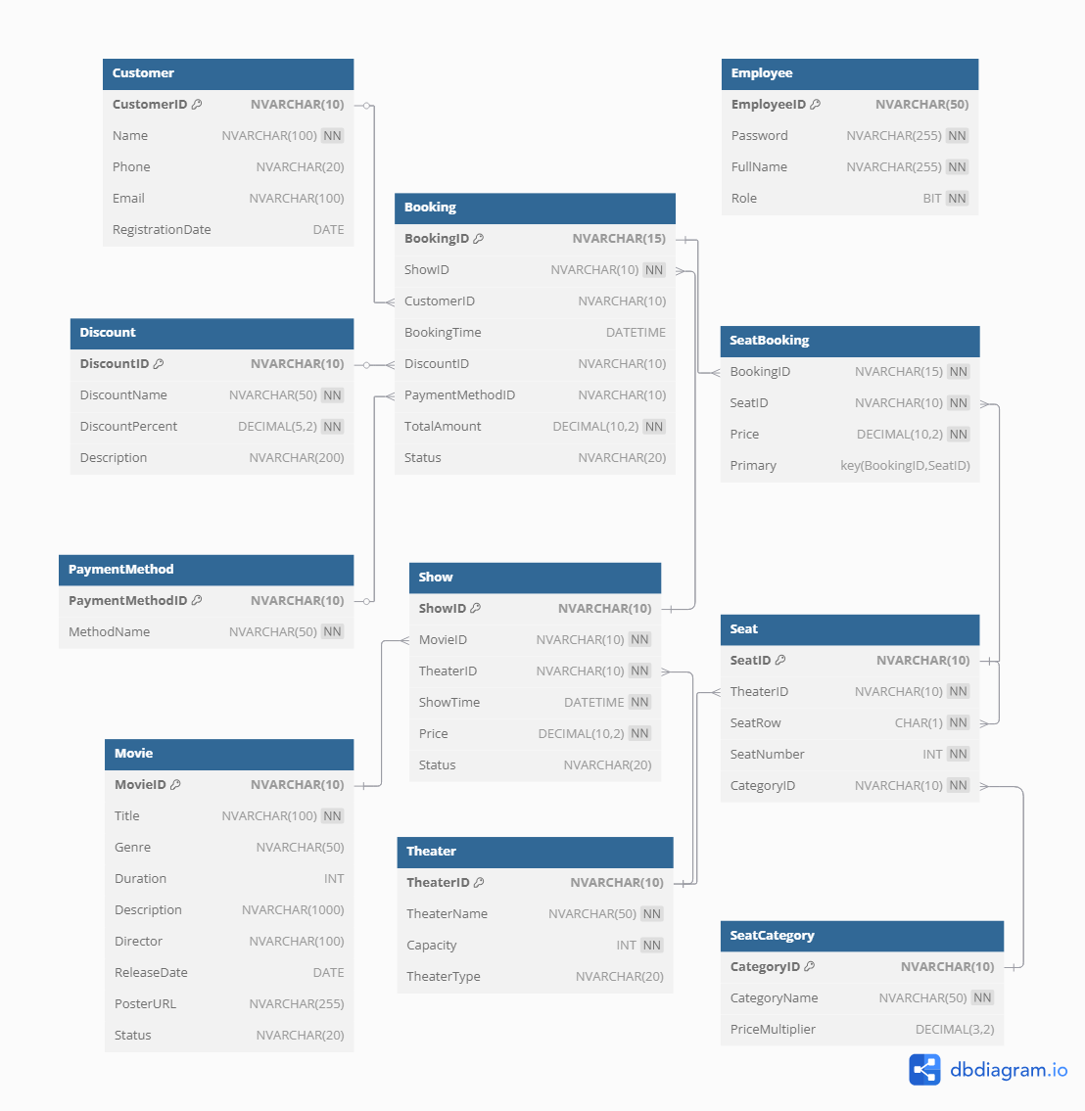

Figure 1: Database Diagram

The following sections describe each table in **CinemaDB**, explaining its purpose and key attributes:

* Movie Table: The Movie table stores information about films shown in the Cinema. Each movie has a unique ID, a title, and details such as genre, duration, description, director, and release date. It also includes a poster URL for display purposes. The status field indicates whether the movie is currently active or not.
* Theater Table: The Theater table keeps track of all Cinema halls. Each theater has a unique ID, a name, and a seating capacity that defines how many people it can accommodate. The theater type specifies whether it is a standard or special type of theater.
* Show Table: The Show table represents movie screenings in specific theaters. Each show has a unique ID and is linked to a movie and a theater. It also contains the scheduled showtime, ticket price, and status to indicate if the show is currently available.
* SeatCategory Table: The SeatCategory table classifies seats into different categories. Each category has a unique ID, a name, and a price multiplier. The price multiplier adjusts the ticket price based on the category of the seat.
* Seat Table: The Seat table stores seating arrangements for each theater. Each seat has a unique ID and is assigned to a specific theater. It includes details like row letter, seat number, and category ID, which determines the seat price.
* Discount Table: The Discount table contains promotional discounts. Each discount has a unique ID, a name, a discount percentage, and a description explaining the offer. This helps customers get reduced ticket prices under certain conditions.
* PaymentMethod Table: The PaymentMethod table lists different ways customers can pay for bookings. Each payment method has a unique ID and a name, such as "Credit Card" or "Cash."
* Customer Table: The Customer table stores details of registered customers. Each customer has a unique ID, name, phone number, email, and a registration date, which is set automatically when they sign up.
* Booking Table: The Booking table records movie ticket reservations. Each booking has a unique ID and links to a show and a customer. It also stores the booking time, any applied discount, payment method, total amount paid, and booking status.
* SeatBooking Table: The SeatBooking table tracks which seats are reserved in a booking. Each record links a booking ID with a seat ID and includes the price paid for that specific seat.
* Employee Table: The Employee table stores information about Cinema staff. Each employee has a unique ID, a password for login, a full name, and a role. The role is either a regular employee or an admin, who has higher access privileges.

## III. Task Assignment

|  |  |  |  |
| --- | --- | --- | --- |
| No. | Task Description | Member(s) | Progress |
| 1 | Initialize the project | Truong Dang Truc Lam | 100% |
| 2 | Design the database | Le Anh Quan (primary) | 100% |
| Truong Dang Truc Lam | 100% |
| 3 | Develop the Login Form | Le Xuan Thanh | 100% |
| 4 | Design the Staff Forms | Le Anh Quan (primary) | 100% |
| Le Xuan Thanh | 100% |
| 5 | Design the Admin Forms | Tran Trung Nguyen | 100% |
| 6 | Code review and remove conflicts | Truong Dang Truc Lam | 100% |

## IV. Result

Our Cinema management application will allow staff to handle movie scheduling, seat reservations, and customer bookings efficiently. Role-based access will ensure that admins can manage schedules, while staff focus on reservations and payments, keeping the workflow organized.

* Administrators can add, edit, or remove movies, set showtimes, and assign theaters, ensuring accurate scheduling.
* Staff members can select seats, lock them during booking, and process payments while applying discounts. The system updates seat availability in real-time to prevent double bookings.

Our Cinema application will also support multiple payment methods and promotions, making transactions flexible for customers. A ticket layout will be generated after booking for easy reference.

This is our GitHub repository: <https://github.com/LamSut/Cinema>

### 1. Login Form

This is the login form for our Cinema management system, it is designed to allow employees to access different parts of the application based on their role. The form has two input fields: Employee ID and Password. When users enter their credentials and click on the Login button, the system will verifiy the details by checking the SQL database (CinemaDB).

The verification is done using the GetUserRole method, which runs an SQL query to check the Employee table. If the credentials match an entry in the database, the system retrieves the user's role:

* If the role is 0, the user is a regular employee. The system opens the SeatsForm window, which likely manages seat bookings or seating arrangements.
* If the role is 1, the user is an admin. The system opens the AdminMainForm, giving access to administrative functions.
* If the credentials are incorrect or do not exist in the database, an error message is displayed informing the user that the login attempt has failed.

Last but not least, when the login form is closed, the entire application will automatically exit to prevent unauthorized access. This is for ensuring security and proper application flow.

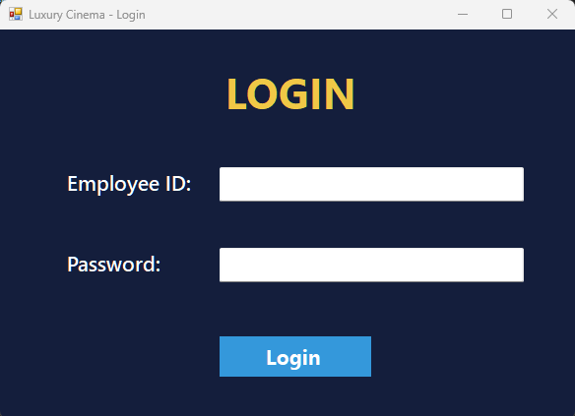

Figure 2: Login Form

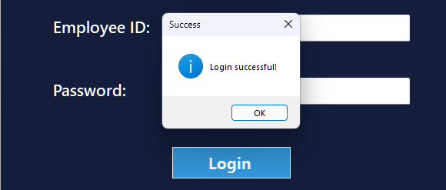

Figure 3: Login attempt has success

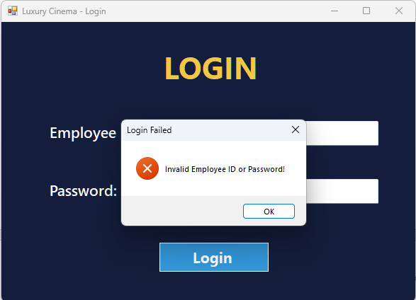

Figure 4: Login attempt has failed

### 2. Staff Forms

#### 2.1. General Design

The BookingForm is designed for Cinema staff to manage the booking process, including seat selection, ticket pricing, and booking confirmation. It connects to the CinemaDB database to retrieve real-time information about available seats, ticket prices, showtimes, and theaters. The form provides an intuitive and structured layout to ensure that staff can efficiently assist customers in booking their seats.

When the form loads, it will initialize seat categories, ticket pricing and a dynamic seat layout. The seating arrangement consists of 8 rows, labeled A to H, with 16 seats per row. These seats of our Cinema are divided into three sections: the left section with 4 seats per row, the center section with 8 seats per row, and the right section with 4 seats per row. Each seat belongs to a specific pricing category and it is colored for easy identification:

* Standard Seats – Blue (regular pricing)
* Premium Seats – Green (higher pricing)
* VIP Seats – Purple (most expensive category)
* Booked Seats – Red (cannot be selected)

The system ensures that booked seats are disabled to prevent double booking. When staff selects an available seat, it changes color to indicate selection, and the total price updates automatically based on the seat type. If a seat is deselected, the system reverts it to its original category color and recalculates the price accordingly.

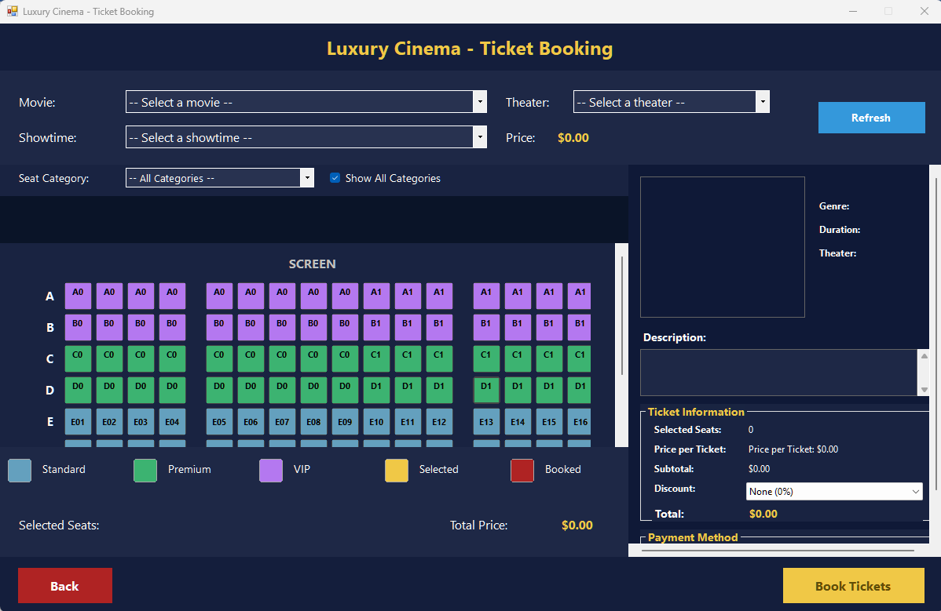

Figure 5: Booking Form

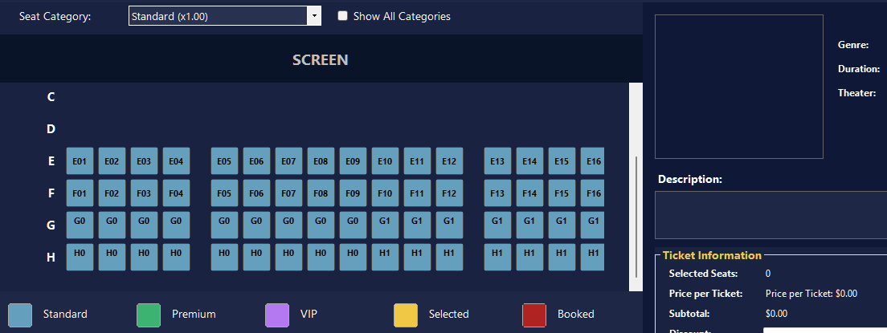

Figure 6: Seat category filters

#### 2.2. Booking Preparation

The movie selection panel allows staff to choose a movie, theater, and showtime before selecting seats. Once a movie is selected, the system displays detailed information, including the movie title, genre, duration, and description. A movie poster is also displayed, either retrieved from an online source or shown as a placeholder if unavailable. Based on the selected movie, the system loads the available showtimes and theaters. If a theater is selected, the seating layout is updated to reflect the correct seating arrangement and pricing details.

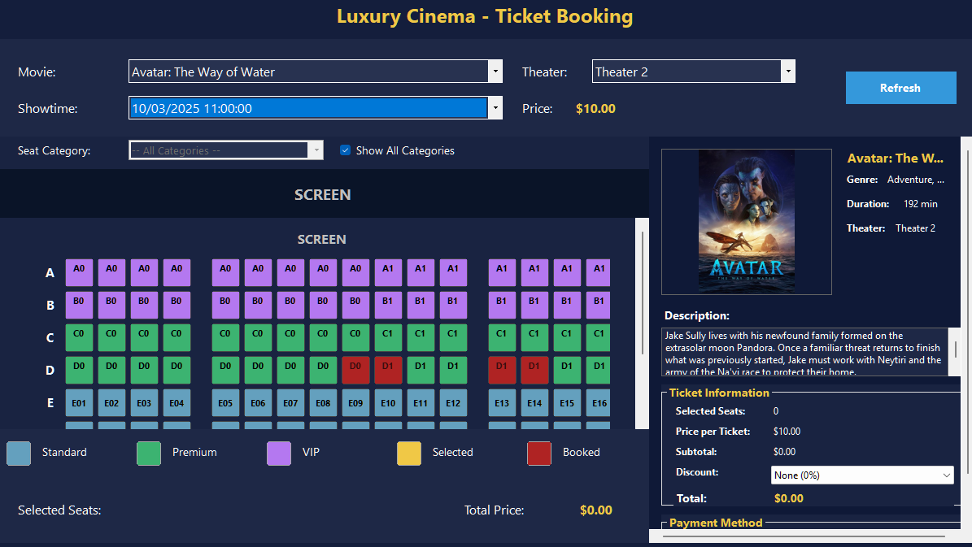

Figure 7: Select movie information

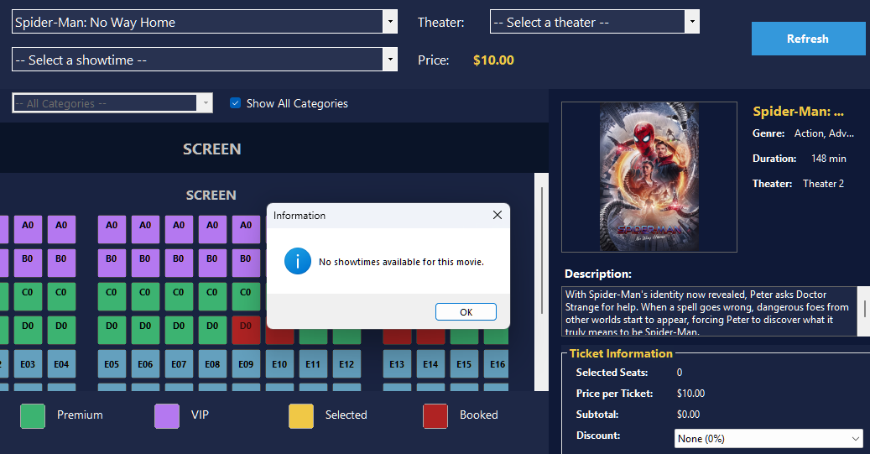

Figure 8: The movie that has not been scheduled for showtime yet

Cinema staff can click on any available seat to select it, and the system will immediately update the total ticket price in real time. The price calculation is based on the selected seat categories, ensuring that each seat type Standard, Premium or VIP is charged correctly. If a staff member deselects a seat, the system automatically removes it from the selection and recalculates the total price, preventing any errors in billing. This allows for a flexible booking process, where staff can adjust selections without the need for manual recalculations.

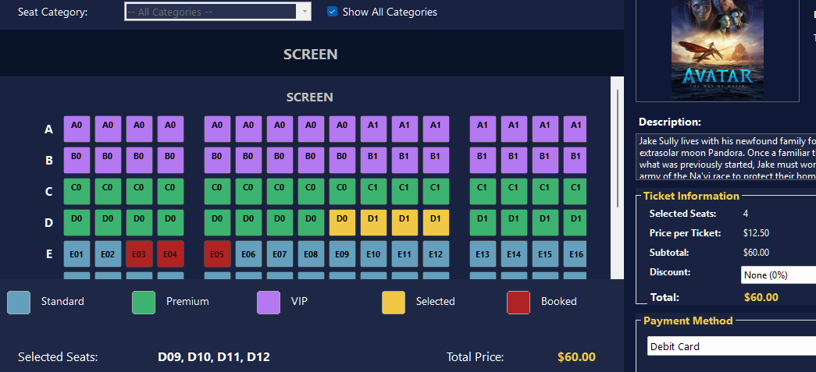

Figure 9: Select seats for booking

To further enhance the booking experience, the system includes a discount feature that allows staff to apply various promotional offers. Discounts can be applied for specific groups, such as students, seniors, or loyalty program members, reducing the overall ticket cost accordingly. Once a discount is selected, the system automatically adjusts the final price, ensuring that customers receive the appropriate reductions. This feature provides a more personalized experience, allowing staff to cater to different customer needs efficiently.

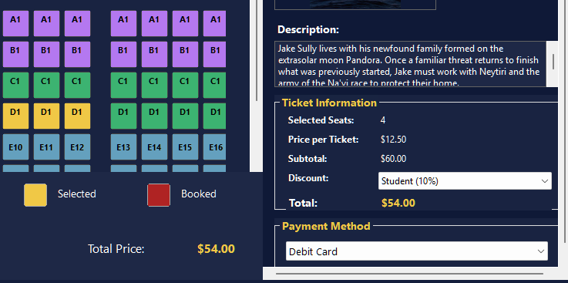

Figure 10: Apply discount for booking

If necessary, staff can refresh the booking data which will reload the latest movie listings, theaters, showtimes and seat availability. This feature is particularly useful during peak hours when seat availability changes frequently.

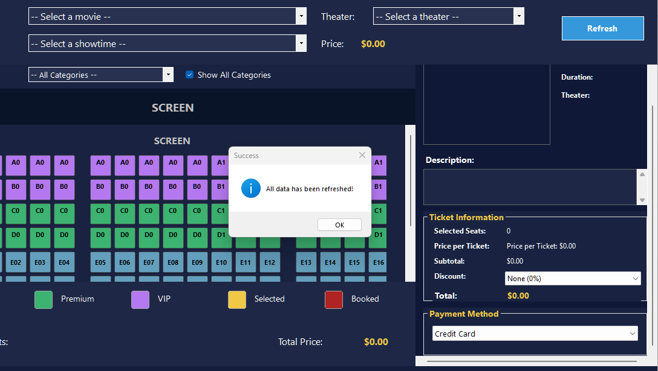

Figure 11: Refresh booking data

#### 2.3. Booking Confirmation

A summary section is included to help staff review all booking details before we finalize the transaction. This section clearly displays the selected seats, total number of tickets, applied discounts, and final price, ensuring that all information is correct before proceeding. In addition, staff must choose a payment method from available options including credit card, debit card, cash or mobile payment. By offering multiple payment options, the system ensures that customers can complete their transactions using their preferred method.

Once the booking is successfully confirmed, the system marks the selected seats as "booked" in the database, preventing any double booking or accidental selection by another customer. This ensures that seat availability is accurately reflected in the system at all times. Additionally, a movie ticket will be generated and linked to the booking information, including details such as the movie, theater, showtime, selected seats and payment method.

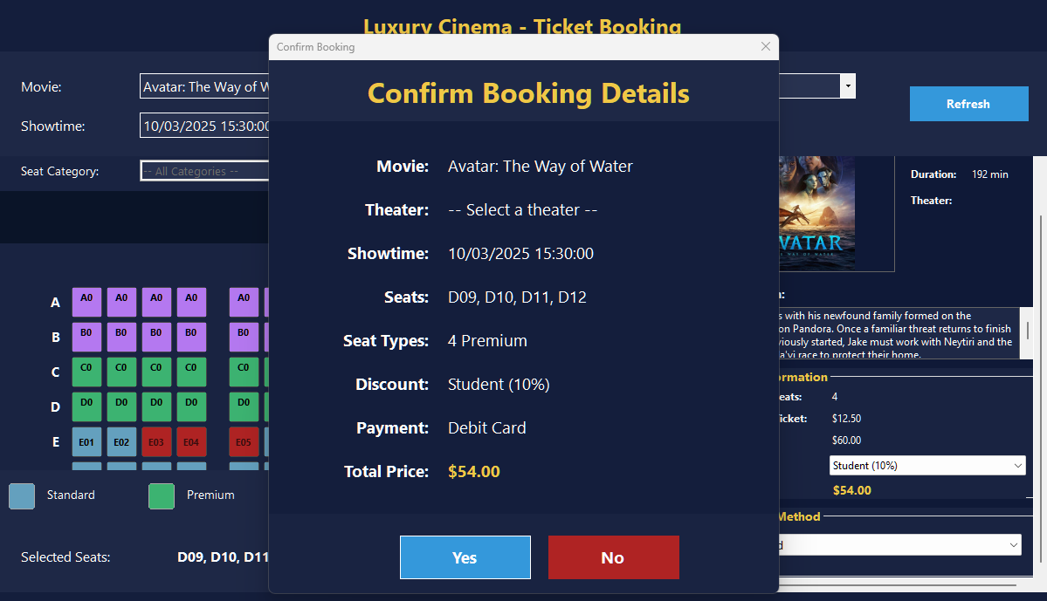

Figure 12: Summary section before booking

The generated movie ticket will contain all essential details for the customer's viewing experience. The ticket includes the **Booking ID**, ensuring a unique reference for the reservation. It also specifies the **movie title, theater name, and showtime**, providing clear information about when and where the movie will be screened. Additionally, the ticket displays the **selected seats** along with their **category**, such as Standard, Premium, or VIP, to indicate seating preferences. The **total price** of the booking is also calculated and shown, reflecting any applicable seat pricing adjustments. This ticket serves as proof of purchase and is required for entry into the theater. If needed, customers can verify their booking details through the system, ensuring a seamless and well-organized movie experience.

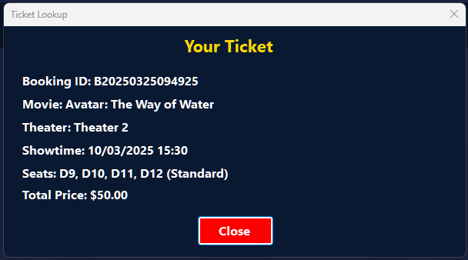

Figure 13: The Ticket after booking

### 3. Admin Forms

#### 3.1. Admin Dashboard

The AdminDashboardForm will help Cinema administrators can track some crucial business metrics. When the form initializes, it will connect to the CinemaDB database and retrieve real-time data to keep the dashboard updated. The application first counts the total number of registered customers from the Customer table and displays it on the dashboard. Then it will check the Booking table to get the total number of bookings. To calculate revenue, it will sum the total amount from completed bookings, ignoring those marked as "Cancelled".

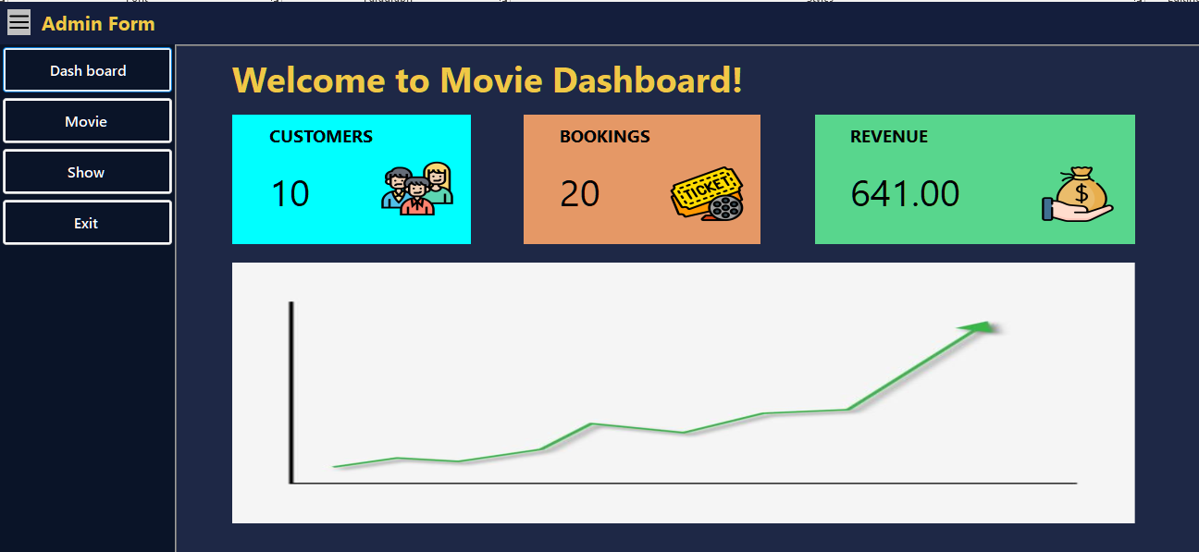

Figure 14: Admin Dashboard

#### 3.2. Movies Management

The Admin Movies Form is designed to be a tool that can help administrators manage the list of movies in the cinema system. It connects to the CinemaDB database and displays all movies in a table, showing details like the title, genre, duration, director, release date, and status. From this form, admins can add new movies, edit existing ones, or remove outdated records. When the form is opened, it will automatically load all movies from the database and present them in a neat table. This table is designed for quick navigation, filled with sortable columns and a clear layout.

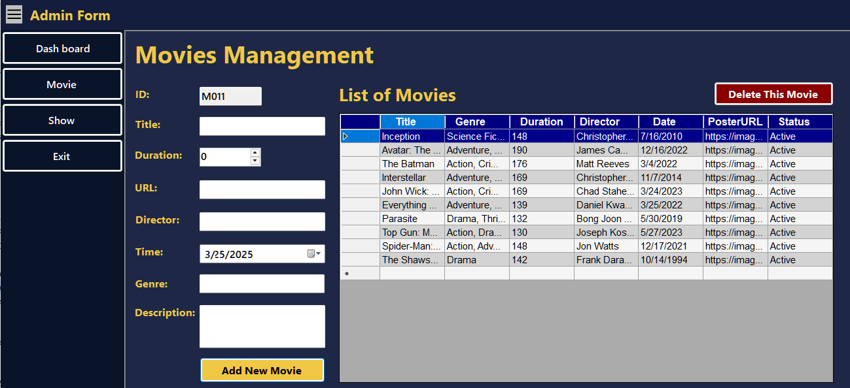

Figure 15: Movies Management Form

Adding a new movie is simple. The admin just fills in the required details such as the movie title, genre, and release date. Then he/she can click the "Add New Movie" button. If everything is correct, the movie is added to the database and appears instantly in the list. If any required information is missing, the system shows a warning to remind the user.

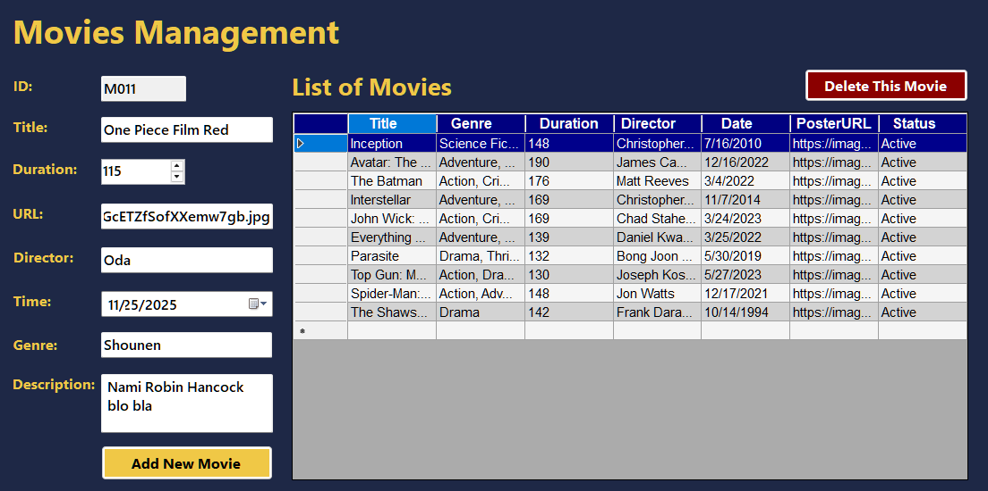

Figure 16: Prepare to add a new movie

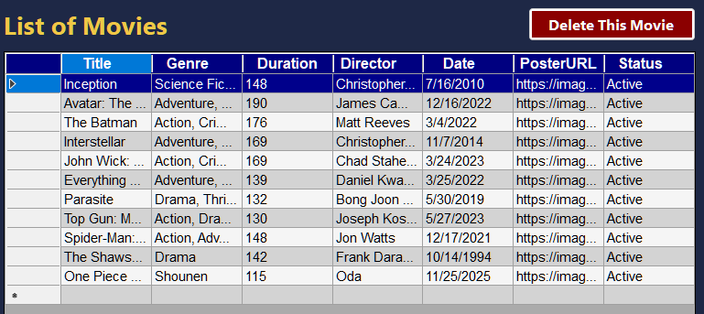

Figure 17: The added movie

Instead of opening a separate window, admins can update movie details directly in this table. When they change a value, the system checks the original data and updates the database only if something has been modified. If the update is successful, a message confirms the change.

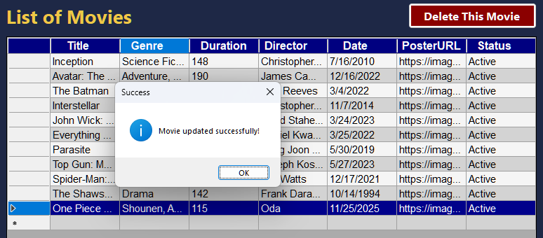

Figure 18: The updated movie

Deleting a movie requires selecting a row from the table first. When the admin click on the “Delete This Movie” button, a confirmation message will appear to prevent accidental deletions. If confirmed, the movie is removed from the database. If no movie is selected, the system reminds the admin to choose one first.

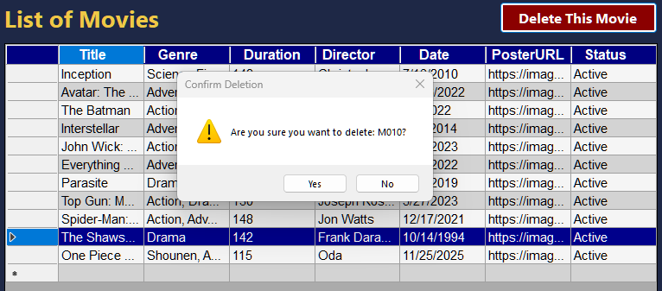

Figure 19: Prepare to delete a movie

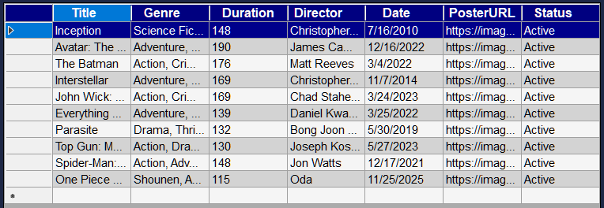

Figure 20: The movie has been deleted

#### 3.3. Showtimes Management

The Admin Shows Form is designed for admins to handle movie showtimes in our Cinema system. It will connect to the CinemaDB database and display all scheduled shows in a table. From this form, admins can add new shows, update existing ones, and delete outdated or canceled screenings. When the form loads, it will automatically retrieve all showtimes data from the database, the Movie Title field is set to read-only since they are linked to other database tables.

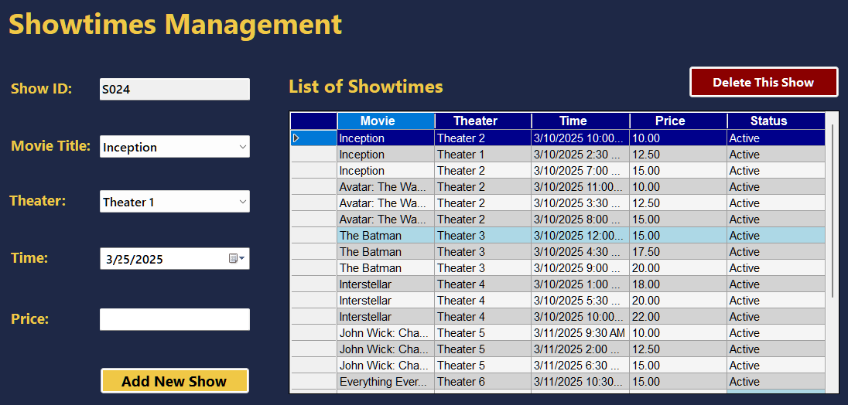

Figure 21: Showtimes Management Form

Adding a new show is straightforward. The admin selects a movie title and a theater name from dropdown lists, chooses a showtime using a date and time picker, and enters the ticket price. Clicking the "Add Show" button inserts the new showtime into the database. If everything is correct, the new showtime appears instantly in the table.

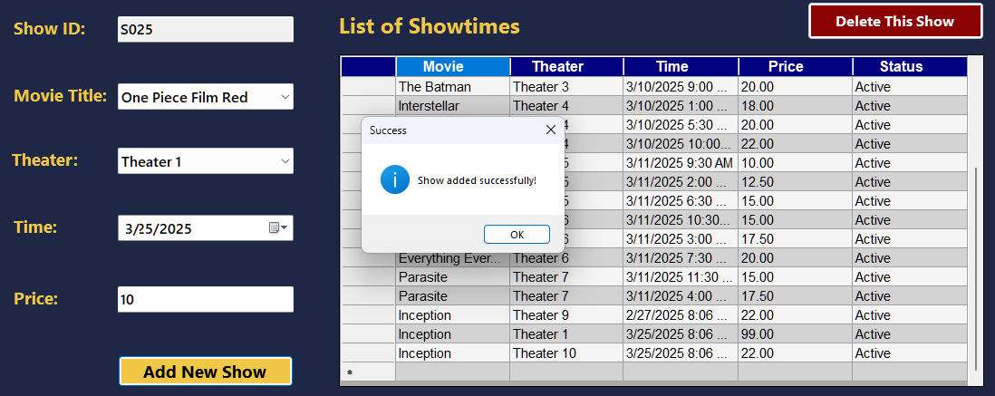

Figure 22: Added new showtime

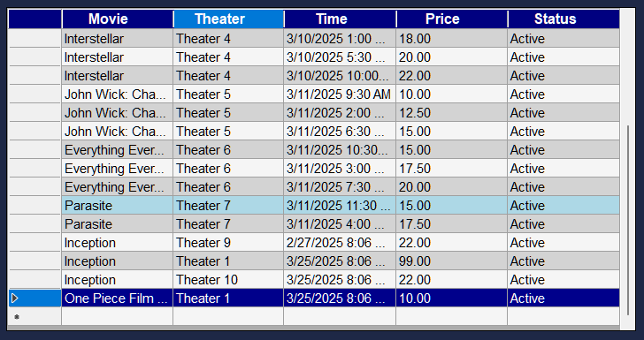

Figure 23: The result after added new showtime

Admins can also edit existing showtimes directly in the table. When a cell is modified, the system checks if the value has changed before updating the database. If an admin tries to edit a movie title or theater name directly, the system prevents changes and displays an informational message. Changes to price or showtime are validated to ensure they follow the correct format.

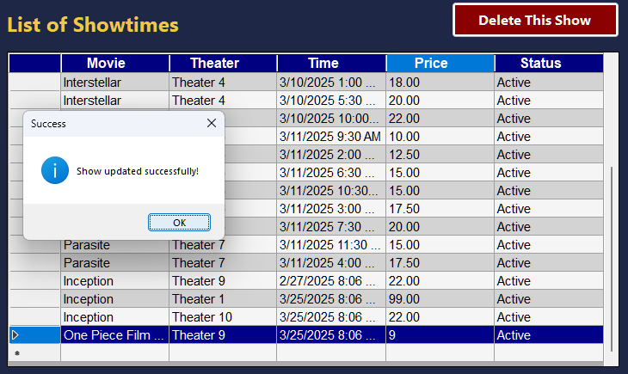

Figure 24: Edited a showtime

To delete a showtime, the admin will select a row of showlist from the table and click the "Delete This Show" button. A confirmation message appears to prevent accidental deletions. If confirmed, the system removes the show from the database. If no show is selected, the admin is prompted to choose one first.

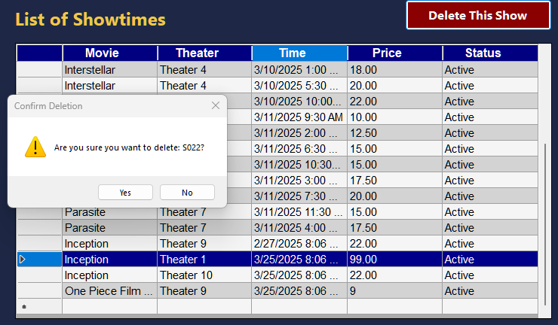

Figure 25: Prepare to delete a showtime

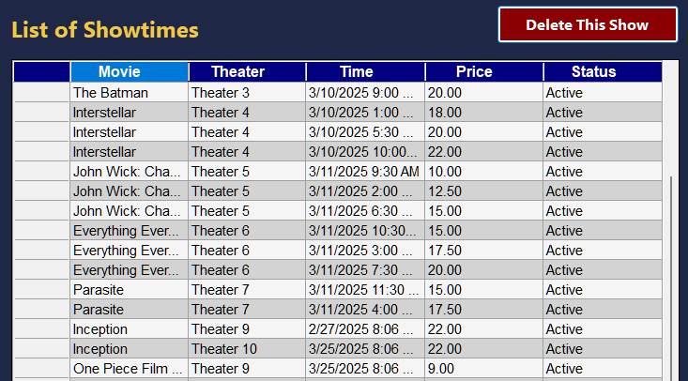

Figure 26: Deleted a showtime

# CONCLUSION

## 1. Result

The Cinema Management System can provide a well-structured and efficient platform for handling movie bookings and administrative tasks. The Booking Form ensures a smooth booking process by allowing staff to manage seat selections, apply discounts, and confirm transactions in real time. Meanwhile, the Admin Forms can empower administrators to oversee movie listings, schedule showtimes, and track business performance with ease.

By integrating real-time database updates, intuitive user interfaces, and validation mechanisms, our application will enhance the overall cinema experience for both staff and administrators. With essential features like seat management, automated pricing calculations and secure booking confirmations, our application will ensure accuracy, efficiency and a seamless workflow for Cinema operations.

## 2. Development Orientation

Moving forward, our Cinema Management System will continue to develope with new features and improvements to enhance usability and security. Future updates will focus on expanding automation, such as optimizing the booking process and streamlining seat management. Additionally, integrating an online booking system can allow customers to reserve seats directly through a web or mobile application, reducing staff workload and improving customer convenience.

To ensure scalability, our system will be optimized to handle larger databases and higher transaction volumes as the Cinema expands. Security enhancements, such as multi-factor authentication for administrators and encrypted payment processing, will be introduced to protect user data. Continuous feedback from staff and customers will also be considered to refine the system, making it more intuitive and efficient for everyday operations.

# REFERENCES

[1] **Microsoft.** "Windows Forms Documentation." Microsoft Learn. Accessed March 19, 2025. <https://learn.microsoft.com/en-us/dotnet/desktop/winforms/>.

[2] **Microsoft.** "Transact-SQL (T-SQL) Documentation." Microsoft Learn. Accessed March 19, 2025. <https://learn.microsoft.com/en-us/sql/t-sql>.

[3] Slideshare.net. 2012. Cinema Management System. Accessed March 20, 2025. <https://www.slideshare.net/slideshow/h-thng-qun-l-rp-chiu-phim/14175366.>

[4] Hasanaj, Enise, and Lavdim Beqiri. 2023. "Development of the Application for Cinema Management with .NET Technology." In UBT International Conference 2023, October 28–29. University for Business and Technology Knowledge Center. Accessed March 20, 2025. <https://knowledgecenter.ubt-uni.net/conference/IC/CS/7>.

[5] Acharya, Kamal. 2023. "A Case Study of Cinema Management System Project." SSRN. September 25, 2023. Accessed March 20, 2025. <https://ssrn.com/abstract=4841209.>