Before implementation of the front end, the first step was sketching the design and figuring out the functionality of the project application. The group decided to implement a navigation bar which would aid visitors in accessing information about movies and its actors. Considering having experience in HTML and CSS, the group used these languages with aid of JavaScript language and its library – jQuery.

The navigation bar contains 5(five) section and depending which section the visitor choose it would navigate him/her to the new page or provide additional options that link users to different section of the project.

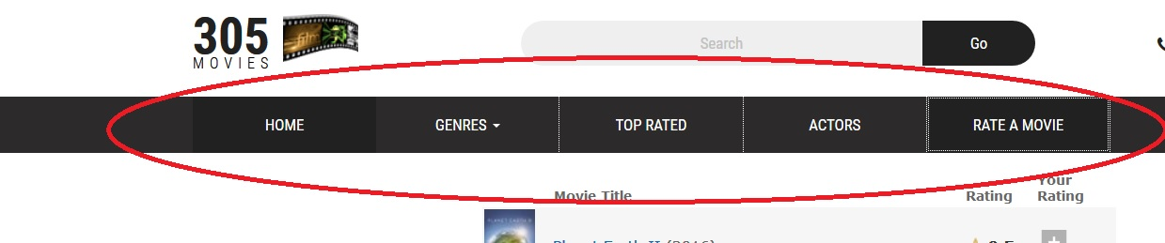

The HOME tab directs users t the main page of the project where he/she can see every available movie from the database.

The GENRES tab provides options of different genres:

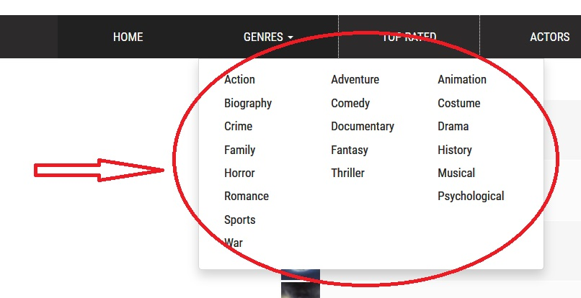

To get a drop-down menu with different options in the base HTML file the JavaScript code was added:

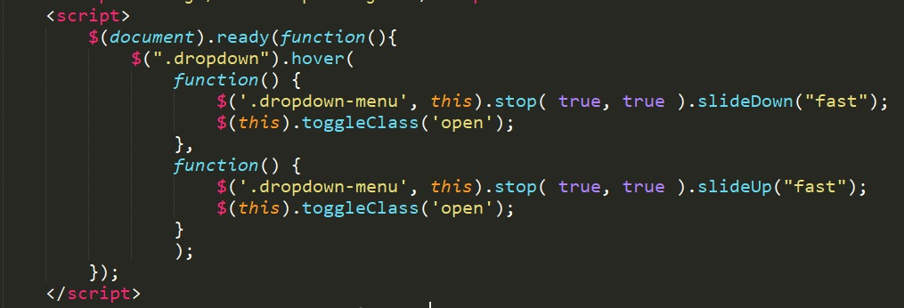

The TOP RATED tab directs user to the list of available movies in the database sorted by rating (from highest to lowest).

The ACTORS tab navigate user to the list of all actors that were casted in the movies.

The RATE A MOVIE gives an opportunity to rate the movies from the database.

After completing implementation of the navigation bar using HTML, CSS, JavaScript and jQuery, the container of the movies and actors were designed. In this case, pure HTML and CSS languages were used without any other “helper” languages: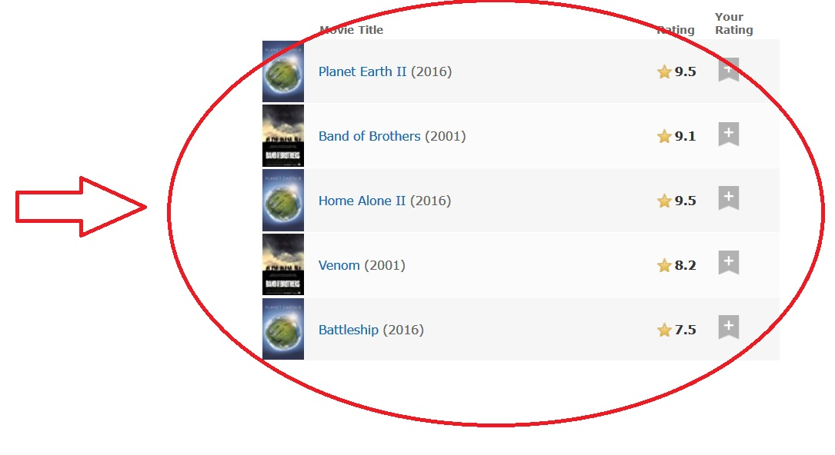

In HTML file, a structured set of data – <table> was used in conjunction with the <theads>, <tbody>, <tr> and <td> tags. The colors, font styles and icons were manyally picked and set in css files. Each movie name is the link to the movie detailed information.

Similarly, the list of actors was implemented with using HTML and CSS only:

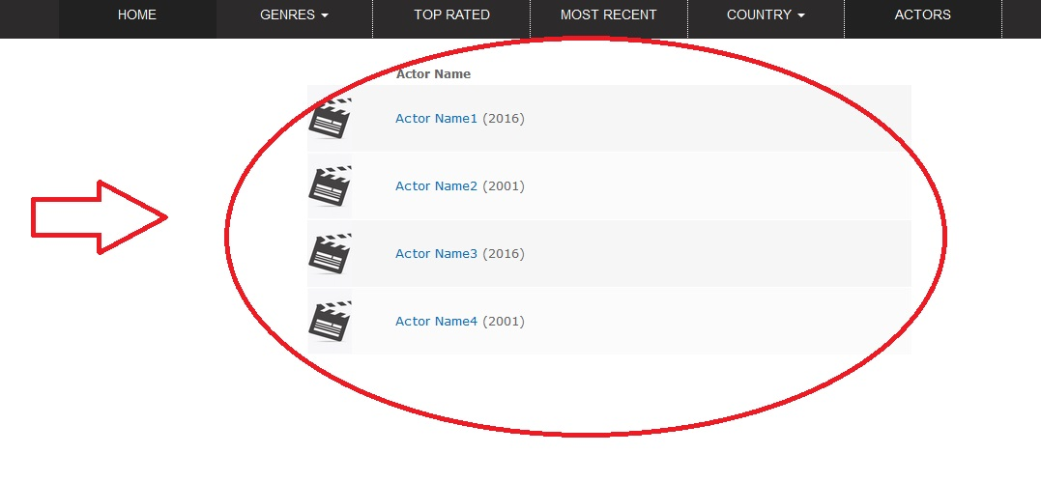

To display a detailed information about movie and its actors clean HTML and CSS language were used. Multiple division tags (<div>) were used in HTML in order to format the page and give it a pleasant look. Font format, background and images were set in CSS files.

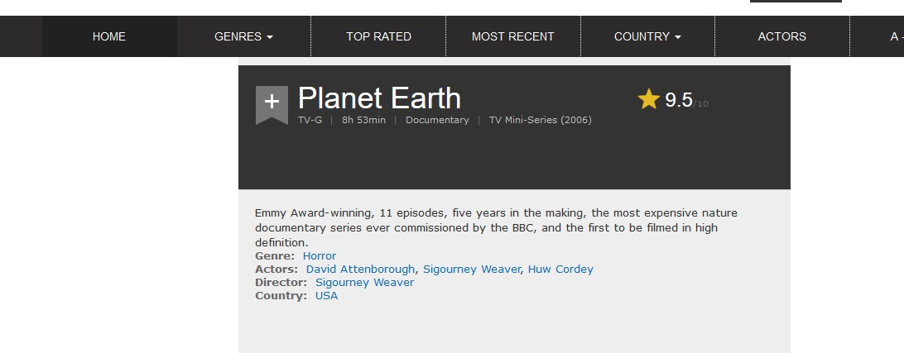

To improve the user interaction with the web application, the search bar was added at the top of every page. By typing the name of the movie in the search bar, the user can quickly navigate to that movie and read its detailed information:

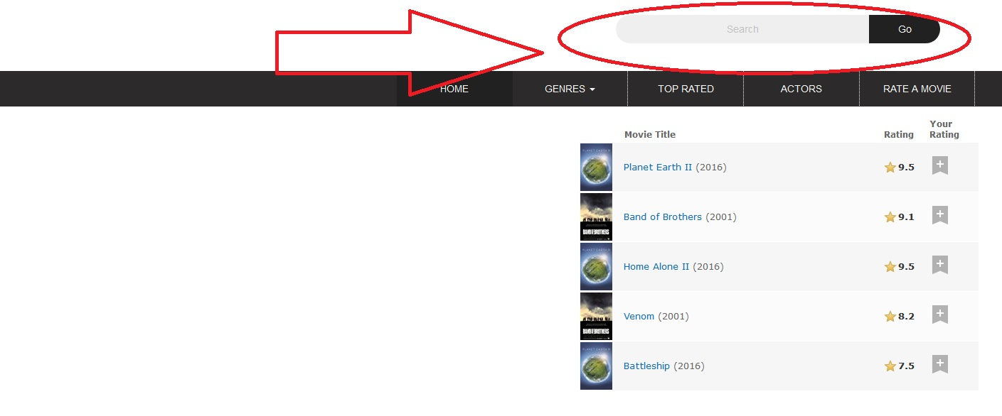

For the server configuration in addition to Apache version 2.4, Wampserver 64 was installed and used in this project.

For the database, movie_data.sql file was imported using phpMyAdmin to populate the database.