**Cytometry** **Flow**

**Report**

**Final**

|  |
| --- |
| **Specimen Information** |

**Clinical History/ICD-10 Code:**

{{ClinicalHistory}}

**Symptoms/Reason for FCM request:**

{{SymptomsReason}}

**Patient Name:** {{PatientName}}

**Date of Birth/Age:** {{PatientAge}}

**Gender:** {{Gender}}

**MRN:** {{MRN}}

**External Specimen ID:** {{ExternalSpecimenId}}

**Referring Physician:** {{ReferringPhysician}}

**Institution:** {{Institution}}

**Flow Cytometry ID:** {{FlowCytometryId}}

**Requesting Pathologist:** {{RequestingPathologist}}

**Specimen Source:** {{SpecimenSource}}

**Specimen Type:** {{SpecimenType}}

**Collection Date:** {{CollectionDate}}

**Received Date:** {{ReceivedDate}}

**Report Date:** {{ReportDate}}

|  |
| --- |
| **Interpretation** |

**BONE MARROW:**

**Comment:**

|  |  |  |
| --- | --- | --- |
| **Flow Differential and population Analysis** | | |
| **Population** | **Percentage** | **Comments** |
| Lymphocytes | 17% |  |
| Hematogones | 1% |  |
| Granulocytes | 67% |  |
| Blasts | 1% |  |
| Monocytes | 8% |  |
| CD45- | 6% |  |
| viability | 95% |  |

**Images/Histograms:**

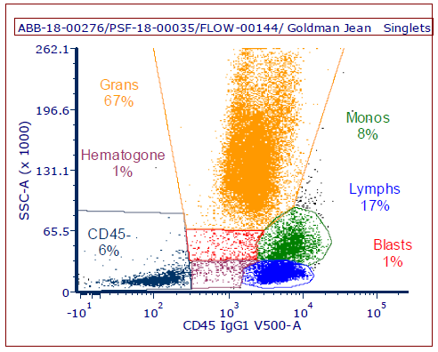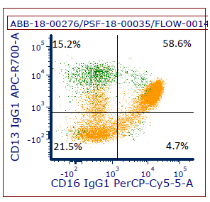

|  |
| --- |
| **Methodology** |

Flow Cytometric Testing was performed using 10 Color Flow Cytometry Panel for acquisition and analyzed using FCS Express.  FCS Express is an analysis tool for flow cytometry data. De Novo Software has produced FCS Express IVD under all relevant requirements of 21 CFR §820 “Quality Systems Regulations”. FCS Express is a powerful tool for analyzing Flow Cytometry data. Antibodies vary in their degree of lineage specificity, and because many leukemias lack one or more antigens expected to be present on normal cells of a lineage, it is recommended that a certain degree of redundancy be built into a panel used for leukemia phenotyping.

**Antibodies used (CDs):** CD1a, CD2, CD3, CD4, CD5, CD7, CD8, CD10, CD11c, CD13, CD14, CD15, CD16, CD19, CD20, CD23, CD30, CD33, CD34, CD38, CD45, CD56, CD57, CD64, CD71, CD117, TCR a/b, TCR g/d, KAPPA, LAMBDA, HLA-DR (31 Markers).

**Morphologic Correlation:**

N/A

**Electronically Signed by {{firtName}} {{lastName}}, M.D. on {{signedDate}} at ALTA BATES – Anatomic Pathology**

, M.D.