Table of Contents

目录
Table of Contents 1
1. Project Management 4
1.1. Version Control 4
1.2. People Involved 5
1.3. Relevant documentations 6
2. Introduction 6
2.1. Key terms and definitions in PRD 7
2.2. Background and Objectives 7
2.3. Requirement Summary 7
2.4. Measurement of product success 8
3. Scope of Requirements 8
3.1. System performance expectations (Optional) 8
3.2. Product architecture/framework (Optional) 8
3.3. State machine definitions and flow (Optional) 8
3.4. Backward compatibility(optional) 8
3.5. Front End Flow (App) 9
3.5.1. FE user flow 9
3.5.2. Edge cases & how to handle them 9
3.5.3. Country specific differences 9
3.6. Front End Tracking (App) (Optional) 9
3.7. Front End Flow (Admin) 9
3.8. Back End Flow 9
3.8.1. Message Processing Sequence（Phase 1） 9
3.8.2. Common Checks Flow 15
3.8.3. Network Management Message Processing（Phase 1） 35
3.8.4. Authorization Message Processing 51
3.8.5. Authorization Finality（Phase 1） 68
3.8.6. Advice Message（Phase 1） 69
3.8.7. Authorization Reversal Message Processing 71
3.8.8. Authorization Expiry Handling（Phase 2） 74
3.8.9. Card Digitization (Tokenization)（P3） 75
3.8.10. DWH Requirement（Not Phase 1） 76
3.8.11. Admin Portal 77
3.8.12. Notification Message（Phase 2） 79
3.8.13. Issuer File Update(P3) 81
3.8.14. Manual Adjustment(P4:2023-11-02) 83
3.8.15. Error Code and Response Code Mapping 84
3.9. Security Requirements 84
3.9.1. User Access Matrix 84
3.9.2. Audit Log 84
3.10. Monitoring and Alarms 84
3.10.1. Monitoring Item 84
3.10.2. Alarm Template 84
3.11. Data Design 84
3.12. Transaction Signing 84
4. Rollout plan 84
4.1. Country roll-out plan 84
4.2. Production operation plan 84
5. Other requirements 84
5.1. Financial Risk Assessment 84
6. Risk and Mitigation 84
6.1. Risk Assessment Metrics 84
6.2. Risk and Impact Considerations 85
6.3. Risk Assessment 85
6.4. Additional Security Measures 85
6.4.1. System Activity Logging 85
6.4.2. Security Event Tracking and Exception Handling 85
7. Appendix 85

Project Management

Version Control

People Involved

Relevant documentations

Introduction

Key terms and definitions in PRD
Term | Explanation
ATM | Automated Teller Machine
CBS | Core Banking System
CMS | Card Management System
RBA | Risk Based Authentication
API | Application Program Interface
OTP | One Time Password
ACS | Access Control System
PIN | Personal Identification Number
ASI | Account Status Inquiry
HSM | Host Security Module
MTI | Message Type Identifier
SG | Singapore
CVC | Card Verification Code
UCAF | Universal Cardholder Authentication Field
ARQC | Authenticate request cryptogram
DCC | Dynamic Currency Conversion

Background and Objectives

Requirement Summary

Measurement of product success

Scope of Requirements

System performance expectations (Optional)

Product architecture/framework (Optional)

State machine definitions and flow (Optional)

Backward compatibility(optional)

Front End Flow (App)

FE user flow

Edge cases & how to handle them

Country specific differences

Front End Tracking (App) (Optional)

Front End Flow (Admin)

Back End Flow

Message Processing Sequence（Phase 1）
ISO 8583 messages have a specific format consisting of fixed-length fields and variable-length fields. The message begins with a Message Type Indicator (MTI) that indicates the purpose and type of the message.
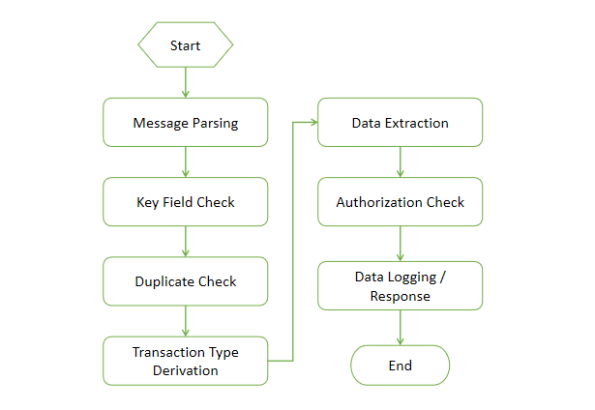

Message Parsing
Message Length: The first few bytes of the message typically represent the length of the entire message, including the header and data.

Field Definition: ISO 8583 defines a set of standard fields, each identified by a numeric field number. The field definition specifies the length, data type, and other characteristics of each field.

Field Extraction: The parser reads the message and extracts the fields based on their positions and lengths. The field extraction process involves identifying the field boundaries and copying the data into separate variables or structures for further processing.

Data Conversion: The extracted field values may need to be converted from their binary or character representations into the appropriate data types, such as numeric values or ASCII strings. The data conversion ensures that the extracted data can be easily manipulated and understood.

Field Interpretation: Each field within the ISO 8583 message carries specific information related to the transaction. The parser interprets the extracted field values based on the field definitions and the context of the message. For example, field 4 may represent the transaction amount, and field 48 may contain additional data related to the transaction.

Error Handling: During the parsing process, the parser should handle any errors or inconsistencies encountered in the message. This includes validating field lengths, checking for missing or unexpected fields, and verifying the integrity of the message structure. Error handling ensures the reliability and correctness of the parsed data.

Mandatory Field Check
After the message is successfully unpacked, Authorization system will perform the below field validations. If any field check failed, Authorization system will stop the process and revert to MC with corresponding response code.
Message Fields | Checking rules | Rejection Reason Code | Response Code (DE39) | Additional Response Data (DE44)
Card Number (DE2) | Not present (to CMS) or not a numeric type or all zeros | A00001 | 30 | 002
 | Length greater than 16 digits | A00001 | 30 | 002
 | If [Track2 data (DE35)] is present , but the "card number" in the track does not match the [card number (DE2)] in the interface message | A00001 | 30 | 002
 | If [Track1 data (DE45)] is present , but the "card number" in the track does not match the [card number (DE2)] in the interface message | A00001 | 30 | 002
Processing Code (DE3) | Not present or not in numeric type/form | A00002 | 30 | 003
 | If the first digit of the TCC usage (transaction code) of [Private Additional Data (DE48)] is "P" and [Processing Code (DE03)] is not "28" | A00002 | 30 | 003
Transaction Amount (DE4) | Not present or not in numeric type/form | A00003 | 30 | 004
 | All 0 except for inquiries for the following transactions:  Account Status Inquiry – [POS Transaction Status (DE61 SF7) is "8"] | A00003 | 30 | 004
Cardholder Billing Amount (DE6) | Not present or not in numeric type | A00004 | 30 | 006
Transaction Transmission Date and Time (DE7) | Not present or not in numeric type | A00005 | 30 | 007
 | Date/time format not “MMDDhhmmss” | A00005 | 30 | 007
Cardholder Billing Conversion Rate (DE10) | [Cardholder Billing Amount (DE6)] is present, but [Cardholder Billing Conversion Rate (DE10)] is not present | A00006 | 30 | 010
System Audit Trace Number (DE11) | Not present or not in numeric type or All 0s | A00007 | 30 | 011
Local Transaction Time (DE12) | If present and time format not “hhmmss” | A00020 | 30 | 012
Local Transaction Date (DE13) | If present and date format not “MMDD” | A00021 | 30 | 013
Card Expire Date (DE14) | If present and date format not “YYMM” | A00008 | 30 | 014
 | [Card expiry date (DE14)] and [Track2 data (DE35)] are present, but the "Card expire date" in Track2 does not match the [Card expire date (DE14)] in the interface message | A00008 | 30 | 014
 | If [Card Expire Date (DE14)] and [Track1 Data (DE45)] are present and [Track2 Data (DE35)] is not present, but the "Card Expire Date" in Track1 does not match the [Card Expire Date (DE14)] in the interface message | A00008 | 30 | 014
Merchant Type (DE18) | [Message Type (MTI)] is "0100"/”0120”/”0400”, but [Merchant Type (DE18)] is not present or is a non-numeric type or all 0s | A00009 | 30 | 018
Point-of-Service (POS) Entry Mode (DE22) | Not present or not in numeric type | A00010 | 30 | 022
 | If [POS Entry Mode (DE22 SF1)] is 02/05/07/80/90/91, and [Track 2 Data (DE35) or Track 1 Data (DE45)] is not present | A00023 | 30 | 022
Acquiring Institution Identification Code (DE32) | Not present or not in numeric type | A00011 | 30 | 032
Forward Institution Identification Code (DE33) | If present and not in numeric type | A00022 | 30 | 033
Private Additional Data (DE48) | [Transaction Type Code (DE03 SF1) is 28, but [DE48 Transaction Category Code (TCC)] is not "P" | A00012 | 30 | 048
 | [Transaction Type Code (DE03 SF1) is not 28, but [DE48 Transaction Category Code (TCC)] is not "A”/ “C”/ “F”/ “H”/ “O”/ “R”/ “T”/ “U”/ “X”/ “Z” | A00012 | 30 | 048
 | If [Transaction Category Code (DE48 Position 1) is “T”, and [Track 2 data (DE35) or Track 1 data (DE45) is present | A00024 | 30 | 048000
Transaction Currency Code (DE49) | [Transaction amount (DE4)] is present, but [Transaction currency (DE49)] is not sent or 000 if present or is not a numeric type | A00013 | 30 | 049
Cardholder Billing Currency Code (DE51) | [Cardholder Billing Amount (DE06)] is present, but [Cardholder Billing Currency Code (DE51)] is not present or 00 is sent or is not a numeric type | A00014 | 30 | 051
MasterCard Trace ID (DE48 SE63) | The [Message Type (MTI)] is 0400/0420, and the [Trace ID (DE48. SE63)] is not present | A00015 | 30 | 048063
POS Data (DE61) | [POS Data (DE61)] Not present | A00016 | 30 | 061
 | If [POS Cardholder Presence (DE61 SF4) is “4”, and [Track 2 data (DE35) or Track 1 data (DE45) is present | A00016 | 30 | 061
 | If [POS Cardholder Presence (DE61 SF4) is “1”, and [Track 2 data (DE35) or Track 1 data (DE45) is present | A00016 | 30 | 061
Original Data Element (DE90) | [Message type] is 0400/0420, and [Original data element (DE90)] is not present | A00017 | 30 | 090
Replacement Amounts (DE95) | [Message Type (MTI)] is 0400/0420, and [Actual Transaction Amount (DE95 SF1)] is greater than or equal to [Transaction Amount (DE4)]. | A00018 | 30 | 095
 | [Message Type (MTI)] is 0400/0420, and [Actual Transaction Amount (DE95 SF1)] is greater than 0 and ([Actual Cardholder Billing Amount (DE95 SF3)] is not sent up or is not a number or is 0) | A00018 | 30 | 095
Advice Reason Code (DE60 SF1) | [Message Type (MTI)] is 0420, if [Advice Reason Code (DE60. SF1)] is not 400/401/402/403/409/410/413 | A00019 | 30 | 060
 | [Message Type (MTI)] is 0120, if [Advice Reason Code (DE60. SF1)] is less than 100 | A00019 | 30 | 060
 | [Message Type (MTI)] is 0120, but [Advice Reason Code (DE60 SF1)] is not 100/101/102/103/105/107/108/109/  111/112/113/114/115/116/120/121/126/  140/141/142/151/160/180/190/  191/192/200/650 | A00019 | 30 | 060
Integrated Circuit Card (ICC/Chip) System-Related Data (DE55) | The [Message Type (MTI)] is 0100 and [Transaction Type Code (DE03 SF1)] not equal 20 and [POS Entry Mode (DE22 Subfield 1) is 05/07/09/81 and [Chip Data (DE55)] is present but the following EMV tags are not present (82, 95, 9A, 9C, 5F2A, 9F02, 9F03, 9F10, 9F1A, 9F26, 9F27, 9F36, 9F37,) | A00025 | 30 | 055
Electronic Commerce Indicators (DE48 SE42 SF1 Position 1 & 2) | If DE48 SE42 is present and DE48 SE42 SF1 Position 1 & 2 is not “11”/ “12”/ “14”/ “21”/ “22”/ “91”/ “92” | A00026 | 30 | 048042
Magnetic Stripe Compliance Error Indicator (DE48 SE89) | If DE48 SE89 is present and denotes an error (value = “A”/ “B”/ “C”/ “D”/ “E”/ “F”/ “G”/ “H”/ “I”/ “J”) | A00027 | 30 | 048089

Duplicate Check
Authorization system will have duplicate check according to fields MTI, DE7, DE11, DE32, DE33,DE37(Need precise matching)(2024-01-05). If all these fields matched, this transaction should be a duplicate transaction. Authorization system will set reject reason code to ‘B00002 - Duplicate Transmission detected’ and DE39 = 94.

Transaction Type Derivation
txnType on CMS | Key Fields in Message
POS Purchase Contact Domestic | MTI=0100/0120  DE22.SF01=05  DE03.SF01=00  DE61.SF13=702
POS Purchase Contact Overseas | MTI=0100/0120  DE22.SF01=90/02/05/80  DE03.SF01=00  DE61.SF13<>702
POS Purchase Contactless Domestic | MTI=0100/0120  DE22.SF01=07  DE03.SF01=00  DE61.SF13=702
POS Purchase Contactless Overseas | MTI=0100/0120  DE22.SF01=07  DE03.SF01=00  DE61.SF13<>702
Online Purchase Domestic | MTI=0100/0120  DE22.SF01=81/10/01/09  DE03.SF01=00  DE61.SF13=702
Online Purchase Overseas | MTI=0100/0120  DE22.SF01=81/10/01/09  DE03.SF01=00  DE61.SF13<>702
MoneySend Payment Domestic | MTI=0100  DE03.SF01=28  DE18=6536  DE48.SE77=C07,C52,C53,C54,C55,C56,C57,C58,C59,C65
MoneySend Payment Overseas | MTI=0100  DE03.SF01=28  DE18=6537  DE48.SE77=C07,C52,C53,C54,C55,C56,C57,C58,C59,C65
Refund Domestic | MTI=0100  DE03.SF01=20  DE61.SF13=702
Refund Overseas | MTI=0100  DE03.SF01=20  DE61.SF13<>702
ASI For Purchase | MTI=0100  DE61.SF07=8  DE03.SF01=00
ASI For MoneySend Payment | MTI=0100  DE61.SF07=8  DE03.SF01=28  DE18=6536/6537  DE48.SE77=C07,C52,C53,C54,C55,C56,C57,C58,C59,C65
If the incoming messages can’t meet the transaction type derivation rules above, system will reject the transaction with response code 57.

Common Checks Flow

Card Activation Check（Phase 1）（Phase2）
- Activation Flag Value
Activation Flag Code | Description
NULL | Physical card not issued, only applicable for virtual card
0-Pending For Activation | Physical card issued, not activated.
1-Activated | Physical card activated.
- Activation Flag Check Steps
- If the transaction is not physical card present transaction(DE22.SF1<>05,07,02,90), bypass the card activation check.
- Check the card sequence number :
  - If the DE22.SF1=05/07, get the card sequence number from DE23.
- If DE23 neither equal the sequence number nor the last sequence number in card info, card activation check failed, exit.
- If DE23 equal the sequence number in card info , and activation flag is 1-Activated, then pass the card activation check, exit.
- If DE23 equal the last sequence number in card info , and last activation flag is 1-Activated, and the activation flag is NOT 1-Activated, then pass the card activation check,exit.
- Otherwise, card activation check failed.
  - If the DE22.SF1=02/90, get the card sequence number from DE35 or DE45(Refer to the Track1/Track2 format in card issuance).
- If the sequence number in track(DE35/DE45) neither equal the sequence number nor the last sequence number in card info, card activation check failed, exit.
- If the sequence number in track(DE35/DE45) equal the sequence number in card info , and activation flag is 1-Activated, then pass the card activation check, exit.
- If the sequence number in track(DE35/DE45) equal the last sequence number in card info , and last activation flag is 1-Activated, and the activation flag is NOT 1-Activated, then pass the card activation check,exit.
- Otherwise, card activation check failed.
- Not meet the scenario above, card activation check failed.
- An example to clarify the activation check logic:
- Note :The card renewal scenario is not in MVP

Card Status（Phase 1）
- Card Status Value
Card status value table is shown as below.
Card Status | Description
0-New | Card status when a new virtual card is opened
1-Active | When there is a transaction within 12 months
2-Stationary | When there is no transaction within 12 months
8-Closed | Card closed
- Card Status Check Steps
Card Status | Authorization Transaction Check Rules
0 - New | Pass all the transactions
1 - Active | Pass all the transactions
2 - Stationary | Pass all the transactions
8 - Closed | Decline all the debit transactions;  Moneysend Payment,Refund transactions are allowed;  Moneysend Payment ASI is allowed, the other ASI not allowed.
- Card Status Change
If card status is 2- Stationary, when authorization transaction comes in, card status will be changed to 1-Active.
In addition, regardless whether card status updated successfully or not, it will not impact the authorization transaction response.

CVC/Chip CVC（Phase 1）
This routine provides a gateway to communicate with MariBank encryption platform, to validation the Card Verification Code (CVC).
The CMS Authorization system performs the following edits on the Authorization Request/0100 message for magnetic stripe and chip transactions.
When | Then CMS Authorization system…
MTI = 0100 and  DE22_1 = 90 /05/07/02 and  DE35 is not present and  DE45 is not present | Formats and sends the Authorization Request Response/0110 where:  DE39 = 30  DE44 Length = 3  DE44 = 022
When the above pre-edits passed, the actual CVC1 validation is then performed.
- Set the CVC1 result as “Not Processed”.
- Check whether On-behalf (OB) Service 11 (CVC Pre-validation Service) is present – field will be in DE48, SE71, SF1 value 11. If the said OB service is present, then check the result from DE48, SE71, SF2 and set the corresponding CVC result and decline reason. Below table depicts the possible results:
Result (Field Value) | Result Description | Remarks
V | ‘CVC Match’ | CVC validation is successful
I | ‘Invalid CVC’ | CVC not matched
U | ‘Not Processed’ | Unable to validate CVC
K | ‘Mastercard Other Error’ | System error
Once the CVC result is set, exit the CVC routine.
- When Track 2 data (DE35) is present, ensure all fields are valid.
When | Then…
DE35.F2 (Card Number) is not numeric or  DE35.F3 (Separator) is not = (“D” and “=”) or  DE35.F4 (Expiry Date) is not numeric | Set CVC Result = “Invalid Track Data”
DE35 length is not numeric or  DE35 length is less than 32 | Set CVC Result = “Invalid Track Length”
DE35.F5 (Service Code) is not numeric or  DE35.F6 position 1 (Discretionary data - PVK Index) is not numeric or  DE35.F6 position 2-5 (Discretionary data - PVV) is not numeric or  DE35.F6 position 6-8 (Discretionary data - CVC Index) is not numeric | Set CVC Result = “Invalid Track Data”
DE35.F5 (Service Code) = ‘000’ and  DE22_1 = 90, 05, 07, 80 or 91 | Set CVC Result = “Invalid Service Code”
- When Track 1 data (DE45) is present, ensure all fields are valid.
When | Then…
DE45.F3 (Card Number) is not numeric or  DE45.F4 (Separator 1) is not = (“^” or “¬”) or  DE45.F6 (Separator 2) is not = (“^” or “¬”) or  DE45.F7 (Expiry Date) is not numeric | Set CVC Result = “Invalid Track Data”
DE45 length is not numeric or  DE45 length is less than 76 | Set CVC Result = “Invalid Track Length”
DE45.F8 (Service Code) is not numeric or  DE45.F9 position 1 (Discretionary data - PVK Index) is not numeric or  DE45.F9 position 2-5 (Discretionary data - PVV) is not numeric or  DE45.F9 position 11-13 (Discretionary data - CVC) is not numeric | Set CVC Result = “Invalid Track Data”
DE45.F8 (Service Code) = ‘000’ and  DE22_1 = 90, 05, 07, 80 or 91 | Set CVC Result = “Invalid Service Code”
- Format the interface message and call the Encryption Platform to validate the CVC1. Following are the key fields used to validate the CVC.
Field | Description/Remarks
Card Number | Value from DE35 or DE45 depending on which field is present
Expiry Date | Value from DE35 or DE45 depending on which field is present
Service Code | When DE22_1 = 05 or 07, then use service code = 999  When DE22_1 = 90 or 02, then use service code = 201
- Check the response code returned by HSM via the Encryption Platform.
  - If the response code is successful (RC = ‘00’), then set the CVC result as ‘CVC Match’ and exit the routine
  - If the response code is not successful (RC = ‘01’), then set the CVC result as ‘Invalid CVC’, format DE48 SE87 = ‘Y’ in the response message and exit the routine
  - If the response code is other than RC = ‘00’ or ‘01’, then set the CVC result as ‘System Error’ and exit the routine
Sample transaction processing flow:
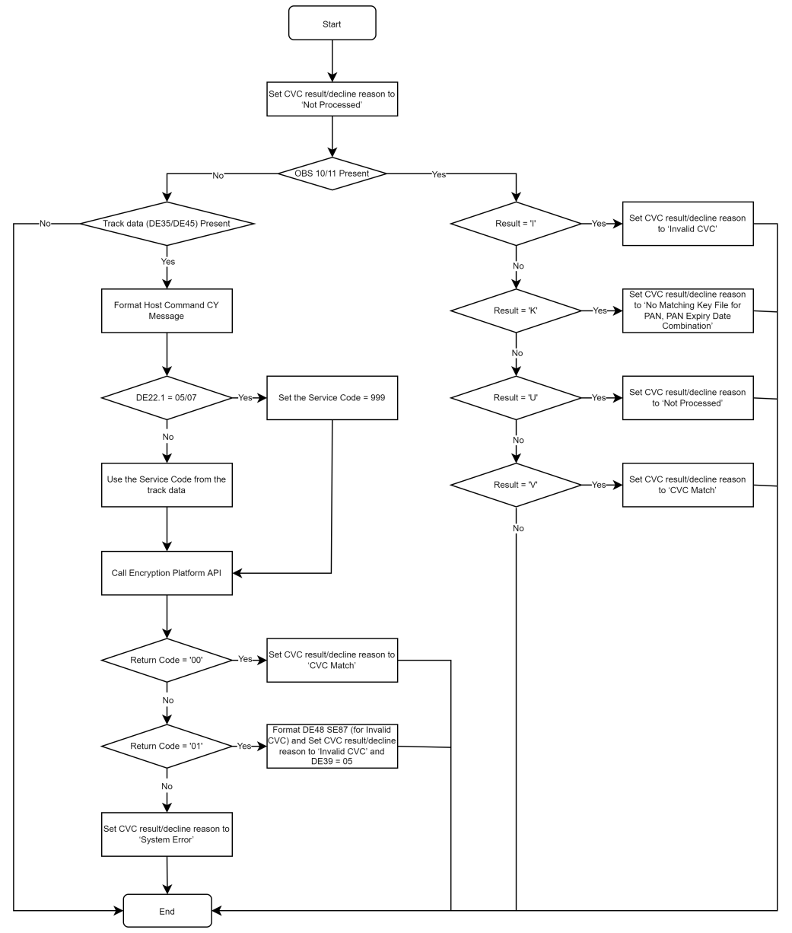
- CVC Lock and Retry Count Reset
- If the CVC validate fails, the CVV retry count will increase by one; if the number of CVV errors exceeds the number of times the CVC can be exceeded by the CMS parameter setting, CMS will lock the card and update the blocking code to N1.
- When the CVC validate passed, and the retry count for the CVC is greater than zero, the retry count for CVC will be reset to zeros.
- If the CVC validation bypassed, the block code and CVC retry count will remain unchanged.
- Parameter Default Settings
CVC Retry Times | 3 Times

Card Block Code（Phase 1）
This function will check the card block code to see whether transaction will be approved or decline.
- Get card block code from card record table, if card block code is not blank, then read the block code parameter table to get the ‘authorization control sign’, below is the card block code mapping and card block code parameter portal in CMS.
CMS Block Code（2BIT） | Authorization Control Sign | Reason Codes | DE39 RC
C0 | 1 |  | 57
F0 | 3 | Fraud | 57
G0 | 1 | Government Request | 57
B0 | 1 | Bank request | 57
N0 | 1 | PIN retry too many times | 57
N1 | 1 | CVC1 retry too many times | 57
N2 | 1 | CVC2 retry too many times | 57
N3 | 0 | Activation retry too many times | 00
The definition of Authorization control sign values:
Value | Action | Decline Reason Code
0 | Approved | 0000-Approve
1 | Decline | 4001-Card Block Code Decline
3 | Decline | 4003-Card Block Decline Fraud Code
- If the ‘authorization control sign’ is equal to ‘0-Approve’, then the card block check will be pass.
- If the ‘authorization control sign’ is not equal to ‘0-Approve’, then the card block check will be fail.
- Card Block Code check items will not be configured for the credit transaction type including Moneysend Payment and Refund.

CVC2 （Phase 1）
If CVC2 is not present, bypass the CVC2 validation. If CVC2 is invalid, system will assign check result to DE48 SE87 and continue to proceed.

This routine is performed as part of the authorization check sequence and based on the configured transaction type.
The CMS Authorization system performs the actual CVC2 validation as below.
- Set the CVC2 result as “Not Processed”.
- Check whether DE48 is not present, then set the CVC2 result as ‘Bypassed’ and go to Step 6.
- Check whether DE48 SE87 is present and DE48 SE87 contains a value of ‘U’, then go to Step 6.
- Check whether DE48 SE92 is not present, then set the CVC2 result as ‘Bypassed and go to Step 6.
- At this point, it implies that CVC2 is present for validation.
  - Check whether DE48 SE92 is not numeric or not greater than zero, then set the CVC2 result as ‘Invalid CVC2’, set DE39 = ‘05’ and go to Step 6.
  - Call the Encryption Platform to validate the CVC 2 using the card number, card expiry date and service code = ‘000’. The cvkH_CVC2 in the card info will be used.
  - If the Return Code from the Encryption Platform is successful, then set the CVC 2 Result as ‘CVC2 Match’. Otherwise, set the CVC2 result as ‘Invalid CVC2’, set DE39 = ‘05’.
- As required in the Authorization Request Response/0110 message, we need to format the CVC2 result in DE48 SE87 before we exit the CVC2 validation routine.
When | Then…
CVC2 Result = “CVC2 Match” | Set DE48 SE87 value as ‘M’
CVC2 Result = “Invalid CVC2” | Set DE48 SE87 value as ‘N’
CVC2 Result contains other than “CVC2 Match” or “Invalid CVC2” | Set DE48 SE87 value as ‘P’
Sample transaction processing flow:
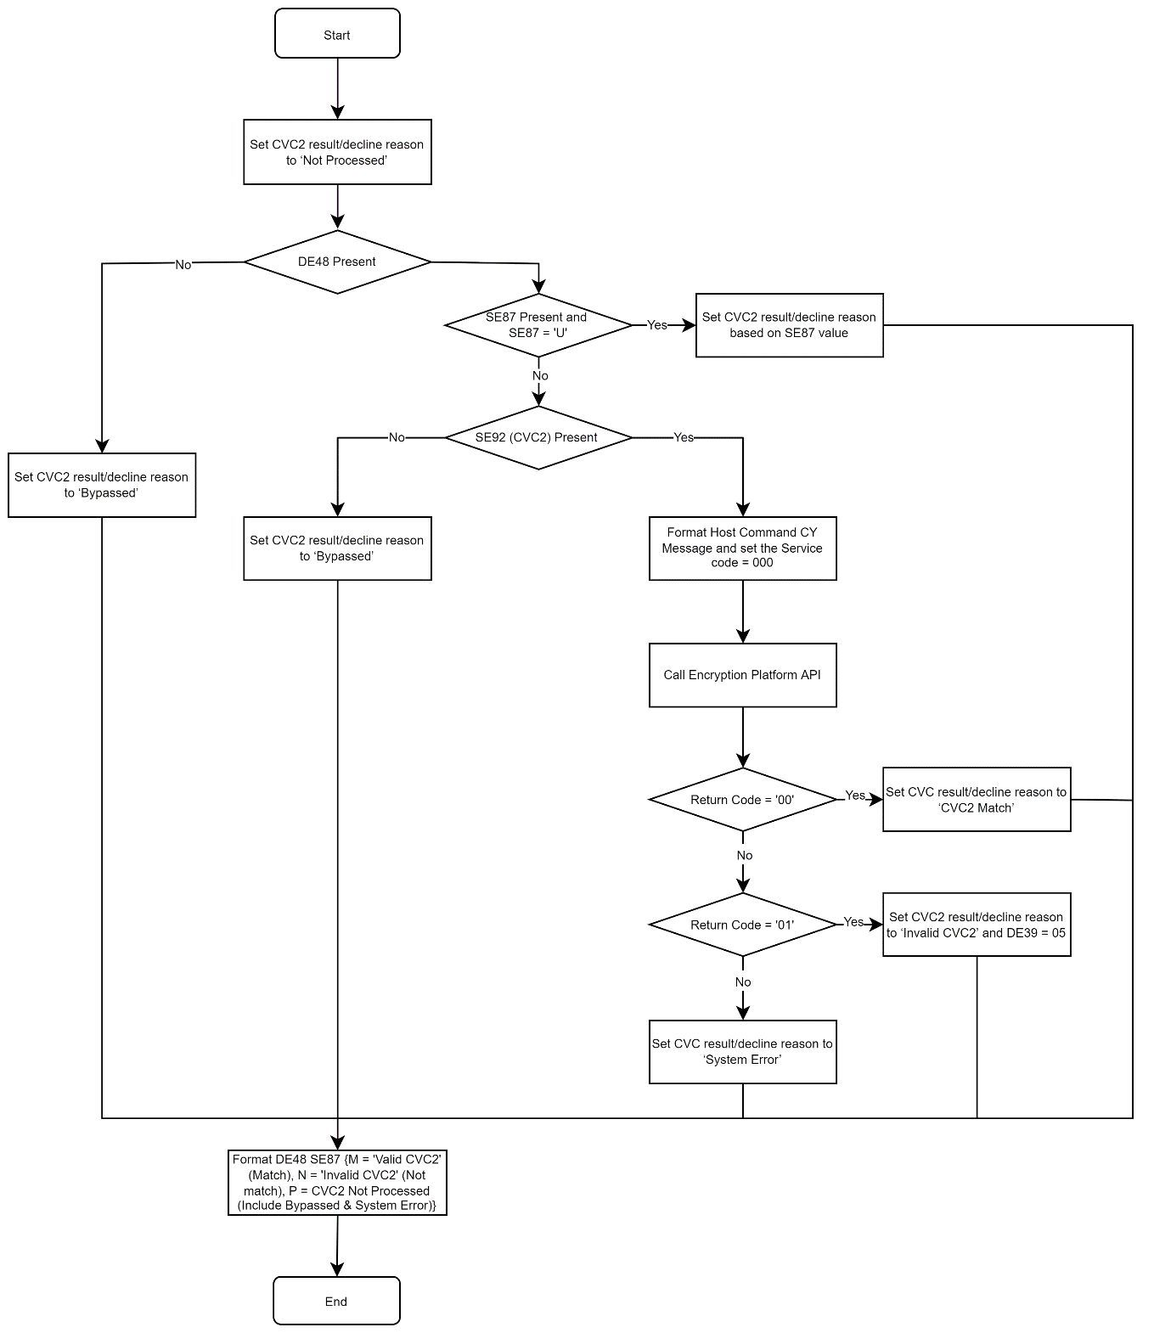

- CVC2 Lock And Retry Counts Reset
- If the CVC2 validate fails, the CVC2 retry count will increase by one; if the number of CVV errors exceeds the number of times the CVC2 can be exceeded by the CMS parameter setting, CMS will lock the card and update the blocking code to N2.
- When the CVC2 validate passed, and the retry counter for the CVC2 is greater than zero, the retry counter for CVC2 will be reset to zeros.
- If the CVC2 validation bypassed, the block code and CVC2 retry count will remain unchanged
- Parameter Default Settings:
CVC2 Retry Times | 3 Times

PIN（Phase 1）
This routine is performed as part of the authorization check sequence and based on the configured transaction type.
The CMS Authorization system performs the actual PIN validation as below.
- Set the PIN result as “Not Processed”
- Check whether DE52 is not present
  - Set the PIN result as ‘Bypassed’, Exit the PIN routine
- If DE52 present, CMS will call the Anti-fraud API to validation the PIN :
  - Set the PIN result based on the Return Code sent by the Anti-fraud System:
When | Then
Return Code = ‘00’ | Set PIN result = ‘PIN Match’  Set PIN retry count to zero
Return Code = ‘01’ | Set PIN result = ‘Invalid PIN’  Set DE39 = ‘55’  Add 1 to PIN retry count  If PIN Retry Count > Max Retry Count, then, set DE39 = ‘75’ and Card Block Code to ‘N0’  NOTE: Card Block Code is checked first, thus, subsequent transactions will be declined due to card is blocked
Return Code not = ‘00’ and ‘01’ | Set PIN result = ‘System error’  Set DE39 =’86’
  - Exit the PIN routine
Sample transaction processing flow:
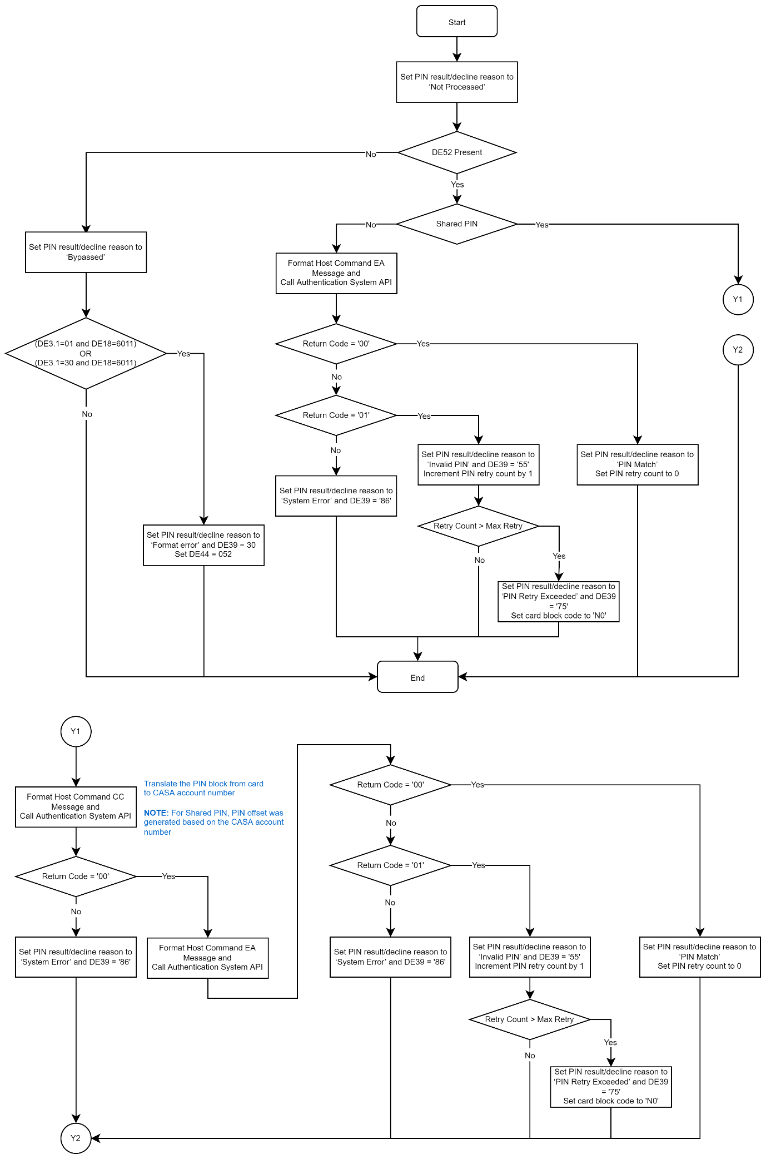
- PIN Lock And Retry Count Reset
- If the PIN validate fails, the PIN retry count will increase by one; if the number of PIN errors exceeds the number of times the PIN can be exceeded by the CMS parameter setting, CMS will lock the card and update the blocking code to N0.
- When the PIN validate passed, and the retry count for the PIN is greater than zero, the retry count for PIN will be reset to zeros.
- If the PIN validation bypassed, the block code and PIN retry count will remain unchanged
- Parameter Default Settings
PIN Retry Times | 3 Times

ARQC（Phase 1）
This routine provides a gateway to communicate with Maribank encryption platform, to authenticate the Authorization Request Cryptogram (ARQC) and to generate the Authorization Response Cryptogram (ARPC).
The CMS Authorization system performs the following edits on the Authorization Request/0100 message for chip transactions.
When | Then CMS Authorization system…
MTI = 0100 and  DE22_1 = (05 or 07) and  DE55 is not present and  DE3_SF1 not = 20 | Formats and sends the Authorization Request Response/0110 where:  DE39 = 30  DE44 Length = 3  DE44 = 055
MTI = 0100 and  DE55 is present and  DE22_1 not =05 or 07 | Formats and sends the Authorization Request Response/0110 where:  DE39 = 30  DE44 Length = 3  DE44 = 055
MTI = 0100 and  DE22_1 = (05, 07) and  DE55 is present  Then  Expand DE55  Expand_ReturnCode not successful | Formats and sends the Authorization Request Response/0110 where:  DE39 = 30  DE44 Length = 3  DE44 = 055
MTI = 0100 and  DE22_1 = (05, 07) and  DE55 is present  Then  Expand DE55  Expand_ReturnCode successful and  (Tag-5F2A is not Present or  Tag-82 is not Present or  Tag-95 is not Present or  Tag-9A is not Present or  Tag-9F02 is not Present or  Tag-9F10 is not Present or  Tag-9F1A is not Present or  Tag-9F26 is not Present or  Tag-9F27 is not Present or  Tag-9F36 is not Present or  Tag-9F37 is not Present) | Formats and sends the Authorization Request Response/0110 where:  DE39 = 30  DE44 Length = 3  DE44 = 055
When the above pre-edits passed, the actual ARQC validation is then performed.
- Set the ARQC result as “Not Processed”
- Check whether On-behalf (OB) Service 02 (ARQC Pre-validation Service) is present –
field will be in DE48, SE71, SF1 value 02. If the said OB service is present, then check the result from DE48, SE71, SF2 and set the corresponding ARQC result and decline reason.
Below table depicts the possible results:
Result (Field Value) | Result Description | Remarks
V | ‘ARQC Match’ | ARQC validation is successful
Y | ‘Invalid ARQC’ | ARQC not matched
U | ‘Not Processed’ | Unable to validate ARQC
K, G, T | ‘Mastercard Other Error’ | System error
Once the ARQC result is set, exit the ARQC routine.
- If we arrived at this point, we know that we are processing the ARQC internally – all the mandatory EMV tags are present. Following are the required data elements and EMV tags to validate the ARQC as well as generate the ARPC:
Fields | Description | Remarks
PAN Length | Length of Card number plus Card sequence number | Value = ‘8’
PAN/PAN Sequence Number | Card number plus card sequence number | Card last 14-digit number plus card sequence number last 2-digits
Tag 9F36 | Application Transaction Counter
Transaction Data Length | Length of the chip transaction data
Transaction Data |  | See Table below for the detailed layout
Tag 9F26 | ARQC
DKI | Derivation Key Index | When 9F10 Length = 32, then Position 7:10  When 9F10 Length = 18, then Position 5:12  When 9F10 Length = Others, then Position 7:8
ARC | Authorization Response Code
Below table shows the layout of the said transaction data:
EMV Fields | EMV Tags | Remarks
Transaction Amount | 9F02
Cashback Amount | 9F03
Terminal Country Code | 9F1A
Terminal Verification Result | 95
Transaction Currency | 5F2A
Transaction Date | 9A
Transaction Type | 9C
Transaction Unpredictable Number | 9F37
Application Interchange Profile | 82
Application Transaction Counter | 9F36
Card Verification Result | 9F10 | When 9F10 Length = 32, then Position 7:10  When 9F10 Length = 18, then Position 5:12  When 9F10 Length = Others, then Position 7:8
End of Data |  | X’80’ (Ø)
- Call the Encryption Platform to validate the ARQC and generate the ARPC.
- Check the response code returned by the Encryption Platform
  - If the response code is successful (RC = ‘00’), perform the following
    - Set the ARQC result as ‘ARQC Match’
    - Format DE55 containing the Tag 91 (Authorization Response Cryptogram). This EMV tag is returned by the HSM via Encryption Platform
    - Exit the routine
  - If the response code is not successful (RC = ‘01’), then set the ARQC result as ‘Invalid ARQC’ and exit the routine
  - If the response code is other than RC = ‘00’ or ‘01’, then set the ARQC result as ‘System Error’ and exit the routine
Sample transaction processing flow:
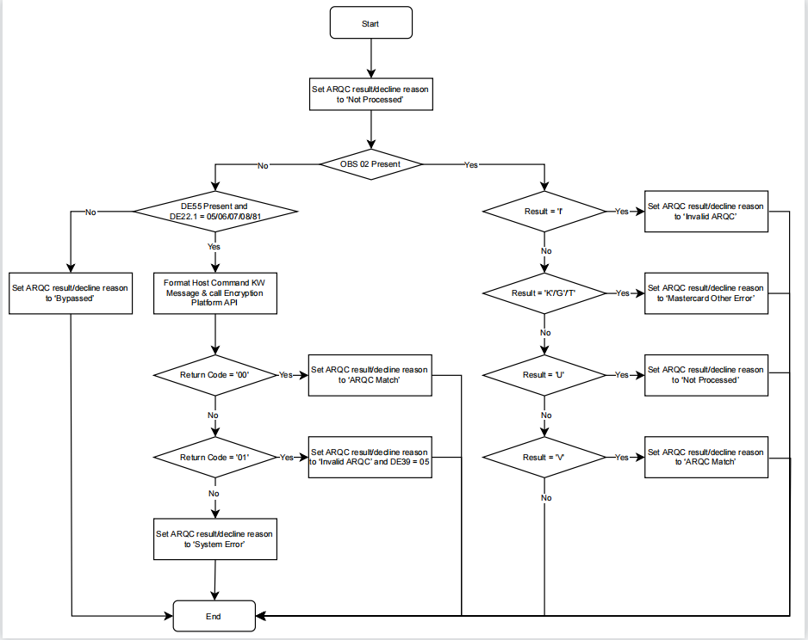

UCAF/IAV（Phase 1）
- Check for the following Pre-validation Services
On-Behalf Services (OBS) | Value | Remarks
05 | DE48SE71SF1 | Mastercard Identity Check AAV Verification Service
06 | DE48SE71SF1 | Mastercard Identity Check AAV Verification in Stand-In Processing
- Set the UCAF validation results based on DE48SE71SF2 (OB Result 1) values:
  - V = Valid (UCAF match)
  - U = Not Processed
  - Other = Unmatched UCAF
- If DE48SE42 and DE48SE43 are not present, set UCAF validation results as bypassed and exit
- If DE48.SE42.SF1 = 210 or 211, then reject the authorization.
- The following fields are required to validate the UCAF:
Condition 1
Fields | Value | Remarks
DE22SF1 | 81 or 10 | 81 = PAN/Token entry via electronic commerce with optional Identity Check-AAV or DSRP cryptogram in UCAF  10 = Credential on File
DE61SF4 | 4 or 5 | 4 = Standing order/recurring transactions  5 = Cardholder not present (Electronic order [home PC, Internet, mobile phone, PDA])
DE61SF10 | 6 | Authorized Level 6 CAT: Electronic commerce
DE48SE42SF1 position 3 | 2
Condition 2
Fields | Value | Remarks
DE22SF1 | 81 or 10 | 81 = PAN/Token entry via electronic commerce with optional Identity Check-AAV or DSRP cryptogram in UCAF  10 = Credential on File
DE61SF4 | 3 | Cardholder not present (phone or Automated Response Unit [ARU])
DE61SF10 | - | Not 6 (Authorized Level 6 CAT: Electronic commerce)
DE48SE42SF1 position 3 | 2

If met one of the conditions above, authorization system will forward DE48SE43 to encryption platform for validating UCAF(By Calling the API).If validation is passed, set UCAF validation results as matched, otherwise, set it as unmatched, exit.
- If both conditions not met,
  - when DE48.SE42.SF1 = 210 or 211, UCAF check failed, reject the authorization.
  - Otherwise, bypass the UCAF validation.

Expire Date（Phase 1）
- Expire Date Presence
For the following scenarios, the expire date is not required in the authorization messages:
- Recurring Transaction(DE61.SF4=4)
- MOTO Transactions/ Electronic commerce(DE48.TCC=T)
- Payment Transaction(DE03.SF1=28 and DE48.TCC=P) (2024-01-19:Credit transactions do not require verification of Expire Date.)
- Expire Date Check Steps
- Extract the expire date from DE14 or DE35 or DE45
- If expire date not present,
  - If the transaction is Recurring/MOTO/EC/Payment transactions, and expire date in the card info is not less than the system business date, then pass the expire date check.
  - Otherwise, the expire date check fails.
- If expire date present,
  - If the expire date from the message neither equal the expire date nor the last expire date in the card info, expire date check fails.
  - If the expire date from the message is equal to the expire date in the card info ,
    - If the expire date from the message is not less than the system business date, pass the expire date check.
    - If the expire date from the message is less than the system business date
      - Refund or Moneysend Payment or Moneysend Payment ASI transactions, pass the expire date check.
      - Purchase transaction, expire date check fails
  - If the expire date from the message is equal to the last expire date in the card info ,
    - If the expire date from the message is not less than the system business date, pass the expire date check.
    - If the expire date from the message is less than the system business date,
      - Refund or Moneysend Payment or Moneysend Payment ASI transactions, pass the expire date check.
      - Purchase transaction, expire date check fails.
  - Otherwise, expire date check fails.
- Note :The card renewal scenario is not in MVP.

Velocity Check（Phase 2）
- Basic Velocity Check Rules
- The velocity settings is based on the transaction limit groups, refer to Card Issuance PRD for the details.
- If authorization transaction type is fall into the transaction limit group which have setup the velocity , then will check .
  - Amount Checking: If the transaction amount plus the accumulated amount has exceeded the threshold, velocity check fails (DE6).
  - Count Checking:If the accumulated amount plus one has exceeded the threshold, velocity check fails.DE39 will return ‘96’.
- If the authorization request have been approved finally, the velocity statistics will be update accordingly.
- The mapping between transaction types and transaction type groups is as below.
Transaction Type | Transaction Limit Group
POS Purchase Contact Domestic | 01-Card All transaction type
POS Purchase Contact Overseas | 01-Card All transaction type
POS Purchase Contactless Domestic | 01-Card All transaction type
POS Purchase Contactless Overseas | 01-Card All transaction type
Online Purchase Domestic | 01-Card All transaction type
Online Purchase Overseas | 01-Card All transaction type

- Advanced Velocity Check Rules
Advanced Velocity Rules feature enables to setting up the control on the particular transaction which may not be identified as a predetermined transaction type, e.g. all the transaction from a specific MCC or Country Code.
The factor to drive the advanced velocity rules will be customerization for Mari Card as below:
Rule Type | Comment
Merchant type | DE18 in Authorization Message
Merchant name | DE43 in Authorization Message
Merchant number | DE42 in Authorization Message
Card Product Number | The Product Code in CMS
Transaction Limit Group | Transaction Limit Group in CMS
Transaction Type | Transaction Type in CMS
Country code | DE61.SF13 in Authorization Message

Safety Switch Rules（Phase 2）
- The Safety Switch Rules settings is based on the transaction type groups, refer to Card Issuance PRD for the details.
- If authorization transaction type is fall into the transaction type group which have setup the Safety Switch , then will check .
  - If the Safety Switch for this transaction type group on the card is ON, then the Safety Switch Rules checking passed.
  - If the Safety Switch for this transaction type group on the card is OFF, then the Safety Switch Rules checking failed.
- The mapping between transaction types and transaction type groups is as below.
Transaction Type | Transaction Type Group
POS Purchase Contact Domestic | 01-POS Purchase Domestic
POS Purchase Contact Overseas | 02-POS Purchase Overseas
POS Purchase Contactless Domestic | 01-POS Purchase Domestic
POS Purchase Contactless Overseas | 02-POS Purchase Overseas
Online Purchase Domestic | 03-Online Purchase Domestic  03-Online Purchase(2023-11-24:Online Transaction does not distinguish between domestic and overseas.)
Online Purchase Overseas | 04-Online Purchase Overseas  03-Online Purchase(2023-11-24)
- Both the Cardholder and the Ops can setup this Safety Switch , more detail please refer to the section 3.5.2.6 in Card Issuance PRD.

Anti-Fraud Check（Phase 1）
Authorization will call Anti-fraud system to check if card is in blacklist. If blacklist is hit, the Anti-Fraud Check fails.
If transaction is rejected due to blacklist in Anti-fraud, Authorization system will trigger the notification with template ID = 1000182.

Magnetic Stripe Activation Check （Phase 1）
When… | Then…
DE22 = 90 or  DE22 = 80 and  DE61.SF13 <> 702 and  Foreign POS Magnetic Stripe = ‘D’ | DE39 = 57
DE22 = 90 or  DE22 = 80 and  DE61.SF13 <> 702 and  Foreign POS Magnetic Stripe = ‘A’ and  Foreign POS Magnetic Stripe Active Time Start date > Current Date and  Foreign POS Magnetic Stripe Active Time End date < Current Date | DE39 = 57
DE22 = 90 or  DE22 = 80 and  DE61.SF13 = 702 and  Local POS Magnetic Stripe = ‘D’ | DE39 = 57
DE22 = 90 or  DE22 = 80 and  DE61.SF13 = 702 and  Local POS Magnetic Stripe = ‘A’ and  Local POS Magnetic Stripe Active Time Start date > Current Date and  Local POS Magnetic Active Time End date < Current Date | DE39 = 57

<dConfiguration page of the Magnetic Stripe switch on the Portal page>
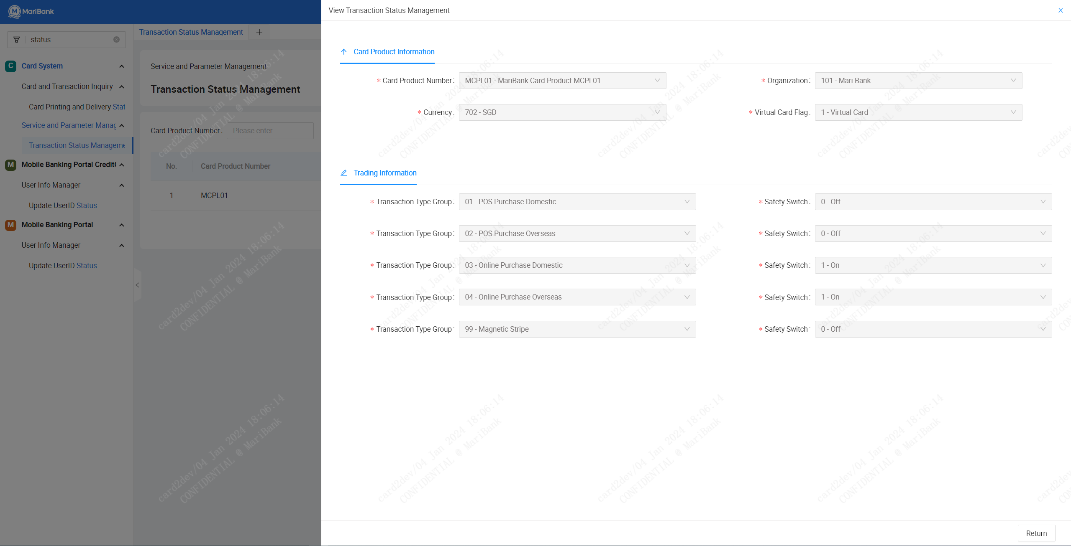

Authorization Earmarking （Phase 1）
After all the check item in CMS authorization processed , if the authorization not rejected, CMS will call the CTS API to do further check or earmark process, it will be in the CTS system. CMS will do the subsequent process based on the response from CTS . API Path: /api/card/v1/auth/purchase(2023-11-24).

Please be noted, this content in this section is not a standard check item in CMS, the logic are all in CTS .

Network Management Message Processing（Phase 1）
The authorization system allows the processing to perform Mastercard specific functions such as sign-on to Mastercard network, sign-off from Mastercard network and inquire Mastercard network connection status.
The following Mastercard network parameters are required to be set which will be used during the interaction between MariBank and Mastercard.
Network Processing Parameters List
Purpose | To check the version, view, edit, add a new parameter by using the copy function and inquire about the processing control parameters.
Operator Instructions | Click on the “Network Processing Para” tab.  Click on the Chevron (dropdown) icon and select the preferred search field from the list and click on ‘Search’ button.  Following are the search fields:  Processing Para ID
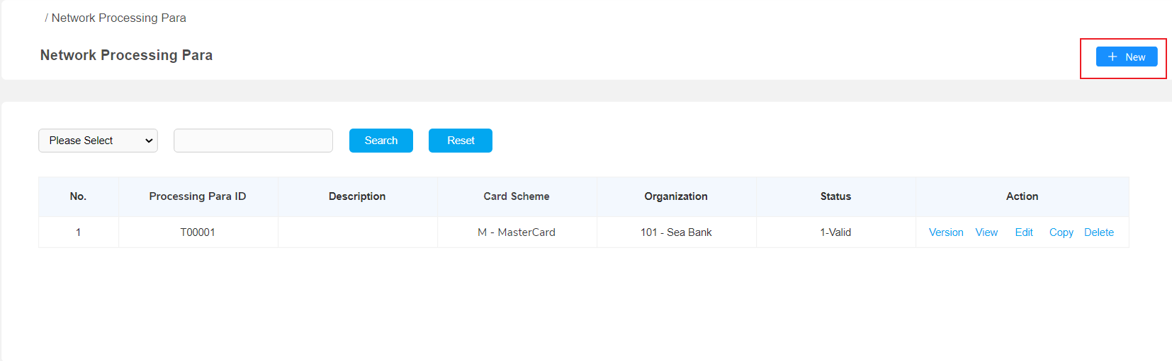
Display Fields
No. | The serial/sequence number of Processing Para ID
Processing Para ID | This is the group ID assigned to this Mastercard control parameters.
Description | Brief description of the processing parameters
Card Scheme | M - MasterCard  V - Visa
Organization | 101 - MariBank
Status | 1 - Valid  0 - Invalid
Action | - Version  - View  - Edit  - Copy  - Delete

Network Processing Parameters
Purpose | To add, update, delete and inquire about the Mastercard control parameters.
Operator Instructions | Click on the “+New” tab.  Input the field value that user would like to use.
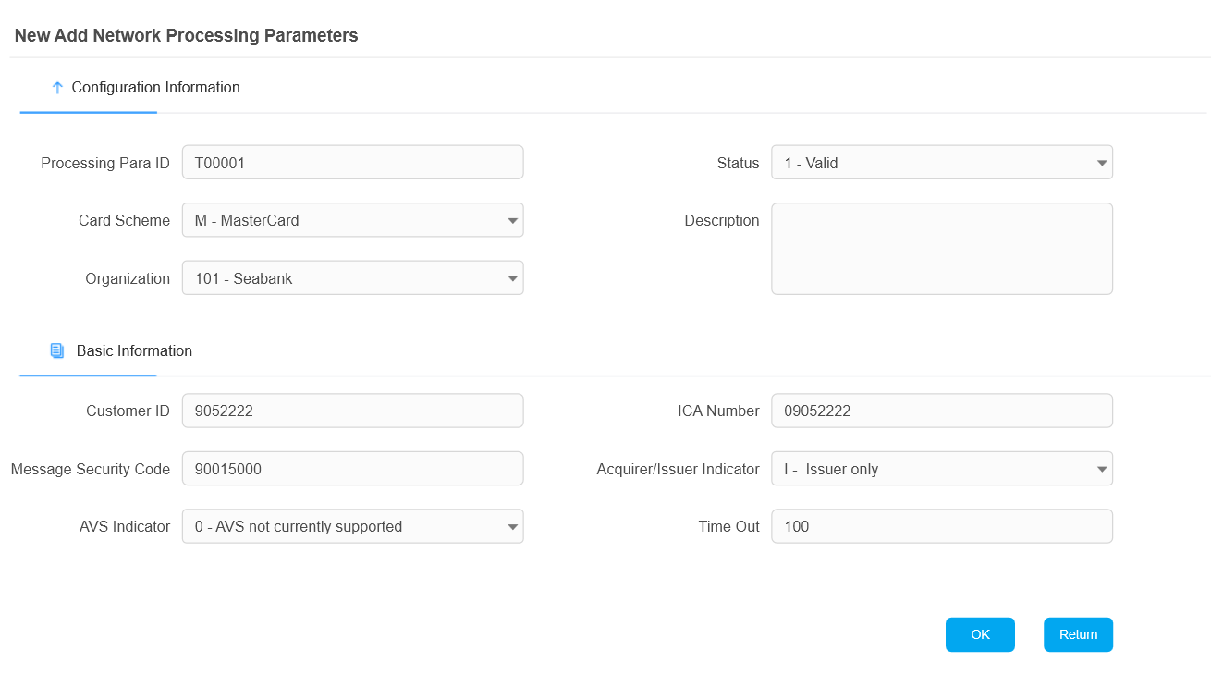
Display Fields
Processing Para ID | This is the group ID assigned to this Mastercard control parameters.
Status | The status of this processing parameters.  Valid values:  0 – Invalid. This parameter is not in used  1 – Valid. This parameter is in use
Card Scheme | The type of network parameter. Select ‘M’ for Mastercard network
Description | Brief description of the processing parameters
Organization | The organization number assigned for MariBank
Customer ID | MariBank’s customer/member identification number assigned by Mastercard
ICA | Interbank Card Association number – A four-digit number assigned by Mastercard to identify the member in transactions
Message Security Code | Message Security Code is an Issuer File Update security code used to indicate that a message originator is authorized to update a file.
Acquirer/Issuer Indicator | A = Acquirer only  I = Issuer only  B = Both acquirer and issuer
Address Verification Support Indicator | MariBank will not support address verification for MVP. Valid values:  0 = AVS not currently supported  1 = Issuer receives complete address data  2 = Issuer receives condensed address data (uses the first five numeric digits in an address)  3 = Issuer receives condensed address data (uses up to the first five numeric digits in an address)  4 = Issuer receives condensed numeric postal code and condensed numeric address data only
Outgoing Timer | Time interval to wait before checking the response from MasterCard for outgoing requests
When the operator clicks on “OK” button, the system will then display the list of Network Processing Parameters.
Network Information – Connection Parameter
Purpose | To view and operation about the Mastercard network. Displays the query breakdown results for status sign-on
Operator Instructions | Click on the “Connection Para” tab.  Input the field value that user would like to use for Mastercard network.
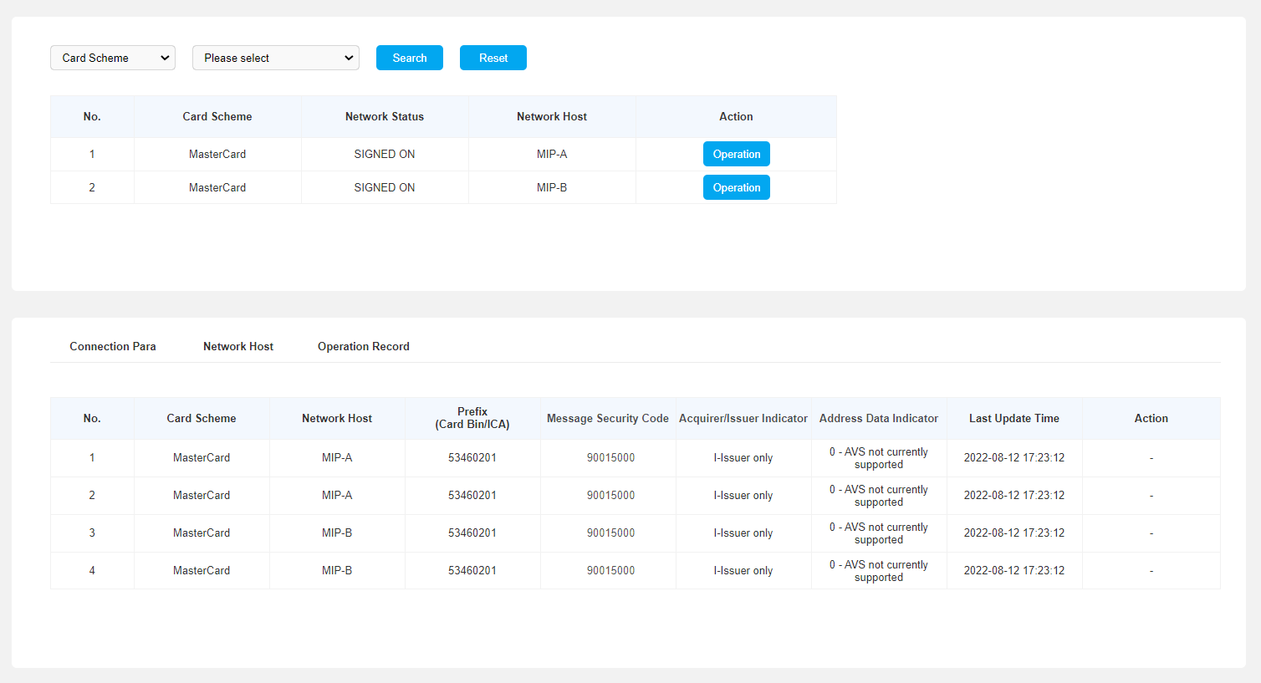
Display Fields
No. | This is the seq no for MIP.
Card Scheme | The type of network parameter. ‘M’ stands for Mastercard network
Network Status | The status of this MIP network status.  Valid values:  SIGNED ON. This MIP has been signed on  SIGNED OFF. This MIP has been signed off
Network Host | Valid values:  MIP-A  MIP-B
Prefix | Card BIN or ICA number for the Mastercard connection
Message Security Code | Assign by Mastercard
Acquirer/Issuer Indicator | 1-Issuer Only
Address Data Indicator | 0 = AVS not currently supported
Last Update Time | The last time update the connection status
Network Information – Network Host
Purpose | To view and operation about the Mastercard network. Display query breakdown results.
Operator Instructions | Click on the “Network Host” tab.  Input the field value that user would like to use for Mastercard network.
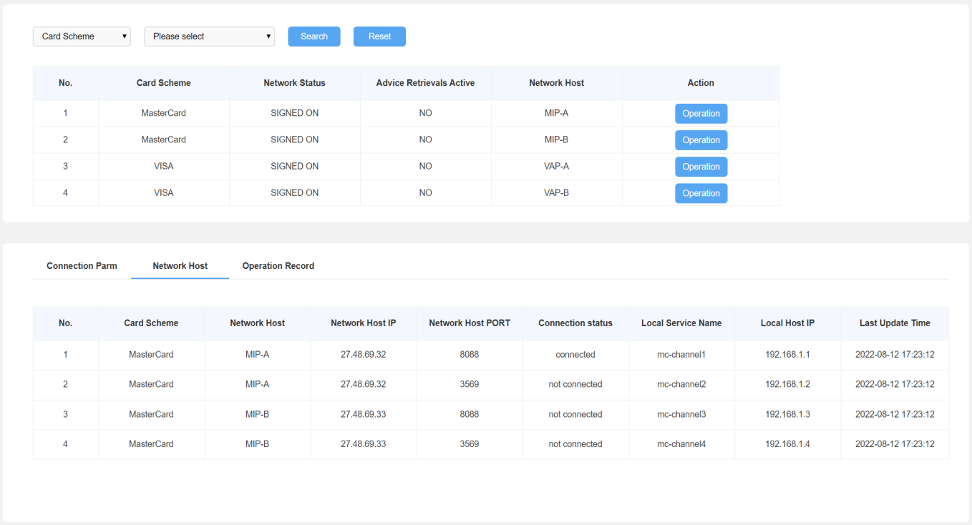
Display Fields
No. | This is the seq no for network host.
Card Scheme | The type of network parameter. ‘M’ stands for Mastercard network
Network Host | Valid values:  MIP-A  MIP-B
Network Host IP | The network host IP
Network Host PORT | The network host PORT
Connection status | Connection status  -connected  -not connected
Local Service Name | The name of the local service
Local Host IP | The IP address of the local host
Last Update Time | The last time that update
Network Information – Operation Record
Purpose | To view and operation about the Mastercard network.
Operator Instructions | Click on the “Operation Record” tab.  Input the field value that user would like to use for Mastercard network.
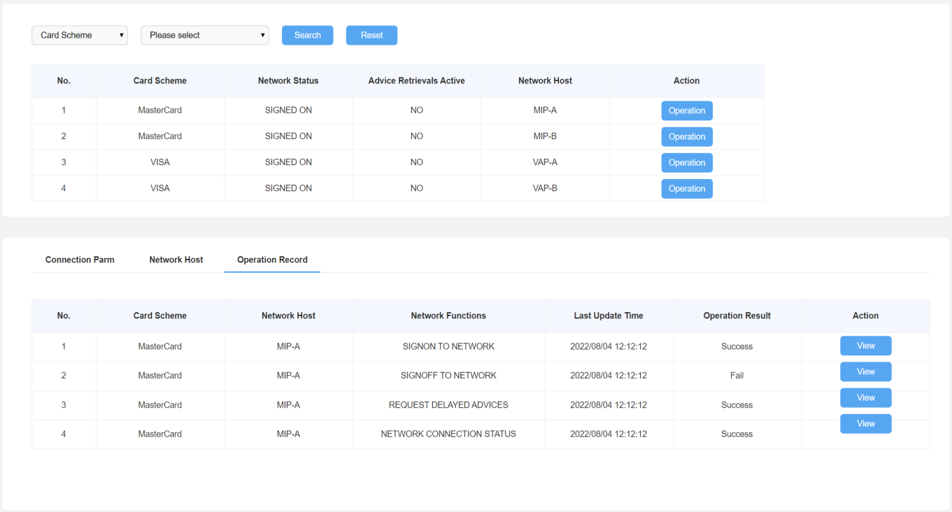
Display Fields
No. | This is the seq no for Operation Record.
Card Scheme | The type of network parameter. ‘M’ stands for Mastercard network
Network Host | Valid values:  MIP-A  MIP-B
Network Function | Network Functions include all the function that done by Ops in the operation record
Last Update Time | The last time Ops update this record
Operation Result | This value shows the result of the operation  -Success  -Fail

Sign-On Message
The below table shows the list of network processing parameter. Which allows user to check each parameter for network processing. User can version/view/edit/copy/delete the network processing parameter.
After click ‘Send’ button, CMS will link with Mastercard host through TCP/IP and the network host will show Mastercard IP. CMS will assemble into 8583 0800 messages.
Network Operation – Sign-on to Mastercard Network
Purpose | To sign-on to Mastercard network by card prefix/group.
Operator Instructions | Click on the ‘Operation” tab.  The operator will select fields as below.
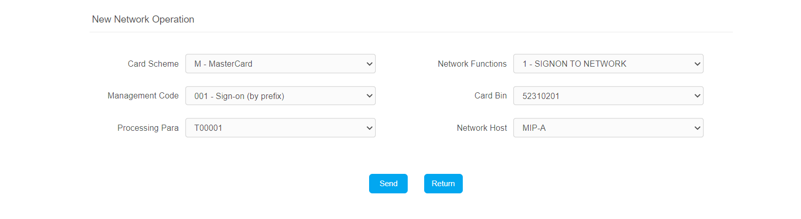
Display Fields
Card Scheme | Select “M – Mastercard” from the dropdown
Network Functions | Select “1 – SIGNON TO NETWORK” from the dropdown
Management Code | Select below code from the dropdown  - 001 – Sign-on (by Prefix)  - 061 - Group Sign-on
Card Bin | Select the corresponding Card BIN prefix from the dropdown (Applicable only for Sign-on by Prefix)
Processing Para | Select “ID – Mastercard Network Parameters” from the dropdown
Network Host | Select below code from the dropdown  - MIP-ALL – The system will sign-on to Mastercard network for all the available MIPs  - MIP-A – The system will sign-on MIP-A to Mastercard network  - MIP-B – The system will sign-on MIP-B to Mastercard network
MIP connection is manually configured between Mastercard and MariBank.
When the operation clicks on the “Send” button, CMS Authorization system will then forward the Network Management Request/0800 – Sign-on by Prefix to Mastercard. Below table depicts the data elements required.
Data Element | Values | Remarks
MTI | 0800
1 (Secondary Bitmap) | Based on field presence
2 (PAN) | Sign-on (by prefix) Card prefix number  Group sign-on Customer ID | From para-DB
7 (Transmission Date & Time) | Derived from system date & time
11 (System Audit Trace Number) | Derived by application from DB
33 (Forwarding Institution ID) | ICA number | From para-DB
70 (Network Management Info Code) | 001 = Sign-on (by prefix)  061 = Group sign-on
94 (Service Indicator)
Sub-field 1 | ‘0’
Sub-field 2 | ‘I’ (Acquirer/Issuer Indicator) | For MVP
Sub-field 3 | ‘0’ (AVS Indicator) | For MVP
96 (Message Security Code) | Authorization Security Code | From para-DB

The below diagram shows the message flow for Sign-on by Prefix:
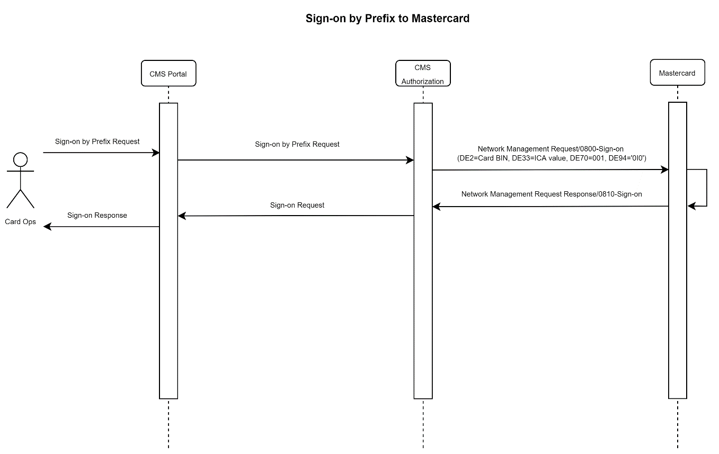
The below diagram shows the message flow for Group Sign-on:
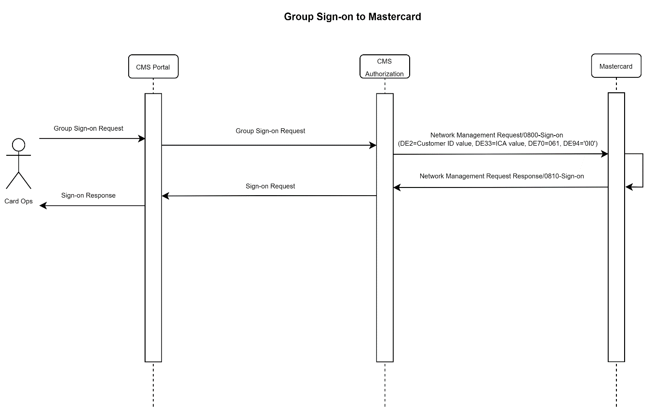

The following screen is displayed when the Authorization system receives a successful response from Mastercard. The operation result should be ‘Success’
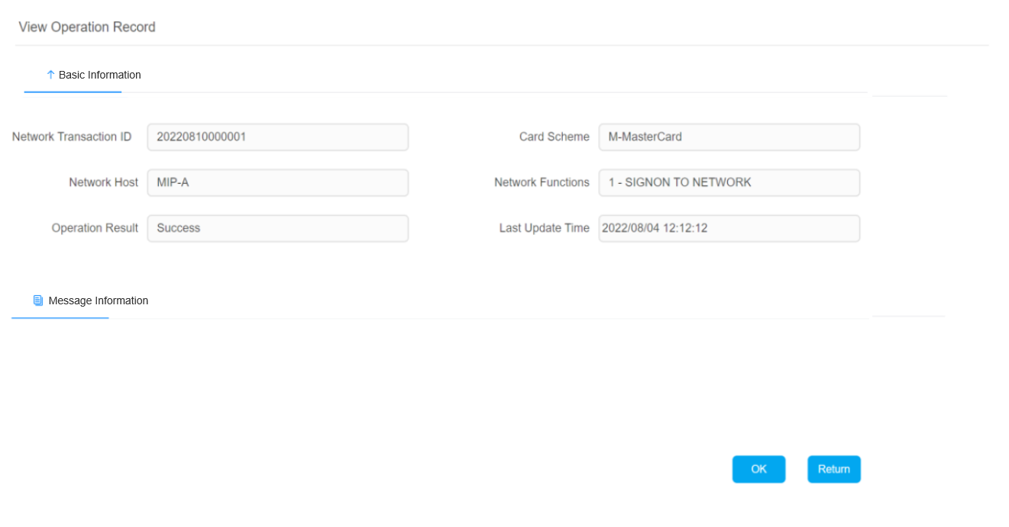
Display Fields
Network Transaction ID
Card Scheme | The type of network parameter. Use ‘M’ for Mastercard network
Network Host | The result will be which host is sign on or sign off
Network Function | Show the function that for this operation
Operation Result | Show response from Mastercard, if user’s operation is successful then a ‘Success’ message will display, otherwise, a ‘Fail’ message will display  - Success  - Fail
Last Update Time | Show the timestamp for this operation

Sign-Off Message
Network Operation – Sign-off to Mastercard Network
Purpose | To sign-off to Mastercard network by card prefix/group.
Operator Instructions | Click on the ‘Operation” tab.  The operator will select fields as below.
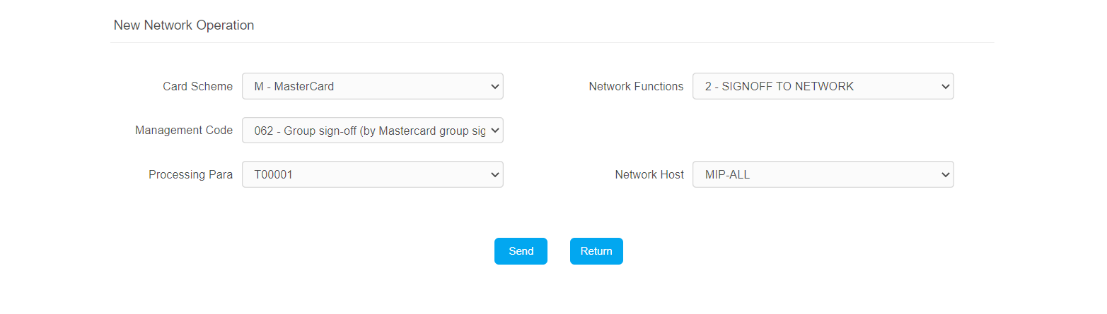
Display Fields
Card Scheme | Select “M – Mastercard” from the dropdown
Network Functions | Select “2 – SIGNOFF TO NETWORK” from the dropdown
Management Code | Select below code from the dropdown  - 002 – Sign-off (by Prefix)  - 062 – Group Sign-off
Processing Para | Select “ID – Mastercard Network Parameters” from the dropdown
Network Host | Select below code from the dropdown  - MIP-ALL – The system will sign-off from Mastercard network for all the available MIPs  - MIP-A – The system will sign-off MIP-A from Mastercard network  - MIP-B – The system will sign-off MIP-B from Mastercard network
When the operation clicks on the “Send” button, CMS Authorization system will then forward the Network Management Request/0800 – Sign-off by Prefix to Mastercard. Below table depicts the data elements required.
Data Element | Values | Remarks
MTI | 0800
1 (Secondary Bitmap) | Based on field presence
2 (PAN) | Sign-on (by prefix) Card prefix number  Group sign-on Customer ID | From para-DB
7 (Transmission Date & Time) | Derived from system date & time
11 (System Audit Trace Number) | Derived by application from DB
33 (Forwarding Institution ID) | ICA number | From para-DB
70 (Network Management Info Code) | 002 = Sign-off (by prefix)  062 = Group sign-off
94 (Service Indicator)
Sub-field 1 | ‘0’
Sub-field 2 | ‘I’ (Acquirer/Issuer Indicator) | For MVP
Sub-field 3 | ‘0’ (AVS Indicator) | For MVP
96 (Message Security Code) | Authorization Security Code | From para-DB

The below diagram shows the message flow for Sign-off by Prefix:
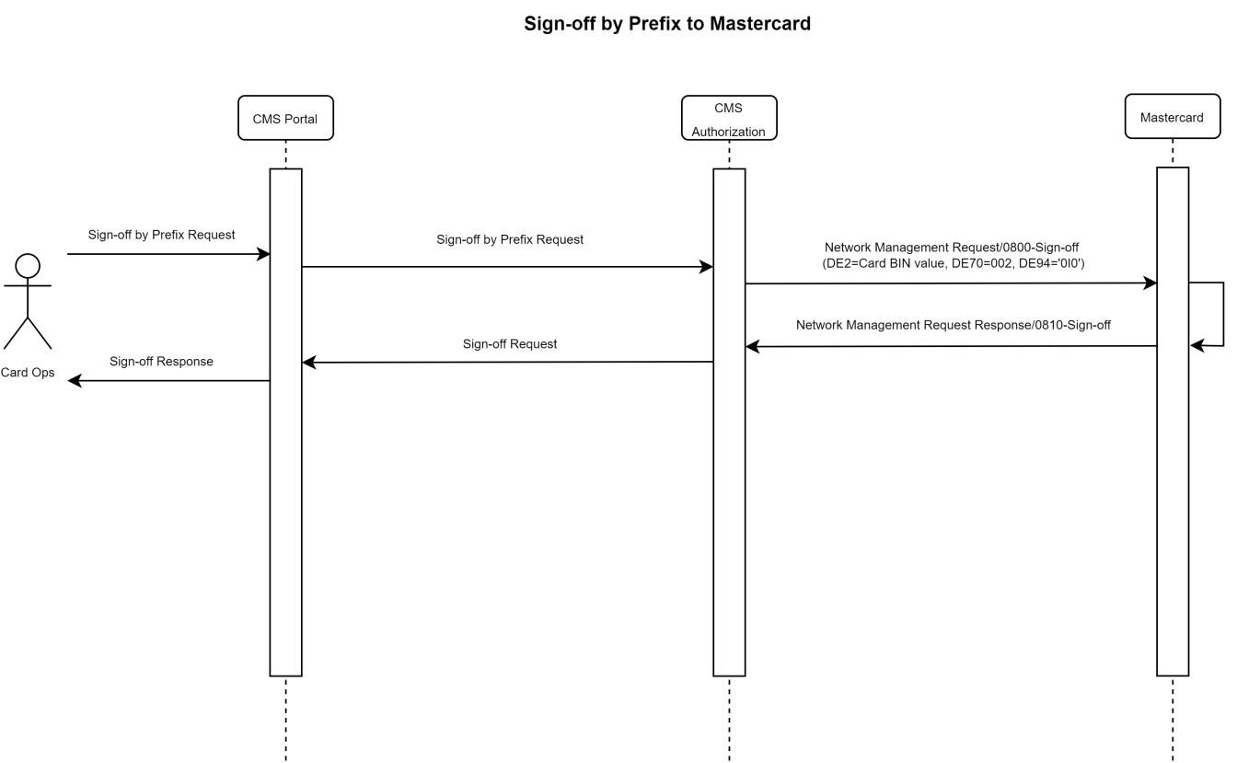
The below diagram shows the message flow for Group Sign-off:
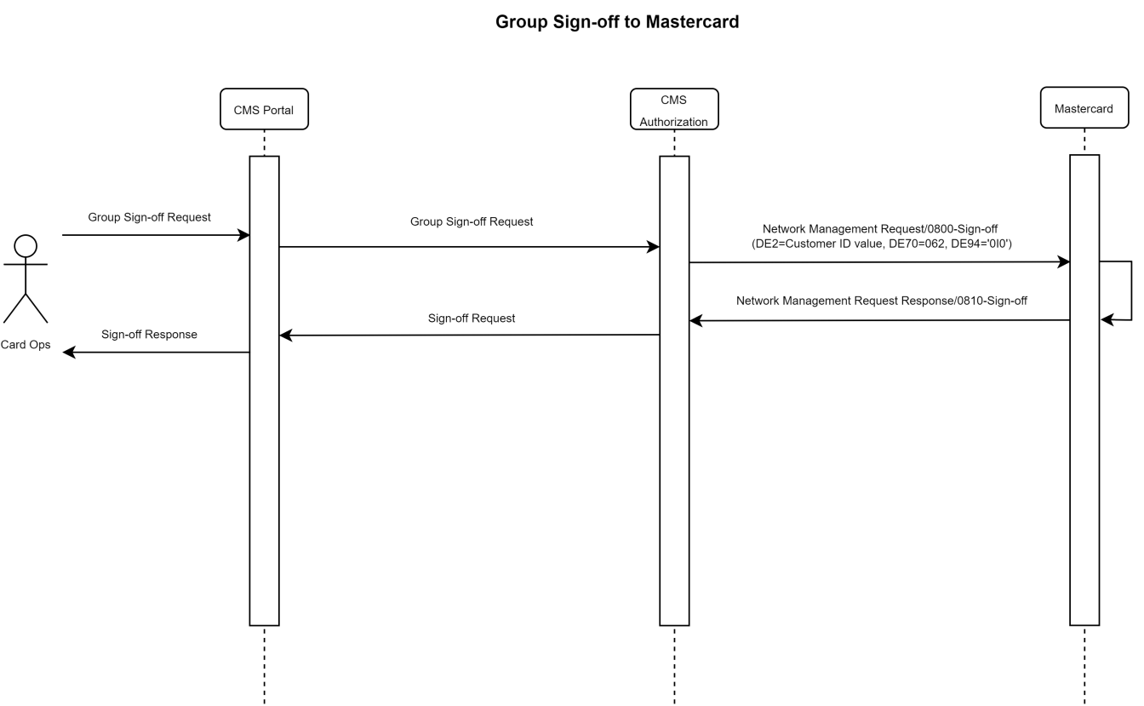

Network Connection Status – Member Generated
Network Operation – Network Connection Status Request to Mastercard Network
Purpose | To request network connection status to Mastercard network
Operator Instructions | Click on the ‘Operation” tab.  The operator will select fields as below.
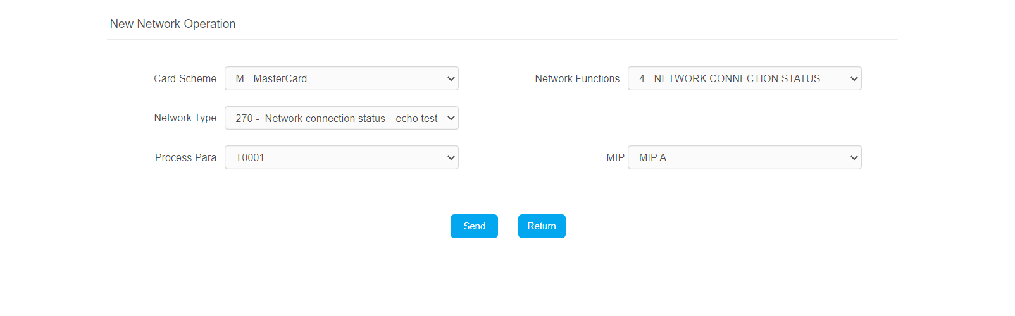
Display Fields
Card Scheme | Select “M – Mastercard” from the dropdown
Network Functions | Select “4 – NETWORK CONNECTION STATUS” from the dropdown
Management Code | Select below code from the dropdown  - 270 - Network connection status-echo test
Processing Para | Select “ID – Mastercard Network Parameters” from the dropdown
Network Host | - MIP-ALL – The system will check the network connection status for all the available MIPs  - MIP-A – The system will check the connection status of MIP-A from Mastercard network  - MIP-B – The system will check the connection status of MIP-B from Mastercard network
When the operation clicks on the “Send” button, CMS Authorization system will then forward the Network Management Request/0800 – Network Connection Status Request to Mastercard. Below table depicts the data elements required.
Data Element | Values | Remarks
MTI | 0800
1 (Secondary Bitmap) | Based on field presence
2 (PAN) | Group Customer ID | From para-DB
7 (Transmission Date & Time) | Derived from system date & time
11 (System Audit Trace Number) | Derived by application from DB
33 (Forwarding Institution ID) | ICA number | From para-DB
70 (Network Management Info Code) | 270
The below diagram shows the message flow for Network Connection Status Request:
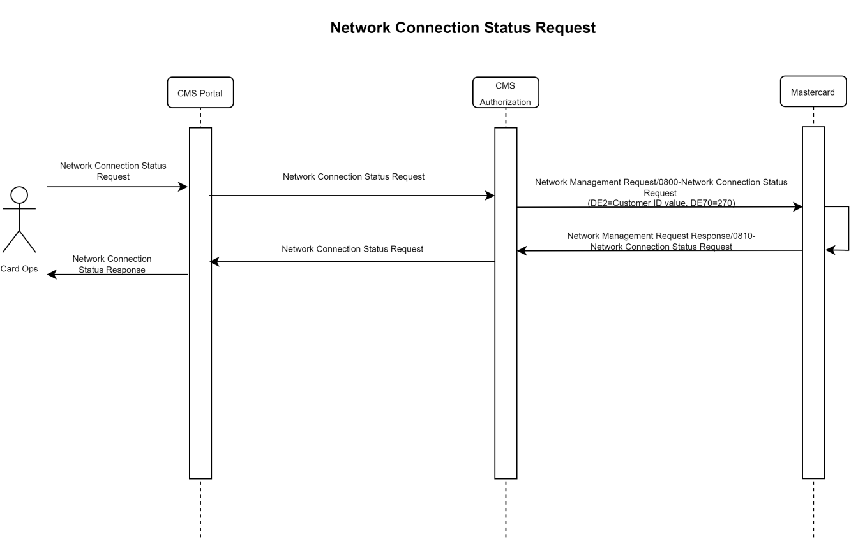

Network Connection Status – System Generated
The authorization system will return a good response to MasterCard if this message is received.
Network Connection Status Request
Data Element | Values | Remarks
MTI | 0800
1 (Secondary Bitmap) | Provided by MasterCard
2 (PAN) | Provided by MasterCard
7 (Transmission Date & Time) | Provided by MasterCard
11 (System Audit Trace Number) | Provided by MasterCard
33 (Forwarding Institution ID) | Provided by MasterCard
70 (Network Management Info Code) | 270
94 (Service Indicator) | Provided by MasterCard
96 (Message Security Code) | Provided by MasterCard
The below diagram shows the message flow for the Network Connection Status Request from Mastercard
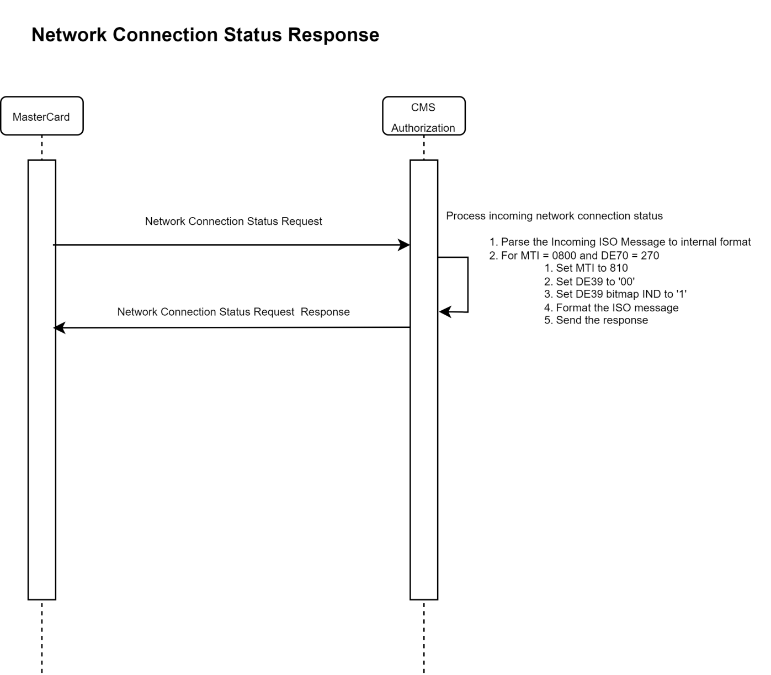
When an incoming network connection status request is received, authorization will return the following:
- Set MTI to 0810
- Set DE39 to ‘00’
- Set DE39 bitmap IND to ‘1’
- Format the ISO message
- Send the response

Zero-Length-Message Probe
A Zero-Length-Message probe is a packet that has a two-byte header length containing 0x0000 and contains no data.
Either the Mastercard Interface Processor (MIP) or the customer host may create these messages.
The MlP can receive zero-length messages; however, it will not send anything in response to receiving one.
The CMS can send and receive zero-length message to deal with broken socket errors.

Authorization Message Processing
2024-01-05：
- Authorization Check Items can be configured through the CMS Portal.The configuration entrance: CMS Portal - Card System > Service and Parameter Management/Authorization/Authorization Check Group.Refer to Portal PRD for more configuration details.
- Transaction Fee(DCC or Markup fee) can be configured through the CMS Portal. The configuration entrance: CMS Portal - Card System > Service and Parameter Management/Fee Management/Transaction Fee.

POS Purchase Contact Domestic（Phase 1）
- Transaction Type Derivation
txnType on CMS | Key Fields in Message
POS Purchase Contact Domestic | MTI=0100  DE22.SF01=05  DE03.SF01=00  DE61.SF13=702
- Authorization Check Items
Authorization Check Items | Check Priority | Response Priority | Check Method
Card Activation Check | 1 | 1 | Check All, Response By Response Priority
Card Block Code | 2 | 2
Card Status | 3 | 3
CVC/Chip CVC | 4 | 4
CVC2 | N/A | N/A
PIN | 5 | 5
ARQC | 6 | 6
UCAF/IAV | N/A | N/A
Expire Date | 7 | 7
Safety Switch Rules | 8 | 8
Velocity Check | 9 | 9
Anti-Fraud Check | 10 | 10
Magnetic Stripe Activation Check | 11 | 11
- Transaction Flow
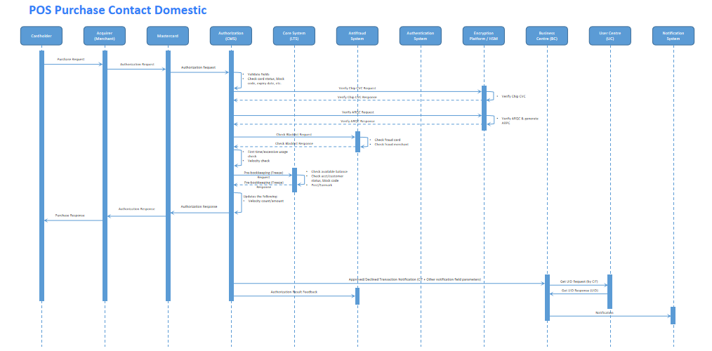

- Fee Processing And Special Handling
Markup Fee: If not SGD currency transaction, will charge the markup fee.
Overseas SGD/DCC Fee: Should not charge the DCC fee regardless the currency.

POS Purchase Contact Overseas（Phase 1）
- Transaction Type Derivation
txnType on CMS | Key Fields in Message
POS Purchase Contact Overseas | MTI=0100  DE22.SF01=90/02/05  DE03.SF01=00  DE61.SF13<>702
- Authorization Check Items
Authorization Check Items | Check Priority | Response Priority | Check Method
Card Activation Check | 1 | 1 | Check All, Response By Response Priority
Card Block Code | 2 | 2
Card Status | 3 | 3
CVC/Chip CVC | 4 | 4
CVC2 | N/A | N/A
PIN | 5 | 5
ARQC | 6 | 6
UCAF/IAV | N/A | N/A
Expire Date | 7 | 7
Safety Switch Rules | 8 | 8
Velocity Check | 9 | 9
Anti-Fraud Check | 10 | 10
Magnetic Stripe Activation Check | 11 | 11
- Transaction Flow
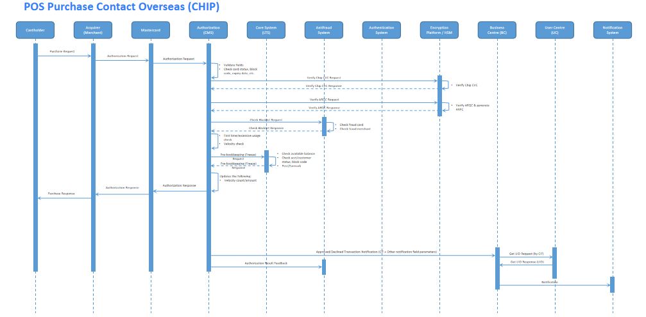
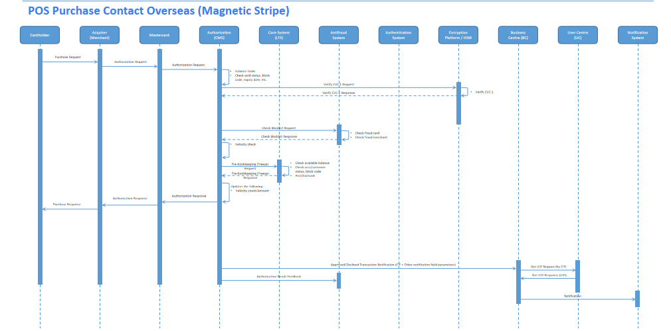
- Fee Processing And Special Handling
Markup Fee: If not SGD currency transaction, will charge the markup fee.
Overseas SGD/DCC Fee: If SGD currency transaction, will charge the DCC fee.

POS Purchase Contactless Domestic（Phase 1）
- Transaction Type Derivation
txnType on CMS | Key Fields in Message
POS Purchase Contactless Domestic | MTI=0100  DE22.SF01=07  DE03.SF01=00  DE61.SF13=702
- Authorization Check Items
Authorization Check Items | Check Priority | Response Priority | Check Method
Card Activation Check | 1 | 1 | Check All, Response By Response Priority
Card Block Code | 2 | 2
Card Status | 3 | 3
CVC/Chip CVC | 4 | 4
CVC2 | N/A | N/A
PIN | 5 | 5
ARQC | 6 | 6
UCAF/IAV | N/A | N/A
Expire Date | 7 | 7
Safety Switch Rules | 8 | 8
Velocity Check | 9 | 9
Anti-Fraud Check | 10 | 10
Magnetic Stripe Activation Check | 11 | 11

- Transaction Flow
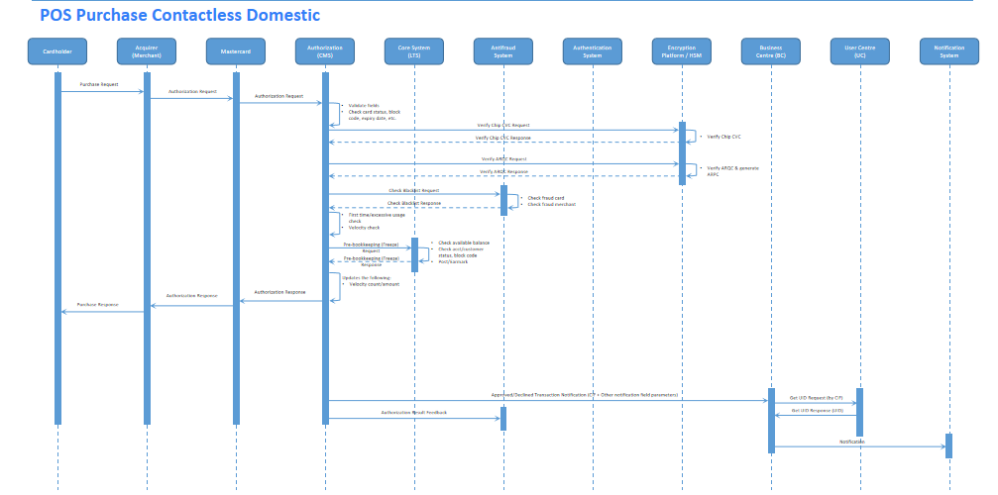
- Fee Processing And Special Handling
Markup Fee: If not SGD currency transaction, will charge the markup fee.
Overseas SGD/DCC Fee: Should not charge the DCC fee regardless the currency.

POS Purchase Contactless Overseas（Phase 1）
- Transaction Type Derivation
txnType on CMS | Key Fields in Message
POS Purchase Contactless Overseas | MTI=0100  DE22.SF01=07  DE03.SF01=00  DE61.SF13<>702
- Authorization Check Items
Authorization Check Items | Check Priority | Response Priority | Check Method
Card Activation Check | 1 | 1 | Check All, Response By Response Priority
Card Block Code | 2 | 2
Card Status | 3 | 3
CVC/Chip CVC | 4 | 4
CVC2 | N/A | N/A
PIN | 5 | 5
ARQC | 6 | 6
UCAF/IAV | N/A | N/A
Expire Date | 7 | 7
Safety Switch Rules | 8 | 8
Velocity Check | 9 | 9
Anti-Fraud Check | 10 | 10
Magnetic Stripe Activation Check | 11 | 11

- Transaction Flow
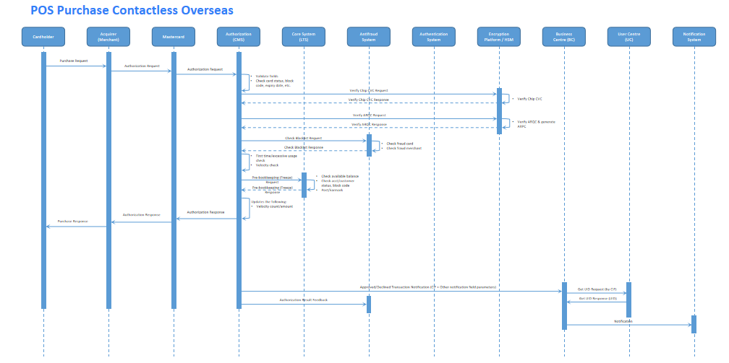
- Fee Processing And Special Handling
Markup Fee: If not SGD currency transaction, will charge the markup fee.
Overseas SGD/DCC Fee: If SGD currency transaction, will charge the DCC fee.

Online Purchase Domestic（Phase 1）
Online Purchase transaction will include the Electronic Commerce Transaction, MOTO transaction and recurring payment transaction.
- Transaction Type Derivation
txnType on CMS | Key Fields in Message
Online Purchase Domestic | MTI=0100  DE22.SF01=81/10/01  DE03.SF01=00  DE61.SF13=702
- Authorization Check Items
Authorization Check Items | Check Priority | Response Priority | Check Method
Card Activation Check | 1 | 1 | Check All, Response By Response Priority
Card Block Code | 2 | 2
Card Status | 3 | 3
CVC/Chip CVC | N/A | N/A
CVC2 | 4 | 4
PIN | 5 | 5
ARQC | 6 | 6
UCAF/IAV | 7 | 7
Expire Date | 8 | 8
Safety Switch Rules | 9 | 9
Velocity Check | 10 | 10
Anti-Fraud Check | 11 | 11
Magnetic Stripe Activation Check | N/A | N/A

- Transaction Flow
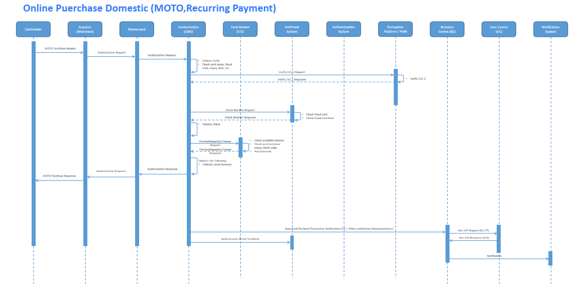
- Fee Processing And Special Handling
Markup Fee: If not SGD currency transaction, will charge the markup fee.
Overseas SGD/DCC Fee: Should not charge the DCC fee regardless the currency.

Online Purchase Overseas（Phase 1）
Online Purchase transaction will include the Electronic Commerce Transaction, MOTO transaction and recurring payment transaction.
- Transaction Type Derivation
txnType on CMS | Key Fields in Message
Online Purchase Overseas | MTI=0100  DE22.SF01=81/10/01  DE03.SF01=00  DE61.SF13<>702
- Authorization Check Items
Authorization Check Items | Check Priority | Response Priority | Check Method
Card Activation Check | 1 | 1 | Check All, Response By Response Priority
Card Block Code | 2 | 2
Card Status | 3 | 3
CVC/Chip CVC | N/A | N/A
CVC2 | 4 | 4
PIN | 5 | 5
ARQC | 6 | 6
UCAF/IAV | 7 | 7
Expire Date | 8 | 8
Safety Switch Rules | 9 | 9
Velocity Check | 10 | 10
Anti-Fraud Check | 11 | 11
Magnetic Stripe Activation Check | N/A | N/A

- Transaction Flow
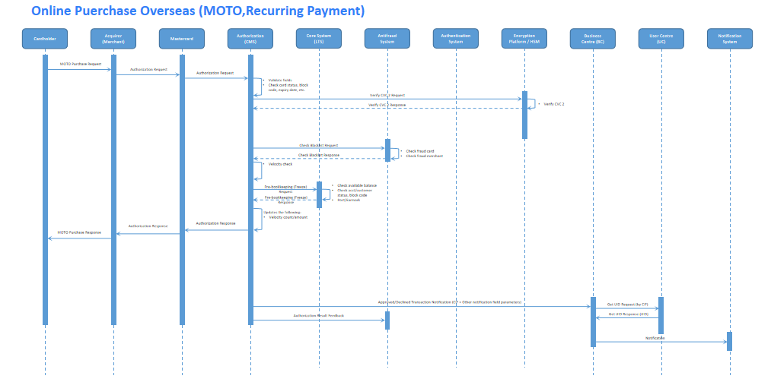
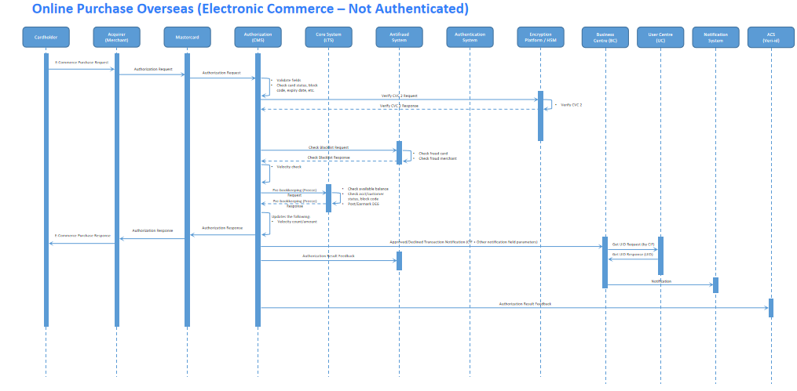
- Fee Processing And Special Handling
Markup Fee: If not SGD currency transaction, will charge the markup fee.
Overseas SGD/DCC Fee: If SGD currency transaction, will charge the DCC fee.

Purchase Refund Domestic（Phase 1）
A refund transaction allows a cardholder to return goods or services previously purchased from a merchant.
- Transaction Type Derivation
txnType on CMS | Key Fields in Message
Purchase Refund Domestic | MTI=0100  DE03.SF01=20  DE61.SF13=702
- Authorization Check Items
Authorization Check Items | Check Priority | Response Priority | Check Method
Card Activation Check | N/A | N/A | Check All, Response By Response Priority
Card Block Code | N/A | N/A
Card Status | N/A | N/A
CVC/Chip CVC | 1 | 1
CVC2 | N/A | N/A
PIN | N/A | N/A
ARQC | 2 | 2
UCAF/IAV | N/A | N/A
Expire Date | 3 N/A | 3 N/A(2024-01-19:Credit transactions not need)
Velocity Check | 8 | 8
Safety Switch Rules | 7 | 7
Anti-Fraud Check | 9 | 9
Magnetic Stripe Activation Check | N/A | N/A

- Transaction Flow
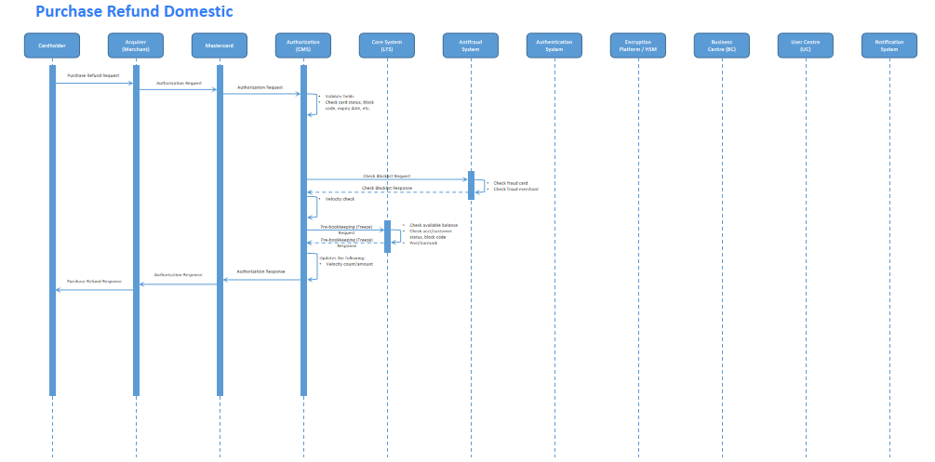

- Fee Processing And Special Handling
- For Refund authorization transactions, only record the transaction info in CMS, not invoke the API to earmark or post to CTS.and invoke Loan’s API to earmark(2023-12-12).
- When calling the CTS API for the Refund transaction(includes refund domestic and refund overseas.), if a timeout occurs, it needs to be returned to Mastercard as a failure. Subsequently, an asynchronous query needs to be performed to check the processing result of the Loan. If the Loan is successfully processed, the auth-cancellation interface needs to be called for reverse processing(2023-12-12).
- 2024-02-02:If the refund transaction(include domestic and overseas) is not matched for more than a certain number of days(Through the configuration of 'MC Final Auth Remaining Days' in Authorization Control, the current configuration is set to 7 days), the cancellation interface needs to be called.

Purchase Refund Overseas（Phase 1）
A refund transaction allows a cardholder to return goods or services previously purchased from a merchant.
- Transaction Type Derivation
txnType on CMS | Key Fields in Message
Purchase Refund Overseas | MTI=0100  DE03.SF01=20  DE61.SF13<>702
- Authorization Check Items
Authorization Check Items | Check Priority | Response Priority | Check Method
Card Activation Check | N/A | N/A | Check All, Response By Response Priority
Card Block Code | N/A | N/A
Card Status | N/A | N/A
CVC/Chip CVC | 1 | 1
CVC2 | N/A | N/A
PIN | N/A | N/A
ARQC | 2 | 2
UCAF/IAV | N/A | N/A
Expire Date | 3N/A | 3N/A(2024-01-19:Credit transactions not need)
Velocity Check | 8 | 8
Safety Switch Rules | 7 | 7
Anti-Fraud Check | 9 | 9
Magnetic Stripe Activation Check | N/A | N/A

- Transaction Flow
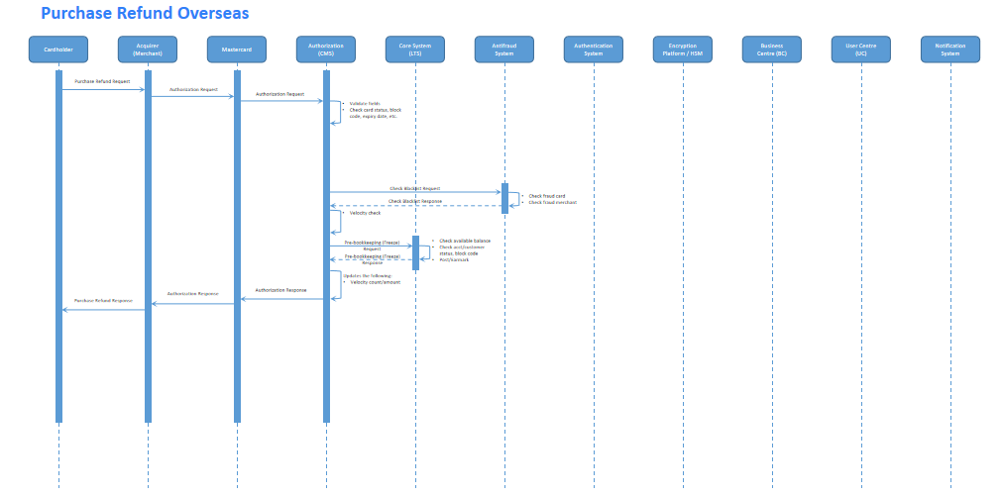
- Fee Processing And Special Handling
For Refund authorization transactions, only record the transaction info in CMS, not invoke the API to earmark or post to CTS.

MoneySend Payment Domestic（Phase 2）
- Transaction Type Derivation
txnType on CMS | Key Fields in Message
MoneySend Payment Domestic | MTI=0100  DE03.SF01=28  DE18=6536  DE48.SE77=C07,C52,C53,C54,C55,C56,C57,C58,C59,C65
- Authorization Check Items
Authorization Check Items | Check Priority | Response Priority | Check Method
Card Activation Check | N/A | N/A | Check All, Response By Response Priority
Card Block Code | N/A | N/A
Card Status | N/A | N/A
CVC/Chip CVC | N/A | N/A
CVC2 | N/A | N/A
PIN | N/A | N/A
ARQC | N/A | N/A
UCAF/IAV | N/A | N/A
Expire Date | 1N/A | 1N/A(2024-01-19:Credit transactions not need)
Velocity Check | 3 | 3
Safety Switch Rules | 2 | 2
Anti-Fraud Check | 4 | 4
Magnetic Stripe Activation Check | N/A | N/A
- Transaction Flow
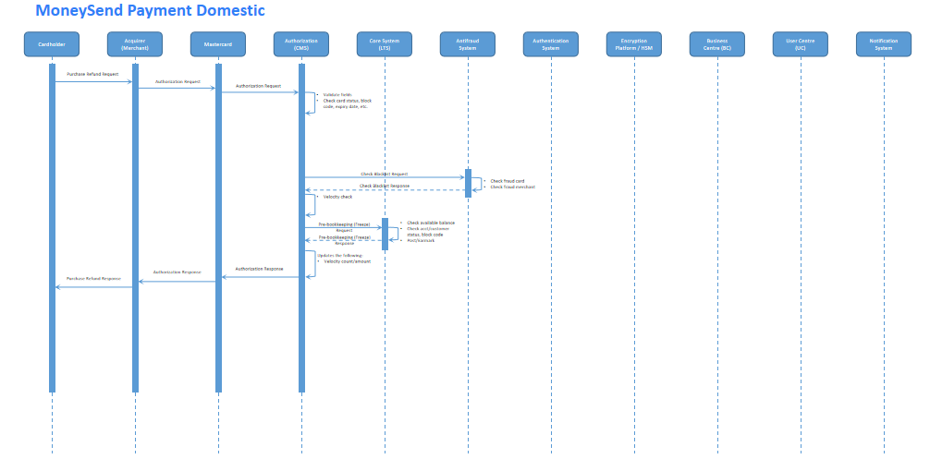
- Fee Processing And Special Handling
- For MoneySend Payment Transactions, if past all the check items in CMS authorization, will call the specified API to CTS . API Path: /api/card/v1/auth/moneysend(2023-11-24)
- 2024-02-27:For MoneySend Bookkeeping Enhancement Required,If the above call to the Loan interface is successful, the MbsdCore_1000_720011(Universal Bookkeeping) API needs to be called again to perform accounting processing and realize the transfer of funds from the Dr Network Interim account to the Cr Suspense Interim Account on the same day.The interface should be called asynchronously. If an exception occurs during the call, the system needs to generate an alert, but it should not affect the result returned to MC.
  - for more API details, can refer the online document：https://docs.google.com/spreadsheets/d/1dkR29HFYV7kQAI_36_7PKfsIffn_HV1o/edit#gid=259689093
Seq | Field Name | Input Source
1 | SOURCE_TYPE | Default value CMS
2 | USER_ID | Default value CMS001
3 | TRAN_TYPE | 2023-12-26:For the latest mapping relations, please refer to <https://docs.google.com/spreadsheets/d/1Rpp-qHQglDTqSmXkFScJpgIaLe15sY9B7mmEQY1HUyM/edit#gid=2044851435>Transaction Type Mapping
4 | TRAN_CCY | Default value SGP
5 | TRAN_AMT | Summary amount
6 | SETTLEMENT_DATE | Settlement date
7 | SETTLEMENT_CYCLE | Settlement cycle

MoneySend Payment Overseas（Phase 2）
2024-02-02：The moneysend overseas transaction is temporarily not supported.

- Transaction Type Derivation
txnType on CMS | Key Fields in Message
MoneySend Payment Overseas | MTI=0100  DE03.SF01=28  DE18=6537  DE48.SE77=C07,C52,C53,C54,C55,C56,C57,C58,C59,C65
- Authorization Check Items
Authorization Check Items | Check Priority | Response Priority | Check Method
Card Activation Check | N/A | N/A | Check All, Response By Response Priority
Card Block Code | N/A | N/A
Card Status | N/A | N/A
CVC/Chip CVC | N/A | N/A
CVC2 | N/A | N/A
PIN | N/A | N/A
ARQC | N/A | N/A
UCAF/IAV | N/A | N/A
Expire Date | 1N/A | 1N/A(2024-01-19:Credit transactions not need)
Velocity Check | 3 | 3
Safety Switch Rules | 2 | 2
Anti-Fraud Check | 4 | 4
Magnetic Stripe Activation Check | N/A | N/A

- Transaction Flow
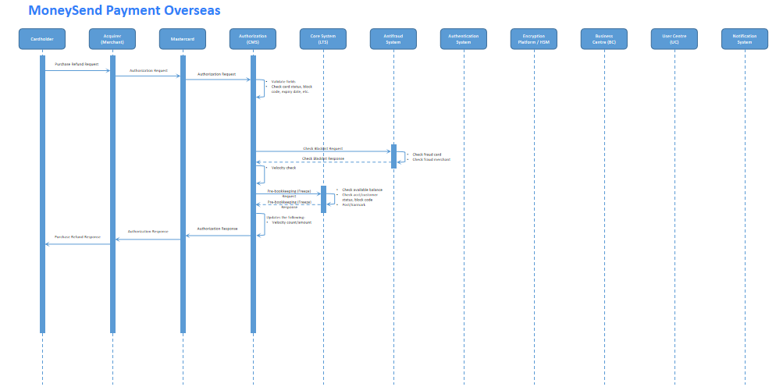
- Fee Processing And Special Handling
- For MoneySend Payment Transactions, if past all the check items in CMS authorization, will call the specified API to CTS . API Path: /api/card/v1/auth/moneysend(2023-11-24)
2024-02-27:For MoneySend Bookkeeping Enhancement Required,refer to the handling of calling the MbsdCore_1000_720011 (Universal Bookkeeping) API in the <3.8.4.9 MoneySend Payment Domestic> section.

ASI For Purchase（Phase1/Phase 2）
- Transaction Type Derivation
txnType on CMS | Key Fields in Message
Account Status Inquiry For Purchase | MTI=0100  DE61.SF07=8  DE03.SF01=00
- Authorization Check Items
Authorization Check Items | Check Priority | Response Priority | Check Method
Card Activation Check | 1 | 1 | Check All, Response By Response Priority
Card Block Code | 2 | 2
Card Status | 3 | 3
CVC/Chip CVC | 4 | 4
CVC2 | 5 | 5
PIN | 6 | 6
ARQC | 7 | 7
UCAF/IAV | N/A | N/A
Expire Date | 8 | 8
Velocity Check | 10 | 10
Safety Switch Rules | 9 | 9
Anti-Fraud Check | 11 | 11
Magnetic Stripe Activation Check | N/A | N/A

- Transaction Flow
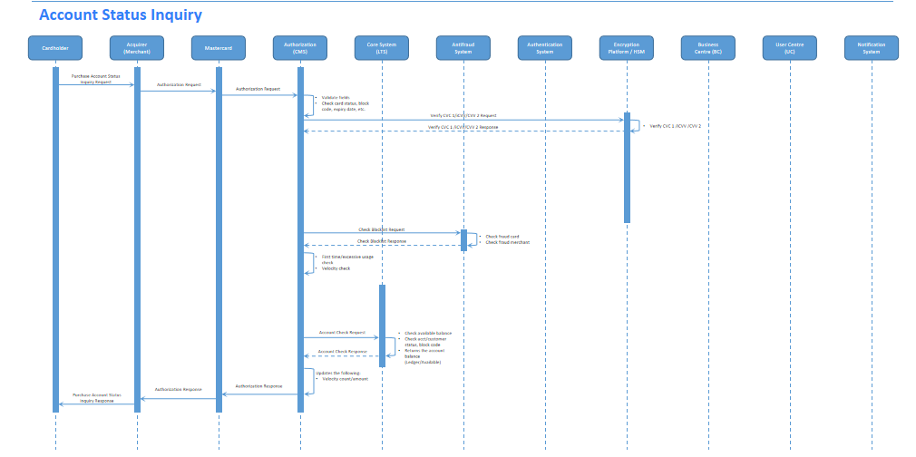
- Fee Processing And Special Handling
Fee Processing will not be involved for the ASI transactions.

ASI For MoneySend Payment（Phase1/Phase 2）
- Transaction Type Derivation
txnType on CMS | Key Fields in Message
ASI For MoneySend Payment | MTI=0100  DE61.SF07=8  (DE03.SF01=28 AND DE18=6536/6537 AND  DE48.SE77=C07,C52,C53,C54,C55,C56,C57,C58,C59,C65)
- Authorization Check Items
Authorization Check Items | Check Priority | Response Priority | Check Method
Card Activation Check | 1 | 1 | Check All, Response By Response Priority
Card Block Code | 2 | 2
Card Status | 3 | 3
CVC/Chip CVC | 4 | 4
CVC2 | 5 | 5
PIN | 6 | 6
ARQC | 7 | 7
UCAF/IAV | N/A | N/A
Expire Date | 8 | 8
Velocity Check | 10 | 10
Safety Switch Rules | 9 | 9
Anti-Fraud Check | 11 | 11
Magnetic Stripe Activation Check | N/A | N/A

- Transaction Flow

- Fee Processing And Special Handling
Fee Processing will not be involved for the ASI transactions.

Authorization Finality（Phase 1）
<Detailed description/transaction flow>

Preauthorization
An authorization request is properly identified as a preauthorization when DE61.SF7=4, and the DE48.SE61.SF5 must be 0 or not present. it may have incremental authorizations associated with it. It must be present within 30 calendar days of the the last authorization approval date.

Final Authorization
Final authorization is an authorization request for an amount greater than zero. Any transaction corresponding to an authorization identified as a final authorization must be presented within 7 calendar days of the authorization approval date. An authorization request is properly identified as a final authorization when DE61.SF7 = 0 and DE 48.SE61.SF5 = 1.
Authorization system will retrieve the fee table and derive the transaction fee applied to this transaction. It will then compute the posting amount (Principal and Fee Charge) and calls the CTS API to do the earmark process.API Path: /api/card/v1/auth/purchase(2023-11-24)
When CTS system returned a good response, the system will then update the velocity statistic data, log the final authorization and set the corresponding approval response code.

Undefined Authorization
An authorization that can’t be identify as neither preauthorization nor final authorization is undefined transaction. The undefined authorization also must be presented within 7 calendar days of the authorization approval date.

Incremental Authorization
Incremental Preauthorization provides a means to associate incremental preauthorization to a single clearing presentment.
Each incremental preauthorization transaction associated with a single cardholder event must reference the original preauthorization. When incremental authorization Request/0100 messages are sent for the same transaction, acquirers must include DE63 (Network Data) and DE15 (Date, Settlement) information from the original Authorization Request Response/0110 message in DE48.SE63 (Trace ID) as follows:
- Positions 1–3 = value from DE 63.SF1 (Financial Network Code)
- Positions 4–9 = value from DE 63.SF2 (Banknet Reference Number)
- Positions 10–13 = value from DE15 (Date, Settlement)
- Positions 14–15 = blank filled

Advice Message（Phase 1）
<Detailed description/transaction flow
- 0420 Advice
Reversal Advice/0420 message fully reverses a previous Authorization Request/0100 message. It advises an issuer of a Reversal Request/0400 message responded to by Mastercard’s Authorization Platform.
Mastercard may generate this message if an exception condition is detected while processing a previous Authorization Request Response/0110 message.
Mastercard may also generate this message when MariBank CMS’ Authorization system is unavailable to respond a Reversal Request/0400 or is delayed in providing a Reversal Request Response/0410 message.
In addition, this message is automatically generated when MariBank received an Authorization Response Negative Acknowledgement/0190 from Mastercard. Transaction duplicate check should also be performed for 0420 reversal advice request before next processing.
The DE39 in the 0420 message is the reason why the Acquirer/MasterCard initiates the reversal, so when the issuer received the 0420 message, should always try to locate the original transaction and handle the reversal based on the result of the original transaction
- 0120 Advice
CMS Authorization does support authorization advice of which Mastercard approves the Authorization Request on behalf of the Issuer. Mastercard will then forward this transaction as an Authorization advice to the Issuer.
CMS Authorization also support authorization advice which is generated by the acquirer. The typical scenario is Automated Fuel Dispenser. An AFD transaction is identified with MCC 5542 and may occur at a cardholder-activated terminal (CAT) or as an e-commerce transaction.
AFD 0100 Request | MTI=0100  MCC=5542
AFD 0120 Advice | MTI=0120  MCC=5542  Advice Reason Code= 191

- The acquirer sends an Authorization Request/0100 message to verify a minimum availability of funds in the cardholder’s account for an Automated Fuel Dispenser transaction.
- The issuer can approve the request and response the 0100 message with 00 or 87(Partial Approve), or decline the request.
- If the request not declined, the acquirer can send 0120 message to the issuer, specifying the total amount of the AFD transaction.
- When CMS received the 0120 AFD message, will locate the original 0100 request, reverse the approved amount in 0110 response , and use the amount in 0120 to earmark the account. The velocity statistics will be updated accordingly.
- The acquirer can also send 0400 to cancel the 0100 AFD messages before send the 0120 advice.
Notes：
If the DE39 have value 08 , 10 , 87 in the 0120 message, it will be considered as approved / partial approved . However, The issuer should not receive 0120 message that having DE39 with value 87 in MariCard.
- 0190 Advice
The Authorization Platform sends an Authorization Response Negative Acknowledgement/0190 message to the issuer, indicating it has no record of a corresponding Authorization Request/0100 message.
When an Authorization Response Negative Acknowledgement/0190 is received from Mastercard, CMS authorization system begins the process by calling the ISO parser API to unpack the incoming Mastercard ISO8583.
When the incoming ISO message was successfully expanded, it will then check whether this is a Negative Acknowledgement/0190 message.

Authorization Reversal Message Processing
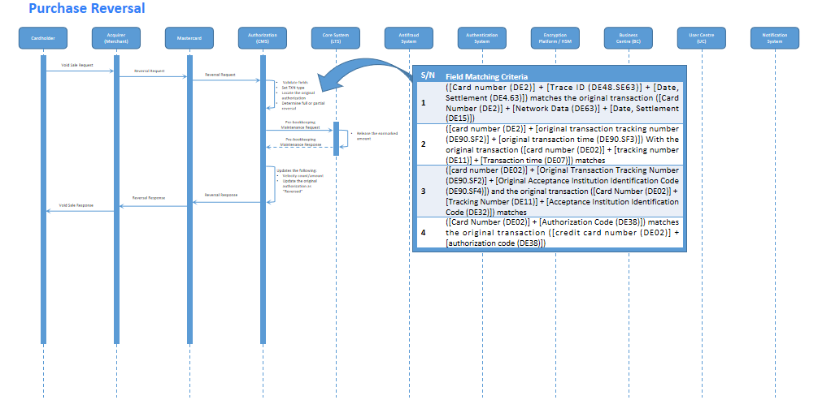
Reversal Request/0400 message reverses fully or partially an earlier authorization request.
When MTI = 0400, the incoming request is reversal transaction, transaction duplicate check should also be performed for reversal request, If passed, authorization system continue to find original transaction. Authorization system will use hash PAN tracking original transaction.
- Searches for the original authorization transaction according to the [Original Transaction Matching Rules] .
  - If the matching fails, set the [Rejection Reason Code] "E00005-Original authorization transaction does not exist" and DE39 = 76.
  - If the match is successful, it is determined whether the original transaction can be reversed
- Original Transaction [Transaction Status] is "2 - Reversed Status", then the transaction is rejected, and set the [Rejection Reason Code] to "E00007-Original transaction has been reversed" and DE39 = 00.
- Original Transaction [Transaction Status] is "3 - Rejected Status", then the transaction is rejected, and set the [Rejection Reason Code] to "E00006-Original transaction has been rejected" and DE39 = 00.
- If original transaction is already settled, then the transaction is rejected, and set the [Rejection Reason Code] to "E00008-Original transaction has been settled" and DE39 = 57.
- Full Reversal Process
If the transaction actual amount (DE95.SF1) is not present or equal to 0, this is a full reversal transaction, authorization system will call the CTS API to release the earmark amount.API Path: /api/card/v1/auth/cancel(2023-11-24).
Full Reversal is applicable for all the purchase,refund and moneysend payment transaction.
- Partial Reversal Process
If the transaction actual amount (DE95.SF1) is present and greater than the transaction amount (DE4), authorization system will decline the reversal transaction, set reject reason code = ‘E00009 - Replacement amount greater than original amount’ and DE39 = 13.

If the transaction actual amount (DE95.SF1) is present, greater than 0 and less than DE4, this is a partial reversal transaction, authorization system will call the CTS API to update the earmarked amount. API Path: /api/card/v1/auth/adjustment(2023-11-24).If the cardholder billing actual amount (DE95 SF3) is present and contains greater than zeros, DE95 SF3 will be the new principal amount, otherwise DE95 SF1 will be used . Velocity statistics will also be reversed.

Partial Reversal Amount Calculation :
- If DE95.SF3 present and greater than zero, the reversal principal amount will be DE06 minus the DE95.SF3, it is in billing currency(SGD).
- If DE95.SF3 not present or equal to zeros, the reversal principal amount will be DE04 minus the DE95.SF1, it is in transaction currency.

Partial Reversal is not applicable for the following transactions:
- MoneySend Payment
- Refund Payment
- ASI

POS Purchase Contact Domestic（Phase 1）
- Locate the original transaction
- Call the CTS API to reverse the earmark amount . API Path: /api/card/v1/auth/cancel(2023-11-24)
- Reverse the amount that have accumulated on the velocity statistics.

POS Purchase Contact Overseas（Phase 1）
- Locate the original transaction
- Call the CTS API to reverse the earmark amount .API Path: /api/card/v1/auth/cancel(2023-11-24)
- Reverse the amount that have accumulated on the velocity statistics.

POS Purchase Contactless Domestic（Phase 1）
- Locate the original transaction
- Call the CTS API to reverse the earmark amount .API Path: /api/card/v1/auth/cancel(2023-11-24)
- Reverse the amount that have accumulated on the velocity statistics.

POS Purchase Contactless Overseas（Phase 1）
- Locate the original transaction
- Call the CTS API to reverse the earmark amount .API Path: /api/card/v1/auth/cancel(2023-11-24)
- Reverse the amount that have accumulated on the velocity statistics.

Online Purchase Domestic（Phase 1）
- Locate the original transaction
- Call the CTS API to reverse the earmark amount .API Path: /api/card/v1/auth/cancel(2023-11-24)
- Reverse the amount that have accumulated on the velocity statistics.

Online Purchase Overseas（Phase 1）
- Locate the original transaction
- Call the CTS API to reverse the earmark amount .API Path: /api/card/v1/auth/cancel(2023-11-24)
- Reverse the amount that have accumulated on the velocity statistics.

Purchase Refund Domestic（Phase 1）
- Locate the original transaction, update the status of the outstanding transaction.
- No earmark amount need to be reversed for Refund transactions.

Purchase Refund Overseas（Phase 1）
- Locate the original transaction, update the status of the outstanding transaction.
- No earmark amount need to be reversed for Refund transactions

MoneySend Payment Domestic（Phase 2）
- Locate the original transaction, update the status of the outstanding transaction
- For MoneySend Payment authorization reversal transaction, will call the specified reversal API to CTS . API Path: /api/card/v1/auth/moneysend/reversal(2023-11-24)
- 2024-01-05:According to the P4 function, moneysend reversal will be adjusted manually without calling the CTS interface. The reversal process above is deleted, and manual adjustment processing is described in the <manual adjustment> section of Clearing Module PRD.
- 2024-02-27:For MoneySend Bookkeeping Enhancement Required,after the above manual adjustment process is completed,the MbsdCore_1000_720011(Universal Bookkeeping) API needs to be called again to perform accounting processing.Refer to the handling of calling the MbsdCore_1000_720011 (Universal Bookkeeping) API in the <3.8.4.9 MoneySend Payment Domestic> section.

MoneySend Payment Overseas（Phase 2）
- Locate the original transaction, update the status of the outstanding transaction
- For MoneySend Payment authorization reversal transaction, will call the specified reversal API to CTS . API Path: /api/card/v1/auth/moneysend/reversal(2023-11-24)
2024-01-05:According to the P4 function, moneysend reversal will be adjusted manually without calling the CTS interface. The reversal process above is deleted, and manual adjustment processing is described in the <manual adjustment> section of Clearing Module PRD.
2024-02-02：The moneysend overseas transaction is temporarily not supported.

ASI For Purchase（Phase 1 / Phase 2）
For ASI reversal messages, just log the transaction into CMS, no need to check or reverse anything.

ASI For MoneySend Payment（Phase 1 / Phase 2）
For ASI reversal messages, just log the transaction into CMS, no need to check or reverse anything.

Authorization Expiry Handling（Phase 2）
Usually the Preauthorization will be present within 30 days and the other type of authorizations will be present within 7 days. If the authorization not matched by the clear & settlement transaction in this period, CMS authorization will call the API to CTS to release the outstanding authorization. API Path: /api/card/v1/auth/cancel(2023-11-24)
Only the Preauthorization will expire in 30 days , the others(2024-02-02:include refund transaction) will expire in 7 days.
There will be a daily batch job to process the outstanding authorization transactions that already expired, use the cancel API to release the earmark amount. After that, the status of the transaction will marked as ‘Released’.
For example, there is a final authorization request been approved on August 01, if this authorization not be matched on August 08, it will be released on the August 08 EOD batch run.

Card Digitization (Tokenization)（P3）

Token Provisioning
For more information, refer to the Card Issuing PRD <Section name and hyperlink>.

Token Authorization
CMS authorization will be enhanced to handle eWallet transactions.
Token transaction is determined based on the following information in the Authorization Request Message/0100:
Data Element ID | Values | Notes
DE48, SE33, SF1 | C = Secure Element | iOS – Apple Pay
 | H = Cloud-based Payments | Android – Google Pay
 | F = Static Token | The merchant store the Token instead of PAN on the file for e-com transactions.
DE48, SE33, SF2 | Token Number | Digital PAN (DPAN)
DE48, SE33, SF3 | Token Expiration Date
DE48, SE33, SF6 | Token Requester ID
For token transactions, MDES will validate the ARQC or UCAF and dynamic CVC 3(Functionally supported) and pass the verification results in DE48, SE71, SF1 (OB Service), and SF2 (OB Service Result) to MariBank.
The CMS Authorization System will be enhanced to check the on-behalf service and set the corresponding approval response based on the results. Following is a list of possible OB services and OBS results:
Data Element ID | Values | Notes
DE48, SE71, SF1 | 50 | MDES PAN Mapping
DE48, SE71, SF2 | C = Successful
DE48, SE71, SF1 | 51 = Secure Element | MDES Chip Pre-validation
 | 52 = Secure Element | MDES CVC3 Chip Pre-validation
DE48, SE71, SF2 | V = Valid
DE48, SE71, SF1 | 61 = Cloud-based Payments | MDES Cloud-based Payments  Chip Pre-validation Service
 | 62 = Cloud-based Payments | MDES Cloud-based Payments  Magnetic Stripe Pre-validation Service
DE48, SE71, SF2 | V = Valid
In addition, CMS will bypass the following security validations for token transactions:(2024-01-19)
When… | Then…
DE48, SE33, SF1 = C, H, F and  DE35 or DE45 present | Bypass CVC or Chip CVC or dynamic CVC 3 validation
DE48, SE33, SF1 = C, H, F and  DE55 present | Bypass ARQC validation
DE48, SE33, SF1 = C, H, F and  DE48, SE43 present | Bypass UCAF validation
DE48, SE33, SF1 = C, H, F and  DE104, SE001 present | Bypass UCAF validation
DE48, SE33, SF1 = C, H, F | Bypass Card Activation validation
The data elements mentioned above carry the token information that will be logged into the authorization database.
2023-12-26:Other banking systems need to perform data statistics on Apple Pay and Google Pay, and DE48SE26SF1 can accurately identify the specific methods, so it needs to be saved to the database and synchronized with the data warehouse later.

Token Life Cycle Management
For more information, refer to the Card Issuing and CMS Portal PRD <Section name and hyperlink> and <Section Name and hyperlink> respectively.

DWH Requirement
Full data load into the warehouse.

Admin Portal

Transaction Type Code（Phase 1）
After receiving incoming message from MC, authorization system will go through all the transaction identification configurations according to priority (the smaller number the priority higher) to capture some result information like transaction type code

The below table is an excerpt of the transaction type list that user can search configuration by priority and description.
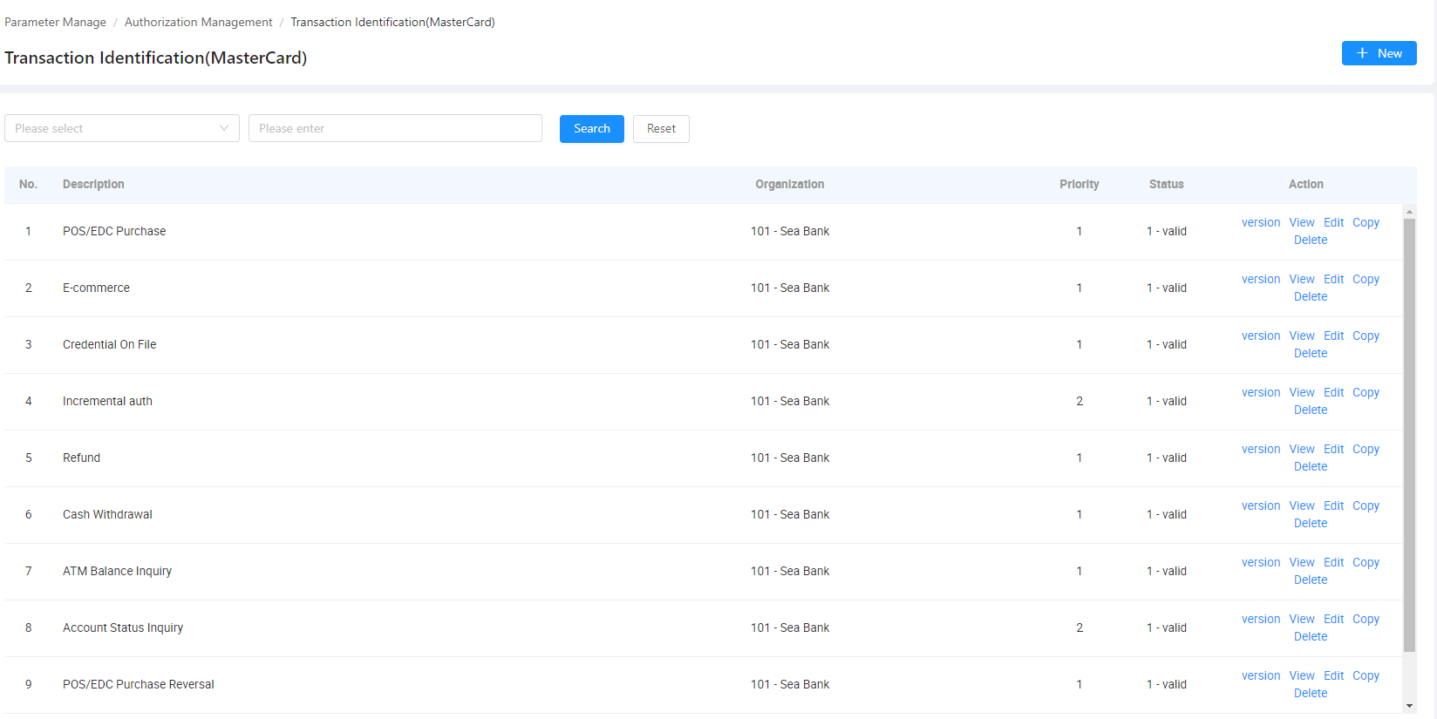
Following are the functions that can be performed in the Transaction Configuration screen.
- New: Allows the user to add/insert a new transaction type configuration
- Version: Shows all the history versions and/or the audit logs
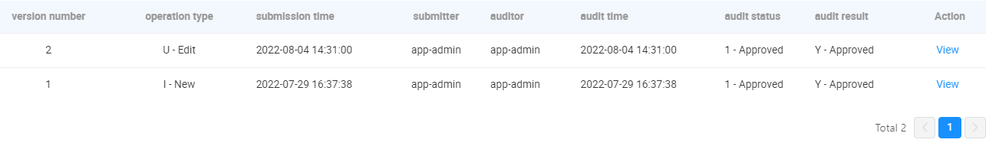
- View: Shows the configuration details.
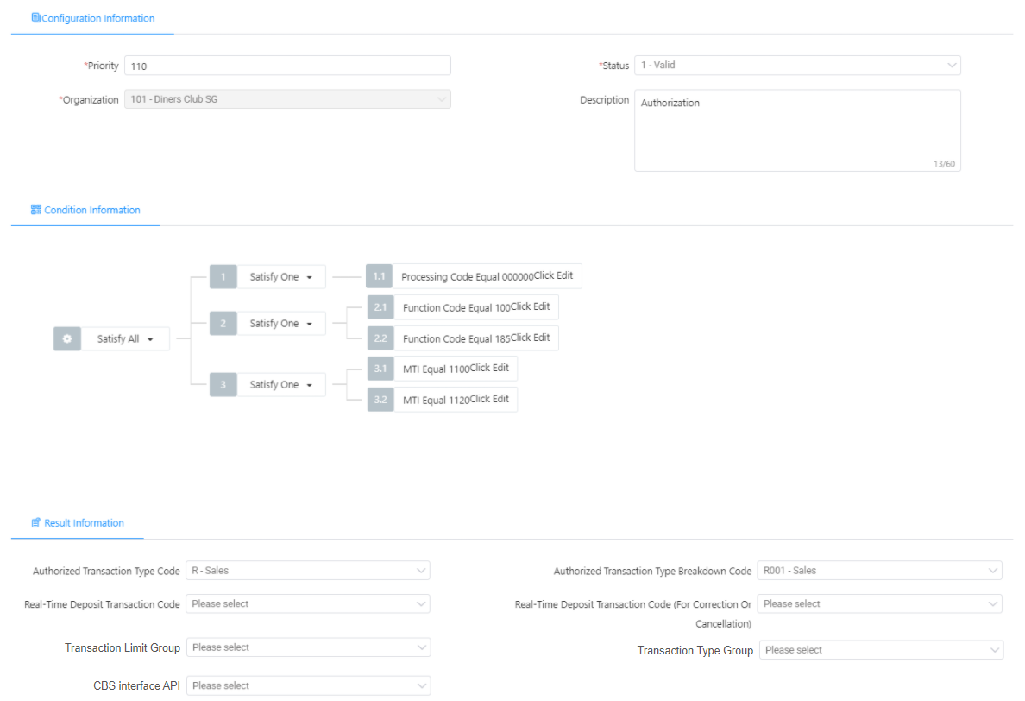
Authorized Transaction Type Code and Authorized Transaction Type Breakdown Code will be defined in system dictionary: System -> Organization Component - > System Dictionary - > AUTH_TRANSACTION_TYPE.
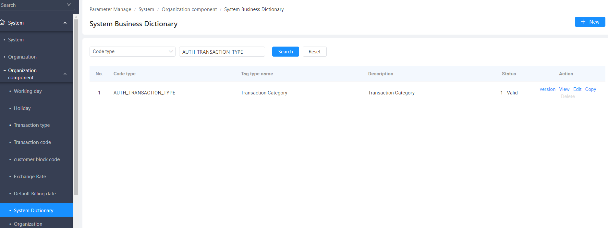
User can view/add/update/delete the authorization type.
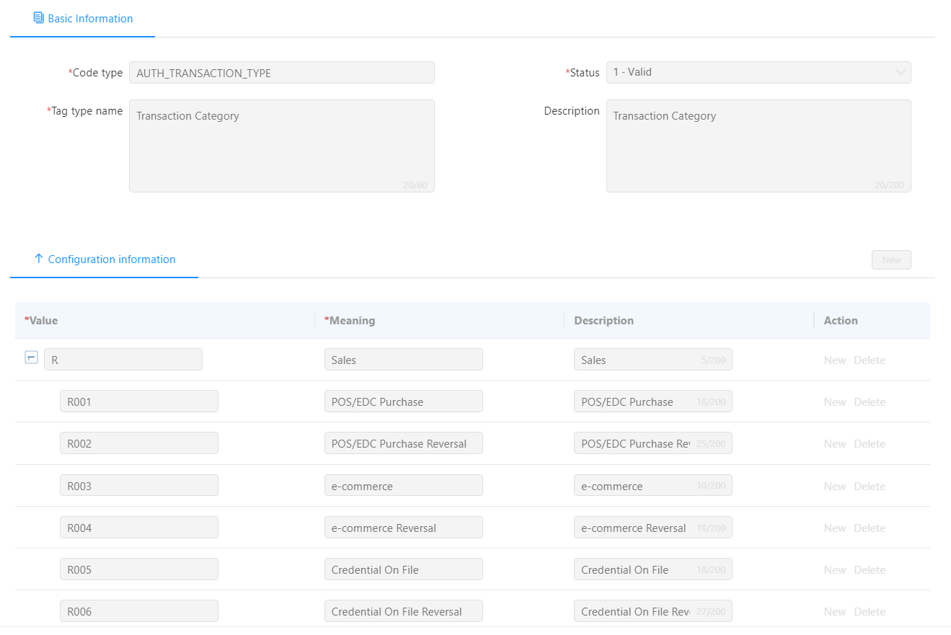
- Edit: Allows the user to update existing configuration record
- Copy: Allows the user to copy an existing configuration record. A new record will be added in table.
- Delete: Allows the user to delete an existing configuration record

Report（Phase 2）
No Authorization Report requirement .

Notification Message（Phase 2）

Notification
The following scenario in authorization process will trigger the notification.(2023-12-26)
Scenario | Template ID | Condition | parameter
Card Transaction Successful | 1000410 | Card payment transaction is successful | ${TIMESTAMP_CARD_TRANSACTION}  ${TRANSACTION_AMOUNT}  ${LAST_4_CARD_NUMBER}  ${MERCHANT_NAME}  ${TRANSACTION_NO}  ${TRANSACTION_SUBCATEGORY}
Card Transaction Unsuccessful  (Generic Message) | 1000412 | Card payment transaction is unsuccessful. Provide generic message if none of the custom message applies. | ${TIMESTAMP_CARD_TRANSACTION}  ${TRANSACTION_AMOUNT}  ${LAST_4_CARD_NUMBER}  ${MERCHANT_NAME}  ${TRANSACTION_NO}  ${TRANSACTION_SUBCATEGORY}
Card Transaction Unsuccessful  (Physical Card not Activated) | 1000413 | Card payment transaction is unsuccessful due to physical card not activated | ${TIMESTAMP_CARD_TRANSACTION}  ${TRANSACTION_AMOUNT}  ${LAST_4_CARD_NUMBER}  ${MERCHANT_NAME}  ${TRANSACTION_NO}  ${TRANSACTION_SUBCATEGORY}
CVC Reached Max Attempts | 1000414 | CVC reached maximum attempts allowed. N1 block code is placed. | ${LAST_4_CARD_NUMBER}  ${TIMESTAMP_BLOCK_N1}
CVC2 Reached Max Attempts | 1000415 | CVC2 reached maximum attempts allowed. N2 block code is placed. | ${LAST_4_CARD_NUMBER}  ${TIMESTAMP_BLOCK_N2}
Merchant Refund Transaction | 1000416 | Merchant refund payment to card is successful | ${TIMESTAMP_REFUND_TRANSACTION}  ${TRANSACTION_AMOUNT}  ${LAST_4_CARD_NUMBER}  ${MERCHANT_NAME}  ${TRANSACTION_NO}  ${TRANSACTION_SUBCATEGORY}
Incoming MoneySend Payment | 1000417 | Incoming moneysend payment (either local or overseas) is successful | ${TIMESTAMP_MONEYSEND_TRANSACTION}  ${TRANSACTION_AMOUNT}  ${LAST_4_CARD_NUMBER}  ${MERCHANT_NAME}  ${TRANSACTION_NO}  ${TRANSACTION_SUBCATEGORY}
Card Transaction Unsuccessful  (Card Locked) | 1000424 | Card payment transaction is unsuccessful due to card is locked (either by B0 or C0 block codes) | ${TIMESTAMP_CARD_TRANSACTION}  ${TRANSACTION_AMOUNT}  ${LAST_4_CARD_NUMBER}  ${MERCHANT_NAME}  ${TRANSACTION_NO}  ${TRANSACTION_SUBCATEGORY}
Card Transaction Unsuccessful  (Overseas Payment Disabled) | 1000428 | Card payment transaction is unsuccessful due to overseas payment control is off | ${TIMESTAMP_CARD_TRANSACTION}  ${TRANSACTION_AMOUNT}  ${LAST_4_CARD_NUMBER}  ${MERCHANT_NAME}  ${TRANSACTION_NO}  ${TRANSACTION_SUBCATEGORY}
Card Transaction Unsuccessful  (Online Payment Disabled) | 1000429 | Card payment transaction is unsuccessful due to online payment control is off | ${TIMESTAMP_CARD_TRANSACTION}  ${TRANSACTION_AMOUNT}  ${LAST_4_CARD_NUMBER}  ${MERCHANT_NAME}  ${TRANSACTION_NO}  ${TRANSACTION_SUBCATEGORY}
Card PIN Reached Max Attempts | 1000438 | Card PIN reached maximum attempts allowed. N0 block code is placed. | ${LAST_4_CARD_NUMBER}  ${TIMESTAMP_BLOCK_N0}
Please take note that Online Transaction 3DS Authentication OTP should not be triggered by the CMS.
2023-12-26：
According to the requirements of Rewards, new parameter is used for APP location-based transactions, and when clicked in the notification bar, it will redirect to the specific transaction details page.
New parameter | Logic
${TRANSACTION_NO} | Authorization Reference No.(AuthGlobalFlowNumber)
${TRANSACTION_SUBCATEGORY} | if this is a purchase auth, Assigned to CARD PURCHASE  if this is a refund auth, Assigned to REFUND CARD PURCHASE  if this is a moneysend, Assigned to MONEYSEND

Business Alerts
<Detailed description/transaction flow>

Issuer File Update(P3)
- Function description
The bank can synchronize the change information of the card to MasterCard through the Issuer File Update function. Subsequently, MasterCard will refer to the change information when deciding authorization on behalf of the issuer.
- Scope of application
Currently we only consider scenarios where the block code updates to trigger this processing. Contains F0 and G0 block code, other block codes are not affected.
- Process method
Issuer File Update function mainly includes the following scenarios:
Current block code | Updated | DE91 in 0302 message | Field 2 in MCC102
Blank(Normal),  C0,B0,N0,N1,N2,N3 | G0 | 1-Add | O-Other
Blank(Normal),  C0,B0,N0,N1,N2,N3 | F0 | 1-Add | O-Other
G0 | Blank(Normal),  C0,B0,N0,N1,N2,N3 | 3-Delete | /
F0 | Blank(Normal),  C0,B0,N0,N1,N2,N3 | 3-Delete | /
G0 | F0 | No processing required | /
F0 | G0 | No processing required | /
The Issuer File Update function in CMS is implemented by sending the 0302 online message to update the MCC102 file of MasterCard.The 0302 message should be sent to MasterCard in quasi-real-time basis. If the message sent out but not received the response, need to try again and up to three times, If it still fails, an alert is required.
2023-12-26:If there is an exception in the authorization module sending 0302 message to Mastercard, it will be written into the exception handling table. System batch will automatically resend every 15 minutes until it is successfully sent (the maximum number of times of resend is currently configured as 999).
For the 0312 message received, DE39 in the message indicate the processing result of the processing.
Value | Description | CMS Action
00 | Issuer File Update action completed successfully | No action need
25 | Unable to locate record on file (no action taken) | No action need
26 | Record already in active status | No action need
27 | Issuer File Update field edit error | Alert
28 | Record permanently deleted | No action need
29 | Delete request less than 540 days | Alert
30 | Format error | Alert
40 | Requested function not supported | Alert
63 | Security violation | Alert
80 | Duplicate add, action not performed | No action need
96 | System error | Retry
CMS needs to create a new data table for recording the MCC102 processing, assemble the 0302 online message to be sent to MasterCard by asynchronous means, and update the CMS data table after getting the return response message/0312 from MasterCard.We can use this data table to track processing progress in CMS.
  - 0302 online message layout:
DE ID | Field Name | Notes
- | Message Type Identifier (MTI) | ‘0302’
- | Bit Map, Primary | Mandatory
1 | Bit Map, Secondary | Mandatory
2 | Primary Account Number(PAN) | PAN
7 | Transmission Date and Time | Transaction time stamp;
11 | Systems Trace Audit Number (STAN) | Transaction trace number; must be unique value for transaction initiator within each UTC day.
33 | Forwarding Institution ID Code | Mastercard-assigned customer ID code. Identifies the institution submitting this file maintenance request.
56 | Payment Account Data | ‘MCC102’ is not required
63 | Network Data | Not Required for issuer.
91 | Issuer File Update Code | Refer to the table above.
96 | Message Security Code | Issuer File Update password or security code used to authenticate Issuer File Update permissions.  Data must be provided in EBCDIC hexadecimal format.
101 | File Name | ‘MCC102’
120 | Record Data | Assembled according to MCC102 format
127 | Private Data | ‘MCC102’ is not required

Manual Adjustment(P4:2023-11-02)
- Required Manual Adjustment scenarios include:
- Handling of Moneysend Reversal transactions in Authorization process.
- During the Authorization process, if the transaction is identified as a Moneysend Reversal transaction, CMS does not need to call Loan's API for posting. Instead, it needs to be marked as ‘Manual Adjustment’ to generate a Manual Adjustment report at the end of the day, and send a notification to the business when the report has been successfully generated, so that the subsequent business can be based on the report records to be processed manually.
- A new field has been added to mark 'Manual Adjustment' so that it can subsequently be used to filter the data.
- Other scenarios refer to CMS Clearing PRD.
- Report generation, sending notifications, Portal presentation, reference to Clearing PRD.

Error Code and Response Code Mapping
2023-12-26：Refer to the description of DE 39 (Response Code) in MasterCard's Customer Interface Specification.

Security Requirements

User Access Matrix

Audit Log

Monitoring and Alarms

Monitoring Item

Alarm Template

Data Design

Transaction Signing

Rollout plan

Country roll-out plan

Production operation plan

Other requirements

Financial Risk Assessment

Risk and Mitigation

Risk Assessment Metrics

Risk and Impact Considerations

Risk Assessment

Additional Security Measures

System Activity Logging

Security Event Tracking and Exception Handling

Appendix

