Федеральное государственное автономное образовательное учреждение
высшего образования
«Национальный исследовательский университет «Высшая школа экономики»

Факультет биологии и биотехнологии
Образовательная программа «Когнитивная нейробиология»
бакалавриат

О Т Ч Е Т
по проектной практике

научно-исследовательский или прикладной проект
(исследовательский)

Применение нейронных сетей для классификации паттернов ЭМГ-сигналов при написании цифр

Выполнил студент 2 курса гр. БКОНЕ241

Юркин Олег Викторович

Проверил:
Макарова Анна Отчество

____________________________
(подпись)

______________
(дата)

Outline

Introduction

Methods

Results

Conclusion

References

Supplementary

Introduction
Surface electromyography (sEMG) has become a cornerstone of modern human-machine interaction (HMI) systems, providing a non‑invasive physiological interface that reflects movement intent by measuring the electrical potentials generated during muscle contractions (Li et al., 2021). These signals find extensive application in the control of assistive robotics, such as intelligent prosthetic hands and exoskeletons, as well as in neurological rehabilitation for patients with upper limb impairments (Atzori et al., 2016). Beyond medical fields, sEMG is increasingly utilized for daily interaction with consumer electronics, biometric identification, and even complex motor tasks like handwriting decoding (Linderman et al., 2009). However, the practical deployment of these technologies is hindered by the high non‑stationarity and noise levels of the signal, along with the significant inter‑subject variability inherent in neuromuscular systems (Ameri et al., 2020). While models often achieve high performance in controlled laboratory settings for specific users, their accuracy frequently deteriorates when applied to new individuals due to differences in muscle mass, subcutaneous fat, skin impedance, and personalized movement habits (Hu et al., 2021).
Researchers have historically approached the challenge of robust gesture recognition through two primary methodologies. The first group of studies focused on handcrafted feature engineering combined with traditional machine learning algorithms. Descriptors in the time domain (e.g., Mean Absolute Value, Root Mean Square, Waveform Length), frequency domain, and time‑frequency domain have been used to characterize muscle activity (Li et al., 2021). For instance, Karapinar Senturk and Bakay (2021) demonstrated that classifiers like Support Vector Machines (SVM) and Naive Bayes could achieve high accuracy on small, balanced datasets, with Naive Bayes reaching over 97% for specific gestures (they used a dataset of 10 able‑bodied subjects performing 6 hand gestures). Despite these results, traditional models often require individual‑specific training and are highly sensitive to physical variations like electrode shift, leading to accuracy drops of 15–20% when sensor placement changes even slightly (Hu et al., 2021).
The second group of research leverages deep learning (DL) to automate feature extraction and improve robustness (Côté-Allard et al., 2019). Architectures such as Convolutional Neural Networks (CNNs) and Recurrent Neural Networks (RNNs) have shifted the paradigm from feature engineering to feature learning (Atzori et al., 2016). Compact CNN models, such as the one proposed by Zheng and Chen (2020), achieved 98.81% accuracy on the Myo Dataset (8 channels, 10 subjects, 7 hand gestures) using a five‑fold within‑subject cross‑validation protocol. Hybrid architectures like CNN‑LSTM have also been employed to capture both local spatial patterns and temporal dynamics (Li et al., 2021). However, it is crucial to note that all these deep learning results were reported within‑subject validation (training and testing on different segments of the same individual). When the same models were evaluated on completely unseen users, performance dropped substantially, highlighting that cross‑user generalization remains a significant hurdle for end‑to‑end deep learning (Wang et al., 2023).
To bridge this generalization gap without requiring cumbersome per‑user calibration, a third group of studies has emerged focusing on domain adaptation and transfer learning (Ameri et al., 2020). These methods aim to extract subject‑invariant features that are solely related to the gesture pattern. For example, Wang et al. (2023) proposed an Iterative Self‑Training based Domain Adaptation (STDA) method to align data distributions between existing users and new users. On the NinaPro DB‑5 dataset (10 able‑bodied subjects, 52 gestures), STDA provided up to a 25% improvement over baseline models, although the final cross‑user accuracy remained moderate (approximately 52.69% for 52 gestures). Another innovative approach, proposed by Yuan et al. (2024), involves disentanglement models using autoencoders to separate task‑specific components from subject‑specific ones. This method enabled cross‑subject accuracies up to 84.3% on a dataset of 20 subjects performing 12 hand gestures, but still required careful calibration of the latent space. In parallel, data augmentation and signal normalization techniques have been explored to reduce the impact of electrode shift. Wu et al. (2020) demonstrated that dilated CNNs combined with data augmentation (simulating electrode displacement) improved HD‑sEMG pattern recognition robustness, while Tanaka et al. (2022) showed that sliding‑window normalization (SWN) can mitigate performance degradation caused by sensor repositioning. Despite these advances, achieving high accuracy on completely unseen users while maintaining robustness against daily signal variability and sensor displacement is still an open research question (Ameri et al., 2020; Li et al., 2021).
This study aims to address the limitations of cross‑subject generalization by systematically investigating the impact of different validation protocols (within‑subject 5‑fold cross‑validation vs. leave‑one‑subject‑out cross‑validation) on three classes of models: traditional machine learning (SVM, Logistic Regression, XGBoost) with hand‑crafted time‑domain features, a compact 1D CNN, and a hybrid CNN‑Transformer architecture. Building on recent findings that sliding‑window normalization (Tanaka et al., 2022) and spatial data shifts (Wu et al., 2020) can mitigate performance degradation, we propose a methodology centered on optimizing the model’s ability to learn from a diverse pool of subjects. We specifically examine the impact of different dataset partitioning strategies and the integration of on‑paper slicing and band‑pass filtering to enhance the stability of deep learning models in multi‑user scenarios. Our results quantify the generalisation gap between within‑subject and cross‑subject evaluations and provide practical recommendations for building more robust myoelectric interfaces.

Methods

Dataset and Signal Recording
This work utilised a dataset collected using the protocol described in the study by Linderman et al. (2009). The data consist of surface electromyography (sEMG) recordings from 11 participants, each of whom performed a task involving writing handwritten digits. The participant sat at a table and wrote the digits from ‘0’ to ‘9’ on an Intuos 3/Wacom graphics tablet. Each digit was written approximately 50 times, resulting in around 500 trials per recording session.
Muscle electrical activity was recorded using eight bipolar surface electrodes placed on the forearm and hand muscles involved in finger and hand movements during writing. Four electrodes were placed on the forearm (radial wrist flexor, finger extensor, ulnar wrist extensor, radial wrist extensor) and four on the hand (thumb opponens, short abductor of the thumb, medial and lateral heads of the first dorsal interosseous muscle). A reference electrode was placed on the forehead. The sEMG signals were amplified (gain factor 1000), band-pass filtered (5-500 Hz) and digitised at a rate of 1000 Hz. To synchronise the physiological data with the moments when digits were written on the tablet, a piezoelectric film was used to detect pen contact with the surface (state on_paper == 1). This allowed the temporal boundaries of each trial to be precisely identified.

Data pre-processing
Based on preliminary experiments, an optimal pre-processing configuration was selected, consisting of three components (referred to in the text as F1, F2, F3).
F1 - dynamic window boundaries. Previously, the signal was divided into windows of fixed length, which did not account for the varying writing speeds of different people. Instead, for each trial, the exact start and end times of the movement were determined: the start being the moment the pen touched the surface (on_paper == 1), and the end being the moment the pen lifted off. Intervals of 150 ms before and after were added to the detected boundaries (step_back = 150, step_forward = 150) so as not to lose information about the preparation and completion of the movement.
F2 - filtering on a continuous signal. To avoid edge distortions, filtering was performed not on individual windows but on the original continuous recording. A 4th-order Butterworth bandpass filter with a passband of 20–450 Hz (sometimes the lower limit was lowered to 5 Hz) and a 50 Hz notch filter were applied to suppress mains interference.
F3 - normalisation across the entire session. Instead of per-channel normalisation within each individual trial (which distorted amplitude ratios), the mean and standard deviation were calculated for each channel across all data from a specific subject for the entire session. This allowed the natural dynamics of muscular effort between different symbols to be preserved.
All three improvements were applied together (F1+F2+F3) in the final pipeline.

Baseline models
For comparison, classical machine learning algorithms and a simple convolutional neural network were used. All baseline models were trained on features extracted from the raw signal using the `extract_emg_features` function, which calculates four temporal descriptors for each of the 8 channels: mean absolute value (MAV), root mean square (RMS), variance, and signal length (waveform length). The features were standardized (StandardScaler) on the training set.
Classical models:
- Logistic regression: multinomial loss, lbfgs solver, maximum number of iterations 2000.
- Support Vector Machine (SVM): RBF kernel, regularisation parameter C=1.0, gamma=“scale”, probability enabled.
- XGBoost: 150 trees, maximum depth 4, learning rate 0.1, subsampling 0.8, target multi:softprob.
- Neural network baseline - simple 1D-CNN (SimpleCNNBaseline).

Final model. CNN‑Transformer
The final architecture combines parallel depthwise convolutions with a transformer encoder. The model parameters are shown in Table 1.
Table 1. Parameters of the final CNN-Transformer model.
Parameter | Meaning | Description
in_ch | 8 | Number of EMG input channels
n_classes | 10 | Number of classes (digits 0–9)
d_model | 64 | Latent space dimensionality
n_heads | 4 | Number of attention heads
ff_dim | 256 | Hidden layer size in the Transformer
num_layers | 2 | Number of layers in the TransformerEncoder
dropout | 0.01 | Dropout probability
k_cnn | 15 | Kernel size for compression (ChannelCNN)
stride_cnn | 24 | Compression stride
k1, k2, k3 | 11, 55, 75 | Kernel sizes of parallel depthwise convolutions
env_size | 181 | Window size for envelope smoothing
The parallel depthwise convolution block has three branches with kernel sizes 11, 55, and 75. This design captures both local and long-range patterns simultaneously. The outputs from these branches are averaged, passed through a ReLU activation, and then smoothed using a low-pass filter with a kernel size of 181 to produce a continuous EMG amplitude envelope. The smoothed envelope is fed into a ChannelCNN layer with a stride of 24. This reduces the temporal dimension and projects the signal into a latent space of size 64. Sinusoidal embeddings are added to the latent representation. The transformer encoder consists of two layers with 4 attention heads each, a hidden layer size of 256, GELU activation, and a dropout rate of 0.01. A linear layer outputs predictions over 10 classes. The maximum number of epochs varies between 350 and 500 depending on the validation protocol. An early stopping mechanism is used with patience ranging from 50 to 150 epochs to ensure convergence.

Data augmentation
All augmentations are applied only during training (when self.training == True). Each augmentation is activated with a specified probability. The augmentation parameters are shown in Table 2.
Table 2. Data augmentation methods and their parameters.
Метод | Описание | Вероятность | Параметры
Noise | Adding Gaussian noise scaled relative to the RMS of each channel | 0.35 | noise_rms_frac=0.1
Gain | Random amplitude change (multiplicative factor from a log-normal distribution) | 0.70 | gain_log_std=0.25
Time shift | Cyclical time shift of the signal | 0.50 | max_shift=120
Channel dropout | Zeroing random channels (simulating electrode failure). | 0.45 | ch_drop_rate=0.25
Time mask | Zeroing a random continuous time segment | 0.60 | tmask=100
Time warp | Nonlinear time stretching/compressing (interpolation). | 0.005 | twarp_strength=0.3
Bracelet shift | Spatial channel shift (simulating bracelet displacement). | 0.70 | max_frac_shift=0.5

Validation protocols
Two independent protocols were used to monitor overfitting and assess generalization ability.
- Within-Subject Stratified 5-Fold Cross-Validation. Data from each subject is shuffled and split into 5 folds, maintaining original class balance (stratification). The model trains on 4 folds and tests on the remaining fold.
- Leave-One-Subject-Out (LOSO) Protocol. Data from one subject is entirely excluded from training and used only for final testing (test subject). Data from a second subject is used for validation and early stopping (validation subject). This setup prevents data leakage and simulates working with a new user.

Metrics and logging
For each fold and model, the following metrics were calculated Accuracy, Macro F1-score.
To ensure reproducibility the following were saved and logged during experiments:
- Fold splits: indexes or subject IDs included in train, validation, and test sets, along with sample proportions.
- The random_state value used to fix seeds for all random operations.
- Quality metrics for each fold, plus mean and standard deviation across folds.
- Confusion matrix for each experiment, visualized with matplotlib and saved as PNG with transparent background and 300 dpi.
All graphs and tables in the Results section are based on these saved data.

Results

Evaluation of Classical Classifiers and Hybrid CNN-Transformer Architecture via 5-Fold Cross-Validation
The initial comparative analysis demonstrated that the proposed end-to-end hybrid deep learning architecture (CNN-Transformer) achieved a decoding performance closely matching that of the traditional machine learning pipeline based on manual feature engineering. The classical model, utilizing hand-crafted time-domain features and ensemble classifiers, achieved a mean classification accuracy of 78.81% (std = 13.47%). In comparison, the end-to-end deep learning framework reached a mean accuracy of 78.74% (std = 13.00%). A paired t-test confirmed that the performance difference between these two distinct paradigms at this stage was not statistically significant (t = 0.049, p = .9616).
Despite the highly similar global averages, a granular examination of the results across individual participants revealed substantial inter-subject variability (see Figure 1). Both modeling approaches exhibited highly robust and stable predictions for specific users; for instance, Subjects 7, 9, and 10 consistently achieved accuracies of approximately 90% with minimal variance across folds (SD < 0.03). Conversely, performance degraded drastically on other participants, as evidenced by Subject 8, who obtained a mean accuracy of only 50.2%, and Subject 2, who exhibited a high standard deviation across the validation folds.
To further investigate the underlying performance bottlenecks of the hybrid DL model, the cross-validation confusion matrices were aggregated and analyzed (see Figure 2). The matrix revealed systematic classification errors and recurrent confusions between specific character classes. These misclassifications were predominantly concentrated among numeric digits that share highly overlapping graphomotor trajectories and similar physical stroke patterns, most notably between "4" and "7".
Taken together, these baseline findings indicate that while end-to-end deep learning networks can successfully bypass manual feature engineering without a loss in accuracy, they remain critically sensitive to subject-specific signal characteristics and minor behavioral variations in handwriting. This severe performance drop on outlier subjects and the presence of structural trajectory confusions directly motivated the subsequent phases of this study, which focus on implementing targeted data augmentation techniques and exploring advanced cross-subject generalization protocols.
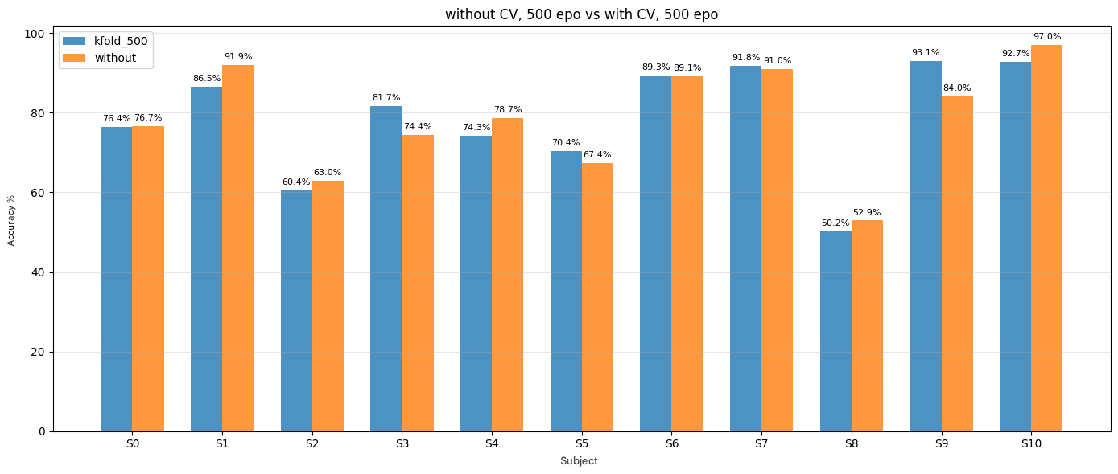
Figure 1. Comparison of Classification Accuracy Across Individual Subjects Using Classical and Deep Learning Pipelines.
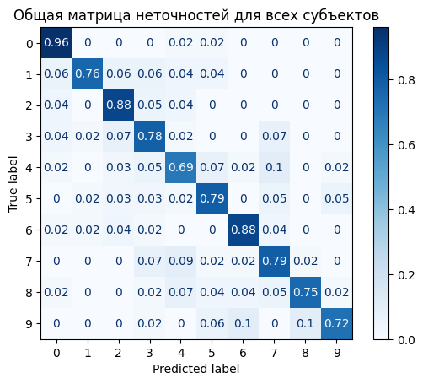
Figure 2. Within-Subject Confusion Matrix for the Hybrid CNN-Transformer Architecture.

Impact of Dataset Preprocessing and Preparation Techniques on Classification Results
Following the update to the model architecture and the implementation of two validation protocols (Within-Subject and LOSO), a study was conducted to assess the impact of three improvements (F1, F2, F3), described in methods 2.3, in data pre-processing.
All 8 possible combinations of these parameters were examined - ranging from all three disabled to all three enabled - to determine the optimal pre-processing option. The study was conducted using data from three participants (M5, C, A) with the LOSO protocol: each participant served in turn as a test subject, one as a validation subject, and the others as training subjects. The results are presented in Table 3 and Figure 3.
Table 3. The accuracy and macro F1 scores for different combinations of pre-processing methods.
Applied feature | Within accuracy | Within F1 | LOSO accuracy | LOSO F1
Nothing | 0.682 | 0.664 | 0.094 | 0.067
F1 | 0.771 | 0.763 | 0.141 | 0.057
F2 | 0.690 | 0.668 | 0.115 | 0.057
F3 | 0.707 | 0.692 | 0.100 | 0.038
F1+F2 | 0.769 | 0.760 | 0.122 | 0.045
F1+F3 | 0.761 | 0.749 | 0.184 | 0.102
F2+F3 | 0.687 | 0.668 | 0.085 | 0.042
F1+F2+F3 | 0.770 | 0.762 | 0.186 | 0.092
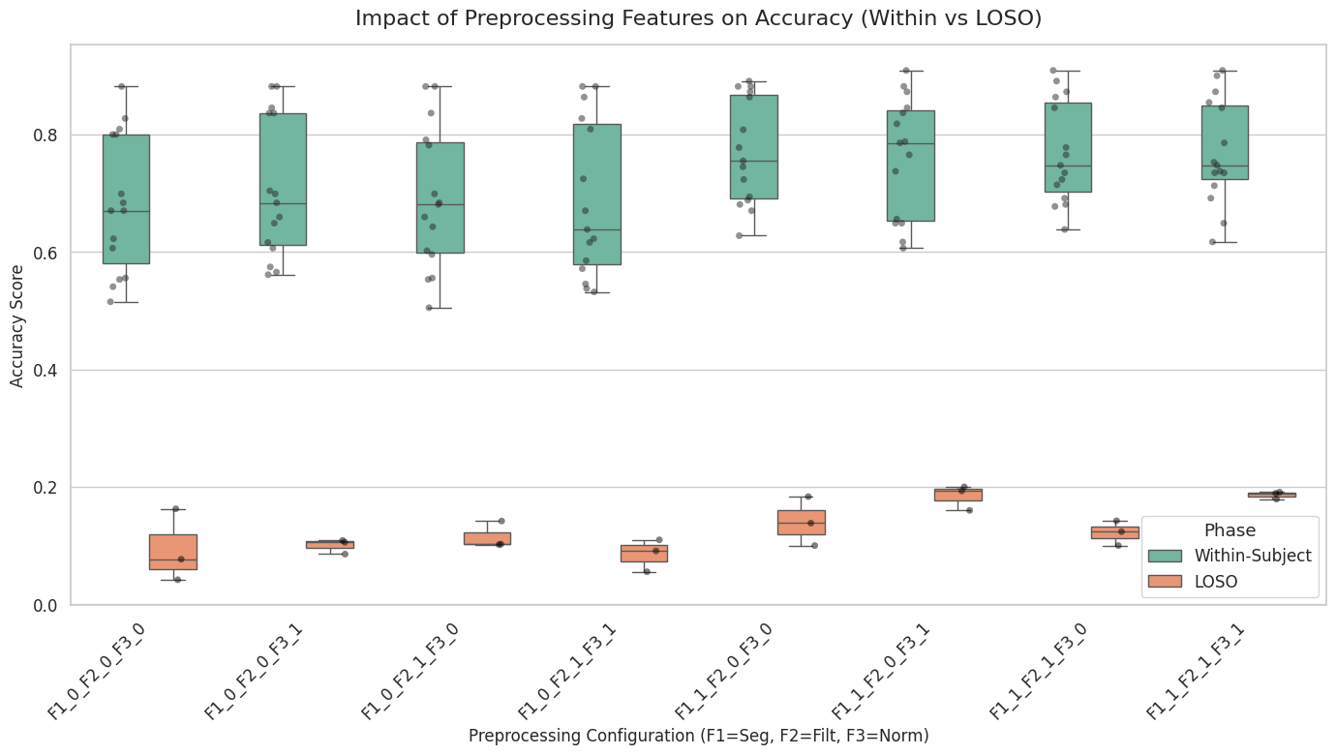
Figure 3. Results of comparison of classification accuracy for different combinations of F1, F2 and F3 for within- and between-subject (LOSO) validation.
Analysis of the data suggests that dynamic segmentation (F1) plays a key role and ensures high accuracy both for a single user (around 0.77) and when working with new subjects. Filtering (F2) does not yield a noticeable improvement in the inter-subject approach, and sometimes even slightly reduces the result. Session normalisation (F3), together with F1, shows the best results in LOSO validation (accuracy 0.184, F1 0.102). Combining all three methods (F1 + F2 + F3) yields a maximum precision of 0.186, whilst the F1 score drops slightly to 0.092, which may be due to the characteristics of the small sample size.
Based on the comparison, the combination of all three pre-processing methods (F1 + F2 + F3) is considered optimal, as it depicts the most stable and highest results in cross-subject testing.

Comparative Analysis of 2-Subject vs. 1-Subject Validation Schemes with and without Features
In a supplementary experiment, we investigated how the number of participants in the validation sample affects the model’s accuracy. The study was conducted using all six recordings of subject M (M1–M6). We compared two variants of LOSO cross-validation (Val 1 - one participant was included in the validation sample; Val 2 - two participants were included in the validation sample). In both cases, a single subject was tested. The fold-splitting schemes are presented in Table 4. The effect of using the feature set F1+F2+F3 (features) was also investigated, compared with no pre-processing (no features).
Table 4. Cross-subject into M-subject recordings, Val 1 / Val 2 with features
subj_test / subj_val | test_acc | best_val_acc
Val 2. No features
M1 / [M6, M4] | 0.344 | 0.732
M2 / | 0.572 | 0.616
M3 / [M6, M4] | 0.741 | 0.784
M4 / [M2, M3] | 0.665 | 0.494
M5 / [M2, M6] | 0.569 | 0.633
mean | 0.578 | 0.652
Val 2. With features
M1 / [M6, M4] | 0.565 | 0.809
M2 / [M3, M6] | 0.822 | 0.797
M3 / [M6, M4] | 0.919 | 0.812
M4 / [M2, M3] | 0.876 | 0.804
M5 / [M2, M6] | 0.771 | 0.790
mean | 0.791 | 0.8024
Val 1. No features
M1 / M6 | 0.266 | 0.512
M2 / M3 | 0.847 | 0.811
M3 / M6 | 0.708 | 0.533
M4 / M2 | 0.811 | 0.855
M5 / M2 | 0.591 | 0.851
mean | 0.645 | 0.712
Val 1. With features
M1 / M6 | 0.567 | 0.695
M2 / M3 | 0.831 | 0.932
M3 / M6 | 0.886 | 0.710
M4 / M2 | 0.922 | 0.920
M5 / M2 | 0.765 | 0.939
mean | 0.794 | 0.839

A paired t-test was used to assess the differences. The p-values are presented in Table 5.
Table 5. A paired t-test results of comparing Val 1/Val2 Features applied/No features applied cases
Cases | P-value | Significance
Val 1 without features vs. Val 2 without features | p = 0.6736 | no statistically significant differences.
Val 1 with features vs. Val 2 with features | p = 0.3591 | no statistically significant differences.
Val 1 without features vs. Val 1 with features | p = 0.0447 | the difference is significant.
Val 2 without features vs. Val 2 with features | p = 0.0001 | the difference is significant.
The use of features improves the quality of predictions regardless of whether validation is performed on one or two participants (p < 0.05 in both cases). The number of participants in the validation sample (one or two) does not have a statistically significant effect on the final accuracy (p > 0.05 both with and without features) .
Since the average accuracy for Val 1 with features (0.794) is slightly higher than for Val 2 with features (0.791), validation on a single participant was chosen for further experiments. This option is simpler, more cost-effective and is not inferior in quality to the two-participant scheme.

Final Model vs. Baseline Performance Analysis
This study compared the performance of baseline machine learning (Logistic Regression, SVM, XGBoost, 1D CNN) and deep learning models. The models were evaluated using two protocols: Within-Subject validation and LOSO cross-validation (1 subject for validation).
The final proposed model combined a CNN and Transformer architecture. It used extracted statistical features, data augmentation, and updated hyperparameters.
In the Within-Subject tests, all models performed consistently well (Table 6), effectively adapting to individual muscle activity patterns. Neural network-based models (CNN and CNN-Transformer) achieved the highest accuracy and the most stable error rates.
Table 6. Baseline within-subject comparing
subj_test | test_acc_logreg | test_acc_svm | test_acc_xgboost | test_acc_cnn | test_acc_cnn_transformer
A | 0.866 ± 0.027 | 0.827 ± 0.019 | 0.831 ± 0.049 | 0.894 ± 0.035 | 0.913 ± 0.055
B | 0.892 ± 0.032 | 0.886 ± 0.024 | 0.872 ± 0.019 | 0.913 ± 0.042 | 0.951 ± 0.026
C | 0.757 ± 0.028 | 0.657 ± 0.046 | 0.680 ± 0.037 | 0.729 ± 0.048 | 0.876 ± 0.019
J | 0.903 ± 0.028 | 0.869 ± 0.048 | 0.845 ± 0.016 | 0.873 ± 0.037 | 0.950 ± 0.038
M1 | 0.870 ± 0.036 | 0.865 ± 0.028 | 0.834 ± 0.019 | 0.891 ± 0.033 | 0.943 ± 0.025
M2 | 0.965 ± 0.021 | 0.947 ± 0.025 | 0.927 ± 0.029 | 0.971 ± 0.026 | 0.957 ± 0.029
M3 | 0.950 ± 0.013 | 0.930 ± 0.027 | 0.915 ± 0.032 | 0.952 ± 0.022 | 0.967 ± 0.011
M4 | 0.942 ± 0.021 | 0.911 ± 0.0178 | 0.909 ± 0.030 | 0.949 ± 0.020 | 0.980 ± 0.015
M5 | 0.965 ± 0.021 | 0.967 ± 0.015 | 0.938 ± 0.018 | 0.978 ± 0.012 | 0.978 ± 0.021
M6 | 0.932 ± 0.030 | 0.914 ± 0.014 | 0.923 ± 0.023 | 0.941 ± 0.008 | 0.955 ± 0.041
mean | 0.914 | 0.883 | 0.867 | 0.909 | 0.947

However, In the LOSO tests, the baseline models and the simple CNN experienced a sharp drop in accuracy. This was due to the high variability between individuals, such as differences in electrode placement and muscle mass (table 7).
The CNN-Transformer model performed better than the baselines in the LOSO scenario. Using data augmentation and the transformer's self-attention helped reduce the impact of individual differences. The model achieved an average inter-subject accuracy of about 69.3%, reaching up to 96.1% for some subjects, which is a notable improvement over traditional methods (table 7, figure 4).
Table 7. Baseline LOSO comparing
subj_test / subj_val | test_acc_logreg | test_acc_svm | test_acc_xgboost | test_acc_cnn | subj_tes/val_cnn_transformer | test_acc_cnn_transformer
A / B | 0.175 | 0.179 | 0.207 | 0.100 | A / C | 0.528
B / C | 0.314 | 0.210 | 0.232 | 0.216 | B / J | 0.371
C / J | 0.168 | 0.192 | 0.181 | 0.183 | C / M1 | 0.348
J / M1 | 0.201 | 0.235 | 0.272 | 0.245 | J / M1 | 0.656
M1 / M2 | 0.208 | 0.172 | 0.137 | 0.158 | M1 / M3 | 0.758
M2 / M3 | 0.433 | 0.351 | 0.265 | 0.182 | M2 / J | 0.831
M3 / M4 | 0.364 | 0.335 | 0.404 | 0.219 | M3 / J | 0.961
M4 / M5 | 0.270 | 0.342 | 0.392 | 0.242 | M4 / M2 | 0.944
M5 / M6 | 0.187 | 0.242 | 0.264 | 0.091 | M5 / M2 | 0.802
M6 / A | 0.186 | 0.159 | 0.181 | 0.227 | M6 / J | 0.726
mean | 0.251 | 0.242 | 0.254 | 0.186 | - | 0.693
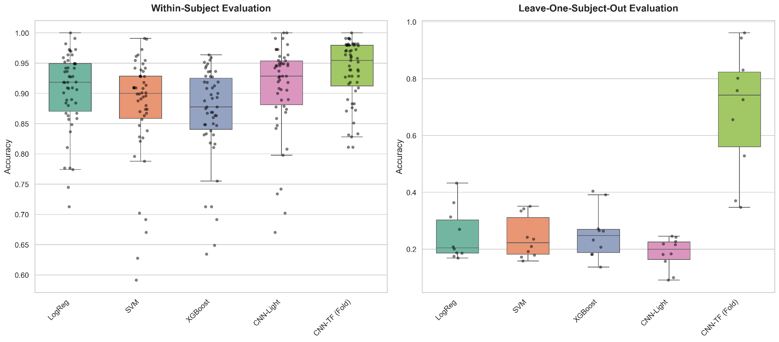
Figure 4. Comparison of classification accuracy between Within-Subject and LOSO evaluation strategies across different ML and DL models
More detailed information with confusion matrix provided in supplementary.

Conclusions
This study examined how machine learning and advanced deep learning models can classify sEMG signal patterns recorded during handwriting tasks. We tested both Within-Subject and Cross-Subject (Leave-One-Subject-Out) validation methods to measure the significant generalization gap in myoelectric interfaces and explored ways to reduce it. The experimental results lead to several important conclusions:
- The proposed hybrid CNN-Transformer architecture achieved a peak average accuracy of 94.7% under the Within-Subject validation protocol. This performance substantially outperforms traditional machine learning baselines (Logistic Regression, SVM, XGBoost) as well as a basic 1D-CNN.
- Cross-subject evaluation on unseen participants revealed a significant limitation in the baselines, as traditional models and the simple CNN fell to 18.6%-25.4% accuracy. The proposed CNN-Transformer model effectively addressed this vulnerability by incorporating targeted augmentations (channel dropout, noise injection, and bracelet spatial shift simulations). Consequently, the final architecture achieved a 69.3% average inter-subject accuracy, with top performance reaching 96.1% (Subject M3).
- Ablation studies verified that effective preprocessing is a prerequisite for cross-subject transfer. Specifically, dynamic segmentation based on pen-to-surface interaction (F1) stabilized temporal patterns against variations in writing speed. Combining this approach with continuous session-wide normalization (F3) produced the highest and most consistent accuracy during cross-subject validation (p < 0.05).
- Based on a paired t-test, reducing the validation sample from two subjects (Val 2) to a single subject (Val 1) had no statistically significant impact on the final classification accuracy (p > 0.05).
In summary, while inter-subject variability, sensor displacement, and individual anatomical differences remain challenging for sEMG pattern recognition, this study demonstrates that end-to-end deep learning models can successfully overcome the user barrier when enhanced by specialized temporal-spatial augmentations and robust preprocessing. These findings offer practical insights for developing robust, user-independent handwritten text recognition systems.

References
- Ameri, A., Akhaee, M. A., Scheme, E., & Englehart, K. (2019). A deep transfer learning approach to reducing the effect of electrode shift in EMG Pattern Recognition-Based control. IEEE Transactions on Neural Systems and Rehabilitation Engineering, 28(2), 370–379. https://doi.org/10.1109/tnsre.2019.2962189
- Atzori, M., Cognolato, M., & Müller, H. (2016). Deep Learning with Convolutional Neural Networks Applied to Electromyography Data: A Resource for the Classification of Movements for Prosthetic Hands. Frontiers in Neurorobotics, 10, 9. https://doi.org/10.3389/fnbot.2016.00009
- Cote-Allard, U., Fall, C. L., Drouin, A., Campeau-Lecours, A., Gosselin, C., Glette, K., Laviolette, F., & Gosselin, B. (2019). Deep learning for electromyographic hand gesture signal classification using transfer learning. IEEE Transactions on Neural Systems and Rehabilitation Engineering, 27(4), 760–771. https://doi.org/10.1109/tnsre.2019.2896269
- Hu, R., Chen, X., Zhang, X., & Chen, X. (2020). Adaptive electrode calibration method based on muscle core activation regions and its application in myoelectric pattern recognition. IEEE Transactions on Neural Systems and Rehabilitation Engineering, 29, 11–20. https://doi.org/10.1109/tnsre.2020.3029099
- Senturk, Z. K., & Bakay, M. S. (2021). Machine learning based hand gesture recognition via EMG data. ADCAIJ ADVANCES IN DISTRIBUTED COMPUTING AND ARTIFICIAL INTELLIGENCE JOURNAL, 10(2). https://doi.org/10.14201/adcaij2021102123136
- Li, W., Shi, P., & Yu, H. (2021). Gesture recognition using surface electromyography and deep learning for prostheses Hand: State-of-the-Art, Challenges, and Future. Frontiers in Neuroscience, 15, 621885. https://doi.org/10.3389/fnins.2021.621885
- Linderman, M., Lebedev, M. A., & Erlichman, J. S. (2009). Recognition of Handwriting from Electromyography. PLoS ONE, 4(8), e6791. https://doi.org/10.1371/journal.pone.0006791
- Tanaka, T., Nambu, I., Maruyama, Y., & Wada, Y. (2022). Sliding-Window normalization to improve the performance of Machine-Learning models for Real-Time motion prediction using electromyography. Sensors, 22(13), 5005. https://doi.org/10.3390/s22135005
- Wang, K., Chen, Y., Zhang, Y., Yang, X., & Hu, C. (2023). Iterative Self-Training based Domain adaptation for Cross-User SEMG gesture recognition. IEEE Transactions on Neural Systems and Rehabilitation Engineering, 31, 2974–2987. https://doi.org/10.1109/tnsre.2023.3293334
- Wu, L., Zhang, X., Wang, K., Chen, X., & Chen, X. (2020). Improved High-Density myoelectric pattern recognition control against electrode shift using data augmentation and dilated convolutional neural network. IEEE Transactions on Neural Systems and Rehabilitation Engineering, 28(12), 2637–2646. https://doi.org/10.1109/tnsre.2020.3030931
- Yuan, Y., Liu, J., Dai, C., Liu, X., Hu, B., & Fan, J. (2024). Exploring pattern-specific components associated with hand gestures through different sEMG measures. Journal of NeuroEngineering and Rehabilitation, 21(1), 233. https://doi.org/10.1186/s12984-024-01526-3
- Chen, L., Fu, J., Wu, Y., Li, H., & Zheng, B. (2020). Hand gesture recognition using compact CNN via surface electromyography signals. Sensors, 20(3), 672. https://doi.org/10.3390/s20030672

Supplementary
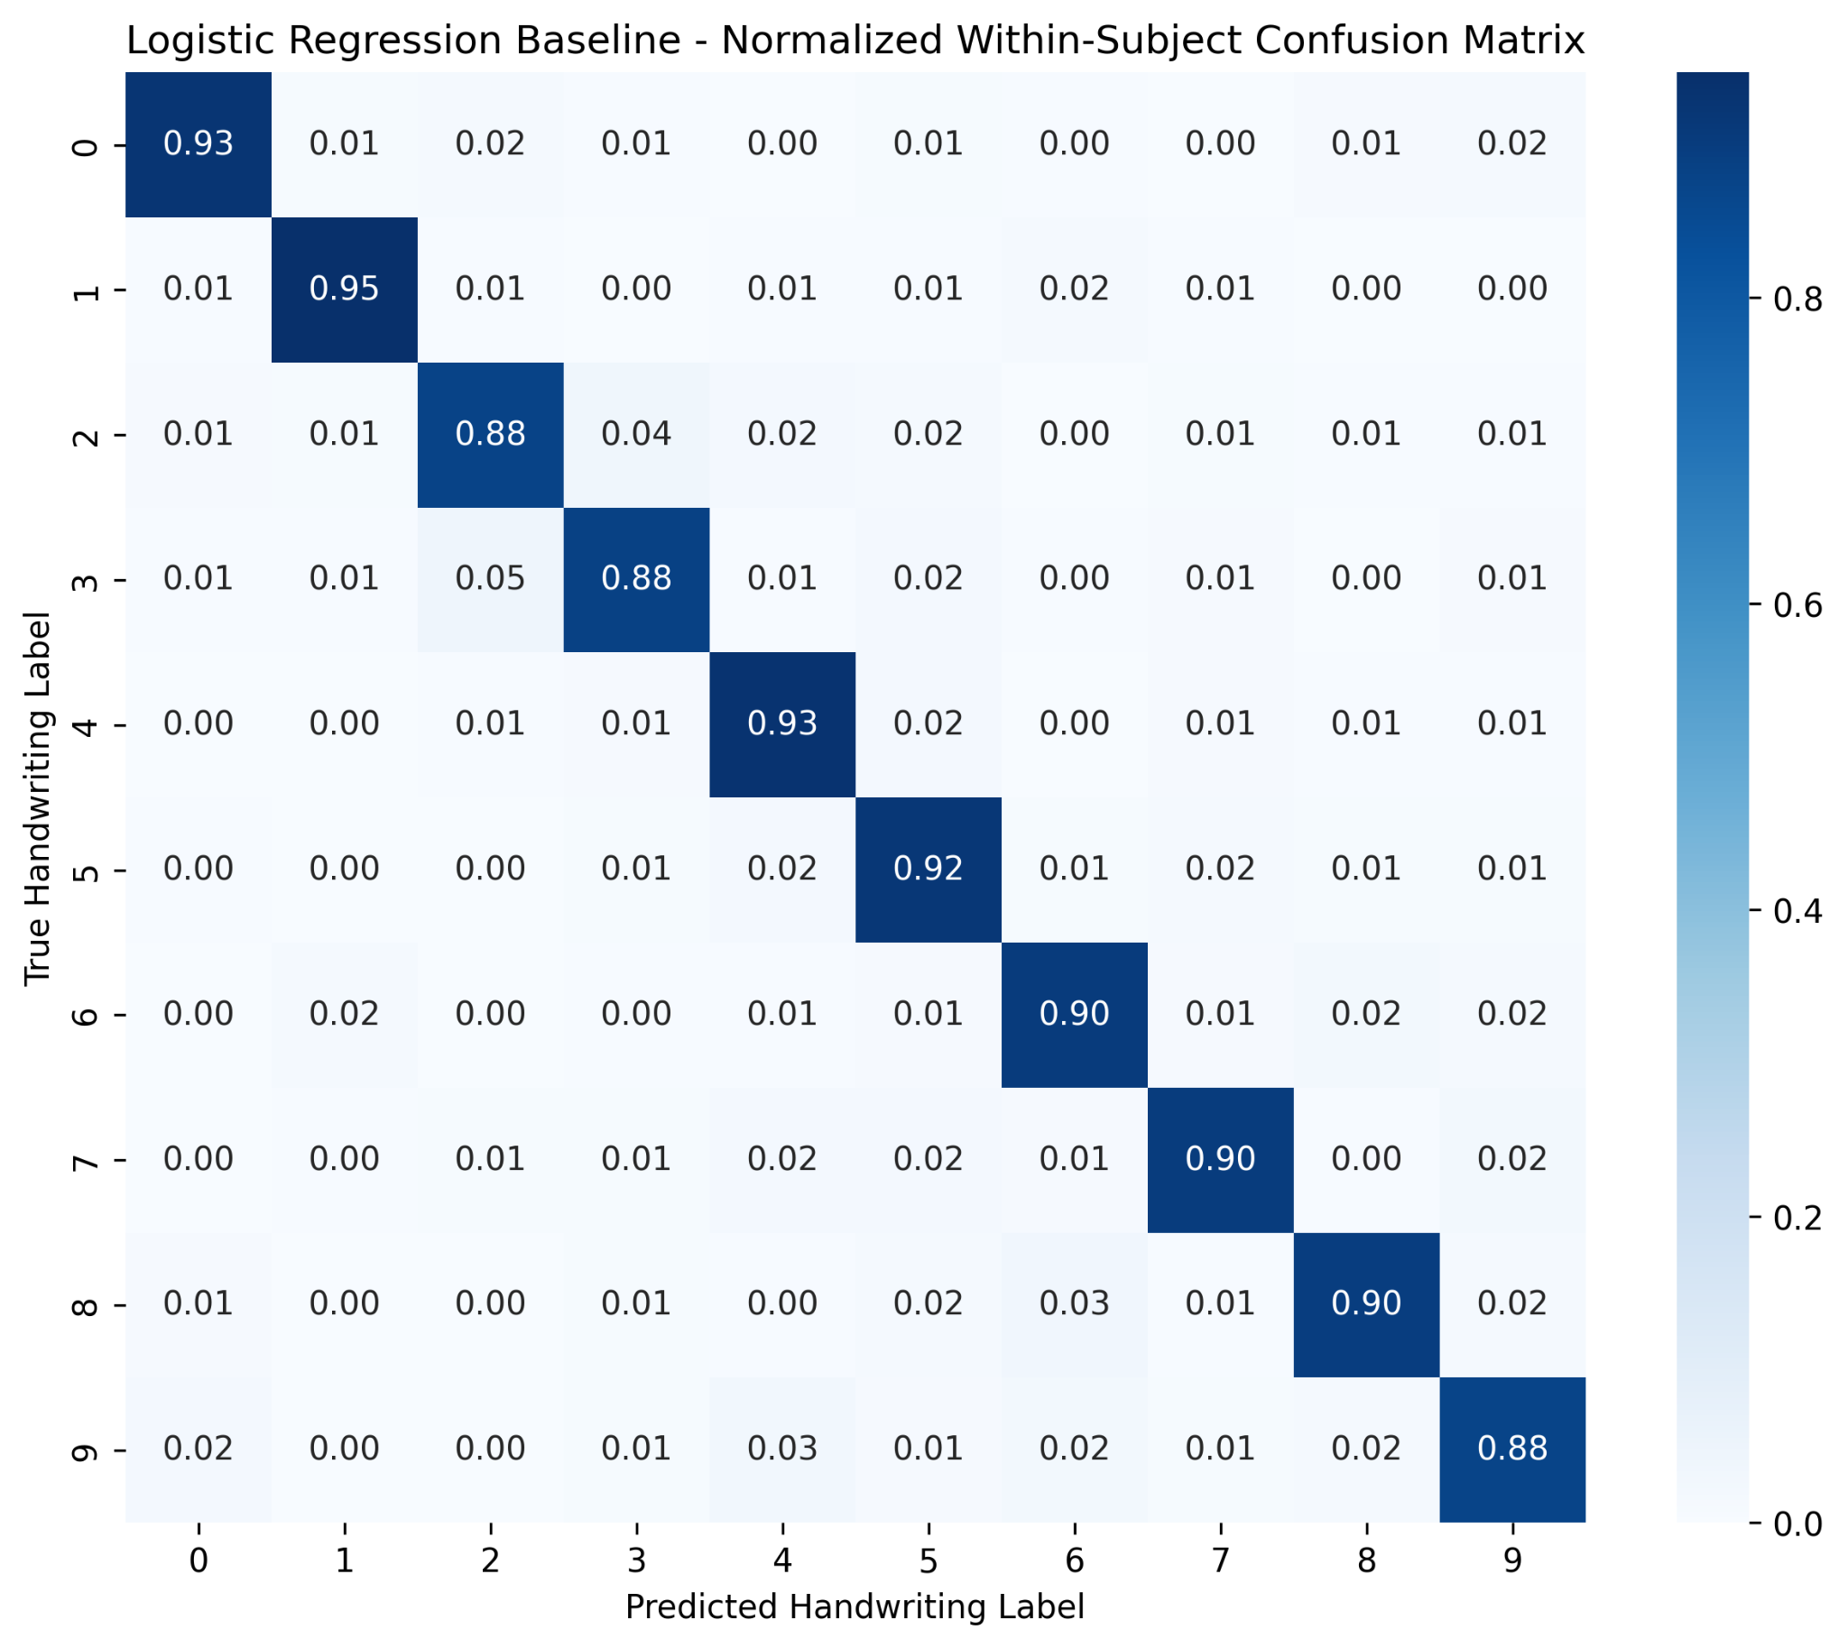
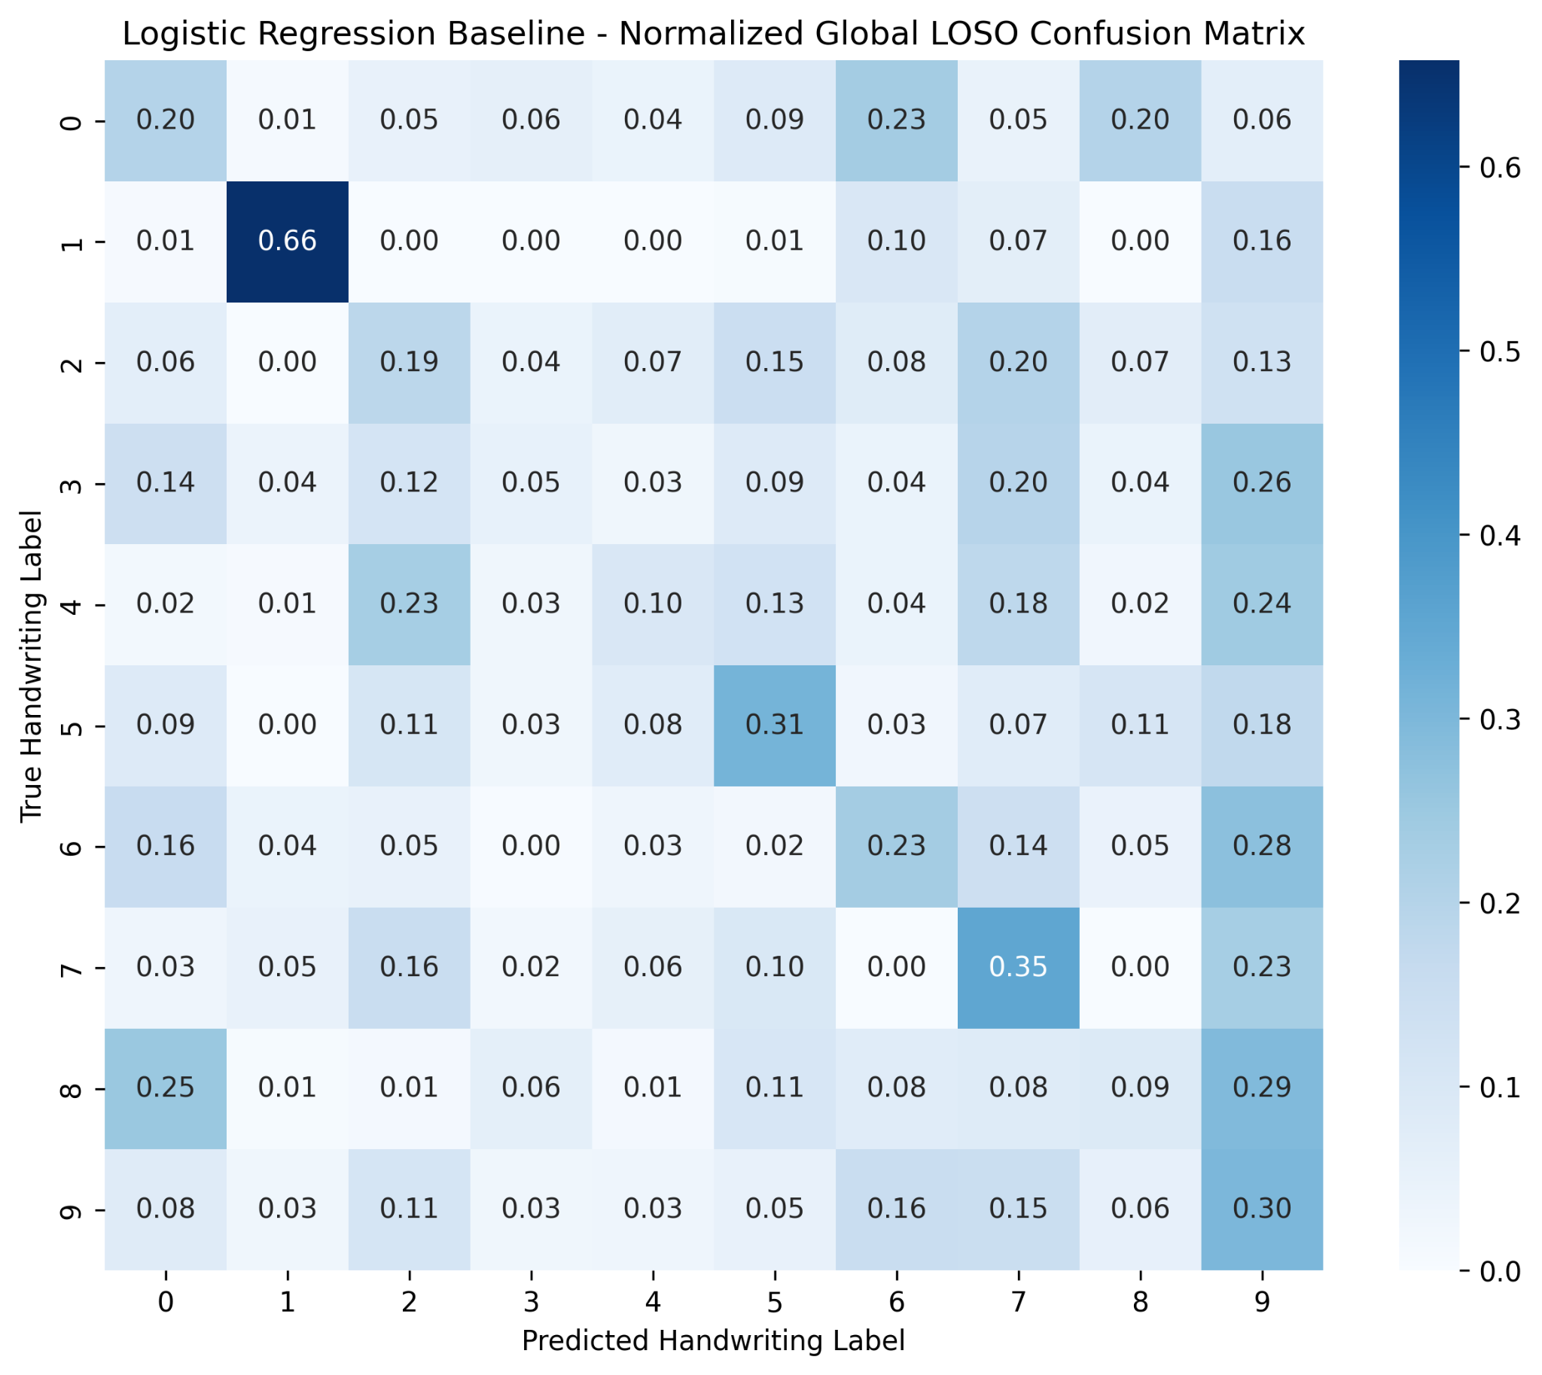
Figure S1. Normalized confusion matrices for the Logistic Regression baseline model. The top panel displays the within-subject validation performance, demonstrating strong diagonal alignment across all handwritten labels (0–9). The bottom panel illustrates the performance under the global Leave-One-Subject-Out (LOSO) cross-validation protocol, highlighting a severe drop in classification accuracy and significant inter-subject confusion.
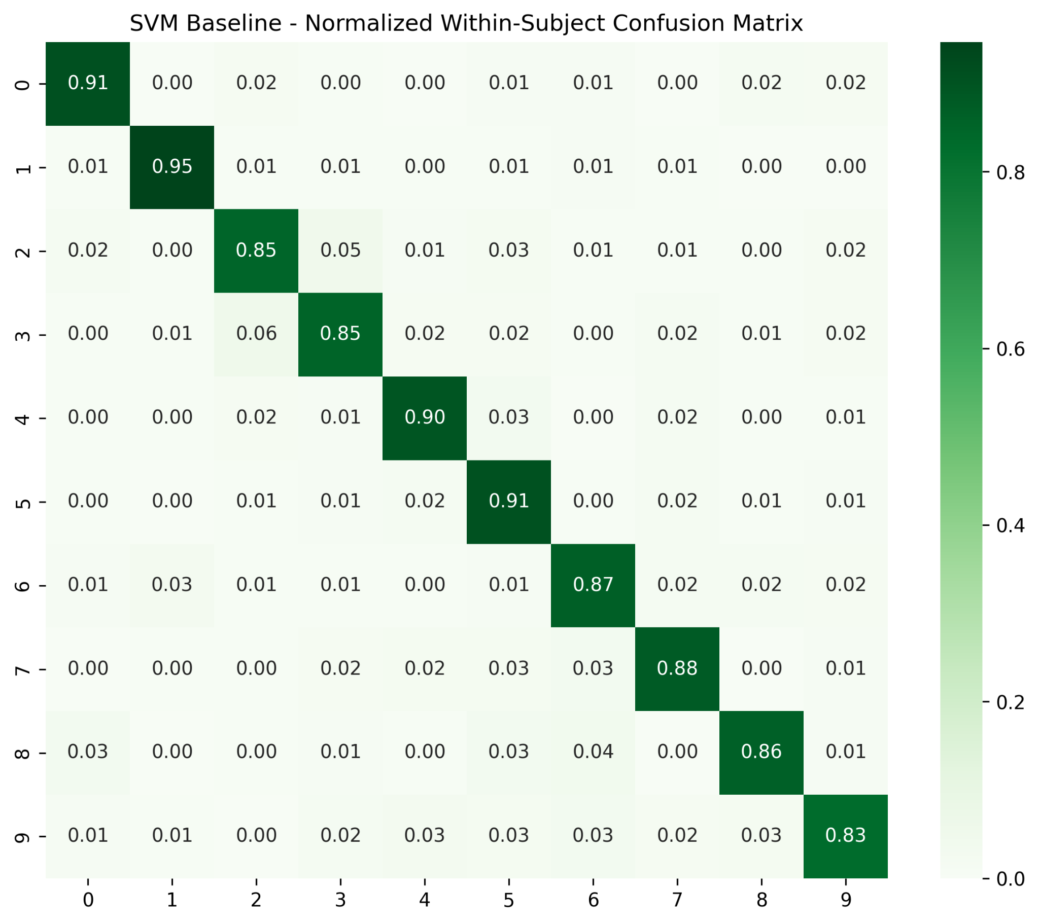
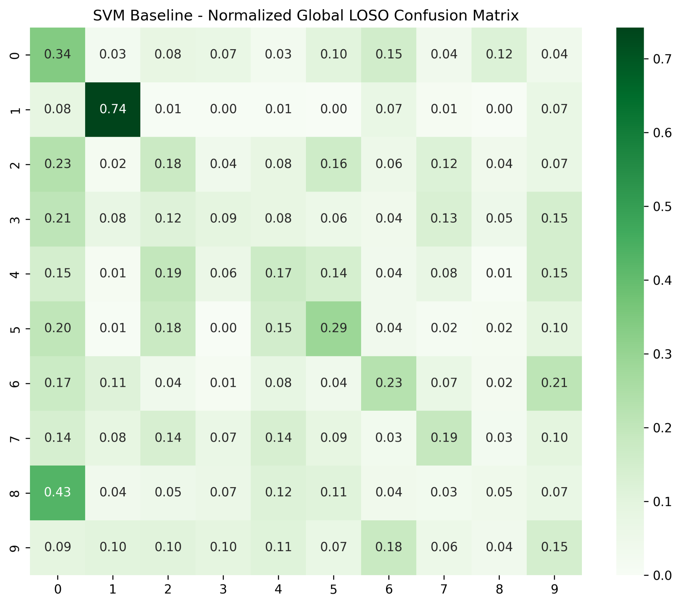
Figure S2. Normalized confusion matrices for the SVM baseline model. The top panel displays the within-subject validation performance, showing high diagonal precision across all target classes. The bottom panel illustrates the performance under the global Leave-One-Subject-Out (LOSO) cross-validation protocol, capturing the breakdown of classifier boundaries and substantial misclassification due to cross-subject domain shift.
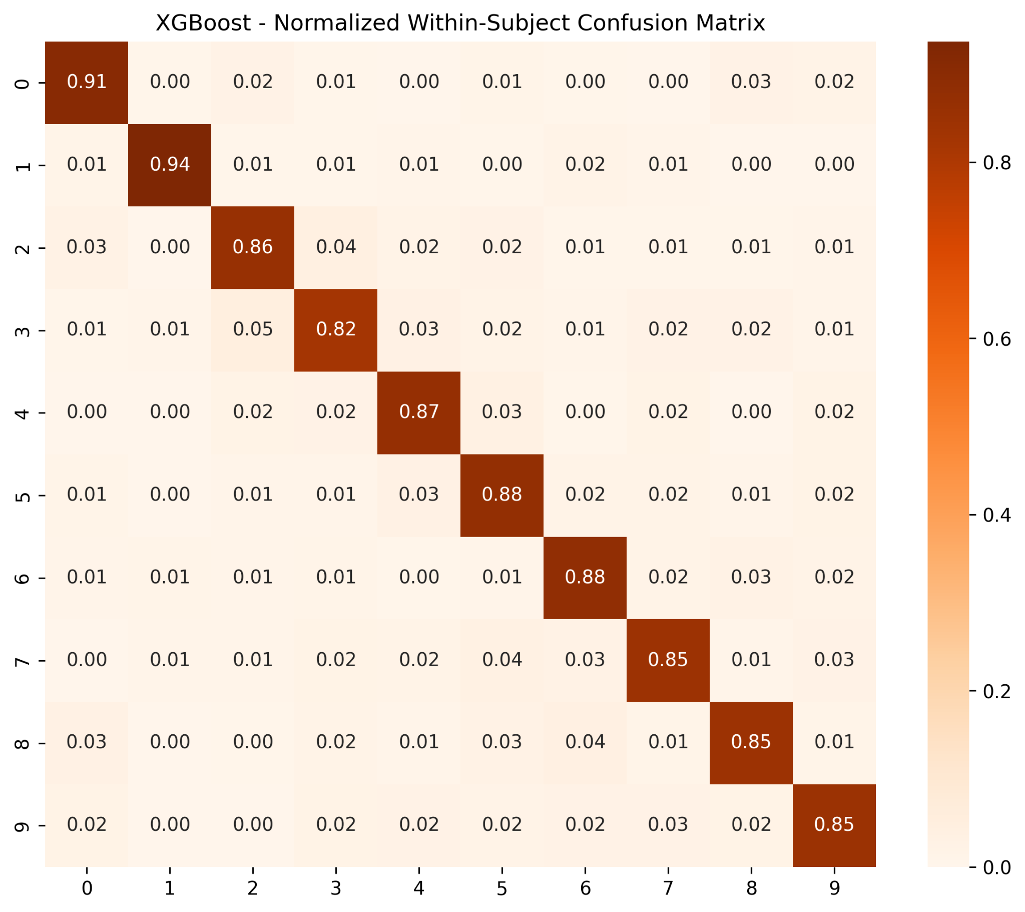
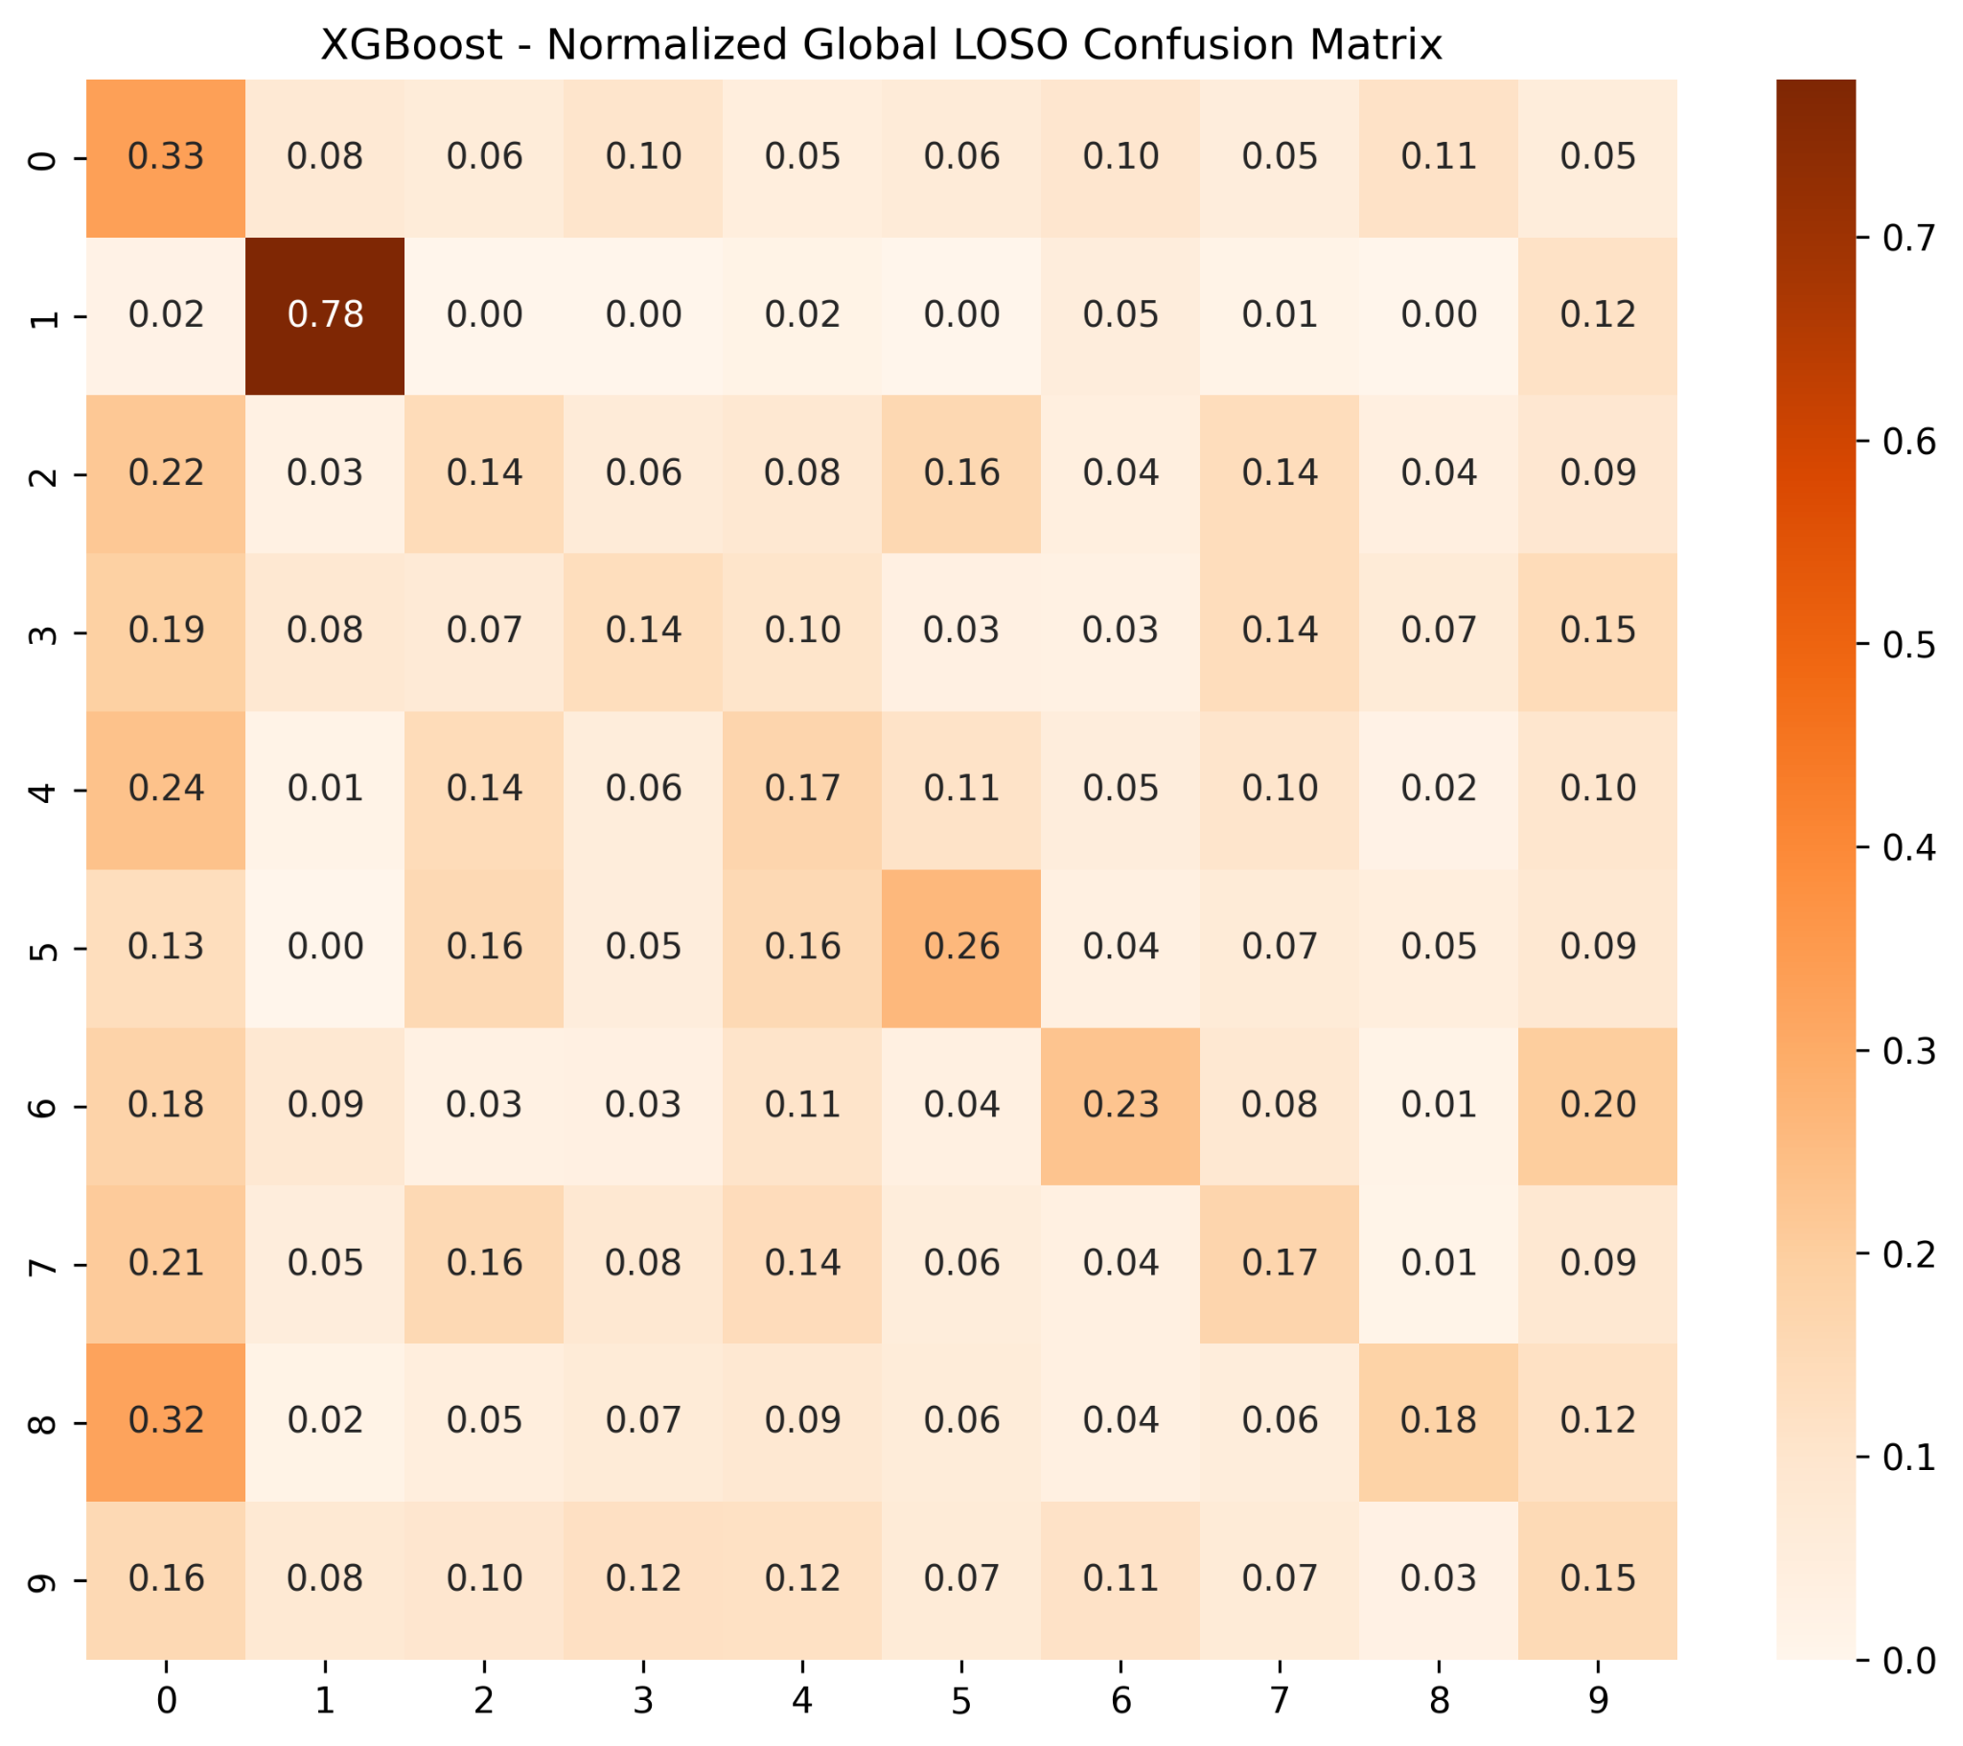
Figure S3. Normalized confusion matrices for the XGBoost baseline model. The top panel shows the within-subject validation results, demonstrating high true-positive rates along the main diagonal. The bottom panel depicts the global Leave-One-Subject-Out (LOSO) cross-validation results, revealing a high degree of inter-class confusion and structural performance degradation across unseen participants.
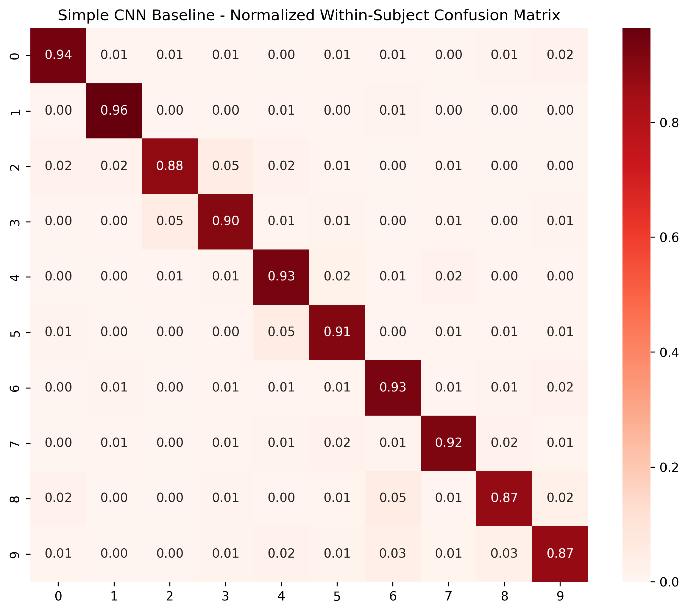
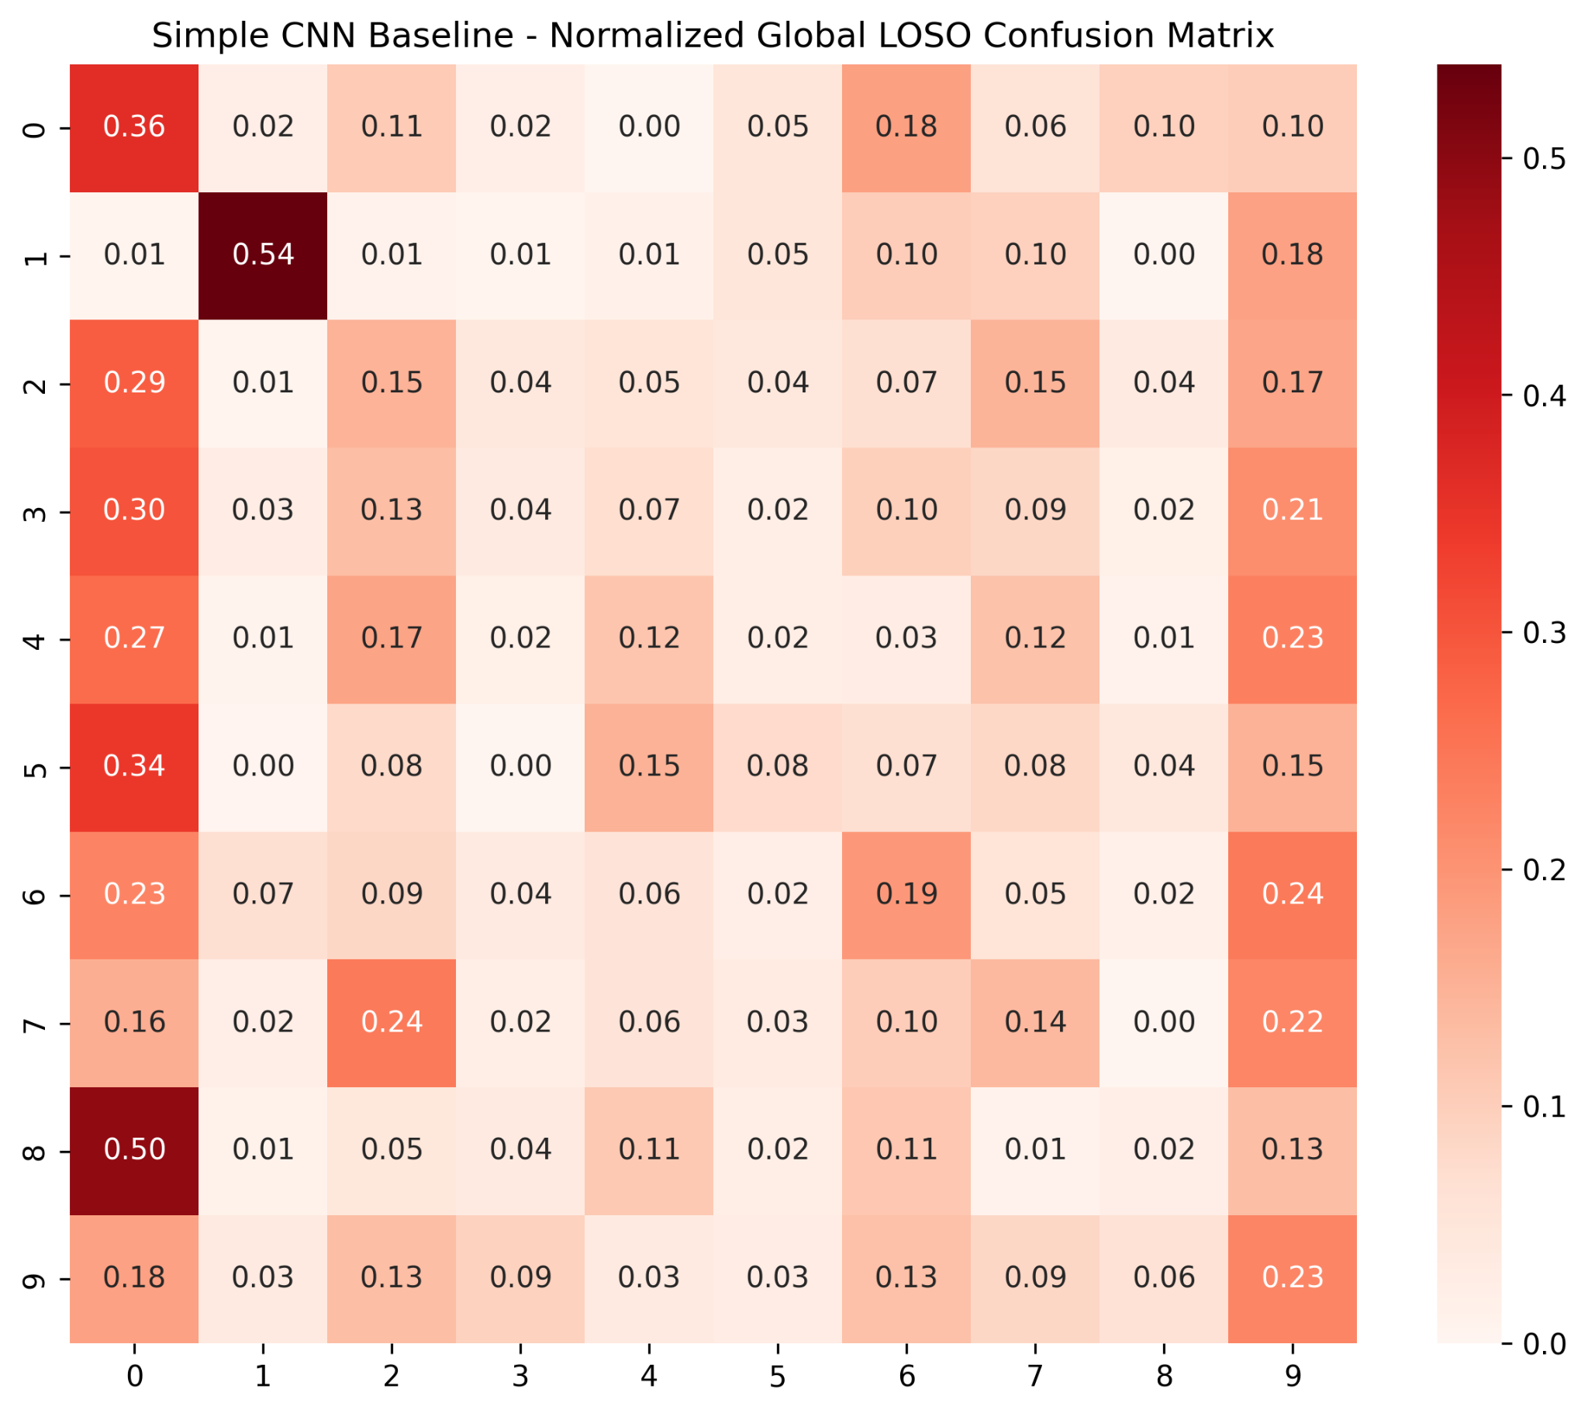
Figure S4. Normalized confusion matrices for the Simple CNN baseline model. The top panel presents the within-subject validation performance, highlighting strong diagonal convergence for deep-feature-based classification. The bottom panel illustrates the global Leave-One-Subject-Out (LOSO) cross-validation performance, indicating a prominent failure to generalize across unseen subjects with substantial misclassification noise.
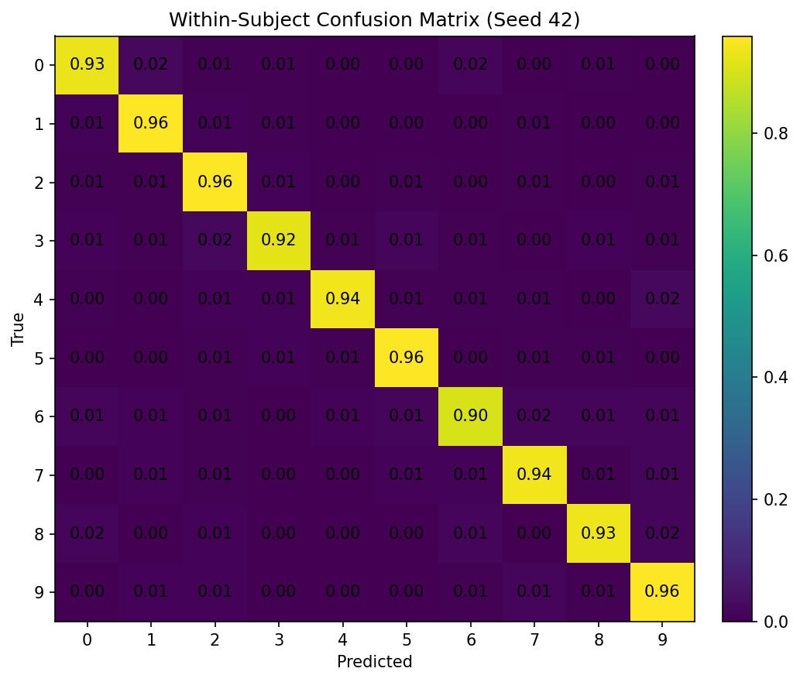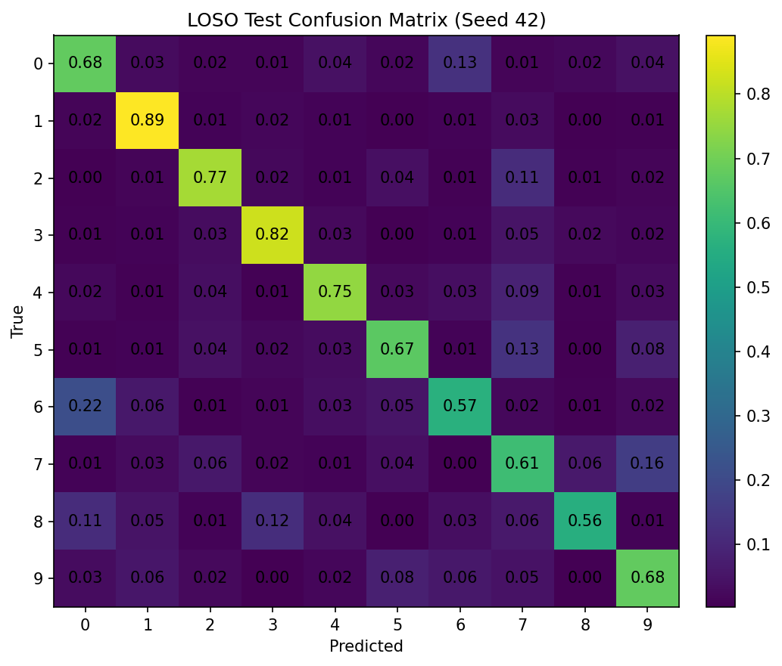
Figure S5. Normalized confusion matrices for the proposed final CNN-Transformer architecture incorporating robust preprocessing, feature extraction, and advanced data augmentations. The top panel demonstrates near-perfect within-subject classification across all handwritten characters. Notably, the bottom panel (LOSO Test) shows that the model successfully overcomes the user independent barrier, maintaining high diagonal precision.

