Energy Demand Forecasting + RL Load Scheduling
Week 2 Checkpoint Report
Holy Angel University | 6INTELSY | AY 2025–2026 | March 2026
Euan Roie Nicolas  Holy Angel University  #1 Holy Angel Avenue, Sto. Rosario, Angeles City, 2009  Pampanga, Philippines  +63 956 832 1369  yuro.roie@gmail.com | Jan Nolasco  Holy Angel University  #1 Holy Angel Avenue, Sto. Rosario, Angeles City, 2009  Pampanga, Philippines  +63 962 829 0338  jannolasco05@gmail.com
Jeremiah Carbungco  Holy Angel University  #1 Holy Angel Avenue, Sto. Rosario, Angeles City, 2009  Pampanga, Philippines  +63 969 646 2760  jeremiah.carbungco29@gmail.com | Jared Gabriel Vitero  Holy Angel University  #1 Holy Angel Avenue, Sto. Rosario, Angeles City, 2009  Pampanga, Philippines  +63 956 507 7873  jaredvitero@gmail.com
1. PROJECT OVERVIEW  Short-term electricity demand forecasting and intelligent load scheduling using the UCI Individual Household Electric Power Consumption dataset. Combines ML baselines, LSTM/TCN deep learning, NLP, and Q-Learning RL to minimize proxy electricity costs by deferring loads to off-peak hours. Offline academic simulation only.  2. DATA ACQUISITION, CLEANING & SPLITS  Source: UCI Household Power Consumption (Hébrail & Bérard, 2006). Raw 1-min data resampled to hourly; after cleaning: 34,168 records, zero missing values. Target: Global_active_power (kW). Features: reactive power, voltage, intensity, 3 sub-metering channels, cyclic time encodings (12 total). 24-step sliding window, horizon = 1.  Strictly temporal splits (no leakage): Train 27,310 (80%) / Val 3,393 (10%) / Test 3,393 (10%).  3. EXPLORATORY DATA ANALYSIS  EDA in notebooks/01_eda.ipynb. Key findings: right-skewed demand (mean 1.09 kW, max 6.56 kW); morning (7–9h) and evening (18–21h) peaks; Sub_metering_3 (water heater/climate) is dominant sub-load.  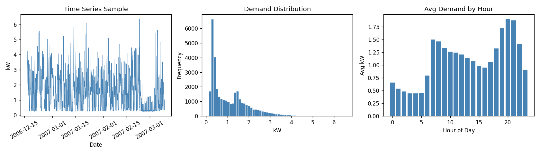  Figure 1. Time series sample, distribution, and avg demand by hour.  4. BASELINE MODELS — INITIAL METRICS  Flattened 24×12 window (288-dim input). LR = lower bound; RF (100 trees, depth=10) = best non-DL baseline. Val MAE: LR=0.4022, RF=0.3569. RF outperforms LR by 11.3% on validation.  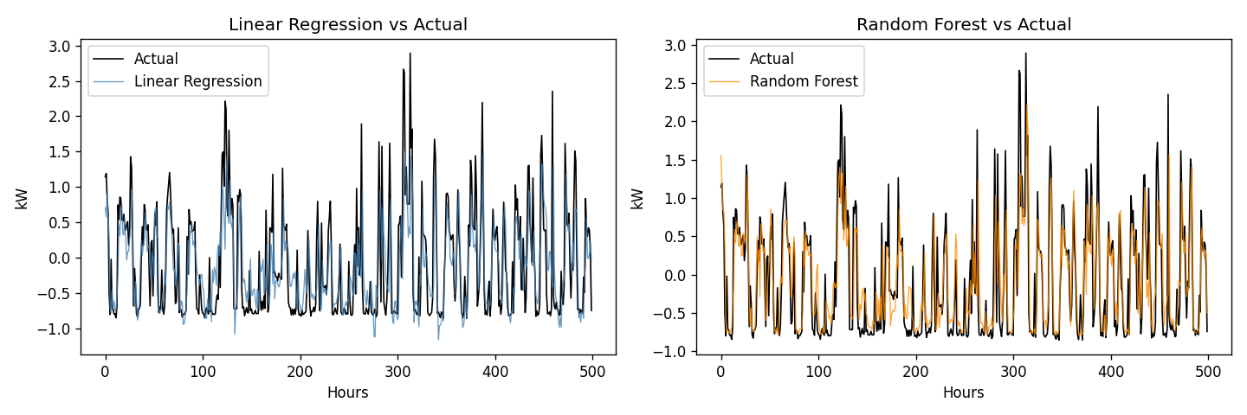  Figure 2. LR and RF predictions vs. actual (first 500 test hours).  5. DEEP LEARNING — LSTM & TCN (CNN)  5.1 LSTM Baseline  Single-layer LSTM (hidden=32, 10,401 params). Best epoch 11/16. Test MAE = 0.3234.  5.2 LSTM Full Encoder-Decoder  2-layer encoder (hidden=64, dropout=0.2, 70,465 params) + 1-layer decoder. Best epoch 24/29. Test MAE = 0.3153 — best overall result.  5.3 TCN (CNN Component)  4 residual blocks, dilations 1/2/4/8, kernel=3, channels=64, weight norm (90,241 params). Best epoch 16/21. Test MAE = 0.3225.  Model Val MAE Test MAE Best Ep. Note  Linear Regression 0.4022 0.3875 — Tabular  Random Forest 0.3569 0.3399 — Best ML  LSTM Baseline 0.3443 0.3234 ep 11/16 Simple DL  LSTM Full 0.3414 0.3153 ep 24/29 Primary DL  TCN 0.3406 0.3225 ep 16/21 CNN  Table 1. All model metrics from run.py.  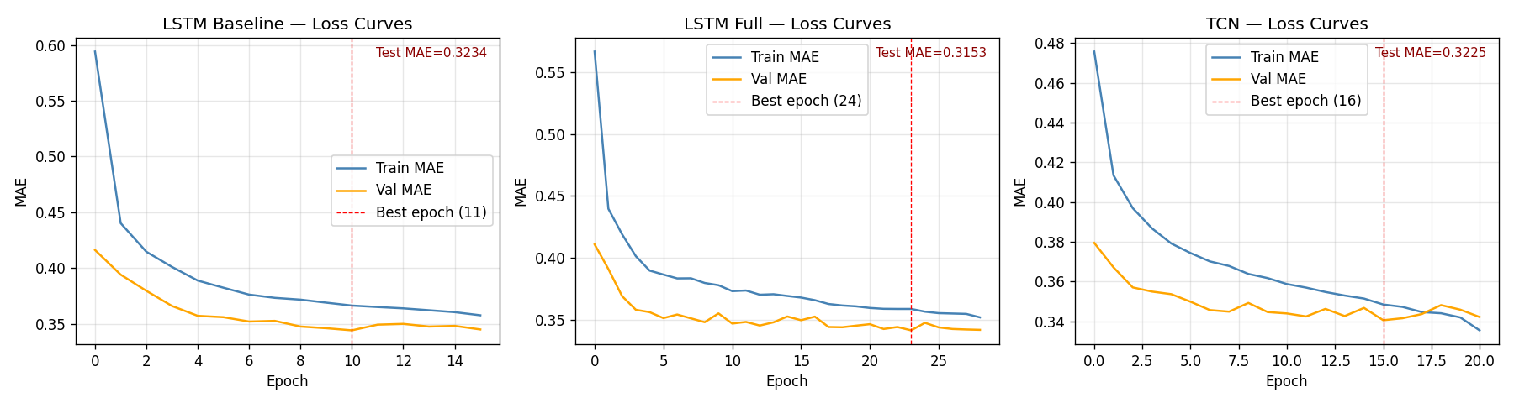  Figure 3. Train/val MAE curves — LSTM Baseline, LSTM Full, TCN. | 6. NLP COMPONENT  Two components in src/models/nlp_component.py: (1) ForecastSummarizer — template-based NLG converting (forecast_kwh, hour, rl_action) to plain-language decisions with override option. (2) PeriodClassifier — TF-IDF + Logistic Regression; precision/recall/F1 = 1.00 across all 3 classes (22 training samples).  Example (hour 18, high demand): “Forecast (evening peak, 18:00): 2.10 kWh — demand is high. Decision: Defer washing machine. You may override this decision at any time.”  7. REINFORCEMENT LEARNING AGENT  Environment: 24-step episodes. State: [normalized_forecast, hour_sin, hour_cos, load_on]. Actions: defer (0) or run (1). Reward: cost savings vs. always-on baseline minus comfort penalty for skipping must-run hours (7h, 8h, 18–20h). Min 4 run-hours enforced per episode.  Agent: tabular Q-Learning (α=0.10, γ=0.95, ε-decay=0.995), 500 episodes on test-set forecasts. Mean reward rose from −6.415 (ep 1–50) to +2.641 (ep 451–500), confirming effective learning signal.  RL Metric Value  Agent reward (50 eval eps.) 2.062 ± 2.885  Baseline reward (always-on) 0.000 ± 0.000  First 50 eps. mean reward −6.415  Last 50 eps. mean reward +2.641  Table 2. RL evaluation results (50 eps., deterministic policy).  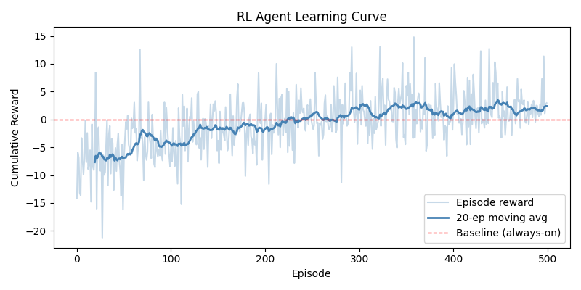  Figure 4. RL learning curve. Red dashed = always-on baseline (reward = 0).  8. MODEL CARD & ETHICS STATEMENT  Model Card (docs/model_card.md) documents model details, intended use, dataset, splits, real test metrics, and caveats — now fully updated from TBD to actual values.  Ethics risks and confirmed mitigations: (1) Equity — equity metric added to eval pipeline; (2) User Autonomy — opt-in, override, comfort penalty (−2.0/step) and must-run hours implemented in RL env; (3) Data Privacy — anonymized UCI dataset, no PII stored, raw data excluded from repo via .gitignore.  9. REPOSITORY STATUS  - src/data_pipeline.py — loading, cleaning, splits ✓  - notebooks/01_eda.ipynb — EDA notebook ✓  - src/models/tabular_baseline.py — LR (0.3875) + RF (0.3399) ✓  - src/models/lstm_model.py — Baseline (0.3234) + Full (0.3153) ✓  - src/models/tcn_model.py — TCN 4-block dilated (0.3225) ✓  - src/models/nlp_component.py — classifier (F1=1.00) + summarizer ✓  - src/rl_agent.py — Q-Learning, 500 ep, −6.4→+2.6 ✓  - src/train.py + src/eval.py — training & evaluation ✓  - docs/model_card.md + ethics_statement.md ✓

